Function | Peripheral | Channel / Mode | MCU Pin | Notes
CAN_RX | CAN1 | RX (remapped) | PB8 | Requires AFIO CAN remap = 10
CAN_TX | CAN1 | TX (remapped) | PB9 | Requires AFIO CAN remap = 10
Encoder A | TIM3 | CH1 (encoder) | PA6 | Quadrature A
Encoder B | TIM3 | CH2 (encoder) | PA7 | Quadrature B
Index / 1-rev pulse | GPIO / EXTI | — | PB0 | Use EXTI or timer capture for index (optional if available)
ADC Input 1 | ADC1 | IN1 | PA1 | 0–3 V signal
ADC Input 2 (optional) | ADC1 | IN2 | PA2 | 0–3 V signal
ADC Input 3  (optional) | ADC1 | IN3 | PA3 | 0–3 V signal
Reference Voltage | ADC1 | IN4 | PA4 | Analog reference sense
PWM1 High | TIM1 (adv.) | CH1 | PA8 | High-side 1 (complementary)
PWM1 Low | TIM1 (adv.) | CH1N | PB13 | Low-side 1 (complementary)
PWM2 High | TIM1 (adv.) | CH2 | PA9 | High-side 2 (complementary)
PWM2 Low | TIM1 (adv.) | CH2N | PB14 | Low-side 2 (complementary)
JTMS |  |  | PA13 | Programmer Data Input
JTCK |  |  | PA14 | Programmer Data CLK

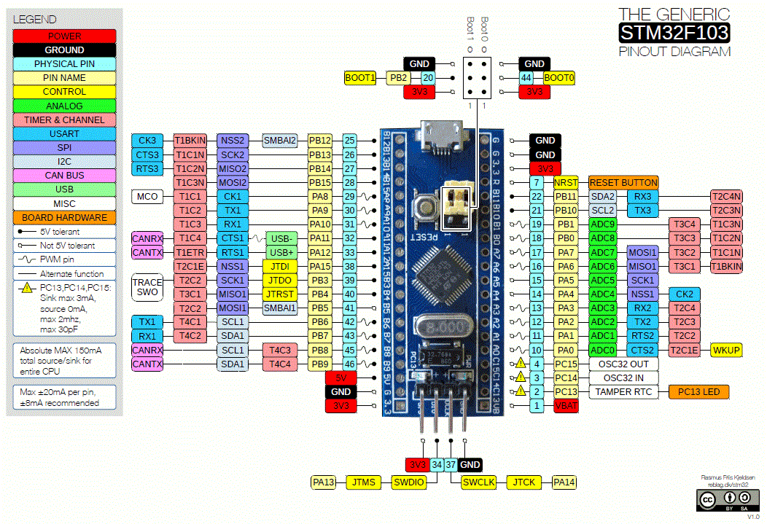
Abbildung 1 STM32F103-Controller als fertige Platine mit Pinheader.

CAN-Bus-Sub-D-Stecker für die Printmontage:
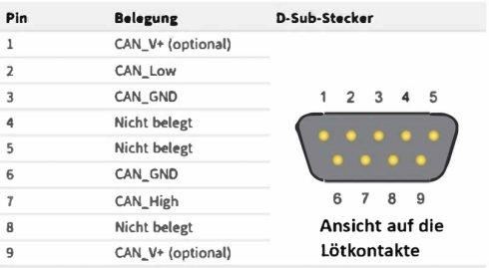
Verwendung folgender PINS beim Printmontage:
Pin 2: CAN_Low
Pin 3: CAN_GND
Pin 7: CAN_High
Pin 9: +3V oder +5V (Extern, wird nicht von unserer PCB geliefert!)
Footprint: DSUB-9_Female_Horizontal_P2.77x2.84mm_EdgePinOffset7.70mm_Housed_MountingHolesOffset9.12mm
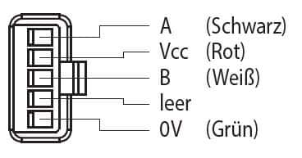
Abbildung 2 Encoder Stecker mit A: Channel A, Vcc=3.3V, B: Channel B, leer: NC, 0V: GND
Footprint: Wago_734-135_1x05_P3.50mm_Vertical

