1.The player gets indigestion consuming excess of food.so he consumes bark of slippery elm or alovera as a cooling agent to the stomach

2.Player finds that he has no more water but the water in the lake is contaminated. So he run on a simple purification process like this to make water purified. He use fine rocks, sand from river banks, rough rocks,charcoal(burning coconut shell) to filter out the water. He needs chemistry knowledge to place this item in order.

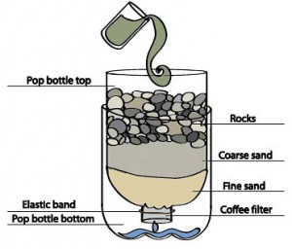

3.As he walks through the jungle he gets sun burns unexpectedly.So he adds 2 cups of baking soda to the bath to help ease irritation and redness from sunburn.Because the basic nature of baking soda helps relieve the burning sensation.

4.player wants to signal about his position to a rescue team.so he uses gun powder in his backpack/from store to light up fireworks.

When he add some heat, he provide enough **activation energy** (the energy that kick-starts a chemical reaction) to make solid chemical compounds packed inside the firework combust (burn) with oxygen in the air and convert themselves into other chemicals, releasing smoke and exhaust gases such as carbon dioxide, carbon monoxide, and nitrogen in the process. For example, this is an example of one of the chemical reactions that might happen when the main gunpowder charge burns:

2KNO3 (potassium nitrate) + S (sulfur) + 3C (carbon in charcoal form) → K2S (potassium sulfide) + N2 (nitrogen gas)

(making firework is not simple and it’s a bit tight practical chemistry)