My primary project this summer was to work with the GPS data we received from our detector in order to approximate its resolution, and ultimately come up with the standard for how the latitude and longitude were computed in the geometry data. The way I went about this was by looking at the number of satellites the detector was seeing, and split up the data accordingly. I wrote two Perl scripts to help me look at the GPS data by the number of satellites it saw. The first script (gps_data.pl) took a raw data file with DGs interspersed, and printed out the following data:
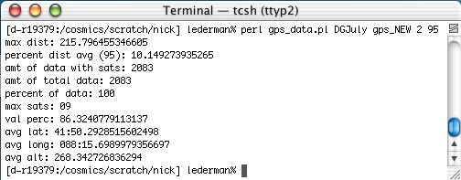
The results are broken down like this:
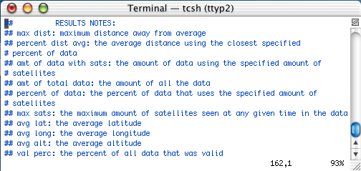
The command line for this script was:
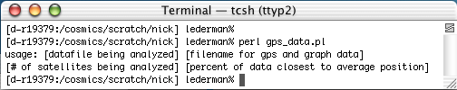
The other helpful result this script produced was an output file of three columns, one of latitude in meters, one in longitude in meters, and one in altitude in meters, which could be run through a plotting script to get either a 2-D plot of just latitude and longitude or a 3-D plot of latitude, longitude, and altitude. These were a very helpful visual explanation of how much the GPS output varied between each signal it sent. It also showed how much the data could be trusted based on how many satellites it was seeing at that time.
A 2-D plot that it would produce would look like this:
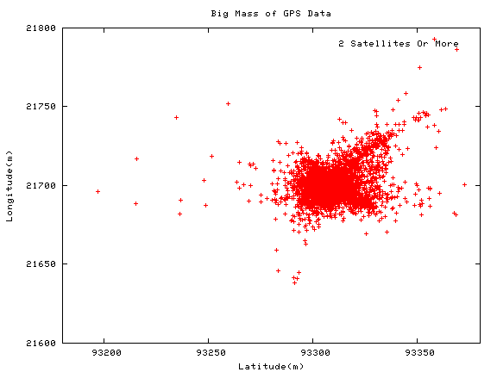

This shows very clearly the variance in latitude and longitude that our GPS detector has with few satellites. However, the data does get more localized the more satellites it sees, as this graph will indicate:
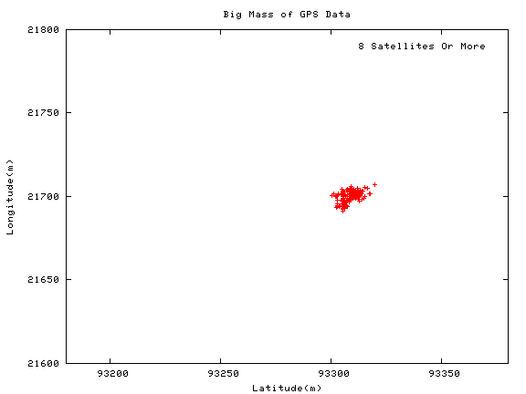

You can see the same sort of localization in the 3-D graph that this script outputs. Here’s a graph using as little as two satellites:
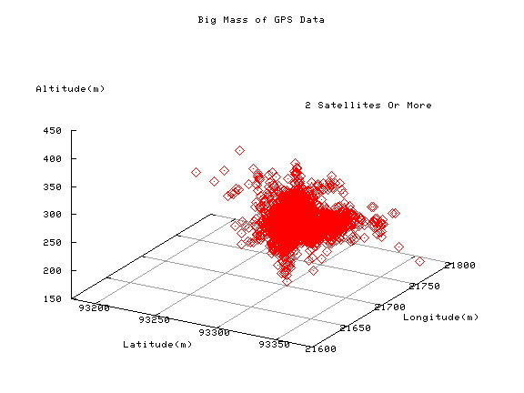

When you take only as little as eight satellites, again the data gets demonstrably more localized:
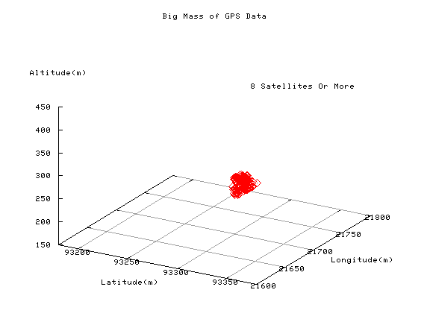

The other script I wrote once again used the number of satellites as a dividing factor, but this time looked at the amount of satellites not in relation to position, but to time. We wanted to know at what time during the day we had the best chance to see the most amount of satellites, thus giving us the best possible time to get accurate position data from the GPS. I decided that the best way to use time would be to categorize it in hours. Another functionality I implemented as an afterthought was the percent of data that was valid during a given time period for a given amount of satellites. This showed how trustworthy the data was that I was analyzing. This program’s output is in the form of a table, with time of day running across the top on the x-axis and number of satellites running down the y-axis:
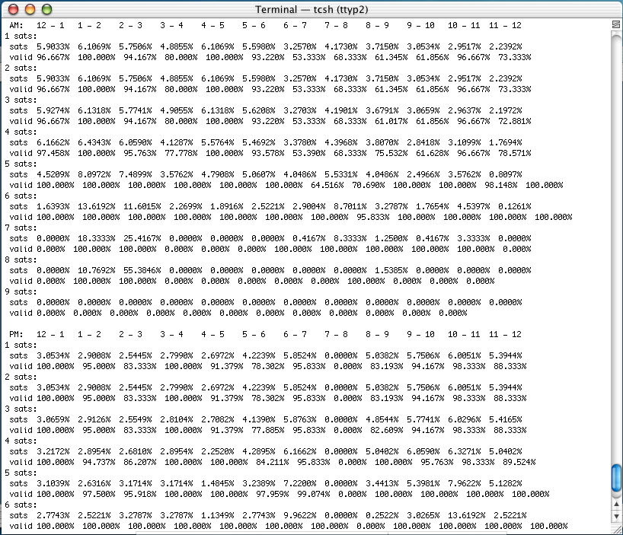
These results are easier to decipher than my first program, but this program has a bit more flexibility in what you can do with it. Here’s the command line:
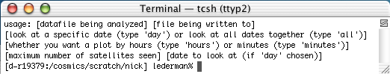

You might notice that there are more options with this command line than my first one offered. The options, however, don’t really affect the immediate output graph. Just like my first script, this script will create a new file of two columns: time and number of satellites. You can run that file through a plotting script to come up with a plot of time of day vs. number of satellites. The two options on the command line decide how the graph is made up. You can either look at all the dates in the file or just one specific date, and you can also either look at a graph of satellites by the hour or by the minute (that one’s really long). Here’s what a graph of satellites by the hour looks like:

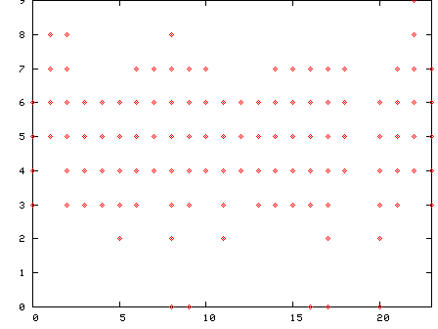

I used these two programs to sort through all the GPS data we had and come up with an idea of how to get an accurate position reading from the detector. At first, we were only seeing a maximum of six satellites, so we went up onto the roof and moved the detector to a position where it could see more of the sky. I started taking more data and analyzing it, and finally decided that Paul’s script for collecting geometry information on our web site would not take the position information if the detector was seeing less than six satellites or if the data was invalid. I wrote the subroutine that ran through the data and pulled out the geometry information, but skipped every entry that used less than six satellites or invalid data.

Here’s the graph of 5 satellites or more that I decided wasn’t accurate enough:
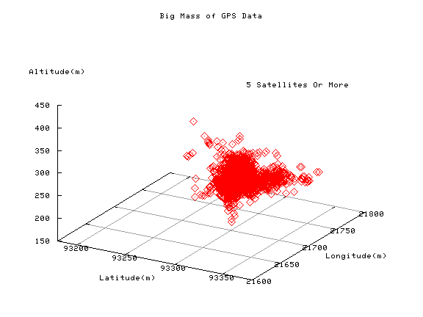

The graph of six satellites or more looks a lot better, but it’s still a bit spread out. The reason I went with six instead of seven was because of the amount of times we saw each satellite. Obviously the more satellites you see the better, but I still needed to choose a number that there would be enough data points for to get a decent average. Since I saw at least six satellites 42% of the time and at least seven satellites only 12% of the time, I decided to still go with six. Here’s the graph of six satellites:
