The short answer is to set the voltage for each counter on the power box at 1.0 volts (1000 volts on the tube). The manufacturer suggests that the optimum voltage range is 850 to 1350 volts.

The long answer is:

Stack the counters as suggested in the flux study section of the Quarknet manual. Make sure that the counters are directly over one another. Set the voltage on the top and bottom tube to 1.0 volts and the middle counter to zero. To calculate the efficiency of the middle counter at a particular voltage it is necessary to divide the number of coincidences in all three counters by the number of coincidences in the top and bottom counters (Over the same time interval). The logic behind this method is that a particle that hits the top and bottom counter must necessarily go through the center counter.
A plot of the efficiency versus the tube voltage should give a plateau that looks like graph A. Operating the tube voltage well onto the plateau (100 volts or so) guarantees that small fluctuations in input voltage do not affect efficiency and therefore counting rate. Caution: higher voltages increase tube noise (dark current) and excessive voltage can damage the tube.
Using NIM electronics these counts can be taken simultaneously, but with the DAQ electronics board it is not possible. However, since the cosmic ray rate is relatively constant (about 1 per square centimeter per minute) these counts can be taken separately with good results using the scalars on the board.

To make these counts:

First set the thresholds to 300 millivolts. (See manual)
Connect the board to a computer and open Hyperterminal. Set the baud rate as high as possible (115 kbaud for old boards, 921 kbaud for newer boards). See manual for instructions. (After you reset a baud rate you will not be able to communicate with the board until you reconfigure the Hyperterminal connection to the higher rate)
Type the command to open the first three channels and count triple coincidences. (WC 00 27 if you are connected to the first three inputs from left to right)
ALL COMMANDS WILL EXECUTE WHEN RETURN (ENTER) IS DEPRESSED.

In order to find a starting point for your tube voltage: A. Older boards (5000 series or lower)-type the command CE and then enter into Hyperterminal and begin to slowly (The potentiometer is very touchy) turn up the voltage on the center counter. At some point data should appear and begin to scroll up on the screen very slowly. Start trials near this voltage. Type CD and then enter to stop this scrolling. B. Newer boards (6000 series)—turn the voltage up slowly until the second blue light just begins to flash. (The first and third lights should begin flashing when the voltage was set to 1.0 volts on the top and bottom detectors) Start trials near this voltage.

Find the counter reset (scalar reset on older boards) button (NOT BOARD RESET) on the DAQ. When the button is depressed the display and scalars on the board will be reset to zero. Entering the command DS will display the scalar values. S₀-S₅. S₀ corresponds to the number of counts from the first input; S_{1,} the second input; S_{2,} the third input; S₃, the fourth input; and S₄, the number of coincidences. Ignore S₅. The number
on the DAQ display is normal base ten but the numbers displayed for the scalars are in hexadecimal and must be converted to base ten.
Since the triple coincidence data cannot be taken simultaneously with the double coincidence data it is imperative that each data set be taken over the same time interval.
Start a stopwatch or some other type of accurate timer just as you press the counter(or scalar) reset button on the board. Since this procedure is dependent of the average muon count being constant longer counting times are preferable (15 minutes or so) but may be less depending on the time available. As the counting time decreases the plateau will become less well defined. See graphs A, B, and C The scalar values on the board cycle continuously so their values must be recorded at the proper time. Type the command DS and press enter at exactly the end of your counting interval. The scalar S₄ gives you the number of coincidences in hexadecimal. Record this number. Convert to base ten.
After counting the triple coincidences set the board for double coincidence between the top and bottom counters. (WC 00 15). Using the method described above, count for the same time period as the triple coincidences. The percent efficiency is given by the triple coincidences for top, middle, and bottom divided by the double coincidences for top and bottom times 100.
Since the doubles and triples are not recorded simultaneously it is not necessary to take the double coincidence count each time the triple coincidence is taken. It is advisable to take the doubles count more than once (possibly beginning, middle, and end) to establish some type of average. Repeat this procedure for increments of about 0.05 volts on the power box until a plateau is achieved. Values of 99% are normal. Values on the plateau may fluctuate (and even exceed 100%) because the muon flux rate is not actually constant.
Moving the top or bottom paddle to the center of the stack allows that paddle to be calibrated in the same manner as the first.

The absolute efficiency is the product of the efficiencies of the individual counters. Calculating the absolute efficiency allows the actual muon rate (counts per square meter per minute) to be found from the data for triple coincidences for a certain detector area per minute. Actual muon rate equals triple coincidence rate divided by absolute efficiency.

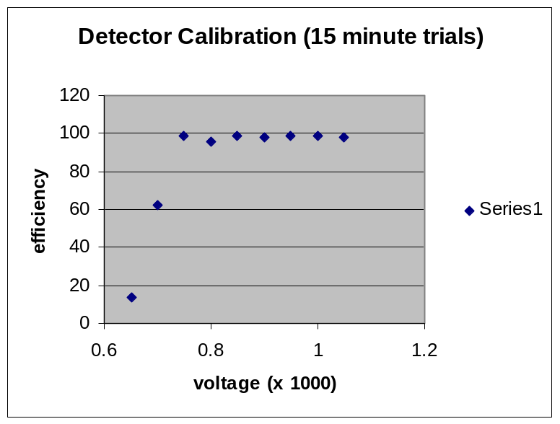
Graph A

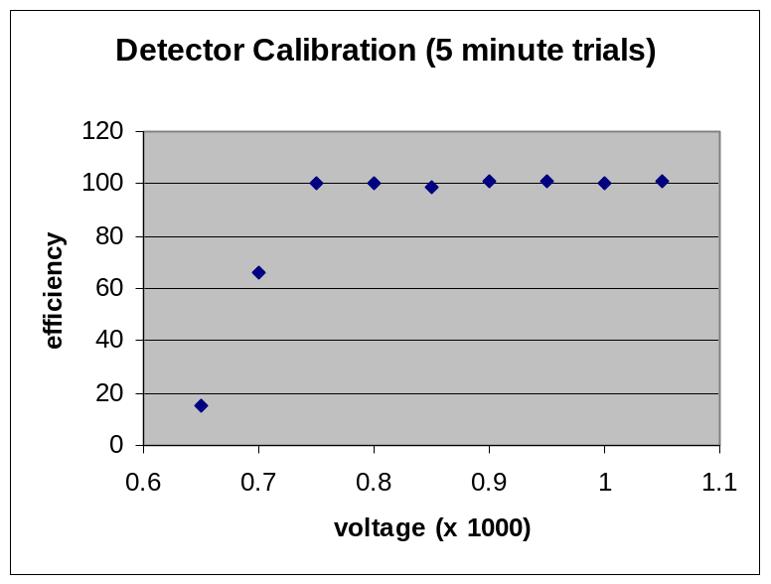
Graph B

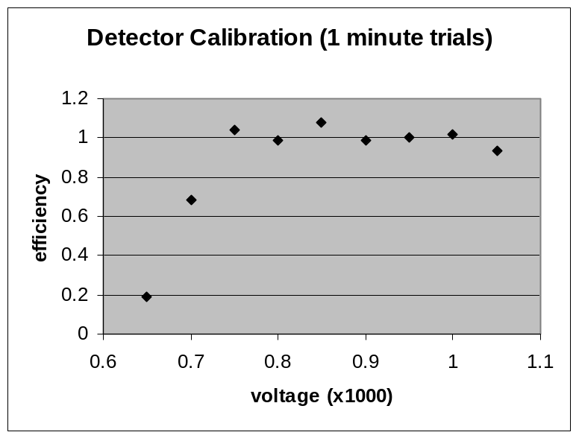
Graph C

