How to build a Cosmic-Ray Cloud Chamber
October, 2008 Version 1.2
- QuarkNet version. Fermilab National Accelerator Laboratory.
- Instructions written by Jeremy Paschke, York HS, and Anne Mary Teichert, Fermilab.
- Model initially designed and built by Robert Peterson, Fermilab.
If you have further questions, or improvements of your own you would like to share with the QuarkNet group, please contact: Jeremy Paschke, York High School Physics Instructor (jpaschke@elmhurst205.org), or Bob Peterson, Fermilab Education Specialist, (rspete@fnal.gov).

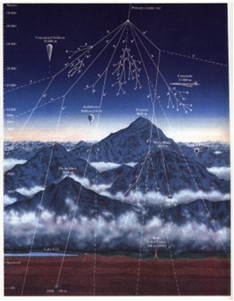
Justification:
Showing your class a working cloud chamber is one of the best ways to generate student-interest in modern physics. The cloud chamber described below will display natural background radiation (muons generated by cosmic-ray collisions). Furthermore, you can build it with materials that are readily available.

How it works:
The cloud chamber relies on a supersaturated alcohol vapor. As the charged particles (muons, unless you are using a radioactive source) move through the chamber, they ionize a path of alcohol molecules. These ionized molecules act as condensation centers and a thin line of alcohol liquid appears. This delicate cloud trail then settles to the bottom of the chamber.

Muon flux at sea level is approximately 1 muon per cm per minute. Because the cross section of this chamber is about 400 cm, you can expect to see a trail almost every second.

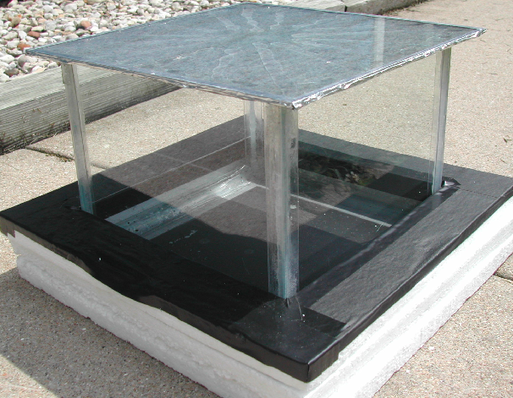
Project timeline:
Once you have purchased all the items and gathered the necessary tools, constructing the cloud chamber should take you no more than a few hours. However, the thick layer of aquarium sealant requires a full week to cure.

Before you shop:
We recommend purchasing as many of the items as possible at a local hardware store. Tell the employee you are constructing something for educational purposes. Ask if they can help cut and file the metal plate. Check with your school secretary and bring your school’s tax exemption code. Approximate cost: $60 plus dry ice
Items
# | Description | Quantity / Size | Supplier and Cost
1 | Galvanized Steel Plate 22 Gauge or thinner | One 12” x 24” sheet, split into 12" x 12" | Local Hardware.  $10.00
2 | Sheet ¾” thick insulating foam. (Try to find the kind that doesn’t flake into bits.) | Enough to make three 15” x 15” square pieces | Local Hardware  $7.00
3 | Aquarium sealant 100% silicon | 2 standard sized tubes. | Local Hardware  $6.50 x 2
4 | Disposable thin rubber gloves, for smoothing the silicon sealant | One pair | Local Hardware  $2.00
5 | Double Stick tape | One roll (~20”) | Local Hardware  $3.00
6 | Clear plastic corner guard with sticky strip. | Two 4-foot pieces | Local Hardware  $3.00 x 2
7 | Heavy Duty Scour Pad | One | Local Hardware  $4.00
8 | Black duct tape, flat black is best if you can find it. | One roll | Local Hardware  $6.50
9 | Black felt | One square 12” x 12”. Extra can be used to help block ambient light | Local Fabric Store  $4.00
10 | Wood shims. (paint stirrers work fine) | Four | Local Hardware  $0.00
11 | Flat black spray paint or primer. | One can | LustreKote® or  Zynolyte®  $12.00
12 | Teri-cloth hand towel and 1-gallon Zip-lock bag. | One | Supply Cabinet
13 | Isopropyl, or Ethyl Alcohol, 200 proof (100%) | ~6 ounces | Chemistry supply cupboard
14 | Pre-cut picture glass | Four 8” x 10” pieces, one 12” x 12” piece | Local Hardware ~$15.00
15 | Optional: large shop lamp with spring clamp | 8 ½" diameter; 30 watt bulb | Local Hardware
16 | Dry ice | Slab ~1-inch thick, ~10” x 10” (or equivalent volume); also may have to use chips or pellets | Meijer®, local butcher shops or ice-creameries  $15.00

Tools:
- Scissors  - Rulers  - Paper towel | - Razor blade, box cutter, or X-acto knife | - Tools to cut the metal plate to size (file, hacksaw).
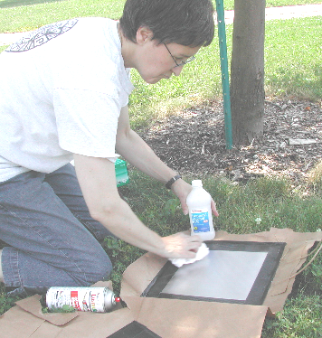
A) Prepare and paint the metal plate.
The metal plate will sit directly on top of the dry ice and will hold a thin layer of alcohol. Quality paint and a good preparation of the surface will prevent peeling and flaking. The black color is necessary as a viewing backdrop for the cosmic-ray muons.

- First cut the metal to a 12” x 12” square.
- File down any sharp corners or edges. (Local hardware stores may help with this process, Ace® helped us.)
- Scour the metal plate with a heavy duty scouring pad.

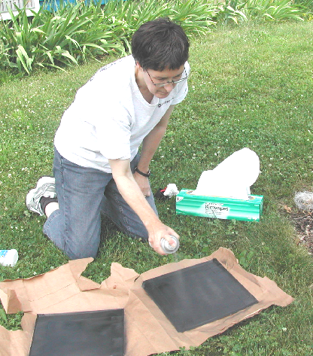
- Thoroughly wash the metal plate with detergent to remove any oils; then dry with a paper towel.
- Clean the plate a final time with rubbing alcohol and a paper towel.
- Mask off the outer 1.5” of the plate with tape. This is done so you can secure the glass walls directly to the metal.
- Spray on the black paint. Make sure to work in a well-ventilated environment.
- Use multiple thin layers.
- Let paint dry for 30-45 minutes.

Here are the websites for Lustrekote and Zynolyte, two recommended paints:
http://www.monokote.com/lustrekote/lustrekote.html
http://www.zynolyte.com/zynolytehome.asp

Alternative to painting the bottom:
Finding a strong, flat black paint might be difficult. Also the paint may bubble and peel after repeated usage under extreme conditions. One alternative is to use artist black paper on the bottom of the chamber. The paper lies flat on the chamber, and can be lifted out to dry after each viewing session.

The paper must be black because it serves as your primary viewing background. Cut the paper to fit squarely on the bottom of the chamber. When you run the chamber, soak the paper by pressing all edges and corners down into the alcohol. We tested Strathmore Artist Papers ® 400 series Textured Sheets (black) and obtained satisfactory results. Estimate paying $5.00 at an art supply store.

B) Cut the foam insulation to size.
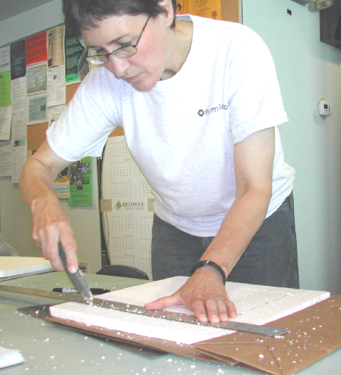
  - Use a razor blade to cut (or score and then break) the foam into appropriately sized pieces.
  - Cut three 15” x 15” square pieces.
  - Leave one piece intact. This is the base.
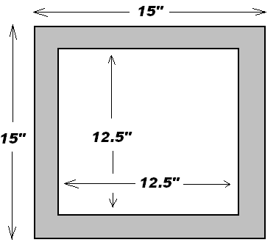
  - Cut a 12.5” square out of the second piece. This piece will loosely sit beneath the chamber, and help insulate the dry ice.
  - Cut a 10.5” square out of the third piece. Cover this piece with black tape. This piece will act like a sleeve around the bottom of the glass enclosure and will act as a backdrop for viewing the cloud trails.

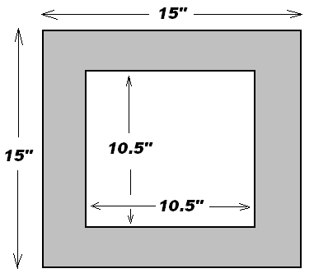

Cover this piece with black tape

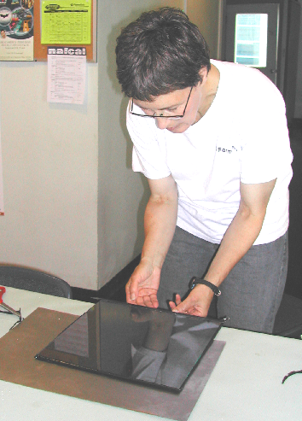

- Prepare the cover
  - Cut the black felt into a 12” x 12” square. The dimensions could be slightly smaller than 12” because it will tape to the glass cover more easily.
  - Spread some of the silicon sealant on the glass; then press the felt into the sealant.
  - Use black tape to cover the sharp edges of the glass.
  - If the felt does not stick to the glass, you can use magnets on the outside and inside of the glass cover to keep the felt from sagging downward.

- Build the glass enclosure
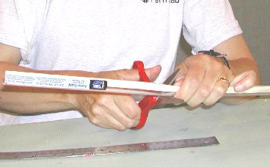
  - Using a strong pair of scissors, cut the corner guard to the appropriate size.
  - Each vertical corner needs to be 8”; and pieces at the bottom of each side should be 8.5”.
  - Apply strips of double stick tape to the inside of each vertical piece and the outside of the bottom pieces.
  - Make sure the black paint on the metal plate is dry to touch.
  - Set two glass pieces at right angles on the metal plate. (8” vertical and 10” horizontal); and press them into the corner guard. Keep the glass edges as close as possible.
  - Complete the square of four glass pieces. Now you have an enclosure.
  - Make sure the sides are level.
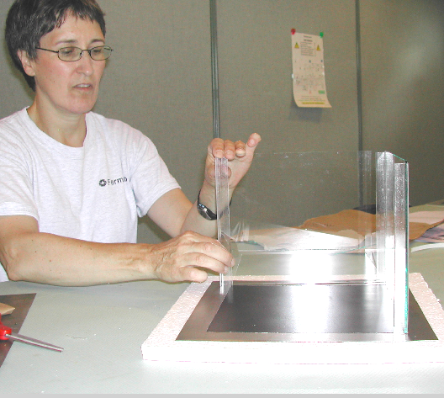
  - Position the enclosure in the middle of the metal plate.
  - Press the bottom corner guard pieces down on the metal plate and against the outside of the chamber.
  - Once the enclosure is secured to the metal plate, you need to seal the bottom and sides of the inside of the chamber.

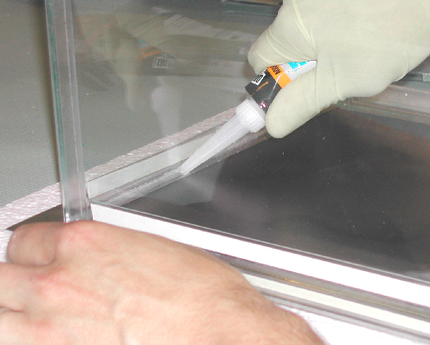
  - Apply a thick bead of the silicone aquarium sealant along the bottom edges. Look carefully for cracks or air bubbles. While wearing a rubber glove, press the sealant into all cracks with your fingertips forming a fillet.
  - Run a bead of sealant up each of the corners, and press into the corner with your fingertip forming a fillet.
  - Cover the outside bottom corners with sealant.
  - We recommend waiting a full week for the sealant to dry.

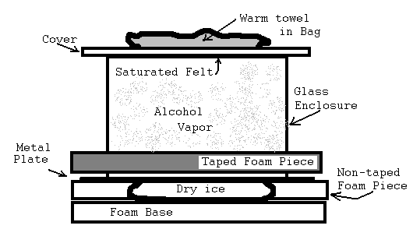
- Operating the Chamber:
Note: The chamber may take 10-20 minutes to cool down. If you plan on showing the cloud chamber to a class of students, make sure the chamber is up and running before kids walk in the door. Or, have a plan to fill the time as you wait and make minor adjustments. We prefer to set up the cloud chamber long before presentation time. The chamber will operate for several hours.

- Darken the room as much as possible before operating the cloud chamber. (This will enhance viewing.)
- Position the chamber in a place where people can view it from multiple sides.
- Place the foam bottom piece on a wooden board or a table top.
- Place the dry ice on the foam. (Always use gloves while handling dry ice.)
- Pick up the chamber by the corners and slowly place the metal plate on the dry ice. (Hold on, as it may easily slide off.)
- Pour 2-3 ounces of alcohol on the felt that covers the underside of the top piece. (Ethyl alcohol 200% is best, but we found isopropyl alcohol 92% also works.)
- Pour more alcohol on the bottom of the chamber, just enough for a very thin layer. Or, saturate a 10” x 10” piece of black artist’s paper with alcohol and place that flat against the bottom of the chamber.
- Place the cover on the chamber.
- Level the chamber by sliding shims under the base, so the alcohol spreads evenly and does not pool along one side.
- Run a hand towel under very hot tap water (or use a microwave to warm the wet towel). Wring the towel once and place it in the one-gallon sealed bag. Place the warm bag on the cover of the chamber. The heat from above helps the alcohol vaporize and saturate the chamber. Heating the top is crucial to creating a super saturated alcohol vapor allowing the cosmic ray tracks to condense. (Alternative: place a large shop clamp light with 30 watt bulb upside down on the top glass.)
- Illuminate the chamber with a light beam directed slightly down from the horizontal. Ideas for lighting include a clamp light with a 75-watt bulb, a slide or film projector, intense hand-held flashlights, or a line of bright LEDs.
- Wait another 10-15 minutes for conditions inside the chamber to create a strong temperature gradient. You should see a fine mist raining down onto an undulating cloud at the bottom of the chamber.
- Cosmic-ray muons will soon appear as fine threads of condensation. The thread will slowly fall to the bottom of the chamber.
- Adjust the position of the light for optimal viewing. Look toward the light beam using the cloud chamber top as a shield.

