Plateauing Counters

In order to determine the operating voltage of each of your counters, it is necessary to perform a procedure to “plateau the counter”. This step is necessary for two reasons:
1) to establish an operating voltage so the counter fires efficiently when a muon traverses it and 2) because the signal output of the counter can change due to drifts in the tube gain or power supply during the experiment. Once a discriminator threshold has been fixed, the HV applied to the counter should be varied to determine a stable, efficient operating point. If the HV is set too high, noise pulses exceed the discriminator threshold and many counts unrelated to muons are generated. If the HV is set too low, some pulses from muons are smaller than the discriminator threshold, so the counter is inefficient. The goal of plateauing is to find a region between those two extremes, where the counter operation is efficient, not too noisy, and stable if the HV drifts slightly.

How to Plateau a counter
There are two methods to plateau a counter. Since they are sensitive to different conditions; it is best to perform both at the same time.
- Plateauing using a single counter
- Plateauing using multiple counters.
The first technique is simpler, but if the counter signals are small compared to noise levels, it may be difficult to identify the plateau. There are many different types of counters in use within QuarkNet: the 2006 model has a strong signal and little noise, so the plateau stands out with a single counter technique; typical 2004-2005 counters have weak signals and both techniques are required; old CASA counters have aged and have such a weak signal, no plateau is visible; and some thick counters used in lifetime experiments have strong signals, but their square cross section allows muons to traverse a corner of the counter, generating a range of signal sizes that complicate the plateau measurement.

Plateauing using a single counter
Choose a threshold value for the discriminator and hold it constant during the experiment (Chapter 2 discusses how to choose a discriminator threshold). Turn on the DAQ
board and connect it to your computer so that you can view the datastream on your monitor using a terminal emulation program. (See Appendix C for help setting up a terminal emulation program.) Once you see the datastream, convince yourself that lower potentiometer dial values result in a lower counting rate while higher settings produce a very high datastream rate on your monitor. Do not bother to raise the HV beyond a value at which the singles counting rates exceeds 400Hz counting rate. The actual muon rate is less than 10Hz for most QuarkNet counters and most counters are operated at less than 100 Hz single rates.

Noting the potentiometer reading on the bottom of the PMT base, perform a simple
experiment to determine the singles rate for the channel that the counter is connected to
using the visual scaler. Reset the scaler using the manual reset button located on the side of the DAQ card, wait a fix time (~1 min), and then record the value on the visual scaler. Continue the process for different voltages (potentiometer settings) to produce a graph similar to the one shown in Figure 23. Remember that the scalers on most boards increment in hex format, but the visual scalers on some new DAQ cards readout in decimal. If the scaler counts from 0 to 9, it’s decimal. If the scaler counts from 0 to F, it’s hex and you must convert to decimal by hand.

Note: Channels numbered 1, 2, 3, and 4 on the board are numbered 0, 1, 2, and 3 respectively on the monitor. This numbering scheme (starting 0 instead of 1) is consistent with engineering and computer programming practice.

Record the number of counts at a specific voltage setting during a fixed time interval, typically around 1 minute. Create the plot as you proceed: one data point at a time. Sample the range of HV between just barely counting and a fast rate, with approximately 8 data points. You can easily find the appropriate lowest voltage, because is no data flow, and therefore no counts, below that point. Avoid operating the counter with voltages that cause singles rates above 400Hz. You don’t have to change the HV monotonically. Once you see the general pattern, go back and take data points that show more detail in the knee region, so you know where the counter is operating efficiently.

The optimum operating voltage is where the graph looks the most horizontal.
For the graph shown, this occurs around 5.5V. Sometimes it is difficult to “see” the plateau with this technique. If multiple counters are available, the technique outlined below will make the plateau more apparent.

Note: Some of the scales on the potentiometers on older bases have tended to decouple from the dial, either spinning or jamming. You can use a DVM (digital volt meter) to directly measure test points that is proportional to the applied voltage. Some base voltages (model 2006) are controlled via a separate box, so DVM measurements are required.

Note: Manually reset scalers with button onside of DAQ (NOT the reboot button on the rear of the DAQ card)

Note: Statistical errors are proportional to the square root of the number of counters in your bin, so 100 counts has a 10% error. If you want a more accurate measurement, you have to count longer.

Plateauing Using Multiple Counters
The rate of your single counter as a function of HV may show a very small plateau region. Using two or more counters to define a coincidence rejects much of the noise from the counter you are plateauing. A muon that passes through both generates signals in both counters at the same time, and occurs more often than the random overlap of noise in multiple counters. Noise from the plateau counter has to randomly overlap with the signals from the second counter, within the trigger gate time, to generate a noise trigger. This is very unlikely unless the counters have very high singles rates. (see yy below) Obtaining this data is slightly more complicated than the single counter method, because a trigger must be configured.

Consider the three-counter setup in Figure 24. Let’s plateau counter 2. (This can occur even if counters 1 and 3 have not been plateaued.) You can setup an experiment to investigate the coincidence frequency between counters 1 & 2, 2 & 3, and 1 & 2 & 3 as a function of the potentiometer setting on the base of counter 2. Any of the triggers will allow you to study counter 2, using the other counters to increase the probability that a muon traversed counter 2, instead of noise. Let’s study the 1 & 2 rate as a function of HV applied to counter 2.

Program the DAQ to trigger on 2-fold coincidences, enabling only the first two counters. (WC 0 13, whereas WC 0 16 enables counters 2 and 3, and WC 0 27 enables all three counters in a 3-fold trigger). You can record the number of triggers in a fixed time period as before, using the visual scaler. However, there is more information available on the scaler output of the DS command. The first 4 outputs contain the singles rates of the counters. You can observe the rate changes of counter 2 and also check that rates of the other counter remain constant. These singles scalers are independent of the trigger condition. They use hexadecimal, so you will get experienced at converting to decimal. The fifth scaler contains the number of triggers and should agree with the visual scaler on the DAQ board. The singles rates and trigger rates can both be recorded and plotted at the same time.

Note: If the trigger rate is very high, the output stream may exceed the serial line capacity. A simple fix would be to reduce the overlap of the counters, thus reducing the area where a single muon fires both counters.

Again, construct the plot with each data point you obtain, as you obtain it. Don’t waste your time by taking very fine steps in HV. Get some points at low rates and high rates and then fill in the center coarsely. You can always collect data at more HV settings to add more detail to the plot, so that you determine the knee accurately. Your plot should show a very broad plateau region.

As you raise the HV on counter 2, gathering the 2-fold trigger data, you may reach a HV region that is far above the knee, but where the plateau hasn’t risen much. Counter 2 may be running very hot (for example at 1kHz, a factor of 10 above any normal operating rate). Since the HV on counter 1 has remained constant, the 2-fold rate will not rise much above the rate of a muon traversing both counters. Only when the increasing noise in counter 1 randomly overlaps with signals from counter 1 will the 2-fold trigger rate rise appreciably. That is why it is good practice to measure the singles rate at the same time, so you don’t get carried away with the HV on counter 2!

Both the 2-fold trigger rates and single counter rates are shown in Figure 25. You
can see that the triggered plateau region is flatter than was the case with the single
counter technique. The optimum HV setting is at a location on the plateau, well above the knee, with singles rates “not too” large.

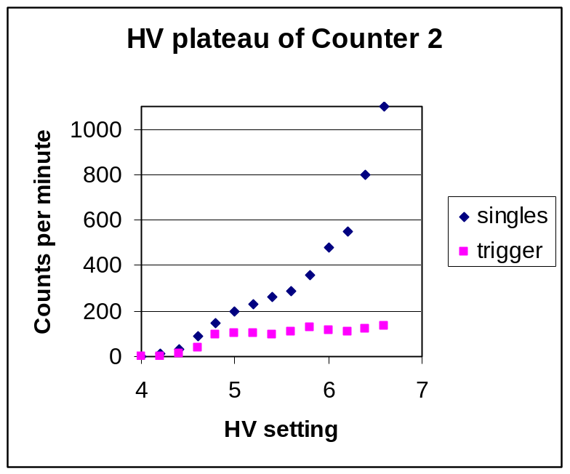
knee
plateau
operating point

Why does a 2-fold trigger improve plateauing?
yy
Constructing a 2-fold trigger including the counter you are studying, plus another counter whose HV remains constant, selects muons rather than noise and makes the plateau region stand out A gate width of 150ns is large enough to ensure overlap of signals and small enough so random coincidences will be negligible. For example, the random coincidence rate is approximately R1*R2*gate width. Let’s assume C1 operates at 50Hz and you vary C2 HV until it fires at 200Hz. The rate of random triggers is (50 Hz)*(200 Hz)*(150*E-9 s) = 1.5E-4 Hz. If both counters have single rates of 1000Hz with a microsecond trigger gate, the random trigger rate would be:
(1000 Hz)* (1000 Hz)*(1.0 E-6 s) = 1 Hz, a significant background, but still below the typical 5Hz of real single muons.

Expert comments
The plateau depends on both the HV and discriminator threshold. The plateauing techniques described above varied HV with a fixed, default discriminator threshold. We could do the opposite as well. If the HV is fixed, the plateau region can also be measured by varying the discriminator threshold. In some older counters, the muon signal is very small, even at maximum high voltage, so you may have to find an operating point with a lower discriminator threshold. In addition, if you leave the HV fixed and look at the signal on a scope (see fig xxxx), you can identify the regions of noise and muon signal. Imagine how many noise or signal signals exceed a hypothetical threshold voltage. If the threshold is set very low, all signals fired the discriminator, but so do many noise pulses. If the threshold is high, muon signals are lost. The ideal region is above the noise and below the signal. Most of the time those two regions overlap, so the plateauing procedure is used.

