# Getting Started with Sharing Ideas WordPress Blog and Facebook July 2011

We have changed the “Share Ideas” part of the e-Labs to use the I2U2 WordPress Blog and Facebook I2U2 Users Group instead of MediaWiki and the Forum that Eric Myers set up. To use both the I2U2 Blog and Facebook you need to be a member.

<http://www.i2u2.org/elab/cosmic/teacher/community.jsp>



## I2U2 Blog

**Registering:**  Go to URL in the email ([www.i2u2.org/blog](http://www.i2u2.org/blog)). Click on the **Register** link on the right under **Meta**.



This will take you to a page where you can register. Enter your email address, the password you want to use when you log into the blog, the invitation code “inquiry” and click “Register”.



**Using the I2U2 Blog:** Now you should be able to go back to the I2U2 Blog Home page and log in with your email address as user name and the password you entered.

We can elevate members to admins once they are registered. Generally, these are staff members for i2u2 or QuarkNet.

For each new workshop, the instructor can email an invitation to all the participants.

Alternatively the instructor can also just have them do this during the workshop by taking them to the “Share Ideas” page on the teacher pages and have them click on the I2U2 Blog link. They can register themselves. We encourage using the same password they used for the e-Lab, assuming that they are using a reasonable password (not the crazy random number and letter sequence that they may get by default).

Once you log in, you will see the Dashboard. This summarizes everything you have access to on the Blog. You may want to fill in more information about yourself in the Profile (highlighted in yellow in this graphic, but not on the real page).

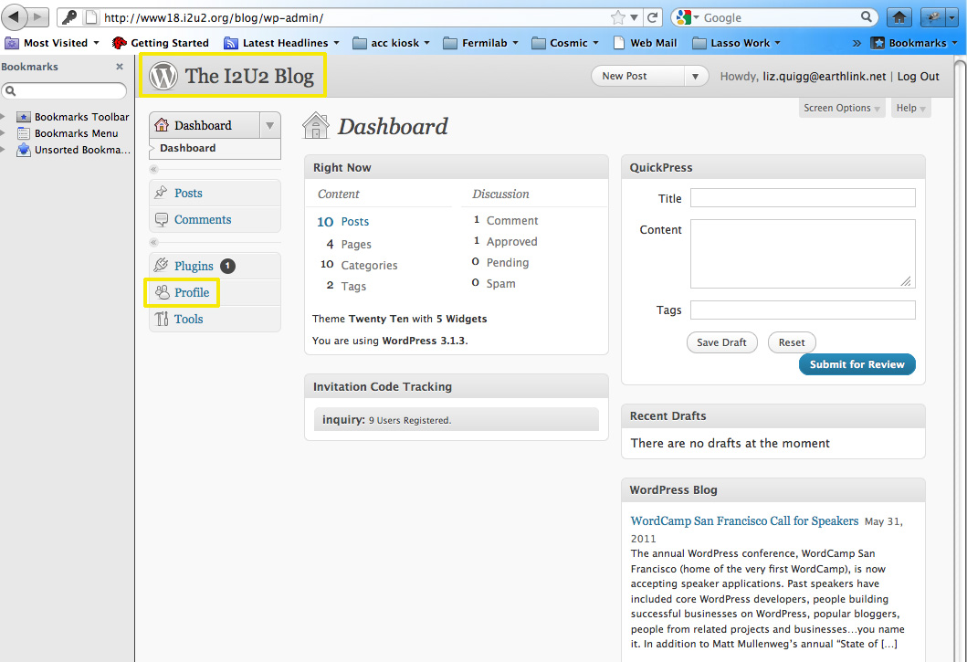

To see the main blog page, click on The I2U2 Blog (highlighted in yellow). The content on the Blog Home page will depend on what was the last entry to the blog. You can click on the various Categories on the right to see posts with the Category assigned. We started out with three Categories per e-Lab: a general one, an Implementation Plan and a Classroom Activities one. For example, for Cosmic, we have “Cosmic”, “Cosmic Implementation Plan” and “Cosmic Classroom Activities”. A Category only shows up on the right if there are posts with that Category.

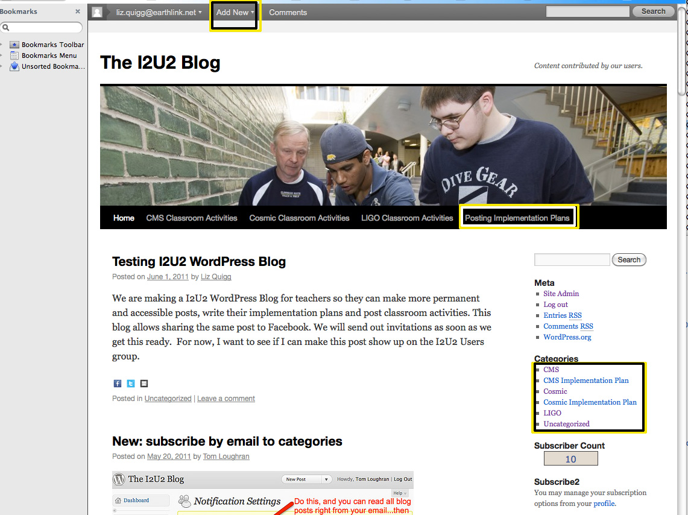

Right under the photo is a menu of WordPress Pages. These are different from the blog rolls you get by clicking on a Category and generally have more static content. We have one page per e-Lab to display exemplary classroom activities. Teachers can post classroom activities and assign them the Category “Classroom Activities”. When we see one that is really good, we can add it to the exemplary “Classroom Activities” Page. The posts can be more informal.

The WordPress Page that is relevant during workshops is the Page accessed by clicking on the link (highlighted in yellow) to **Posting Implementation Plans**. This contains the instructions on how to post the implementation plan. You will see that there are multiple ways to make a new post. For the post to show up under the proper Category, the teacher making the post will have to assign it to the proper Category. (e.g., a CMS e-Lab teacher would assign it to the Category “CMS Implementation Plan”). The easiest way to make a new post from the Home page is to use the “Add New” pull-down on the very top menu. This takes you to a screen where you can add your post and assign it the proper Category (see yellow highlighted section). In the case of the Implementation Plan, the instructions tell the teacher to copy text to the post as a starting point. Here is how it will look when you paste in the Template text. Once the teacher has filled out the post, they can click the **Publish** button on the right.



## Facebook

On Facebook, I2U2 has a Page and a Group. The Page “Interactions in Understanding the Universe” is an organization page where we have information about I2U2. It is not a page for Facebook users to add posts. Users can “Like” I2U2” to show their support for I2U2. Phong added a link on the e-Lab home pages to allow e-Lab users to do this. Phong also posts important messages here about the state of the e-Labs.

The Group page, “I2U2 Users” allows users to submit a request to join the group and once they are approved, they can post and see the posts of other users. Groups also support creating events, documents and having chat sessions.

If you are not a member of Facebook, the first step is to become a member. You cannot use either of these pages without being a member. Go to the site <http://www.facebook.com> and register. If you want to separate your professional Facebook profile from your personal one, sign up so that it is clear this is your professional web page (i.e., For a Fermilab employee, use your fnal email). Many people already have Facebook accounts and don’t mind having one account for professional and personal use.



Once you are a member, log in and change your profile so it displays only what you want (e.g., you may want to hide your birthday!) Click Profile, and then Edit Profile.



Make all the changes you want to the profile and save your changes.

Next change the account and privacy settings to limit who can see your information and what kind of notifications you want. Click on Account and then Account Settings and Privacy Settings. Here is how the pull-down menu looks for Liz Kelley Quigg.



There is help provided on these pages. You may want to limit access as much as possible except for allowing people to see the posts you make to the I2U2 Users group. You may need an experience Facebook user to hold your hand here because it is a little overwhelming to see all the choices!

Next search for “Interactions …” by typing in the search box at the top of your Facebook page.



Click on the top icon in the search results with the new I2U2 Logo. This will take you to the Interactions in Understanding the Universe Page (not the I2U2 Users group).



You should click the “Like” button so you are listed as one of the people who “Like” this Page. You also want to subscribe via RSS or SMS if you are experienced with these.

Next use the search box at the top to go to the I2U2 Users group.



Click on the icon to see the I2U2 Users group. In the top right hand corner, you can click

“Request to Join.” This will send a message to the administrators of the group and they can approve your request.



Once you are a member of the I2U2 Users group, you can join in the discussion. Look at the posts of your fellow group members. Check out who has joined. Make your own posts by entering text in the text box or clicking on the various icons outlined in yellow. The items outlined in blue on the right show additional functionality: chatting with I2U2 Users group members, creating a document, creating an event, etc. Maybe you want to have an event when you encourage all the Cosmic e-Lab users to take data at the same time.

In the future we want to set up cross-posting between the WordPress blog and the Facebook group.