# Getting Started with Sharing Ideas Facebook Updated July 2014

In 2011, we changed the “Share Ideas” part of the e-Labs to use the Facebook I2U2 Users Group instead of MediaWiki and the Forum that Eric Myers set up. This document reflects the Facebook pages as they were in 2011. There may be some changes in the Facebook interface since then, but the general approach is the same.

To use Facebook you need to be a member.

<http://www.i2u2.org/elab/cosmic/teacher/community.jsp>

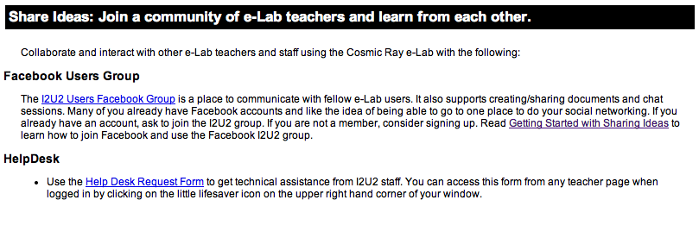

## Facebook

On Facebook, I2U2 has a Page and a Group. The Page “Interactions in Understanding the Universe” is an organization page where we have information about I2U2. It is not a page for Facebook users to add posts. Users can “Like” I2U2” to show their support for I2U2.

The Group page, “I2U2 Users” allows users to submit a request to join the group and once they are approved, they can post and see the posts of other users. Groups also support creating events, documents and having chat sessions.

If you are not a member of Facebook, the first step is to become a member. You cannot use either of these pages without being a member. Go to the site <http://www.facebook.com> and register. If you want to separate your professional Facebook profile from your personal one, sign up so that it is clear this is your professional web page (i.e., For a Fermilab employee, use your fnal email). Many people already have Facebook accounts and don’t mind having one account for professional and personal use.



Once you are a member, log in and change your profile so it displays only what you want (e.g., you may want to hide your birthday!) Click Profile, and then Edit Profile.



Make all the changes you want to the profile and save your changes.

Next change the account and privacy settings to limit who can see your information and what kind of notifications you want. Click on Account and then Account Settings and Privacy Settings. Here is how the pull-down menu looks for Liz Kelley Quigg.



There is help provided on these pages. You may want to limit access as much as possible except for allowing people to see the posts you make to the I2U2 Users group. You may need an experienced Facebook user to hold your hand here because it is a little overwhelming to see all the choices!

Next search for “Interactions …” by typing in the search box at the top of your Facebook page.



Click on the top icon in the search results with the new I2U2 Logo. This will take you to the Interactions in Understanding the Universe Page (not the I2U2 Users group).



You should click the “Like” button so you are listed as one of the people who “Like” this Page. You also want to subscribe via RSS or SMS if you are experienced with these.

Next use the search box at the top to go to the I2U2 Users group.



Click on the icon to see the I2U2 Users group. In the top right hand corner, you can click

“Request to Join.” This will send a message to the administrators of the group and they can approve your request.



Once you are a member of the I2U2 Users group, you can join in the discussion. Look at the posts of your fellow group members. Check out who has joined. Make your own posts by entering text in the text box or clicking on the various icons outlined in yellow. The items outlined in blue on the right show additional functionality: chatting with I2U2 Users group members, creating a document, creating an event, etc. Maybe you want to have an event when you encourage all the Cosmic e-Lab users to take data at the same time.