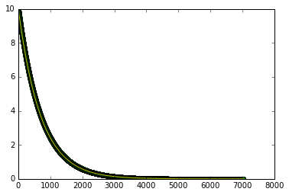

This is the one-star radioactive decay graph. We see exponential decay, graphed alongside our expected solution (in yellow). The graphs match up. Here, our initial number of isotopes equals 10.

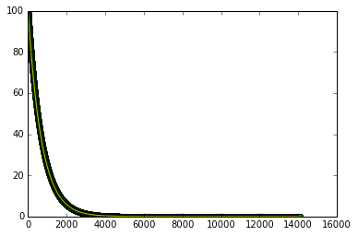

This is the same problem as before, except now we begin with 100 isotopes and the final time is twice as long. We still see exponential decay.

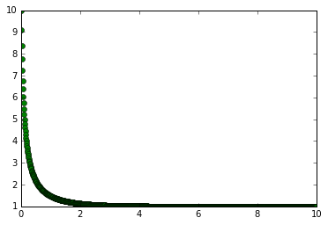

This is the population graph when both a and b are equal to 1. The population exponentially decays until it reaches a stable threshold.

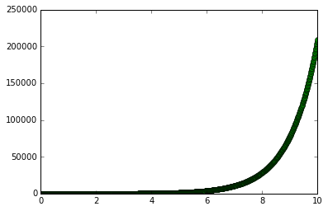

This is the population graph when a = 1 and b = 0. There are no deaths in the population, so we see an exponential growth.

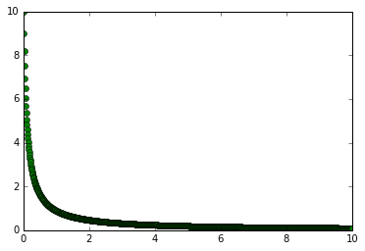

This is the population graph when a = 0 and b = 1. There are no births in the population, so the population experiences exponential decay until it dies off.

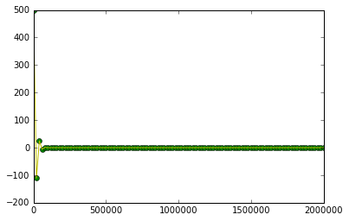

This is the first three-star radioactive decay problem. There are initially 5 A isotopes and 500 B isotopes. We see minor oscillation in the decay until both isotopes reach zero. This does not seem right to me, but my code runs well. Something is wrong, but I don’t know what it is.

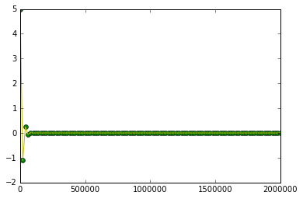

This is the same problem as before, except now there are 5 B isotopes and 5000 A isotopes. The graph is the same except for the y-axis values. This should not be the same graph. The y-axis for both graphs follows the number of B isotopes instead of both A and B. I don’t know why.

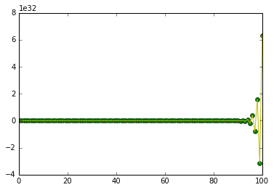

This is the second three-star problem where A and B decay into each other according to coupled differential equations. Here, there are 5 A isotopes and 500 B isotopes. There are no isotopes for the first 90 years, then we see oscillation in the graph as the number of isotopes increases and decreases. As A and B decay into each other, this makes sense.



This is exactly the same graph, although for this run I set the number of A isotopes equal to the number of B isotopes (500). It makes sense that the number of isotopes increases and decreases, but I don’t know why the graph is exactly the same (unless it’s the same issue with the first three-star problem where the graph only follows the number of B isotopes).