成都信息工程学院计算机学院

课
程
实
验
报
告

实验课程： | 网络游戏编程技术
实验项目： | 注册与登录
指导教师：
学生姓名:
学生学号：
班 级：
实验地点：
实验时间： | 20 24 年 11 月 20 日 16：00 点~ 17:40点
实验成绩：

一【上机实验内容】
1. 为单机游戏增加场景，能连接课程群中的服务器，并保持在线。具体应用层协议见实验指导书；
2. 完成客户端的注册功能；
3. 完成客户端的登录功能；
4. 以上2、3两条，控制用户输入用户名时，不能出现空格。

二【上机实验步骤】（重点）

操作步骤
1.编辑客户端代码，使客户端能成功连接服务器。
2.编辑客户端代码，使客户端能在注册后成功返回对应字符串。
3.编辑客户端代码，使客户端在登录后能成功返回对应字符串。
4.编辑服务端代码，使服务端能正确接收客户端的字符串并做出对应反应。

关键代码
服务端代码：
- package com.cy.socket;
import com.cy.mapper.UserMapper;
import com.cy.pojo.User;
import com.cy.util.MD5Util;
import com.cy.util.MybatisUtil;
import org.apache.ibatis.session.SqlSession;
import java.io.BufferedReader;
import java.io.IOException;
import java.io.InputStreamReader;
import java.io.PrintWriter;
import java.net.ServerSocket;
import java.net.Socket;
import java.util.HashSet;
import java.util.Scanner;
import java.util.Set;
public class ChatServer {
private static final int PORT = 10002;
private static final Set<ClientHandler> clientHandlers = new HashSet<>();
private static SqlSession sqlSession = MybatisUtil.sqlSessionFactory();
private static UserMapper userMapper = sqlSession.getMapper(UserMapper.class);
public static void main(String[] args) {
startServer();
listenForMessages();
}
public static void startServer() {
System.out.println("服务器启动，监听端口：" + PORT);
new Thread(() -> {
try (ServerSocket serverSocket = new ServerSocket(PORT)) {
while (true) {
Socket clientSocket = serverSocket.accept();
ClientHandler handler = new ClientHandler(clientSocket);
synchronized (clientHandlers) {
clientHandlers.add(handler);
System.out.println("客户端已添加，当前数量为" + clientHandlers.size());
}
handler.start();
}
} catch (IOException e) {
e.printStackTrace();
}
}).start();
}
public static void listenForMessages() {
new Thread(() -> {
try (Scanner scanner = new Scanner(System.in)) {
while (true) {
String message = scanner.nextLine();
sendMessageToAllClients(message);
}
}
}).start();
}
public static void sendMessageToAllClients(String message) {
synchronized (clientHandlers) {
System.out.println("当前连接的客户端数量: " + clientHandlers.size());
for (ClientHandler handler : clientHandlers) {
handler.sendMessage(message);
// 打印客户端信息
System.out.println("消息发送到客户端: " + handler.getId());
}
}
}
private static class ClientHandler extends Thread {
private Socket socket;
private PrintWriter out;
private BufferedReader in;
public ClientHandler(Socket socket) {
this.socket = socket;
System.out.println("新客户端连接: " + socket.getInetAddress().getHostAddress() + ":" + socket.getPort());
try {
in = new BufferedReader(new InputStreamReader(socket.getInputStream()));
out = new PrintWriter(socket.getOutputStream(), true);
} catch (IOException e) {
e.printStackTrace();
}
}
public void run() {
try {
String message;
while ((message = in.readLine()) != null) {
System.out.println("收到消息: " + message);
String s1 = message.split(" ")[0];
//注册操作
if ("Regist".equals(s1.replace("\uFEFF", ""))) {
String password = MD5Util.getMD5(message.split(" ")[2].replace("\uFEFF", ""));
String username = message.split(" ")[1].replace("\uFEFF", "");
String ip = socket.getInetAddress().getHostAddress() + ":" + socket.getPort();
User user = userMapper.select(username);
//用户名存在
if (user != null) {
sendMessage("RegistFail 1 ");
System.out.println("用户名存在");
} else {
User user1 = new User();
user1.setUsername(username);
user1.setPassword(password);
user1.setOnline(1);
user1.setScore(0);
user1.setUserIp(ip);
userMapper.regist(user1);
sqlSession.commit();
sendMessage("RegistSuccess ");
System.out.println("注册成功");
}
} else if (message.split(" ")[0].replace("\uFEFF", "").equals("Login")) {//登录操作
String password = MD5Util.getMD5(message.split(" ")[2].replace("\uFEFF", ""));
String username = message.split(" ")[1].replace("\uFEFF", "");
User user = userMapper.select(username);
//登录成功
if (user != null && user.getPassword().equals(password)) {
String ip = socket.getInetAddress().getHostAddress() + ":" + socket.getPort();
userMapper.online(username, ip);
sqlSession.commit();
sendMessage("LoginSuccess");
System.out.println("登录成功");
} else if (user == null) {
sendMessage("LoginFail 1");
System.out.println("用户不存在");
} else if (!user.getPassword().equals(MD5Util.getMD5(password))) {
sendMessage("LoginFail 2");
System.out.println("密码错误");
} else if (user.getOnline() == 1) {
sendMessage("LoginFail 3");
System.out.println("用户已登录");
}
}
//这会把消息重新发送给所有客户端
// broadcast(message);
}
} catch (IOException e) {
e.printStackTrace();
} finally {
try {
synchronized (clientHandlers) {
clientHandlers.remove(this);
String ip = socket.getInetAddress().getHostAddress() + ":" + socket.getPort();
User user = userMapper.findByIp(ip);
if (user != null) {
userMapper.updateByIp(ip);
sqlSession.commit();
}
System.out.println("客户端数量为" + clientHandlers.size());
}
socket.close();
} catch (IOException e) {
e.printStackTrace();
}
}
}
public void sendMessage(String message) {
out.println(message);
}
private void broadcast(String message) {
synchronized (clientHandlers) {
for (ClientHandler handler : clientHandlers) {
handler.sendMessage(message);
}
}
}
}
}

客户端代码：
using System;
using System.Collections;
using System.Collections.Generic;
using System.IO;
using System.Net.Sockets;
using System.Text;
using TMPro;
using UnityEngine;
using UnityEngine.SceneManagement;
using UnityEngine.UI;

public class Netword_u1 : MonoBehaviour
{

TMP_InputField usernameInputField;
TMP_InputField passwordInputField;
TMP_Text outputText;

Socket clientSocket;
byte[] recvBuff = new byte[1024];
string recvStr;
byte[] sendBuff;
NetworkStream networkStream;
StreamWriter writer;
StreamReader reader;
bool isConnected = false;
// Start is called before the first frame update
void Start()
{
usernameInputField = GameObject.Find("Canvas/UsernameInput").GetComponent<TMP_InputField>(); // 获取 InputField 组件
passwordInputField = GameObject.Find("Canvas/PasswordInput").GetComponent<TMP_InputField>(); // 获取 InputField 组件
outputText = GameObject.Find("Canvas/OutputText").GetComponent<TMP_Text>();
}

public void ButtonClicked()
{
clientSocket = new Socket(AddressFamily.InterNetwork, SocketType.Stream, ProtocolType.Tcp);
try
{
clientSocket.Connect("localhost", 10002);
networkStream = new NetworkStream(clientSocket);
writer = new StreamWriter(networkStream, Encoding.UTF8);
reader = new StreamReader(networkStream, Encoding.UTF8);
isConnected = true;
GameObject.Find("Canvas/ConnectBtn").GetComponent<Button>().enabled = false;
StartCoroutine(ReceiveData());
}
catch (System.Exception)
{
throw;
}

}

public void RegistBtnClicked()
{
if (isConnected && writer != null)
{
try
{
string username = usernameInputField.text;
string password = passwordInputField.text;
string sendStr = "Regist " + username + " " + password;
writer.WriteLine(sendStr);
writer.Flush();
Debug.Log("发送消息" + sendStr);
}
catch (Exception e)
{
Debug.Log("消息发送失败" + e.Message);
}
}
}

public void LoginBtnClicked()
{
if (isConnected && writer != null)
{
try
{
string username = usernameInputField.text;
string password = passwordInputField.text;
string sendStr = "Login " + username + " " + password;
writer.WriteLine(sendStr);
writer.Flush();
Debug.Log("发送消息" + sendStr);
}
catch (Exception e)
{
Debug.Log("消息发送失败" + e.Message);
}
}
}

private IEnumerator ReceiveData()
{
while (isConnected)
{
if (networkStream.DataAvailable)
{
try
{
recvStr = reader.ReadLine();
if (!string.IsNullOrEmpty(recvStr))
{
Debug.Log("收到服务器消息: " + recvStr);
string[] args = recvStr.Split(' ');
if (args[0] == "RegistSuccess")
recvStr = "regist success";
if (args[0] == "RegistFail")
recvStr = "username access";
if (args[0] == "LoginFail")
{
switch (args[1])
{
case "1":
recvStr = "username no access, please regist";
break;
case "2":
recvStr = "password error";
break;
case "3":
recvStr = "has login";
break;
}
}
if (args[0] == "LoginSuccess")
SceneManager.LoadScene(1);
outputText.text = recvStr;
}
}
catch (Exception e)
{
Debug.LogError("接收消息失败: " + e.Message);
isConnected = false;
}
}
yield return null;
}
}

// Update is called once per frame
void Update()
{

}
}

运行结果截图
注册成功
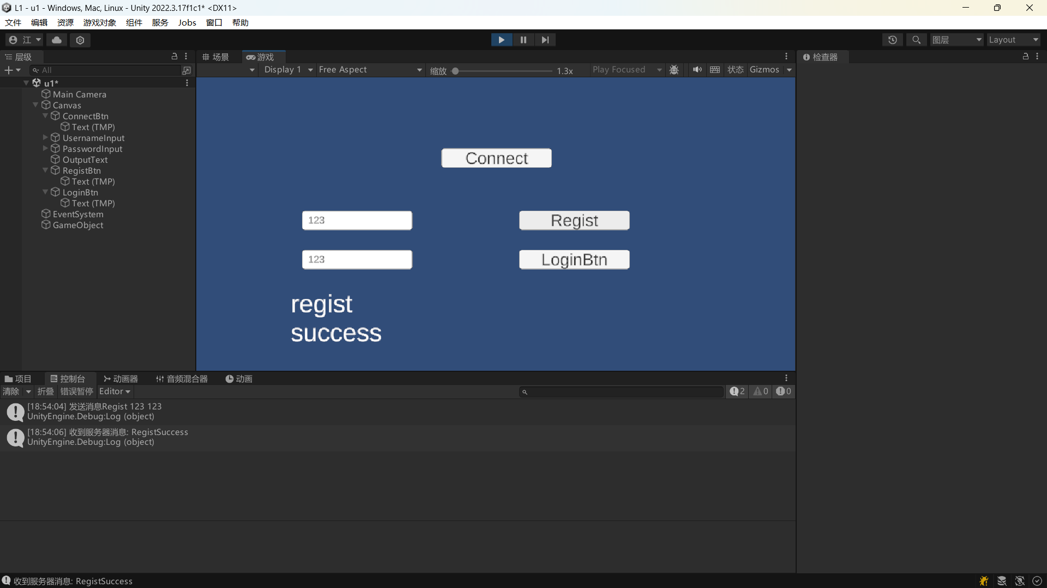
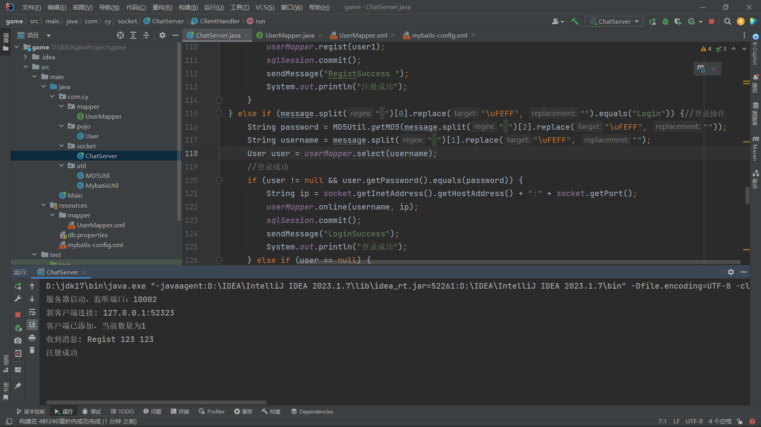
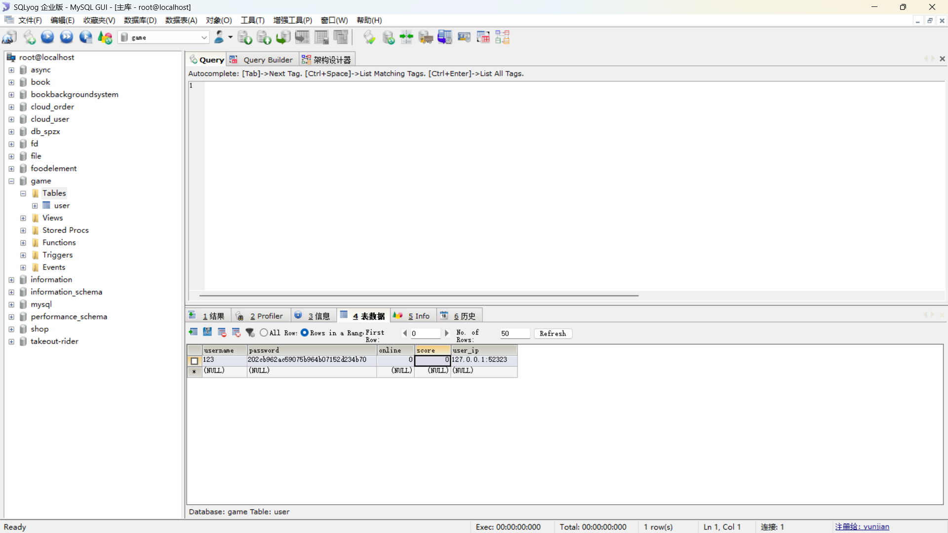
注册时，用户名已存在：
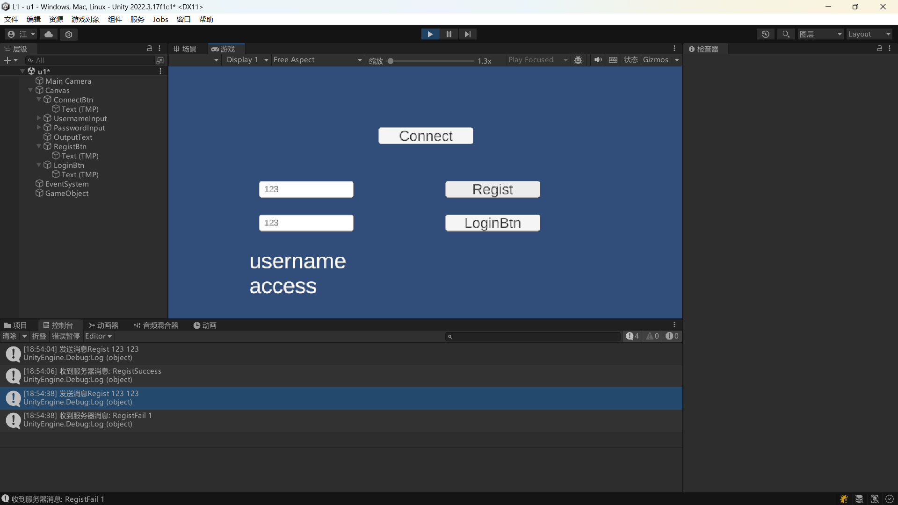
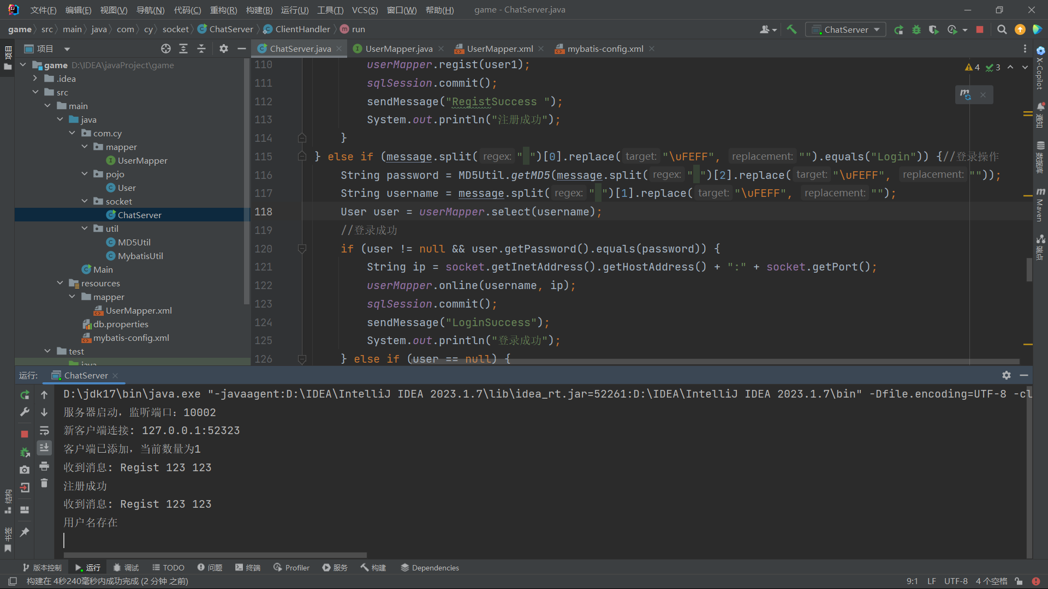
登录时密码错误：
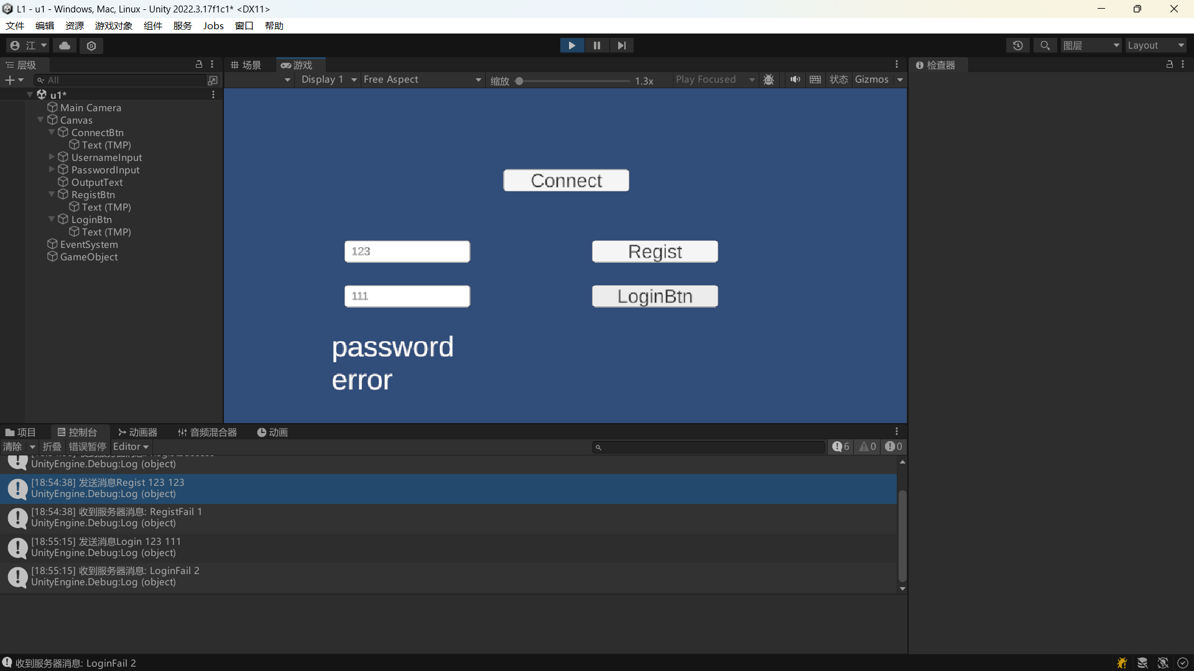
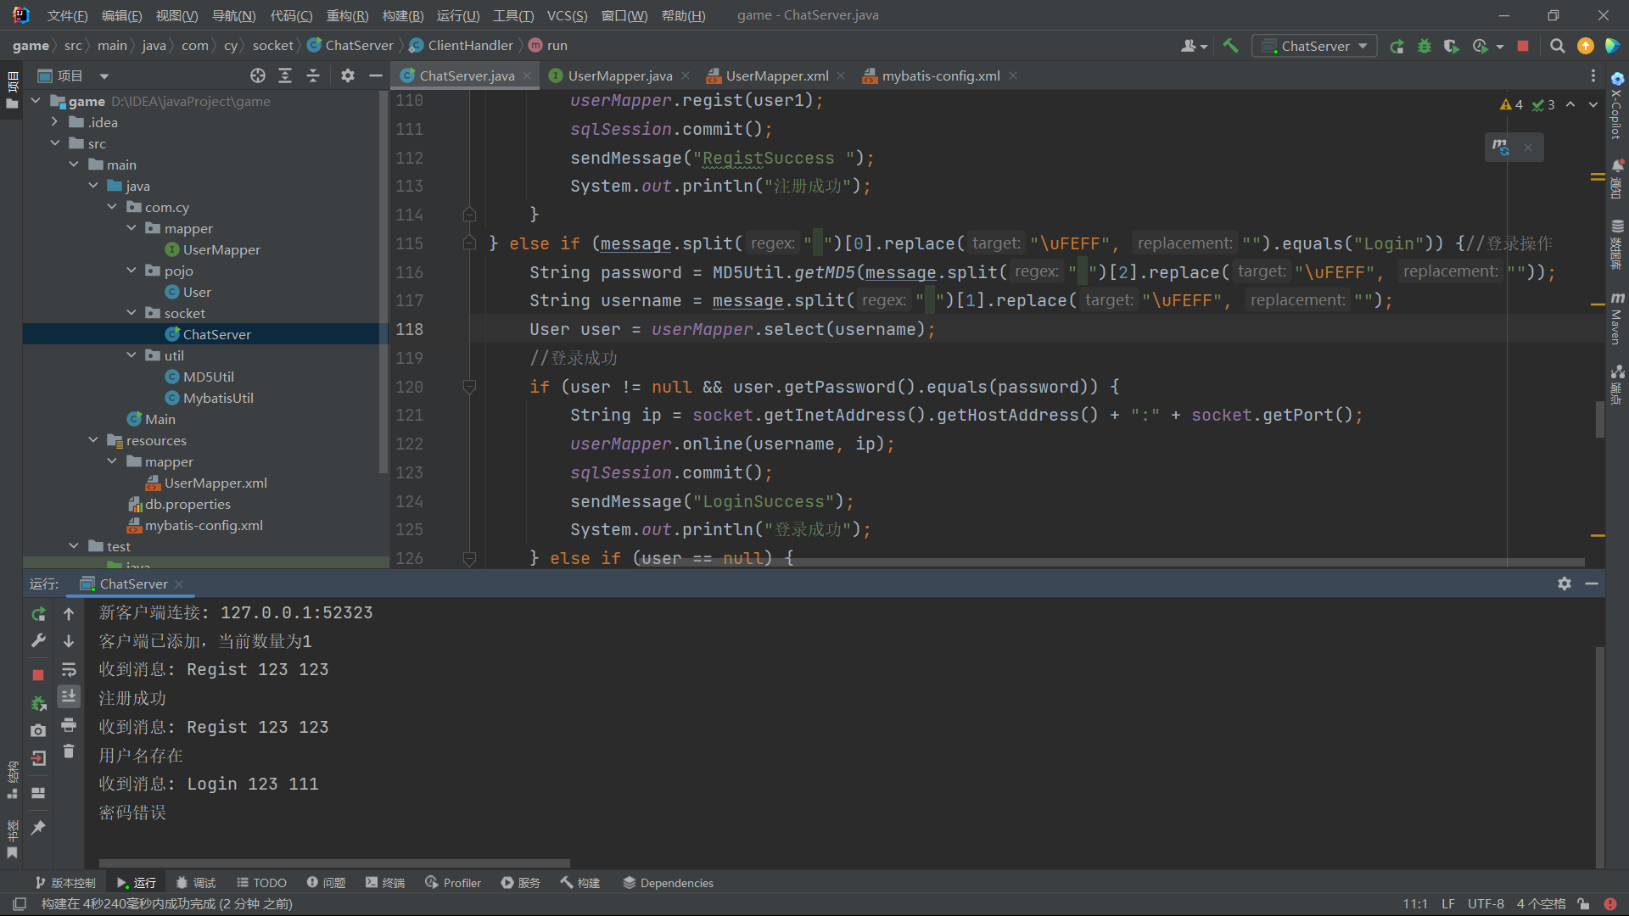
登录时用户名不存在：
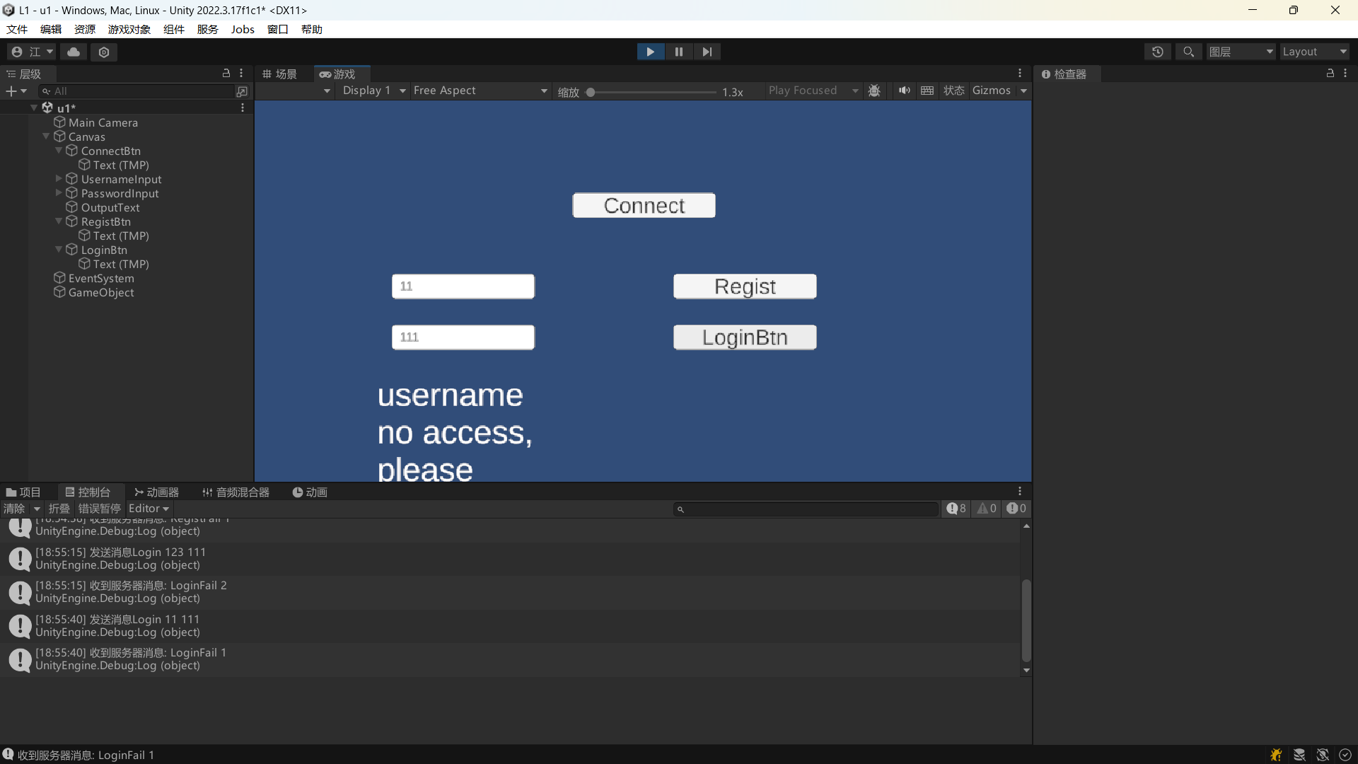
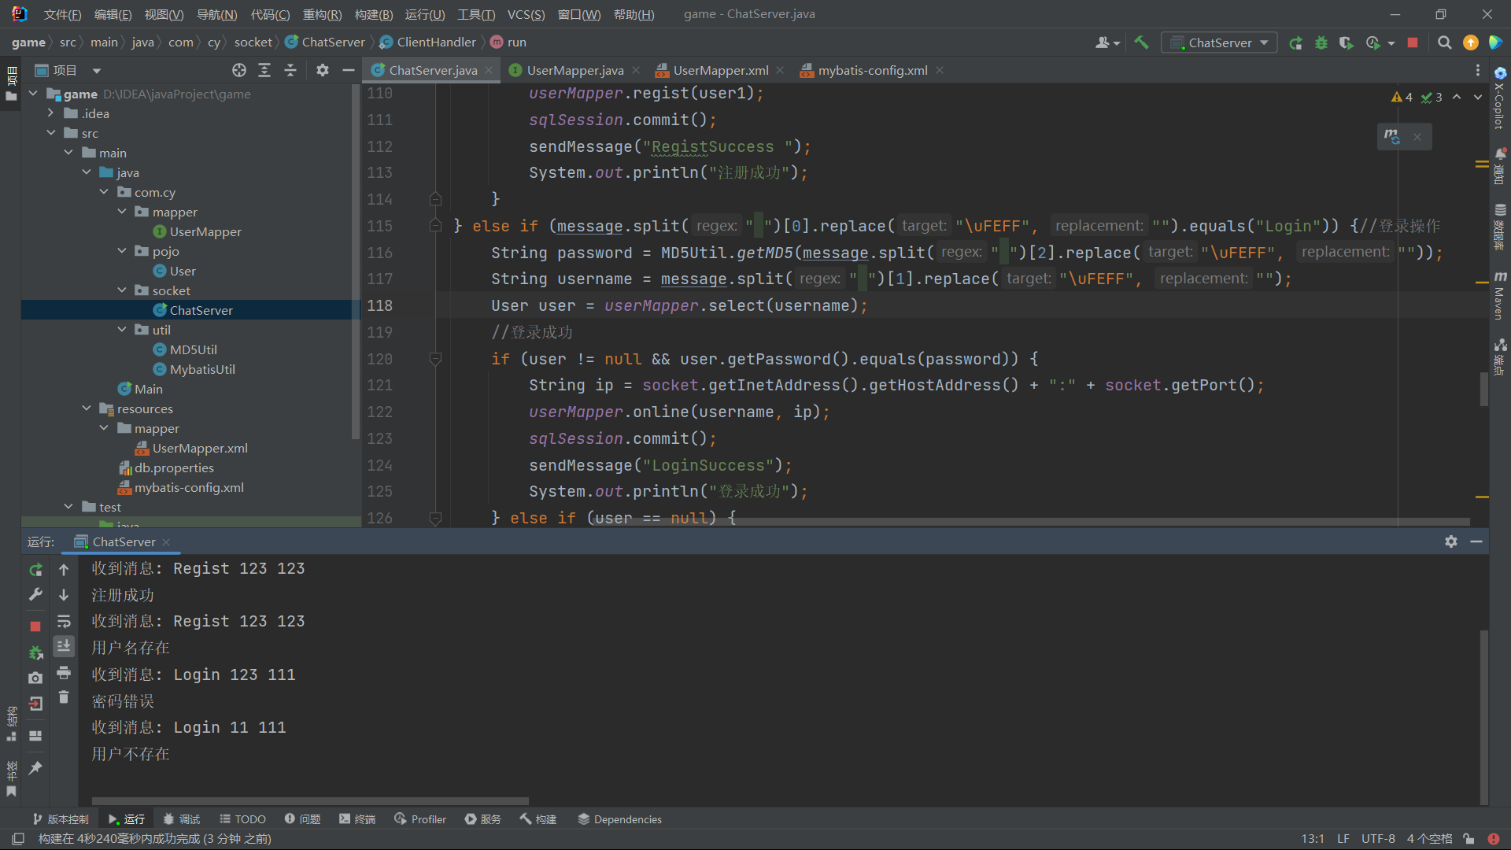
登录成功：
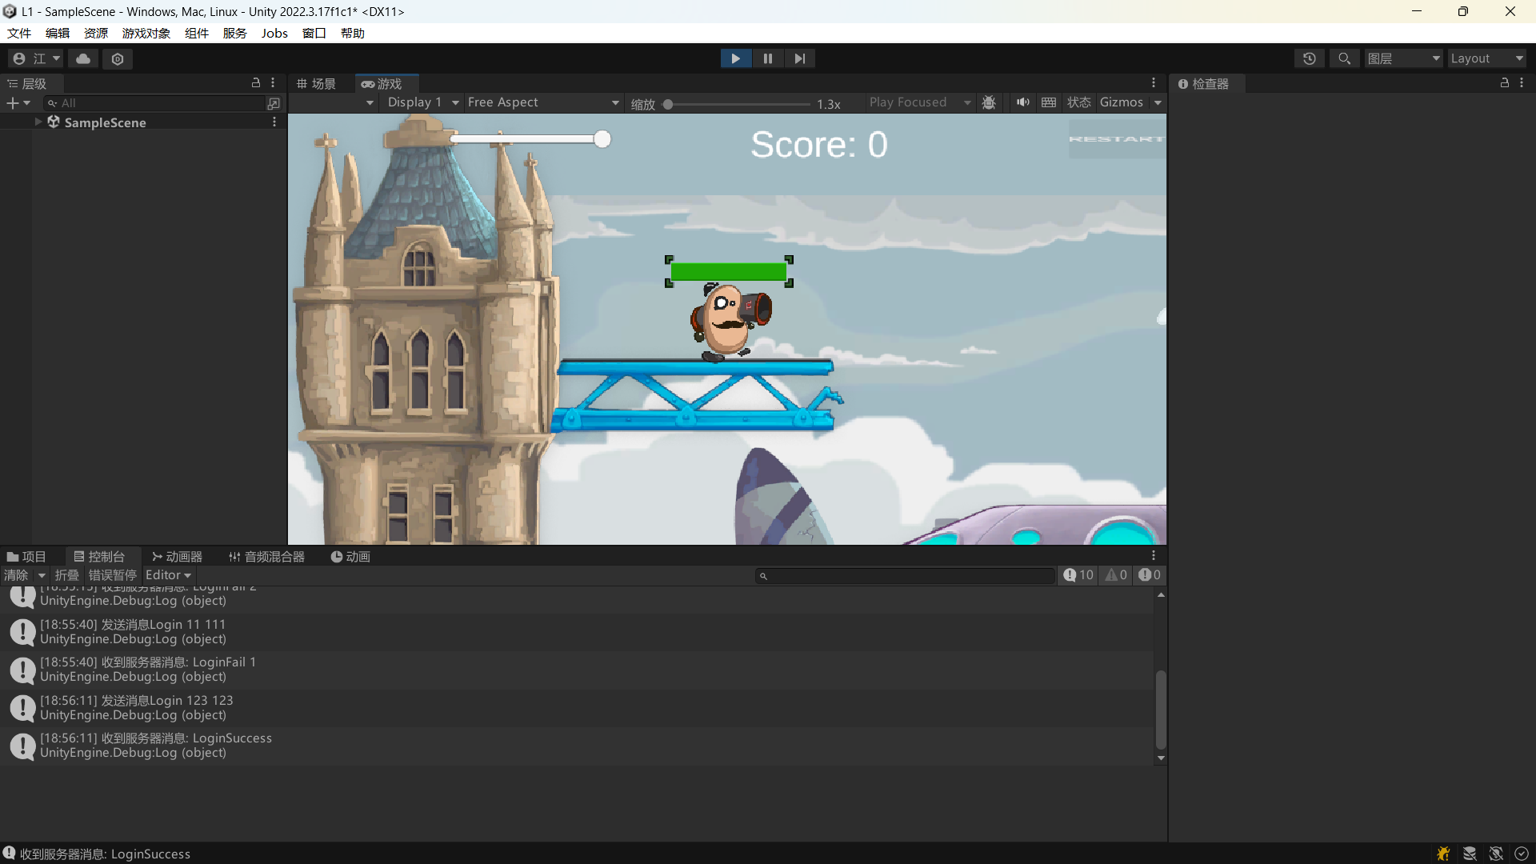
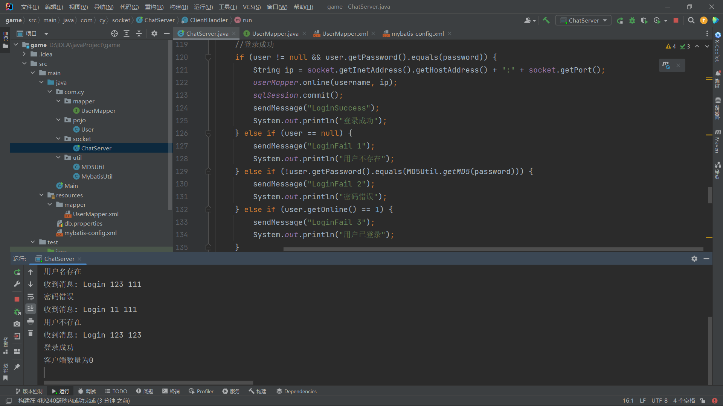

三【上机实验中的其他它问题及心得】
这次实验我学会了如何注册登录与服务器和客户端的交互。

