成都信息工程学院计算机学院

课
程
实
验
报
告

实验课程： | 网络游戏编程技术
实验项目： | 游戏同步
指导教师：
学生姓名:
学生学号：
班 级：
实验地点：
实验时间： | 2024 年 12 月 4 日 16 点~ 17:40 点
实验成绩：

一【上机实验内容】
1. 实验三的配对成功后跳转到游戏场景；
2. 向服务器发送位置同步、转身同步、开火同步协议；
3. 在接收到服务器转发来的位置同步、转身同步、开火同步协议时，实现相应操作；
4. 实现hero2的血条跟随、hero与rocket的碰撞检测、血量同步；

二【上机实验步骤】（重点）

操作步骤
实现客户端的位置发送，转身和开火协议。
接收协议时，客户端执行操作。
实现hero2的血量跟随
编写服务端代码

关键代码
客户端代码：
using System;
using System.Collections;
using System.Collections.Generic;
using System.Diagnostics;
using System.IO;
using System.Net.Sockets;
using System.Text;
using TMPro;
using UnityEngine;
using UnityEngine.SceneManagement;

public class Sample : MonoBehaviour
{
// Start is called before the first frame update
public Socket clientSocket;
NetworkStream networkStream;
StreamWriter writer;
StreamReader reader;
string recvStr;
bool isConnected = false;
public string myUsername;
private Coroutine receiveCoroutine; // 用于存储接收协程
GameObject hero1, hero2;
int frameCount = 0;

// Start is called before the first frame update
void Start()
{
getSocket();
DontDestroyOnLoad(this.gameObject);
hero1 = GameObject.Find("Hero");
hero2 = GameObject.Find("Hero2");
hero2.GetComponent<PlayerControl2>().Flip();
UnityEngine.Debug.Log(hero1);
UnityEngine.Debug.Log(hero2);
UnityEngine.Debug.Log(myUsername);
}

private IEnumerator ReceiveData() // 场景三的ReceiveData
{
while (isConnected)
{
if (networkStream.DataAvailable)
{
try
{
recvStr = reader.ReadLine();
if (!string.IsNullOrEmpty(recvStr))
{

string[] args = recvStr.Split(' ');
if (args[0] != "Position" && args[0] != "roomList")
{
UnityEngine.Debug.Log("收到服务器消息: " + recvStr);
}
// 检查 args 数组的长度
if (args.Length > 0)
{
if (args[0] == "Position")
{
SetPosition(args[1], args[2]);
}
else if (args[0] == "Flip")
{
hero2.GetComponent<PlayerControl2>().Flip();
}
else if (args[0] == "Fire")
{
GameObject.Find("Hero2/Gun").GetComponent<Gun2>().Fire();
}
else if (args[0] == "Health")
{
hero1.GetComponent<PlayerHealth>().health = float.Parse(args[1]);
hero1.GetComponent<PlayerHealth>().UpdateHealthBar();
}
else if (args[0] == "over")
{
Destroy(gameObject);
SceneManager.LoadScene(1);
}
}
else
{
UnityEngine.Debug.LogWarning("接收到的消息为空或格式不正确: " + recvStr);
}
}
}
catch (Exception e)
{
UnityEngine.Debug.LogError("接收消息失败: " + e.Message);
isConnected = false;
}
}
yield return null;
}
}

void getSocket()
{
Room room = FindObjectOfType<Room>();
myUsername = room.myUsername;
UnityEngine.Debug.Log(room);
if (room != null)
{
clientSocket = room.clientSocket;
networkStream = new NetworkStream(clientSocket);
writer = new StreamWriter(networkStream, Encoding.UTF8);
reader = new StreamReader(networkStream, Encoding.UTF8);
isConnected = true;

room.StopReceivingData(); // 停止场景二的ReceiveData
receiveCoroutine = StartCoroutine(ReceiveData()); // 启动场景三的ReceiveData
}
else
{
UnityEngine.Debug.LogError("未找到场景一的 Netword_u1 实例");
}
}

void SendPosition()
{
float x = hero1.transform.position.x;
float y = hero1.transform.position.y;
string sendStr = "Position " + x.ToString() + " " + y.ToString() + " ";
//UnityEngine.Debug.Log("向服务器发送消息" + sendStr);
writer.WriteLine(sendStr);
writer.Flush();
}

public void SendHealth(float health)
{
UnityEngine.Debug.Log("向服务器发送消息" + "Health " + health);
writer.WriteLine("Health " + health);
writer.Flush();
}

public void Filp()
{
writer.WriteLine("Flip ");
writer.Flush();
}

public void Fire()
{
writer.WriteLine("Fire ");
writer.Flush();
}

void SetPosition(string strX, string strY)
{
float x = -float.Parse(strX);
float y = float.Parse(strY);
Vector2 newPosition = new Vector2(x, y);
hero2.transform.position = newPosition;
}

public void gameOver()
{
writer.WriteLine("over ");
writer.Flush();
}

// Update is called once per frame
void Update()
{
if (frameCount % 5 == 0) SendPosition();
frameCount++;
frameCount %= 5;
}
}
服务端代码：
package com.cy.socket;
import com.cy.mapper.UserMapper;
import com.cy.pojo.User;
import com.cy.util.MD5Util;
import com.cy.util.MybatisUtil;
import org.apache.ibatis.session.SqlSession;
import java.io.BufferedReader;
import java.io.IOException;
import java.io.InputStreamReader;
import java.io.PrintWriter;
import java.net.ServerSocket;
import java.net.Socket;
import java.util.HashMap;
import java.util.HashSet;
import java.util.Scanner;
import java.util.Set;
import java.util.concurrent.Executors;
import java.util.concurrent.ScheduledExecutorService;
import java.util.concurrent.TimeUnit;
public class ChatServer {
private static final int PORT = 10002;
private static final Set<ClientHandler> clientHandlers = new HashSet<>();
private static SqlSession sqlSession = MybatisUtil.sqlSessionFactory();
private static UserMapper userMapper = sqlSession.getMapper(UserMapper.class);
private static HashMap<String, String> map = new HashMap<>();
public static void main(String[] args) {
startServer();
listenForMessages();
}
public static void startServer() {
System.out.println("服务器启动，监听端口：" + PORT);
new Thread(() -> {
try (ServerSocket serverSocket = new ServerSocket(PORT)) {
while (true) {
Socket clientSocket = serverSocket.accept();
ClientHandler handler = new ClientHandler(clientSocket);
synchronized (clientHandlers) {
clientHandlers.add(handler);
System.out.println("客户端已添加，当前数量为" + clientHandlers.size());
}
handler.start();
}
} catch (IOException e) {
e.printStackTrace();
}
}).start();
}
public static void listenForMessages() {
new Thread(() -> {
try (Scanner scanner = new Scanner(System.in)) {
while (true) {
String message = scanner.nextLine();
sendMessageToAllClients(message);
}
}
}).start();
}
public static void sendMessageToAllClients(String message) {
synchronized (clientHandlers) {
System.out.println("当前连接的客户端数量: " + clientHandlers.size());
for (ClientHandler handler : clientHandlers) {
handler.sendMessage(message);
// 打印客户端信息
System.out.println("消息发送到客户端: " + handler.getId());
}
}
}
private static class ClientHandler extends Thread {
private Socket socket;
private PrintWriter out;
private BufferedReader in;
private ScheduledExecutorService scheduler;
private StringBuilder messageToSend = new StringBuilder("roomList 0"); // 定义要发送的消息内容
public ClientHandler(Socket socket) {
this.socket = socket;
System.out.println("新客户端连接: " + socket.getInetAddress().getHostAddress() + ":" + socket.getPort());
try {
in = new BufferedReader(new InputStreamReader(socket.getInputStream()));
out = new PrintWriter(socket.getOutputStream(), true);
// 初始化定时器
scheduler = Executors.newScheduledThreadPool(1);
for (ClientHandler handler : clientHandlers) {
if (!handler.messageToSend.equals("roomList 0")) {
this.messageToSend = handler.messageToSend;
}
}
scheduler.scheduleAtFixedRate(() -> sendMessage(messageToSend.toString()), 0, 2, TimeUnit.SECONDS);
} catch (IOException e) {
e.printStackTrace();
}
}
public void run() {
try {
String message;
while ((message = in.readLine()) != null) {
if (!message.split(" ")[0].replace("\uFEFF", "").equals("Position")) {
System.out.println("收到消息: " + message);
}
String s1 = message.split(" ")[0];
//注册操作
if ("Regist".equals(s1.replace("\uFEFF", ""))) {
String password = MD5Util.getMD5(message.split(" ")[2].replace("\uFEFF", ""));
String username = message.split(" ")[1].replace("\uFEFF", "");
String ip = socket.getInetAddress().getHostAddress() + ":" + socket.getPort();
User user = userMapper.select(username);
//用户名存在
if (user != null) {
sendMessage("RegistFail 1 ");
System.out.println("用户名存在");
} else {
User user1 = new User();
user1.setUsername(username);
user1.setPassword(password);
user1.setOnline(0);
user1.setScore(0);
user1.setUserIp(ip);
userMapper.regist(user1);
sqlSession.commit();
sendMessage("RegistSuccess ");
System.out.println("注册成功");
}
} else if (message.split(" ")[0].replace("\uFEFF", "").equals("Login")) {//登录操作
String password = MD5Util.getMD5(message.split(" ")[2].replace("\uFEFF", ""));
String username = message.split(" ")[1].replace("\uFEFF", "");
User user = userMapper.select(username);
if (user == null) {
sendMessage("LoginFail 1");
System.out.println("用户不存在");
} else if (!user.getPassword().equals(password)) {
sendMessage("LoginFail 2");
System.out.println("密码错误");
} else if (user.getOnline() == 1) {
sendMessage("LoginFail 3");
System.out.println("用户已登录");
} else {
String ip = socket.getInetAddress().getHostAddress() + ":" + socket.getPort();
userMapper.online(username, ip);
sqlSession.commit();
sendMessage("LoginSuccess");
System.out.println("登录成功");
}
} else if (message.split(" ")[0].replace("\uFEFF", "").equals("createRoom")) {
String[] s = messageToSend.toString().split(" ");
StringBuilder ms = new StringBuilder("roomList " + (Integer.parseInt(s[1]) + 1) + " ");
String username = userMapper.findByIp(socket.getInetAddress().getHostAddress() + ":" + socket.getPort()).getUsername();
for (int i = 2; i < s.length; i++) {
ms.append(s[i]).append(" ");
}
ms.append(username).append(" ");
messageToSend = ms;
broadcast(ms.toString());
updateRooms(ms.toString());
} else if (message.split(" ")[0].replace("\uFEFF", "").equals("enterRoom")) {
String username = message.split(" ")[1];
User select = userMapper.select(username);
for (ClientHandler handler : clientHandlers) {
if ((handler.socket.getInetAddress().getHostAddress() + ":" + handler.socket.getPort()).equals(select.getUserIp())) {
handler.sendMessage("begin 1");
}
}
sendMessage("begin 0");
map.put(select.getUserIp(), this.socket.getInetAddress().getHostAddress() + ":" + this.socket.getPort());
map.put(this.socket.getInetAddress().getHostAddress() + ":" + this.socket.getPort(), select.getUserIp());
} else if (message.split(" ")[0].replace("\uFEFF", "").equals("Position")) {
String ip = map.get(this.socket.getInetAddress().getHostAddress() + ":" + this.socket.getPort());
for (ClientHandler handler : clientHandlers) {
if ((handler.socket.getInetAddress().getHostAddress() + ":" + handler.socket.getPort()).equals(ip)) {
handler.sendMessage("Position " + message.split(" ")[1].replace("\uFEFF", "") + " " + message.split(" ")[2].replace("\uFEFF", "") + " ");
}
}
} else if (message.split(" ")[0].replace("\uFEFF", "").equals("File")) {
String ip = map.get(this.socket.getInetAddress().getHostAddress() + ":" + this.socket.getPort());
for (ClientHandler handler : clientHandlers) {
if ((handler.socket.getInetAddress().getHostAddress() + ":" + handler.socket.getPort()).equals(ip)) {
handler.sendMessage("Flip ");
}
}
} else if (message.split(" ")[0].replace("\uFEFF", "").equals("Fire")) {
String ip = map.get(this.socket.getInetAddress().getHostAddress() + ":" + this.socket.getPort());
for (ClientHandler handler : clientHandlers) {
if ((handler.socket.getInetAddress().getHostAddress() + ":" + handler.socket.getPort()).equals(ip)) {
handler.sendMessage("Fire ");
}
}
} else if (message.split(" ")[0].replace("\uFEFF", "").equals("Health")) {
String ip = map.get(this.socket.getInetAddress().getHostAddress() + ":" + this.socket.getPort());
for (ClientHandler handler : clientHandlers) {
if ((handler.socket.getInetAddress().getHostAddress() + ":" + handler.socket.getPort()).equals(ip)) {
handler.sendMessage("Health " + message.split(" ")[1].replace("\uFEFF", "") + " ");
}
}
} else if (message.split(" ")[0].replace("\uFEFF", "").equals("over")) {
String username = userMapper.findByIp(socket.getInetAddress().getHostAddress() + ":" + socket.getPort()).getUsername();
System.out.println("游戏结束，赢家为：" + username);
String ip = map.get(this.socket.getInetAddress().getHostAddress() + ":" + this.socket.getPort());
for (ClientHandler handler : clientHandlers) {
if ((handler.socket.getInetAddress().getHostAddress() + ":" + handler.socket.getPort()).equals(ip)) {
handler.sendMessage("over ");
}
}
map.remove(this.socket.getInetAddress().getHostAddress() + ":" + this.socket.getPort());
map.remove(ip);
}
//这会把消息重新发送给所有客户端
// broadcast(message);
}
} catch (IOException e) {
e.printStackTrace();
} finally {
try {
// 关闭定时器
if (scheduler != null) {
scheduler.shutdown();
}
synchronized (clientHandlers) {
clientHandlers.remove(this);
String ip = socket.getInetAddress().getHostAddress() + ":" + socket.getPort();
User user = userMapper.findByIp(ip);
if (user != null) {
userMapper.updateByIp(ip);
sqlSession.commit();
}
System.out.println("客户端数量为" + clientHandlers.size());
}
socket.close();
} catch (IOException e) {
e.printStackTrace();
}
}
}
public void sendMessage(String message) {
out.println(message);
}
private void broadcast(String message) {
synchronized (clientHandlers) {
for (ClientHandler handler : clientHandlers) {
handler.sendMessage(message);
}
}
}
private void updateRooms(String message) {
synchronized (clientHandlers) {
for (ClientHandler handler : clientHandlers) {
if (!handler.messageToSend.equals(this.messageToSend)) {
handler.messageToSend = new StringBuilder(message);
}
}
}
}
}
}

运行结果截图
进入游戏场景：
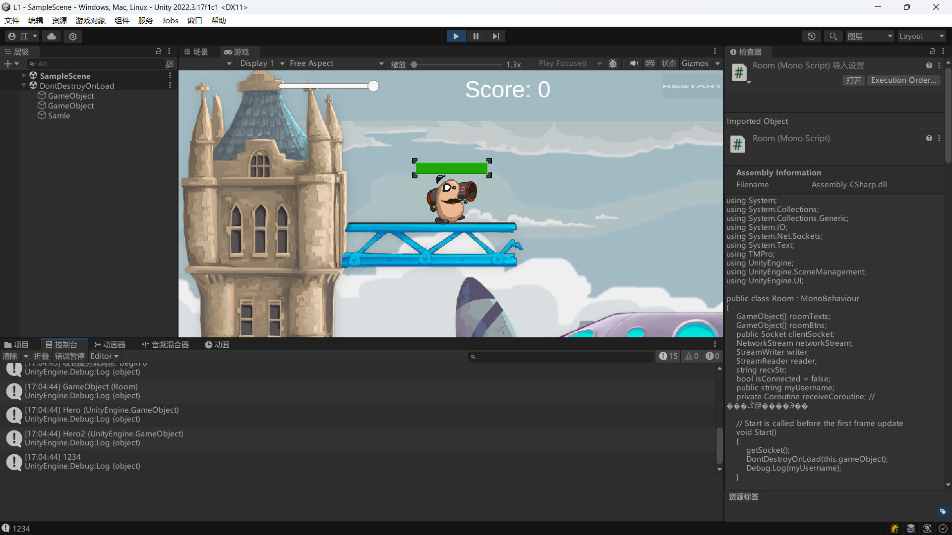
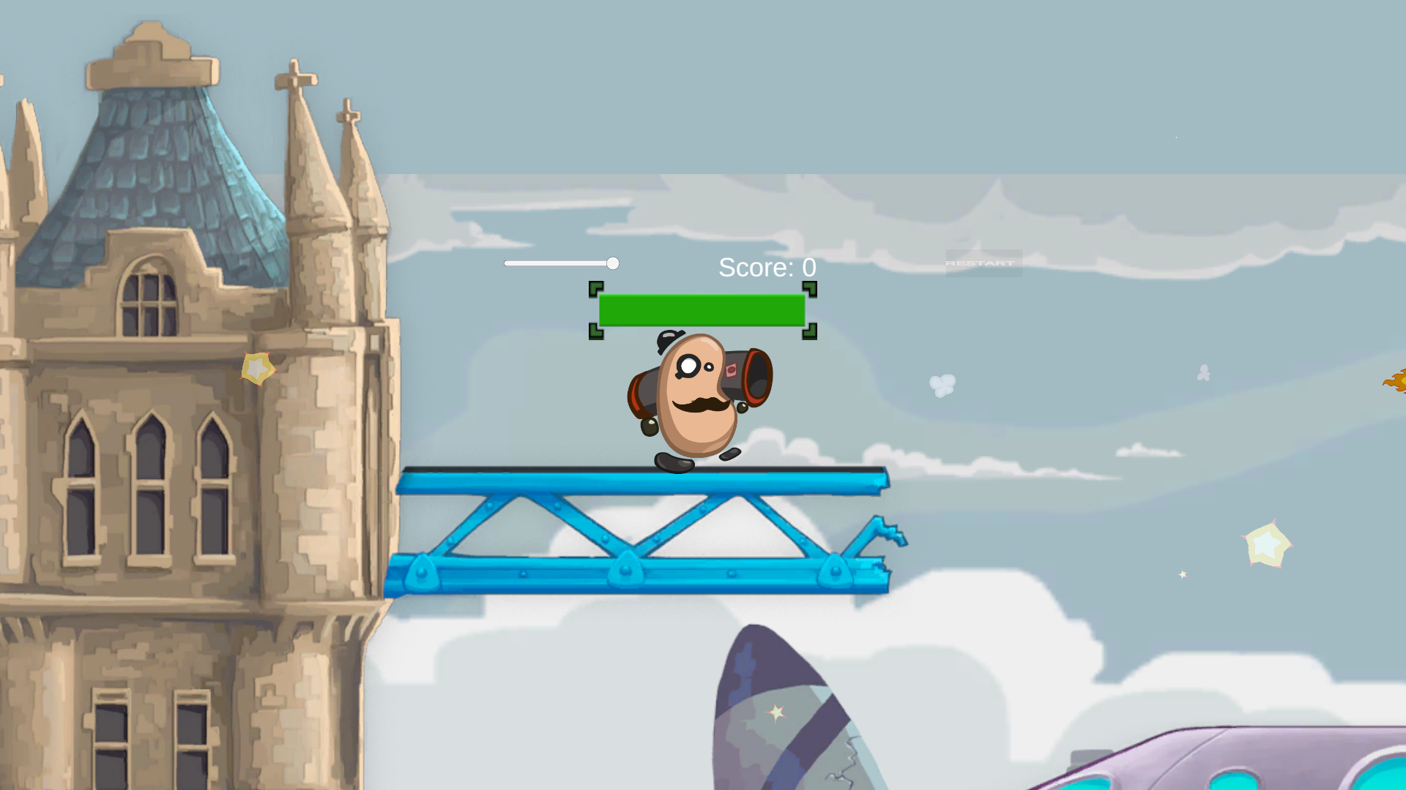
开火与血量同步：
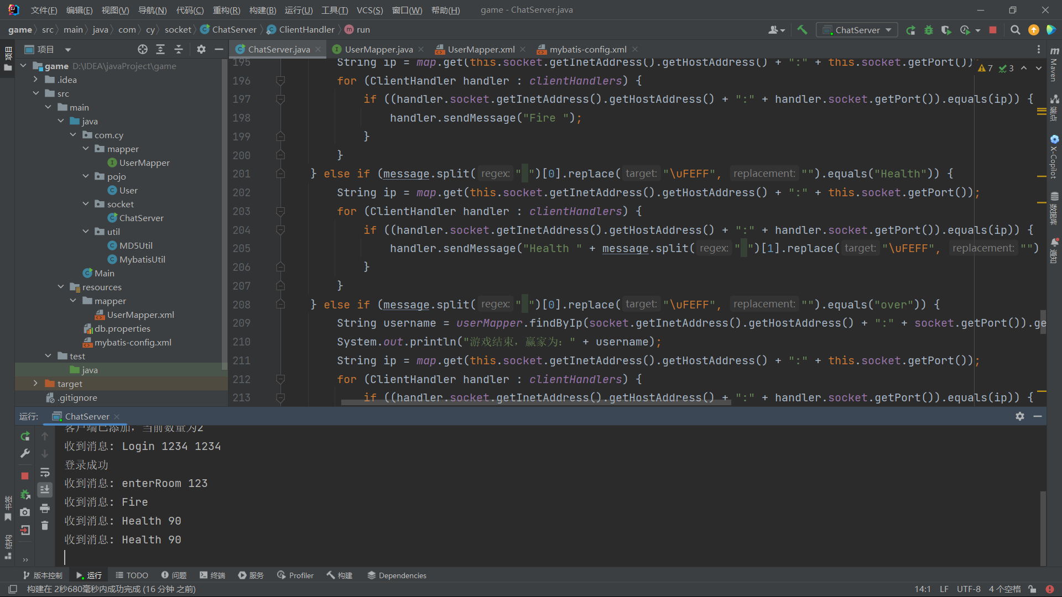
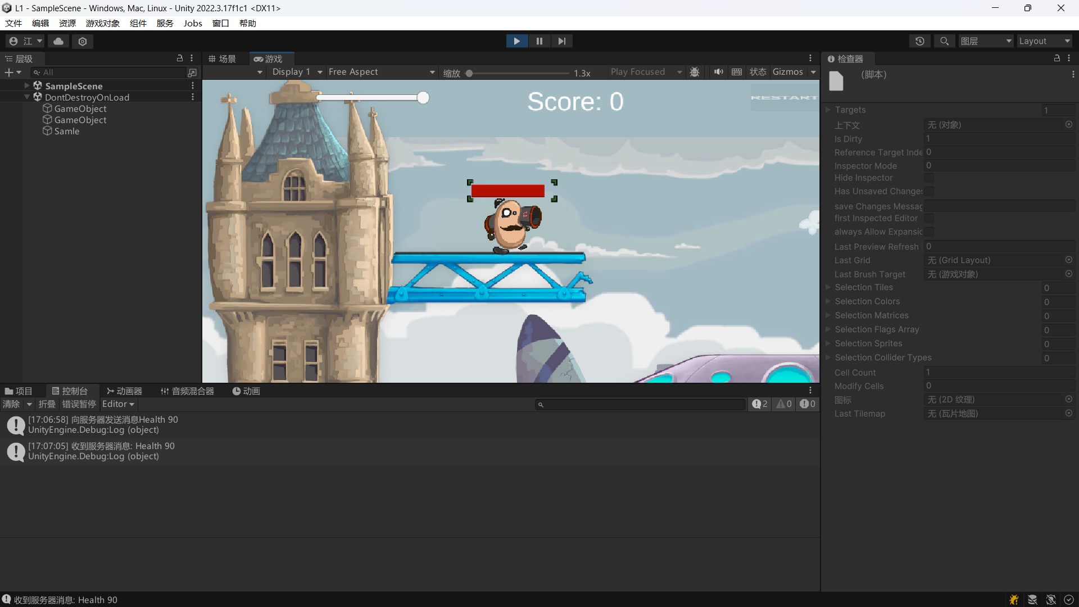
位置同步，转身同步：
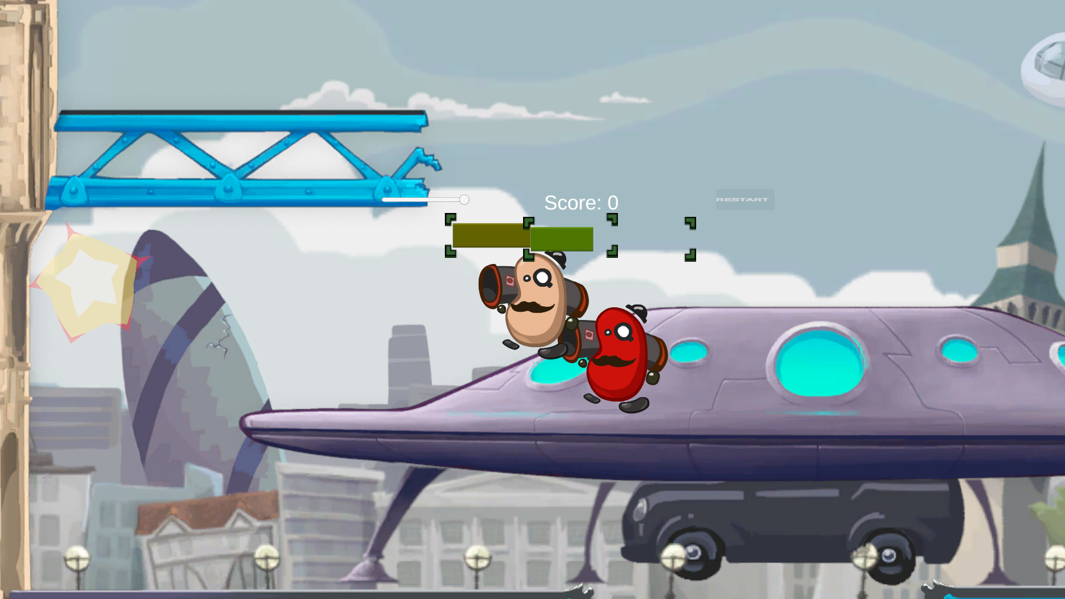
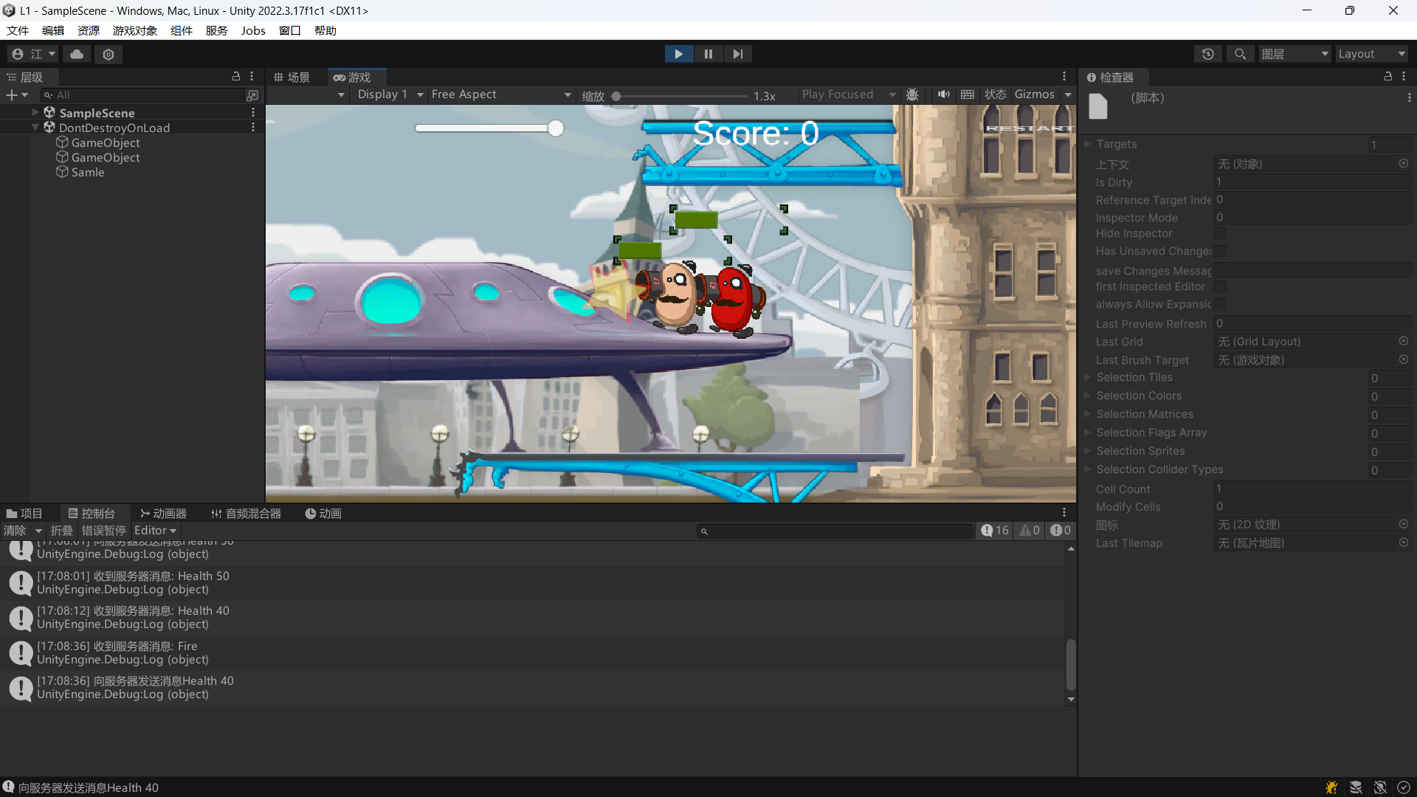
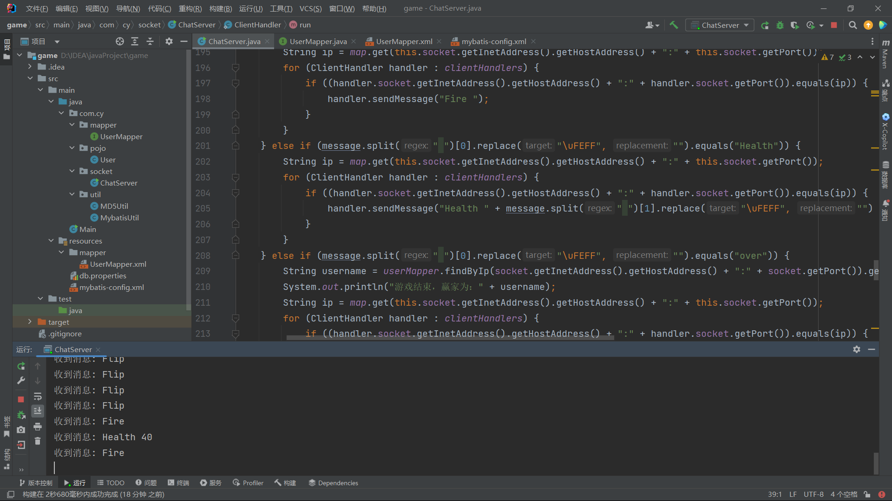
Hero2血量跟随：
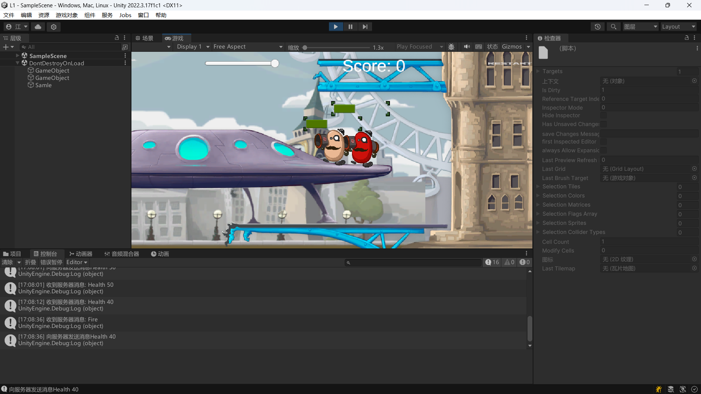
游戏结束向服务端发送结果：
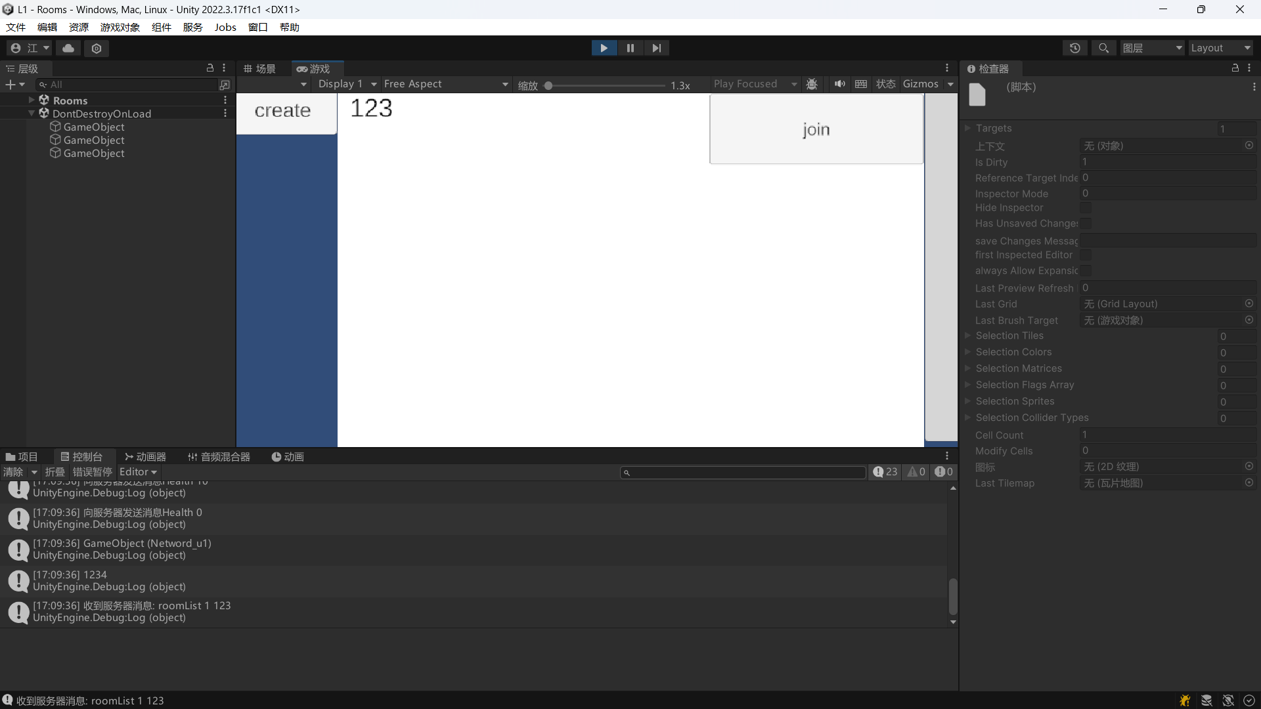
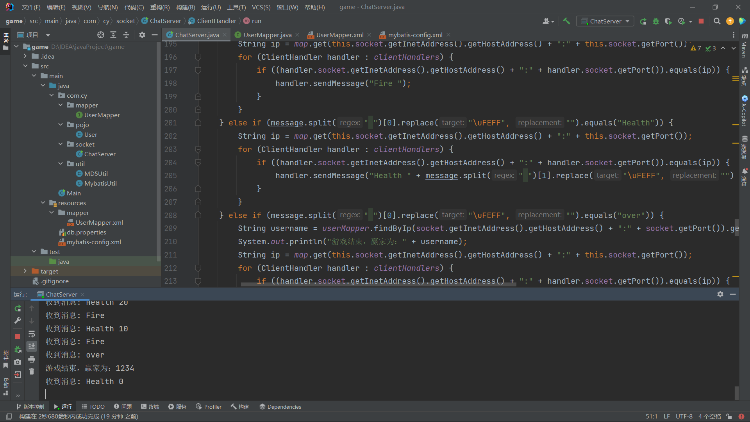

三【上机实验中的其他它问题及心得】
这次实验我学到了客户端与服务端位置同步，血量同步的编写。

