
UNIVERSITI TUNKU ABDUL RAHMAN
FACULTY OF INFORMATION AND COMMUNICATION TECHNOLOGY
UCCD3243 SERVER-SIDE WEB APPLICATIONS DEVELOPMENT
GROUP ASSIGNMENT

Project Title: Student Routine Organizer: Your life, completely organized
Group Number: 3
Group Leader: Tiong Kung Ho
Lecturer: Nur Athirah Nabila binti Mohd Idros
Name | Student ID | Practical Group | Programme
Tiong Kung Ho | 2301306 | P5 | CS
Kelvin Lai Yu Ting | 2400848 | P5 | CS
Majji Madu Mangala | 2301945 | P2 | CS
Ng Chuan He | 2401890 | P5 | CS

RUBRIC MARK:

 |  | Student 1 | Student 2 | Student 3 | Student 4
STUDENT ID |  | 2301306 | 2400848 | 2301945 | 2401890
STUDENT NAME |  | Tiong Kung Ho | Kelvin Lai Yu Ting | Majji Madu Mangala | Ng Chuan He
PROGRAMME |  | CS | CS | CS | CS
MODULE |  | Exercise Tracker | Diary Journal | Money Tracker | Habit Tracker
Attribute | Actual Marks
Report Section (Group) | 30
Site Hierarchy and Navigation | 5
System Flowcharts | 10
Overview of Database Structure | 5
Functional Requirements | 10
Application Section (Individual) | 35
Module Implementation | 15
Data and Logic Flow | 10
Coding Structure | 5
Error Handling and Debugging | 5
Application Section (Group) | 35
Professional Outlook  (Front and Back End) | 5
Integration of Modules | 20
Testing and Debugging | 10
Total | 100

Site Hierarchy and Navigation (For Overall System):
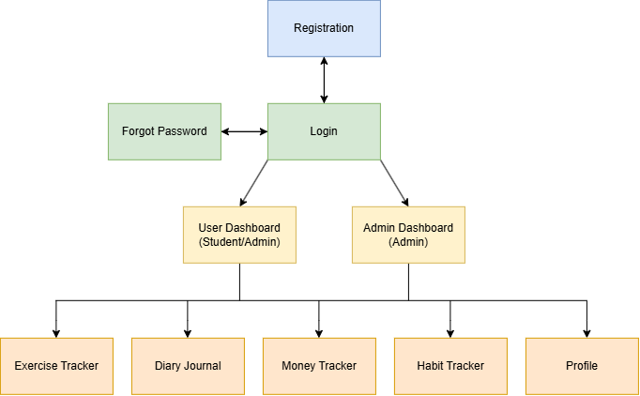

A new user starts at Registration page, which lets them create an account in the shared users table with the default role fixed to student, the user returns to Login page to fill their details log in. A returning user goes straight to Login page. If they have forgotten their password, Login page links to Forgot Password, which generates a 30 minute time limited reset token and allows the user to return to Login page after resetting their password, matching the two way arrows between Login, Forgot password and Registration page in the diagram.

On a successful login, login.php stores the user's identity in the session and reads their role to decide which dashboard to send them to. The students go to User Dashboard page, while admins go to Admin Dashboard page. Users with student role cannot freely switch between the two dashboards, but admin can access both dashboards once logged in and redirected to Admin Dashboard page first. This is why the diagram shows separate paths from Login to the two dashboards. Login also functions as the fallback destination when a user's session expires. The auth.php is included in all pages after logging in, which enforces a 30 minute inactivity timeout that logs out user by destroying their login session.

From either dashboard, users can access the shared destinations with Exercise Tracker, Diary Journal, Money Tracker, Habit Tracker and Profile page. The navigation bar implemented through layout.php allows users to move between the different pages with ease. Additionally, the main difference by role is that the Admin Dashboard is only displayed in the navigation bar for admin users, while students do not see or have access to it. Overall, the site hierarchy provides a clear and secure navigation structure for the Student Routine Organizer. Through role-based access and organized navigation, users can efficiently access the system modules and manage their activities according to their assigned permissions.

System Flowcharts (For Individual Module):
The flowchart uses few 4 components to show how the individual module works in the system. An oval shape is used to mark the beginning or the end of a process. A rectangle represents an action carried out by the user or system and a diamond shows a decision point, where the system or user needs to make a choice. Lastly, the arrows connect the symbols and show the order in which each step is performed.

Exercise Tracker Module Flowchart:

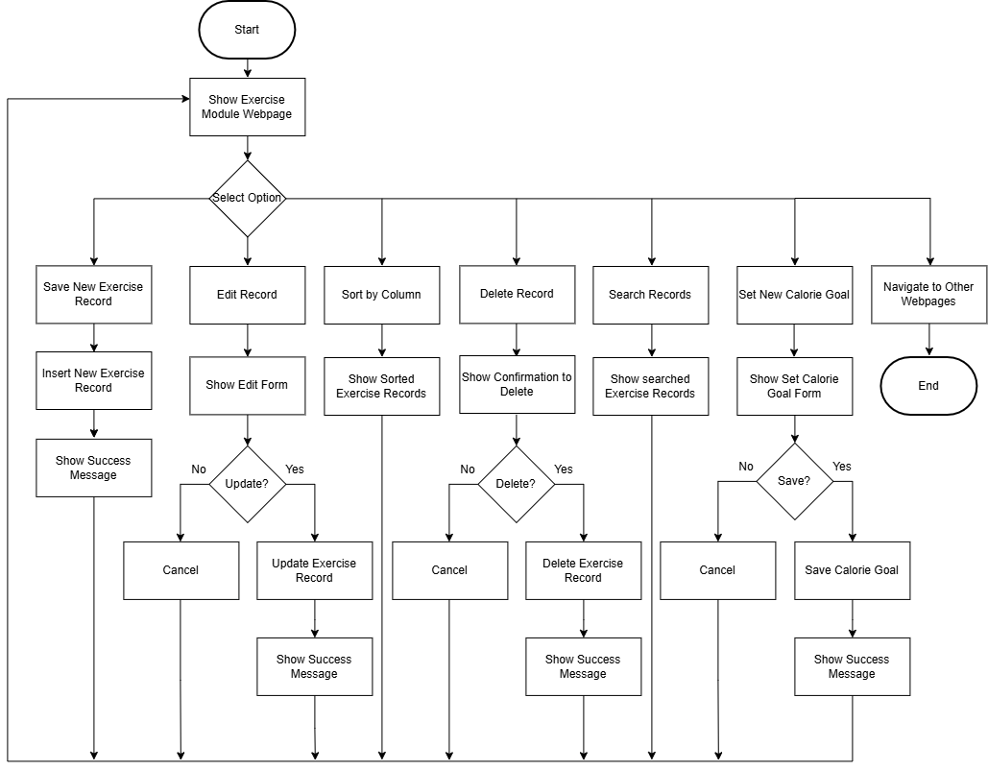

The flowchart shows the overall user flow of the Exercise Module, showing how users can manage their exercise records and calorie goal. The process begins when the user accesses the Exercise Module webpage, then the user can choose to add a new exercise record, edit an existing record, delete a record or set a new calorie goal. When saving a new exercise, the system inserts the new exercise details into the database and shows a success message if it is successful. When editing a record, the system displays the selected exercise record in the edit form, then allowing the user to either cancel the operation or update the record, after which a success message is shown if it is successful. For deletion, the system first displays a confirmation and if the user confirms, the selected exercise record is deleted and a success message is displayed, while cancelling returns the user to the module’s webpage.
The user also can set or update a calorie target, that shows a success message displayed if it is successful. In addition to that, the user can search or sort the exercise records to make browsing easier. When searching, the user enters a keyword and the system displays only the exercise records that match the activity type, status, or intensity level. When sorting, the user selects a column to sort and exercise records will be shown accordingly. Lastly, the user can also choose to leave the exercise module and explore other parts of the website. Overall, the flowchart demonstrates the exercise module's CRUD functionality, sort feature, search feature and calorie goal feature along with confirmation and success messages.

Diary Journal Module Flowchart:

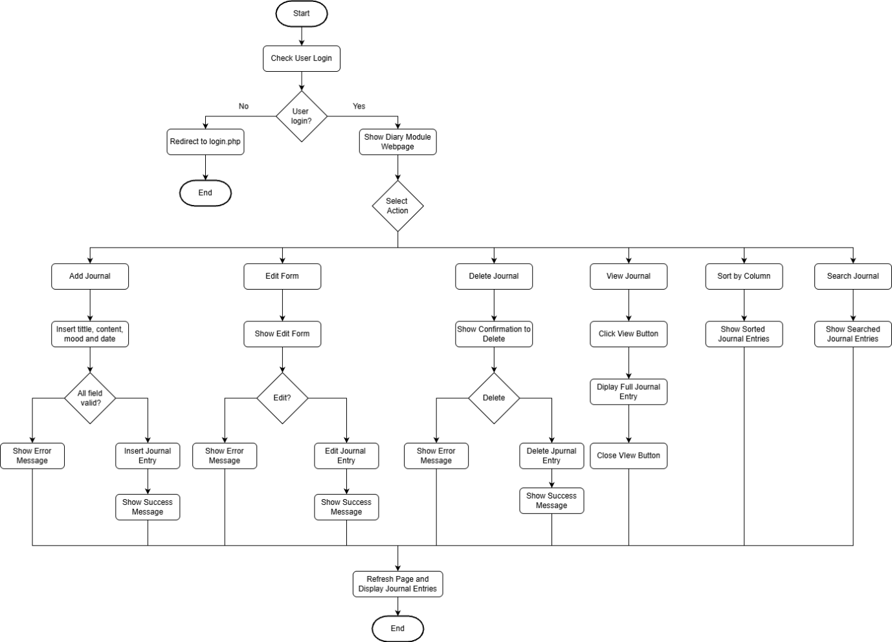

This flowchart illustrates how to handle users' journal entries via the Diary Module. The first step is determining if the user is logged into the system. If they are not, they are redirected to the login.php page. Once the user is logged in, the Diary module appears and from here the user goes to the section to perform the action on the journal entries such as adding, editing, deleting, viewing, sorting or searching.

To add a journal entry, the user is required to input the journal entry title, content, mood and date. The system checks if all fields are filled. If not, an error message will be displayed to the user to fill all the required fields. Once all the required fields are filled, the journal entry is added to the system and a success message is shown to the user.

To edit a journal entry, the user selects a journal entry and the system displays the details of the selected journal entry in the edit form. The user then inputs the new values and submits the edit. The system checks the values to be edited. An error message is shown to the user if there are any errors. Otherwise, the edit is successful. A success message is shown to the user if the edit was successful.

To delete a journal entry, the system asks for confirmation. The selected entry is deleted if the user wishes to proceed with the deletion. The deletion is confirmed by a success message, and a failure is indicated by an error message.

To see a journal entry, click the View button of that journal entry. It displays the selected journal entry in full. After viewing the entry, it is closed and users can continue to view the journal entries list.

To Sort & Search functions allow users to change the order of the journal entries and search for specific journal entries. When these function buttons are clicked, the system performs the corresponding function and displays the appropriate messages.

This flowchart illustrates the main functions of the Diary Module including Add, View, Edit, Delete, Sort and Search functions of journal entries. It also illustrates how the system validates user inputs and notifies the user of successful and unsuccessful functions, respectively. After an operation is completed, the page refreshes to show the new updated entry.

Money Tracker Module Flowchart:

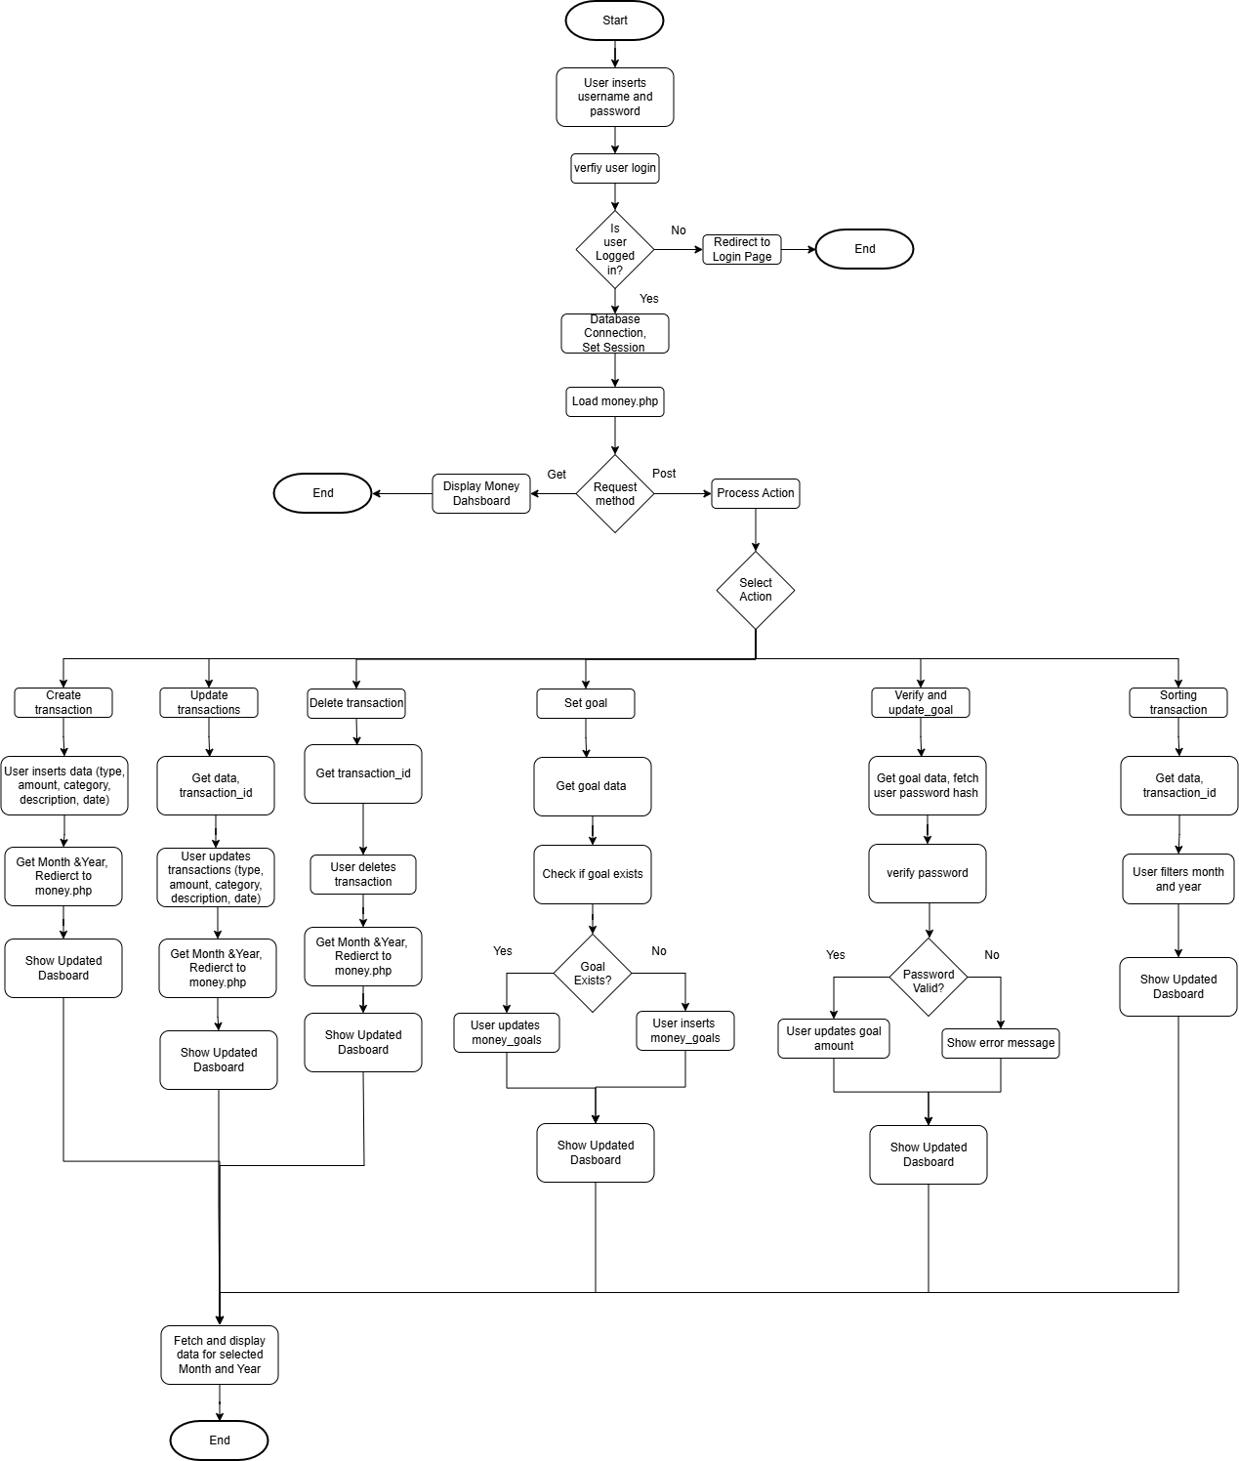

This flowchart shows the overall process of the Money Management Module, which allows users to manage their financial transactions and savings goals. The process begins by verifying the user is logged into the system or not. If the user is not logged in, they are redirected to the login page. If the login is successful, the system establishes a database connection, sets the user session, and loads the money.php page.
To create a transaction, the user enters the transaction type, amount, category, description, and date. The system processes the submitted information and stores the transaction in the database together with the user's ID. After the transaction is successfully added, the system redirects the user back to the Money Management Dashboard and displays the updated information.
To update the transaction, the user selects an existing transaction and it provides the updated information. The system retrieves the transaction ID and updates the transaction details in the database. The system also ensures that the transaction belongs to the current user. After the update is completed, the user is redirected back to the dashboard, where the updated transaction is displayed.
To delete a transaction, the user selects an existing transaction for deletion. The system obtains the transaction ID and removes the corresponding transaction from the database while checking the user's ID. After the deletion is completed, the system redirects the user back to the dashboard and displays the updated transaction list.
The set goal function allows users to establish a savings goal for a specific month and year. The user provides the target amount, month, and year. The system checks whether a savings goal already exists for the selected period. If a goal exists, the system updates the existing goal; otherwise, a new goal is inserted into the database. The updated goal is then displayed on the dashboard.
The verify and update goal function provides an additional verification step when changing a savings goal. The user provides the new goal amount and password. The system retrieves the user's stored password and verifies the entered password. If the password is invalid, an error message is displayed and the goal remains unchanged. If the password is valid, the system updates the existing goal or creates a new goal if one does not already exist. The updated information is then displayed on the dashboard.
The sorting and filtering allow users to view their transactions according to a selected month and year. The system retrieves the relevant transactions belonging to the current user and displays them according to the selected period. Users can also filter the transactions based on their type, such as income, expense, or all transactions.
Finally, the system fetches and display the financial information for the selected month and year. The dashboard shows the user's transactions, total income, total expenses, savings, overall balance, expenses by category, and savings goal progress. After completing any transaction or goal operation, the system refreshes the dashboard so that the user can immediately view the updated financial information.
In conclusion, the flowchart demonstrates the complete functionality of the Money Management Module. It also shows how user authentication, database processing, and dashboard updates work together to provide a secure and organized way for users to manage their finances.
Habit Tracker Module Flowchart:

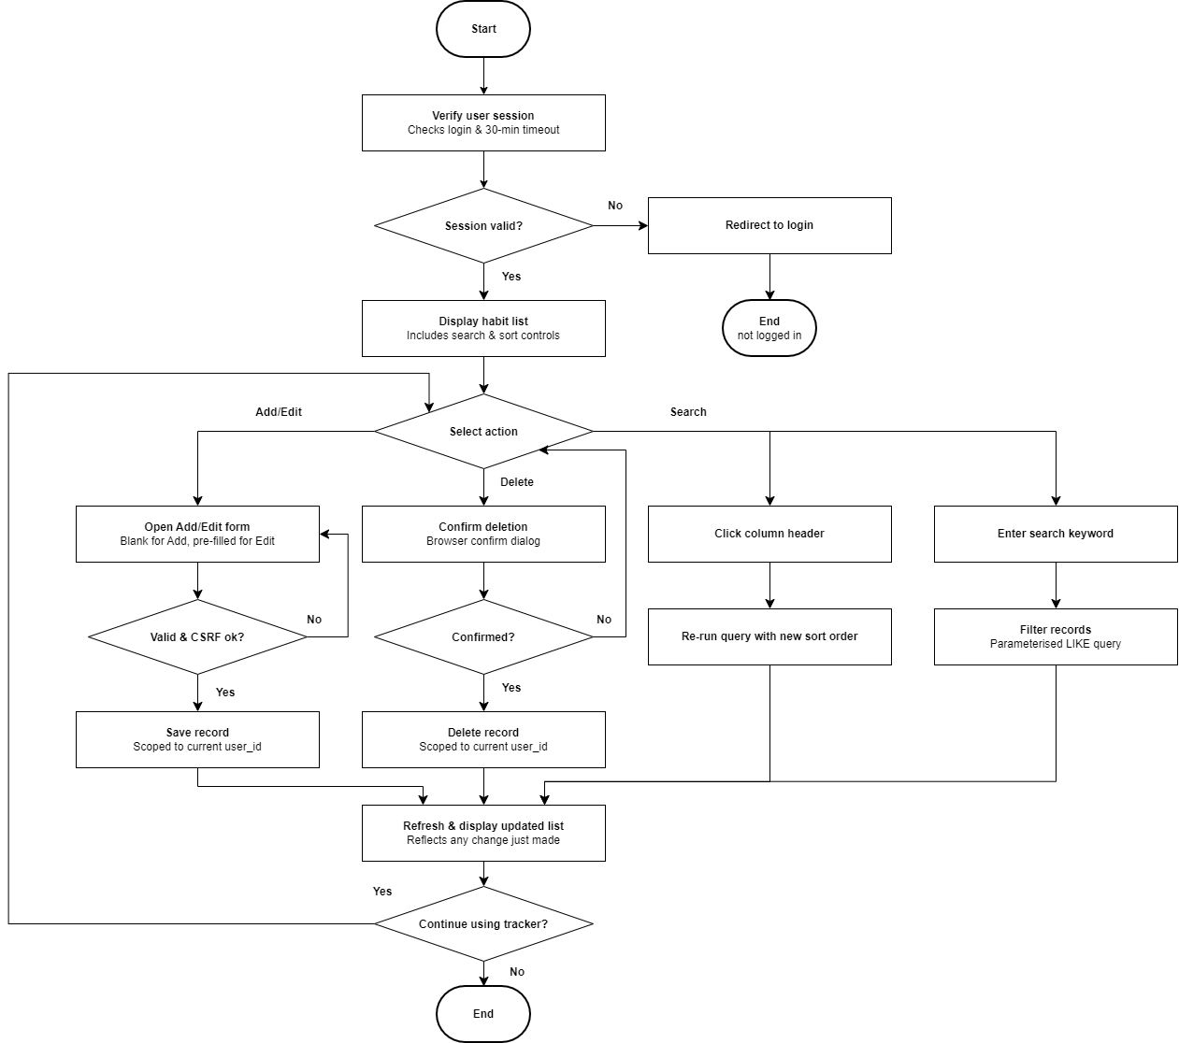

The flowchart above shows the flow within the Habit Tracker module, starting from the system-wide session check and branching separately for each of the four actions the module supports.
Entry and session check. When the user navigates to the Habit Tracker tab, the system first verifies the session (checking that the user is logged in and has not been idle beyond the 30-minute timeout enforced by auth.php). If the session is invalid, the user is redirected to Login and the flow ends there. If valid, the system displays the user's habit list along with the search and sort controls, and the user is presented with a choice of action: Add/Edit, Delete, or Search.
Add/Edit branch. Choosing to add or edit a habit opens a form, either blank (Add) or pre-filled with the record's current values (Edit).

On submission, the system checks that the fields are valid (required fields present, date well-formed, status one of the two allowed values) and that the CSRF token matches the session. If this check fails, the user is returned to the same form with an error shown. If it passes, the system saves the record, always scoped to the current user's user_id so a user can only ever affect their own data.

The user may select a sort option such as habit name, target frequency, completion status, or date. The system validates the selected sort column against a predefined allow-list before re-running the query and displaying the habits in the requested order. This allows users to organize habit records according to their preference while preventing invalid or malicious input.

Delete branch. Choosing to delete a habit triggers a browser confirm dialog. If the user cancels, the flow loops back to "Select action?" so they can choose a different action or choose Delete again if they change their mind; no request is sent to the server. If the user confirms, the system verifies the CSRF token and deletes the record, again scoped to user_id. Search branch. Choosing to search does not require a confirmation step; the user's keyword is applied directly as a parameterised LIKE filter against habit name, target frequency, and notes, and the query re-runs scoped to the current user, convergence and end.

All three branches feed back into the same step: the page reloads with the updated, current-user-scoped list, reflecting whatever change (or search filter) was just applied. The system then asks whether the user wants to continue using the tracker. If yes, the flow loops back to "Select action?" so another operation can be performed; if no, the flow ends. The purpose of branching by action rather than using one generic "process request" step is to make clear that each action has a distinct point where it can fail safely: Add/Edit can be rejected and retried without losing the user's other data, Delete can be cancelled with zero side effects, and Search has no failure state at all since an empty result is still a valid outcome. In every branch, the system never trusts a submission blindly, and every write to the database is scoped to the record owner.

System Flowcharts Conclusion:
Overall, the Student Routine Organizer integrates the Exercise Tracker, Habit Tracker, Diary Journal and Money Tracker modules into a single platform that helps students manage different aspects of their daily lives. Each module follows a structured workflow that allows users to securely create, view, update, delete, search, and organize their personal records while ensuring that only authorized users can access their own information. The Exercise Tracker supports fitness monitoring and goal tracking, the Habit Tracker tracks daily routines, the Diary Journal provides a space for recording personal experiences and reflections, the Money Tracker helps users manage their finances and savings goals. Together, these modules work seamlessly to provide a centralized and organized system that promotes productivity, organization and better control with overview to their daily life.

Overview of Database Structure (For Overall System):

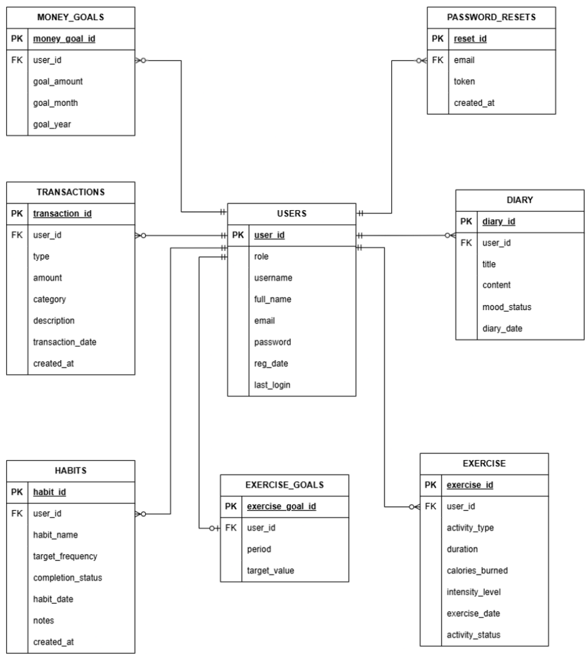

The Student Routine Organizer uses a database which consisting of eight tables. The user table acts as main table, while the remaining tables support different modules such as Exercise Tracker, Habit Tracker, Money Tracker and Diary Journal. This applied in PHP with each module retrieves, inserts, updates and deletes data from its respective table using the user id as the foreign key, which ensuring that users can only access their own records.

1. User Table
The table stores the account information of every registered user which including the username, full name, email, password, role, registration date and last login. The user id is the primary key and is referenced by all other tables. In the system, during user registration and login, this table used where session authentication identifies the current user before allowing access to any module.

2. Transactions Table
This table stores all income and expense records for the Money Tracker Module. Each transaction includes the transaction type, amount, category, description, transaction date and creation date. The relationship between USERS and TRANSACTIONS is (1:M) because a user can record multiple financial transactions over time. In the system, the table supports the CRUD functions. Users can add new transactions, edit existing records, delete unwanted records and retrieve transactions history.

3. Money_Goals Table
This table stores user's monthly savings targets, goal amount, goal month and goal year. One user may create multiple savings goals for different months, resulting to a (1:M) relationship with the User table. In the system, this table been used to set and display monthly savings goals.

4. Diary Table
This table stores personal journal entries written by users. Each record contains the journal title, content, mood status and diary date. The relationship between USERS and DIARY is (1:M) because a user can write multiple diary entries over time. In the system, this table will enable users to create, edit, delete, and view their journal entries.

5. Habit Table
This table manages use's habit information by getting details of habit name, target frequency, completion status, habit date, notes and creation date. It also follows a one-to-many (1:M) relationship with the USERS table. In the system, the CRUD applies in this module. The habit records are displayed on the user's personal dashboard for progress monitoring.

6. Exercise Table
This table will store workout activities the user does. Each record includes the activity type, duration, calories burned, intensity level, exercise date, and activity status. One user can record many exercise activities, forming a (1:M) relationship with the USERS table. In the application, CRUD implemented to let the user to manage the data and able to monitor their exercise activities

7. Exercise_Goals Table
This table stores fitness target based on a selected period, such as weekly or monthly exercise goals. Each goal belongs to a user through the user_id foreign key. The relationship between USERS and EXERCISE_GOALS is (1:1) because a user may create one goal only and update the exercise goal if needed. The system allows users to create and manage exercise goals, while the application compares completed exercise records with the target value and stored in the table

8. Password_Resets Table
The PASSWORD_RESETS table stores password recovery requests, including the user's email, reset token, and request creation time. The relationship between USERS and PASSWORD_RESETS is (1:M). The table stores password recovery requests associated with registered users through the email field. In the application, this table supports the Forgot Password feature. When a user requests a password reset, the system generates a unique token, stores it in this table, and verifies the token before allowing the user to create a new password. Each time a token is generated the previous reset token for that email will be deleted to prevent the previous link to be reused.

In conclusion, the User table acts as the parent entity for all modules in the Student Routine Organizer. The integration between PHP as the application logic and the database enables secure data management, maintains data consistency and referential integrity, and ensures that each user's information is properly associated with their respective records. This integration also supports the CRUD operations and allows the different modules to work together effectively, providing users with a complete and organized system for managing their daily activities, habits, exercises, diary entries, and transactions.

Functional Requirements (For Individual Module):
Exercise Tracker Module Functional Requirements:
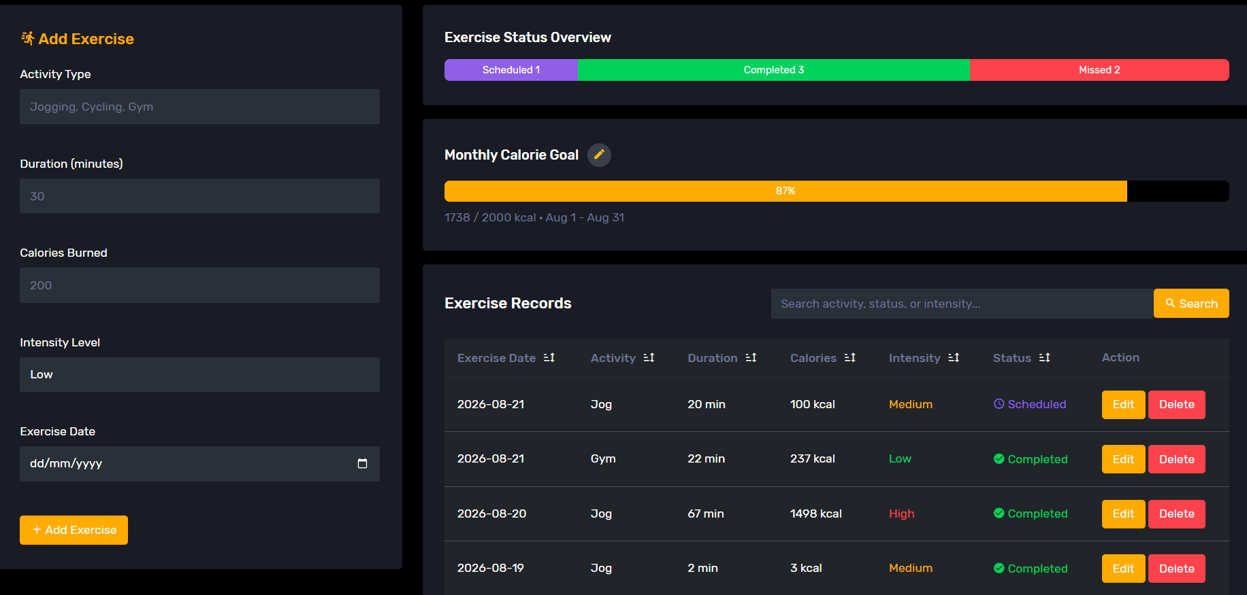

This module allows users to manage their exercise activities by scheduling and monitoring their workouts. Users can add, update, delete, search, sort and view exercise records, track the status of each activity and set calorie burning goals. The module also provides progress tracking and status overviews to help users monitor their exercise performance and maintain their fitness routine.

Feature 1: Add Exercise Record
The user fills in the Add Exercise form with attributes like activity type, duration in minutes, calories burned, intensity level which has (Low/Medium/High) as the option and the exercise date attribute that can be manually typed or can be filled through the calendar. The user can then click the Add Exercise button and the system will process to see if the input is valid. If it is valid then the system will insert a new record with status set to “Scheduled” and a success message is shown. Else, the system will show error message for the invalid integer inputs in the form as the duration and calories burned must be greater than 0 and all fields are required to be filled. This is a core feature for of this module for users to maintain a complete record of their exercise activities for tracking and monitoring purposes by scheduling in this module.

Feature 2: Edit Exercise Record
The user clicks the Edit button on a record, the add exercise form then changes to edit exercise that shows the selected record’s values on the form and then the user is allowed to modify it. The user can then click Update Exercise button to save the changes to the record selected or Cancel button to return to add exercise form. The same validation from Add Exercise Record is applied here with the same attributes involved with the addition of activity status that has the value of (Scheduled/Completed/Missed). If valid input, then it will save and show success message and if not, it will ask the user to input values greater than 0. This ensures exercise records remain accurate and up to date whenever corrections are needed.

Feature 3: View Exercise Records
The records load automatically upon entering the exercise tracker module page. The system retrieves all records belonging to the current authenticated logged in user and the exercise records are sorted by the most recent exercise date by default. The exercise attributes displayed in the table are the exercise date, activity, duration, calories, intensity and status.
This allows users to review and monitor their exercise records conveniently in one place.

Feature 4: Delete Exercise Record
The user clicks the Delete button and a confirm message will appear. The user can cancel or confirm to delete the record. If confirmed, then the record will be removed from the database accordingly by finding the correct exercise id. The table updates accordingly for the user to see and a success message is also shown. This helps users remove incorrect or unnecessary exercise records from the system.

Feature 5: Calorie Goal with Progress Tracking
The user clicks the pencil icon to set or update a calorie goal by selecting either a weekly or monthly period and entering a target calorie value. The user then clicks the Save Goal button or Cancel button. The system validates that the target value is greater than 0 before processing the request. If a goal record does not exist for the user, the system creates a new goal. Otherwise, the existing goal is updated. The attributes involved include period and target value. Once a goal has been set, the system automatically calculates the user's progress based on completed exercise records within the selected goal period. The calculation includes attributes such as calories burned, exercise date, activity status, goal period and target value. The system displays the progress using a percentage and progress bar, with progress capped at 100% even when the target is exceeded. The progress is also automatically reset at the start of each new week or month depending on the selected period. This feature helps users set exercise targets, monitor their achievements and stay motivated to maintain a consistent fitness routine.

Feature 6: Automatic Status Update
Each time the page loads, the system checks all “Scheduled” exercises against the current date and any exercise with an exercise date that is lesser than the current date is automatically updated to "Missed". Attributes involved are exercise date and activity status. So, the user will always see an accurate status without manually updating exercises as missed. This ensures exercise statuses remain accurate without requiring manual updates from the user.

Feature 7: Exercise Status Overview
The system also automatically counts the number of exercises marked as “Scheduled”, “Completed” and “Missed” based on the current user's records. The tally will be displayed using a progress bar to give a quick summary. This helps users obtain a quick summary of their overall exercise performance.

Feature 8: Search Exercise Records
The user enters a keyword into the search box and clicks the Search button. The system searches the user's exercise records and returns any matching records based on the activity type, activity status, or intensity level. If matching records are found, the system displays the filtered results in the exercise records table. Otherwise, a message is displayed to inform the user that no matching records were found. The user is also able to reset the search filter by clicking on the clear button. This feature overall helps users locate specific exercise records more quickly without having to manually browse through all saved records.

Feature 9: Sort Exercise Records
The user can click the sort icon beside a column heading in the exercise records table to sort by ascending or descending. The system then sorts the records according to the selected attribute, including exercise date, activity type, duration, calories burned, intensity level or activity status. Additionally, the sort feature can also be used after filtering through search. Overall, this feature helps users organize exercise records according to their preferences and makes it easier to analyse and compare exercise information.

Diary Journal Module Functional Requirements:
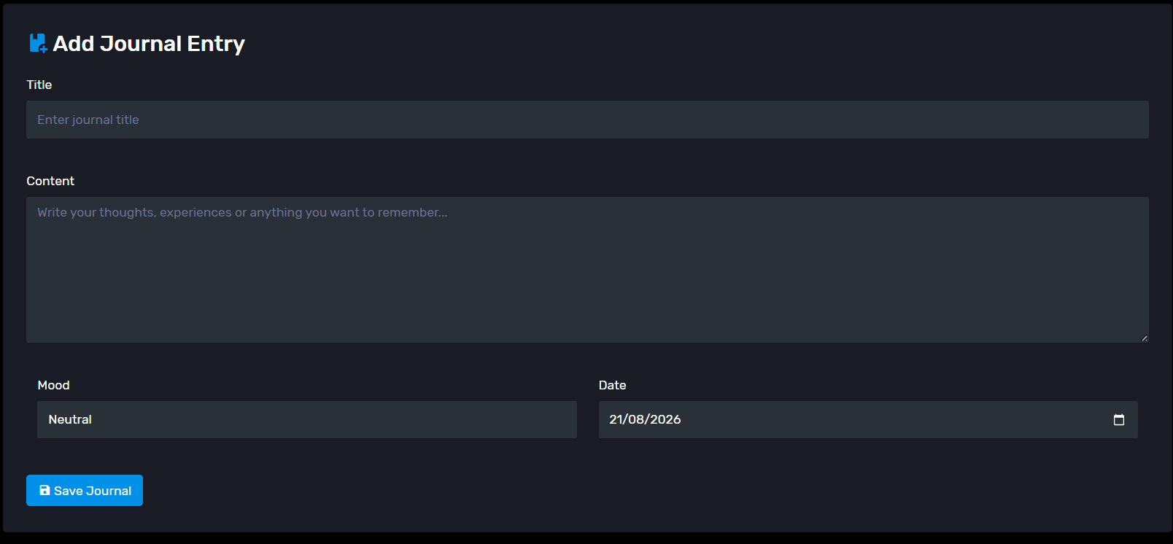
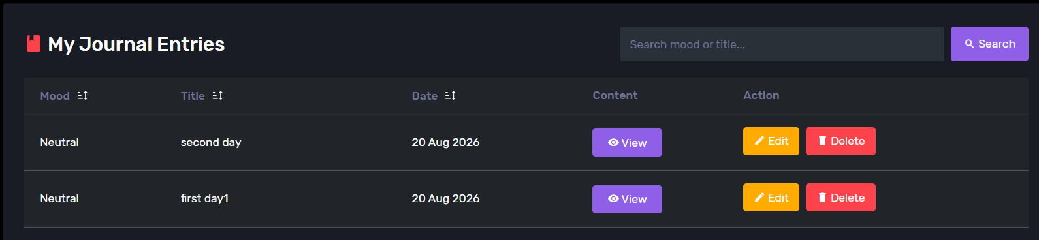

This module enables management of personal journal entries with add, view, edit, delete, search and sort functionalities for journal records. To add a journal entry, users fill in the title, journal content, mood and journal date to submit. Users can manage their journal records and the search and sort functionality makes entry management more efficient. This module supports the management of personal journals by providing users with the ability to record, retain and review personally journal entries in an organized manner.

Feature 1: Add Journal Entry
The user can fill an Add Journal Entry form title, content, mood, and journal date. The mood can be selected from Happy, Good, Neutral, Sad and Angry. After journal entry submission, the system validates the fields to see if all fields are not left empty, record the journal entry and redirect to the Diary Module, otherwise, an error message is displayed to the user and journal entry submission is blocked. This feature supports the main function of the Diary Module by providing a means for users to create and store their journal entries.

Feature 2: View Journal Entries
The user can view their journal entries from the My Journal Entries pane with the system automatically fetching the relevant journal records. Each entry’s mood, title, journal date, content and associated actions View, Edit, and Delete will be rendered in this pane. To view the content of a particular journal entry, simply click the View button which will open the journal content in a pop-up model for that entry. The system retrieves journal records related to the currently authenticated user’s ID. This feature supports users in reviewing their saved journal entries and fulfils the system’s requirement to maintain a personal journal.

Feature 3: Edit Journal Entry
The user clicks the Edit button on an existing journal record, and the system retrieves the selected entry and displays its current title, content, mood and date in the edit form. The user can modify the information and click the Update Journal button to save the changes or click Cancel to return to the normal Add Journal Entry form. The system verifies that a valid journal entry has been selected and that the title, content and journal date have not been left empty. If the input satisfies the validation rules, the system is then able to perform an update on the selected journal entry in the database and return the user to the Diary Module. The update also includes a check on the authenticated user ID to confirm that the journal record selected is owned by the current user. This feature gives users the ability to edit their journal entries to maintain accurate and up to date records of their journal entries.

Feature 4: Delete Journal Entry
The user clicks on the Delete button adjacent to the journal entry they wish to remove. The system displays a confirmation message to tell user that the journal entry intent to be deleted will be removed permanently. The system asks the user to confirm the deletion. If the user confirms, the system identifies the selected journal record using its journal ID and deletes the record from the database. After the successful deletion of the record, the user is directed back to the Diary Module in which the deleted journal entry is hidden. If the user cancels the confirmation, the record remains unchanged. This feature allows users to remove unwanted or unnecessary journal entries and maintain relevant journal records.

Feature 5: Search Journal Entries
The user enters a search term into search box labelled "Search mood or title..." field and click Search. The system processes the user's journal records, searches the journal title and mood status and returns only the journal entries that match the search term, if any. Otherwise, a message is displayed to the user stating that no matching journal entries exist. A user can click Clear to remove the search filter and retrieve all journal records. This feature allows users to quickly find specific journal entries without having to browse each of their records.

Feature 6: Sort Journal Entries
The user can click the sort of icon in the heading of a given column to shift journal entries by the mood status, title or date of the journal entry. The system sorts the records according to the selected attribute in either ascending or descending order. When sorting is performed while a search keyword is active, the search keyword is retained so that the filtered results remain available. This feature allows users to adjust the order of journal entries and access journal records that are most important to the users quickly.

Money Tracker Module Functional Requirements:
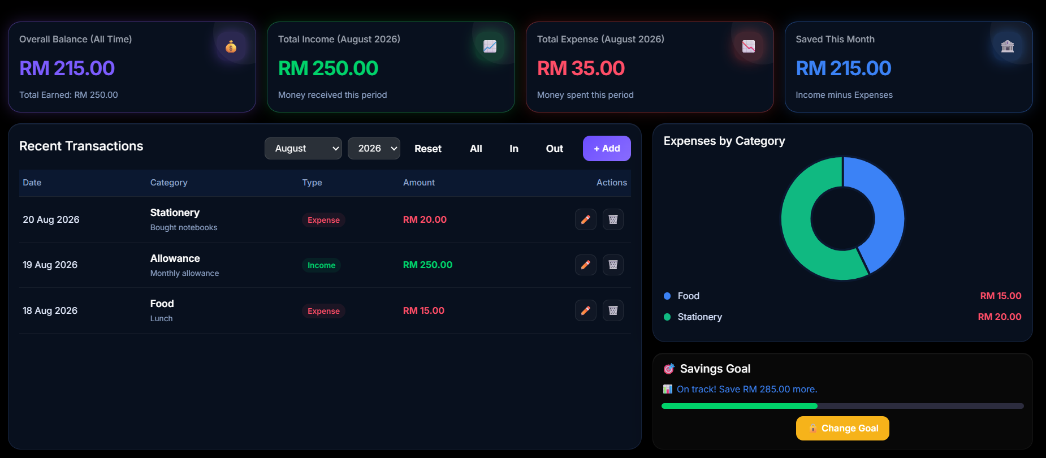

This module allows users to manage their personal finances by recording and monitoring their income and expense transactions. Users can add, update, delete, filter, and view transaction records, categorize their financial activities, and analyse their spending through visual reports. The module also enables users to set monthly savings goals, track their savings progress, and view financial summaries to help them manage their budget and develop better financial habits.

Feature 1: Add Transaction
The user can fill an Add Transaction form by selecting the transaction type (Income or Expense), entering the amount, category, description, and transaction date. After submission, the system validates the required fields, stores the transaction in the database, and redirects the user to the Money Tracker dashboard. If any required field is empty, the transaction is not recorded. The attributes involved include transaction type, amount, category, description, and transaction date. This feature allows users to record their daily financial activities.

Feature 2: Edit Transaction
The user can update an existing transaction by clicking the Edit button in the transaction table. The system displays the current transaction details in a modal form, allowing the user to modify the type, amount, category, description, and date. After saving, the updated information is stored in the database and reflected on the dashboard. The attributes involved include transaction type, amount, category, description, and transaction date. This feature enables users to correct or update their financial records.

Feature 3: Delete Transaction
The user can remove a transaction by selecting the Delete button. Before deletion, the system displays a confirmation dialog to prevent accidental removal. Once confirmed, the selected transaction is identified through its transaction id and is permanently deleted from the database and the dashboard is refreshed. This feature helps users maintain accurate financial records.

Feature 4: Filter Transactions
The user can filter transactions by month, year, income, expense, or all records. The system retrieves only the transactions that match the selected filter and updates the financial summary accordingly. Users may also reset the filter to display all available records. The attributes involved include month, year, transaction type, income records, and expense records. This feature makes it easier to review financial data for a specific period.

Feature 5: Financial Dashboard Summary
The system automatically calculates and displays four financial summaries: Overall Balance, Total Income, Total Expense, and Saved This Month. These values are updated whenever transactions are added, edited, deleted, or filtered by date. The attributes involved include transaction type, amount, transaction date, total income, total expense, overall balance, and monthly savings. This feature provides users with a quick overview of their financial performance.

Feature 6: Expense Analysis Chart
The system generates a doughnut chart that visualizes expenses based on transaction categories such as Food, Transport, Rent, and Entertainment. The chart updates automatically according to the selected month and year, allowing users to identify their major spending categories. The attributes involved include transaction category, amount, transaction type, month, and year. This feature improves financial analysis through visual reporting.

Feature 7: Monthly Savings Goal
The user can set a monthly savings goal by entering a target amount for a selected month and year. The system stores the goal, compares it with the user's monthly savings, and displays a progress bar together with achievement status messages such as Goal Achieved, On Track, or Missed Goal. The attributes involved include goal amount, month, year, monthly savings, progress percentage, and achievement status. This feature encourages users to monitor and achieve their savings objectives.

Feature 8: Secure Goal Update
The user can modify an existing savings goal only after entering their account password. The system verifies the password before allowing the goal amount to be updated. If the password is incorrect, the goal remains unchanged and an error message is displayed. The attributes involved include password, goal amount, goal month, and goal year. This feature enhances security by preventing unauthorized changes to financial goals.

Feature 9: View Complete Transaction History
The dashboard displays the five most recent transactions by default. If additional records exist, the user can select View All to open a scrollable modal containing the complete transaction history for the selected period. The attributes involved include transaction date, transaction type, amount, category, and description. This feature allows users to access both recent and historical financial records conveniently.

Habit Tracker Module Functional Requirements:
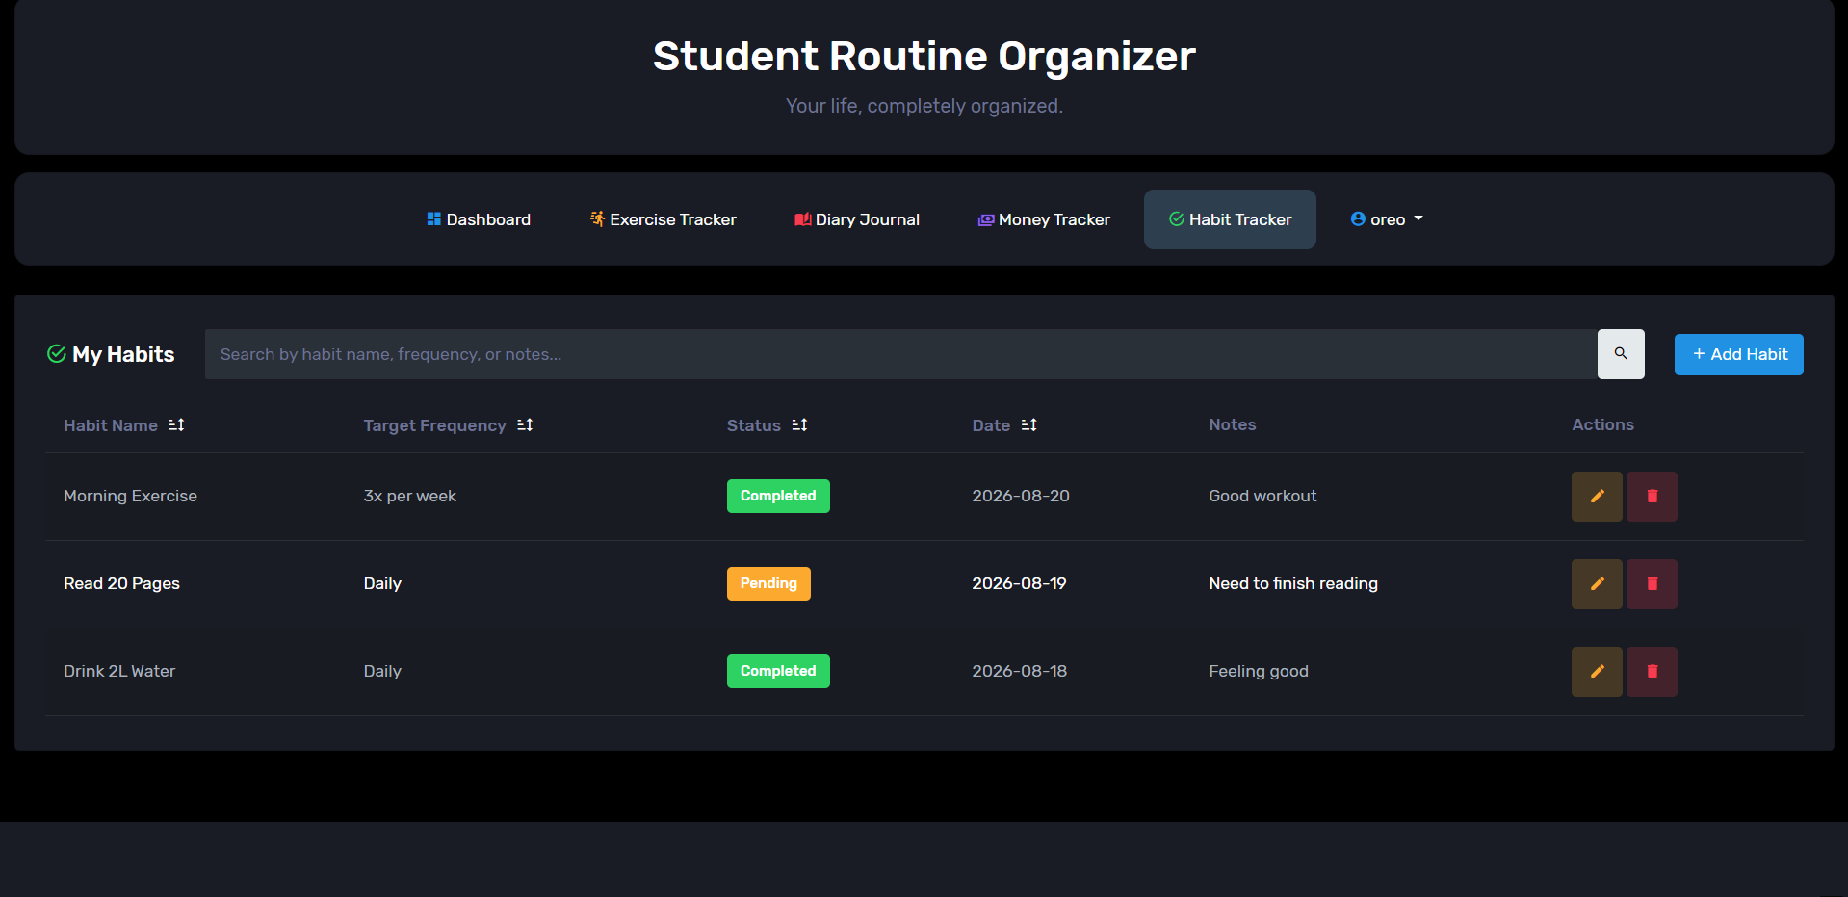

The habit tracker allows a logged-in student to create and monitor personal habits, recording what the habit is, how often it should be done with notes if needed, whether it has been completed, and when, so they can track progress on positive daily routines over time. All records are private to the user who created them.

Feature 1: View habit records
The user navigates to the Habit Tracker tab, and the system retrieves all habit records belonging to the logged-in user and displays them in a table, most recent date first by default. The fields involved are habit name, target frequency, completion status, date, and notes. No validation is required from the user for this action. The system restricts the query to the current session's user_id so only that user's records can ever be returned. As a result, the user sees a complete, up-to-date list of their own habits, or a message indicating they have none yet.

Feature 2: Sort habit records
The user clicks a column header (Habit Name, Target Frequency, Status, or Date), and the system re-runs the query with ORDER BY set to the chosen column, toggling between ascending and descending on repeated clicks. This feature uses the same fields as Feature 1. The requested sort column is checked against a fixed allow list before being used in the query, preventing malicious input from being injected via the URL. The table then displays again but in the newly selected order without losing an active search term.

Feature 3: Search habit records
The user types a keyword into the search box between the module title and the Add button and submits it, and the system filters the current user's records to those whose habit name, target frequency, or notes contain the keyword. The fields involved are habit name, target frequency, and notes. The keyword is matched using a parameterised query (LIKE with bound parameters) to prevent SQL injection, and an empty search simply returns the full list. Only matching records are then shown, with a clear option to reset the search and a distinct message if nothing matches.
Feature 4: Add a new habit record
The user clicks Add Habit, which opens a modal form, fills in the required fields, and submits, and the system validates the submission before inserting a new row into the habits table linked to the current user's user_id. The fields involved are habit name (required), target frequency (required), completion status (Pending/Completed, defaults to Pending), date (required), and notes (optional). Validation requires that habit name and target frequency are not empty, that habit name does not exceed 100 characters, that the date is a valid Y-m-d value, that the status is one of the two allowed options, and that a CSRF token matches the session. On success, the new habit appears in the list immediately with a confirmation message; on failure, the form displays again with the specific validation error shown.

Feature 5: Edit an existing habit record
The user clicks the edit icon on a row, which opens a modal pre-filled with that habit's current data, user makes changes and submits. The system validates the submission before updating the matching row, but only if it belongs to the current user. The fields involved are the same as Feature 4, with the addition of the record's ID. The same field-level validation rules from Feature 4 apply here. Additionally, the update query includes WHERE habit_id = ? AND user_id = ?, so a user cannot edit another user's record even if they manipulate the request. The record then updates in place and the list reflects the new values with a confirmation message.

Feature 6: Delete a habit record
The user clicks the delete icon on a row and confirms the browser prompt, and the system verifies the CSRF token before deleting the matching row, again scoped to the current user's user_id. The only field involved is the record's ID. The CSRF token must match, and the delete query is scoped to the owning user, so a forged request for another user's record ID affects nothing. The record then disappears from the list immediately, with a confirmation message, and the action cannot be undone.

Functional Requirements Conclusion:
Overall, the functional requirements of the Student Routine Organizer ensure that each module provides the necessary features to support its intended purpose. Through functions such as adding, editing, viewing and deleting record but also searching, sorting, tracking and reporting features. Through these features, users are able to effectively manage their exercise activities, journal entries, financial information, and personal habits within a single integrated system.

Reference:
[1] “Corona Admin Free | Dark Free Admin Dashboard Template,” BootstrapDash, May 11, 2020. https://www.bootstrapdash.com/product/corona-free (last accessed Aug. 23, 2026).

