Report - Fixing sitemap.xml - page is not in this property - 08/11/2021

Accountable: Fernando

**Contextualization**

We have a Sitemap.xml file that maps all pages from our website. The structure of this file goes like this:

**<?xml version="1.0" encoding="UTF-8"?>**

**<urlset xmlns="http://www.sitemaps.org/schemas/sitemap/0.9" xmlns:content="http://www.google.com/schemas/sitemap-content/1.0">**

**<url>**

**<loc>http://tecnologiaeinformacao.netlify.com/java/java-ide-ptbr.html</loc>**

**<PageMap xmlns="http://www.google.com/schemas/sitemap-pagemap/1.0">**

**<DataObject type="thumbnail">**

**<Attribute name="url">http://tecnologiaeinformacao.netlify.com/assets/imgs/java-ide-ptbr.png</Attribute>**

**<Attribute name="width">471</Attribute>**

**<Attribute name="height">328</Attribute>**

**</DataObject>**

**</PageMap>**

**</url>**

**</urlset>**

**Problem**

Trying to inspect any URL from the website the following error pop-up.

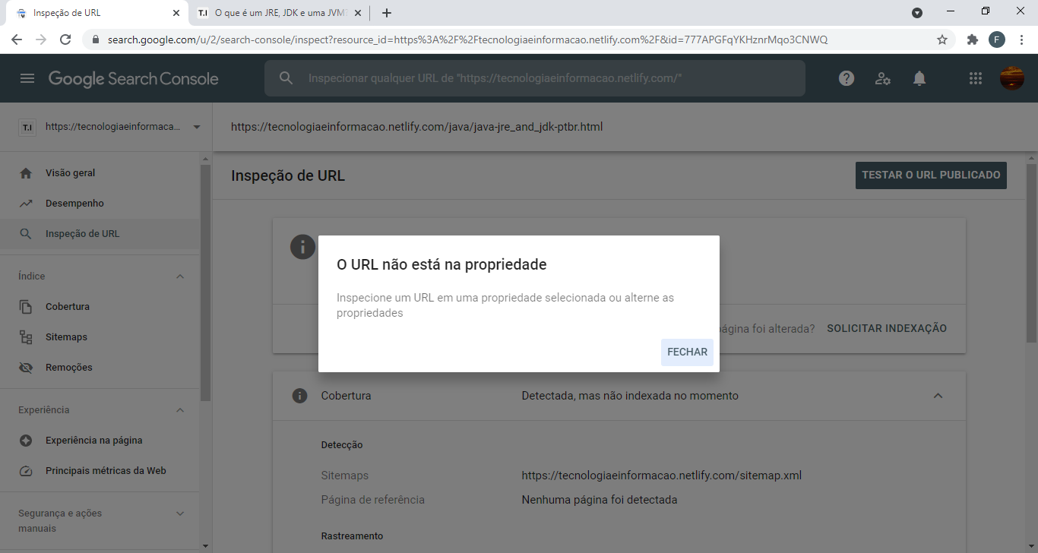

Since sometime ago, the URL for any Netlify website uses .app instead of .com. As the version with .com has been used in the sitemap, Google search console is not being able to find the actual links.

**Solution**

Changing the URL property from _config.xml file. Jekyll could then recreate the sitemap.xml file appropriately.