CS3733-D26 Prof. Wong
Team Quasar Quinotaurs
Iteration 1
Team Coach: Keira Schoolcraft

Name | Role | GitHub Username
Norah Anderson | Full-time SWE (Frontend) | nj-anderson
Theron Boozer | Scrum Master | TheronBoozer
Daniel Gomes | Assistant Lead (Backend) | GoldenEagle765
Ben Reinherz | Assistant Lead (Frontend) | ben-turtles
Rashi Roselin | Documentation Analyst | RashiRoselin-cs2
Benjamin Santana | Lead SWE | Ben-Santana
Abyshek Sukumar | Product Owner | abyshek1605-cmd
Ali Tariq | Full-time SWE (Backend) | alitariq1
Kylie Welcher | Project Manager | KylieWelcher

Github Repo: https://github.com/QuasarQuinotaur
Deployment Link: https://teamq-prototype.onrender.com/

Log in information:
Admin
- admin@quinotaur.com
- admin1-A
Employee 1 (Business Analyst)
- emp1@quinotaur.com
- employee1-A
Employee 2 (Underwriter)
- emp2@quinotaur.com
- employee2-A

2 - Table of Contents

2 - Table of Contents 1
3 - Introduction 2
4 - Software Development Environment 3
5 - Functional Requirements Gathering 4
5.1 Brainstorming Results 5
5.2 Survey Questions 5
5.3 Formal Interview Protocol 5
6 - Functional Model 5
6.1 Epics 6
6.2 Sized User Stories 6
6.3 Use Case Diagram 6
6.4 (Optional) Scenarios 6
7 - Design Models 6
7.1 Style Guide 7
7.2 Component Design 7
7.3 Class Diagram 7
7.4 ERD 7
8 - Project Management 7
8.1 Changes in Team Positions 8
8.2 Assistance Given to / Received from Other Teams 8
8.3 Results of Project 2 Retrospective Meeting 8
8.4 Team Events for Team Bonding 8
8.5 Team Member Contributions 8

3 – Introduction
We are developing an application that will allow insurance employees at Hanover Insurance to create, manage, and upload important documents to aid in the speed and functionality of their process. In the app, employees can only access documents that they are authorized to access. All employees can add documents and modify/delete documents they have access to too. Admins can access all documents and add/delete/modify employees. The app requires login through Auth0.

4 - Software Development Environment
- React Router [ 7.13.2 ]
- Shadcn [ 4.1.2 ]
- Discord [ NA ]
- Express [ 5.2.1 ]
- Supabase [ NA ]
- Jira [ 10.3.0 ]
- React Confetti [ 6.4.0 ]
- Draw.io
- WebStorm [ 2025.3.3 ]

5 - Functional Requirements Gathering

5.1 Brainstorming Results
Most of our brainstorming was coming up with what we wanted our app to look like. While we came up with a lot of fun themes (list of themes we came up with) and plan to implement them as a bonus theme option, we agreed a simple, calm theme would be the best default coloring. Thus, we came up with the style sheet in 7.1. We also reviewed general page layout and other components/features (example: cards). We also discussed how the tables would be set up.

5.2 Survey Questions
Survey Link (Microsoft Form: Hanover Insurance Group Content Management System (CMS) Preliminary Survey – Fill out form

5.3 Formal Interview Protocol
Interview Questions:
- Consent:
  - We are students from Worcester Polytechnic Institute (WPI) working with Professor Wilson Wong in his CS 3733 Software Engineering course to create a Content Management System (CMS) tool/website for Hanover Insurance. This tool will be accessible to Hanover Insurance Group to help organize documents and other files for the company. The tool will store sensitive information because it stores files, but it will not read or store specific data.
  - Results from this interview will inform the selection of our included features and the general structure of the tool/website. The interview will include questions about your opinion on comfort/ability to use certain features. It will also ask for your feedback and any additional suggestions.
  - Please confirm your verbal consent (or signature)

- Demographic:
  - What is your name?
  - Do you currently work at Hanover Insurance Group?
  - What is your title?
  - What office do you currently work at?
  - What is your department?
  - What would you say your proficiency level with technology is?
  - Do you know what a content management system is?
  - What would you say your proficiency level with CMS is?
  - How often do you manage or access digital content?

- Current Experience:
  - How do you currently manage or access important documents/links?
  - Do you currently have any major frustrations with the content management at Hanover?
    - What are the biggest frustrations?
      - Examples if needed: Difficultly finding items, ownership/access issues, version control
  - How often do you encounter outdated or incorrect content?
  - How do you currently verify that a document is updated or the correct document?
    - Examples if needed: timestamps, trust the system
- New Features:
  - Can you think of any features that you would want to include in a new CMS?
    - Examples if needed: centralized content repo, version tracking, tagging (automatic), searching, etc.
  - How much customization would you want to use?
  - How much training would you want/expect to use the new CMS?
  - What would make you adopt a new CMS system over your current solution?
  - What concerns would you have about using a CMS like this?
  - Any additional features or suggestions you would like to see?
Interviewees:
- Minimum 1 Underwriter
- Minimum 1 Business Analyst
- At least 5 employees from every department
- Allen Kwasniewski
- At least 1 employee from every office location
Plan Contacts:
- Professor Wong and any contacts he provides
- Allen Kwasniewski (WPI Alumni that works at Hanover)
Conduct Interviews:
- Not a part of this project.

6 - Functional Model

6.1 Epics & 6.2 Sized User Stories
Epics / User Stories for Sprint: | Points | Done?
Epic: Control access to documents: Ensure users can only access and edit documents relevant to their role, stored securely in the cloud.
- As an Insurance Agent, I only want permission to access/edit the documents pertaining to my role so that I don't accidentally edit someone else's document. | 8 | Y
- As an Insurance Agent, I want my documents to be stored in secure, scalable cloud storage so that only I or anyone else with permission can access them when we need to. | 8 | Y
- As an Insurance Agent, I want to be able to view documents online so that I don't have to download them if I only want to preview them. | 5 | Y
Epic: User Experience: Provide a clean, navigable interface with a welcoming home page and role-based personalized views.
- As an Insurance Agent, I want to navigate between pages using a menu so that I can move through the application easily. | 8 | Y
- As an Insurance Agent, I want to see a home page with a hero section so that I have a clear and welcoming entry point to the application. | 3 | Y
- As an admin, I want to view every document and control which job roles can see which documents so that the other agents have controlled access to documents. | 13 | Y
- As a Admin, I want to have the only access to employee page be able to edit employee to prevent random sign-ins and people leaving the company | 13 | Y
Epic: Organized Data: Data that is well organized to allow easy adding, submitting, fetching, and editing of individual data points and tables.
- As an Insurance Agent, I want to add, update, and remove documents I own so that I can manage my content. | 13 | Y
- As an Insurance Agent, I want to check-in/check-out of documents to prevent concurrent edits. | 21 | N
- As an Insurance Agent, I want automated review reminders for expired documents so that documents are kept up to date. | 3 | N
- As an Insurance Agent, I want to track metadata including create/update/review dates, review cycle, next review date, document status, and content owner so that I am well informed about the details of documents. | 8 | Y
- As an Insurance Agent, I want my reference and workflow content separated for better organization and ease of use. | 3 | Y
Total User Points Completed | 106

6.3 Use Case Diagram
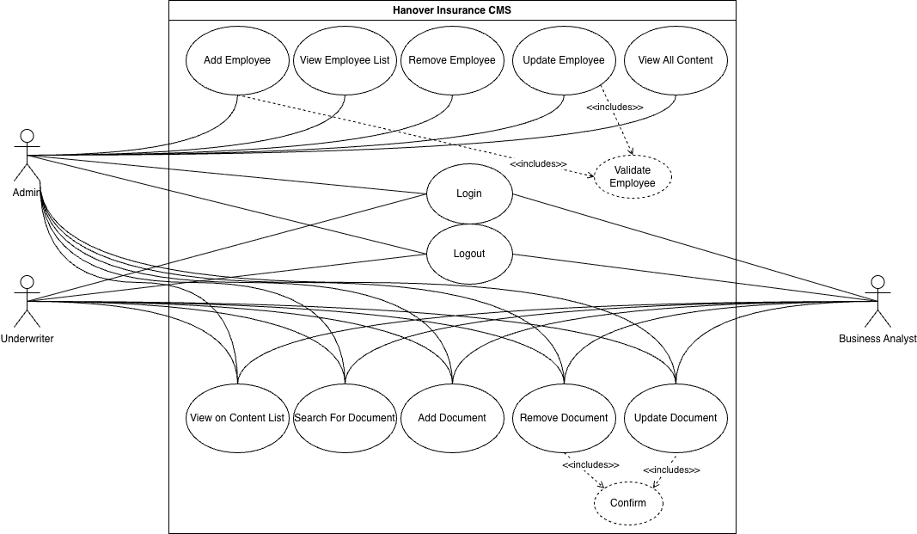

7 - Design Models

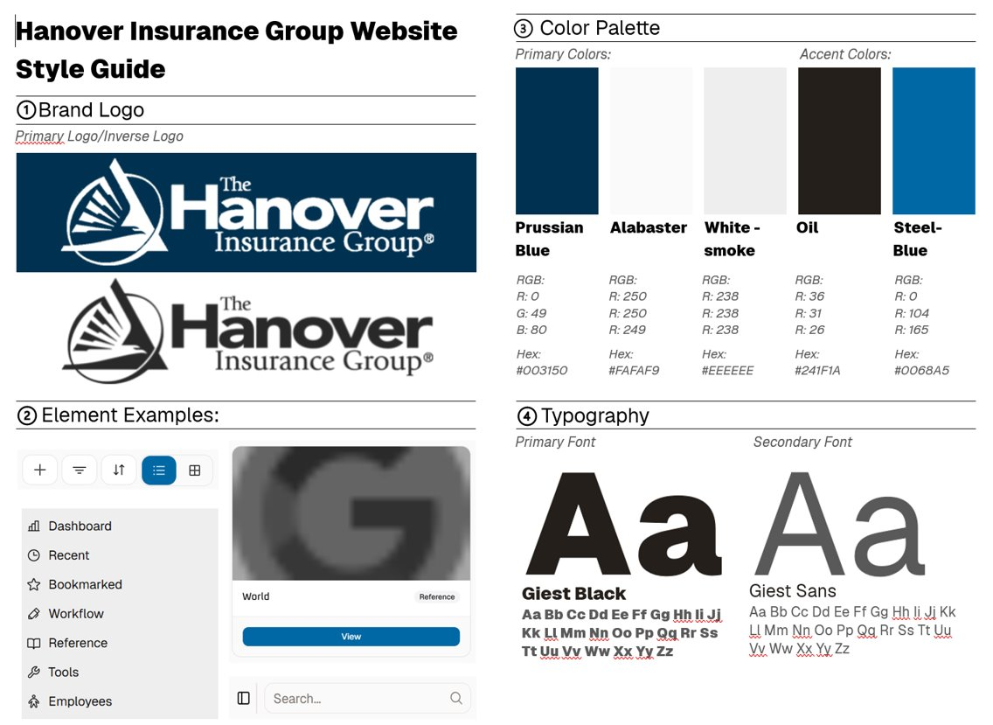
7.1 Style Guide

7.2 Component Design (Examples can be seen in Style Guide)
Components: | Elements: | Navigation Design
- Card | - Button | - Sidebar at side for page
- Calendar | - Tags | navigation
- Navbar | - Text Area | - tool bar includes
- Sidebar | - Input (text field) | buttons to add in search,
- Toolbar | - Label | filtering, and modifying/
- Pagination | - Drop-down selection | adding/deleting content
- Employee Form |  | Or employees
- Document Form |  | - Cards have tags and labels  - Forms for changing employees or content have dropdowns, text fields, and buttons  - Navbar for employees to access profile and sign-out

7.3 Class Diagram
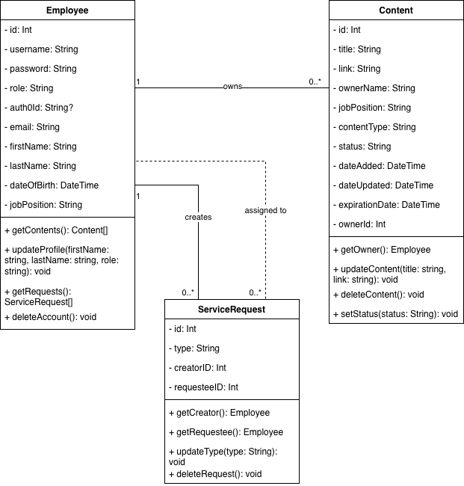

7.4 ERD

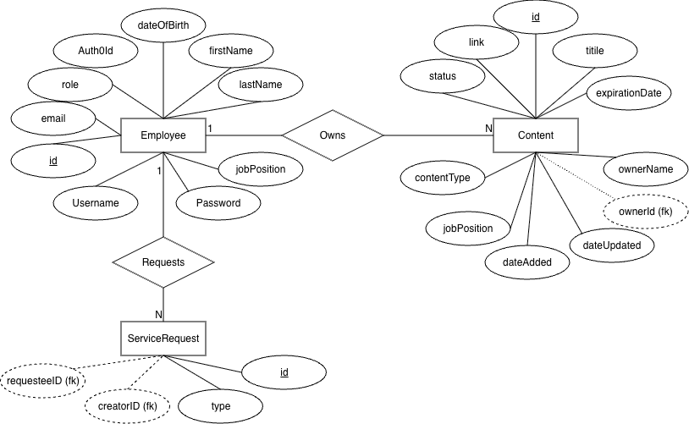

8 - Project Management

8.1 Changes in Team Positions
No changes in team positions since the last sprint.
Name | Role
Norah Anderson | Full-time SWE (Frontend)
Theron Boozer | Scrum Master
Daniel Gomes | Assistant Lead (Backend)
Ben Reinherz | Assistant Lead (Frontend)
Rashi Roselin | Documentation Analyst
Benjamin Santana | Lead SWE
Abyshek Sukumar | Product Owner
Ali Tariq | Full-time SWE (Backend)
Kylie Welcher | Project Manager

8.2 Assistance Given to / Received from Other Teams
Our team did not give or receive assistance from other teams during this sprint.

8.3 Results of Project 2 Retrospective Meeting
Project 2 Good:
Intra-group communication: Both frontend and backend communicated well within their own teams.
Asynchronous work: While we made use of pair-programming, we were able to work well alone.
Friendliness: All of us get along well.
Project 2 Bad:
Time management: Some members had poor time management during project 2.
Inter-group communication: Feature requirements between teams were poorly communicated, leading to confusion.
What went differently in Iteration 1:
Members of the team managed their time more effectively for iteration 1.
We held more active communication between teams.

8.4 Team Events for Team Bonding
Our socialization has diminished some as our work has increased. However, we still socialize during our work time. Sometimes this is just through talking as we code together, and other times we take breaks. On Tuesday night we took a break from coding to have some late-night snacks and talk with one another.

8.5 Team Member Contributions
Last name, First name | Contributions
Anderson, Norah | - Frontend code including employee card UI, list-view/grid-view implementation, and reworking the card implementation with Ben R  - Helped create the document
Boozer, Theron | - Began on Auth0 work  - Helped create the presentation  - Helped create the document
Gomes, Daniel | - Implemented link/file uploading from the form.  - Helped create the presentation  - Helped create the document
Reinherz, Ben | - Implemented reworked content card on frontend  - Implemented update/delete dropdown for content cards  - Refactored frontend components including content/employee pages for more reusability  - Helped connect update content feature to backend
Roselin, Rashi | - Wrote introduction and software environment sections  - Presented intro and class diagram slides
Santana, Benjamin | - Deployment  - Got Auth0 working  - Managing the dev branch (any git issues, bugs, helping people set up backend/frontend)  - Add/delete document function linking frontend/backend  - Add/delete employee function  - Downloading and previewing pdf documents
Sukumar, Abyshek
Tariq, Ali | - ERD  - Class Diagram  - OOD for the database
Welcher, Kylie | - Powerpoint  - Style sheet  - Canva themes  - Vitesting code  - Helped with database issues but had no individual assignment assigned

