CS3733-D26 Prof. Wong
Team Quasar Quinotaurs
Team Coach: Keira Schoolcraft

Name | Role | GitHub Username
Norah Anderson | Full-time SWE (Frontend) | nj-anderson
Theron Boozer | Scrum Master | TheronBoozer
Daniel Gomes | Assistant Lead (Backend) | GoldenEagle765
Ben Reinherz | Assistant Lead (Frontend) | ben-turtles
Rashi Roselin | Documentation Analyst | RashiRoselin-cs2
Benjamin Santana | Lead SWE | Ben-Santana
Abyshek Sukumar | Product Owner | abyshek1605-cmd
Ali Tariq | Full-time SWE (Backend) | alitariq1
Kylie Welcher | Project Manager | KylieWelcher

https://github.com/QuasarQuinotaur

Table of Contents
Table of Contents 2
Tools Used 3
Survey Questions 4
Formal Interview Protocol 4
Brainstorming Session Features 6
Epics/User Stories 7
Additional Features Implemented 9
Use Case Diagram, Activity Diagram, & ERD 10
Team Bonding 11
Project Management 12

Tools Used
- React Router [ 7.13.2 ]
- Shadcn [ 4.1.2 ]
- Discord [ NA ]
- Express [ 5.2.1 ]
- Supabase [ NA ]
- Jira [ 10.3.0 ]
- React Confetti [ 6.4.0 ]
- Draw.io

Survey Questions
Survey Link (Microsoft Form: Hanover Insurance Group Content Management System (CMS) Preliminary Survey – Fill out form

Formal Interview Protocol
Interview Questions:
- Consent:
  - We are students from Worcester Polytechnic Institute (WPI) working with Professor Wilson Wong in his CS 3733 Software Engineering course to create a Content Management System (CMS) tool/website for Hanover Insurance. This tool will be accessible to Hanover Insurance Group to help organize documents and other files for the company. The tool will store sensitive information because it stores files, but it will not read or store specific data.
  - Results from this interview will inform the selection of our included features and the general structure of the tool/website. The interview will include questions about your opinion on comfort/ability to use certain features. It will also ask for your feedback and any additional suggestions.
  - Please confirm your verbal consent (or signature)

- Demographic:
  - What is your name?
  - Do you currently work at Hanover Insurance Group?
  - What is your title?
  - What office do you currently work at?
  - What is your department?
  - What would you say your proficiency level with technology is?
  - Do you know what a content management system is?
  - What would you say your proficiency level with CMS is?
  - How often do you manage or access digital content?

- Current Experience:
  - How do you currently manage or access important documents/links?
  - Do you currently have any major frustrations with the content management at Hanover?
    - What are the biggest frustrations?
      - Examples if needed: Difficultly finding items, ownership/access issues, version control
  - How often do you encounter outdated or incorrect content?
  - How do you currently verify that a document is updated or the correct document?
    - Examples if needed: timestamps, trust the system
- New Features:
  - Can you think of any features that you would want to include in a new CMS?
    - Examples if needed: centralized content repo, version tracking, tagging (automatic), searching, etc.
  - How much customization would you want to use?
  - How much training would you want/expect to use the new CMS?
  - What would make you adopt a new CMS system over your current solution?
  - What concerns would you have about using a CMS like this?
  - Any additional features or suggestions you would like to see?
Interviewees:
- Minimum 1 Underwriter
- Minimum 1 Business Analyst
- At least 5 employees from every department
- Allen Kwasniewski
- At least 1 employee from every office location
Plan Contacts:
- Professor Wong and any contacts he provides
- Allen Kwasniewski (WPI Alumni that works at Hanover)
Conduct Interviews:
- Not a part of this project.

Brainstorming Session Features
Valid | Possible | Not likely | Incomplete | Unusable/Joke
Filter by date and size.  AI tagging for untagged files.  Comment/ suggestion mode  Teams/Roles assigned to your directory  Tasks Calendar  Document renaming  Deep linking and inline viewing.  Centered headings | Search by document title  Color themes  Face ID + email  Easy uploading from local computer and other third parties  Speech to text  Tagging (@ing)  Search by client | Confetti  Report a problem button/file report  Mascot  Public/private viewing  Editing history | Direct Messaging | 90FA
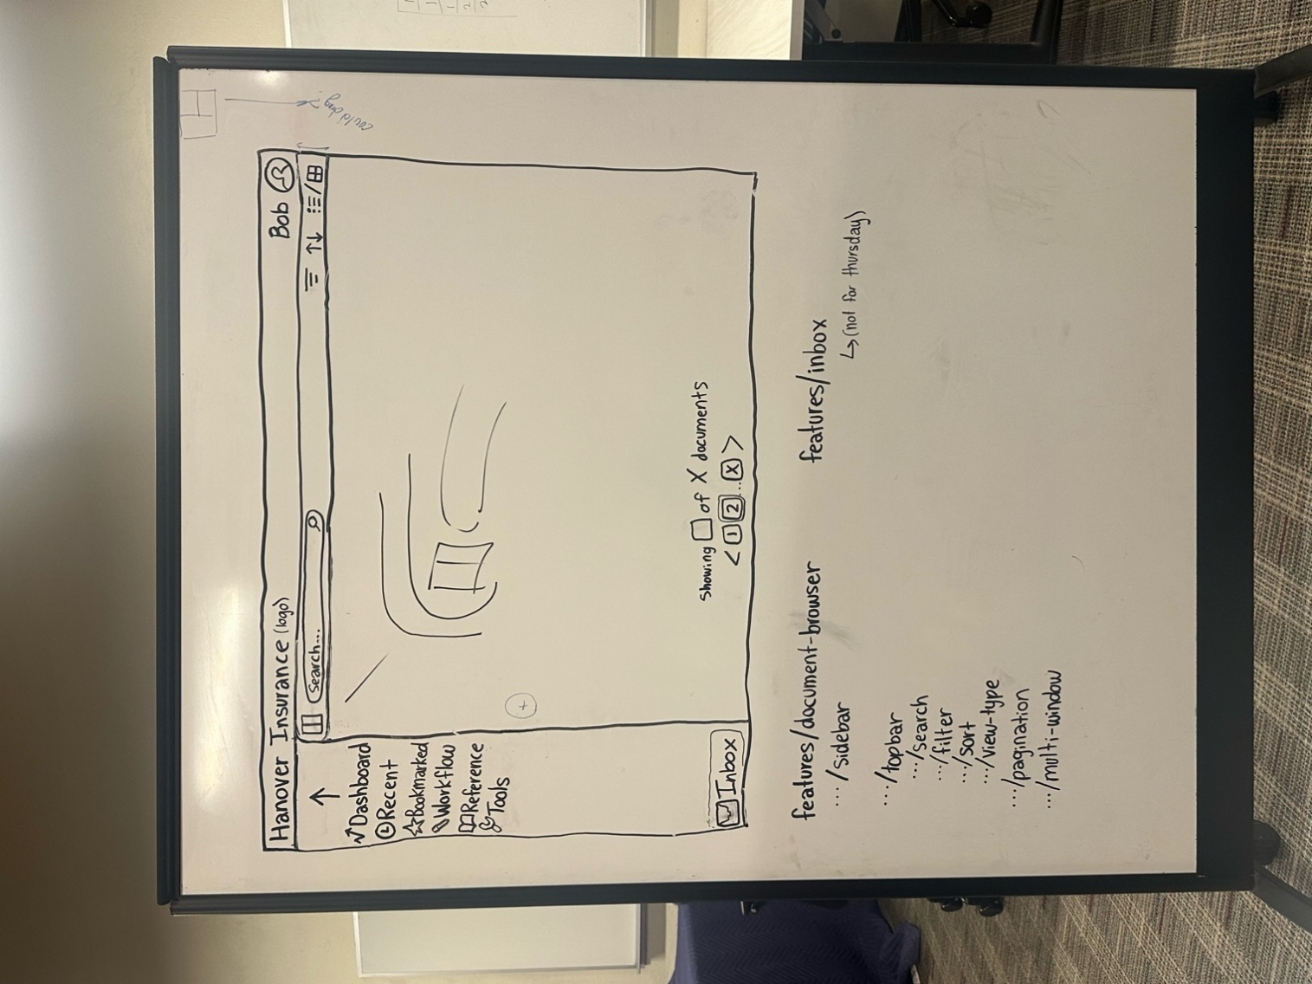
General Look of Website:

Epics/User Stories
Epics / User Stories for Sprint: | Points | Done?
Epic 1: Database Set Up: Connect to Express and Supabase/PostgreSQL to establish functioning backend (adding, submitting, fetching, and editing of individual data points and tables).
- As an Insurance Agent, I want a backend database to allow the storage of data and ensure security of the data. | 8 | Y
- As an Insurance Agent, I want content data organized in one table/place so I can easily find and sort data about content. | 5 | Y
- As an Insurance Agent, I want employee data organized in one table/place so I can easily find and sort employee data. | 3 | Y
- As an Insurance Agent, I want a centralized database to make accessing data easier. | 3 | Y
- As an Insurance Agent, I want to be able to display employee and content data to assess data in an intuitive way for a basic user. | 5 | Y
- As an Insurance Agent, I want to be able to connect the database to a server to access information on web. | 13 | Y
- As an Insurance Agent, I want to be able to display data in the webpage console to be able to see data online. | 8 | Y
Epic 2: Front End Set Up: Create an aesthetic and easily navigable user interface with add employee and add document forms
- As an Insurance Agent, I want a consistent and aesthetic user interface so that I enjoy using the application | 8 | Y
- As an Insurance Agent, I want to fill out an employee form so that I can add an employee to the database | 3 | Y
- As an Insurance Agent, I want to fill out a document form so that I can add a document to the database | 2 | Y
- As an Insurance Agent, I want easy access to tools and reference materials so that I have assistance performing workflow tasks | 13 | Y
- As an Insurance Agent, I want to easily navigate the application so that I can work efficiently | 8 | Y
Total User Points Completed | 73
FUTURE PLANNED:
Epics / User Stories for Entire Project:
Epic 1: Organized Data: Data that is well organized to allow easy adding, submitting, fetching, and editing of individual data points and tables.
- As an Insurance Agent, I want to add, update, and remove documents I own so that I can manage my content.
- As an Insurance Agent, I want to check-in/check-out of documents to prevent concurrent edits.
- As an Insurance Agent, I want automated review reminders for expired documents so that documents are kept up to date.
- As an Insurance Agent, I want to track metadata including create/update/review dates, review cycle, next review date, document status, and content owner so that I am well informed about the details of documents.
- As an Insurance Agent, I want my reference and workflow content separated for better organization and ease of use.
Epic 2: Control access to documents: Ensure users can only access and edit documents relevant to their role, stored securely in the cloud.
- As an Insurance Agent, I only want permission to access/edit the documents pertaining to my role so that I don't accidentally edit someone else's document.
- As an Insurance Agent, I want my documents to be stored in secure, scalable cloud storage so that only I or anyone else with permission can access them when we need to.
- As an Insurance Agent, I want to be able to view documents online so that I don't have to download them if I only want to preview them.
Epic 3: Searching & Filtering: Allow users to efficiently find and group documents using search and filter tools.
- As an Insurance Agent, I want to search for documents by title or URL to easily find a specific document that I need.
- As an Insurance Agent, I want to search for documents by status, owner, and tags to easily group documents I want to find.
- As an Insurance Agent, I want to filter documents by role to easily view all available documents pertaining to a specific company role.
- As an Insurance Agent, I want to filter documents by document type to easily view all available documents of that type.
Epic 4: User Experience: Provide a clean, navigable interface with a welcoming home page and role-based personalized views.
- As an Insurance Agent, I want to navigate between pages using a menu so that I can move through the application easily.
- As an Insurance Agent, I want to see a home page with a hero section so that I have a clear and welcoming entry point to the application.
Epic 5: Reporting & Analysis: Build and populate back-end database tables and verify data access through the server.
- As a Developer, I want an employee table in PostgreSQL populated with at least 5 employees so that employee data is available in the system.
- As a Developer, I want a content table in PostgreSQL populated with at least 5 items so that content data is available in the system.
- As a Developer, I want to run a server.js file using PrismaORM so that I can verify both tables are accessible and display their data correctly.
Epic 6: Training & Collaboration: Help users get onboarded and keep them informed of document changes and updates.
- As a new User, I want an interactive, automatic pop-up tutorial for my specific role so that I can easily understand how to use and navigate the site without having to read a cumbersome document.

Additional Features Implemented
- Tool bar with search, filter, sort, and view-type (currently non functional buttons)
- Implemented pagination on sidebar and for reference/tool content
- Implemented file uploading from the terminal to Supabase.
- Implemented confetti component for future celebratory occasions (imagine Canvas confetti)
- Implemented easily editable theming conventions throughout the site.

Use Case Diagram, Activity Diagram, & ERD

Activity Diagram:
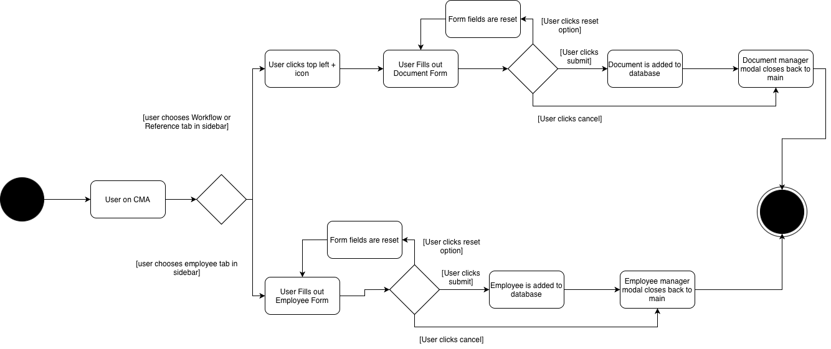
ERD:
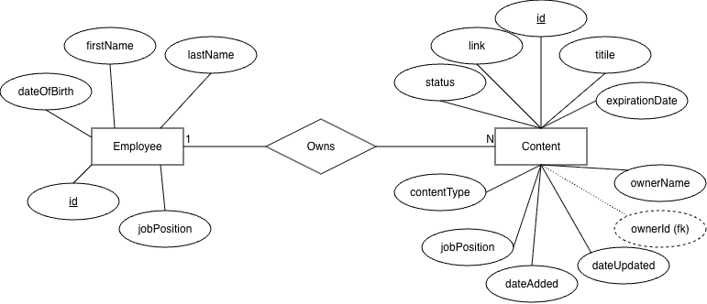

Use Case Diagram:
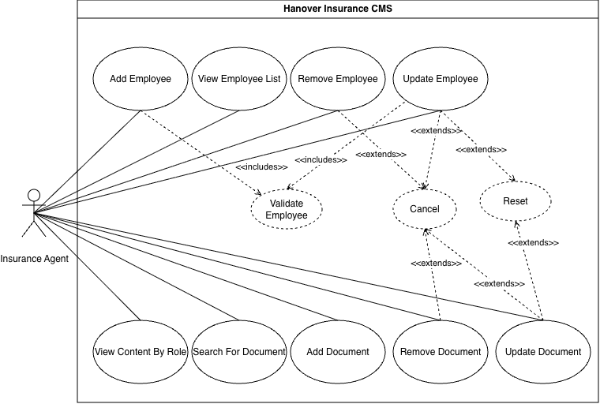
Textual Use Cases:
1. Add Employee
Participating Actor:
Insurance Agent
Entry Conditions:
Insurance Agent is logged into the Hanover CMS and has navigated to the employee management form.
Exit Conditions:
A new employee record has been saved to the system and appears in the employee list.
Flow of Events:
1. Insurance Agent navigates to the Manage Employees page.
2. Insurance Agent clicks "Add Employee."
3. System displays the employee form with fields for name, email, job position, and date of birth.
4. Insurance Agent fills in all required fields.
5. System validates the entered data. (include: Validate Employee Data)
6. Insurance Agent clicks "Submit."
7. System saves the new employee record and displays a confirmation message.
Alternate Flow - Reset Form:
1. At step 4, Insurance Agent clicks "Reset."
2. System clears all form fields.
3. Insurance Agent may re-enter information or navigate away.
Special Requirements:
All fields must be validated before submission. Email must be unique.

2. Update Employee
Participating Actor:
Insurance Agent
Entry Conditions:
Insurance Agent is logged in and at least one employee record exists in the system.
Exit Conditions:
The selected employee record has been updated and the changes are reflected in the employee list.
Flow of Events:
1. Insurance Agent navigates to the Manage Employees page.
2. Insurance Agent selects an employee record to edit.
3. System displays the employee form pre-filled with existing data.
4. Insurance Agent modifies one or more fields.
5. System validates the updated data. (include: Validate Employee Data)
6. Insurance Agent clicks "Save."
7. System saves the updated record and displays a confirmation message.
Alternate Flow - Cancel:
1. At any point before step 6, Insurance Agent clicks "Cancel."
2. System discards all changes and returns to the employee list.
Special Requirements:
Updated email must remain unique in the system.

3. Remove Employee
Participating Actor:
Insurance Agent
Entry Conditions:
Insurance Agent is logged in and the employee record to be removed exists in the system.
Exit Conditions:
The selected employee record has been permanently deleted from the system.
Flow of Events:
1. Insurance Agent navigates to the Manage Employees page.
2. Insurance Agent selects an employee record.
3. Insurance Agent clicks "Remove."
4. System displays a confirmation prompt.
5. Insurance Agent confirms the deletion.
6. System deletes the employee record and updates the employee list.
Alternate Flow - Cancel:
1. At step 4, Insurance Agent clicks "Cancel" on the confirmation prompt.
2. System dismisses the prompt and no changes are made.
Special Requirements:
None.

4. View Employee List
Participating Actor:
Insurance Agent
Entry Conditions:
Insurance Agent is logged into the Hanover CMS.
Exit Conditions:
A list of all employee records is displayed to the Insurance Agent.
Flow of Events:
1. Insurance Agent navigates to the Manage Employees page.
2. System retrieves all employee records from the database.
3. System displays the list of employees with their name, job position, and email.
Special Requirements:
None.

5. Validate Employee Data «include»
Participating Actor:
Insurance Agent (initiated by Add Employee or Update Employee)
Entry Conditions:
Insurance Agent has filled in the employee form and attempted to submit.
Exit Conditions:
All fields are confirmed valid and submission proceeds, or errors are displayed for the agent to correct.
Flow of Events:
1. System checks that all required fields (name, email, job position) are filled in.
2. System checks that the email address is in a valid format.
3. System checks that the email is not already assigned to another employee.
4. If all checks pass, system proceeds with the submission.
5. If any check fails, system highlights the invalid fields and displays error messages.
Special Requirements:
Email uniqueness must be enforced at the database level.

6. Add Content
Participating Actor:
Insurance Agent
Entry Conditions:
Insurance Agent is logged in and has navigated to the content management form.
Exit Conditions:
A new content record has been saved and is visible in the content list.
Flow of Events:
1. Insurance Agent navigates to the Manage Content page.
2. Insurance Agent clicks "Add Content."
3. System displays the content form with fields: name, URL, content owner, job position (underwriter or business analyst), last modified date, expiration date, content type (reference or workflow), and document status.
4. Insurance Agent fills in all required fields.
5. Insurance Agent clicks "Submit."
6. System saves the new content record and displays a confirmation message.
Alternate Flow - Reset Form:
1. At step 4, Insurance Agent clicks "Reset."
2. System clears all form fields.
3. Insurance Agent may re-enter information or navigate away.
Special Requirements:
Job position must be one of the two defined personas: underwriter or business analyst.

7. Update Content
Participating Actor:
Insurance Agent
Entry Conditions:
Insurance Agent is logged in and at least one content record exists in the system.
Exit Conditions:
The selected content record has been updated and changes are reflected in the content list.
Flow of Events:
1. Insurance Agent navigates to the Manage Content page.
2. Insurance Agent selects a content record to edit.
3. System displays the content form pre-filled with existing data.
4. Insurance Agent modifies one or more fields.
5. Insurance Agent clicks "Save."
6. System updates the record, sets the last modified date to today, and displays a confirmation message.
Alternate Flow - Cancel:
1. At any point before step 5, Insurance Agent clicks "Cancel."
2. System discards all changes and returns to the content list.
Special Requirements:
Last modified date must be automatically updated on save.

8. Remove Content
Participating Actor:
Insurance Agent
Entry Conditions:
Insurance Agent is logged in and the content record to be removed exists in the system.
Exit Conditions:
The selected content record has been permanently deleted from the system.
Flow of Events:
1. Insurance Agent navigates to the Manage Content page.
2. Insurance Agent selects a content record.
3. Insurance Agent clicks "Remove."
4. System displays a confirmation prompt.
5. Insurance Agent confirms the deletion.
6. System deletes the content record and updates the content list.
Alternate Flow - Cancel:
1. At step 4, Insurance Agent clicks "Cancel" on the confirmation prompt.
2. System dismisses the prompt and no changes are made.
Special Requirements:
None.

9. View Content by Role
Participating Actor:
Insurance Agent
Entry Conditions:
Insurance Agent is logged into the Hanover CMS.
Exit Conditions:
Content filtered by the selected job position (underwriter or business analyst) is displayed.
Flow of Events:
1. Insurance Agent navigates to the content page.
2. Insurance Agent selects a job position (underwriter or business analyst) from the persona menu.
3. System retrieves all content records associated with that job position.
4. System displays the filtered content list with names and URLs.
Special Requirements:
Content must be organized under the two defined personas per the project requirements.

Team Bonding
After each SCRUM meeting we all hung out before class; this often constituted about an hour of chatting and getting to know one another each day this week. Furthermore, we worked together for several hours in an open discussion style planning meeting.
We feel that most of us get along very well with nobody who feels especially left out. Most people attend every meeting and are great at communicating through Discord, with short response times.

Project Management
Last name, First name | Contributions
Anderson, Norah | - Implemented sidebar UI  - Implemented pagination to subpages through sidebar buttons  - Implemented rendering of subpages  - Contributed to brainstorming  - Contributed to generation of Epics and User Stories  - Contributed to poker planning
Boozer, Theron | - Created document card components  - Created references and tools pages  - Implemented pagination of references and tools pages  - Contributed to brainstorming  - Contributed to generation of Epics and User Stories  - Contributed to poker planning  - Lead scrums
Gomes, Daniel | - Set up Supabase  - Implemented file uploading from the terminal to Supabase.  - Merged and tested all backend features  - Contributed to brainstorming  - Contributed to poker planning  - Updated README for .env files.
Reinherz, Ben | - Implemented minor top bar UI  - Implemented ‘add employee’ button and form  - Implemented ‘add document’ button and form  - Contributed to brainstorming  - Contributed to poker planning
Roselin, Rashi | - Created Use Case Diagram  - Contributed to generation of epics and user stories  - Contributed to brainstorming
Santana, Benjamin | - Set up starter repo, github org and github repo  - Implemented React Routing  - Implemented pages convention for frontend utilizing react router <outlet>  - Implemented home page and hero section  - Implemented confetti button to be used later, for now get quote button is confetti button  - Started main CMA page with shadcn sidebar-8 component  - Added the ‘major top bar’ / navbar that has company logo and profile icon to the CMA (/documents) page
Sukumar, Abyshek | - Determined user story points
Tariq, Ali | - Implemented and Populated the employee table  - Implemented and Populated the content table  - Implemented the typescript/node.js program for displaying data  - Created the ERD Diagram  - Created the Textual Description of the Case Diagram
Welcher, Kylie | - Implemented the content table  - Implemented optional Express sever  - Implemented optional display of data on sever  - Implement optional test of server  - Created survey & interview protocol

