Module Seven README
Quavonda Bell
Southern New Hampshire University
CS-340-14224-M01 Client/Server Development
Instructor Tad Kellogg
October 18, 2026

Project Overview
For this project, I built a dashboard for Grazioso Salvare to help identify shelter dogs that could be candidates for rescue training. The dashboard connects to the Austin Animal Center Outcomes data in MongoDB and lets the user narrow down the records by rescue type. Instead of looking through the entire database manually, the user can choose a rescue category and see the matching dogs in a table, a breed chart, and a location map.
Required Functionality
The dashboard opens with the full animal dataset. Radio buttons let the user switch between Water Rescue, Mountain or Wilderness Rescue, and Disaster or Individual Tracking. Choosing All Animals (Reset) brings the data back to the original unfiltered view. The table supports paging, sorting, and column filtering, and the chart summarizes breeds in the current results. Selecting a row changes the location shown on the map.
The dashboard also includes the Grazioso Salvare logo and my name as an identifier. I kept the controls straightforward so someone using the application can find information without needing to know MongoDB commands.
Tools and Why I Used Them
MongoDB and the CRUD Python Module
MongoDB stores the animal shelter records as documents. This worked well because the project needed to search records by fields such as animal type, breed, sex, and age. I reused the Python CRUD module from Project One to connect to MongoDB and retrieve records through its read method. PyMongo handles the connection between Python and the database.
Python, Pandas, Dash, Plotly, and Dash Leaflet
Python ties the database queries and dashboard together. Pandas turns the returned records into a DataFrame that is easier to prepare for the table and charts. Dash provides the web layout and callbacks that respond when a user changes a rescue filter or selects an animal. Plotly displays the breed distribution as a donut chart, while Dash Leaflet provides the interactive location map. I developed and tested the application in the Codio Jupyter notebook environment.
This follows the model-view-controller approach described in the project instructions: MongoDB holds the data, dashboard widgets show the results, and the Python callbacks use the CRUD module to respond to user actions.
How I Built the Dashboard
- I started with the ProjectTwoDashboard.ipynb starter notebook and imported the CRUD_Python_Module.py class developed in Project One.
- I connected to the animal database, read the shelter records, and removed the MongoDB _id field from the DataFrame so its ObjectId values would not interfere with the Dash table.
- I added the Grazioso Salvare logo, dashboard title, student identifier, and the four rescue-type radio options.
- I configured the DataTable to display the retrieved records and support pagination, sorting, and filtering.
- I wrote MongoDB queries for each rescue type and connected them to the radio buttons through a Dash callback.
- I added a donut chart that updates to summarize the breeds in the filtered table, then connected the Leaflet map to the selected animal record.
- I tested the starting view, all three rescue filters, the reset option, and individual row selection.
Reproducing the Project
The project submission should include ProjectTwoDashboard.ipynb, CRUD_Python_Module.py, and the Grazioso Salvare Logo.png image. The Austin Animal Center dataset must already be imported into the MongoDB collection used by the CRUD module.
- Open the project files in the provided Codio environment and launch the Jupyter notebook.
- Make sure the required Python libraries are available: pandas, dash, plotly, dash-leaflet, jupyter-dash, and pymongo, along with the other imports used in the notebook.
- Keep the CRUD Python module and logo in a location the notebook can access. Confirm the import name and image path match the actual files.
- Configure the MongoDB connection using the database account and credentials supplied for the course environment. Do not publish working passwords to a public repository.
- Run the notebook cell to start the Dash application. Open the displayed dashboard link in the Codio environment.
- Choose each rescue filter and check that the table and donut chart update. Select a table row to test the map marker. Choose All Animals (Reset) to restore the original view.
Challenges and Fixes
One challenge was getting all the dashboard pieces to update without errors. I had to correct a Python bracket error and a callback error caused by a variable name that had not been defined. I also adjusted the chart because the original pie chart had too many small slices to read. Grouping the smaller categories and using a donut chart made the starting view easier to understand.
The map did not appear at first, so I worked through the layout and callback code until the map displayed and updated when a row was selected. I also fixed the logo so clicking it no longer redirected the browser away from the dashboard. After making these changes, I tested the rescue filters again to make sure the table, chart, and map still worked together.
Dashboard Testing Screenshots
These screenshots show the dashboard after testing the required views. The starting state and Reset use the same All Animals view; the reset behavior should also be demonstrated by switching to a rescue filter and then selecting All Animals (Reset).
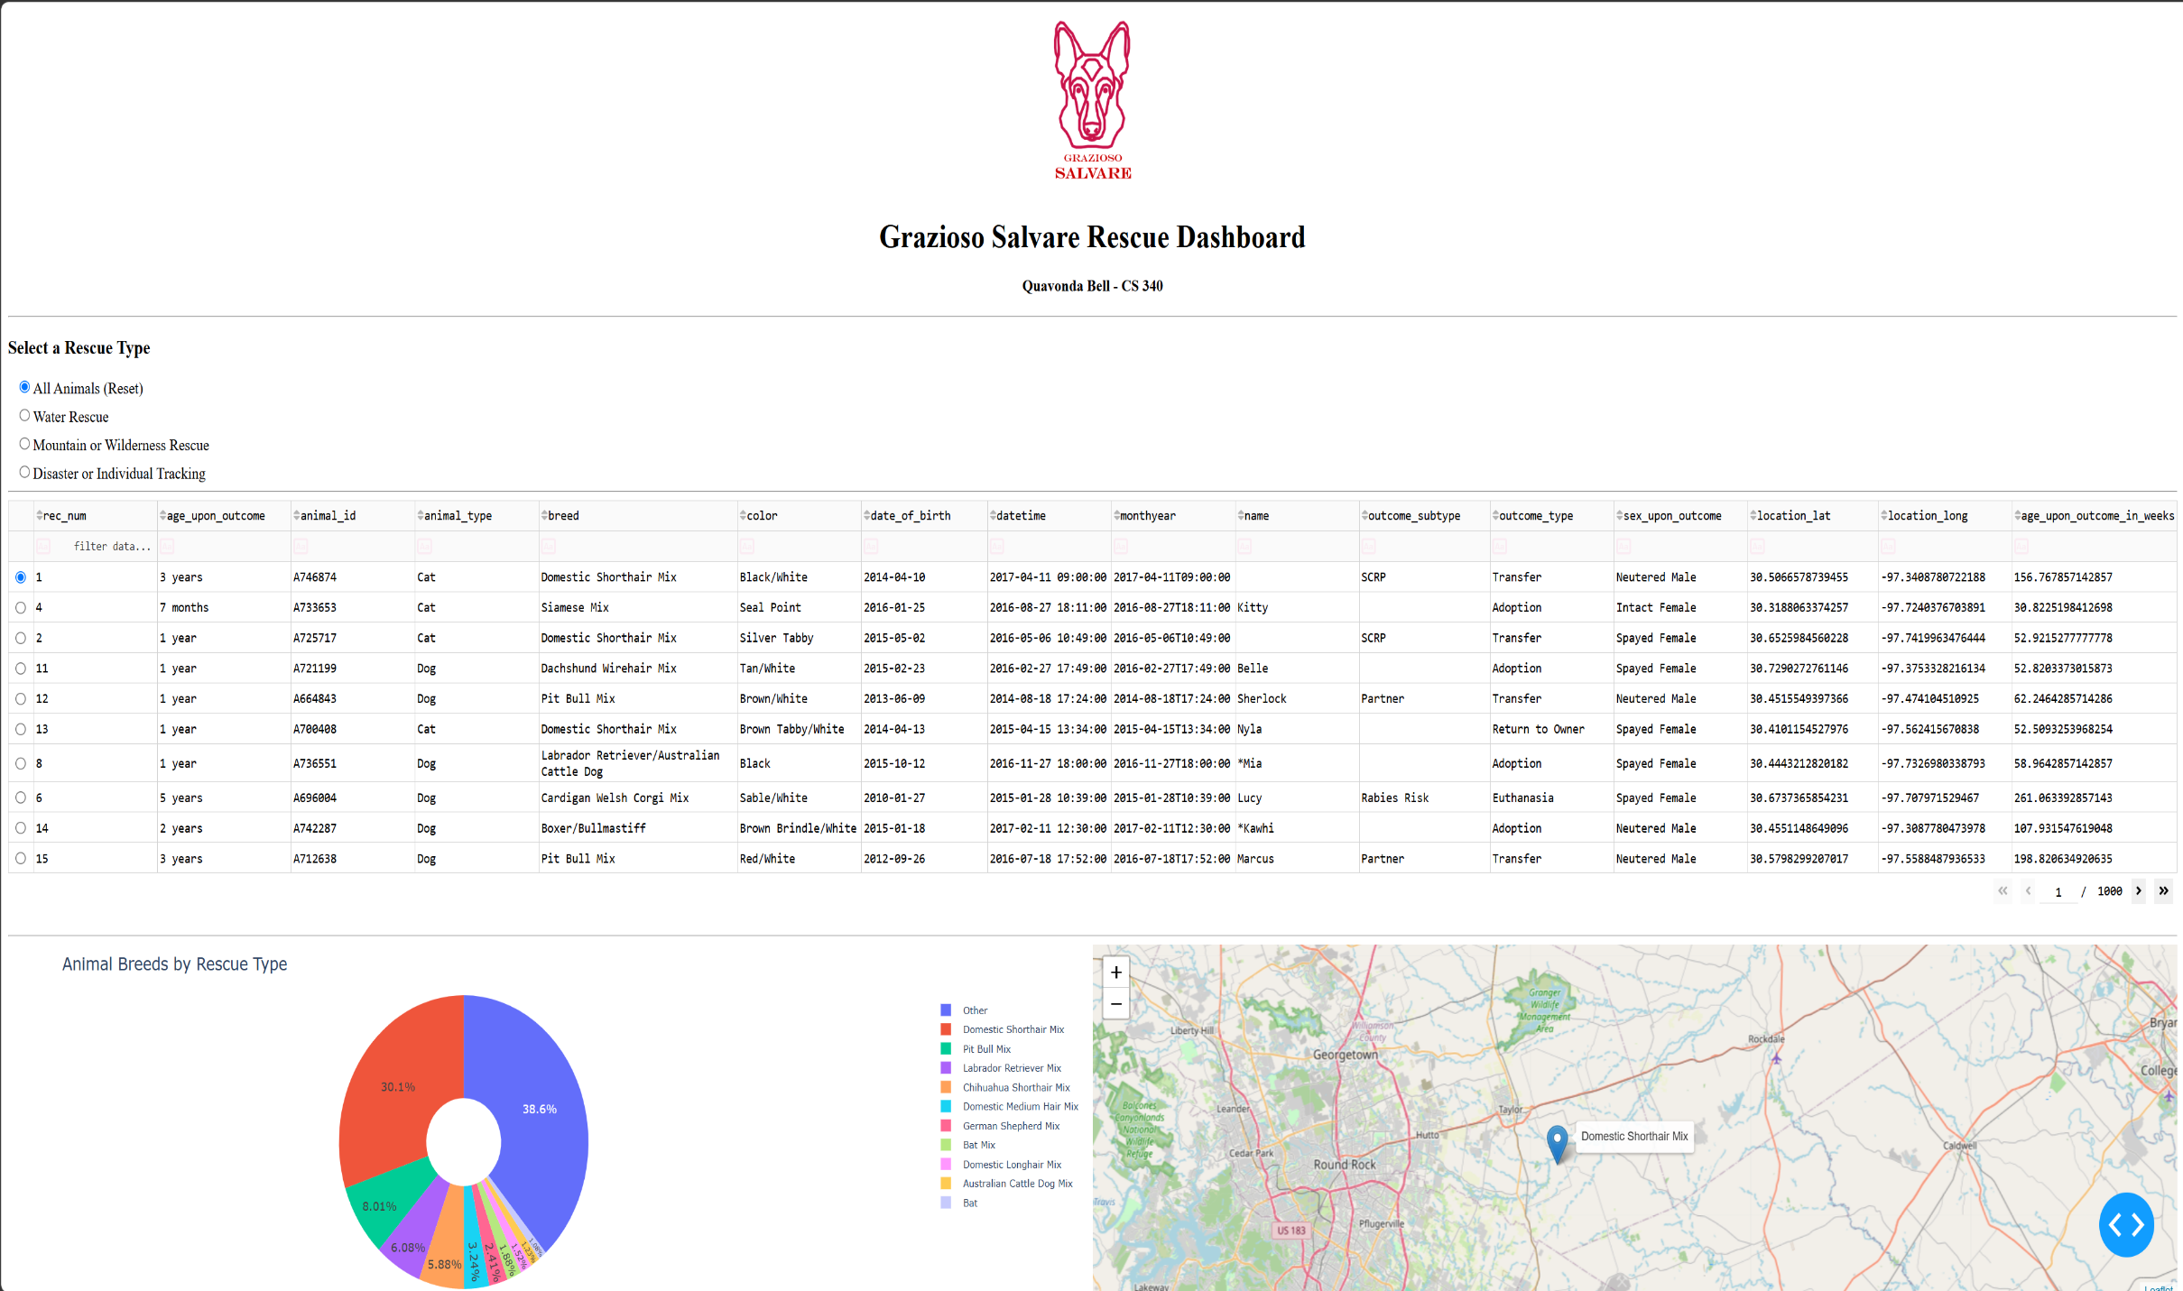
Figure 1. All Animals starting view / Reset state.
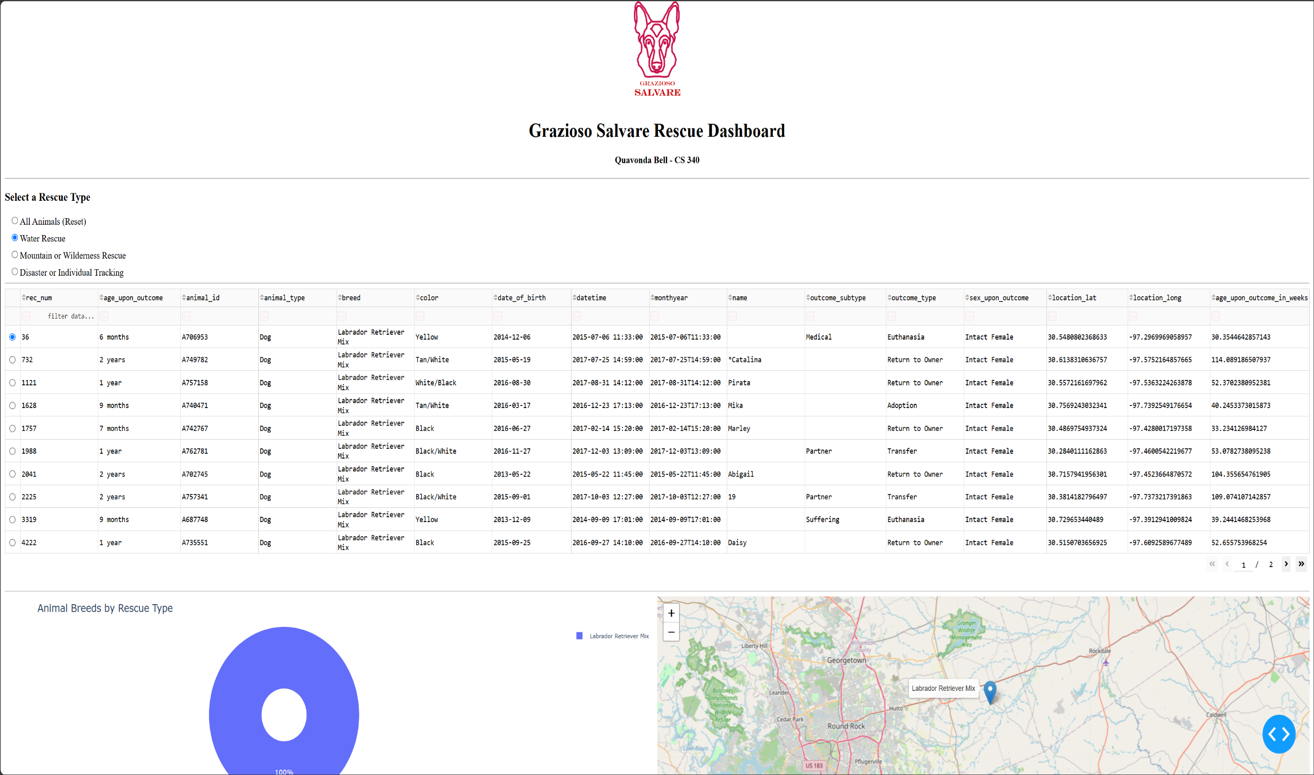
Figure 2. Water Rescue filter applied.
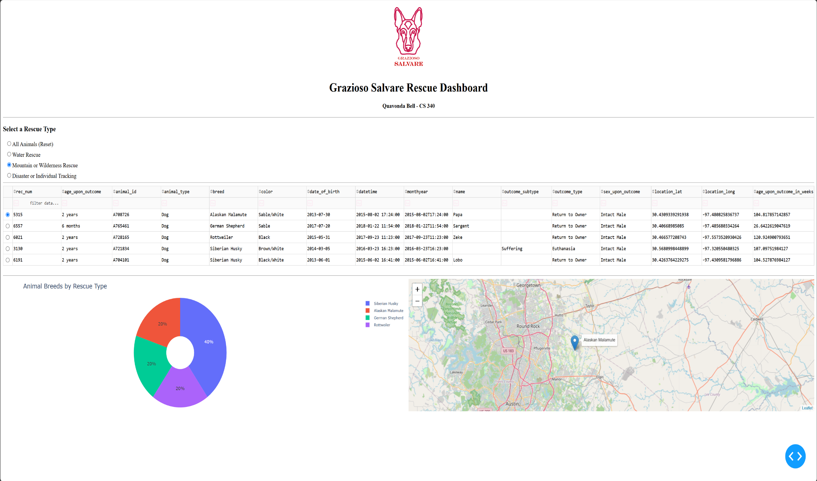
Figure 3. Mountain or Wilderness Rescue Filter applied.
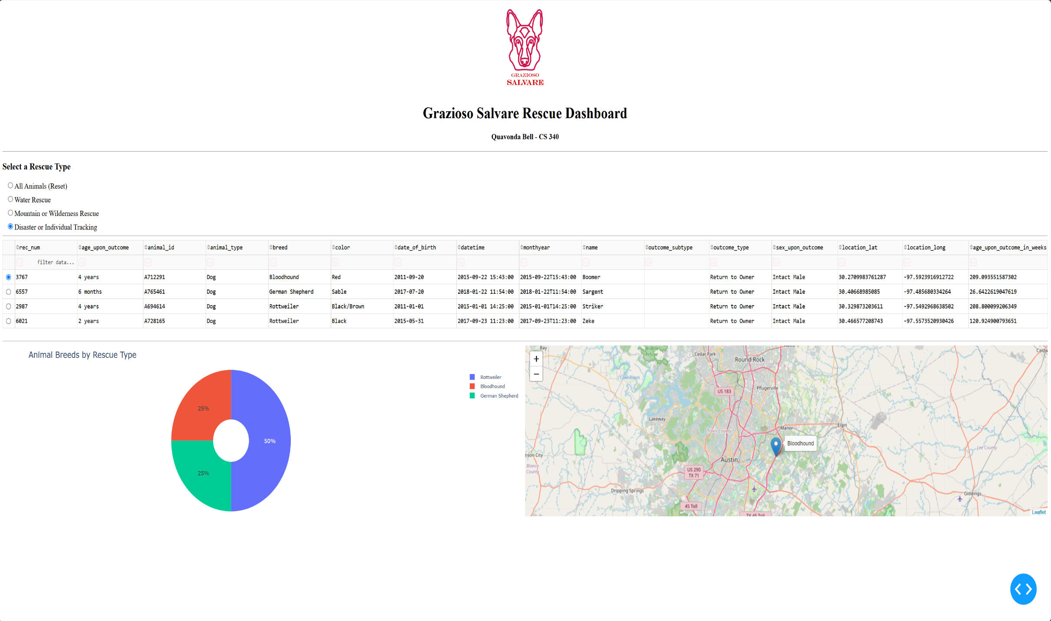
Figure 4. Disaster or Individual Tracking filter applied.
Resources
Austin Animal Center. (2020). Austin Animal Center Outcomes [Data set]. City of Austin, Texas Open Data Portal. https://doi.org/10.26000/025.000001
MongoDB documentation: https://www.mongodb.com/docs/
Dash documentation: https://dash.plotly.com/
Dash Leaflet documentation: https://dash-leaflet-docs.onrender.com/
README guidance: https://www.makeareadme.com/

