CHAPTER THREE
METHODOLOGY

3.0 Introduction
This chapter describes how the study was carried out. Section 3.1 presents the research design and the development model that was followed, together with a use-case diagram of the proposed system. Section 3.2 explains the sources of the data used in the study and the ethical considerations. Section 3.3 analyses the challenges of the existing system. Section 3.4 describes the design of the proposed system through its data flow, Section 3.5 the design of the dataset, and Section 3.6 the architectural design, the system requirements, and the algorithm of the redaction guard. Section 3.7 sets out the method by which the system is evaluated and the limitations of that method, and Section 3.8 summarises the chapter. The exact prompts given to the vision-language model are reproduced in Appendix A, and screenshots of the two mock forms not shown in the body of the chapter are given in Appendix B.

3.1 Design Science Research Model
The study follows the design science research approach. In design science, knowledge is produced by building an artefact that addresses a real problem and then evaluating how well it does so (Hevner et al., 2004). This suits the present study, whose aim is to design, implement, and evaluate a visual redaction framework. The artefact has two parts: a benchmark of annotated screenshots, and a redaction guard that is tested on it.
The work was organised according to the six activities of the design science research methodology of Peffers et al. (2007), shown in Figure 3.1. The first activity, problem identification and motivation, was completed in Chapter One: screenshot-driven agents disclose a whole page of personal data to a third-party model at every step. The second, the objectives of the solution, produced the five objectives listed in Section 1.3. The third, design and development, produced the benchmark and the guard described in this chapter. The fourth, demonstration, applied the guard to recorded tasks on mock government forms. The fifth, evaluation, consists of the three experiments set out in Section 3.7. The sixth, communication, is this report.
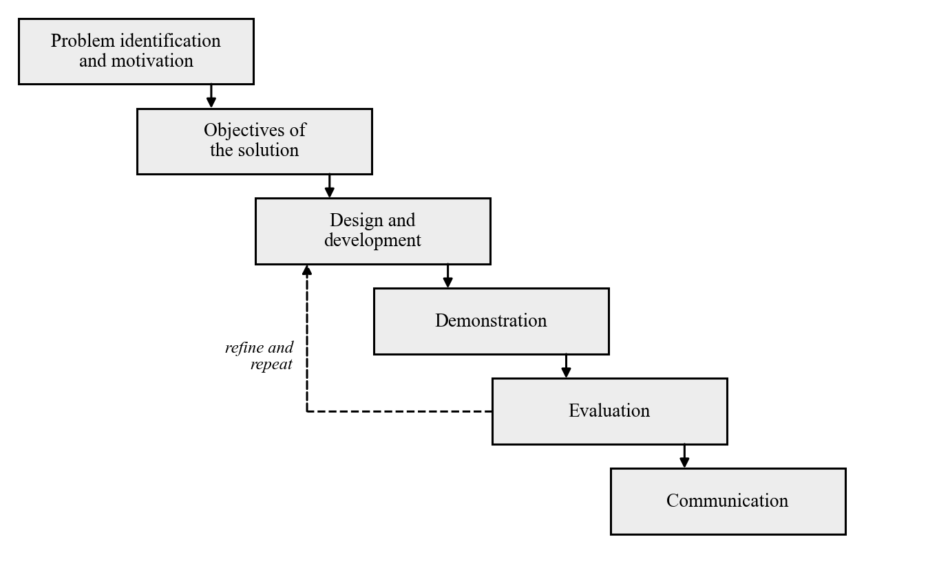
Fig. 3.1: Design Science Research Model of the Proposed Redaction Framework
Unlike the waterfall model, in which each phase is completed once before the next begins, this model is iterative. The dashed arrow in Figure 3.1 shows that the result of an evaluation is used to refine the design, after which the artefact is built and evaluated again. This was necessary in practice. The guard went through three cycles of building and testing before its design was fixed, and two of the design decisions reported in Section 3.4 came directly from errors found in the earlier cycles. An iterative model was chosen for this reason: the behaviour of an optical character recognition engine on real browser screenshots could not be fully predicted in advance and had to be learned by testing.

3.1.1 Use-case Diagram
A use-case diagram shows the ways in which the actors of a system interact with it. Figure 3.2 depicts the use cases of the proposed system. There are four actors. The user gives a task to the agent, for example to enter a residential address on a tax form. The screenshot-driven agent captures a screenshot of the page, passes it to the redaction guard, and sends the redacted result to the model. The cloud-hosted vision-language model (VLM) receives only the redacted screenshot and returns the next action. The researcher generates the benchmark and runs the experiments. Redacting a screenshot includes four smaller use cases, which correspond to the four stages of the guard: extracting the text, attributing values to form fields, applying the redaction policy, and masking the selected values.
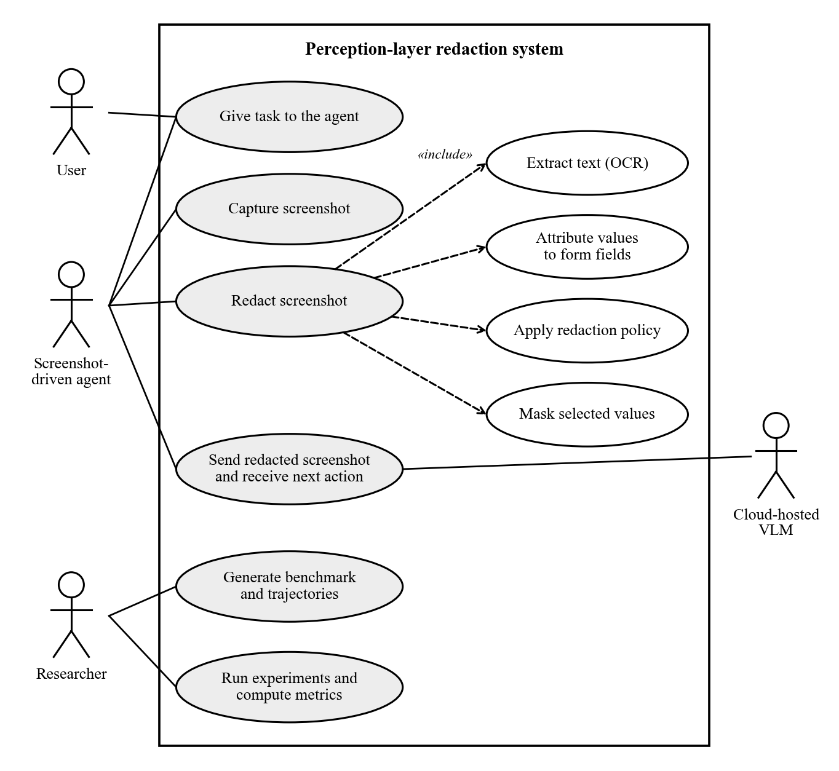
Fig. 3.2: Use-case Diagram of the Proposed Redaction Framework
The study did not build an autonomous agent, as stated in Section 1.4. In the experiments the part of the agent is played by recorded task steps, and the guard is applied to the screenshot of each step exactly as it would be inside a running agent.

3.2 Source of Data Collection
The study did not collect data from people. No interviews, questionnaires, or on-site observations were carried out, and no real citizen data or live government portal was used. Screenshots of real e-service sessions would contain citizens’ personal information, which could not be collected or shared for this study. All the data was therefore generated for the study, from four sources.
Mock e-service portals. Three web forms were written in HTML and styled to resemble Nigerian government e-service pages. They are modelled on services that citizens use online: a personal income tax self-assessment, a driver’s licence renewal, and an international passport application. Each form is a template with one placeholder per field, and is accompanied by a manifest that records, for every field, its position in the page, its type of personal information, and the order in which it is filled. The manifest also defines the tasks that can be performed on the form and the fields each task needs. Table 3.1 lists the forms and the five tasks.
Table 3.1: Mock Portals, Fields and Tasks
Mock portal | Mock agency | Fields | Tasks and the fields they need
Personal Income Tax Self-Assessment | State Internal Revenue Service | 12: surname, first name, date of birth, TIN, NIN, street address, LGA, state, annual income, BVN, account number, email | T01: enter the residential address (street address, LGA, state). T02: enter the annual income and bank details (annual income, BVN, account number).
Driver’s Licence Renewal | Federal Road Safety Corps | 10: licence number, surname, first name, date of birth, NIN, phone, email, street address, LGA, state | T03: enter the phone number and email address (phone, email). T04: enter the licence number and NIN (licence number, NIN).
International Passport Application | Nigeria Immigration Service | 10: surname, first name, date of birth, NIN, passport number, phone, email, street address, LGA, state | T05: enter the NIN and previous passport number (NIN, passport number).
Source: form manifests of the study.
Synthetic identities. Fifty fictitious identities were produced by a generator written for the study. First names and surnames were drawn from lists of Yoruba, Igbo, Hausa, and Niger Delta names. Addresses were composed from street and area names in twelve states, each paired with one of its local government areas. Identifiers were produced as random values in the national formats shown in Table 3.2. The generator uses a fixed random seed, so the same fifty identities are produced every time it is run. The values are random and were not taken from or checked against any registry, and every email address uses the reserved domain example.com. Section 3.2.1 considers the possibility that a random value matches a real identifier by chance.
Table 3.2: Types of Personal Information and the Format of the Synthetic Values
Type | Format of the synthetic value | Example
PERSON | First name and surname from Nigerian name lists | Chiamaka Okonkwo
DOB | Date of birth as DD/MM/YYYY, age 18 to 70 | 14/03/1987
NIN | 11 digits | 12345678901
BVN | 11 digits beginning with 22 | 22123456789
TIN | 8 digits, a hyphen, 4 digits | 12345678-0001
BANK_ACCOUNT | 10 digits (NUBAN) | 0123456789
PASSPORT | One letter (A, B or C) and 8 digits | A12345678
LICENCE_NO | 3-letter state code, 5 digits, 2 letters, 2 digits | LAG12345AB67
PHONE | +234 followed by 10 digits with a mobile prefix | +234 803 456 7890
EMAIL | Name-based address at example.com | chiamaka.okonkwo@example.com
ADDRESS | Street line, local government area, state | 12 Adeola Odeku Street, Victoria Island; Eti-Osa; Lagos
FINANCIAL | Annual income as a whole number of naira | 4200000
Source: identity generator of the study. The examples are fictitious.
Benchmark screenshots. Each form was filled with each identity in three states: empty, partly filled (the first half of the fields), and fully filled. Every combination was opened in a headless Chromium browser at a width of 1,280 pixels and captured as a full-page screenshot. Three forms, fifty identities, and three states give 450 screenshots. Because the pages were rendered by the study itself, the ground truth did not have to be drawn by hand. For every filled field, a script read the position of the input box from the page and measured the width of the text inside it in the field’s own font, which gives a tight box around the text itself. The value, its type, its field, and this box were saved as the annotation of the screenshot. Figure 3.3 shows one of the screenshots, and the other two forms are shown in Appendix B.
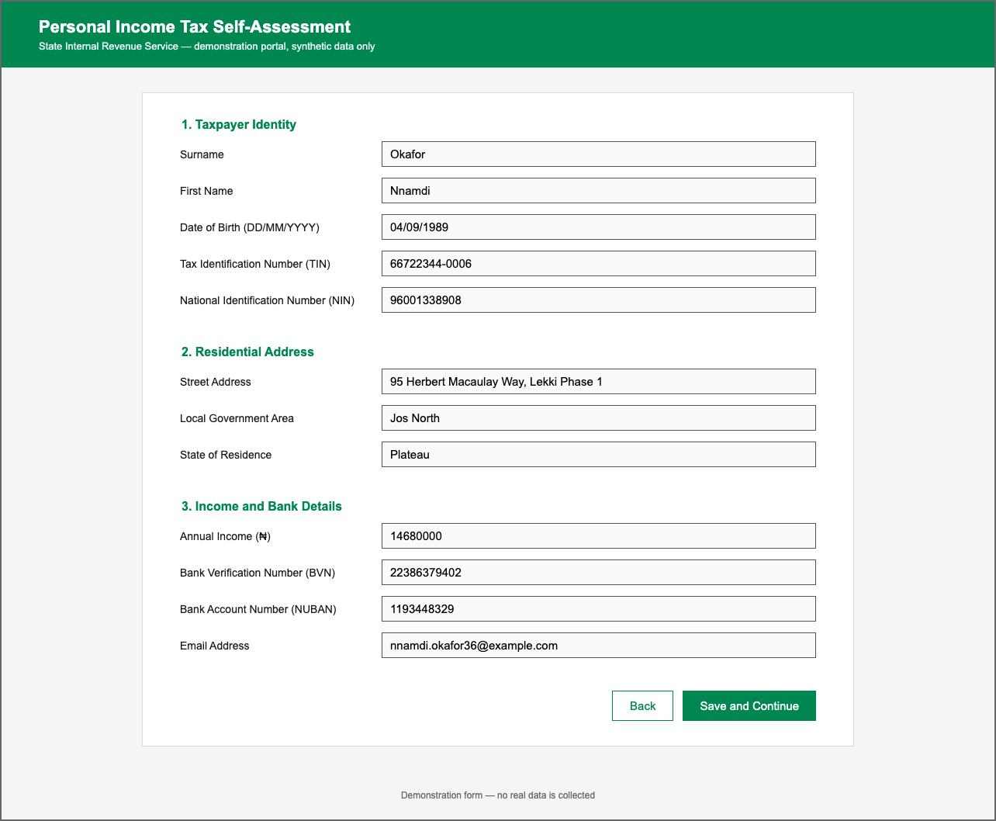
Fig. 3.3: A Fully Filled Benchmark Screenshot of the Mock Tax Self-Assessment Form
Recorded task trajectories. To measure the effect of redaction on an agent, each of the five tasks was performed for three identities and recorded, giving fifteen trajectories. A trajectory begins with every field outside the task already filled, as if the agent had reached that part of the form. The fields the task needs are then typed one at a time in the order of the form, and finally the “Save and Continue” button is clicked. Before each of these actions the page was captured with its annotations, and the correct action was saved beside it. Each step therefore holds the screen as an agent would see it at the moment of choosing that action. A task with three fields has four steps and a task with two fields has three, which gives 51 steps in all. Because the trajectories were recorded from a live browser, their screenshots contain details that static pages lack, notably the blue focus ring that the browser draws around the field just typed into.
Table 3.3 summarises the dataset. In addition to this generated data, the formats of the identifiers and the wording of the forms were based on the published documents of the issuing agencies reviewed in Section 2.3.
Table 3.3: Composition of the Dataset
Part | How it was produced | Screenshots | Annotated values
Benchmark | 3 forms × 50 identities × 3 fill states | 450 | 2,400
Trajectories | 5 tasks × 3 identities = 15 trajectories | 51 steps | 495
Total |  | 501 | 2,895
Source: dataset of the study.

3.2.1 Ethical Considerations
The study involved no human participants and no personal data. Every name, address, and identifier in the dataset is fictitious. The identifiers are random values in the national formats; they were not taken from any registry and were not checked against one. A random eleven-digit number could by chance coincide with a number that has been issued, but it is paired here with an invented name and address and is not linked to the details of any real person. All email addresses use the domain example.com, which is reserved for use in examples and is not assigned to any person or organisation.
No live government portal was accessed, automated, or tested. The forms were written for the study, and each page states in its header that it is a demonstration portal containing synthetic data only, so that a screenshot of it cannot be mistaken for the real service of the agency it is modelled on. In Experiments 2 and 3 screenshots are sent to a vision-language model hosted by a third party. These screenshots contain only the synthetic data described above, so no real personal data is sent to the model provider in the course of the experiments.

3.3 Challenges of the Existing System
The existing arrangement considered in this study is that of a screenshot-driven agent on the web. The agent captures the screen and sends the image, unchanged, to a cloud-hosted VLM at every step of a task. Where protection is applied to such an agent, the review in Chapter Two found it mainly in two forms: safeguards on the agent’s actions, and general-purpose detectors of personally identifiable information (PII). Chapter Two also reviewed recent redaction layers for mobile agents, some of which take the task into account (Section 2.6). They were not designed for web forms or for Nigerian identifiers, and they are not part of the arrangement analysed here. The review suggested the following challenges with this arrangement.
- The whole page is disclosed at every step. A step that types one field still sends every other value on the page to the model. On the forms studied here, every field holds personal information.
- Action-level safeguards are not aimed at what the model sees. Requiring the user to click the final button, or restricting the agent to official websites, governs what the agent may do. In general the screenshots are still sent in full.
- General-purpose detectors usually examine each piece of text on its own. Applied to the text extracted from a screenshot, such a detector sees a value without the label beside it. An eleven-digit number may be a NIN or a BVN, and an income figure is only a number, so the text alone does not show what the value is.
- Nigerian identifiers are not covered by the baseline detector. The version of the general-purpose detector used as the baseline in this study has recognisers for the identifiers of several countries but none for Nigeria. It relies on a general English language model to recognise names, and earlier studies found such models less reliable on African names (Section 2.5.2).
- A general-purpose detector does not tie detection to the task. A detector that does not know which field a value belongs to can mask only what it recognises, and it cannot be told to leave visible the fields that the current step needs. The task-aware layers reviewed in Section 2.6 deal with this for mobile applications; no equivalent was found for web forms.
- Trained visual detectors need annotated data, and none was found for this setting. Detectors trained on images require large annotated sets of screenshots. The published sets found in the review cover e-commerce pages and mobile applications, not government forms.
The proposed system was designed in response to these challenges. It places a guard between the capture of the screenshot and its transmission, and it identifies each value from the label of its form field. How far it meets the challenges is what the evaluation in Section 3.7 is intended to show.

3.4 System Design
The proposed redaction guard was analysed using a data flow diagram, and each of its modules was then designed in turn.

3.4.1 Data Flow Diagram of the Proposed System
A data flow diagram (DFD) shows how data moves through a system: where it enters, which processes transform it, what stored data those processes consult, and where the result goes. Figure 3.4 shows the data flow of the proposed system. The screenshot enters from the browser and passes through four processes. The first extracts the text. The second decides which pieces of text are personal information, using a stored vocabulary of field labels and a set of format patterns. The third decides which of them to hide, using the definition of the current task. The fourth paints over the chosen regions on the original screenshot. Only the redacted screenshot goes to the VLM, and the action it returns goes back to the agent.
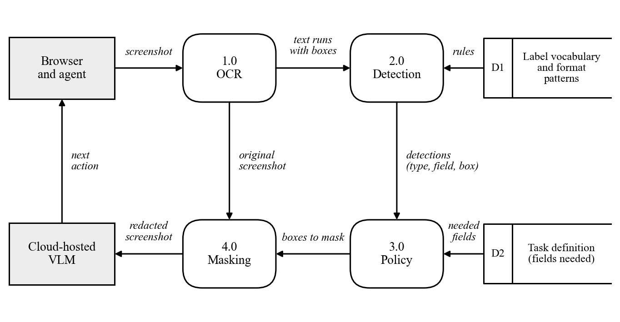
Fig. 3.4: Data Flow Diagram of the Proposed Redaction Guard
Optical Character Recognition Module: this module turns the screenshot into text with positions, as shown in Figure 3.5. The image is first prepared. Pixels in the blue of the browser’s focus ring are painted white, because in early tests the OCR engine skipped the text inside a ringed field, which is the field the agent has just typed into. The image is then converted to greyscale and enlarged to twice its size, since the engine is more accurate on larger text than on the 15-pixel text of a web form. The words are recognised with the Tesseract engine (Smith, 2007) in its full-layout mode. Tokens that are empty, or that consist only of the marks the engine produces when it reads the border of an input box, are discarded. No word is discarded for low confidence: a word the engine is unsure of is still a candidate for masking. This is a design choice in favour of privacy: a missed value is treated as the more serious error. The cost of any unnecessary masks to the agent is part of what Experiment 3 measures. Finally, the words on each line are grouped into runs. A line is split wherever the horizontal gap between two words exceeds 1.5 times the height of the line. A row of a form thus becomes two runs, the label and the value, each with its own bounding box.
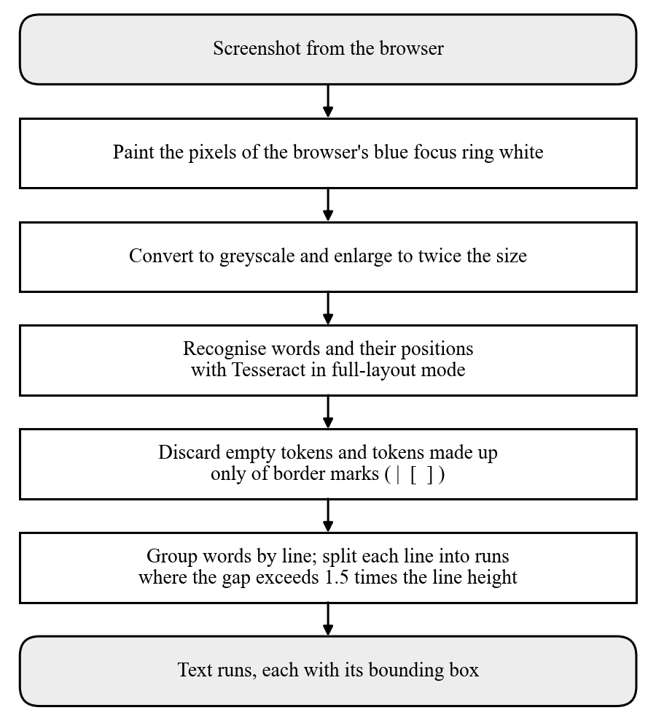
Fig. 3.5: Flow of the Optical Character Recognition Module
Detection Module: this module decides which runs are personal information and what kind. It is the module on which the task-aware policy depends, and it follows the flow in Figure 3.6. For each run, the module first looks for a field label on the same row. A run qualifies as that label if it ends to the left of the run being examined, overlaps it vertically by at least half the height of the shorter of the two, and contains one of the keywords in Table 3.4. If several runs qualify, the nearest is taken. When a label is found, the run is recorded as a value of that field and takes the field’s type. This is how the guard tells a NIN from a BVN, although both are eleven digits long.
Table 3.4: Vocabulary of Field Labels Used by the Detection Module
Order | Keywords looked for in the label | Field | Type assigned
1 | date of birth; dob | Date of birth | DOB
2 | tax identification; tin | Tax identification number | TIN
3 | national identification; nin | National identification number | NIN
4 | bank verification; bvn | Bank verification number | BVN
5 | account number; nuban | Bank account number | BANK_ACCOUNT
6 | annual income; income | Annual income | FINANCIAL
7 | email; e-mail | Email address | EMAIL
8 | phone; mobile | Phone number | PHONE
9 | passport | Passport number | PASSPORT
10 | licence; license | Driver’s licence number | LICENCE_NO
11 | street; address | Street address | ADDRESS
12 | local government; lga | Local government area | ADDRESS
13 | surname; last name | Surname | PERSON
14 | first name; given name | First name | PERSON
15 | state | State | ADDRESS
Source: guard of the study. The first entry that matches is used, so specific keywords come before general ones.
A run with no label to its left is examined further. If the run itself reads as a label or heading and matches none of the format patterns, it is left visible, so that the labels of the form are never masked. Otherwise the run is tested against the format patterns in Table 3.5, in the order shown. The order matters because some shapes contain others. A run that matches no pattern is passed to the general-purpose detector, Presidio (Microsoft, 2025). If Presidio reports an entity with a score of 0.4 or more, the run is recorded with the corresponding type, but with no field. Each detection records its type, its field where known, its text, its bounding box, and which of the three rules produced it.
Table 3.5: Format Patterns Used When No Label Is Found
Order | Type assigned | Shape of the text
1 | EMAIL | Text containing the @ sign followed by a domain name
2 | PHONE | +234 followed by 10 digits, with or without spaces; or 11 digits beginning 07, 08 or 09
3 | TIN | 8 digits, a hyphen, 4 digits
4 | PASSPORT | The letter A, B or C followed by 8 digits
5 | LICENCE_NO | 3 letters, 5 digits, 2 letters, 2 digits
6 | DOB | A date written as DD/MM/YYYY
7 | NIN | 11 digits
8 | BANK_ACCOUNT | 10 digits
9 | FINANCIAL | 5 to 9 digits
Source: guard of the study.
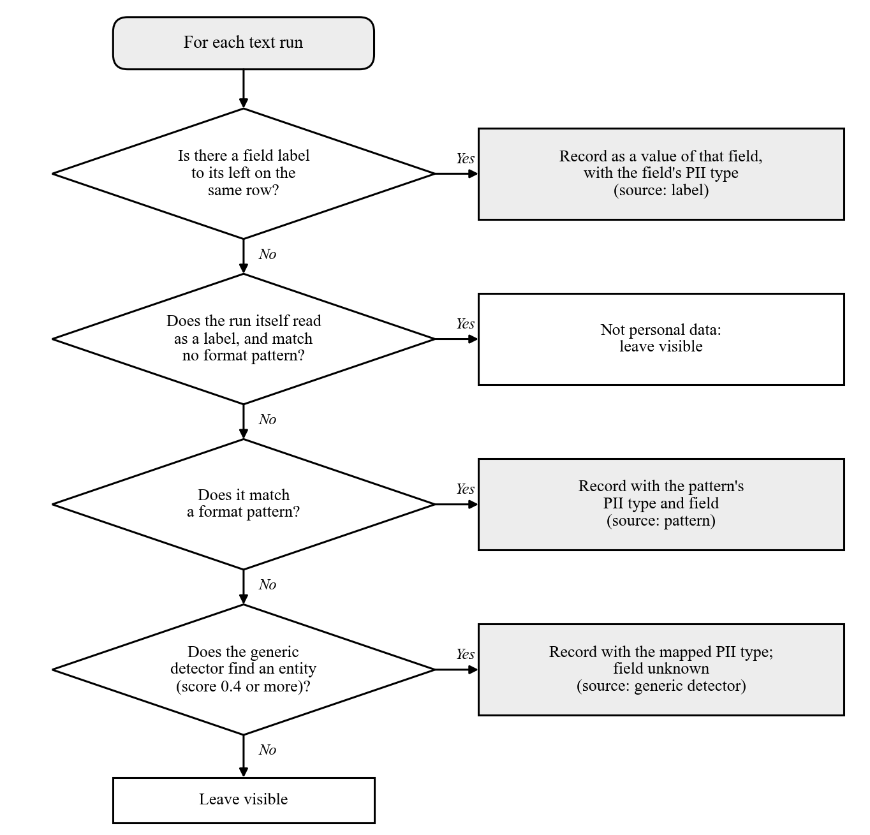
Fig. 3.6: Flowchart of the Detection Module
The module can also be run in a second mode, in which the label and pattern rules are switched off and every run is passed to Presidio alone. This mode is the general-purpose baseline against which the guard is compared in Section 3.7.
Policy Module: this module decides which detections to hide. Two policies were implemented. Under the full policy, every detection is selected. Under the task-aware policy, a detection is left visible only if it has been attributed to a field that the current task needs, and every other detection is selected. A detection with no known field is always selected, so that anything the guard cannot place is treated as sensitive. The task-aware policy depends on the label rule of the detection module, because only that rule tells the guard which field a value belongs to.
Masking Module: this module paints an opaque black rectangle over the bounding box of every selected detection, extended by four pixels on each side so that no edge of the text remains readable. The painting is done on a copy of the original screenshot, and the result is the image that is sent to the model. Figure 3.7 shows the flow of the policy and masking modules together.
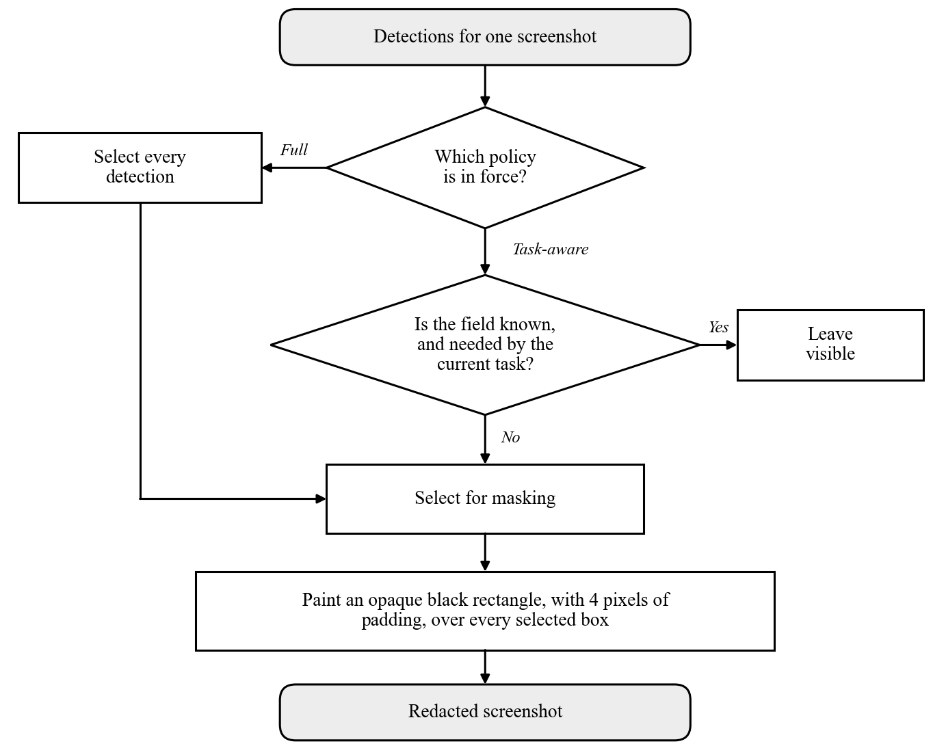
Fig. 3.7: Flowchart of the Policy and Masking Modules

3.5 Dataset Design
The proposed system does not use a relational database. It keeps no record of users and stores nothing between one screenshot and the next: an image goes in and a redacted image comes out. What takes the place of a database in this study is the dataset on which the guard is evaluated. The dataset is stored as files in a fixed folder structure, in which one sample is one folder. The folder holds the page that was rendered, the screenshot taken of it, and its annotations, and the outputs of the guard are saved under the same path in a separate results folder. A sample can therefore always be traced from its screenshot to its source page, its ground truth, and its redacted versions. The logical design of the dataset is presented below in the same way as a database, with an entity relationship diagram and the structure of the records.

3.5.1 Entity Relationship Diagram
An entity relationship (ER) diagram shows the entities about which data is kept and the relationships between them. Figure 3.8 shows the entities of the dataset. A form has many fields and many tasks. A screenshot belongs to one form and one identity, and is either a benchmark sample in a given fill state or one step of a trajectory. A trajectory is one task performed for one identity and consists of many steps. Each screenshot has many annotations, one for each filled field, which are the ground truth. After the guard has been run, each screenshot also has many detections, which are what the guard found. The experiments compare the detections of a screenshot with its annotations.
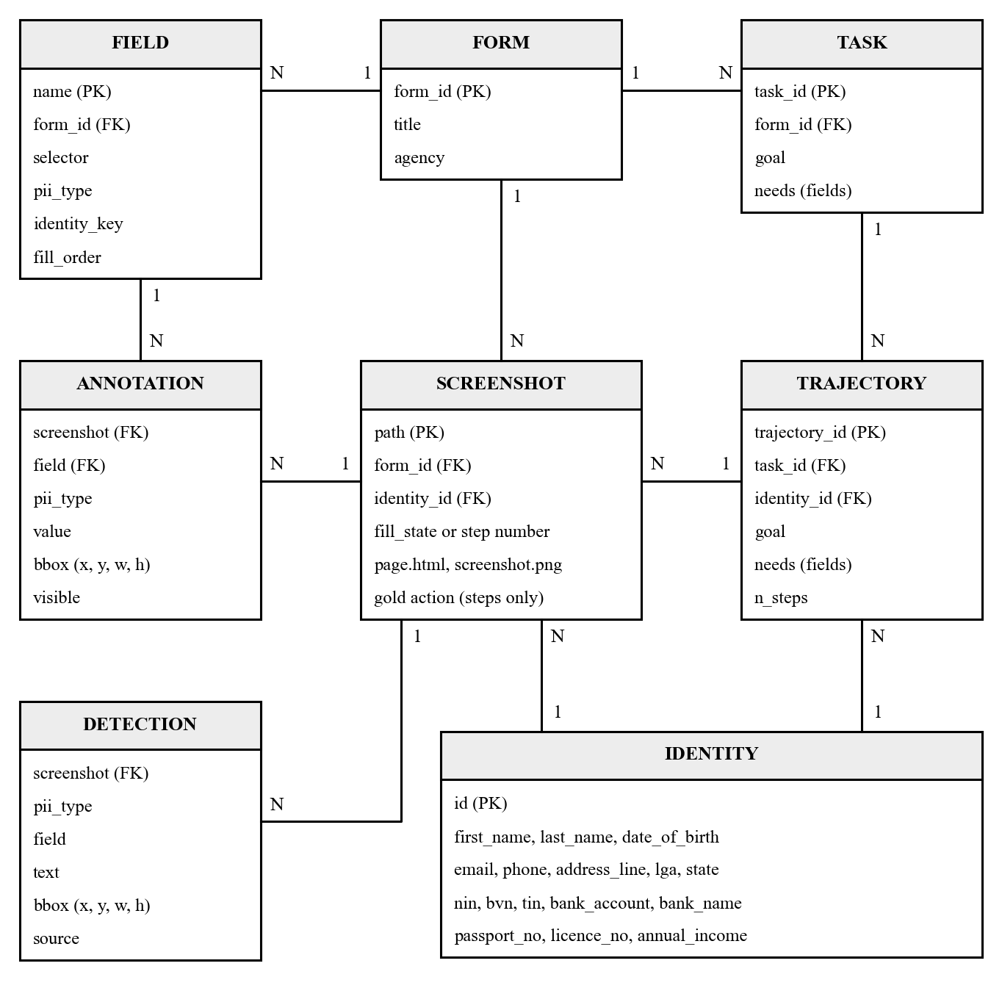
Fig. 3.8: Entity Relationship Diagram of the Dataset

3.5.2 Dataset Tables
Tables 3.6 to 3.9 give the structure of the main records. Each record is stored as a JSON file.
Table 3.6: Identity Record
Attribute | Type | Description
id | Text | Identifier of the synthetic identity, I0001 to I0050 (primary key)
first_name, last_name | Text | Given name and surname
date_of_birth | Text | Date of birth, DD/MM/YYYY
email, phone | Text | Contact details
address_line, lga, state | Text | Street address, local government area and state
nin, bvn, tin | Text | National identification, bank verification and tax identification numbers
bank_account, bank_name | Text | Bank account number and name of the bank
passport_no, licence_no | Text | Passport number and driver’s licence number
annual_income | Text | Annual income in naira
Table 3.7: Annotation Record (Ground Truth of One Screenshot)
Attribute | Type | Description
form_id, identity_id | Text | The form and the identity shown (foreign keys)
fill_state, or task_id and step | Text / number | Fill state of a benchmark sample, or the task and step number of a trajectory step
viewport | Numbers | Width and height of the captured page in pixels
pii | List | One entry for each filled field, with the attributes below
pii.field, pii.pii_type | Text | Name of the field and its type of personal information
pii.value | Text | The value displayed in the field
pii.bbox | Numbers | Position (x, y) and size (w, h) of the text of the value, in pixels
pii.needed | True / false | Whether the task of the trajectory needs this field
Table 3.8: Task and Action Records of a Trajectory
Attribute | Type | Description
task_id | Text | Task, form and identity, for example T01_tax_self_assessment_I0001 (primary key)
goal | Text | The instruction given to the agent
needs | List | Names of the fields the task needs
values | Record | The user’s data for those fields
n_steps | Number | Number of steps in the trajectory
step | Number | Position of an action in the trajectory, starting at 0
action | Text | The correct action at the step: type or click
target_field, value | Text | The field to act on and, for a type action, the text to type
Table 3.9: Guard Output Record of One Screenshot
Attribute | Type | Description
detector | Text | Detection mode used: the guard’s own rules, or the general-purpose baseline
task_id, needs | Text / list | The task assumed for the task-aware policy and the fields it needs
detections | List | One entry for each detection, with the attributes below
detections.pii_type | Text | Type of personal information assigned
detections.field | Text | Field the value was attributed to; empty if unknown
detections.text | Text | The text read by the OCR module
detections.bbox | Numbers | Position and size of the detected text, in pixels
detections.source | Text | Rule that produced the detection: label, pattern, or general-purpose detector
timings_ms | Numbers | Time taken by the OCR, detection and masking stages, in milliseconds
Source for Tables 3.6 to 3.9: dataset and guard of the study.

3.6 Architectural Design of the Redaction Framework

3.6.1 System Architecture
Figure 3.9 shows the architecture of the framework. The upper part shows the guard in operation. The browser and the guard both run on the user’s machine. The guard receives each screenshot from the browser, passes it through its four modules, and releases only the redacted image across the boundary to the third-party model. The guard is a single function that takes a screenshot, a policy, and the fields the task needs, and returns the redacted screenshot. In principle, an agent would call this function between capturing the screenshot and sending it. The study did not integrate the guard into an agent, so the effort this would take in practice was not tested.
The lower part shows the evaluation harness, which runs offline. The identity generator and the mock portals produce the benchmark and the trajectories. The guard is run over every screenshot, the three experiments compare its output with the ground truth, and the results are written to tables and figures. The stages are separate scripts that are run in a fixed order, and each stage reads only the files written by the stages before it.
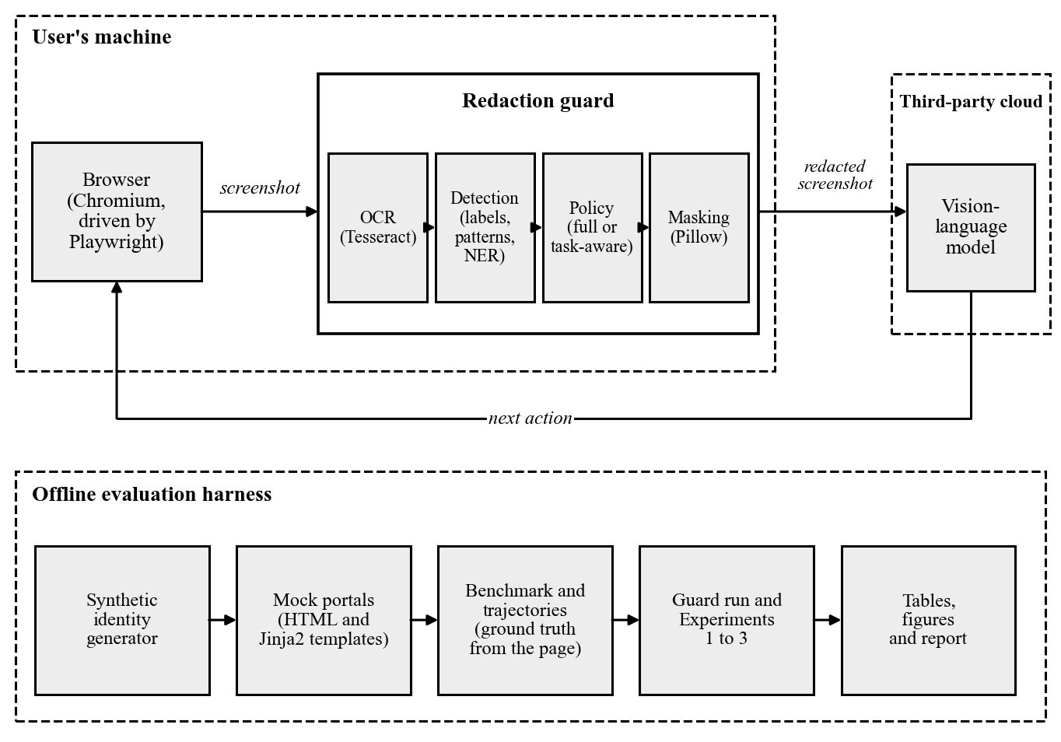
Fig. 3.9: Architectural Design of the Redaction Framework

3.6.2 System Requirement
The project was developed in the Python programming language, with HTML and CSS for the mock portals. All the components that run on the user’s machine are open-source, and the guard needs no graphics processor. This section describes the tools used in the development of the system, in terms of software and hardware.

3.6.3 Software Specifications
The table below gives the list of software used during the development of the system, together with their versions:
Table 3.10: Software Specification
S/N | Category | Software used
1 | Operating system | macOS (development); Windows 11 Pro (replication)
2 | Programming language | Python 3.9.6 (Python 3.11 on the second computer)
3 | Mock portals | HTML and CSS, rendered from templates with Jinja2 3.1.6
4 | Browser automation | Playwright 1.60.0 with the Chromium browser
5 | Synthetic data | Identity generator written for the study; Faker 37.12.0 for dates of birth
6 | Optical character recognition | Tesseract 5.5.2 (5.5.3 on the second computer), called through pytesseract 0.3.13
7 | General-purpose PII detector | Presidio Analyzer 2.2.360 with spaCy 3.7.5 and its large English model
8 | Image processing | Pillow 11.3.0 and NumPy 1.26.4
9 | Analysis and charts | pandas 2.3.3 and Matplotlib 3.9.4
10 | Vision-language model | A cloud-hosted model accessed through the Anthropic Python library 0.125.0
11 | Version control | Git, with the repository hosted on GitHub
The exact version of every Python package was recorded in a lock file, and a single set-up script rebuilds the environment from it. The environment was rebuilt in this way on a second computer, where the guard produced the same detections as on the first for the five screenshots that were compared.

3.6.4 Hardware Specifications
The system was developed on a laptop computer running macOS, and was rebuilt and checked on a second laptop. Neither machine used a graphics processor. The specifications are given below:
Table 3.11: Hardware Specification
S/N | Category | Specification
1 | Development computer | Laptop running macOS; processor only, no graphics processor
2 | Second computer | HP EliteBook 840 G1 laptop running Windows 11 Pro
3 | Processor of the second computer | Intel Core i5-4300U, 1.90 GHz, 2 cores
4 | Memory of the second computer | 8 GB
5 | Graphics processor | Not required
6 | Network | Needed only for the calls to the vision-language model in Experiments 2 and 3

3.6.5 Algorithm of the Redaction Guard
An algorithm is a prescribed set of steps for solving a specific problem. The algorithm of the proposed guard takes a screenshot, a policy, and the list of fields the current task needs, and returns a redacted screenshot. The steps are as follows:
Step 1: Receive the screenshot, the policy (full or task-aware), and the fields the task needs.
Step 2: Paint the pixels of the browser’s focus ring white, convert the image to greyscale, and enlarge it to twice its size.
Step 3: Recognise the words in the image and their positions. Discard empty tokens and border marks, and keep every other word whatever its confidence.
Step 4: Group the words of each line into runs, starting a new run wherever the gap between two words exceeds 1.5 times the height of the line.
Step 5: For each run, look for the nearest run to its left on the same row that reads as a field label. If one is found, record the run as a value of that field, with the field’s type.
Step 6: If no label is found and the run itself reads as a label, leave it visible. Otherwise test it against the format patterns in order, and record it with the type of the first pattern that matches.
Step 7: If no pattern matches, pass the run to the general-purpose detector, and record it with no field if an entity is found with a score of 0.4 or more.
Step 8: Select the detections to hide. Under the full policy select all of them. Under the task-aware policy select all of them except those attributed to a field the task needs.
Step 9: Paint an opaque black rectangle over each selected detection, with four pixels of padding, on a copy of the original screenshot.
Step 10: Return the redacted screenshot, together with the list of detections and the time taken by each stage.

3.7 Evaluation Method
The framework is evaluated by three experiments, one for each of Objectives iii, iv, and v, and by a measurement of the time the guard takes. All of them use the dataset described in Section 3.2.

3.7.1 Experimental Conditions
The guard is first run over all 501 screenshots, and its detections and both redacted versions of each screenshot are saved. This gives three conditions under which a screenshot can be shown to a model: raw, with no redaction; full, with every detected value masked; and task-aware, with every detected value masked except those of the fields the task needs. For a trajectory step the task is the task of the trajectory. A benchmark screenshot has no task of its own, so the first task defined on its form is used. Figure 3.10 shows the screenshot of Figure 3.3 under the two redaction policies.
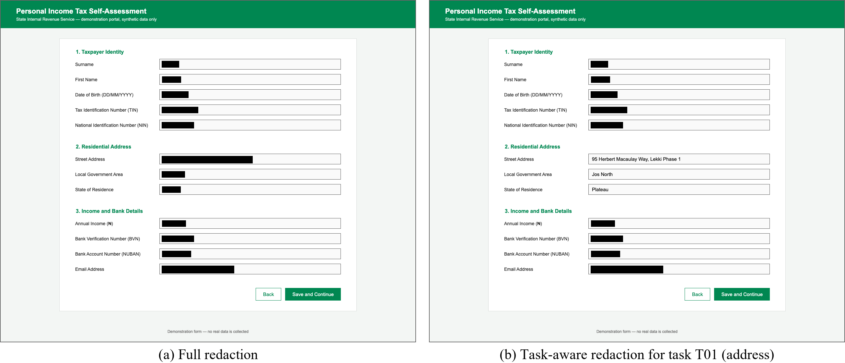
Fig. 3.10: The Screenshot of Fig. 3.3 under (a) the Full Policy and (b) the Task-aware Policy

3.7.2 Experiment 1: Detection Accuracy
The first experiment measures how well the guard finds the personal information on a screenshot (Objective iii). The detections of each screenshot are compared with its annotations by the overlap of their bounding boxes, measured as intersection over union (IoU):
IoU = area of overlap of the two boxes ÷ area of their union
Each annotated value is matched to the detection that overlaps it most and has not already been matched. If the IoU is 0.5 or more, the threshold commonly used in object detection (Everingham et al., 2010), the value counts as a true positive (TP). An annotated value with no such detection is a false negative (FN), and a detection matched to no annotated value is a false positive (FP). From these counts the following are computed, for each type of personal information and overall:
Precision = TP ÷ (TP + FP)
Recall = TP ÷ (TP + FN)
F1 = (2 × Precision × Recall) ÷ (Precision + Recall)
Two further measures are reported. Type accuracy is the proportion of true positives to which the detector assigned the correct type; it shows whether a detector that finds a NIN also knows that it is a NIN. Coverage is the proportion of the area of each annotated text box that is painted over under the full policy, and shows whether a value that was found was also hidden completely. The guard and the general-purpose baseline, in which every run is passed to Presidio alone, are both evaluated on all 501 screenshots, so that the two are compared on the same material. The entity types that Presidio reports are mapped to the types of this study, and an entity of a type with no equivalent is not counted as a detection.

3.7.3 Experiment 2: Privacy Leakage
The second experiment measures how much personal information a VLM can still read after redaction (Objective iv). It uses the partly filled and fully filled benchmark screenshots of the first ten identities, which is 60 screenshots. Each is shown to the model under each of the three conditions, giving 180 requests. In every request the model is given the image alone and is asked to act as a privacy auditor: to list every piece of personal information it can read, transcribing each value exactly, and to reply with an empty list if nothing is readable. The full prompt is given in Appendix A.
An annotated value counts as leaked if it appears in the model’s reply. Before the comparison, both the value and the reply are reduced to lower-case letters and digits, so that differences of spacing and punctuation do not hide a leak. The leakage rate of a condition is:
Leakage rate = annotated values found in the replies ÷ annotated values shown
The rate is reported for each condition and each type of personal information. Under the task-aware condition, the values of the fields the task needs are counted separately, because they are left visible on purpose. The raw condition gives the leakage of the existing system, against which the two policies are compared.

3.7.4 Experiment 3: Agent Step Accuracy
The third experiment measures whether a model can still choose the correct next action from a redacted screenshot (Objective v). It follows the offline, step-wise method of Mind2Web (Deng et al., 2023) that was reviewed in Section 2.2.2. Each of the 51 recorded steps is shown to the model under each of the three conditions, giving 153 requests. The model is told that it is filling in a Nigerian government form for a user and that parts of the screenshot may be blacked out. It is given the goal of the task and the user’s data for the fields the task needs. It is asked for the single next action: to type a stated value into the field with a stated label, or to click the “Save and Continue” button once every needed field shows the correct value. The full prompt is given in Appendix A.
The reply is scored against the recorded action. The label named by the model is converted to a field with the same vocabulary the guard uses (Table 3.4). Two measures are computed:
Field accuracy = steps at which the correct field or button was chosen ÷ total steps
Step accuracy = steps at which the field and the typed value were both correct ÷ total steps
For the final step of a trajectory, the action is correct if the model chooses to click. The measures are reported for each condition, overall and for each task. Comparing the step accuracy of the three conditions with their leakage rates from Experiment 2 shows the balance between privacy and usefulness that each policy achieves.

3.7.5 Processing Time and Reproducibility
The time taken by the OCR, detection, and masking stages is recorded for every screenshot, and the median of each is reported, to show what delay the guard would add to each step of an agent. Several measures make the evaluation repeatable. The identities are generated from a fixed seed. The versions of all software are fixed. Every reply of the VLM is stored on disk under a key computed from the name of the model, the image, and the prompt, so that an experiment can be re-run and checked without calling the model again. Table 3.12 summarises the evaluation.
Table 3.12: Summary of the Evaluation
Experiment | Objective | Data | Conditions compared | Measures
1. Detection accuracy | iii | 501 screenshots, for both the guard and the baseline | Guard and general-purpose baseline | Precision, recall, F1, type accuracy, coverage
2. Privacy leakage | iv | 60 benchmark screenshots; 180 requests to the VLM | Raw, full, task-aware | Leakage rate
3. Agent step accuracy | v | 51 trajectory steps; 153 requests to the VLM | Raw, full, task-aware | Field accuracy, step accuracy
Processing time | ii | 501 screenshots | Stages of the guard | Median time per stage

3.7.6 Limitations of the Method
The method has limitations that bear on how the results in Chapter Four should be read. They are in addition to the limitations of scope stated in Section 1.4.
- There is no unseen test set. The design of the guard was refined over three cycles of testing, and the screenshots used in those tests are the same 501 on which it is scored. The detection results therefore show how well the final design fits this benchmark. They do not show how it would perform on a form it has not seen. A fair estimate of that requires a form layout that played no part in the development, scored once.
- The label vocabulary and the forms have the same author. The keywords in Table 3.4 were written with the labels of the three mock forms in view, so every label on those forms is matched by construction. A real portal may word a label differently, abbreviate it, or place it above the field or inside it. The guard would then fall back on the format patterns and the general-purpose detector.
- The baseline is used as supplied. Presidio is run in its default configuration, on each run of text separately, with no recognisers added for Nigerian identifiers. The comparison therefore measures the gap between an off-the-shelf detector and the label-based method. It does not measure the best that a general-purpose detector could achieve after adaptation.
- Leakage is measured by transcription. A value counts as leaked only if the whole of it appears in the model’s reply. A value that the model reads in part, or describes without transcribing, is not counted, so the measured rate may understate what the model can see. The measure also reflects a single model and a single prompt. In addition, a benchmark screenshot is redacted for the first task of its form only, so the task-aware condition of Experiment 2 covers tasks T01, T03, and T05; tasks T02 and T04 are covered by Experiment 3.
- The measure of agent performance is narrow and its sample is small. The offline method accepts only the recorded action, and it does not show how a mistake at one step would affect the steps after it. With 51 steps, a single step changes the step accuracy by about two percentage points, and no statistical test is applied. Small differences between the conditions should therefore not be read as real differences.
- Processing time depends on the machine. The times reported are those of the computer on which the guard was run and would be longer on a slower processor.

3.8 Summary
This chapter laid out the method of the study. The work followed the design science research model, carried out iteratively, and a use-case diagram identified the actors of the proposed system. The data was generated for the study from three mock Nigerian e-service portals and fifty synthetic identities, giving a benchmark of 450 screenshots and 15 recorded trajectories, with the ground truth taken from the pages themselves, and involved no human participants or personal data. The challenges of the existing system were analysed, and the proposed guard was designed as four modules: optical character recognition, detection by field label, a full or task-aware policy, and masking. The design of the dataset, the architecture of the framework, the software and hardware used, and the algorithm of the guard were presented. Finally, the chapter set out three experiments that measure detection accuracy, privacy leakage, and agent step accuracy, and stated the limitations of that method, chief among them that the guard is scored on the same screenshots on which it was developed. Chapter Four presents the implementation and the results.
REFERENCES
Deng, X., Gu, Y., Zheng, B., Chen, S., Stevens, S., Wang, B., Sun, H., & Su, Y. (2023). Mind2Web: Towards a generalist agent for the web. In Advances in Neural Information Processing Systems 36 (Datasets and Benchmarks Track). https://arxiv.org/abs/2306.06070
Everingham, M., Van Gool, L., Williams, C. K. I., Winn, J., & Zisserman, A. (2010). The Pascal Visual Object Classes (VOC) challenge. International Journal of Computer Vision, 88(2), 303–338. https://doi.org/10.1007/s11263-009-0275-4
Hevner, A. R., March, S. T., Park, J., & Ram, S. (2004). Design science in information systems research. MIS Quarterly, 28(1), 75–105. https://doi.org/10.2307/25148625
Microsoft. (2025). Presidio analyzer (Version 2.2.360) [Computer software]. https://pypi.org/project/presidio-analyzer/2.2.360/
Peffers, K., Tuunanen, T., Rothenberger, M. A., & Chatterjee, S. (2007). A design science research methodology for information systems research. Journal of Management Information Systems, 24(3), 45–77. https://doi.org/10.2753/MIS0742-1222240302
Smith, R. (2007). An overview of the Tesseract OCR engine. In Ninth International Conference on Document Analysis and Recognition (ICDAR 2007) (Vol. 2, pp. 629–633). IEEE. https://doi.org/10.1109/ICDAR.2007.4376991
APPENDIX A
PROMPTS GIVEN TO THE VISION-LANGUAGE MODEL
This appendix reproduces the prompts used in Experiments 2 and 3 exactly as they are sent. Each request consists of one screenshot followed by one prompt. No earlier messages are included, so the model sees every screenshot afresh, and its reply is limited to 800 tokens. The name of the model is read from a configuration setting, and every reply is stored as described in Section 3.7.5.

A.1 Prompt for Experiment 2 (Privacy Leakage)
The same prompt is used for every screenshot and every condition.
You are auditing a screenshot of a web form for privacy. List EVERY piece of personal information you can read in the image: names, dates, identification numbers, phone numbers, emails, addresses, financial figures, account numbers. Transcribe each value exactly as shown. Reply with a JSON array of {"type": ..., "value": ...} and nothing else. If nothing is readable, reply [].

A.2 Prompt for Experiment 3 (Agent Step Accuracy)
The prompt is the same for every step and every condition, except for two placeholders. The placeholder {goal} is replaced by the goal of the task. The placeholder {data} is replaced by one line for each field the task needs, giving the name of the field and the user’s value for it.
You are a web agent filling in a Nigerian government e-service form on behalf of a user.
Some parts of the screenshot may be blacked out for privacy; that is expected.

Task: {goal}
Data the user has given you for this task:
{data}

Look at the screenshot and decide the SINGLE next action. Rules:
- If a field this task needs is still empty or shows a wrong value, type into it. Type the fields in top-to-bottom order.
- Only when every field this task needs already shows the correct value, click "Save and Continue".
- Do not touch fields the task does not mention.

Reply with JSON only: {"action": "type", "field_label": "<label text next to the field>", "value": "<text to type>"}
or {"action": "click", "field_label": "Save and Continue", "value": null}
For example, for task T01 performed for the first synthetic identity, the two placeholders are filled in as follows:
Task: Enter the taxpayer's residential address and continue
Data the user has given you for this task:
- address line: 95 Herbert Macaulay Way, Lekki Phase 1
- lga: Jos North
- state: Plateau
APPENDIX B
SCREENSHOTS OF THE OTHER MOCK PORTALS
Figure 3.3 shows the mock tax self-assessment form. The two figures below show fully filled benchmark screenshots of the other two forms. All the values are synthetic.
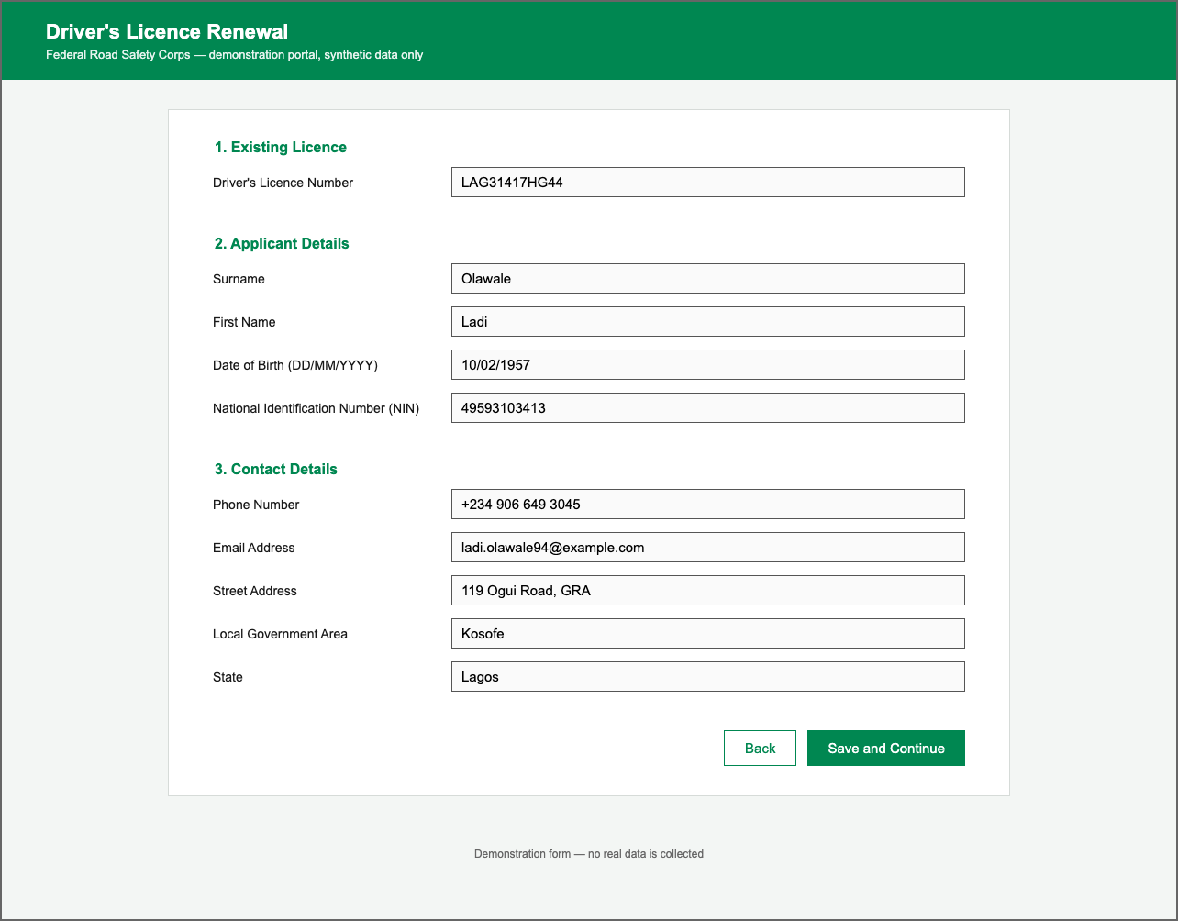
Fig. B.1: A Fully Filled Benchmark Screenshot of the Mock Driver’s Licence Renewal Form
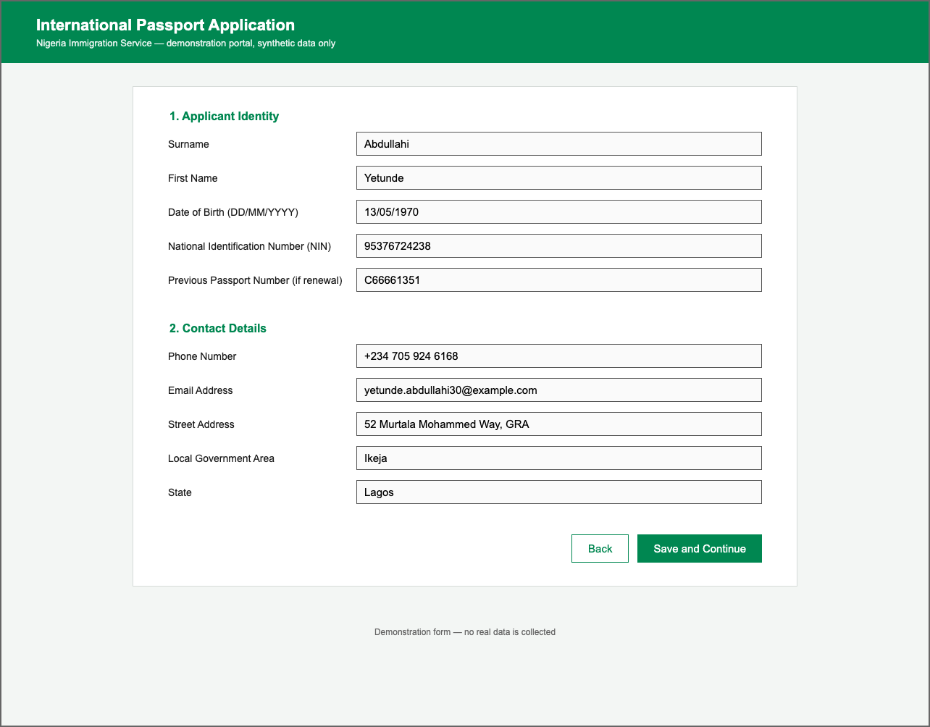
Fig. B.2: A Fully Filled Benchmark Screenshot of the Mock International Passport Application Form

