CHAPTER ONE

1.0 Introduction
The evolution of Artificial Intelligence (AI) has transformed how humans interact with digital systems. Modern AI agents, unlike traditional text-based chatbots, can directly engage with graphical user interfaces by interpreting screenshots, navigating websites, and completing forms. These screenshot-driven agents, powered by Vision-Language Models (VLMs), are being developed and piloted to assist citizens with complex administrative tasks on government portals, such as filing a personal income tax self-assessment, renewing a driver’s licence, or applying for an international passport.
These agents typically operate through a perception-action loop: a screenshot of the page is captured, sent to a VLM that is usually hosted in the cloud, interpreted and reasoned over by that model, and translated into an interface action such as a click or keystroke. The whole screen travels to the model at every step, including everything on it that the current action does not require. It is precisely at this perception stage, after the screenshot is captured and before it is passed onward for reasoning, that this project intervenes.
While these technologies promise efficiency and accessibility, they also introduce significant privacy challenges. A screenshot of a Nigerian e-service form may show a citizen’s name, date of birth, address, phone number, National Identification Number (NIN), Bank Verification Number (BVN), Tax Identification Number (TIN), bank account number, passport number, and income. Without adequate safeguards, a screenshot-driven agent exposes all of this to a third-party model, even when the task at hand needs only one or two of those fields. This project proposes a data minimization framework at the perception layer: a redaction guard that reads each screenshot, works out which form field every visible value belongs to, and masks the values the current task does not need before the image is sent to the model.

1.1 Background of the Study
AI assistants for government services, such as Paperasse, are designed to support citizens in completing procedures on government portals. Paperasse is described as incorporating safeguards on its actions, such as requiring humans to click the final “Submit” button and restricting interactions to official websites. Safeguards of this kind govern what an assistant may do. For an agent that works from screenshots, they leave open the separate question of what the model is shown.
Recent studies highlight that screenshots frequently contain personally identifiable information (PII), which may be transmitted to cloud-hosted AI services for processing. This creates a gap between privacy policies and actual system behaviour. Furthermore, privacy-conscious frameworks such as AirGapAgent demonstrate that limiting access to only task-relevant information can reduce risks without compromising functionality. That work concerns conversational agents that exchange text; this study applies the same principle to the visual input of screenshot-driven agents.
At a high level, redaction guards are usually built by combining optical character recognition (OCR), which extracts the visible text, with named-entity recognition (NER) or pattern-based detectors, which identify sensitive values so that they can be masked. General-purpose detectors of this kind, such as Microsoft Presidio, recognise the identifiers of a fixed list of countries, which in the version used in this study does not include Nigeria, and they examine each piece of text on its own. Government forms challenge that approach. On a Nigerian form, a NIN and a BVN are both eleven-digit numbers, a bank account number is a ten-digit number, and an income figure is simply a number. Nothing in the characters says which is which, or that the value is sensitive at all. What identifies the value is the label printed beside it on the form.
The redaction guard developed in this study is built on that observation. It works in four stages. First, OCR extracts the text on the screenshot together with its position. Second, a detection stage attributes each value to a form field by reading the label on the same row, with format patterns and a generic NER detector as fallbacks. Third, a policy stage decides which fields to hide: either all of them, or all except those the current task needs. Fourth, a masking stage paints opaque boxes over the selected values before the screenshot leaves the perception layer. The works on which this design draws are reviewed in Chapter Two, and the design itself is set out in Chapter Three.
Applying data minimization principles at the perception layer of screenshot-driven agents is one way to give technical effect to the minimization rule found in privacy regulations such as the GDPR and the Nigeria Data Protection Act (NDPA) 2023. It would also complement human-in-the-loop governance, by limiting what the model can see as well as what the agent can do.

1.2 Statement of the Problem
Data minimization is a fundamental principle of privacy engineering, requiring that systems collect and process only the information necessary for a specific purpose. Guidance on applying the principle has mostly concerned structured data such as databases and API communications. How it should apply to the visual data processed by screenshot-driven agents has received much less attention.
As a result, organisations may comply with traditional security requirements yet still expose sensitive information through screenshots. Every screenshot sent to a cloud-hosted model discloses the whole page, although a single step of a task usually needs only a few fields. This gap creates a risk of privacy leakage.
General-purpose PII detection tools, as supplied, do not appear to close this gap for Nigerian e-services, for two reasons. First, the tool examined in this study does not reliably recognise Nigerian identifiers and names. In the evaluation carried out for this study and reported in Chapter Four, a widely used general-purpose detector, in the version tested, found 56 per cent of the personal values on mock Nigerian government forms, and never correctly identified a NIN, BVN, or TIN. Second, a detector of this kind does not know which form field a value belongs to, so it cannot support minimization that depends on the task: it can only mask what it recognises. No perception-layer control was found that takes the structure of a web form into account, and it remains unknown how much information can be withheld from the model before the agent can no longer carry out its task.

1.3 Aim and Objectives of the Study
To design, implement, and evaluate a visual redaction framework that minimizes privacy leakage from screenshots of Nigerian government e-service forms used by AI agents, while preserving the agents’ ability to complete government service tasks effectively.

Objectives
- Develop a benchmark dataset of screenshots of mock Nigerian e-service forms, filled with synthetic identities and automatically annotated with the location, type, and form field of every item of personally identifiable information (PII).
- Design and implement a lightweight visual redaction guard that identifies PII from its form-field label and masks it before screenshot transmission, under both a full redaction policy and a task-aware redaction policy.
- Evaluate the detection accuracy of the guard against the benchmark, and compare it with a general-purpose PII detector used as a baseline.
- Evaluate the effectiveness of the redaction framework in reducing privacy leakage, measured by how much personal information a VLM can still read from redacted screenshots.
- Assess the impact of redaction on AI agent performance, measured by whether a VLM still selects the correct next action at each step of recorded task trajectories.

1.4 Scope and Limitations of the Study

Scope
- Focuses on screenshot-driven AI agents in government service environments, specifically Nigerian e-services.
- Concentrates on perception-layer privacy risks rather than structured data flows: the guard acts on the screenshot after it is captured and before it is sent to the model.
- Uses three mock portals and fifty synthetic identities. The portals are modelled on a personal income tax self-assessment, a driver’s licence renewal, and an international passport application. No real citizen data and no live government portal are involved.
- Covers textual PII displayed in form fields: names, dates of birth, addresses, phone numbers, email addresses, NIN, BVN, TIN, bank account numbers, passport numbers, driver’s licence numbers, and income.
- Evaluates the balance between privacy protection and agent performance under three conditions: no redaction, full redaction, and task-aware redaction.
- Uses Paperasse as an illustration. Paperasse is an existing commercial assistant for government procedures, and it is used here to motivate the problem; the study does not involve direct integration into or deployment on Paperasse’s own codebase.

Limitations
- The study does not address network-level security or database encryption.
- The framework is limited to visual redaction of text. It does not cover photographs or signatures, or broader AI safety risks such as adversarial attacks.
- Evaluation is constrained to mock government forms and synthetic identities, not live portals or general-purpose web applications. The results therefore show how the method behaves, not how any particular government website would.
- The guard depends on field labels. The mock forms share one layout, in English, with each label on the same row as its value. Forms laid out differently may reduce its accuracy.
- The task-aware policy decides field by field. A field that is left visible because the task needs it can disclose a field that was masked, as when an email address contains the name of its owner.
- The evaluation uses a single OCR engine and a single VLM, so the results may not transfer unchanged to other engines or models.
- Agent performance is measured offline on recorded task steps, not with a live agent completing tasks end to end. Human-in-the-loop controls are discussed as context but are not implemented.

1.5 Significance of the Study
This study is relevant to trustworthy AI, privacy engineering, and AI governance, because it examines a privacy risk that arises when AI agents work from screenshots. Specifically:
- It supports GDPR and Nigeria Data Protection Act (NDPA) 2023 compliance by showing one way in which the data minimization principle can be given technical effect. The principle appears both in the GDPR and in Nigeria’s own Act.
- It provides evidence on Nigerian identifiers and names, showing where general-purpose PII detection tools fall short on them and examining form-label reading as an alternative.
- It contributes a reproducible benchmark of Nigerian e-service screenshots whose annotations are generated automatically from the web page, so that other researchers can regenerate and extend it without manual labelling.
- It can strengthen citizen trust in AI-assisted government services by limiting what a third-party model is shown.
- It offers a reference design for privacy-preserving middleware that could inform the design of screenshot-driven agents and of government-service assistants such as Paperasse.
- It adds to research on privacy-preserving perception frameworks for screenshot-driven agents a practical lesson: such guards should be tested on screenshots captured from a live browser.

1.6 Definition of Terms
- Data Minimization: A privacy principle requiring systems to collect and process only the data necessary for a specific purpose.
- Perception Layer: The stage at which an AI agent captures a screenshot or other visual input and passes it to a model for interpretation. In this study, the redaction guard sits at this stage.
- Screenshot-Driven Agent: An AI system that relies on screenshots of web interfaces to perform tasks.
- Vision-Language Model (VLM): An AI model that accepts both images and text as input, used by screenshot-driven agents to interpret the screen and decide the next action.
- Personally Identifiable Information (PII): Data that can identify an individual, alone or in combination with other data, such as names, ID numbers, or financial details.
- NIN, BVN, and TIN: The National Identification Number, Bank Verification Number, and Tax Identification Number: Nigerian identifiers used for national identity, banking, and taxation respectively. The NIN and BVN are both eleven-digit numbers.
- Optical Character Recognition (OCR): The conversion of text in an image into machine-readable text, together with its position in the image.
- Named-Entity Recognition (NER): A language-processing technique that finds and classifies names of people, places, dates, and similar items in text.
- Visual Redaction: The process of masking or concealing sensitive information within screenshots before processing.
- Redaction Guard: The software component developed in this study, which receives a screenshot, detects the PII on it, and returns a masked copy for the model.
- Label-Context Detection: Identifying what a value on a form is from the field label displayed beside it, instead of from the characters of the value itself.
- Task-Aware Redaction: A redaction policy that leaves visible only the fields the agent needs for its current task and masks all others. Full redaction, by contrast, masks every detected value.
- Privacy Leakage: Personal information that remains readable to the model after redaction.
- Step Accuracy: The proportion of steps in a recorded task at which the model chooses the correct next action.
- Human-in-the-Loop (HITL): A governance framework ensuring that humans retain authority over critical AI decisions.

1.7 Summary
This chapter introduced the project on data minimization at the perception layer for screenshot-driven agents, highlighting the privacy risks posed by screenshots in AI-assisted government services. The background established the relevance of Paperasse and recent research on privacy leakage, and explained why a general-purpose PII detector may miss values on Nigerian government forms, where the meaning of a value lies in its label. The problem statement identified that guidance on data minimization has given little attention to visual data, and that general-purpose detection tools as supplied leave a gap, while the aim and objectives outlined the project’s direction: a benchmark, a label-aware redaction guard, and evaluations of detection accuracy, privacy leakage, and agent performance. The scope and limitations clarified boundaries, in particular the use of mock forms and synthetic identities, and the significance set out what the study may contribute. Finally, key terms were defined to provide clarity for subsequent chapters.

CHAPTER TWO
LITERATURE REVIEW

2.0 Introduction
This chapter reviews the literature on which the project rests. Section 2.1 sets out the theoretical framework of the study: contextual integrity, the data minimization principle, and privacy by design. Section 2.2 reviews vision-language models and screenshot-driven agents, and the ways in which such agents are evaluated. Section 2.3 considers AI assistants for government e-services and the Nigerian context in which this study is set. Section 2.4 reviews the privacy risks of AI agents, Section 2.5 the techniques used to detect and redact personal information, and Section 2.6 the recent work on protecting screenshots before they reach a model. Section 2.7 compares the related works and identifies the gap that this study addresses, and Section 2.8 summarises the chapter.

2.1 Theoretical Framework of the Study
Three ideas frame the study. Contextual integrity explains why sending a screenshot of a government form to a third-party model is a privacy problem even when nothing is stolen. The data minimization principle states what the law requires in response. Privacy by design indicates where in a system that requirement should be met.

2.1.1 Contextual Integrity
Nissenbaum (2004) argues that privacy is not secrecy but the appropriate flow of information. Every social context, such as a hospital, a bank, or a government office, carries norms about what information it is appropriate to reveal there and how that information may be passed on. A privacy violation occurs when information moves in a way that breaks the norms of the context in which it was given. The theory is developed at length in Nissenbaum (2010), and it has become a standard lens for studying AI systems: Mireshghallah et al. (2024) and Shao et al. (2024) both use it to test whether language models share information appropriately.
Applied to this study, the theory gives a precise account of the harm. A citizen who types a National Identification Number (NIN) into a driver’s licence renewal form is sharing it with the licensing agency, for the purpose of renewing a licence. When an AI agent captures that page as a screenshot and sends it to a cloud-hosted model, the same number, together with every other value on the page, flows to a party that is outside that context and has no role in the transaction. Under contextual integrity this flow can be questioned even if the model provider neither stores nor misuses the data, because the norms under which the number was given did not anticipate it. A citizen who chooses to use an agent has agreed to some such flow, but arguably only to what the task requires. The theory also explains why the answer cannot simply be to hide everything: some fields must flow to the model for the agent to do the task the citizen asked for. What matters is which information flows, to whom, and for what purpose.

2.1.2 The Data Minimization Principle
Data protection law expresses the same idea as an obligation. Article 5(1)(c) of the General Data Protection Regulation (GDPR) requires personal data to be “adequate, relevant and limited to what is necessary in relation to the purposes for which they are processed” (Regulation (EU) 2016/679, 2016). Nigerian law contains an equivalent rule. Section 24(1)(c) of the Nigeria Data Protection Act requires personal data to be “adequate, relevant, and limited to the minimum necessary for the purposes for which the personal data was collected or further processed” (Nigeria Data Protection Act, 2023), and the General Application and Implementation Directive issued by the Nigeria Data Protection Commission (2025) lists data minimisation among the principles that data controllers must apply.
Two features of the principle matter here. First, it is tied to purpose: the test is not whether data is sensitive in the abstract but whether it is needed for the processing at hand. For a screenshot-driven agent the purpose changes at every step, so the set of fields that may legitimately be shown to the model changes too. Second, the law states the requirement but not the mechanism. It does not say how a system that sees the world through images should limit what it sees. Section 65 of the Act defines sensitive personal data by category, including biometric, health, and genetic data. Identifiers such as the NIN and the Bank Verification Number (BVN) are not named in that list, but they identify a person directly and so are personal data to which the minimization rule applies.

2.1.3 Privacy by Design
Privacy by design holds that privacy should be built into a system from the start and should be its default behaviour, not something added afterwards or left to the user (Cavoukian, 2010). Article 25 of the GDPR makes this a legal duty, requiring that by default only the personal data necessary for each specific purpose is processed (Regulation (EU) 2016/679, 2016). Hoepman (2014) translates the idea into eight design strategies that engineers can apply. Two of them describe this project directly: MINIMISE, which restricts the personal data processed to the least possible amount, and HIDE, which keeps personal data from plain view.
Taken together, the three ideas define the design problem of this study. Contextual integrity identifies the screenshot sent to a third-party model as the inappropriate flow. Data minimization requires that the flow be limited to what each step of the task needs. Privacy by design requires that the limit be enforced by the system itself, before the data leaves the user’s machine. The redaction guard developed in this study is an attempt to implement the MINIMISE and HIDE strategies at exactly that point, which Chapter One called the perception layer.

2.2 Vision-Language Models and Screenshot-Driven Agents

2.2.1 From Text-Based to Screenshot-Driven Agents
A vision-language model (VLM) accepts images as well as text, and can therefore be asked to read a screen and decide what to do next. The first generation of web agents did not work this way. They read a textual representation of the page. The baseline agent of Mind2Web takes the page’s HTML as input (Deng et al., 2023), and the baseline agents of WebArena observe the browser’s accessibility tree (Zhou et al., 2024). Results were modest: the best agent in WebArena completed 14.41 per cent of 812 tasks, against 78.24 per cent for humans (Zhou et al., 2024).
Research then moved towards agents that look at the screen. Yang et al. (2023) showed that overlaying numbered marks on an image helps a VLM refer to specific regions, a technique known as set-of-mark prompting. Zheng et al. (2024) built SeeAct, in which the model chooses the next action from a screenshot and a second step links that action to an element on the page. On live websites it completed 51.1 per cent of tasks when the linking step was done perfectly, against 13.3 per cent for a text-only agent. He et al. (2024) reported a similar gain for WebVoyager, which works from screenshots with numbered boxes and completed 59.1 per cent of 643 tasks on 15 live websites, against 40.1 per cent for its text-only variant. Koh et al. (2024) built VisualWebArena, a benchmark of 910 tasks that cannot be solved without visual understanding, on which the best agent reached 16.37 per cent and humans 88.7 per cent. Xie et al. (2024) extended the idea from the browser to the whole computer with OSWorld, a set of 369 tasks on real operating systems, where the best model completed 12.24 per cent of tasks and humans 72.36 per cent.
Commercial systems followed. Anthropic (2024) released a computer-use capability in which the model views the screen through a series of screenshots and moves the cursor by counting pixels. OpenAI (2025a) described its Computer-Using Agent as a repeated cycle of perception, reasoning, and action over screenshots, and reported 38.1 per cent on OSWorld. In their survey of the field, Zhang et al. (2025) describe the same workflow as common to all such agents: perceive the environment, combine the user’s instruction with the current state of the screen, ask the model for the next action, execute it, and repeat until the task is done.
One consequence of this design is central to the present study. In every cycle of the loop a complete image of the screen is sent to the model, and the model is usually hosted by a third party. The move from text to screenshots made agents more capable, but it also means that everything visible on the page is disclosed at every step, whether or not the step needs it.

2.2.2 How Web Agents Are Evaluated
The literature evaluates agents in two ways. Online evaluation places the agent in a live or simulated environment and checks whether the whole task was completed. WebArena checks the final state of the website programmatically (Zhou et al., 2024), OSWorld runs scripts that inspect the state of the computer (Xie et al., 2024), and WebVoyager relies on human judges, supported by an automatic judge that agreed with them in 85.3 per cent of cases (He et al., 2024).
Offline evaluation instead scores the agent one step at a time against recorded human demonstrations. Mind2Web is the standard example. It contains 2,350 tasks recorded on 137 websites in 31 domains. At each step the model is shown the page and the correct history so far, and is asked for the next action. The prediction is scored for element accuracy, which asks whether the right element was chosen, and for the operation performed on it. A step succeeds when both are right, and the proportion of such steps is the step success rate (Deng et al., 2023). Zheng et al. (2024) reuse the same measures for their offline experiments.
Each method has a cost. Online evaluation is realistic but needs a working environment, and its results vary from run to run. Offline evaluation is cheap and repeatable, and it isolates the effect of a single change to the model’s input. Its weakness is that it accepts only the recorded action, and it does not show how an early mistake affects later steps. This study measures the effect of redaction on the agent with the offline, step-wise method, following Mind2Web, because the question it asks is narrow: whether the model still chooses the correct next action when part of the screenshot has been masked.

2.3 AI Assistants for Government E-Services

2.3.1 E-Government and Personal Identifiers in Nigeria
Nigeria has moved many public services online, but citizens still find them difficult to use. In the United Nations E-Government Survey 2024, Nigeria scored 0.4815 on the E-Government Development Index and ranked 144th of 193 countries (United Nations Department of Economic and Social Affairs, 2024). A systematic review of 26 studies by Ayesha et al. (2025) found that the obstacles most often reported are poor infrastructure and power supply, followed by low digital literacy. An assistant that can read a government form and help a citizen complete it speaks directly to the last of these, which is one reason agents for administrative tasks are attracting interest.
The forms themselves are dense with identifiers. The NIN is issued by the National Identity Management Commission (NIMC) and consists of eleven randomly chosen digits (NIMC, n.d.). The Commission reported over 123.9 million records by the end of October 2025 (NIMC, 2025), and the law under which it operates was replaced by a new NIMC Act in June 2026 (NIMC, 2026). The BVN was launched by the Central Bank of Nigeria in February 2014 (Central Bank of Nigeria, n.d.) and is likewise an eleven-digit number. Bank account numbers follow the Nigeria Uniform Bank Account Number standard, under which the account number given to a customer is ten digits (Central Bank of Nigeria, 2019). Every taxable person is also required to hold a taxpayer identification (Nigeria Tax Administration Act, 2025). Passport and driver’s licence numbers appear on the forms of the agencies that issue them.
Two observations follow. First, these numbers are the keys to a person’s identity, bank, and tax records, so their exposure carries a real risk of fraud. Second, their formats reveal very little. Two of them are eleven digits long and one is ten. Nothing in the digits says which identifier a number is, or that it is an identifier at all. This point becomes important in Section 2.5.

2.3.2 Paperasse and Human-in-the-Loop Safeguards
Paperasse AI is a commercial assistant for French administrative procedures, offered as a browser extension and a mobile application (EverydayMoney SAS, 2026). According to its public documentation, the user opens the government portal and signs in. The assistant then reads the content of the form and, when instructed, fills in fields and moves between pages. It works only on a list of supported official portals, it does not handle passwords, and it never submits a form: nothing is sent until the user has checked it and clicked the button personally. The same documentation states that page content is sent to the service and to third-party AI providers.
Paperasse illustrates a pattern that recurs in the vendors’ own guidance. Anthropic (n.d.) advises developers to keep sensitive data away from a computer-use model, to restrict it to approved websites, and to ask a human to confirm consequential actions. OpenAI (2025b) describes a takeover mode in which the user enters credentials or payment details personally, and during which the agent takes no screenshots. These are human-in-the-loop safeguards. They control what the agent may do, and they are valuable. They do not control what the model is shown during the rest of the task. Takeover mode comes closest, but it is all or nothing and depends on the user stepping in.
Two cautions apply to the use of Paperasse in this study. Its documentation describes the assistant as reading the content of the page; it does not say that the assistant works from screenshots. It is also a product, not a research system, so its internal design is not published. Paperasse is therefore cited here as an example of a government-service assistant with action-level safeguards, while the screenshot channel itself is represented by the computer-use agents reviewed in Section 2.2.

2.4 Privacy Risks in AI Agents

2.4.1 Leakage Through What the Agent Says and Does
Most research on agent privacy asks whether an agent that holds personal information will reveal it inappropriately. Mireshghallah et al. (2024) built ConfAIde, a benchmark based on contextual integrity, and found that GPT-4 and ChatGPT revealed private information in contexts where humans would not in 39 per cent and 57 per cent of cases. Shao et al. (2024) showed with PrivacyLens that the problem is worse in action than in conversation: models that answer questions about privacy correctly still leak when acting as agents, and even with privacy-enhancing instructions GPT-4 leaked in 25.68 per cent of cases and Llama-3-70B in 38.69 per cent. Zharmagambetov et al. (2025) took the question to web agents. Their AgentDAM benchmark of 246 tasks tests whether an agent uses sensitive information only when the task needs it, and they found that agents often pass on information that the task does not require. Their mitigation is a privacy-aware prompt, which reduced leakage but did not remove it.
Agents can also be attacked. Liao et al. (2025) inject malicious content into a web page so that an agent which reads the page is steered into disclosing the user’s data. On 177 action steps drawn from Mind2Web the attack stole specific personal information with up to 70 per cent success, and a defensive system prompt did little to prevent it.
The most instructive defence in this group is AirGapAgent (Bagdasarian et al., 2024). Its authors observe that an agent cannot leak what it was never given. They place a separate minimizer between the user’s data and the conversational agent. The minimizer sees only the task and the user’s profile, and passes on only the fields the task needs. Under an attack designed to make the agent reveal everything, a baseline agent protected 45 per cent of user data and AirGapAgent protected 97 per cent. The work concerns text-based conversational agents with structured user profiles, and no screenshots are involved. In that work, withholding the data protected it better than instructions to the model did. This study takes the same approach to screenshots.

2.4.2 Leakage Through What the Agent Sees
The studies above concern what the agent sends out to websites or to other parties. A screenshot-driven agent has a second and earlier channel: the screenshot itself, sent to the model provider. This disclosure happens however well the agent behaves afterwards, and research on it is more recent.
Vision-language models are good at extracting personal information from images. Tömekçe et al. (2024) showed that such models infer personal attributes of the owner of an ordinary online photograph with up to 77.6 per cent accuracy, and that accuracy rises with the general capability of the model. Lin et al. (2025) tested whether smartphone agents recognise privacy-sensitive content on the screens they handle. Across 7,138 scenarios most agents scored below 60 per cent, and the best reached 67 per cent, which suggests that the agents tested often fail to notice sensitive content themselves. Cen et al. (2026) measured the leakage directly. On screenshot traces from 16 mobile applications, VLMs extracted the sensitive information present with up to 82.5 per cent success, and could build a profile of the user from the accumulated screens. N. Zhao (2026) makes the same point for web agents, noting that cloud-hosted inference exposes the user’s screenshots. The visual channel is therefore a real and measurable source of leakage, and it is the channel that this study addresses.

2.5 Detection and Redaction of Personal Information
Before a value can be hidden it has to be found. This section reviews how personal information is detected in text and in images, where general-purpose detectors fall short, and what research on form understanding offers instead.

2.5.1 Detection in Text
Detectors of personally identifiable information (PII) combine two techniques. Pattern rules recognise values with a fixed shape, such as email addresses and card numbers. Named-entity recognition (NER) uses a statistical language model to find names of people, places, and dates in running text. The approach is most mature in medicine. In the 2014 i2b2/UTHealth shared task on removing identifiers from clinical records, the best system reached an F1 score of 0.936, and the organisers concluded that de-identification was not yet a solved problem (Stubbs et al., 2015). Lison et al. (2021) argue that anonymising text involves more than labelling entities, because what must be hidden depends on the risk of disclosure in context. Pilán et al. (2022) built the Text Anonymization Benchmark of 1,268 court cases on that basis, annotating not only what each identifier is but whether it needs to be masked.
The most widely used open-source tool of this kind is Presidio, which is the baseline in this study. It combines named-entity recognition, regular expressions, rule-based logic, and checksums, and uses the words around a candidate value to adjust its confidence (Microsoft, 2025). Its documentation warns that it cannot guarantee to find all sensitive information. Much of its coverage comes from recognisers written for particular countries. The version used in this study, 2.2.360, includes recognisers for identifiers of the United States, the United Kingdom, Spain, Italy, Poland, Finland, Singapore, Australia, India, and Korea, and none for Nigeria. A later release added an optional recogniser for the NIN, switched off by default, but still none for the BVN, bank account numbers, or tax identifiers (Presidio Contributors, 2026).

2.5.2 Uneven Performance Across Names and Regions
A consistent finding is that these tools do not serve all populations equally. Mishra et al. (2020) tested several NER systems on sentences that differed only in the name used, and found that names typical of some demographic groups were recognised more reliably than others. Mansfield et al. (2022) repeated the exercise on three off-the-shelf PII masking tools and found significant differences in error rate between groups in all three. Ji et al. (2025) report the comparison closest to this study: on names grouped by region, Presidio recalled 0.76 of African names, against 0.90 of European names and 0.91 of names from the Americas.
Part of the cause is the data on which language models are trained. Adelani et al. (2021) note that African languages are under-represented in NER because annotated datasets are lacking, and built MasakhaNER to begin to fill the gap; the dataset and its successor include Hausa, Igbo, Yorùbá, and Nigerian Pidgin (Adelani et al., 2022). That work concerns text written in African languages. No published study was found that evaluates the detection of Nigerian identifiers such as the NIN and BVN, or of Nigerian names in English-language forms.

2.5.3 Detection in Images
Personal information in an image must first be turned into text or located visually. Optical character recognition (OCR) does the former. Tesseract, the open-source engine used in this study, is described by Smith (2007). The usual pipeline for redacting a screenshot is OCR followed by a text detector: Presidio provides an image redactor that works this way, using Tesseract by default, though it is described as a beta feature (Presidio Contributors, 2026). The alternative is to train a model to find private regions directly from pixels. Orekondy et al. (2018) did this for photographs, and were among the first to measure redaction in terms of both privacy and the usefulness of the image that remains.
For screenshots of web pages, N. Zhao (2026) compared the two approaches. An OCR and Presidio pipeline scored 0.183 on the benchmark’s detection measure, the best text-extraction baseline scored 0.357, and a detector trained on the benchmark scored 0.753. The weakness of the OCR pipeline in that comparison is consistent with the limits described above. Once OCR has broken a page into fragments of text, a detector that examines each fragment on its own has lost the layout that gave the fragment its meaning.

2.5.4 Form Understanding and Label Context
Research on document understanding has long recognised that on a form the meaning of a value lies in its relationship to other text. Jaume et al. (2019) built FUNSD, a dataset of 199 scanned forms in which each piece of text is marked as a question, an answer, a header, or other, and in which questions are linked to their answers. Their example is the link from the label “Registration No.” to the value “533”: the number means nothing until it is joined to its label. Xu et al. (2020) showed with LayoutLM that a model given the position of each word on the page as well as the word itself understands forms markedly better, raising the score on FUNSD from 70.72 to 79.27.
In the works reviewed here, this insight has not been carried over to PII detection for agents. The general-purpose detectors read values in isolation, and the trained visual detectors learn what private regions look like. Neither asks which field of the form a value belongs to. Yet on a government form the label is direct evidence of what a value is. The label states that an eleven-digit number is a NIN and not a BVN, and that a plain number is an annual income. The label also identifies the field, which is exactly what is needed to decide whether the current task requires the value. The guard developed in this study is built on this observation. Because web forms are regular, with the label beside its value, it uses a simple geometric rule to link the two and needs no trained model.

2.6 Privacy-Preserving Screenshot Processing for GUI Agents
Work on protecting the screenshots of agents has appeared only recently. Almost all of it dates from 2026 and much of it is not yet peer reviewed. It is nevertheless the work closest to this study and is reviewed here in some detail.
N. Zhao (2026) introduced WebPII, a benchmark for detecting PII in web screenshots. It contains 44,865 synthetic images of e-commerce pages, including forms that are empty or only partly filled, and its annotations cover names, addresses, and payment details as well as order identifiers. A detector trained on it, WebRedact, runs in about 20 milliseconds on a CPU. The work establishes detection in web screenshots as a research task. It stops at detection: it does not decide what a given task needs, it does not measure how redaction affects an agent, and its pages are English-language e-commerce pages with no national identifiers.
Wang et al. (2026) built GUIGuard-Bench, 241 agent trajectories with 4,080 screenshots from Android and desktop applications. Each private region is annotated with its category, its level of risk, and whether the task needs it. They found that current models can often tell that a screenshot contains private information, but struggle to locate it precisely, to categorise it, and to judge whether the task needs it. The benchmark is important for this study because it treats task necessity as part of the privacy question.
Three studies propose defences for mobile agents. Shen et al. (2026) describe CAPED, a layer that runs before screenshots are uploaded, works out what the task requires, and exposes only the interface elements needed for it. In their controlled evaluation it reduced leakage from 0.766 to 0.268, with some remaining cost to task success. Cen et al. (2026) mask elements that are both privacy-sensitive and irrelevant to the task before cloud processing, which reduced the success of user profiling by up to 58 per cent for a loss of about 8 per cent in agent performance. L. Zhao et al. (2026) take a different route: they replace sensitive content in screenshots and interface data with typed placeholders, and a local proxy substitutes the real values when the agent acts, so that even the values a task needs are never shown to the model. A fourth proposal, by Y. Zhao et al. (2026), places an arbitrator on the user’s device that decides for each screenshot whether to allow it, mask it, or ask the user.
This body of work agrees on three points that support the design of the present study. Protection has to happen before the screenshot leaves the device. It should depend on the task, since masking everything costs the agent its ability to act. And it has to be evaluated on both sides, privacy and utility. The same work also shows that the idea of exposing only what the task needs is not new, and this study does not claim it as such.

2.7 Summary of Related Works and Research Gap
Table 2.1 summarises the works most closely related to this study and what each leaves open.
Table 2.1: Summary of related works
Author(s) and year | Focus | Approach | What it leaves open for this study
Orekondy et al. (2018) | Private content in photographs | Trained model that segments and redacts private regions | Natural images, not screens or forms; no agent involved
Bagdasarian et al. (2024) | Leakage by conversational agents | Separate minimizer passes on only the profile fields the task needs | Text and structured profiles only; no screenshots
Zharmagambetov et al. (2025) | Data minimization by web agents | Benchmark of 246 tasks; privacy-aware prompting as mitigation | Measures what the agent outputs, not what the model is shown; no redaction
Liao et al. (2025) | Attacks that make web agents leak | Malicious content injected into the page | An attack study; assumes the model already sees the data
Lin et al. (2025) | Privacy awareness of smartphone agents | Benchmark of 7,138 scenarios | Measures awareness only; proposes no defence
N. Zhao (2026) | PII detection in web screenshots | 44,865 synthetic e-commerce images; trained detector | Detection only; not task-aware; effect on agents not measured; no national identifiers
Wang et al. (2026) | Evaluating privacy-preserving GUI agents | 4,080 annotated screenshots with task-necessity labels | Android and desktop applications; no government forms; a benchmark, not a guard
Shen et al. (2026) | Incidental exposure in mobile agents | Pre-upload layer that exposes only task-needed elements | Mobile applications; aimed at incidental content, not form fields
Cen et al. (2026) | Visual leakage in mobile agents | Benchmark; masks sensitive, task-irrelevant elements | Mobile applications only; no national identifiers
L. Zhao et al. (2026) | Anonymization for mobile agents | Typed placeholders; local proxy restores real values | Masks all PII alike; mobile only; relies on a local proxy to carry out actions
This study | Screenshots of Nigerian e-service forms | OCR, label-based field attribution, full and task-aware masking | Mock forms, a single layout, synthetic identities (see Section 1.4)
Source: compiled by the researcher from the works cited.
Four gaps emerge from the review.
The setting. The work reviewed on screenshot privacy concerns mobile applications and e-commerce pages. None of it addresses government e-service forms, where almost every field is personal and several are identifiers that give access to a citizen’s official records.
The identifiers. No reviewed work covers Nigerian or other African identifiers. General-purpose detectors are documented to perform worse on African names, the detector used as a baseline here had no Nigerian recognisers in the version tested, and no study was found that measures how well any detector finds a NIN, a BVN, or a Nigerian bank account number.
The method. The detectors reviewed either read each value in isolation or learn the appearance of private regions from large sets of training images. Research on form understanding shows that a value’s meaning lies in its label, but no reviewed work uses the label to decide what a value is and whether the task needs it. Doing so offers a way to make redaction task-aware without training data and on an ordinary CPU.
The evaluation. Studies tend to measure one thing: detection accuracy, or leakage, or agent performance. Few measure all three on the same material, so it is hard to say how accurate detection must be before leakage falls, or how much can be hidden before the agent fails.
This study addresses these gaps on a small scale. It builds a benchmark of Nigerian e-service forms with exact annotations (Objective i), implements a guard that attributes values to fields by their labels and applies a full or a task-aware policy (Objective ii), compares its detection with a general-purpose detector (Objective iii), and measures both what a VLM can still read (Objective iv) and whether it still acts correctly (Objective v). It does not claim to be the first to redact screenshots for agents, or the first to make redaction depend on the task. Its contribution is to bring label-based detection to that problem, in a setting and for identifiers that the works reviewed do not cover.

2.8 Summary
This chapter reviewed the literature relevant to data minimization at the perception layer. The theoretical framework drew on contextual integrity, the data minimization principle in the GDPR and the Nigeria Data Protection Act, and privacy by design. The review of web agents showed how the field moved from text to screenshots, and how agents are evaluated online and offline. The review of government e-services described the Nigerian identifiers at stake and the action-level safeguards of assistants such as Paperasse. The literature on agent privacy gave an example in which withholding data protected it better than instructing the model, and showed that the screenshot is a distinct channel of leakage. The literature on PII detection reported that general-purpose tools recognise African names less reliably than others. No study of Nigerian identifiers was found, and research on form understanding suggested the label as a further source of evidence. Finally, the most recent work on protecting screenshots was compared with this study, and four gaps were identified: the setting, the identifiers, the method, and the evaluation. Chapter Three describes the methodology by which the study addresses them.

CHAPTER THREE
METHODOLOGY

3.0 Introduction
This chapter describes how the study was carried out. Section 3.1 presents the research design and the development model that was followed, together with a use-case diagram of the proposed system. Section 3.2 explains the sources of the data used in the study and the ethical considerations. Section 3.3 analyses the challenges of the existing system. Section 3.4 describes the design of the proposed system through its data flow, Section 3.5 the design of the dataset, and Section 3.6 the architectural design, the system requirements, and the algorithm of the redaction guard. Section 3.7 sets out the method by which the system is evaluated and the limitations of that method, and Section 3.8 summarises the chapter. The exact prompts given to the vision-language model are reproduced in Appendix A, and screenshots of the two mock forms not shown in the body of the chapter are given in Appendix B.

3.1 Design Science Research Model
The study follows the design science research approach. In design science, knowledge is produced by building an artefact that addresses a real problem and then evaluating how well it does so (Hevner et al., 2004). This suits the present study, whose aim is to design, implement, and evaluate a visual redaction framework. The artefact has two parts: a benchmark of annotated screenshots, and a redaction guard that is tested on it.
The work was organised according to the six activities of the design science research methodology of Peffers et al. (2007), shown in Figure 3.1. The first activity, problem identification and motivation, was completed in Chapter One: screenshot-driven agents disclose a whole page of personal data to a third-party model at every step. The second, the objectives of the solution, produced the five objectives listed in Section 1.3. The third, design and development, produced the benchmark and the guard described in this chapter. The fourth, demonstration, applied the guard to recorded tasks on mock government forms. The fifth, evaluation, consists of the three experiments set out in Section 3.7. The sixth, communication, is this report.
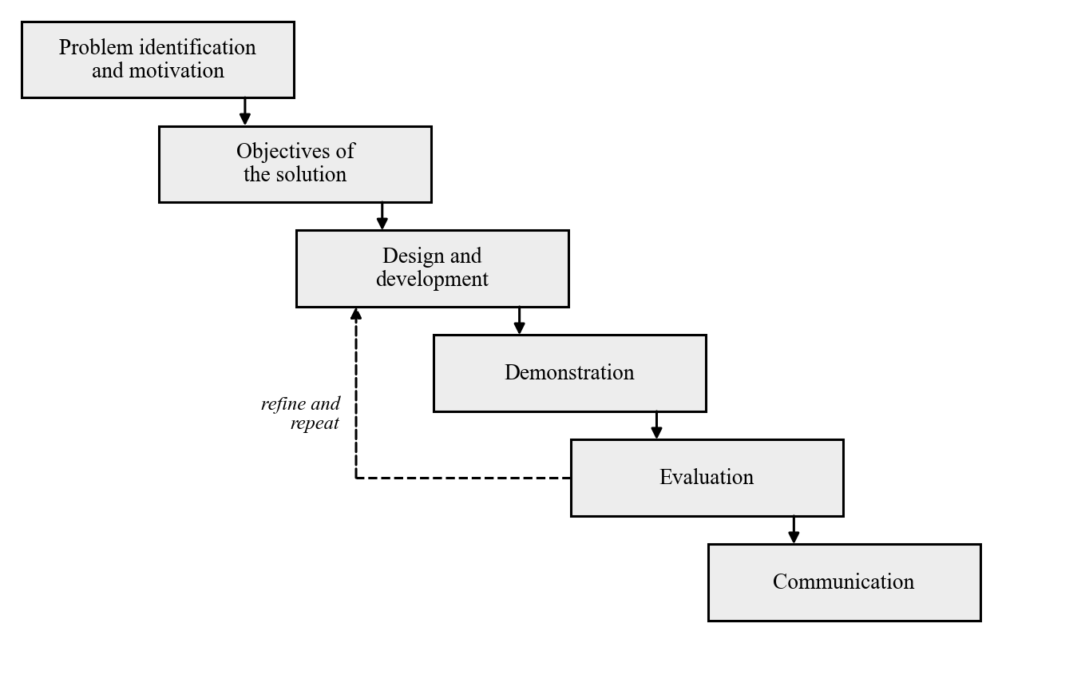
Fig. 3.1: Design Science Research Model of the Proposed Redaction Framework
Unlike the waterfall model, in which each phase is completed once before the next begins, this model is iterative. The dashed arrow in Figure 3.1 shows that the result of an evaluation is used to refine the design, after which the artefact is built and evaluated again. This was necessary in practice. The guard went through three cycles of building and testing before its design was fixed, and several of the design decisions reported in Section 3.4 came directly from errors found in the earlier cycles, which are reported in Section 4.1.5. An iterative model was chosen for this reason: the behaviour of an optical character recognition engine on real browser screenshots could not be fully predicted in advance and had to be learned by testing.

3.1.1 Use-case Diagram
A use-case diagram shows the ways in which the actors of a system interact with it. Figure 3.2 depicts the use cases of the proposed system. There are five actors. The user gives a task to the agent, for example to enter a residential address on a tax form. The screenshot-driven agent captures a screenshot of the page, passes it to the redaction guard, and sends the redacted result to the model. The cloud-hosted vision-language model (VLM) receives only the redacted screenshot and returns the next action. The evaluator loads a screenshot into the web interface of the system, chooses a policy, and inspects the copy that would be sent to the model. The researcher generates the benchmark and runs the experiments. Redacting a screenshot includes four smaller use cases, which correspond to the four stages of the guard: extracting the text, attributing values to form fields, applying the redaction policy, and masking the selected values. Inspecting a redaction through the web interface uses the same redaction.
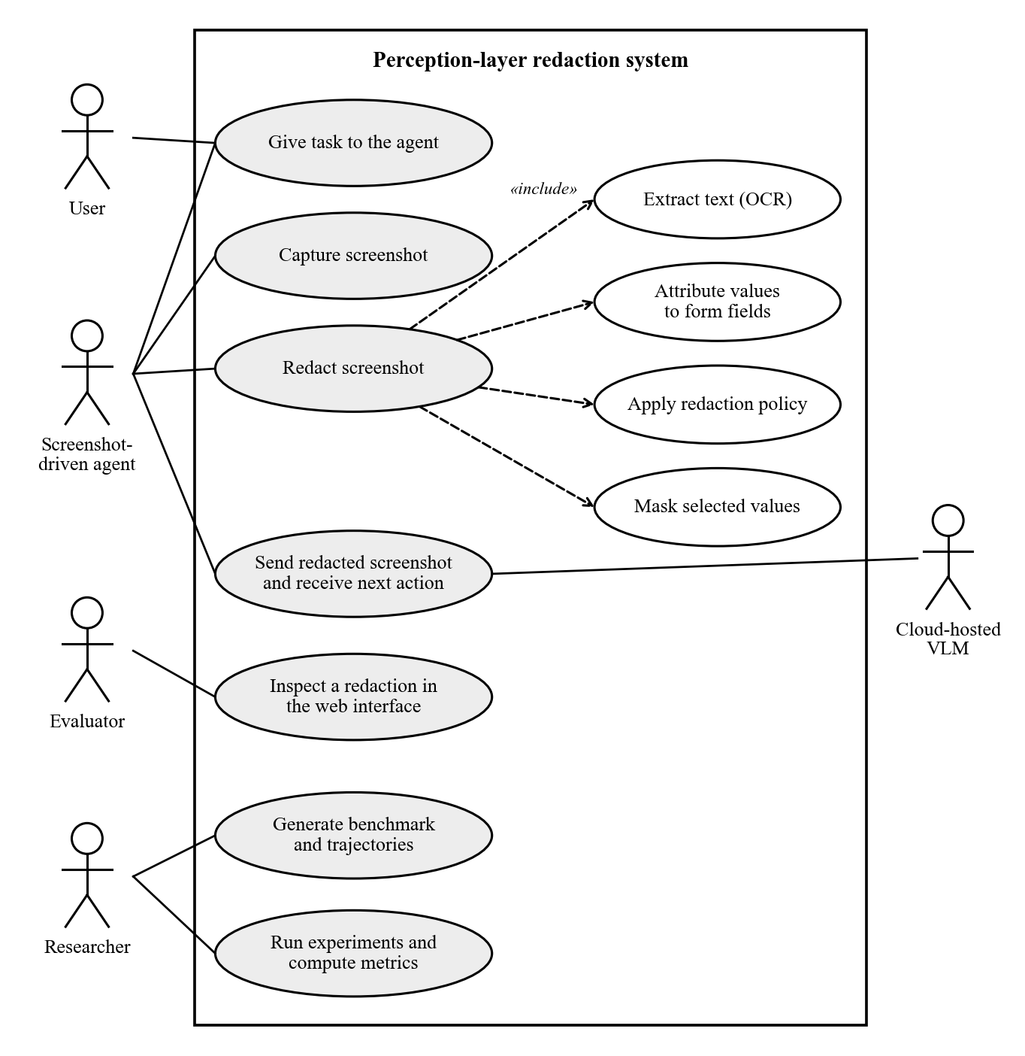
Fig. 3.2: Use-case Diagram of the Proposed Redaction Framework
As stated in Section 1.4, agent performance is measured on recorded task steps and not with a live agent. In the experiments the part of the agent is played by those recorded steps, and the guard is applied to the screenshot of each step exactly as it would be inside a running agent.

3.2 Source of Data Collection
The study did not collect data from people. No interviews, questionnaires, or on-site observations were carried out, and no real citizen data or live government portal was used. Screenshots of real e-service sessions would contain citizens’ personal information, which could not be collected or shared for this study. All the data was therefore generated for the study, from four sources.
Mock e-service portals. Three web forms were written in HTML and styled to resemble Nigerian government e-service pages. They are modelled on services that citizens use online: a personal income tax self-assessment, a driver’s licence renewal, and an international passport application. Each form is a template with one placeholder per field, and is accompanied by a manifest that records, for every field, its position in the page, its type of personal information, and the order in which it is filled. The manifest also defines the tasks that can be performed on the form and the fields each task needs. Table 3.1 lists the forms and the five tasks.
Table 3.1: Mock Portals, Fields and Tasks
Mock portal | Mock agency | Fields | Tasks and the fields they need
Personal Income Tax Self-Assessment | State Internal Revenue Service | 12: surname, first name, date of birth, TIN, NIN, street address, LGA, state, annual income, BVN, account number, email | T01: enter the residential address (street address, LGA, state). T02: enter the annual income and bank details (annual income, BVN, account number).
Driver’s Licence Renewal | Federal Road Safety Corps | 10: licence number, surname, first name, date of birth, NIN, phone, email, street address, LGA, state | T03: enter the phone number and email address (phone, email). T04: enter the licence number and NIN (licence number, NIN).
International Passport Application | Nigeria Immigration Service | 10: surname, first name, date of birth, NIN, passport number, phone, email, street address, LGA, state | T05: enter the NIN and previous passport number (NIN, passport number).
Source: form manifests of the study.
Synthetic identities. Fifty fictitious identities were produced by a generator written for the study. First names and surnames were drawn from lists of Yoruba, Igbo, Hausa, and Niger Delta names. Addresses were composed from street and area names in twelve states, each paired with one of its local government areas. Identifiers were produced as random values in the national formats shown in Table 3.2. The generator uses a fixed random seed, so the same fifty identities are produced every time it is run. The values are random and were not taken from or checked against any registry, and every email address uses the reserved domain example.com. Section 3.2.1 considers the possibility that a random value matches a real identifier by chance.
Table 3.2: Types of Personal Information and the Format of the Synthetic Values
Type | Format of the synthetic value | Example
PERSON | First name and surname from Nigerian name lists | Chiamaka Okonkwo
DOB | Date of birth as DD/MM/YYYY, age 18 to 70 | 14/03/1987
NIN | 11 digits | 12345678901
BVN | 11 digits beginning with 22 | 22123456789
TIN | 8 digits, a hyphen, 4 digits | 12345678-0001
BANK_ACCOUNT | 10 digits (NUBAN) | 0123456789
PASSPORT | One letter (A, B or C) and 8 digits | A12345678
LICENCE_NO | 3-letter state code, 5 digits, 2 letters, 2 digits | LAG12345AB67
PHONE | +234 followed by 10 digits with a mobile prefix | +234 803 456 7890
EMAIL | First name, surname and two digits, at example.com | chiamaka.okonkwo27@example.com
ADDRESS | Street line, local government area, state | 12 Adeola Odeku Street, Victoria Island; Eti-Osa; Lagos
FINANCIAL | Annual income as a whole number of naira | 4200000
Source: identity generator of the study. The examples are fictitious.
Benchmark screenshots. Each form was filled with each identity in three states: empty, partly filled (the first half of the fields), and fully filled. Every combination was opened in a headless Chromium browser at a width of 1,280 pixels and captured as a full-page screenshot. Three forms, fifty identities, and three states give 450 screenshots. Because the pages were rendered by the study itself, the ground truth did not have to be drawn by hand. For every filled field, a script read the position of the input box from the page and measured the width of the text inside it in the field’s own font, which gives a tight box around the text itself. The value, its type, its field, and this box were saved as the annotation of the screenshot. Figure 3.3 shows one of the screenshots, and the other two forms are shown in Appendix B.
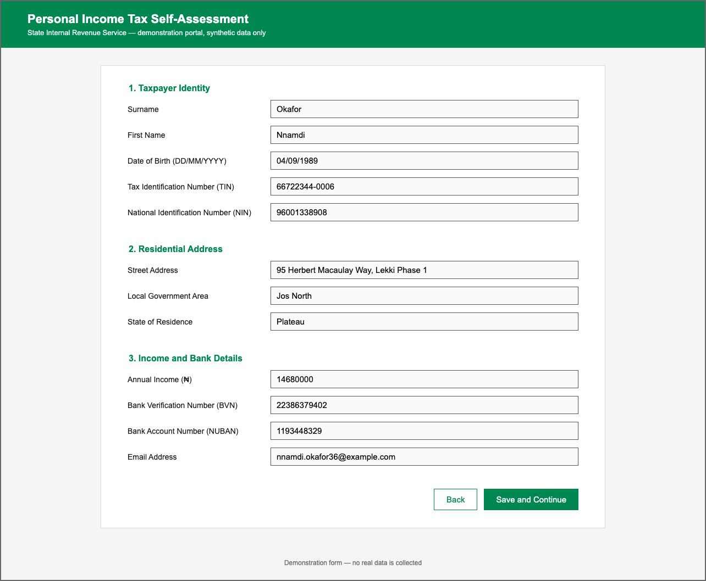
Fig. 3.3: A Fully Filled Benchmark Screenshot of the Mock Tax Self-Assessment Form
Recorded task trajectories. To measure the effect of redaction on an agent, each of the five tasks was performed for three identities and recorded, giving fifteen trajectories. A trajectory begins with every field outside the task already filled, as if the agent had reached that part of the form. The fields the task needs are then typed one at a time in the order of the form, and finally the “Save and Continue” button is clicked. Before each of these actions the page was captured with its annotations, and the correct action was saved beside it. Each step therefore holds the screen as an agent would see it at the moment of choosing that action. A task with three fields has four steps and a task with two fields has three, which gives 51 steps in all. Because the trajectories were recorded from a live browser, their screenshots contain details that static pages lack, notably the blue focus ring that the browser draws around the field just typed into.
Table 3.3 summarises the dataset. In addition to this generated data, the formats of the identifiers and the wording of the forms were based on the published documents of the issuing agencies reviewed in Section 2.3.
Table 3.3: Composition of the Dataset
Part | How it was produced | Screenshots | Annotated values
Benchmark | 3 forms × 50 identities × 3 fill states | 450 | 2,400
Trajectories | 5 tasks × 3 identities = 15 trajectories | 51 steps | 495
Total |  | 501 | 2,895
Source: dataset of the study.

3.2.1 Ethical Considerations
The study involved no human participants and no personal data. Every name, address, and identifier in the dataset is fictitious. The identifiers are random values in the national formats; they were not taken from any registry and were not checked against one. A random eleven-digit number could by chance coincide with a number that has been issued, but it is paired here with an invented name and address and is not linked to the details of any real person. All email addresses use the domain example.com, which is reserved for use in examples and is not assigned to any person or organisation.
No live government portal was accessed, automated, or tested. The forms were written for the study, and each page states in its header that it is a demonstration portal containing synthetic data only, so that a screenshot of it cannot be mistaken for the real service of the agency it is modelled on. In Experiments 2 and 3 screenshots are sent to a vision-language model hosted by a third party. These screenshots contain only the synthetic data described above, so no real personal data is sent to the model provider in the course of the experiments.

3.3 Challenges of the Existing System
The existing arrangement considered in this study is that of a screenshot-driven agent on the web. The agent captures the screen and sends the image, unchanged, to a cloud-hosted VLM at every step of a task. Where protection is applied to such an agent, the review in Chapter Two found it mainly in two forms: safeguards on the agent’s actions, and general-purpose detectors of personally identifiable information (PII). Chapter Two also reviewed recent redaction layers for mobile agents, some of which take the task into account (Section 2.6). They were not designed for web forms or for Nigerian identifiers, and they are not part of the arrangement analysed here. The review suggested the following challenges with this arrangement.
- The whole page is disclosed at every step. A step that types one field still sends every other value on the page to the model. On the forms studied here, every field holds personal information.
- Action-level safeguards are not aimed at what the model sees. Requiring the user to click the final button, or restricting the agent to official websites, governs what the agent may do. In general the screenshots are still sent in full.
- General-purpose detectors usually examine each piece of text on its own. Applied to the text extracted from a screenshot, such a detector sees a value without the label beside it. An eleven-digit number may be a NIN or a BVN, and an income figure is only a number, so the text alone does not show what the value is.
- Nigerian identifiers are not covered by the baseline detector. The version of the general-purpose detector used as the baseline in this study has recognisers for the identifiers of several countries but none for Nigeria. It relies on a general English language model to recognise names, and earlier studies found such models less reliable on African names (Section 2.5.2).
- A general-purpose detector does not tie detection to the task. A detector that does not know which field a value belongs to can mask only what it recognises, and it cannot be told to leave visible the fields that the current step needs. The task-aware layers reviewed in Section 2.6 deal with this for mobile applications; no equivalent was found for web forms.
- Trained visual detectors need annotated data, and none was found for this setting. Detectors trained on images require large annotated sets of screenshots. The published sets found in the review cover e-commerce pages and mobile applications, not government forms.
The proposed system was designed in response to these challenges. It places a guard between the capture of the screenshot and its transmission, and it identifies each value from the label of its form field. How far it meets the challenges is what the evaluation in Section 3.7 is intended to show.

3.4 System Design
The proposed redaction guard was analysed using a data flow diagram, and each of its modules was then designed in turn.

3.4.1 Data Flow Diagram of the Proposed System
A data flow diagram (DFD) shows how data moves through a system: where it enters, which processes transform it, what stored data those processes consult, and where the result goes. Figure 3.4 shows the data flow of the proposed system. The screenshot enters from the browser and passes through four processes. The first extracts the text. The second decides which pieces of text are personal information, using a stored vocabulary of field labels and a set of format patterns. The third decides which of them to hide, using the definition of the current task. The fourth paints over the chosen regions on the original screenshot. Only the redacted screenshot goes to the VLM, and the action it returns goes back to the agent.
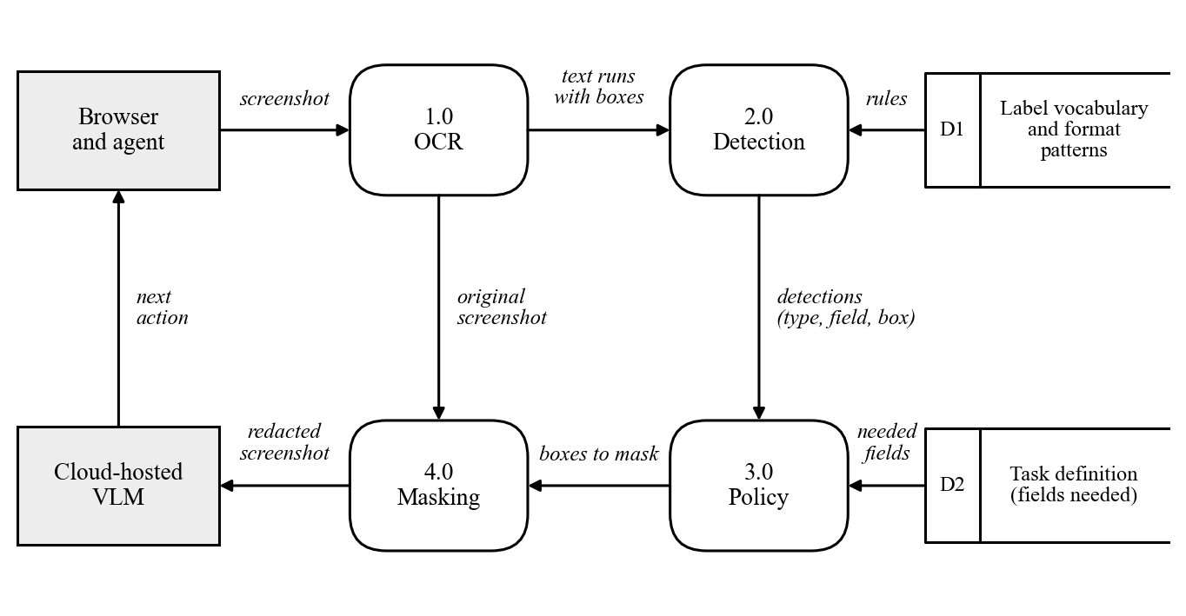
Fig. 3.4: Data Flow Diagram of the Proposed Redaction Guard
Optical Character Recognition Module: this module turns the screenshot into text with positions, as shown in Figure 3.5. The image is first prepared. Pixels in the blue of the browser’s focus ring are painted white, because in early tests the OCR engine skipped the text inside a ringed field, which is the field the agent has just typed into. The image is then converted to greyscale and enlarged to twice its size, since the engine is more accurate on larger text than on the 15-pixel text of a web form. The words are recognised with the Tesseract engine (Smith, 2007) in its full-layout mode. Tokens that are empty, or that consist only of the marks the engine produces when it reads the border of an input box, are discarded. No word is discarded for low confidence. An earlier version applied a cut-off on the engine’s confidence, and testing showed that real values could fall below it. A word the engine is unsure of is therefore still a candidate for masking, and a missed value is treated as the more serious error. The cost of any unnecessary masks to the agent is part of what Experiment 3 measures. Finally, the words on each line are grouped into runs. A line is split wherever the horizontal gap between two words exceeds 1.5 times the height of the line. A row of a form thus becomes two runs, the label and the value, each with its own bounding box.
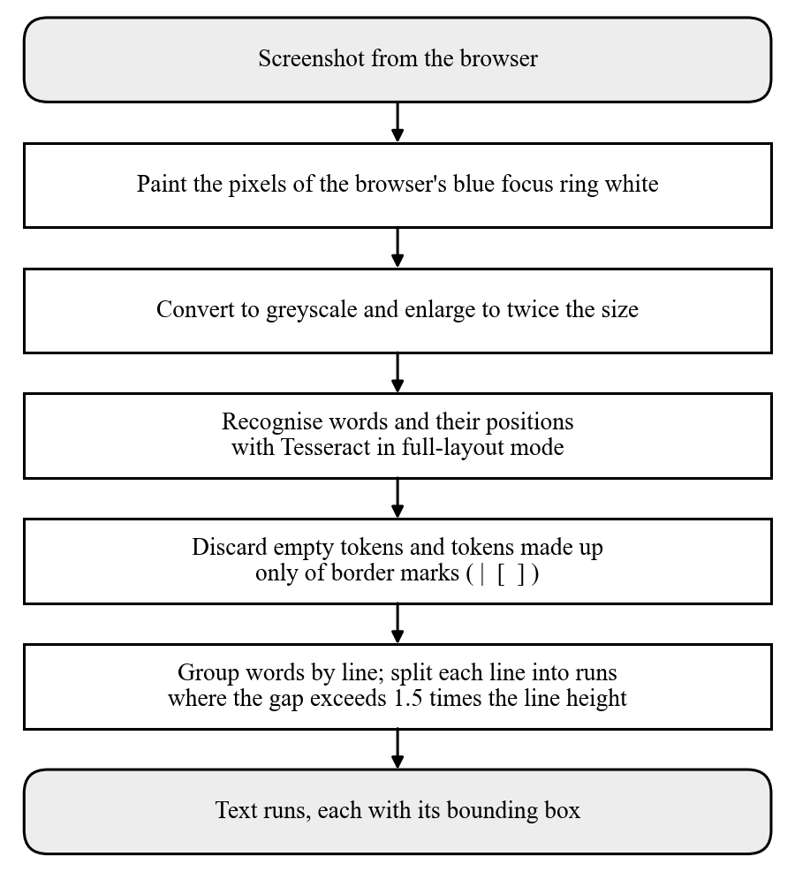
Fig. 3.5: Flow of the Optical Character Recognition Module
Detection Module: this module decides which runs are personal information and what kind. It is the module on which the task-aware policy depends, and it follows the flow in Figure 3.6. For each run, the module first looks for a field label on the same row. A run qualifies as that label if it ends to the left of the run being examined, overlaps it vertically by at least half the height of the shorter of the two, and contains one of the keywords in Table 3.4. If several runs qualify, the nearest is taken. When a label is found, the run is recorded as a value of that field and takes the field’s type. This is how the guard tells a NIN from a BVN, although both are eleven digits long.
Table 3.4: Vocabulary of Field Labels Used by the Detection Module
Order | Keywords looked for in the label | Field | Type assigned
1 | date of birth; dob | Date of birth | DOB
2 | tax identification; tin | Tax identification number | TIN
3 | national identification; nin | National identification number | NIN
4 | bank verification; bvn | Bank verification number | BVN
5 | account number; nuban | Bank account number | BANK_ACCOUNT
6 | annual income; income | Annual income | FINANCIAL
7 | email; e-mail | Email address | EMAIL
8 | phone; mobile | Phone number | PHONE
9 | passport | Passport number | PASSPORT
10 | licence; license | Driver’s licence number | LICENCE_NO
11 | street; address | Street address | ADDRESS
12 | local government; lga | Local government area | ADDRESS
13 | surname; last name | Surname | PERSON
14 | first name; given name | First name | PERSON
15 | state | State | ADDRESS
Source: guard of the study. The first entry that matches is used, so specific keywords come before general ones.
A run with no label to its left is examined further. If the run itself reads as a label or heading and matches none of the format patterns, it is left visible, so that the labels of the form are never masked. Otherwise the run is tested against the format patterns in Table 3.5, in the order shown. The order matters because some shapes contain others. A run that matches no pattern is passed to the general-purpose detector, Presidio (Microsoft, 2025). If Presidio reports an entity with a score of 0.4 or more, the run is recorded with the corresponding type, but with no field. Each detection records its type, its field where known, its text, its bounding box, and which of the three rules produced it.
Table 3.5: Format Patterns Used When No Label Is Found
Order | Type assigned | Shape of the text
1 | EMAIL | Text containing the @ sign followed by a domain name
2 | PHONE | +234 followed by 10 digits, with or without spaces; or 11 digits beginning 07, 08 or 09
3 | TIN | 8 digits, a hyphen, 4 digits
4 | PASSPORT | The letter A, B or C followed by 8 digits
5 | LICENCE_NO | 3 letters, 5 digits, 2 letters, 2 digits
6 | DOB | A date written as DD/MM/YYYY
7 | NIN | 11 digits
8 | BANK_ACCOUNT | 10 digits
9 | FINANCIAL | 5 to 9 digits
Source: guard of the study.
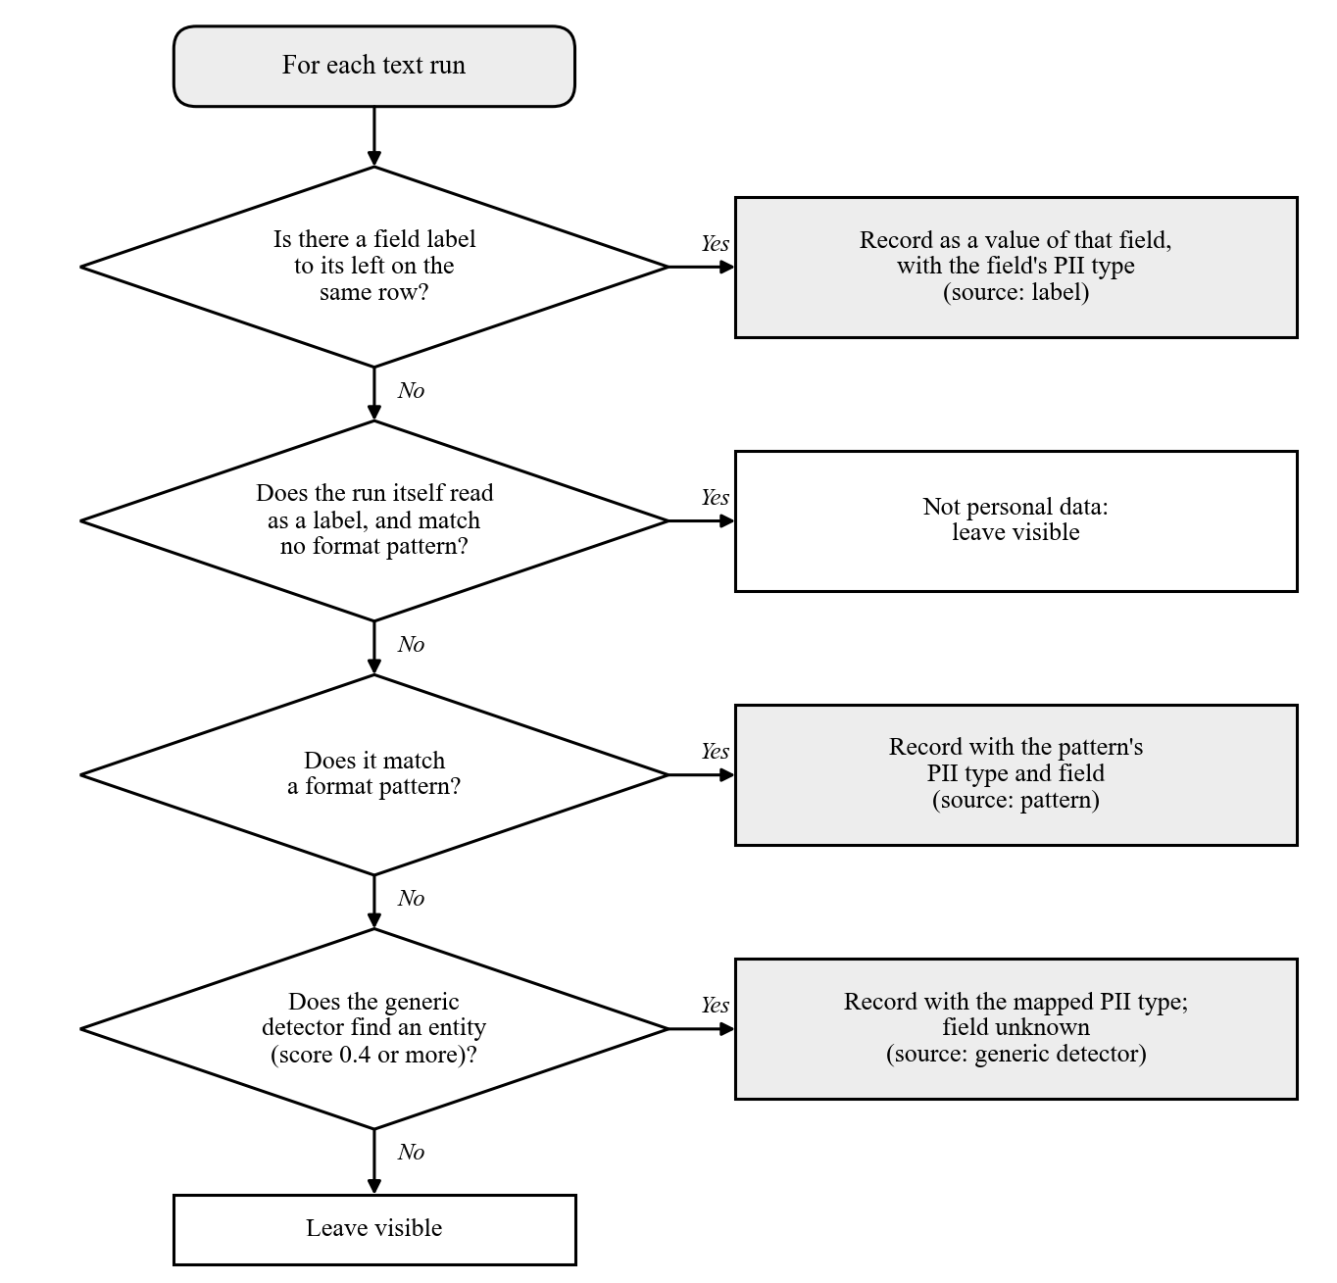
Fig. 3.6: Flowchart of the Detection Module
The module can also be run in a second mode, in which the label and pattern rules are switched off and every run is passed to Presidio alone. This mode is the general-purpose baseline against which the guard is compared in Section 3.7.
Policy Module: this module decides which detections to hide. Two policies were implemented. Under the full policy, every detection is selected. Under the task-aware policy, a detection is left visible only if it has been attributed to a field that the current task needs, and every other detection is selected. A detection with no known field is always selected, so that anything the guard cannot place is treated as sensitive. The task-aware policy depends on the label rule of the detection module, because only that rule tells the guard which field a value belongs to.
Masking Module: this module paints an opaque black rectangle over the bounding box of every selected detection, extended by four pixels on each side so that no edge of the text remains readable. The painting is done on a copy of the original screenshot, and the result is the image that is sent to the model. Figure 3.7 shows the flow of the policy and masking modules together.
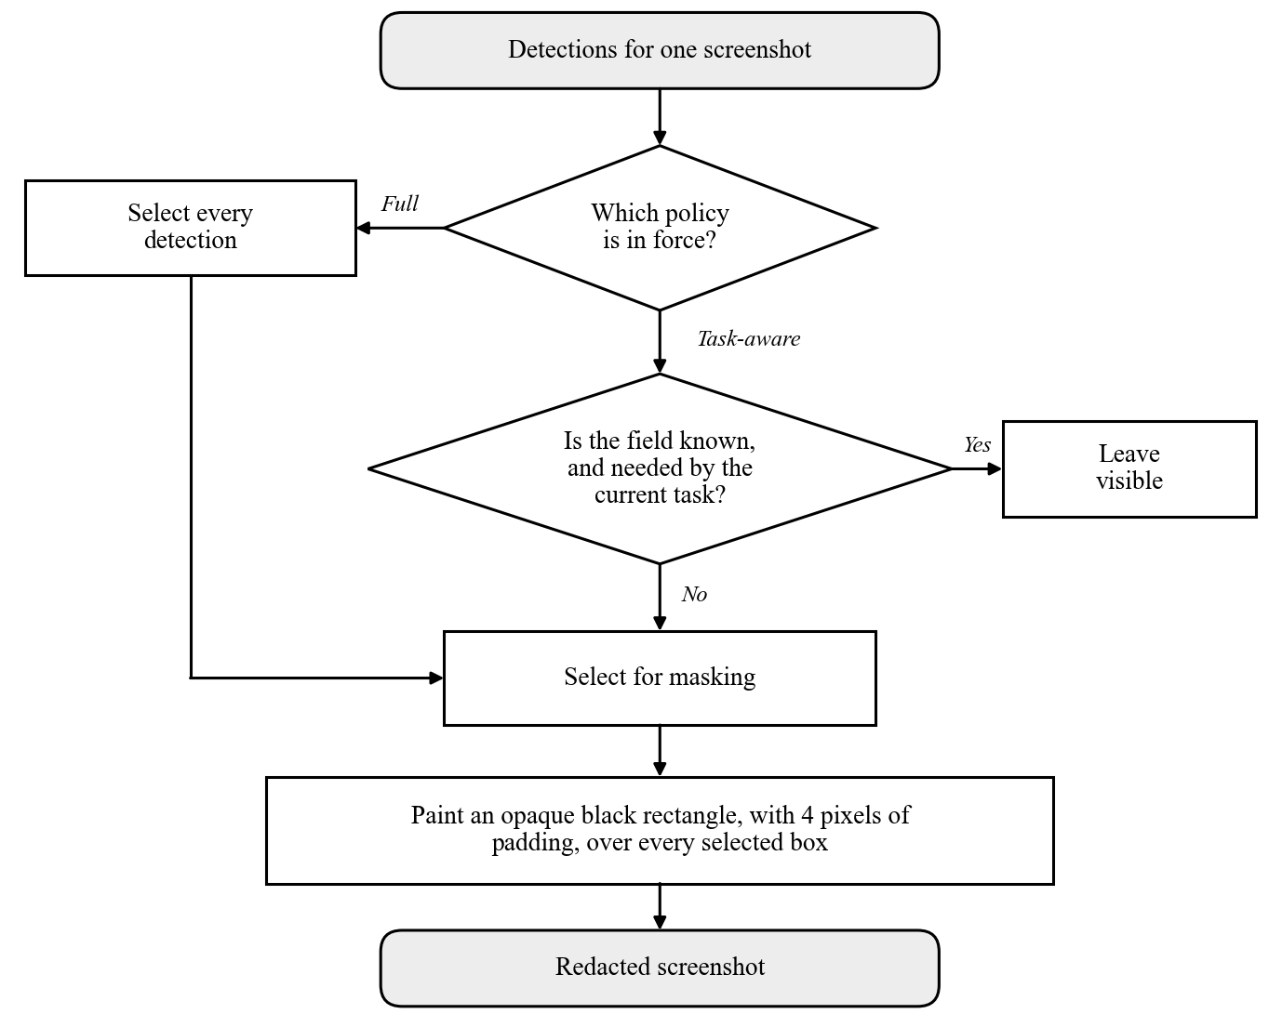
Fig. 3.7: Flowchart of the Policy and Masking Modules

3.5 Dataset Design
The proposed system does not use a relational database. It keeps no record of users and stores nothing between one screenshot and the next: an image goes in and a redacted image comes out. What takes the place of a database in this study is the dataset on which the guard is evaluated. The dataset is stored as files in a fixed folder structure, in which one sample is one folder. The folder holds the page that was rendered, the screenshot taken of it, and its annotations, and the outputs of the guard are saved under the same path in a separate results folder. A sample can therefore always be traced from its screenshot to its source page, its ground truth, and its redacted versions. The logical design of the dataset is presented below in the same way as a database, with an entity relationship diagram and the structure of the records.

3.5.1 Entity Relationship Diagram
An entity relationship (ER) diagram shows the entities about which data is kept and the relationships between them. Figure 3.8 shows the entities of the dataset. A form has many fields and many tasks. A screenshot belongs to one form and one identity, and is either a benchmark sample in a given fill state or one step of a trajectory. A trajectory is one task performed for one identity and consists of many steps. Each screenshot has many annotations, one for each filled field, which are the ground truth. After the guard has been run, each screenshot also has many detections, which are what the guard found. The experiments compare the detections of a screenshot with its annotations.
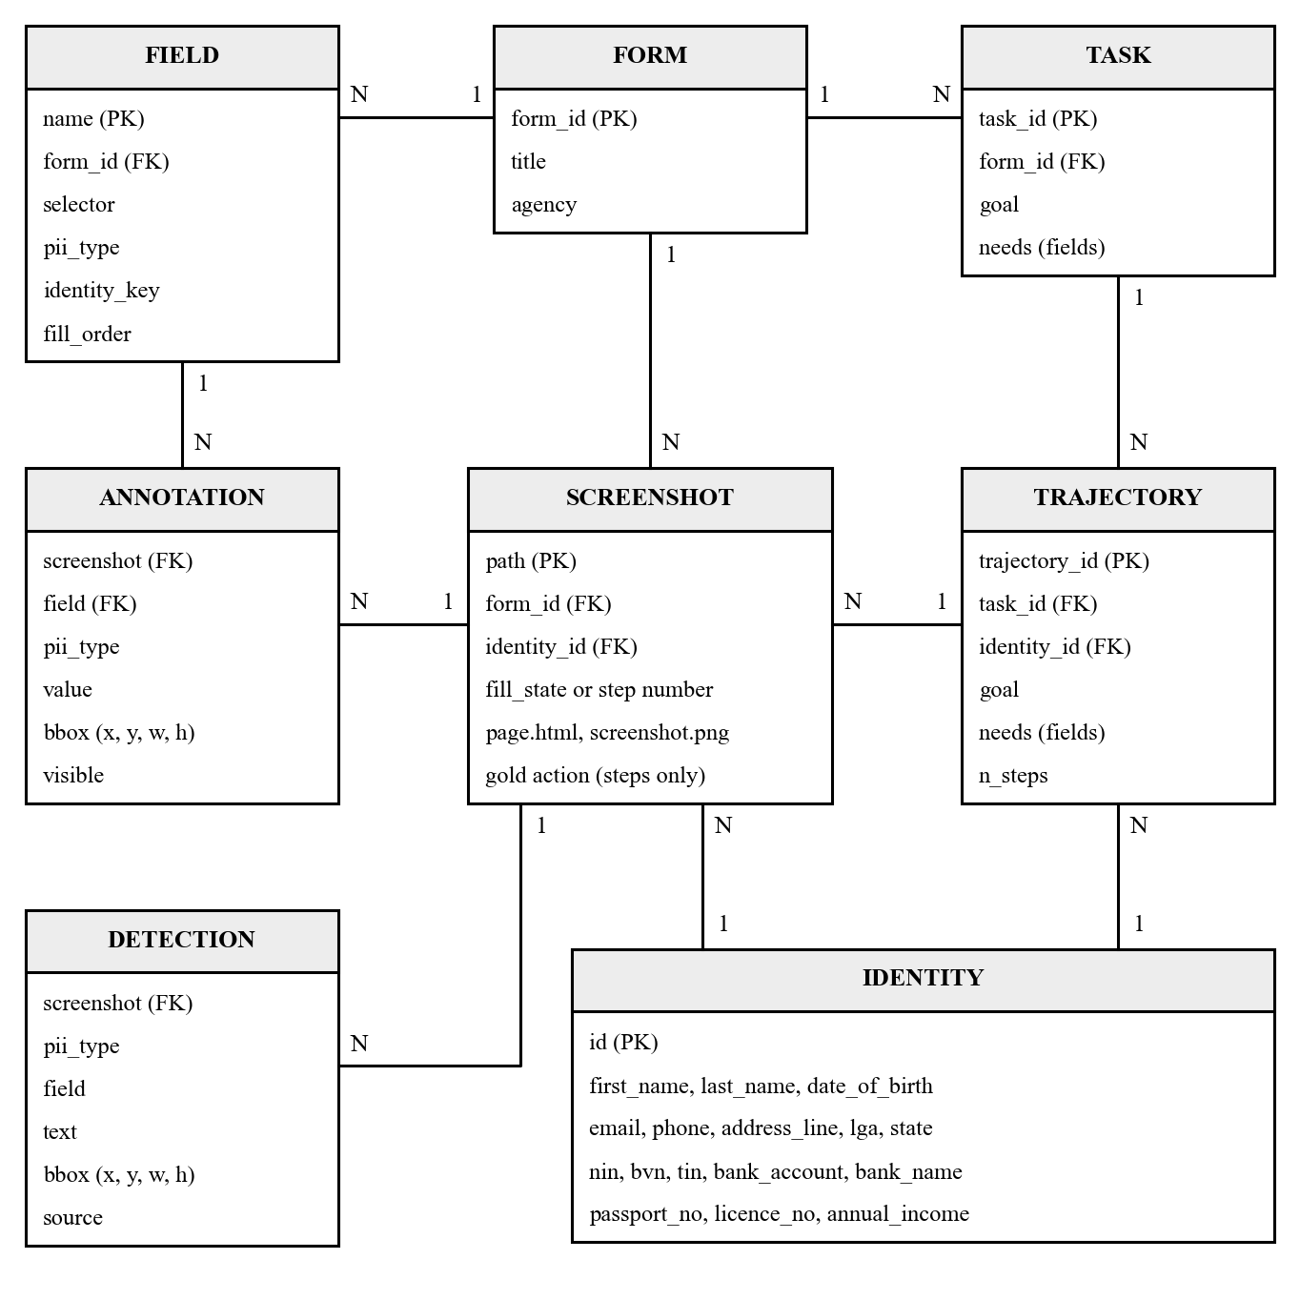
Fig. 3.8: Entity Relationship Diagram of the Dataset

3.5.2 Dataset Tables
Tables 3.6 to 3.9 give the structure of the main records. Each record is stored as a JSON file.
Table 3.6: Identity Record
Attribute | Type | Description
id | Text | Identifier of the synthetic identity, I0001 to I0050 (primary key)
first_name, last_name | Text | Given name and surname
date_of_birth | Text | Date of birth, DD/MM/YYYY
email, phone | Text | Contact details
address_line, lga, state | Text | Street address, local government area and state
nin, bvn, tin | Text | National identification, bank verification and tax identification numbers
bank_account, bank_name | Text | Bank account number and name of the bank
passport_no, licence_no | Text | Passport number and driver’s licence number
annual_income | Text | Annual income in naira
Table 3.7: Annotation Record (Ground Truth of One Screenshot)
Attribute | Type | Description
form_id, identity_id | Text | The form and the identity shown (foreign keys)
fill_state, or task_id and step | Text / number | Fill state of a benchmark sample, or the task and step number of a trajectory step
viewport | Numbers | Width and height of the captured page in pixels
pii | List | One entry for each filled field, with the attributes below
pii.field, pii.pii_type | Text | Name of the field and its type of personal information
pii.value | Text | The value displayed in the field
pii.bbox | Numbers | Position (x, y) and size (w, h) of the text of the value, in pixels
pii.needed | True / false | Whether the task of the trajectory needs this field
Table 3.8: Task and Action Records of a Trajectory
Attribute | Type | Description
task_id | Text | Task, form and identity, for example T01_tax_self_assessment_I0001 (primary key)
goal | Text | The instruction given to the agent
needs | List | Names of the fields the task needs
values | Record | The user’s data for those fields
n_steps | Number | Number of steps in the trajectory
step | Number | Position of an action in the trajectory, starting at 0
action | Text | The correct action at the step: type or click
target_field, value | Text | The field to act on and, for a type action, the text to type
Table 3.9: Guard Output Record of One Screenshot
Attribute | Type | Description
detector | Text | Detection mode used: the guard’s own rules, or the general-purpose baseline
task_id, needs | Text / list | The task assumed for the task-aware policy and the fields it needs
detections | List | One entry for each detection, with the attributes below
detections.pii_type | Text | Type of personal information assigned
detections.field | Text | Field the value was attributed to; empty if unknown
detections.text | Text | The text read by the OCR module
detections.bbox | Numbers | Position and size of the detected text, in pixels
detections.source | Text | Rule that produced the detection: label, pattern, or general-purpose detector
timings_ms | Numbers | Time taken by the OCR, detection and masking stages, in milliseconds
Source for Tables 3.6 to 3.9: dataset and guard of the study.

3.6 Architectural Design of the Redaction Framework

3.6.1 System Architecture
Figure 3.9 shows the architecture of the framework. The upper part shows the guard in operation. The browser and the guard both run on the user’s machine. The guard receives each screenshot from the browser, passes it through its four modules, and releases only the redacted image across the boundary to the third-party model. The guard is a single function that takes a screenshot, a policy, and the fields the task needs, and returns the redacted screenshot. In principle, an agent would call this function between capturing the screenshot and sending it. The study did not integrate the guard into an agent, so the effort this would take in practice was not tested.
The lower part shows the evaluation harness, which runs offline. The identity generator and the mock portals produce the benchmark and the trajectories. The guard is run over every screenshot, the three experiments compare its output with the ground truth, and the results are written to tables and figures. The stages are separate scripts that are run in a fixed order, and each stage reads only the files written by the stages before it.
The framework also has a user interface. It is a web page, served by a small program on the user’s own computer, on which a person loads a screenshot, chooses the full or the task-aware policy, and sees the original beside the copy that would be sent to the model, together with a list of every value the guard found. The interface calls the same guard function as the evaluation harness. It is the means by which an evaluator can operate the system directly, and it is presented in Section 4.1.3. The interface can also be placed on a server, protected by an access code, so that it can be opened from a link. A hosted copy receives the screenshots that its visitors load, so it is meant for the synthetic sample forms only; in real use the guard runs on the user’s own device, which is the point of the design.
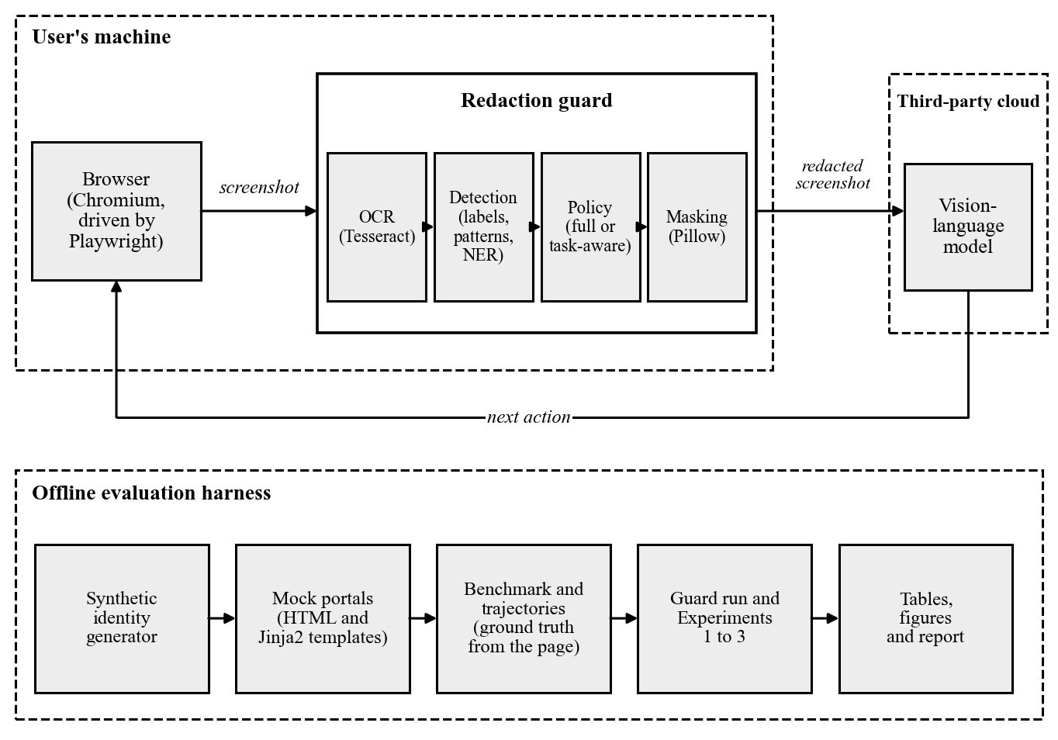
Fig. 3.9: Architectural Design of the Redaction Framework

3.6.2 System Requirement
The project was developed in the Python programming language, with HTML and CSS for the mock portals and the web interface. All the components that run on the user’s machine are open-source, and the guard needs no graphics processor. An AI coding agent, Claude Code, was used to assist with programming, testing, and documentation, under the direction of the researcher. This section describes the tools used in the development of the system, in terms of software and hardware.

3.6.3 Software Specifications
The table below gives the list of software used during the development of the system, together with their versions:
Table 3.10: Software Specification
S/N | Category | Software used
1 | Operating system | Windows 11 Pro
2 | Programming language | Python 3.11
3 | Mock portals and web interface | HTML and CSS; the web interface is served by a small Python program
4 | Browser automation | Playwright with the Chromium browser
5 | Optical character recognition | Tesseract 5.5
6 | General-purpose PII detector | Presidio Analyzer 2.2.360
7 | Vision-language model | Claude Haiku 5.5, a cloud-hosted model
8 | AI coding agent | Claude Code (Anthropic)
9 | Version control | Git, with the repository hosted on GitHub
The table lists the main tools only. The exact version of every supporting Python package is recorded in a lock file in the repository, and a single set-up script rebuilds the environment from it.

3.6.4 Hardware Specifications
The system was run and evaluated on a laptop computer, without a graphics processor. The guard, the baseline, and the two experiments with the vision-language model were all run on this computer. The specifications are given below:
Table 3.11: Hardware Specification
S/N | Category | Specification
1 | Computer | HP EliteBook 840 G1 laptop
2 | Processor | Intel Core i5-4300U, 1.90 GHz, 2 cores
3 | Memory | 8 GB
4 | Graphics processor | Not required
5 | Network | Needed only for the calls to the vision-language model in Experiments 2 and 3

3.6.5 Algorithm of the Redaction Guard
An algorithm is a prescribed set of steps for solving a specific problem. The algorithm of the proposed guard takes a screenshot, a policy, and the list of fields the current task needs, and returns a redacted screenshot. The steps are as follows:
Step 1: Receive the screenshot, the policy (full or task-aware), and the fields the task needs.
Step 2: Paint the pixels of the browser’s focus ring white, convert the image to greyscale, and enlarge it to twice its size.
Step 3: Recognise the words in the image and their positions. Discard empty tokens and border marks, and keep every other word whatever its confidence.
Step 4: Group the words of each line into runs, starting a new run wherever the gap between two words exceeds 1.5 times the height of the line.
Step 5: For each run, look for the nearest run to its left on the same row that reads as a field label. If one is found, record the run as a value of that field, with the field’s type.
Step 6: If no label is found and the run itself reads as a label, leave it visible. Otherwise test it against the format patterns in order, and record it with the type of the first pattern that matches.
Step 7: If no pattern matches, pass the run to the general-purpose detector, and record it with no field if an entity is found with a score of 0.4 or more.
Step 8: Select the detections to hide. Under the full policy select all of them. Under the task-aware policy select all of them except those attributed to a field the task needs.
Step 9: Paint an opaque black rectangle over each selected detection, with four pixels of padding, on a copy of the original screenshot.
Step 10: Return the redacted screenshot, together with the list of detections and the time taken by each stage.

3.7 Evaluation Method
The framework is evaluated by three experiments, one for each of Objectives iii, iv, and v, and by a measurement of the time the guard takes. All of them use the dataset described in Section 3.2.

3.7.1 Experimental Conditions
The guard is first run over all 501 screenshots, and its detections and both redacted versions of each screenshot are saved. This gives three conditions under which a screenshot can be shown to a model: no redaction, in which the screenshot is sent as captured; full, with every detected value masked; and task-aware, with every detected value masked except those of the fields the task needs. For a trajectory step the task is the task of the trajectory. A benchmark screenshot has no task of its own, so the first task defined on its form is used. Figure 3.10 shows the screenshot of Figure 3.3 under the two redaction policies.
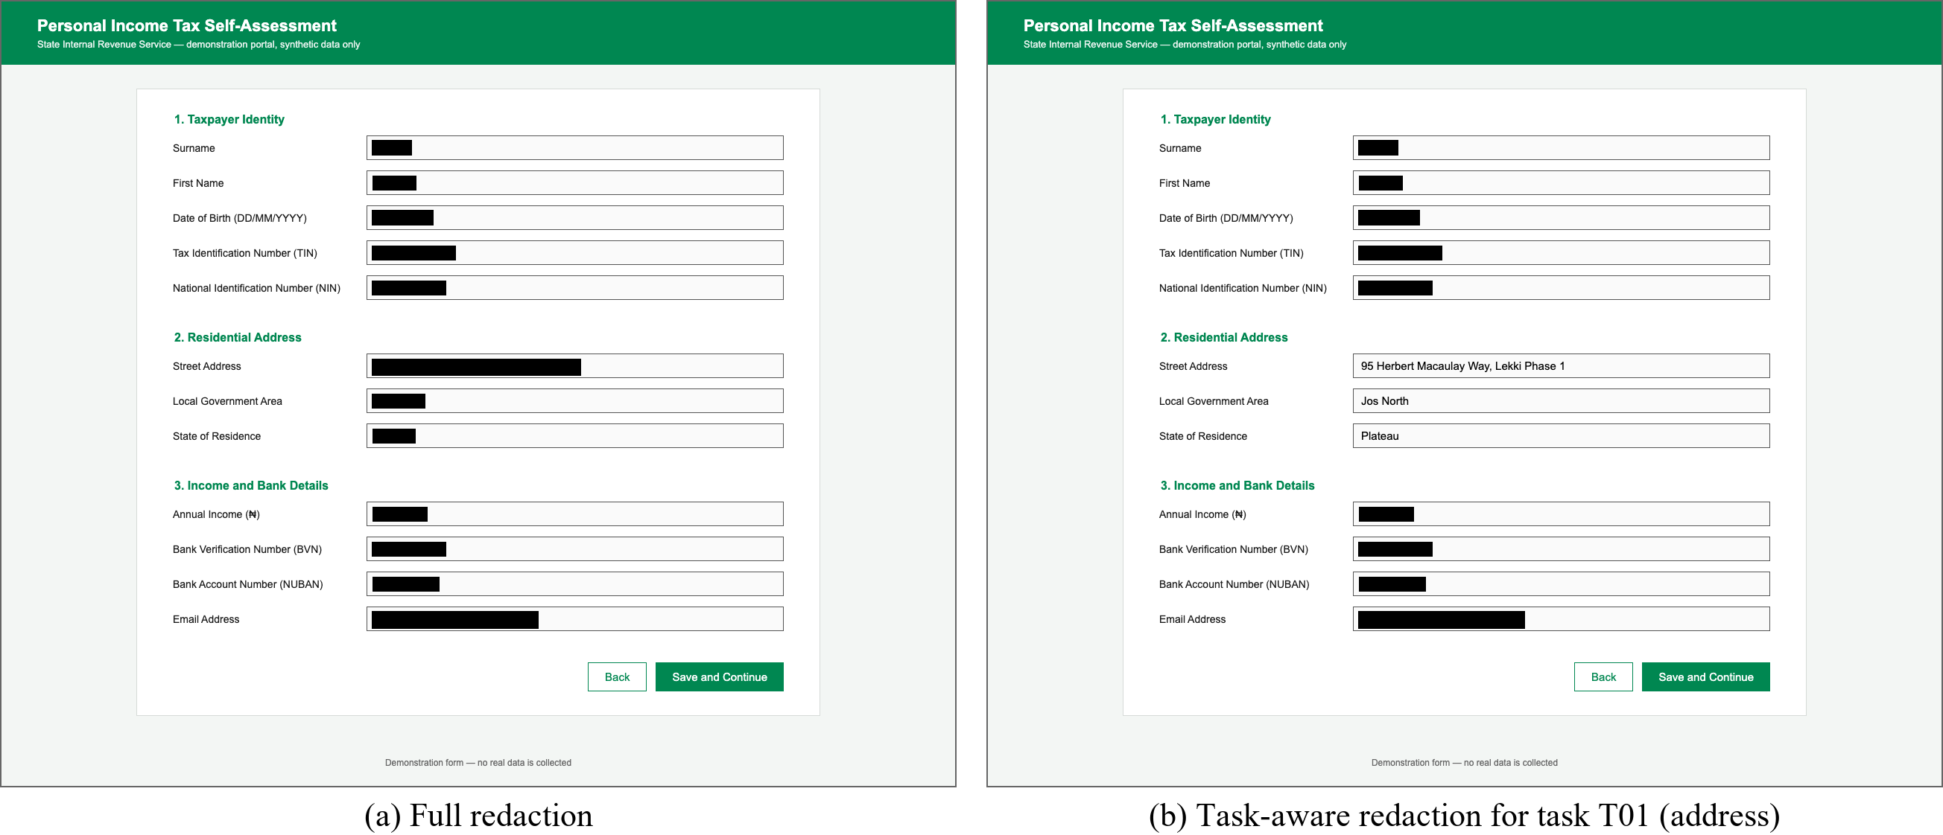
Fig. 3.10: The Screenshot of Fig. 3.3 under (a) the Full Policy and (b) the Task-aware Policy

3.7.2 Experiment 1: Detection Accuracy
The first experiment measures how well the guard finds the personal information on a screenshot (Objective iii). The detections of each screenshot are compared with its annotations by the overlap of their bounding boxes, measured as intersection over union (IoU):
IoU = area of overlap of the two boxes ÷ area of their union
Each annotated value is matched to the detection that overlaps it most and has not already been matched. If the IoU is 0.5 or more, the threshold commonly used in object detection (Everingham et al., 2010), the value counts as a true positive (TP). An annotated value with no such detection is a false negative (FN), and a detection matched to no annotated value is a false positive (FP). From these counts the following are computed, for each type of personal information and overall:
Precision = TP ÷ (TP + FP)
Recall = TP ÷ (TP + FN)
F1 = (2 × Precision × Recall) ÷ (Precision + Recall)
Two further measures are reported. Type accuracy is the proportion of true positives to which the detector assigned the correct type; it shows whether a detector that finds a NIN also knows that it is a NIN. Coverage is the proportion of the area of each annotated text box that is painted over under the full policy, and shows whether a value that was found was also hidden completely. The guard and the general-purpose baseline, in which every run is passed to Presidio alone, are both evaluated on all 501 screenshots, so that the two are compared on the same material. The entity types that Presidio reports are mapped to the types of this study, and an entity of a type with no equivalent is not counted as a detection. For the guard, the number of detections produced by each of its three rules is also reported, to show which of them the results rest on.
One further check is made that does not depend on the detections or on any model. Every fully masked image is examined pixel by pixel, to confirm that all the pixels inside each annotated text box are black, and the image files are examined for embedded text. A masked value is absent from the image that is sent, and this check verifies that directly.

3.7.3 Experiment 2: Privacy Leakage
The second experiment measures how much personal information a VLM can still read after redaction (Objective iv). The disclosure with which the study is concerned takes place when the image is transmitted, whatever the model later says. Leakage therefore means what can be read from the image that was sent. Asking a model to transcribe what it can read is a probe of that; it is not a claim about what a model would volunteer. The experiment uses the partly filled and fully filled benchmark screenshots of the first ten identities, which is 60 screenshots. Each is shown to the model under each of the three conditions, giving 180 requests. In every request the model is given the image alone and is asked to act as a privacy auditor: to list every piece of personal information it can read, transcribing each value exactly, and to reply with an empty list if nothing is readable. The full prompt is given in Appendix A.
An annotated value counts as leaked if it appears in the model’s reply. Before the comparison, both the value and the reply are reduced to lower-case letters and digits, so that differences of spacing and punctuation do not hide a leak. The leakage rate of a condition is:
Leakage rate = annotated values found in the replies ÷ annotated values on the screenshots
The rate is reported for each condition and each type of personal information. Every annotated value on a screenshot is counted, whether or not it was masked. Under the task-aware condition, the values of the fields the task needs are counted separately, because they are left visible on purpose. The condition with no redaction gives the leakage of the existing system, against which the two policies are compared. It also serves as the control: it shows whether the prompt draws the values out of the model when they are present, so that an empty reply to a masked image cannot be put down to the model declining to answer.

3.7.4 Experiment 3: Agent Step Accuracy
The third experiment measures whether a model can still choose the correct next action from a redacted screenshot (Objective v). It follows the offline, step-wise method of Mind2Web (Deng et al., 2023) that was reviewed in Section 2.2.2. Each of the 51 recorded steps is shown to the model under each of the three conditions, giving 153 requests. The model is told that it is filling in a Nigerian government form for a user and that parts of the screenshot may be blacked out. It is given the goal of the task and the user’s data for the fields the task needs. It is asked for the single next action: to type a stated value into the field with a stated label, or to click the “Save and Continue” button once every needed field shows the correct value. The full prompt is given in Appendix A.
The reply is scored against the recorded action. The label named by the model is converted to a field with the same vocabulary the guard uses (Table 3.4). Two measures are computed:
Field accuracy = steps at which the correct field or button was chosen ÷ total steps
Step accuracy = steps at which the field and the typed value were both correct ÷ total steps
For the final step of a trajectory, the action is correct if the model chooses to click. The measures are reported for each condition, overall and for each task. Comparing the step accuracy of the three conditions with their leakage rates from Experiment 2 shows the balance between privacy and usefulness that each policy achieves.

3.7.5 Processing Time and Reproducibility
The time taken by the OCR, detection, and masking stages is recorded for every screenshot, and the median of each is reported, to show what delay the guard would add to each step of an agent.
Experiments 2 and 3 use the same VLM, Claude Haiku 5.5 (Anthropic, 2026), with its default settings. It is the lowest-priced model of its family and was chosen to keep the cost of the experiments low. Each reply is limited to 4,000 tokens. On this model the limit covers the reasoning that precedes an answer as well as the answer itself, so it is set well above the length of any reply the prompts call for. A reply that does not end normally, because it was cut off at the limit or because the model declined to answer, is not stored or scored, and the run stops so that the cause can be examined.
Several measures make the evaluation repeatable. The identities are generated from a fixed seed. The versions of all software are fixed. Every reply of the VLM is stored on disk under a key computed from the name of the model, the image, and the prompt, so that an experiment can be re-run and checked without calling the model again. Table 3.12 summarises the evaluation.
Table 3.12: Summary of the Evaluation
Experiment | Objective | Data | Conditions compared | Measures
1. Detection accuracy | iii | 501 screenshots, for both the guard and the baseline | Guard and general-purpose baseline | Precision, recall, F1, type accuracy, coverage
2. Privacy leakage | iv | 60 benchmark screenshots; 180 requests to the VLM | No redaction, full, task-aware | Leakage rate
3. Agent step accuracy | v | 51 trajectory steps; 153 requests to the VLM | No redaction, full, task-aware | Field accuracy, step accuracy
Processing time | ii | 501 screenshots | Stages of the guard | Median time per stage

3.7.6 Limitations of the Method
The method has limitations that bear on how the results in Chapter Four should be read. They are in addition to the limitations of scope stated in Section 1.4.
- There is no unseen test set. The design of the guard was refined over three cycles of testing, and the screenshots used in those tests are the same 501 on which it is scored. The detection results therefore show how well the final design fits this benchmark. They do not show how it would perform on a form it has not seen. A fair estimate of that requires a form layout that played no part in the development, scored once.
- The label vocabulary and the forms have the same author. The keywords in Table 3.4 were written with the labels of the three mock forms in view, so every label on those forms is matched by construction. A real portal may word a label differently, abbreviate it, or place it above the field or inside it. The guard would then fall back on the format patterns and the general-purpose detector. In the evaluation every detection was produced by the label rule (Section 4.1.6), so those two fallback rules were not exercised and the results say nothing about how well they work.
- The baseline is used as supplied. Presidio is run in its default configuration, on each run of text separately, with no recognisers added for Nigerian identifiers. The comparison therefore measures the gap between an off-the-shelf detector and the label-based method. It does not measure the best that a general-purpose detector could achieve after adaptation.
- Leakage is measured by transcription. A value counts as leaked only if the whole of it appears in the model’s reply. A value that the model reads in part, or describes without transcribing, is not counted, so the measured rate may understate what the model can see. The same rule can also count a value that the model did not read from its own field, when the value occurs inside another that is visible, as a name does inside an email address. The probe asks the model to transcribe. It does not ask the model to infer or guess a masked value from what remains visible, such as the length of a mask, and each screenshot is sent on its own, so what could be pieced together across the steps of a task is not measured. The measure also reflects a single model, the lowest-priced of its family, and a single prompt; a larger model may read more, or act differently in Experiment 3. In addition, a benchmark screenshot is redacted for the first task of its form only, so the task-aware condition of Experiment 2 covers tasks T01, T03, and T05; tasks T02 and T04 are covered by Experiment 3.
- The measure of agent performance is narrow and its sample is small. The offline method accepts only the recorded action, and it does not show how a mistake at one step would affect the steps after it. With 51 steps, a single step changes the step accuracy by about two percentage points, and no statistical test is applied. Small differences between the conditions should therefore not be read as real differences.
- Processing time depends on the machine. The times reported are those of the computer on which the guard was run and would be longer on a slower processor.

3.8 Summary
This chapter laid out the method of the study. The work followed the design science research model, carried out iteratively, and a use-case diagram identified the actors of the proposed system. The data was generated for the study from three mock Nigerian e-service portals and fifty synthetic identities, giving a benchmark of 450 screenshots and 15 recorded trajectories, with the ground truth taken from the pages themselves, and involved no human participants or personal data. The challenges of the existing system were analysed, and the proposed guard was designed as four modules: optical character recognition, detection by field label, a full or task-aware policy, and masking, with a web interface through which the system can be operated. The design of the dataset, the architecture of the framework, the software and hardware used, and the algorithm of the guard were presented. Finally, the chapter set out three experiments that measure detection accuracy, privacy leakage, and agent step accuracy, and stated the limitations of that method, chief among them that the guard is scored on the same screenshots on which it was developed. Chapter Four presents the implementation and the results.

CHAPTER FOUR
RESULTS AND DISCUSSION

4.0 Introduction
The results and discussion of the project are presented under the following sub-headings. Section 4.1 presents the results and discusses them. Section 4.1.1 describes the benchmark dataset that was produced, Section 4.1.2 shows the output of the redaction guard, Section 4.1.3 presents the web interface, and Section 4.1.4 shows the guard at one step of a recorded task. Section 4.1.5 reports how the guard was refined during development. Section 4.1.6 gives the detection accuracy of the guard and of the general-purpose baseline, Section 4.1.7 the processing time, Section 4.1.8 the privacy leakage, and Section 4.1.9 the agent step accuracy. Section 4.1.10 sets privacy against usefulness, and Section 4.1.11 relates the findings to the objectives of the study. Section 4.2 summarises the chapter.

4.1 Result and Discussion
The system described in Chapter Three was implemented and evaluated. The sub-sections below present what was built and the results of the three experiments set out in Section 3.7. All the personal values that appear in the figures are synthetic.

4.1.1 The Benchmark Dataset
The first objective of the study was to develop a benchmark dataset of screenshots of mock Nigerian e-service forms, filled with synthetic identities and annotated automatically. The three mock portals were rendered for fifty synthetic identities in three fill states (empty, partly filled, and fully filled), and each of the five tasks was performed for three identities and recorded step by step, giving fifteen trajectories. The composition of the resulting dataset is given in Table 4.1.
Table 4.1: Composition of the Benchmark Dataset
Part of the dataset | Fields | Screenshots | Annotated values
Tax self-assessment form | 12 | 150 | 900
Driver’s licence renewal form | 10 | 150 | 750
International passport application form | 10 | 150 | 750
Recorded steps of 15 trajectories (tasks T01 to T05) | – | 51 | 495
Total |  | 501 | 2,895
Every annotated value carries its position on the screenshot, its type, and the form field it belongs to. These were read from the page itself at the moment the screenshot was taken, so no value was located or labelled by hand. Figure 4.1 shows one benchmark screenshot with its annotations drawn on it.
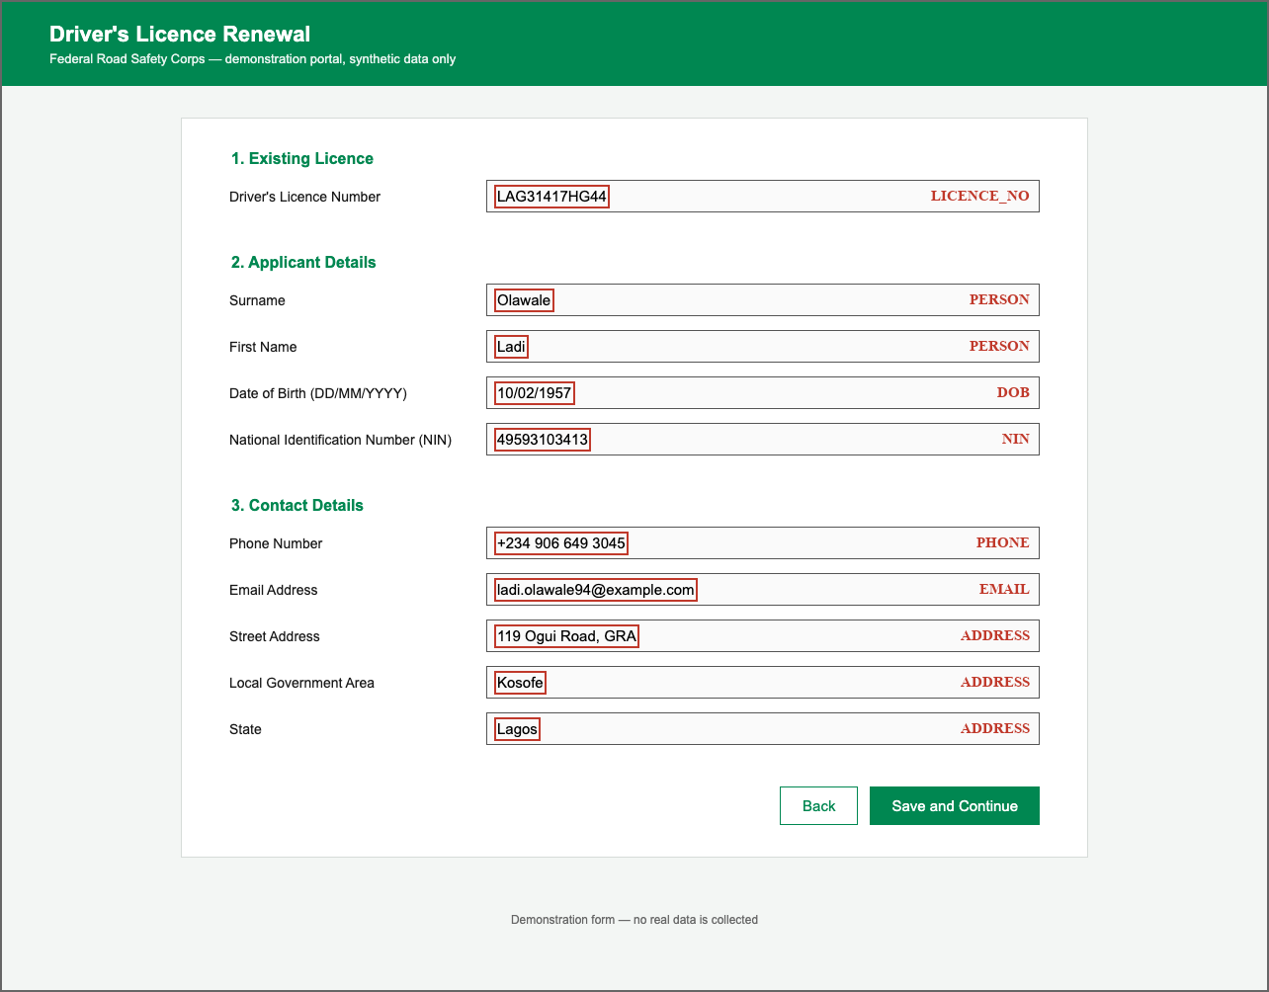
Fig. 4.1: A Benchmark Screenshot of the Driver’s Licence Renewal Form with its Annotations
As shown in Figure 4.1, each personal value is enclosed by a box that fits the text closely, and its type is recorded. The three address fields share one type, and the two name fields share another. The 150 empty screenshots carry no annotated value. They were kept in the benchmark because a detector can raise a false alarm on a form that holds no personal data, and Section 4.1.6 shows that the baseline did so.

4.1.2 Output of the Redaction Guard
The second objective was to design and implement a redaction guard that identifies personal information from its form-field label and masks it before the screenshot is transmitted, under a full policy and a task-aware policy. Figure 4.2 shows the output of the guard for one fully filled screenshot of the driver’s licence renewal form.
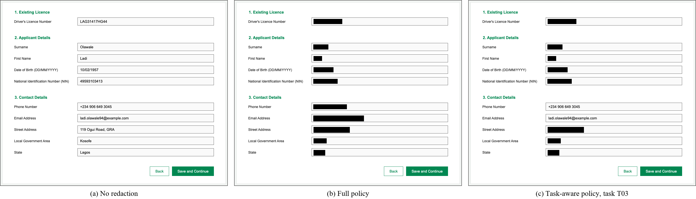
Fig. 4.2: A Screenshot of the Driver’s Licence Renewal Form (a) without Redaction, (b) under the Full Policy, and (c) under the Task-aware Policy for Task T03
As shown in Figure 4.2, under the full policy every one of the ten values is covered by an opaque black box, while the labels, the headings, and the buttons remain readable. Under the task-aware policy for task T03, which is to enter the applicant’s phone number and email address, those two values are left visible and the other eight are masked. In both cases only the text of a value is covered and the outline of its input box is kept, so the layout of the form is preserved.

4.1.3 The Web Interface
The system is operated through the web interface introduced in Section 3.6.1. It is the user interface of the system, and it is the means by which an evaluator can load a screenshot and see for themselves what would be sent to the model. It runs on the user’s own computer, keeps a loaded screenshot in memory only, and calls the same guard functions as the evaluation scripts. The user chooses a screenshot, or one of three samples from the benchmark, and then chooses a policy. Figure 4.3 shows the interface after a sample of the driver’s licence renewal form was redacted under the full policy.
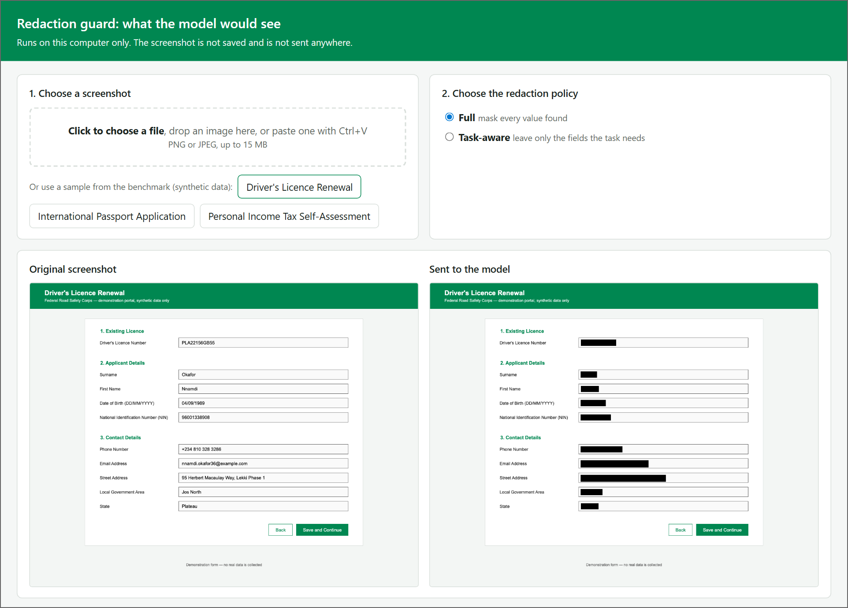
Fig. 4.3: The Web Interface after Redaction under the Full Policy
As shown in Figure 4.3, the interface places the original screenshot beside the copy that would be sent to the model. When the task-aware policy is chosen, the user selects one of the five tasks, or ticks the fields to leave visible. The interface then lists every value the guard read, as shown in Figure 4.4.
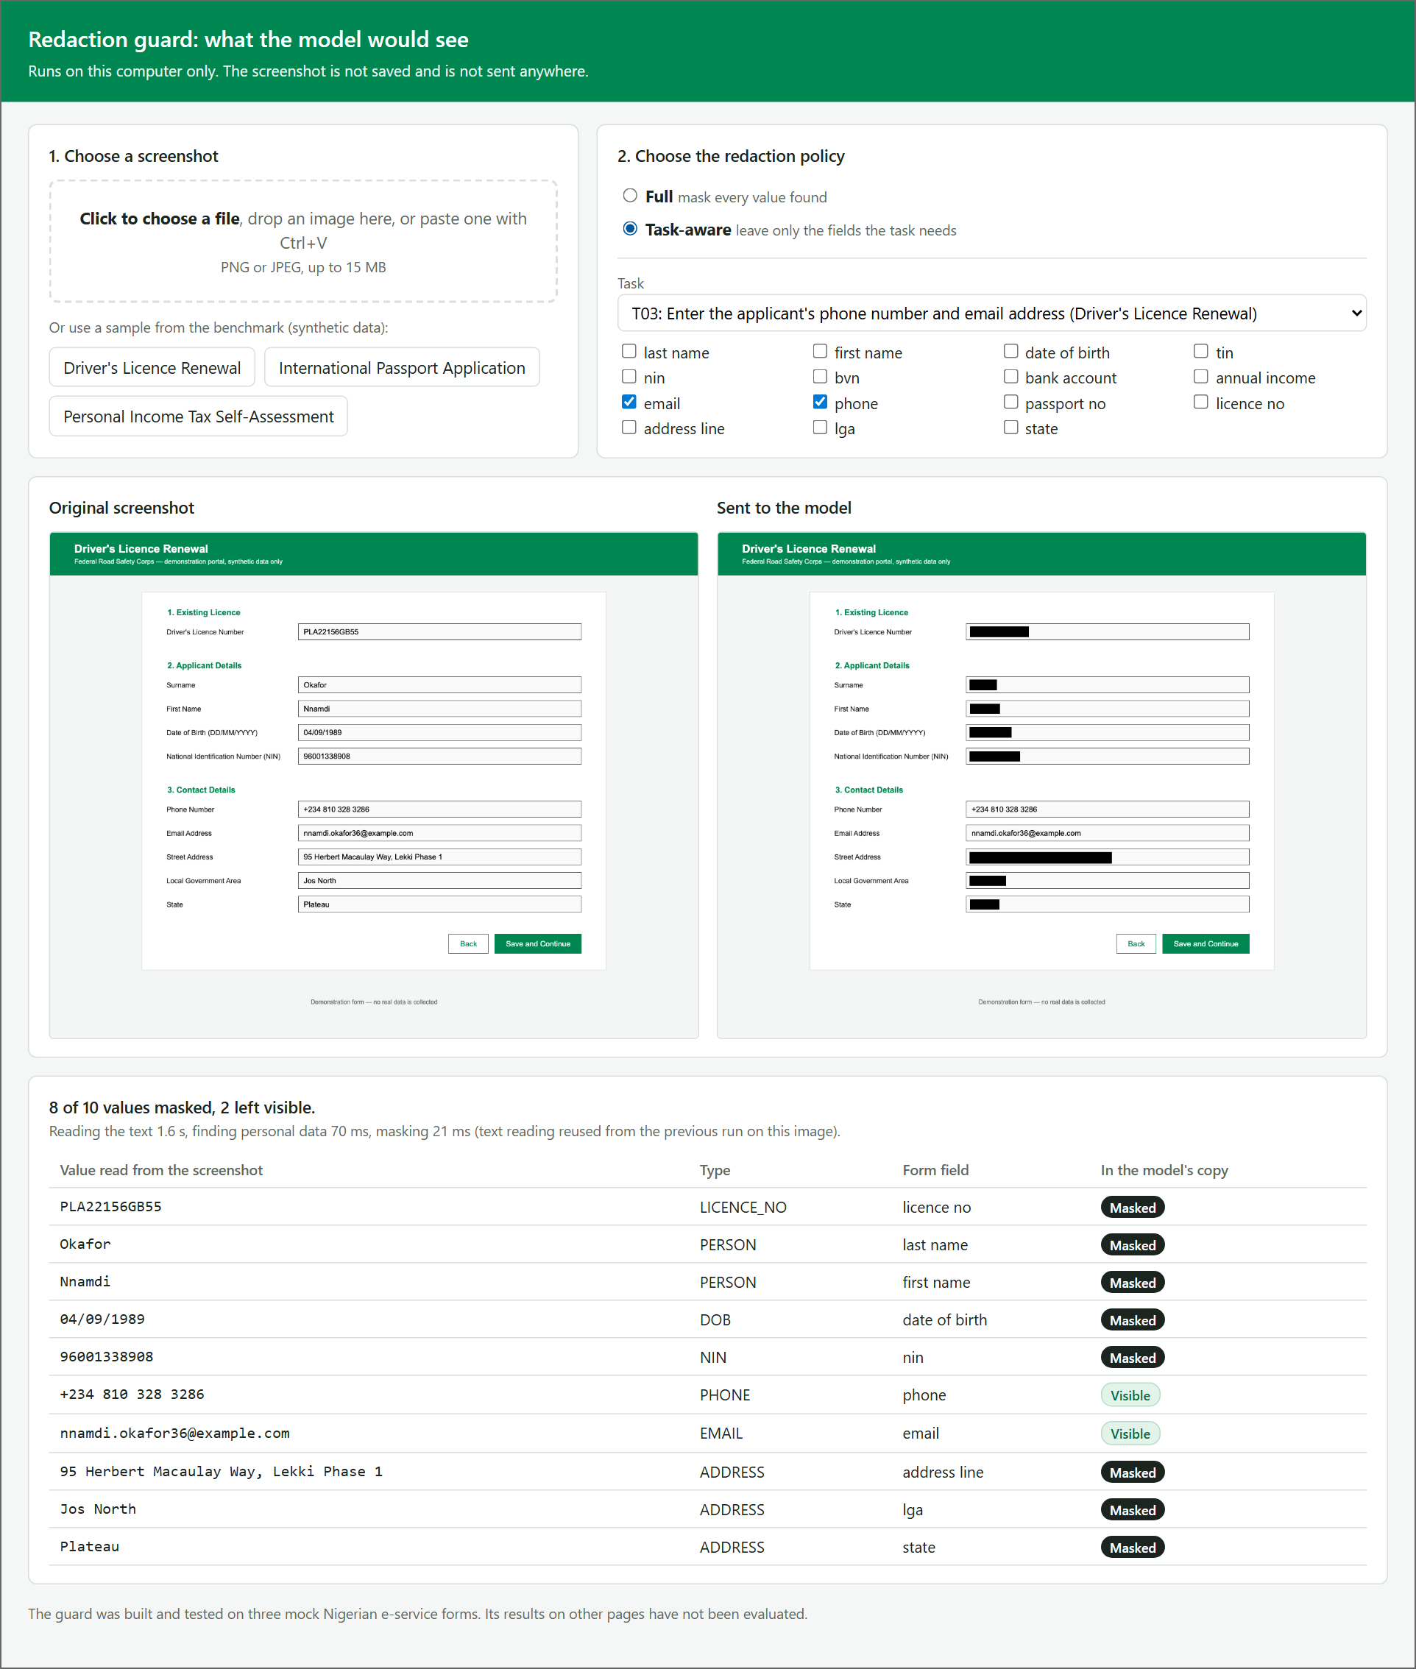
Fig. 4.4: The Web Interface under the Task-aware Policy for Task T03, with the List of Values Found
As shown in Figure 4.4, the list gives each value, its type, the form field to which the guard attributed it, and whether it was masked. For task T03 eight of the ten values were masked and the phone number and email address were left visible. The interface also reports the time taken by each stage on the computer on which it runs.
The figures of the three experiments reported in the sections that follow were produced by the evaluation scripts and not through the interface, so that every screenshot was treated in the same way. The interface can also be placed on a server and opened from a link, behind an access code, so that an evaluator who is elsewhere can use it with the sample forms.

4.1.4 The Guard at One Step of a Task
As stated in Section 1.4, the study works on recorded task steps and not with a live agent. The place of the guard in the loop of an agent is therefore shown on the recorded trajectories. For two of the trajectories, one of task T02 and one of task T04, the screenshot the browser displayed at each step was set beside the image the model would receive under the task-aware policy. Figure 4.5 shows one such step of task T02, which is to enter the annual income and the bank details on the tax form.
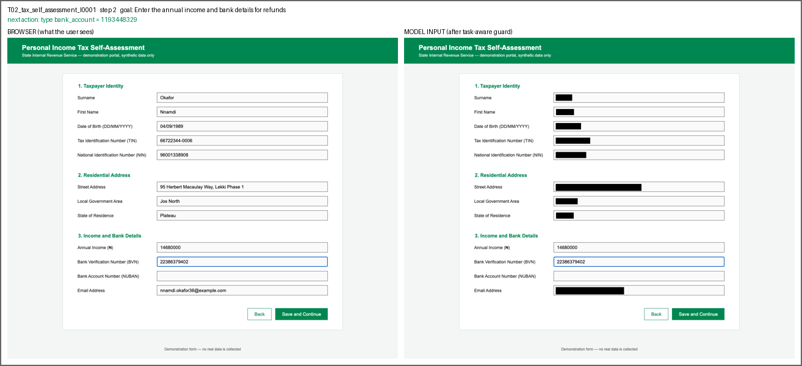
Fig. 4.5: A Step of Task T02 as Displayed by the Browser (left) and as Received by the Model (right)
As shown in Figure 4.5, the annual income and the BVN, which the task needs and which have already been entered, remain readable in the image on the right, and every other value on the form is masked. The bank account field is still empty. The line above the two images gives the goal of the task and the recorded next action, which here is to type the bank account number. It is the action against which the model is scored in Section 4.1.9.

4.1.5 Refinement of the Guard during Development
Section 3.1 stated that the guard went through three cycles of building and testing. Table 4.2 gives the result of each cycle on the full set of 501 screenshots and 2,895 values.
Table 4.2: Detection Results of the Three Development Cycles
Cycle | State of the design | False positives | Missed values | Precision | Recall | F1
1 | First design | 90 | 66 | 0.969 | 0.977 | 0.973
2 | OCR set to analyse the whole page layout; fragments made only of bars dropped; no cut-off on OCR confidence | 0 | 9 | 1.000 | 0.997 | 0.998
3 | Colour of the focus ring painted white before OCR | 0 | 0 | 1.000 | 1.000 | 1.000
All the errors of the first cycle were on trajectory steps taken just after a value had been typed. The browser draws a blue ring around the field in use. The OCR engine, Tesseract, read the borders of input boxes as characters, and it skipped the text inside the ringed field. After the changes of the second cycle, nine values were still missed, and every one was the value in the field that had just been typed into. The value the guard failed to mask was therefore the one the user had most recently supplied. Painting the colour of the ring white before OCR removed these nine misses.
This failure appeared only because the trajectories were captured from a live browser, in which the field in use is ringed. It did not occur on the 450 benchmark screenshots, where no field is in use. It suggests that a guard of this kind should be tested on screenshots taken in the state in which an agent would take them, and not only on still pages.

4.1.6 Detection Accuracy
The third objective was to evaluate the detection accuracy of the guard against the benchmark and to compare it with a general-purpose detector. The measures are defined in Section 3.7.2. The baseline is Presidio (Microsoft, 2025) in its default configuration. Table 4.3 gives the overall results of Experiment 1 for the two detectors on the same 501 screenshots.
Table 4.3: Overall Detection Results of the Guard and the Baseline
Detector | Values found | False positives | Values missed | Precision | Recall | F1 | Type accuracy
Guard | 2,895 | 0 | 0 | 1.000 | 1.000 | 1.000 | 1.000
General-purpose baseline | 1,624 | 174 | 1,271 | 0.903 | 0.561 | 0.692 | 0.759
The guard found all 2,895 annotated values, raised no false positive, and assigned the correct type to every value. Its coverage was also 1.000: each value that was found was painted over completely. All 2,895 of its detections were produced by the label rule. The format patterns and the fallback to the general-purpose detector produced no detection on this benchmark, so the results say nothing about how well those two rules work.
The check that does not depend on the detections or on any model (Section 3.7.2) gave the same answer. In all 501 fully masked images, every pixel inside each of the 2,895 annotated text boxes is black, and the image files carry no embedded text. A value masked under the full policy is therefore absent from the image that would be sent.
The baseline found 1,624 of the values, which is 56.1 per cent, and assigned the correct type to 75.9 per cent of those it found. Its coverage was 0.561, the same as its recall, because a value that is not found is not covered. Table 4.4 gives the results of the baseline for each type of personal information, with the code used for the type in Table 3.2.
Table 4.4: Detection Results of the Baseline for Each Type of Personal Information
Type of personal information | Values | Precision | Recall | F1 | Type accuracy
Email address (EMAIL) | 195 | 1.000 | 1.000 | 1.000 | 1.000
Date of birth (DOB) | 351 | 0.667 | 0.991 | 0.797 | 1.000
Phone number (PHONE) | 124 | 1.000 | 0.919 | 0.958 | 0.877
Address (ADDRESS) | 635 | 1.000 | 0.709 | 0.829 | 0.660
Bank account number (BANK_ACCOUNT) | 65 | 1.000 | 0.692 | 0.818 | 0.000
Name (PERSON) | 702 | 1.000 | 0.484 | 0.653 | 0.859
National Identification Number (NIN) | 342 | 1.000 | 0.281 | 0.438 | 0.000
Driver’s licence number (LICENCE_NO) | 115 | 1.000 | 0.148 | 0.258 | 0.000
Bank Verification Number (BVN) | 68 | 1.000 | 0.088 | 0.162 | 0.000
Tax Identification Number (TIN) | 124 | 1.000 | 0.081 | 0.149 | 0.000
Passport number (PASSPORT) | 103 | 1.000 | 0.019 | 0.038 | 0.000
Annual income (FINANCIAL) | 71 | 1.000 | 0.014 | 0.028 | 0.000
All types | 2,895 | 0.903 | 0.561 | 0.692 | 0.759
The guard scored 1.000 on every measure for every type, so its results are not repeated in the table. Figure 4.6 compares the recall of the two detectors for each type.
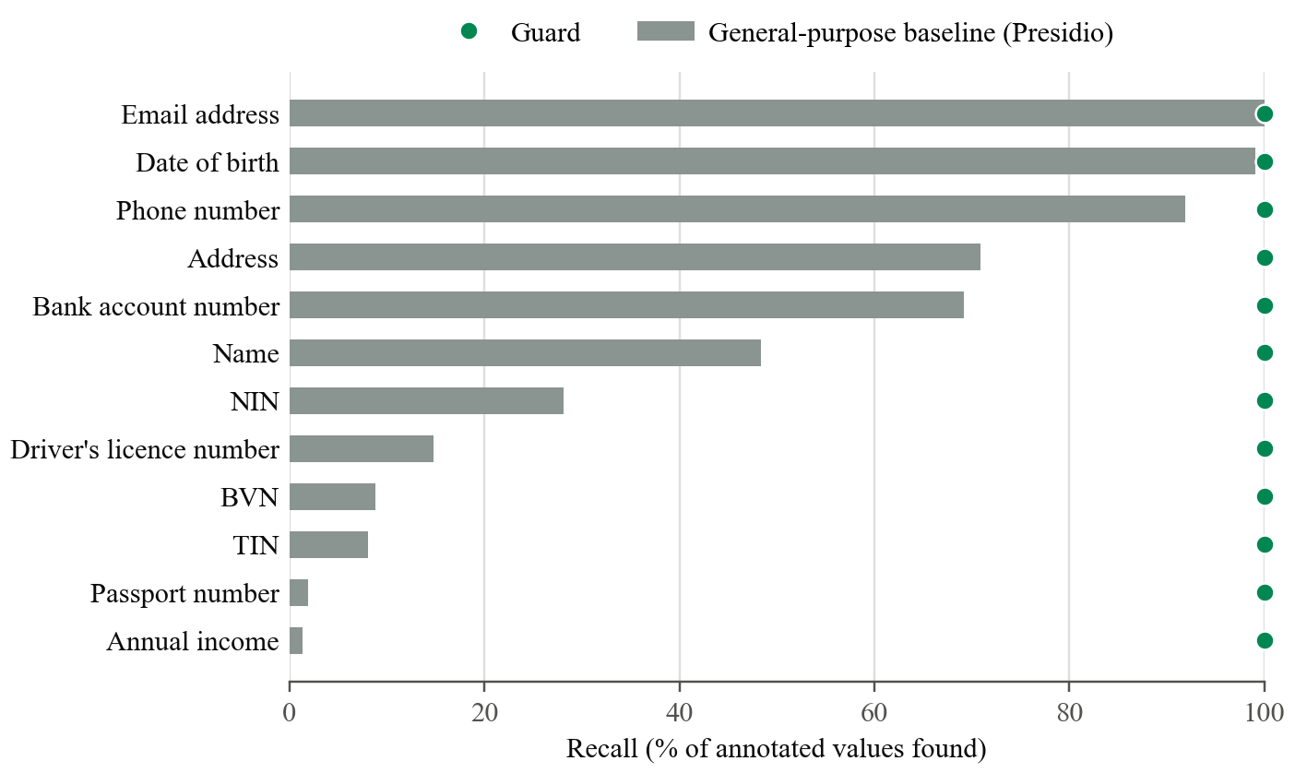
Fig. 4.6: Recall of the Guard and of the Baseline for Each Type of Personal Information
As shown in Figure 4.6, the baseline performed well on the types whose format is the same in every country. It found every email address and almost every date of birth and phone number. It performed poorly on the identifiers that are specific to Nigeria. It found 28.1 per cent of the NINs, 8.8 per cent of the BVNs, 8.1 per cent of the TINs, and fewer than two per cent of the passport numbers and income figures. It found fewer than half of the names. When it did find a NIN, BVN, TIN, bank account number, licence number, or passport number, it never gave it the correct type, as the type accuracy of 0.000 in Table 4.4 shows. The recall of the baseline was 0.595 on the fully filled benchmark screenshots, 0.504 on the partly filled ones, and 0.543 on the trajectory steps.
All 174 false positives of the baseline were the same error. It read the field label “Annual Income” as a date, once on each of the 174 screenshots of the tax form, including the 50 that hold no personal data. This accounts for its precision of 0.667 on dates of birth.
These results agree with what was expected of the baseline. The version of Presidio that was tested has no recognisers for Nigerian identifiers (Section 3.3), and an eleven-digit number gives no sign of whether it is a NIN or a BVN. The guard does not depend on the format of a value. It takes the type from the label beside the field, which is why it separates the two. The comparison therefore measures the gap between an unadapted general-purpose detector and the label-based method on these forms. It does not show what a general-purpose detector could achieve after recognisers for Nigerian identifiers were added to it. As noted in Section 2.5.1, a later release of the tool includes an optional recogniser for the NIN, which was not tested here.
The perfect score of the guard must be read with the limitation stated in Section 3.7.6. The design was refined on the same 501 screenshots on which it is scored, and the label vocabulary was written with the three mock forms in view. The score shows that the final design fits this benchmark. It does not show how the guard would perform on a form it has not seen, where a label may be worded differently or placed above the field.

4.1.7 Processing Time
The second objective describes the guard as lightweight. The time taken by each stage was recorded for every screenshot on the computer described in Table 3.11, and the medians are given in Table 4.5.
Table 4.5: Median Processing Time of Each Stage of the Guard (501 Screenshots)
Stage | Median time (milliseconds)
Optical character recognition | 1,453
Detection | 66
Policy and masking | 108
Sum of the three stages | 1,627
As Table 4.5 shows, the guard took about 1.6 seconds for a screenshot on the processor of a laptop computer, without a graphics processor, and optical character recognition accounted for about 89 per cent of that time. The time depends on the machine and would be shorter on a faster processor. On this computer the guard therefore adds a delay of about 1.6 seconds to each step of an agent. No claim of real-time operation is made.

4.1.8 Privacy Leakage
The fourth objective was to evaluate the reduction in privacy leakage, measured by how much personal information a vision-language model can still read from a redacted screenshot. Experiment 2 is described in Section 3.7.3. The model was Claude Haiku 5.5 (Anthropic, 2026). It was shown 60 screenshots holding 480 annotated values, each under three conditions, and was asked to list every piece of personal information it could read. Every reply ended normally. In Experiments 2 and 3 together, 25 of the 333 requests had the same image and prompt as another request, because the full and the task-aware versions of a screenshot are identical when no field the task needs has been filled in. Each such pair was sent once, so 308 distinct requests were made. Table 4.6 gives the leakage rate of each condition.
Table 4.6: Leakage Rate under Each Condition (Experiment 2)
Condition | Values counted | Values the model read | Leakage rate
No redaction | 480 | 479 | 0.998
Full policy | 480 | 0 | 0.000
Task-aware policy: values the task does not need | 380 | 20 | 0.053
Task-aware policy: values the task needs, left visible on purpose | 100 | 99 | 0.990
Without redaction, the model transcribed 479 of the 480 values. The one it did not transcribe correctly was a street address in which it misread one word. This is the leakage of the existing system: a model that is sent an unredacted screenshot can read practically everything on it. This condition is also the control for the other two. It shows that the prompt draws the values out of the model when they are present.
Under the full policy the model read none of the 480 values. Its reply was an empty list for every one of the 60 screenshots. Since the same prompt returned almost every value from the unredacted screenshots, the empty replies are not explained by the model declining to answer. They agree with the direct check reported in Section 4.1.6, which found the masked values to be absent from the images. Under the task-aware policy it read 99 of the 100 values that the tasks needed, which were left visible on purpose; the one exception was a passport number that it misread by one digit. Of the 380 values that the tasks did not need, it read 20, a leakage rate of 5.3 per cent.
The 20 values were examined, and they have a single cause. All of them are the surname and first name on the ten fully filled screenshots of the driver’s licence renewal form. The guard had masked both name fields, as panel (c) of Figure 4.2 shows. However, the benchmark redacts that form for task T03, which needs the email address, and the email addresses of the synthetic identities are formed from the first name and the surname. The model transcribed the email address, and the name was found inside it. For every other type of personal information, the leakage rate under the task-aware policy was zero, as Table 4.7 shows.
Table 4.7: Values Read by the Model for Each Type of Personal Information (Experiment 2)
Type of personal information | No redaction | Full policy | Task-aware policy: values the task does not need
Name (PERSON) | 120 of 120 | 0 of 120 | 20 of 120
Address (ADDRESS) | 99 of 100 | 0 of 100 | 0 of 60
Date of birth (DOB) | 60 of 60 | 0 of 60 | 0 of 60
National Identification Number (NIN) | 60 of 60 | 0 of 60 | 0 of 40
Email address (EMAIL) | 30 of 30 | 0 of 30 | 0 of 20
Phone number (PHONE) | 20 of 20 | 0 of 20 | 0 of 10
Tax Identification Number (TIN) | 20 of 20 | 0 of 20 | 0 of 20
Driver’s licence number (LICENCE_NO) | 20 of 20 | 0 of 20 | 0 of 20
Passport number (PASSPORT) | 20 of 20 | 0 of 20 | –
Bank Verification Number (BVN) | 10 of 10 | 0 of 10 | 0 of 10
Bank account number (BANK_ACCOUNT) | 10 of 10 | 0 of 10 | 0 of 10
Annual income (FINANCIAL) | 10 of 10 | 0 of 10 | 0 of 10
All types | 479 of 480 | 0 of 480 | 20 of 380
In the last column of Table 4.7 the values that the tasks needed are left out, which is why its totals are smaller. Every passport number on these screenshots was needed by its task, so none is counted there.
This is not an error of detection. It shows a limit of a policy that decides field by field: a field that the task needs can disclose a field that was masked. Real email addresses often contain the name of their owner, so the same disclosure would be expected outside the benchmark. A policy that took account of it would have to treat a value that can be derived from a visible field as visible. The guard has no such rule, and this is recorded as a limitation of the present design.
Three further points bear on these figures. First, as stated in Section 3.7.6, a value counts as leaked only if the whole of it appears in the reply, and the experiment used one model and one prompt. Second, the prompt asked the model to transcribe what it could read. It did not ask the model to infer or guess a masked value from what remained visible, and the name inside the email address came to light only because the scoring rule looks for a value anywhere in the reply. Third, the task-aware condition of this experiment covers tasks T01, T03, and T05 only.

4.1.9 Agent Step Accuracy
The fifth objective was to assess the effect of redaction on the performance of an agent, measured by its choice of the next action on recorded trajectories. Experiment 3 is described in Section 3.7.4 and follows the offline, step-wise method of Mind2Web (Deng et al., 2023). The same model was shown each of the 51 recorded steps under the three conditions and was asked for the single next action. Table 4.8 gives the step accuracy for each task.
Table 4.8: Step Accuracy for Each Task under Each Condition (Experiment 3)
Task | Steps | No redaction | Full policy | Task-aware policy
T01: residential address | 12 | 1.000 | 0.750 | 1.000
T02: annual income and bank details | 12 | 1.000 | 0.917 | 1.000
T03: phone number and email address | 9 | 1.000 | 0.778 | 1.000
T04: licence number and NIN | 9 | 1.000 | 0.889 | 1.000
T05: NIN and previous passport number | 9 | 1.000 | 0.889 | 1.000
All tasks | 51 | 1.000 | 0.843 | 1.000
The field accuracy was equal to the step accuracy in every cell of the table, so it is not shown separately. Figure 4.7 presents the same results as percentages.
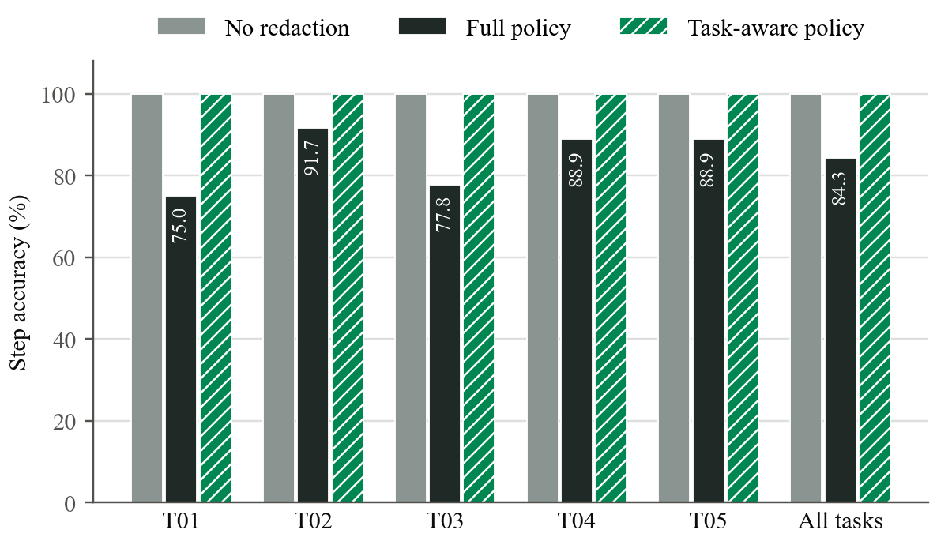
Fig. 4.7: Step Accuracy for Each Task under the Three Conditions
As shown in Figure 4.7, the model chose the recorded action at all 51 steps when it was given the unredacted screenshot, and again at all 51 steps when it was given the screenshot redacted under the task-aware policy. Under the full policy it chose the recorded action at 43 of the 51 steps, a step accuracy of 0.843.
The eight errors under the full policy are of one kind. Each is the final step of a trajectory, at which the recorded action is to click the “Save and Continue” button. The model instead typed one of the values of the task again. The likely reason is that, with every value masked, the model cannot confirm that the fields the task needs already hold the correct values, and the prompt tells it to click only when they do. It still clicked correctly at seven of the fifteen final steps. At the 36 steps at which a value had to be typed, it chose the correct field and value every time under all three conditions. Two things account for this. The values to be typed are given to the model in the prompt (Section 3.7.4), so masking cannot change the value it types. And an empty field is visibly empty even when the rest of the form is masked, so the model can still see which field comes next.
The result points to a specific cost of masking everything: the model could still fill in the form, but it often could not tell that the task was complete. As stated in Section 3.7.6, the sample is small. One step is about two percentage points, no statistical test was applied, and the offline method does not show how an error at one step would affect the steps after it. The difference between 0.843 and 1.000 rests on eight steps of a single kind, and it should be read as a clear pattern in this sample and not as a precise measurement.

4.1.10 Privacy against Usefulness
The results of Experiments 2 and 3 are brought together in Figure 4.8, in which each condition is placed by its leakage rate and its step accuracy.
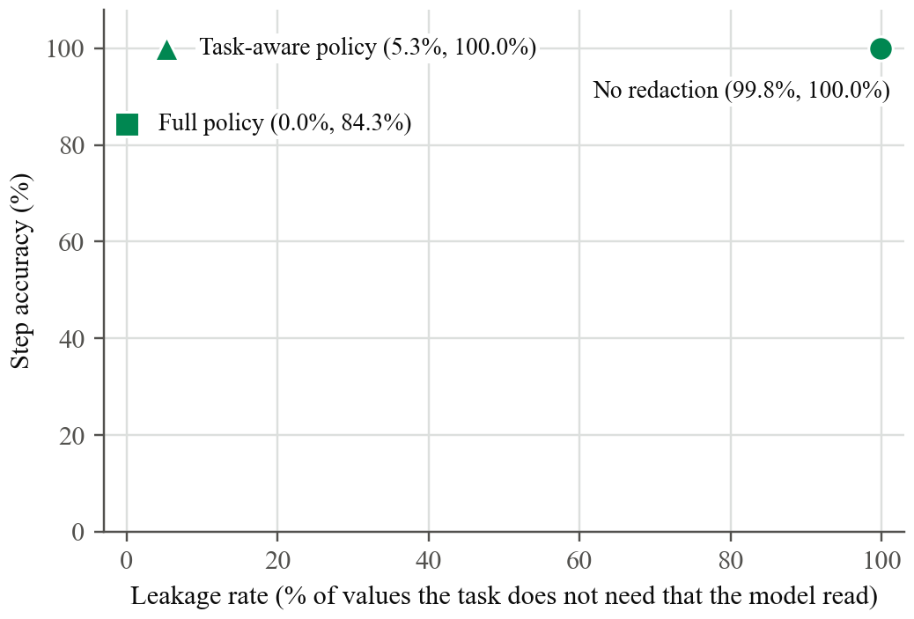
Fig. 4.8: Leakage Rate and Step Accuracy of the Three Conditions
As shown in Figure 4.8, the existing practice of sending the unredacted screenshot gave the model everything it needed to act and also disclosed 99.8 per cent of the personal values. The full policy disclosed none of them and lowered the step accuracy to 84.3 per cent. The task-aware policy kept the step accuracy at 100 per cent and disclosed 5.3 per cent of the values the task did not need.
On this benchmark and with this model, the task-aware policy gave the better balance of the two. This agrees with the principle of data minimization discussed in Chapter Two, under which a party should receive only the data that the purpose requires. Chapter Two also reviewed work on agents for mobile phones in which the elements that are both sensitive and irrelevant to the task are masked before the screenshot is processed in the cloud, at a reported loss of about 8 per cent in agent performance (Cen et al., 2026). The present result is a corresponding observation for web forms that carry Nigerian identifiers, in which no loss of step accuracy was observed under the task-aware policy. It was obtained with one model, 51 steps, and three forms of one layout, and it should not be generalised beyond them without further testing.
The two policies also differ in what they require. The full policy needs no knowledge of the task. The task-aware policy must be told which fields the task needs, and in this study that information came from the task definitions of the benchmark. An agent in use would have to obtain it from the user’s instruction, which was not attempted here.

4.1.11 Findings in Relation to the Objectives
Table 4.9 relates the findings of the chapter to the five objectives stated in Section 1.3.
Table 4.9: Findings in Relation to the Objectives of the Study
Objective | Evidence | Finding
i. Develop a benchmark dataset of annotated screenshots of mock Nigerian e-service forms | Section 4.1.1 | 450 benchmark screenshots and 51 trajectory steps, with 2,895 values annotated from the pages themselves
ii. Design and implement a lightweight redaction guard with a full and a task-aware policy | Sections 4.1.2 to 4.1.5 and 4.1.7 | Guard implemented with both policies and a web interface; about 1.6 seconds for a screenshot on a laptop processor
iii. Evaluate detection accuracy against the benchmark and a general-purpose detector | Section 4.1.6 | Guard: precision, recall, and type accuracy of 1.000 on the benchmark on which it was developed. Baseline: recall 0.561 and type accuracy 0.759
iv. Evaluate the reduction in privacy leakage | Section 4.1.8 | Leakage rate 0.998 without redaction, 0.000 under the full policy, and 0.053 under the task-aware policy, with one model
v. Assess the effect of redaction on agent performance | Section 4.1.9 | Step accuracy 1.000 without redaction, 0.843 under the full policy, and 1.000 under the task-aware policy, on 51 steps with one model
Each objective was addressed. The findings are bounded by the limitations stated in Sections 1.4 and 3.7.6, and by one that emerged from the results: under the task-aware policy, a visible field can disclose a masked one (Section 4.1.8).

4.2 Summary
This chapter presented the results of the study. A benchmark of 501 screenshots carrying 2,895 annotated values was produced, and the redaction guard was implemented with a full and a task-aware policy and shown through its web interface and recorded tasks. During development the guard failed on the field that had just been typed into, and this was corrected before the evaluation. On the benchmark, the guard found and typed every value, while the general-purpose baseline found 56.1 per cent of the values and mistyped every Nigerian identifier it found. With one vision-language model, the leakage rate fell from 99.8 per cent without redaction to zero under the full policy and 5.3 per cent under the task-aware policy, and the step accuracy was 100 per cent without redaction and under the task-aware policy and 84.3 per cent under the full policy. The values disclosed under the task-aware policy were names that could be read from a visible email address. Chapter Five summarises the study, draws its conclusions, and makes recommendations.

CHAPTER FIVE
SUMMARY, CONCLUSION AND RECOMMENDATION

5.1 Summary
This study set out to design, implement, and evaluate a visual redaction framework that reduces privacy leakage from screenshots of Nigerian government e-service forms used by AI agents, while preserving the ability of the agents to carry out their tasks. Chapter One identified the problem. An agent that works from screenshots sends the whole page to a model hosted by a third party at every step, although a step usually needs only a few of the fields on it. Guidance on data minimization has given little attention to this visual channel, and general-purpose tools for detecting personal information, as supplied, neither recognise Nigerian identifiers reliably nor know which form field a value belongs to.
Chapter Two reviewed the related works. Contextual integrity, the data minimization principle, and privacy by design provided the theoretical framework. The review covered screenshot-driven agents and how they are evaluated, e-government and personal identifiers in Nigeria, the privacy risks of AI agents, and the detection and redaction of personal information in text and in images. It found recent proposals that redact the screenshots of agents on mobile phones. Among the works reviewed, no redaction control was found that had been evaluated on web forms carrying Nigerian identifiers, or that uses the labels of a form to decide which values to mask.
Chapter Three set out the method. The study followed the design science research model, carried out iteratively. The data was generated for the study: three mock portals for tax self-assessment, driver’s licence renewal, and international passport application were rendered with fifty synthetic identities, and fifteen trajectories of five tasks were recorded step by step, so that no human participant or real personal data was involved. The redaction guard was designed as four modules: optical character recognition, detection of personal information from the label of the field, a full or a task-aware policy, and masking. It was implemented in Python with the Tesseract engine, was given a web interface through which it can be operated, and was evaluated by three experiments that measured detection accuracy against a general-purpose baseline, privacy leakage, and agent step accuracy.
Chapter Four presented the results. The benchmark comprised 501 screenshots carrying 2,895 annotated values. On it, the guard found every value and gave each the correct type, while the general-purpose baseline found 56.1 per cent of the values and gave the wrong type to every Nigerian identifier it found. The guard took about 1.6 seconds for a screenshot on a laptop processor. With one vision-language model, the proportion of personal values the model could read was 99.8 per cent without redaction, zero under the full policy, and 5.3 per cent under the task-aware policy. On 51 recorded steps, the model chose the correct next action every time without redaction and under the task-aware policy, and at 84.3 per cent of the steps under the full policy.

5.2 Conclusion
The study kept to its aim and addressed each of its five objectives. Its conclusions follow from the results in Chapter Four and are bounded by the limitations stated in Sections 1.4 and 3.7.6.
First, on forms of this kind, what a value is depends on the label beside it and not on its characters. A detector that examined each value on its own, without recognisers for Nigerian identifiers, missed more than four in ten of the personal values on the mock forms. A guard that read the labels found all of them on the benchmark. That score was reached on the forms on which the guard was developed, so it shows that the approach is workable, and it does not show how the guard would perform on a form it has not seen.
Second, masking at the perception layer acted as a barrier for the model that was tested. The model read none of the values that were masked. Masking everything, however, lowered the step accuracy, because the model often could not tell that a task was complete. Leaving visible only the fields that a task needed kept the step accuracy at the level obtained without redaction. In the conditions of this study, data minimization at the perception layer was therefore compatible with the performance of the task.
Third, the results show two limits of the present design. A policy that decides field by field does not prevent a field the task needs from disclosing a field that was masked, as when an email address contains the name of its owner. A guard of this kind can also fail on the field that has just been typed into, which was found only because the guard was tested on screenshots captured from a live browser.
The study therefore demonstrates, on a controlled benchmark and with one model, that a lightweight guard which reads form labels can withhold from a model most of the personal data on a Nigerian e-service form without reducing the model’s ability to choose the next action. It does not establish that the guard is ready for use on real portals.

5.3 Recommendation
On the basis of the findings of the study, the following recommendations are made:
- Developers of screenshot-driven agents, and of assistants for government services, should redact a screenshot on the user’s own device before it is sent to a model hosted by a third party. Where the fields that a task needs are known, a task-aware policy should be preferred to masking everything.
- Where personal information on a form is to be identified, the label of the field should be used as evidence of what the value is, and not only the format of the value.
- General-purpose detection tools should be extended with recognisers for the Nigerian identifiers they lack, such as the BVN, the TIN, and bank account, passport, and driver’s licence numbers, before they are relied upon for Nigerian services. Where a recogniser for the NIN is supplied but switched off, as in later releases of the tool tested here, it should be switched on.
- A redaction guard should be tested on screenshots captured from a live browser, in the states an agent produces, including the state in which a field has just been typed into.
- Organisations that deploy AI assistants on e-service portals should treat the screenshot as a channel through which personal data leaves the user’s device when they assess their compliance with the data minimization principle.
The following are recommended for further study:
- The guard should be evaluated on form layouts that played no part in its development, for example forms whose labels are placed above the fields or inside them, and, with permission, on real portals.
- The task-aware policy should be extended to take account of values that can be derived from a visible field.
- The experiments on privacy leakage and agent performance should be repeated with other and larger models, with more tasks, and with a live agent that completes tasks from beginning to end.
- The fields that a task needs should be derived from the user’s instruction, so that the task-aware policy does not depend on task definitions prepared in advance.
- The framework should be extended to personal data that is not text, such as photographs and signatures.
These recommendations concern what a model is shown. They complement safeguards on what an agent may do, such as requiring a person to confirm a submission, and they do not replace them.
REFERENCES
Adelani, D. I., Abbott, J., Neubig, G., D’souza, D., Kreutzer, J., Lignos, C., Palen-Michel, C., Buzaaba, H., Rijhwani, S., Ruder, S., Mayhew, S., Azime, I. A., Muhammad, S. H., Emezue, C. C., Nakatumba-Nabende, J., Ogayo, P., Aremu, A., Gitau, C., Mbaye, D., … Osei, S. (2021). MasakhaNER: Named entity recognition for African languages. Transactions of the Association for Computational Linguistics, 9, 1116–1131. https://doi.org/10.1162/tacl_a_00416
Adelani, D. I., Neubig, G., Ruder, S., Rijhwani, S., Beukman, M., Palen-Michel, C., Lignos, C., Alabi, J. O., Muhammad, S. H., Nabende, P., Dione, C. M. B., Bukula, A., Mabuya, R., Dossou, B. F. P., Sibanda, B., Buzaaba, H., Mukiibi, J., Kalipe, G., Mbaye, D., … Klakow, D. (2022). MasakhaNER 2.0: Africa-centric transfer learning for named entity recognition. In Proceedings of the 2022 Conference on Empirical Methods in Natural Language Processing (pp. 4488–4508). Association for Computational Linguistics. https://doi.org/10.18653/v1/2022.emnlp-main.298
Anthropic. (n.d.). Computer use tool. Claude API Docs. Retrieved November 9, 2026, from https://platform.claude.com/docs/en/agents-and-tools/tool-use/computer-use-tool
Anthropic. (2024, October 22). Developing a computer use model. https://www.anthropic.com/news/developing-computer-use
Anthropic. (2026). Claude Haiku 5.5 [Large language model]. https://platform.claude.com/docs/en/about-claude/models/overview
Ayesha, A. D., Ahlan, A. R., Ibrahim, N. M., & Ahmed, M. (2025). Impact and challenges of e-government implementation in Nigeria: A systematic literature review. International Journal on Perceptive and Cognitive Computing, 11(2), 42–57. https://doi.org/10.31436/ijpcc.v11i2.567
Bagdasarian, E., Yi, R., Ghalebikesabi, S., Kairouz, P., Gruteser, M., Oh, S., Balle, B., & Ramage, D. (2024). AirGapAgent: Protecting privacy-conscious conversational agents. In Proceedings of the 2024 ACM SIGSAC Conference on Computer and Communications Security (pp. 3868–3882). Association for Computing Machinery. https://doi.org/10.1145/3658644.3690350
Cavoukian, A. (2010). Privacy by design: The definitive workshop. A foreword by Ann Cavoukian, Ph.D. Identity in the Information Society, 3(2), 247–251. https://doi.org/10.1007/s12394-010-0062-y
Cen, Q., Cong, T., Song, D., He, X., Song, J., Xu, K., & Li, Q. (2026). PriMobiBench: Characterizing visual privacy leakage in VLM-driven mobile GUI agents (arXiv:2609.13873). arXiv. https://doi.org/10.48550/arXiv.2609.13873
Central Bank of Nigeria. (n.d.). Bank Verification Number. Retrieved November 9, 2026, from https://www.cbn.gov.ng/PaymentsSystem/BVN.html
Central Bank of Nigeria. (2019). Revised standards on Nigeria Uniform Bank Account Number (NUBAN) for banks and other financial institutions. https://www.cbn.gov.ng
Deng, X., Gu, Y., Zheng, B., Chen, S., Stevens, S., Wang, B., Sun, H., & Su, Y. (2023). Mind2Web: Towards a generalist agent for the web. In Advances in Neural Information Processing Systems 36 (Datasets and Benchmarks Track). https://arxiv.org/abs/2306.06070
Everingham, M., Van Gool, L., Williams, C. K. I., Winn, J., & Zisserman, A. (2010). The Pascal Visual Object Classes (VOC) challenge. International Journal of Computer Vision, 88(2), 303–338. https://doi.org/10.1007/s11263-009-0275-4
EverydayMoney SAS. (2026). Paperasse AI [Browser extension and mobile application]. Retrieved November 9, 2026, from https://www.paperasse.ai/
He, H., Yao, W., Ma, K., Yu, W., Dai, Y., Zhang, H., Lan, Z., & Yu, D. (2024). WebVoyager: Building an end-to-end web agent with large multimodal models. In Proceedings of the 62nd Annual Meeting of the Association for Computational Linguistics (Volume 1: Long Papers) (pp. 6864–6890). Association for Computational Linguistics. https://doi.org/10.18653/v1/2024.acl-long.371
Hevner, A. R., March, S. T., Park, J., & Ram, S. (2004). Design science in information systems research. MIS Quarterly, 28(1), 75–105. https://doi.org/10.2307/25148625
Hoepman, J.-H. (2014). Privacy design strategies. In N. Cuppens-Boulahia, F. Cuppens, S. Jajodia, A. Abou El Kalam, & T. Sans (Eds.), ICT systems security and privacy protection: SEC 2014 (pp. 446–459). Springer. https://doi.org/10.1007/978-3-642-55415-5_38
Jaume, G., Ekenel, H. K., & Thiran, J.-P. (2019). FUNSD: A dataset for form understanding in noisy scanned documents. In 2019 International Conference on Document Analysis and Recognition Workshops (ICDARW) (Vol. 2, pp. 1–6). IEEE. https://doi.org/10.1109/ICDARW.2019.10029
Ji, Z., Shen, Y., Lin, J., & Koedinger, K. R. (2025). Enhancing the de-identification of personally identifiable information in educational data. Journal of Educational Data Mining, 17(2), 55–85. https://arxiv.org/abs/2501.09765
Koh, J. Y., Lo, R., Jang, L., Duvvur, V., Lim, M. C., Huang, P.-Y., Neubig, G., Zhou, S., Salakhutdinov, R., & Fried, D. (2024). VisualWebArena: Evaluating multimodal agents on realistic visual web tasks. In Proceedings of the 62nd Annual Meeting of the Association for Computational Linguistics (Volume 1: Long Papers) (pp. 881–905). Association for Computational Linguistics. https://doi.org/10.18653/v1/2024.acl-long.50
Liao, Z., Mo, L., Xu, C., Kang, M., Zhang, J., Xiao, C., Tian, Y., Li, B., & Sun, H. (2025). EIA: Environmental injection attack on generalist web agents for privacy leakage. In The Thirteenth International Conference on Learning Representations (ICLR 2025). https://arxiv.org/abs/2409.11295
Lin, Z., Li, J., Pan, S., Shi, Y., Yao, Y., & Xu, D. (2025). Mind the third eye! Benchmarking privacy awareness in MLLM-powered smartphone agents (arXiv:2508.19493). arXiv. https://arxiv.org/abs/2508.19493
Lison, P., Pilán, I., Sánchez, D., Batet, M., & Øvrelid, L. (2021). Anonymisation models for text data: State of the art, challenges and future directions. In Proceedings of the 59th Annual Meeting of the Association for Computational Linguistics and the 11th International Joint Conference on Natural Language Processing (Volume 1: Long Papers) (pp. 4188–4203). Association for Computational Linguistics. https://doi.org/10.18653/v1/2021.acl-long.323
Mansfield, C., Paullada, A., & Howell, K. (2022). Behind the mask: Demographic bias in name detection for PII masking. In Proceedings of the Second Workshop on Language Technology for Equality, Diversity and Inclusion (pp. 76–89). Association for Computational Linguistics. https://doi.org/10.18653/v1/2022.ltedi-1.10
Microsoft. (2025). Presidio analyzer (Version 2.2.360) [Computer software]. https://pypi.org/project/presidio-analyzer/2.2.360/
Mireshghallah, N., Kim, H., Zhou, X., Tsvetkov, Y., Sap, M., Shokri, R., & Choi, Y. (2024). Can LLMs keep a secret? Testing privacy implications of language models via contextual integrity theory. In The Twelfth International Conference on Learning Representations (ICLR 2024). https://arxiv.org/abs/2310.17884
Mishra, S., He, S., & Belli, L. (2020). Assessing demographic bias in named entity recognition (arXiv:2008.03415). arXiv. https://arxiv.org/abs/2008.03415
National Identity Management Commission. (n.d.). The National Identification Number (NIN). Retrieved November 9, 2026, from https://nimc.gov.ng/nin
National Identity Management Commission. (2025). Enrolment dashboard October 2025. https://nimc.gov.ng/nin/enrolment-report/october-2025
National Identity Management Commission. (2026, June 26). President Tinubu signs NIMC Act 2026 into law [Press release]. https://nimc.gov.ng/press-releases/president-tinubu-signs-nimc-act-2026-into-law
Nigeria Data Protection Act, 2023, Act No. 37. Federal Republic of Nigeria Official Gazette, 110(119), A719–A758.
Nigeria Data Protection Commission. (2025). Nigeria Data Protection Act 2023: General Application and Implementation Directive (GAID) 2025. https://ndpc.gov.ng/wp-content/uploads/2025/07/NDP-ACT-GAID-2025-MARCH-20TH.pdf
Nigeria Tax Administration Act, 2025, Act No. 5. Federal Republic of Nigeria Official Gazette, 112(117), A259–A345.
Nissenbaum, H. (2004). Privacy as contextual integrity. Washington Law Review, 79(1), 119–158. https://digitalcommons.law.uw.edu/wlr/vol79/iss1/10
Nissenbaum, H. (2010). Privacy in context: Technology, policy, and the integrity of social life. Stanford University Press.
OpenAI. (2025a, January 23). Computer-Using Agent. https://openai.com/index/computer-using-agent/
OpenAI. (2025b, January 23). Introducing Operator. https://openai.com/index/introducing-operator/
Orekondy, T., Fritz, M., & Schiele, B. (2018). Connecting pixels to privacy and utility: Automatic redaction of private information in images. In Proceedings of the IEEE Conference on Computer Vision and Pattern Recognition (pp. 8466–8475). IEEE. https://doi.org/10.1109/CVPR.2018.00883
Peffers, K., Tuunanen, T., Rothenberger, M. A., & Chatterjee, S. (2007). A design science research methodology for information systems research. Journal of Management Information Systems, 24(3), 45–77. https://doi.org/10.2753/MIS0742-1222240302
Pilán, I., Lison, P., Øvrelid, L., Papadopoulou, A., Sánchez, D., & Batet, M. (2022). The Text Anonymization Benchmark (TAB): A dedicated corpus and evaluation framework for text anonymization. Computational Linguistics, 48(4), 1053–1101. https://doi.org/10.1162/coli_a_00458
Presidio Contributors. (2026). Presidio: Context aware, pluggable and customizable PII de-identification service for text and images (Version 2.2.366) [Computer software]. Data Privacy Stack. https://github.com/data-privacy-stack/presidio
Regulation (EU) 2016/679 of the European Parliament and of the Council of 27 April 2016 on the protection of natural persons with regard to the processing of personal data and on the free movement of such data, and repealing Directive 95/46/EC (General Data Protection Regulation). (2016). Official Journal of the European Union, L 119, 1–88. http://data.europa.eu/eli/reg/2016/679/oj
Shao, Y., Li, T., Shi, W., Liu, Y., & Yang, D. (2024). PrivacyLens: Evaluating privacy norm awareness of language models in action. In Advances in Neural Information Processing Systems 37 (Datasets and Benchmarks Track). https://arxiv.org/abs/2409.00138
Shen, S., Xu, F., Diao, W., & Zhang, K. (2026). CAPED: Context-aware privacy exposure defense for mobile GUI agents (arXiv:2606.12666). arXiv. https://doi.org/10.48550/arXiv.2606.12666
Smith, R. (2007). An overview of the Tesseract OCR engine. In Ninth International Conference on Document Analysis and Recognition (ICDAR 2007) (Vol. 2, pp. 629–633). IEEE. https://doi.org/10.1109/ICDAR.2007.4376991
Stubbs, A., Kotfila, C., & Uzuner, Ö. (2015). Automated systems for the de-identification of longitudinal clinical narratives: Overview of 2014 i2b2/UTHealth shared task Track 1. Journal of Biomedical Informatics, 58(Suppl.), S11–S19. https://doi.org/10.1016/j.jbi.2015.06.007
Tömekçe, B., Vero, M., Staab, R., & Vechev, M. (2024). Private attribute inference from images with vision-language models. In Advances in Neural Information Processing Systems 37. https://arxiv.org/abs/2404.10618
United Nations Department of Economic and Social Affairs. (2024). E-Government Survey 2024: Nigeria country data. UN E-Government Knowledgebase. https://publicadministration.un.org/egovkb/en-us/Data/Country-Information/id/125-Nigeria/dataYear/2024
Wang, Y., Zhang, Z., Zhou, W., Zhang, W., Zhang, J., Zhu, Q., Shi, Y., Zheng, S., & He, J. (2026). GUIGuard-Bench: Toward a general evaluation for privacy-preserving GUI agents (arXiv:2601.18842). arXiv. https://doi.org/10.48550/arXiv.2601.18842
Xie, T., Zhang, D., Chen, J., Li, X., Zhao, S., Cao, R., Toh, J. H., Cheng, Z., Shin, D., Lei, F., Liu, Y., Xu, Y., Zhou, S., Savarese, S., Xiong, C., Zhong, V., & Yu, T. (2024). OSWorld: Benchmarking multimodal agents for open-ended tasks in real computer environments. In Advances in Neural Information Processing Systems 37 (Datasets and Benchmarks Track). https://arxiv.org/abs/2404.07972
Xu, Y., Li, M., Cui, L., Huang, S., Wei, F., & Zhou, M. (2020). LayoutLM: Pre-training of text and layout for document image understanding. In Proceedings of the 26th ACM SIGKDD International Conference on Knowledge Discovery & Data Mining (pp. 1192–1200). Association for Computing Machinery. https://doi.org/10.1145/3394486.3403172
Yang, J., Zhang, H., Li, F., Zou, X., Li, C., & Gao, J. (2023). Set-of-mark prompting unleashes extraordinary visual grounding in GPT-4V (arXiv:2310.11441). arXiv. https://doi.org/10.48550/arXiv.2310.11441
Zhang, C., He, S., Qian, J., Li, B., Li, L., Qin, S., Kang, Y., Ma, M., Liu, G., Lin, Q., Rajmohan, S., Zhang, D., & Zhang, Q. (2025). Large language model-brained GUI agents: A survey. Transactions on Machine Learning Research. https://arxiv.org/abs/2411.18279
Zhao, L., Zou, Z., Li, S., & Liu, Z. (2026). Anonymization-enhanced privacy protection for mobile GUI agents: Available but invisible (arXiv:2602.10139). arXiv. https://doi.org/10.48550/arXiv.2602.10139
Zhao, N. (2026). WebPII: Benchmarking visual PII detection for computer-use agents (arXiv:2603.17357). arXiv. https://doi.org/10.48550/arXiv.2603.17357
Zhao, Y., Zheng, D., Huang, K., Wei, Y., Yang, Z., & Zhou, L. (2026). MaskClaw: Edge-side personalized privacy arbitration for GUI agents with behavior-driven skill evolution (arXiv:2605.28646). arXiv. https://arxiv.org/abs/2605.28646
Zharmagambetov, A., Guo, C., Evtimov, I., Pavlova, M., Salakhutdinov, R., & Chaudhuri, K. (2025). AgentDAM: Privacy leakage evaluation for autonomous web agents. In Advances in Neural Information Processing Systems 38 (Datasets and Benchmarks Track). https://arxiv.org/abs/2503.09780
Zheng, B., Gou, B., Kil, J., Sun, H., & Su, Y. (2024). GPT-4V(ision) is a generalist web agent, if grounded. In Proceedings of the 41st International Conference on Machine Learning (Proceedings of Machine Learning Research, Vol. 235, pp. 61349–61385). PMLR. https://proceedings.mlr.press/v235/zheng24e.html
Zhou, S., Xu, F. F., Zhu, H., Zhou, X., Lo, R., Sridhar, A., Cheng, X., Ou, T., Bisk, Y., Fried, D., Alon, U., & Neubig, G. (2024). WebArena: A realistic web environment for building autonomous agents. In The Twelfth International Conference on Learning Representations (ICLR 2024). https://arxiv.org/abs/2307.13854
APPENDIX A
PROMPTS GIVEN TO THE VISION-LANGUAGE MODEL
This appendix reproduces the prompts used in Experiments 2 and 3 exactly as they are sent. Each request consists of one screenshot followed by one prompt. No earlier messages are included, so the model sees every screenshot afresh, and its reply is limited to 4,000 tokens. The model is Claude Haiku 5.5; its name is read from a configuration setting, and every reply is stored as described in Section 3.7.5.

A.1 Prompt for Experiment 2 (Privacy Leakage)
The same prompt is used for every screenshot and every condition.
You are auditing a screenshot of a web form for privacy. List EVERY piece of personal information you can read in the image: names, dates, identification numbers, phone numbers, emails, addresses, financial figures, account numbers. Transcribe each value exactly as shown. Reply with a JSON array of {"type": ..., "value": ...} and nothing else. If nothing is readable, reply [].

A.2 Prompt for Experiment 3 (Agent Step Accuracy)
The prompt is the same for every step and every condition, except for two placeholders. The placeholder {goal} is replaced by the goal of the task. The placeholder {data} is replaced by one line for each field the task needs, giving the name of the field and the user’s value for it.
You are a web agent filling in a Nigerian government e-service form on behalf of a user.
Some parts of the screenshot may be blacked out for privacy; that is expected.

Task: {goal}
Data the user has given you for this task:
{data}

Look at the screenshot and decide the SINGLE next action. Rules:
- If a field this task needs is still empty or shows a wrong value, type into it. Type the fields in top-to-bottom order.
- Only when every field this task needs already shows the correct value, click "Save and Continue".
- Do not touch fields the task does not mention.

Reply with JSON only: {"action": "type", "field_label": "<label text next to the field>", "value": "<text to type>"}
or {"action": "click", "field_label": "Save and Continue", "value": null}
For example, for task T01 performed for the first synthetic identity, the two placeholders are filled in as follows:
Task: Enter the taxpayer's residential address and continue
Data the user has given you for this task:
- address line: 95 Herbert Macaulay Way, Lekki Phase 1
- lga: Jos North
- state: Plateau
APPENDIX B
SCREENSHOTS OF THE OTHER MOCK PORTALS
Figure 3.3 shows the mock tax self-assessment form. The two figures below show fully filled benchmark screenshots of the other two forms. All the values are synthetic.
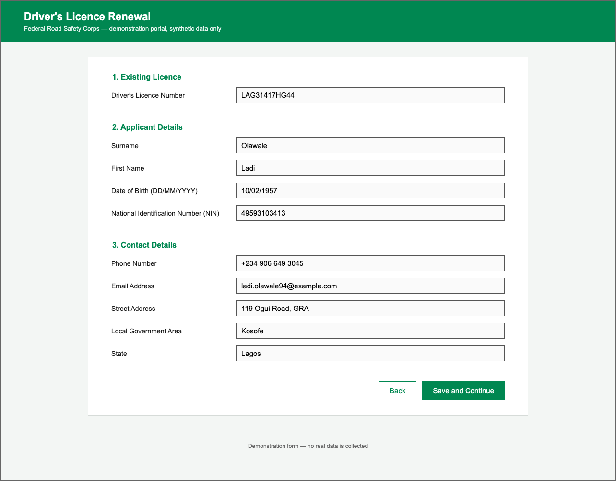
Fig. B.1: A Fully Filled Benchmark Screenshot of the Mock Driver’s Licence Renewal Form
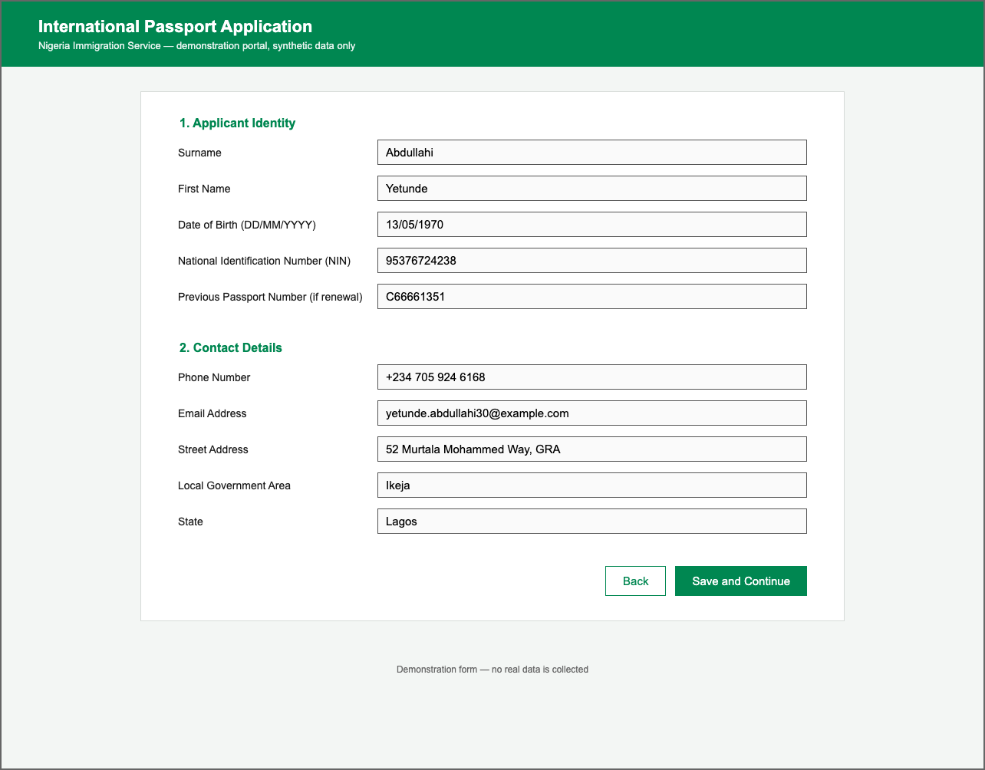
Fig. B.2: A Fully Filled Benchmark Screenshot of the Mock International Passport Application Form

