CHAPTER FOUR
RESULTS AND DISCUSSION

4.0 Introduction
The results and discussion of the project are presented under the following sub-headings. Section 4.1 presents the results and discusses them. Section 4.1.1 describes the benchmark dataset that was produced, Section 4.1.2 shows the output of the redaction guard, Section 4.1.3 presents the demonstration page, and Section 4.1.4 shows the guard at one step of a recorded task. Section 4.1.5 reports how the guard was refined during development. Section 4.1.6 gives the detection accuracy of the guard and of the general-purpose baseline, Section 4.1.7 the processing time, Section 4.1.8 the privacy leakage, and Section 4.1.9 the agent step accuracy. Section 4.1.10 sets privacy against usefulness, and Section 4.1.11 relates the findings to the objectives of the study. Section 4.2 summarises the chapter.

4.1 Result and Discussion
The system described in Chapter Three was implemented and evaluated. The sub-sections below present what was built and the results of the three experiments set out in Section 3.7. All the personal values that appear in the figures are synthetic.

4.1.1 The Benchmark Dataset
The first objective of the study was to construct a benchmark of screenshots of mock Nigerian e-service forms, filled with synthetic identities and annotated automatically. The three mock portals were rendered for fifty synthetic identities in three fill states (empty, partly filled, and fully filled), and fifteen tasks were recorded step by step. The composition of the resulting dataset is given in Table 4.1.
Table 4.1: Composition of the Benchmark Dataset
Part of the dataset | Fields | Screenshots | Annotated values
Tax self-assessment form | 12 | 150 | 900
Driver’s licence renewal form | 10 | 150 | 750
International passport application form | 10 | 150 | 750
Recorded steps of 15 trajectories (tasks T01 to T05) | – | 51 | 495
Total |  | 501 | 2,895
Every annotated value carries its position on the screenshot, its type, and the form field it belongs to. These were read from the page itself at the moment the screenshot was taken, so no value was located or labelled by hand. Figure 4.1 shows one benchmark screenshot with its annotations drawn on it.
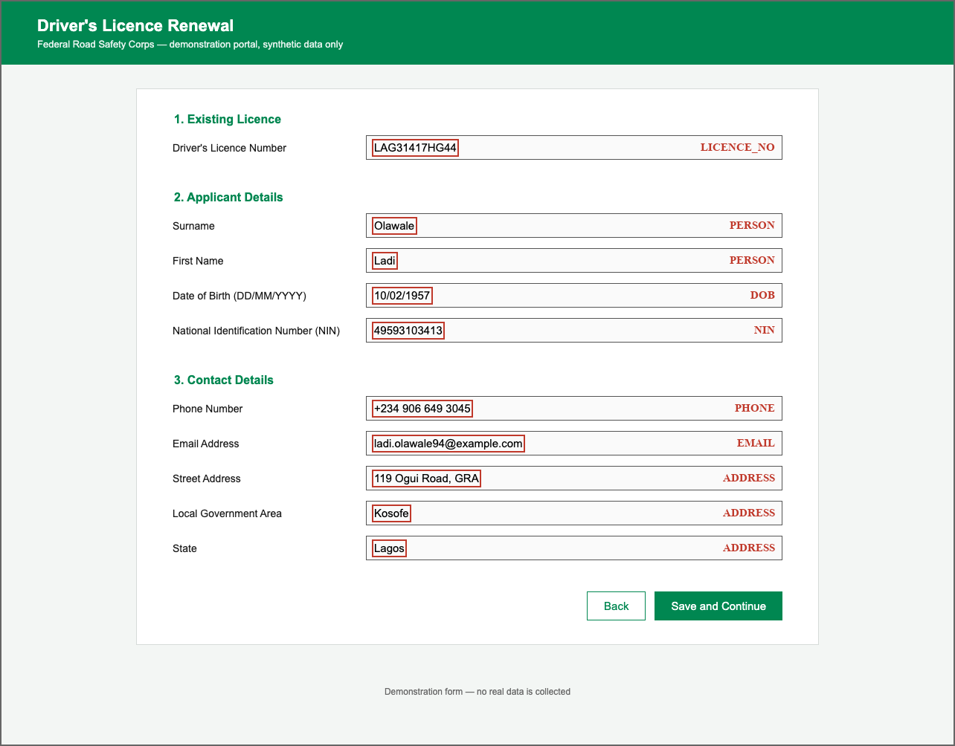
Fig. 4.1: A Benchmark Screenshot of the Driver’s Licence Renewal Form with its Annotations
As shown in Figure 4.1, each personal value is enclosed by a box that fits the text closely, and its type is recorded. The three address fields share one type, and the two name fields share another. The 150 empty screenshots carry no annotated value. They were kept in the benchmark because a detector can raise a false alarm on a form that holds no personal data, and Section 4.1.6 shows that the baseline did so.

4.1.2 Output of the Redaction Guard
The second objective was to design and implement a redaction guard that identifies personal information from its form-field label and masks it before the screenshot is transmitted, under a full policy and a task-aware policy. Figure 4.2 shows the output of the guard for one fully filled screenshot of the driver’s licence renewal form.
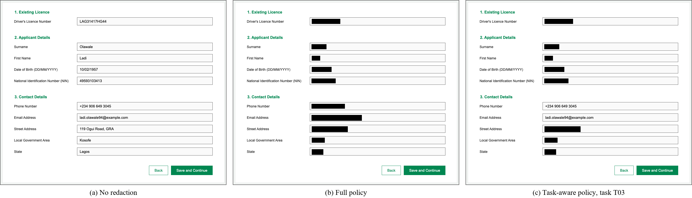
Fig. 4.2: A Screenshot of the Driver’s Licence Renewal Form (a) without Redaction, (b) under the Full Policy, and (c) under the Task-aware Policy for Task T03
As shown in Figure 4.2, under the full policy every one of the ten values is covered by an opaque black box, while the labels, the headings, and the buttons remain readable. Under the task-aware policy for task T03, which is to enter the applicant’s phone number and email address, those two values are left visible and the other eight are masked. In both cases only the text of a value is covered and the outline of its input box is kept, so the layout of the form is preserved.

4.1.3 The Demonstration Page
A demonstration page was built so that the guard can be shown working on a single screenshot. It runs on the user’s own computer, keeps an uploaded screenshot in memory only, and calls the same functions as the experiments. It is an aid to demonstration and took no part in the evaluation. The user chooses a screenshot, or one of three samples from the benchmark, and then chooses a policy. Figure 4.3 shows the page after a sample of the driver’s licence renewal form was redacted under the full policy.
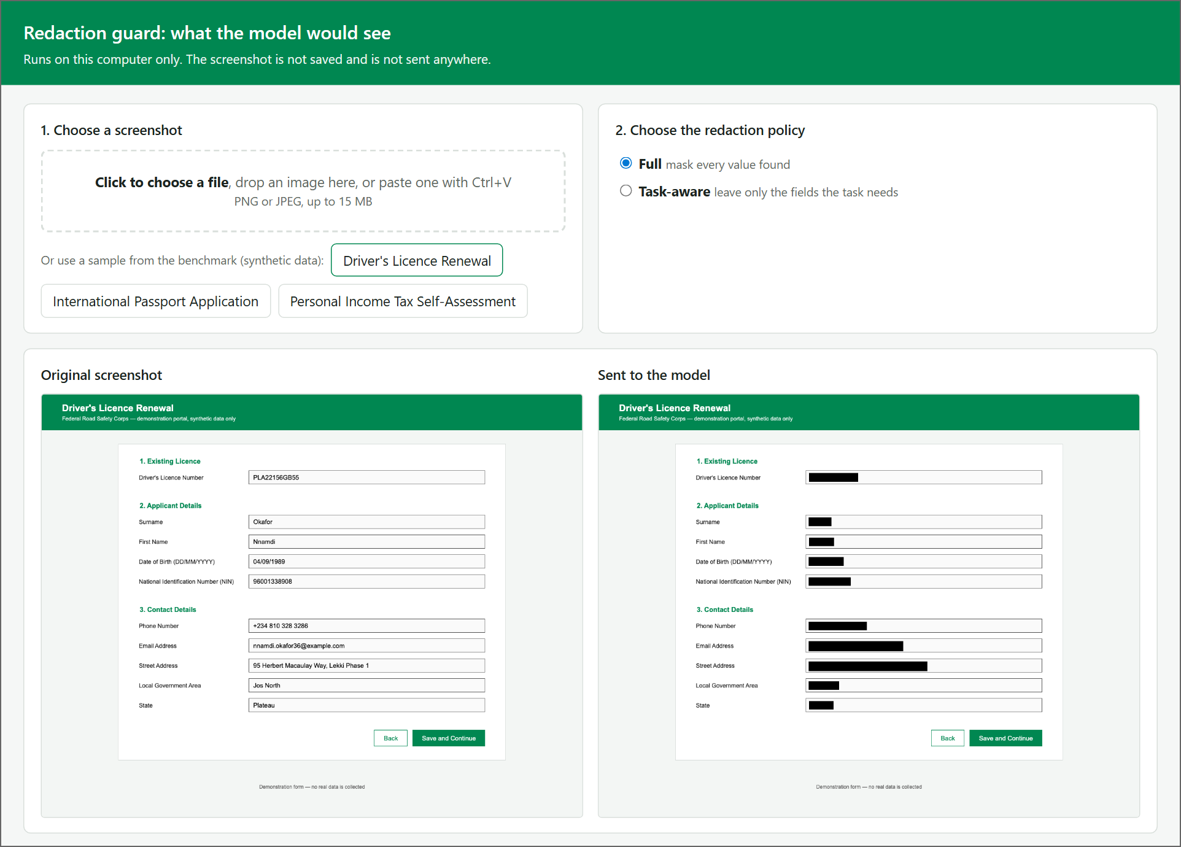
Fig. 4.3: The Demonstration Page after Redaction under the Full Policy
As shown in Figure 4.3, the page places the original screenshot beside the copy that would be sent to the model. When the task-aware policy is chosen, the user selects one of the five tasks, or ticks the fields to leave visible. The page then lists every value the guard read, as shown in Figure 4.4.
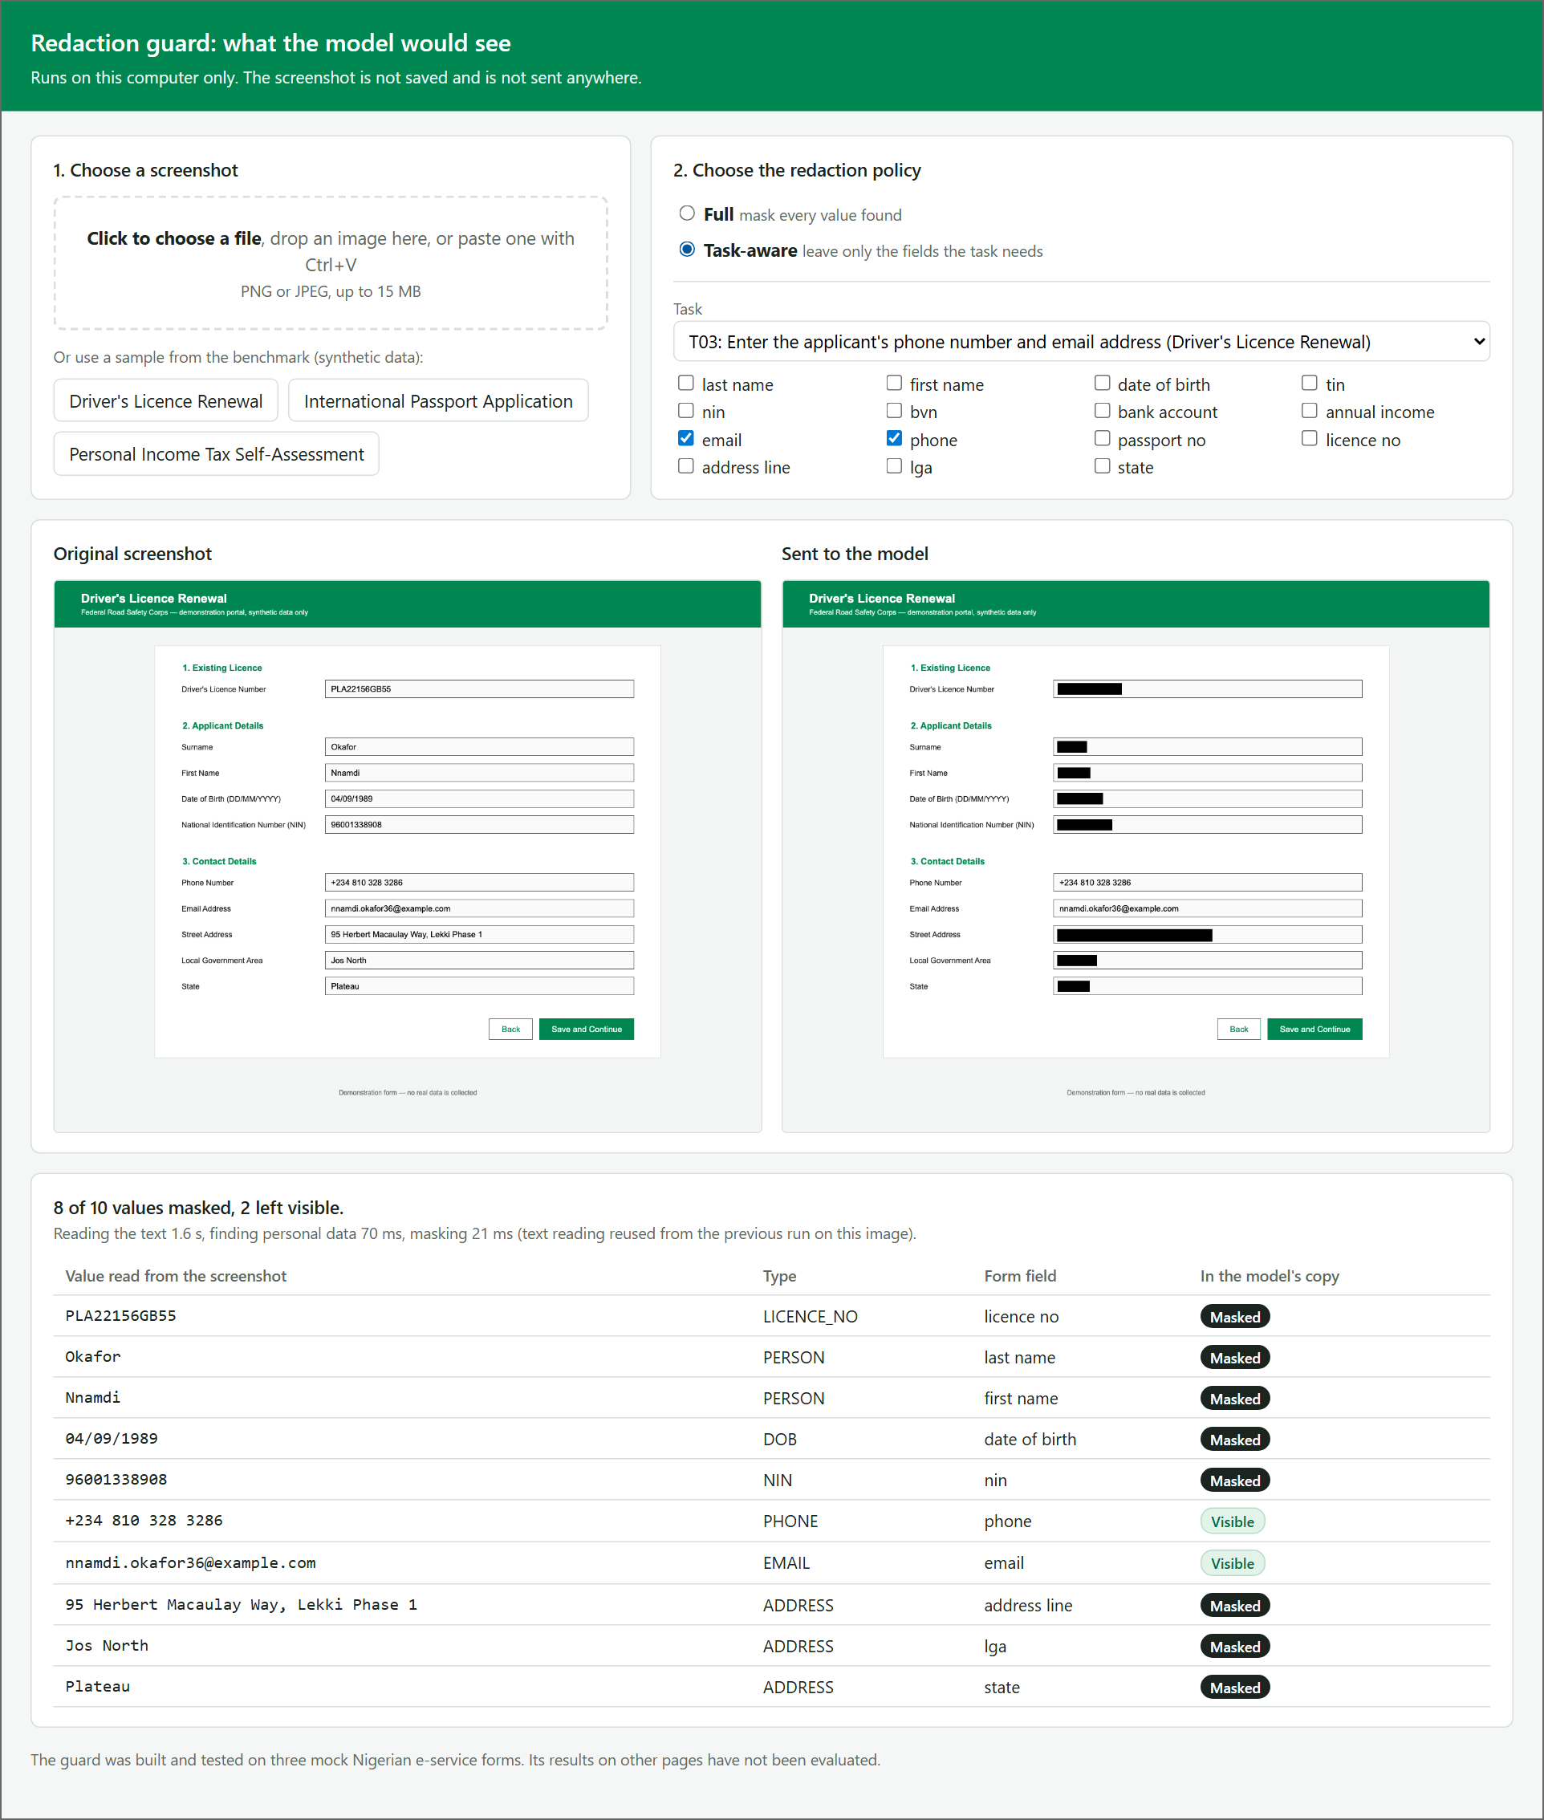
Fig. 4.4: The Demonstration Page under the Task-aware Policy for Task T03, with the List of Values Found
As shown in Figure 4.4, the list gives each value, its type, the form field to which the guard attributed it, and whether it was masked. For task T03 eight of the ten values were masked and the phone number and email address were left visible. The page also reports the time taken by each stage on the computer on which it runs.

4.1.4 The Guard at One Step of a Task
As stated in Section 1.4, the study works on recorded task steps and not with a live agent. The place of the guard in the loop of an agent is therefore shown on the recorded trajectories. For every recorded step, the screenshot the browser displayed was set beside the image the model would receive under the task-aware policy. Figure 4.5 shows one such step of task T02, which is to enter the annual income and the bank details on the tax form.
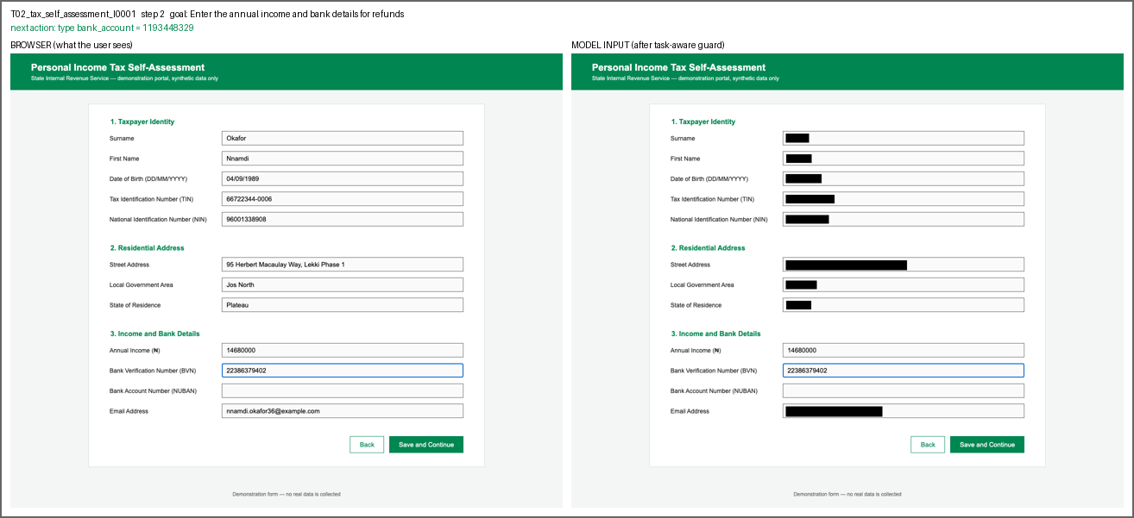
Fig. 4.5: A Step of Task T02 as Displayed by the Browser (left) and as Received by the Model (right)
As shown in Figure 4.5, the annual income and the BVN, which the task needs and which have already been entered, remain readable in the image on the right, and every other value on the form is masked. The bank account field is still empty. The line above the two images gives the goal of the task and the recorded next action, which here is to type the bank account number. It is the action against which the model is scored in Section 4.1.9.

4.1.5 Refinement of the Guard during Development
Section 3.1 stated that the guard went through three cycles of building and testing. Table 4.2 gives the result of each cycle on the full set of 501 screenshots and 2,895 values.
Table 4.2: Detection Results of the Three Development Cycles
Cycle | State of the design | False positives | Missed values | Precision | Recall | F1
1 | First design | 90 | 66 | 0.969 | 0.977 | 0.973
2 | OCR set to analyse the whole page layout; fragments made only of bars dropped; no cut-off on OCR confidence | 0 | 9 | 1.000 | 0.997 | 0.998
3 | Colour of the focus ring painted white before OCR | 0 | 0 | 1.000 | 1.000 | 1.000
All the errors of the first cycle were on trajectory steps taken just after a value had been typed. The browser draws a blue ring around the field in use. The OCR engine read the borders of input boxes as characters, and it skipped the text inside the ringed field. After the changes of the second cycle, nine values were still missed, and every one was the value in the field that had just been typed into. The value the guard failed to mask was therefore the one the user had most recently supplied. Painting the colour of the ring white before OCR removed these nine misses.
This failure appeared only because the trajectories were captured from a live browser, in which the field in use is ringed. It did not occur on the 450 benchmark screenshots, where no field is in use. It suggests that a guard of this kind should be tested on screenshots taken in the state in which an agent would take them, and not only on still pages.

4.1.6 Detection Accuracy
The third objective was to evaluate the detection accuracy of the guard against the benchmark and to compare it with a general-purpose detector. The measures are defined in Section 3.7.2. The baseline is Presidio (Microsoft, 2025) in its default configuration. Table 4.3 gives the overall results of Experiment 1 for the two detectors on the same 501 screenshots.
Table 4.3: Overall Detection Results of the Guard and the Baseline
Detector | Values found | False positives | Values missed | Precision | Recall | F1 | Type accuracy
Guard | 2,895 | 0 | 0 | 1.000 | 1.000 | 1.000 | 1.000
General-purpose baseline | 1,624 | 174 | 1,271 | 0.903 | 0.561 | 0.692 | 0.759
The guard found all 2,895 annotated values, raised no false positive, and assigned the correct type to every value. Its coverage was also 1.000: each value that was found was painted over completely. The baseline found 1,624 of the values, which is 56.1 per cent, and assigned the correct type to 75.9 per cent of those it found. Table 4.4 gives the results of the baseline for each type of personal information.
Table 4.4: Detection Results of the Baseline for Each Type of Personal Information
Type of personal information | Values | Precision | Recall | F1 | Type accuracy
Email address | 195 | 1.000 | 1.000 | 1.000 | 1.000
Date of birth | 351 | 0.667 | 0.991 | 0.797 | 1.000
Phone number | 124 | 1.000 | 0.919 | 0.958 | 0.877
Address | 635 | 1.000 | 0.709 | 0.829 | 0.660
Bank account number | 65 | 1.000 | 0.692 | 0.818 | 0.000
Name | 702 | 1.000 | 0.484 | 0.653 | 0.859
National Identification Number (NIN) | 342 | 1.000 | 0.281 | 0.438 | 0.000
Driver’s licence number | 115 | 1.000 | 0.148 | 0.258 | 0.000
Bank Verification Number (BVN) | 68 | 1.000 | 0.088 | 0.162 | 0.000
Tax Identification Number (TIN) | 124 | 1.000 | 0.081 | 0.149 | 0.000
Passport number | 103 | 1.000 | 0.019 | 0.038 | 0.000
Annual income | 71 | 1.000 | 0.014 | 0.028 | 0.000
All types | 2,895 | 0.903 | 0.561 | 0.692 | 0.759
The guard scored 1.000 on every measure for every type, so its results are not repeated in the table. Figure 4.6 compares the recall of the two detectors for each type.
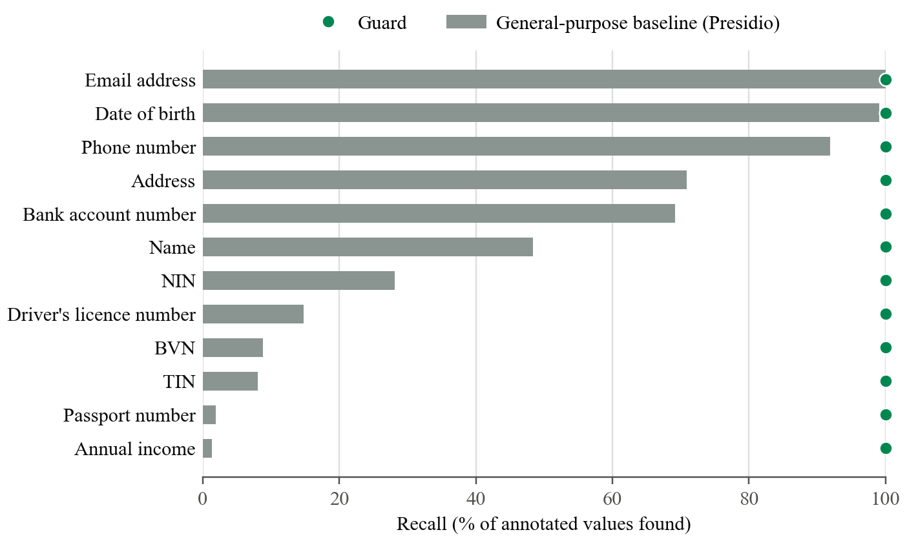
Fig. 4.6: Recall of the Guard and of the Baseline for Each Type of Personal Information
As shown in Figure 4.6, the baseline performed well on the types whose format is the same in every country. It found every email address and almost every date of birth and phone number. It performed poorly on the identifiers that are specific to Nigeria. It found 28.1 per cent of the NINs, 8.8 per cent of the BVNs, 8.1 per cent of the TINs, and fewer than two per cent of the passport numbers and income figures. It found fewer than half of the names. When it did find a NIN, BVN, TIN, bank account number, licence number, or passport number, it never gave it the correct type, as the type accuracy of 0.000 in Table 4.4 shows. The recall of the baseline was 0.595 on the fully filled benchmark screenshots, 0.504 on the partly filled ones, and 0.543 on the trajectory steps.
All 174 false positives of the baseline were the same error. It read the field label “Annual Income” as a date, once on each of the 174 screenshots of the tax form, including the 50 that hold no personal data. This accounts for its precision of 0.667 on dates of birth.
These results agree with what was expected of the baseline. Presidio is supplied without recognisers for Nigerian identifiers (Section 3.7.6), and an eleven-digit number gives no sign of whether it is a NIN or a BVN. The guard does not depend on the format of a value. It takes the type from the label beside the field, which is why it separates the two. The comparison therefore measures the gap between an unadapted general-purpose detector and the label-based method on these forms. It does not show what a general-purpose detector could achieve after recognisers for Nigerian identifiers were added to it.
The perfect score of the guard must be read with the limitation stated in Section 3.7.6. The design was refined on the same 501 screenshots on which it is scored, and the label vocabulary was written with the three mock forms in view. The score shows that the final design fits this benchmark. It does not show how the guard would perform on a form it has not seen, where a label may be worded differently or placed above the field.

4.1.7 Processing Time
The second objective describes the guard as lightweight. The time taken by each stage was recorded for every screenshot, and the medians on the development computer are given in Table 4.5.
Table 4.5: Median Processing Time of Each Stage of the Guard (501 Screenshots)
Stage | Median time (milliseconds)
Optical character recognition | 447
Detection | 17
Policy and masking | 24
Sum of the three stages | 488
As Table 4.5 shows, the guard took about half a second for a screenshot on the processor of a laptop computer, without a graphics processor, and optical character recognition accounted for more than nine-tenths of that time. The time depends on the machine. On the second, older computer described in Table 3.11, the median time of optical character recognition alone was 1,376 milliseconds. The guard therefore adds a delay of between half a second and about one and a half seconds to each step on the two computers that were tested. No claim of real-time operation is made.

4.1.8 Privacy Leakage
The fourth objective was to evaluate the reduction in privacy leakage, measured by how much personal information a vision-language model can still read from a redacted screenshot. Experiment 2 is described in Section 3.7.3. The model was Claude Haiku 5.5 (Anthropic, 2026). It was shown 60 screenshots holding 480 annotated values, each under three conditions, and was asked to list every piece of personal information it could read. Every reply ended normally. Table 4.6 gives the leakage rate of each condition.
Table 4.6: Leakage Rate under Each Condition (Experiment 2)
Condition | Values counted | Values the model read | Leakage rate
No redaction | 480 | 479 | 0.998
Full policy | 480 | 0 | 0.000
Task-aware policy: values the task does not need | 380 | 20 | 0.053
Task-aware policy: values the task needs, left visible on purpose | 100 | 99 | 0.990
Without redaction, the model transcribed 479 of the 480 values. The one it did not transcribe correctly was a street address in which it misread one word. This is the leakage of the existing system: a model that is sent an unredacted screenshot can read practically everything on it.
Under the full policy the model read none of the 480 values. Its reply was an empty list for every one of the 60 screenshots. Under the task-aware policy it read 99 of the 100 values that the tasks needed, which were left visible on purpose; the one exception was a passport number that it misread by one digit. Of the 380 values that the tasks did not need, it read 20, a leakage rate of 5.3 per cent.
The 20 values were examined, and they have a single cause. All of them are the surname and first name on the ten fully filled screenshots of the driver’s licence renewal form. The guard had masked both name fields, as panel (c) of Figure 4.2 shows. However, the benchmark redacts that form for task T03, which needs the email address, and the email addresses of the synthetic identities are formed from the first name and the surname. The model transcribed the email address, and the name was found inside it. For every other type of personal information, the leakage rate under the task-aware policy was zero.
This is not an error of detection. It shows a limit of a policy that decides field by field: a field that the task needs can disclose a field that was masked. Real email addresses often contain the name of their owner, so the same disclosure would be expected outside the benchmark. A policy that took account of it would have to treat a value that can be derived from a visible field as visible. The guard has no such rule, and this is recorded as a limitation of the present design.
Two further points bear on these figures. First, as stated in Section 3.7.6, a value counts as leaked only if the whole of it appears in the reply, and the experiment used one model and one prompt. Second, the task-aware condition of this experiment covers tasks T01, T03, and T05 only.

4.1.9 Agent Step Accuracy
The fifth objective was to assess the effect of redaction on the performance of an agent, measured by its choice of the next action on recorded trajectories. Experiment 3 is described in Section 3.7.4 and follows the offline, step-wise method of Mind2Web (Deng et al., 2023). The same model was shown each of the 51 recorded steps under the three conditions and was asked for the single next action. Table 4.7 gives the step accuracy for each task.
Table 4.7: Step Accuracy for Each Task under Each Condition (Experiment 3)
Task | Steps | No redaction | Full policy | Task-aware policy
T01: residential address | 12 | 1.000 | 0.750 | 1.000
T02: annual income and bank details | 12 | 1.000 | 0.917 | 1.000
T03: phone number and email address | 9 | 1.000 | 0.778 | 1.000
T04: licence number and NIN | 9 | 1.000 | 0.889 | 1.000
T05: NIN and previous passport number | 9 | 1.000 | 0.889 | 1.000
All tasks | 51 | 1.000 | 0.843 | 1.000
The field accuracy was equal to the step accuracy in every cell of the table, so it is not shown separately. Figure 4.7 presents the same results as percentages.
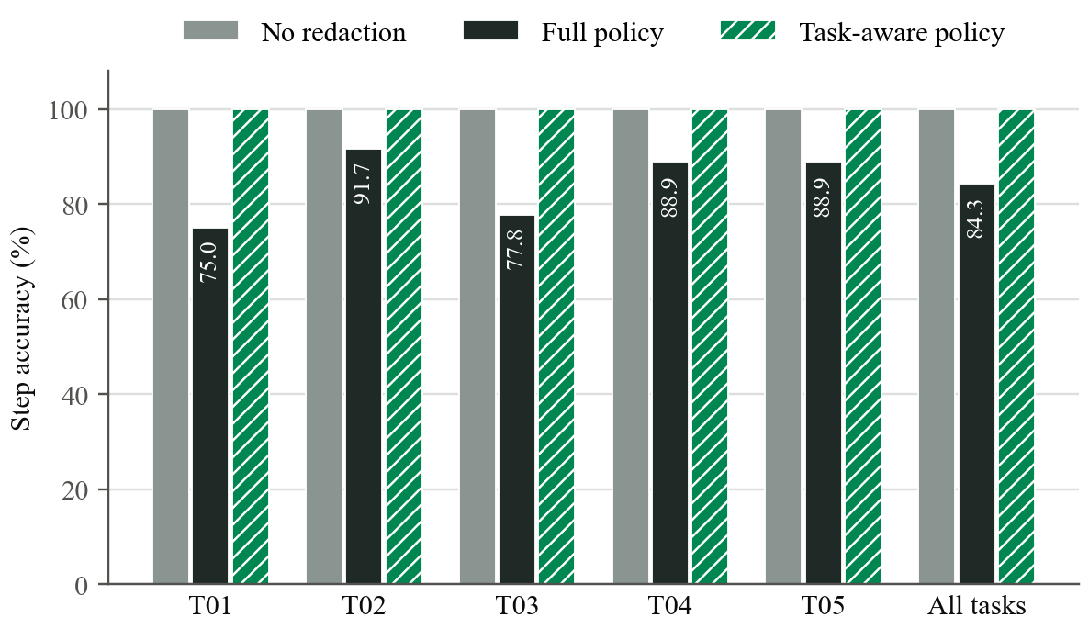
Fig. 4.7: Step Accuracy for Each Task under the Three Conditions
As shown in Figure 4.7, the model chose the recorded action at all 51 steps when it was given the unredacted screenshot, and again at all 51 steps when it was given the screenshot redacted under the task-aware policy. Under the full policy it chose the recorded action at 43 of the 51 steps, a step accuracy of 0.843.
The eight errors under the full policy are of one kind. Each is the final step of a trajectory, at which the recorded action is to click the “Save and Continue” button. The model instead typed one of the values of the task again. The likely reason is that, with every value masked, the model cannot confirm that the fields the task needs already hold the correct values, and the prompt tells it to click only when they do. It still clicked correctly at seven of the fifteen final steps. At the 36 steps at which a value had to be typed, it chose the correct field and value every time under all three conditions. This is consistent with the fact that an empty field is visibly empty even when the rest of the form is masked.
The result points to a specific cost of masking everything: the model could still fill in the form, but it often could not tell that the task was complete. As stated in Section 3.7.6, the sample is small. One step is about two percentage points, no statistical test was applied, and the offline method does not show how an error at one step would affect the steps after it. The difference between 0.843 and 1.000 rests on eight steps of a single kind, and it should be read as a clear pattern in this sample and not as a precise measurement.

4.1.10 Privacy against Usefulness
The results of Experiments 2 and 3 are brought together in Figure 4.8, in which each condition is placed by its leakage rate and its step accuracy.
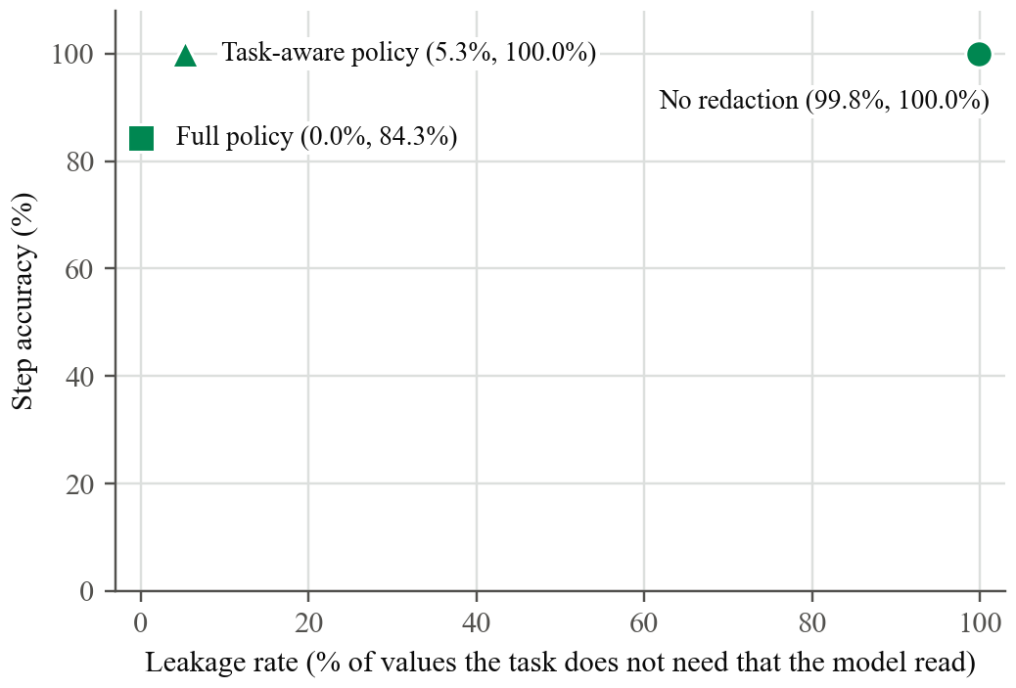
Fig. 4.8: Leakage Rate and Step Accuracy of the Three Conditions
As shown in Figure 4.8, the existing practice of sending the unredacted screenshot gave the model everything it needed to act and also disclosed 99.8 per cent of the personal values. The full policy disclosed none of them and lowered the step accuracy to 84.3 per cent. The task-aware policy kept the step accuracy at 100 per cent and disclosed 5.3 per cent of the values the task did not need.
On this benchmark and with this model, the task-aware policy gave the better balance of the two. This agrees with the principle of data minimization discussed in Chapter Two, under which a party should receive only the data that the purpose requires. Chapter Two also reviewed work on agents for mobile phones in which the elements that are both sensitive and irrelevant to the task are masked before the screenshot is processed in the cloud, at a reported loss of about 8 per cent in agent performance (Cen et al., 2026). The present result is a corresponding observation for web forms that carry Nigerian identifiers, in which no loss of step accuracy was observed under the task-aware policy. It was obtained with one model, 51 steps, and three forms of one layout, and it should not be generalised beyond them without further testing.
The two policies also differ in what they require. The full policy needs no knowledge of the task. The task-aware policy must be told which fields the task needs, and in this study that information came from the task definitions of the benchmark. An agent in use would have to obtain it from the user’s instruction, which was not attempted here.

4.1.11 Findings in Relation to the Objectives
Table 4.8 relates the findings of the chapter to the five objectives stated in Section 1.3.
Table 4.8: Findings in Relation to the Objectives of the Study
Objective | Evidence | Finding
i. Construct an annotated benchmark of mock Nigerian e-service forms | Section 4.1.1 | 450 benchmark screenshots and 51 trajectory steps, with 2,895 values annotated from the pages themselves
ii. Design and implement a lightweight redaction guard with a full and a task-aware policy | Sections 4.1.2 to 4.1.5 and 4.1.7 | Guard implemented with both policies; about half a second for a screenshot on the development computer
iii. Evaluate detection accuracy against the benchmark and a general-purpose detector | Section 4.1.6 | Guard: precision, recall, and type accuracy of 1.000 on the benchmark on which it was developed. Baseline: recall 0.561 and type accuracy 0.759
iv. Evaluate the reduction in privacy leakage | Section 4.1.8 | Leakage rate 0.998 without redaction, 0.000 under the full policy, and 0.053 under the task-aware policy, with one model
v. Assess the effect of redaction on agent performance | Section 4.1.9 | Step accuracy 1.000 without redaction, 0.843 under the full policy, and 1.000 under the task-aware policy, on 51 steps with one model
Each objective was addressed. The findings are bounded by the limitations stated in Sections 1.4 and 3.7.6, and by one that emerged from the results: under the task-aware policy, a visible field can disclose a masked one (Section 4.1.8).

4.2 Summary
This chapter presented the results of the study. A benchmark of 501 screenshots carrying 2,895 annotated values was produced, and the redaction guard was implemented with a full and a task-aware policy and shown through a demonstration page and recorded tasks. During development the guard failed on the field that had just been typed into, and this was corrected before the evaluation. On the benchmark, the guard found and typed every value, while the general-purpose baseline found 56.1 per cent of the values and mistyped every Nigerian identifier it found. With one vision-language model, the leakage rate fell from 99.8 per cent without redaction to zero under the full policy and 5.3 per cent under the task-aware policy, and the step accuracy was 100 per cent without redaction and under the task-aware policy and 84.3 per cent under the full policy. The values disclosed under the task-aware policy were names that could be read from a visible email address. Chapter Five summarises the study, draws its conclusions, and makes recommendations.
REFERENCES
Anthropic. (2026). Claude Haiku 5.5 [Large language model]. https://platform.claude.com/docs/en/about-claude/models/overview
Cen, Q., Cong, T., Song, D., He, X., Song, J., Xu, K., & Li, Q. (2026). PriMobiBench: Characterizing visual privacy leakage in VLM-driven mobile GUI agents (arXiv:2609.13873). arXiv. https://doi.org/10.48550/arXiv.2609.13873
Deng, X., Gu, Y., Zheng, B., Chen, S., Stevens, S., Wang, B., Sun, H., & Su, Y. (2023). Mind2Web: Towards a generalist agent for the web. In Advances in Neural Information Processing Systems 36 (Datasets and Benchmarks Track). https://arxiv.org/abs/2306.06070
Microsoft. (2025). Presidio analyzer (Version 2.2.360) [Computer software]. https://pypi.org/project/presidio-analyzer/2.2.360/

