**TASK-1: Take two inputs and Subtract.**

**CODE:**

IN

Sto 85

IN

Sto 86

LDA 85

SUB 86

Sto 87

OUT

**OUTPUT:**

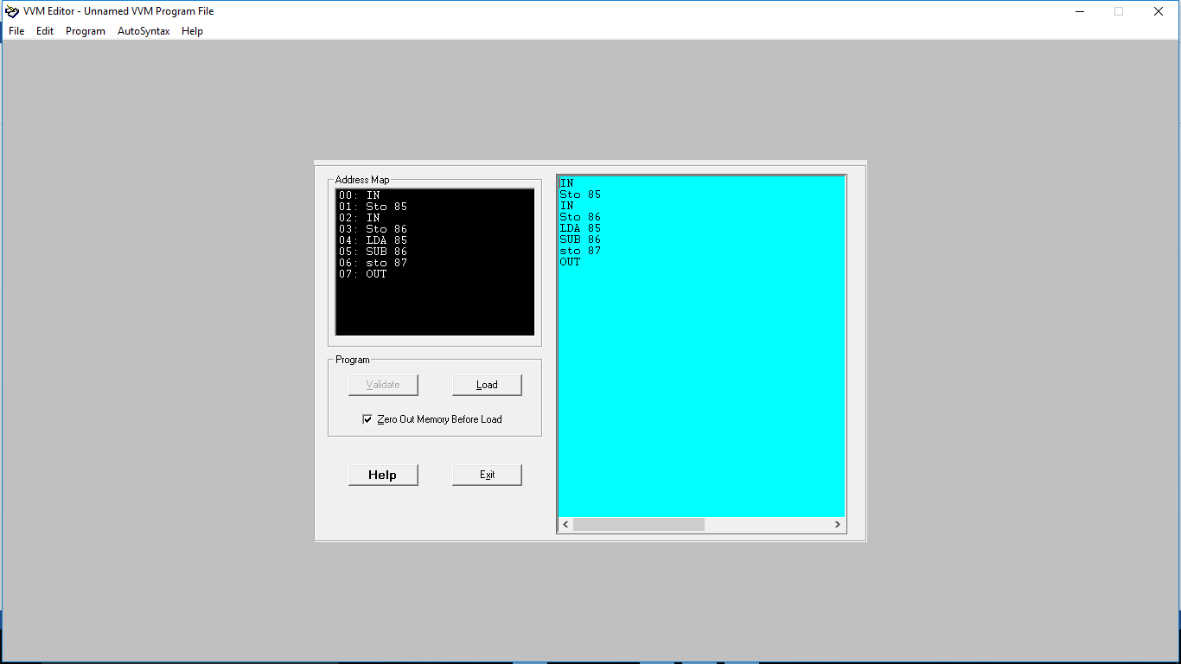

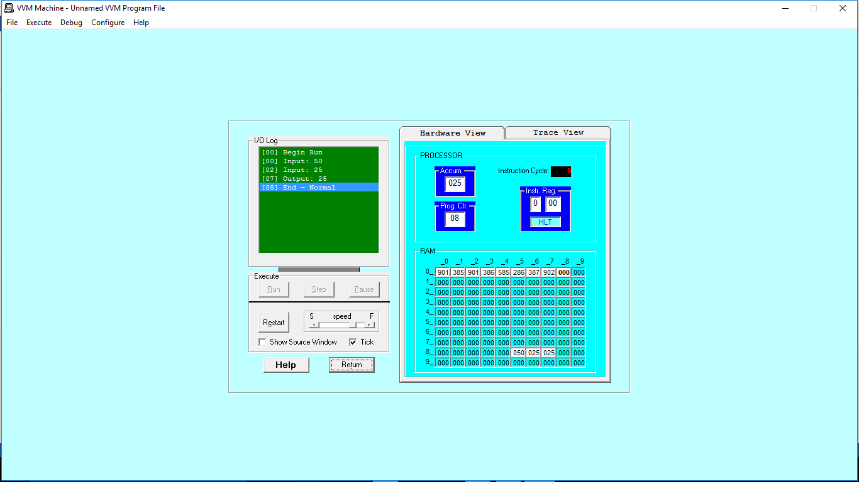

**TASK-2: Take two hardcoded inputs and Add them.**

**CODE:**

LDA 70

ADD 71

OUT

*70

DAT 002

*71

DAT 012

**OUTPUT:**

