1. **Where (to which window) is the output data displayed?**

**ANSWER:**

**SYSTEM I/O (INPUT/OUTPUT):**

The Run I/O tab: Used at runtime for displaying console output and entering console input

As program execution progresses. All the instruction for giving input and to print output are Executed in the input output w

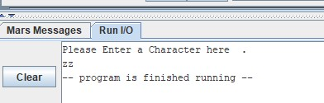

1. **Write down the address of the first instruction of the program (see the text window)?**

**ANSWER:**

During execution, the instruction being executed is highlighted in yellow, address Address of the first instruction of the program is shown as:

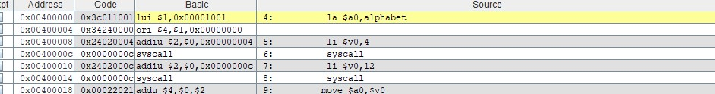

1. **Write down the values of $a0 and $v0 after execution in Register window?**

**ANSWER:**

At all times, the MIPS register window appears on the right-hand side of the screen, even when you are editing and not running a program. While writing a program, this serves as a useful reference for register names and their use.

The value of $a0, $v0 in register window are as:

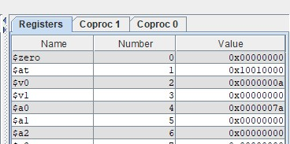

1. **Write an assembly program that print char.**

**Code**

.data alphabet : .asciiz "Please Enter a Character here . \n" .text main: la $a0,alphabet li $v0,4 syscall li $v0,12 syscall move $a0,$v0 li $v0,11 syscall li $v0, 10 syscallOUTPUT:

