**Task # 1:** Write VVM program which take the integer input and display the table of that integer

**Code:**

in Input Number

sto 50 Store value in address 50

sto 51 Store this value to 51

out output

lda 97 Load address 97 (multiplier limit)

sub 98 Subtract with 97

brz 15 check if 0 terminate program

lda 98 load 98

add 99 Add 99

sto 98 Store

lda 50 Load 50

add 51 Add 51

sto 50 Store 50

out

br 04

hlt

*97

dat 010

dat 001

dat 001

**Output:**

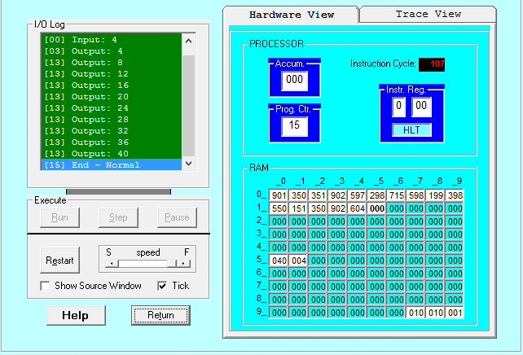

**Task # 2:** Take integer from User and print square of a number

**Code:**

in Input Number A

sto 50 Value stored

sto 51 Value of Square stored

lda 50 Load A

sub 97 Subtract with index

brz 13 go to line 13 if 0

lda 96 load 96

add 97 add 97 Increment Index

sto 97 store 97

lda 51 Load 51

add 50 Add 50

sto 51 Store 51

br 03 Again goto line 03 and check condition

lda 51 load 51

out print square

hlt terminate

*96

dat 001 store initial value

dat 001 store increment

**Output:**

