**ASSIGNMENT NUMBER#3**

**Question#1:**

**Selenium Unit Testing:**

**Student Registration Page:**

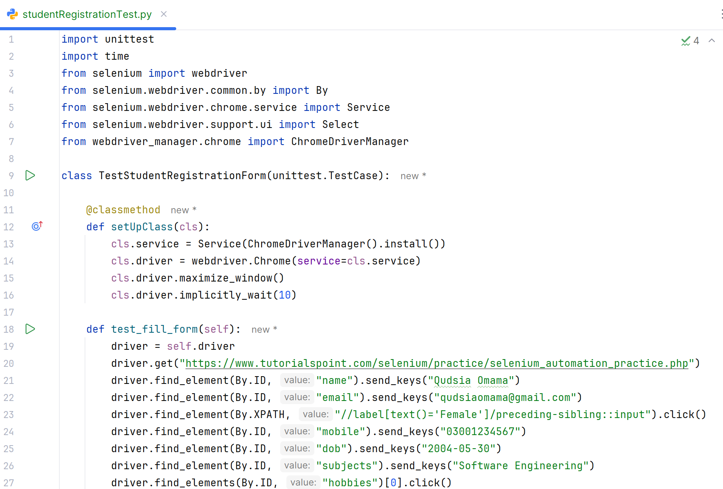

**Output:**

**Question#2:**

**POM:**

**Login Page:**

**Login (POM):**

**Output:**

**Registration Page:**

**Registration (POM):**

**Output:**

