（1）第一个图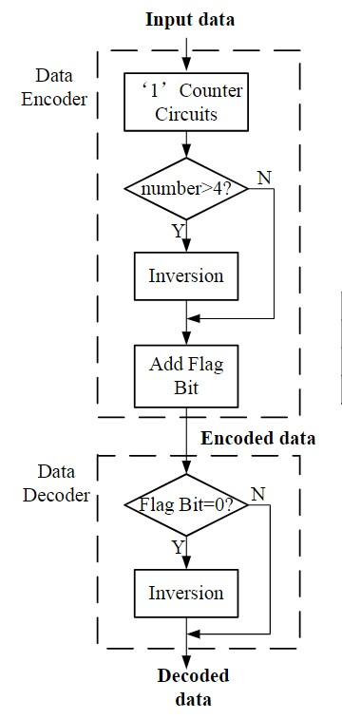

三个黑体字分别在后面标明

Input data（**the higher part**）

Encoded data（**the higher part**）

Decoded data（**the higher part**）

第一个判断框改成**Number>k/2**

（2）第二个图 参考图：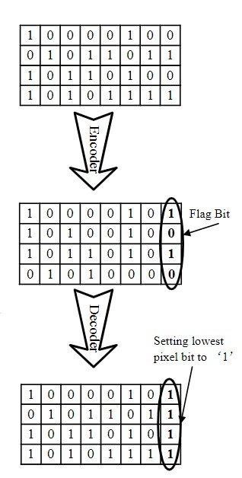

**k=4 as an example**

表头：**Original Data Stream**

|  |  |  |  |  |  |  |  |
| --- | --- | --- | --- | --- | --- | --- | --- |
| 1 | 0 | 0 | 0 | 1 | 1 | 0 | 0 |
| 1 | 1 | 0 | 1 | 0 | 1 | 1 | 0 |
| 1 | 0 | 1 | 0 | 0 | 1 | 0 | 1 |
| 0 | 1 | 0 | 0 | 1 | 1 | 1 | 0 |
| 1 | 1 | 1 | 0 | 0 | 0 | 1 | 1 |
| 1 | 1 | 1 | 1 | 1 | 0 | 1 | 0 |

前四列圈出来标明**The higher part**

后三列圈出来标明**The lower part**

最后一列圈出来标明**Flag bit**

或者这三部分可以用微小的分隔

这个表向下的箭头，箭头写明**Bit-dropping and encoding**

指向下一个表格

|  |  |  |  |  |  |  |  |
| --- | --- | --- | --- | --- | --- | --- | --- |
| 1 | 0 | 0 | 0 | 1 | 0 | 0 | 1 |
| 0 | 0 | 1 | 0 | 0 | 1 | 0 | 0 |
| 1 | 0 | 1 | 0 | 0 | 1 | 0 | 1 |
| 0 | 1 | 0 | 0 | 1 | 0 | 0 | 1 |
| 0 | 0 | 0 | 1 | 0 | 0 | 1 | 0 |
| 0 | 0 | 0 | 0 | 1 | 0 | 0 | 0 |

这个表向下的箭头，箭头写明**Decoding**

表名：**Real storage with proposed strategy**

|  |  |  |  |  |  |  |  |
| --- | --- | --- | --- | --- | --- | --- | --- |
| 1 | 0 | 0 | 0 | 1 | 0 | 0 | 1 |
| 1 | 1 | 0 | 1 | 0 | 1 | 0 | 0 |
| 1 | 0 | 1 | 0 | 0 | 1 | 0 | 1 |
| 0 | 1 | 0 | 0 | 1 | 0 | 0 | 1 |
| 1 | 1 | 1 | 0 | 0 | 0 | 1 | 0 |
| 1 | 1 | 1 | 1 | 1 | 0 | 0 | 0 |

（3）第三个图

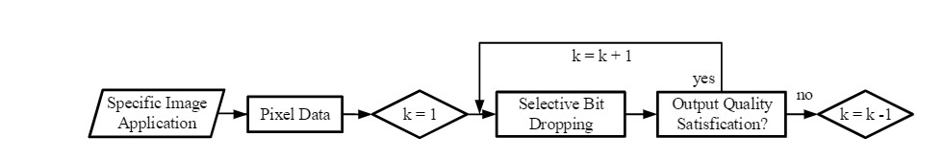

从左往右分别改成

**Practical Image Application**->**Pixel Data**->判断框**k=7**->**Bit-dropping and encoding->Decoding**（多加的一个矩形框）->**Output Quality Threshold Satisfaction?**

**K+1改成k-1**

**K-1改成k+1**

**末尾加一个判断框K=8？->（yes）Accurate storage**

**No->输出k**