IKnew Software

IKnew is a relational database housing the collections data for Eastern Kentucky Herbarium. This database consists of four software packages; MySQL (Online Database), Apache (Web Server), and PHP (Bridges Database & Apache), and PHPMyAdmin (Database Administration Program).

IKnew is highly adaptable, and offers multiple paths to accomplish a task. Administration of the server can be achieved via remote login to <http://herbariumdb.eku.edu/qpadmin/>. From this webpage one can add new herbarium records, edit existing records, delete existing records, search the database, view duplicate records, print labels, and directly manipulate the database using PHPMyAdmin software.

Below is what the qpadministration menu looks like.

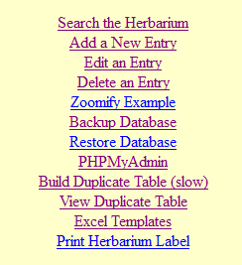

**How to Add Records**

Adding records can be achieved many ways, if one wants to add a single record then one can use <http://herbariumdb.eku.edu/qpadmin/prenew.php> , the first screen that opens is:

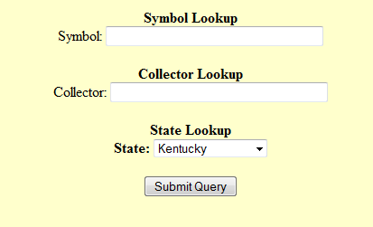

For Symbol field put the first two letters of the genus followed by the first two letters of the species name. For example: Rosa multiflora would be entered as ROMU in the Symbol field.  
  
For the collector field one enters the collectors name in this field. For example: Ron Jones

For state one would use the pull down menu to select the state in which the specimen was located.

After all the fields have been entered, one clicks the button labeled “Submit Query”.

A new screen will open.

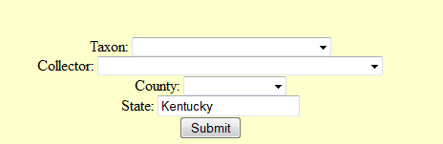

For Taxon use the pull down menu to select the specimen’s taxon as listed on the specimen label.

For collector use the pull down menu to select the appropriate collector.

For county use the pull down menu for the county in which the specimen was collected.

If the Taxon or Collector are not to be found in the list then choose the best match, which can be edited later in this process.

State should be correct.

Click “Submit” Button.

The next screen will look something like below:

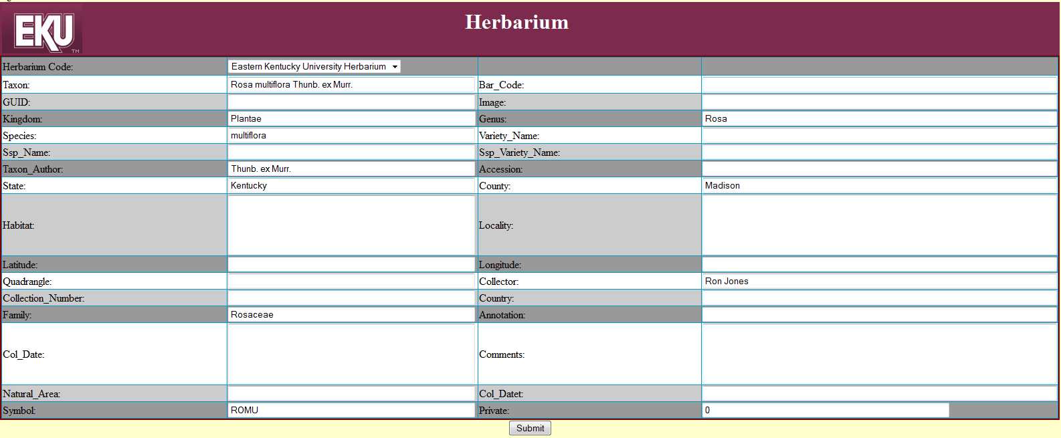

Simply type the data from the label sheet into the appropriate text box. If anything is not correct in the text box such as Collector or Taxon, enter that data into the appropriate field and press the button labeled “Submit”.

The record will have been added to the IKnew database.

**How to Delete a Record**

To delete a record you will need to know it’s unique id (note that this is not the accession number). You can find this id number by performing a query for the specimen. ID number will be found in the first column of the results.

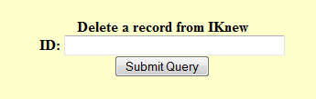

Simply input the ID for the record and press “Submit Query” button, after which the record will be deleted.

**Edit An Entry**

To edit an entry click the Edit an Entry link and the below screen should appear.

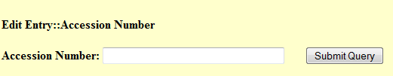

Simply enter the EKY accession number for the specimen you desire to edit. Remember that the accession number should be prefixed with EKY. For example accession number 6132 would be entered into the above box as EKY6132. After entering the appropriate accession number into the text box, press “Submit Query” button.

A screen similar to the one below should open.

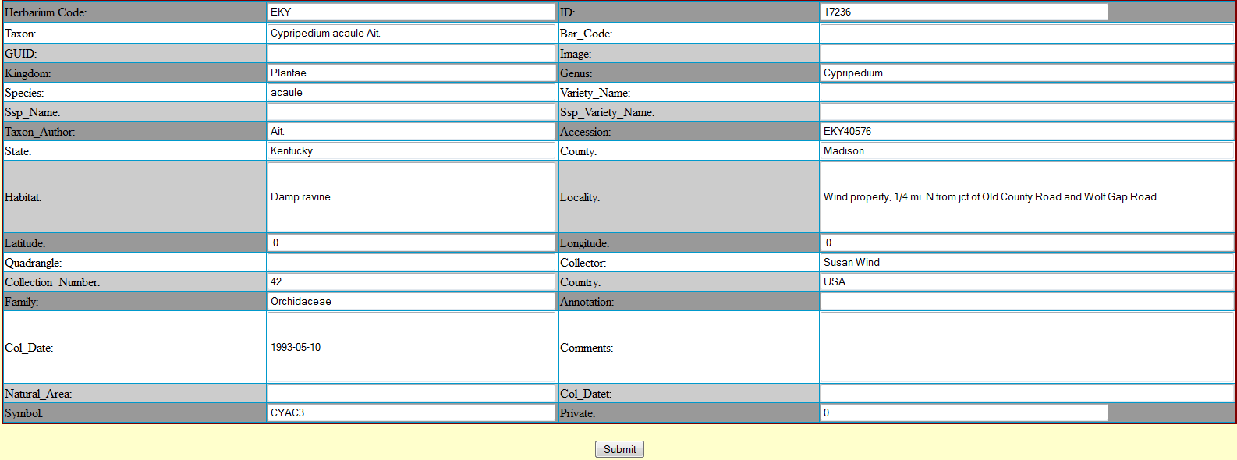

Simply make changes to the IKnew record and when finished press “Submit” button for the record to be updated.

**Backing Up The Database**

A simple way to back up the database is to click the link entitled “Backup Database”. After a brief moment, the database will be backed up.

**Restoring the Database**

To restore the database to the previous backed up copy, click the link entitled “Restore Database”. After a brief moment, the database will be restored.

**PHPMyAdmin**

PHPMyAdmin is a MySQL database management software package which allows intricate manipulation of a MySQL database. Documentation for the use of PHPMyAdmin can be found at <http://herbariumdb.eku.edu/phpMyAdmin/Documentation.html>

Caution must be employed when using PHPMyAdmin as one misstep could corrupt or destroy the database. Before using this feature, please back up the database.

**Build Duplicate Table**

This feature will examine the database looking for duplicate records. It will both store the duplicate records to a table in the database, as well as display the table once the analysis is complete. This feature can take some time to complete and utilizes a significant amount of the computers resources, as such do not do this too often. If you simply want to view the duplicate table generated from last time the table was built, click “View Duplicate Table” instead.

**View Duplicate Table**

This will display the duplicate table that was calculated from the last time the “Build Duplicate Table” was issued.

**Excel Templates**

Excel templates allow individuals to input their collected data into a format which is importable to IKnew. These templates work as field workbooks which can be ran in the field on any suitable tablet/laptop/smartphone which can run MS Office’s MS Excel. There are two forms of the template. One form (with Taxon Table Lookup) is a more robust spreadsheet which automates a significant amount of the data entry. By entering the first two letters of the genus, and the first two letters of the specific epithet the spreadsheet will attempt to enter the following fields: Taxon, Taxon Author, Species, Genus, Varietal, Family, etc. It does this by referencing your input from a large taxon table. Some taxons require a number in addition to the first two letters of genus/species, as they may be multiple taxons with such designation.

For example if you are wanting to enter Cypripedium acaule, you will find that CYAC is Cymopterus acaulis (Pursh) Raf. So one will want to try CYAC1, CYAC2, etc until the correct taxon is located. Another way to do this is to click on the Taxon tab of the spreadsheet and do a CTRL-F (Find) and search for the taxon , and note the Symbol code in the first column for it, and simply enter that code into the Symbol field in the IKnew_Template tab’s symbol column.

The excel template has included help which can be accessed by clicking on the Help tab at the bottom of the Excel screen.

Another powerful feature of the Excel templates is that labels can be printed from the excel templates data. For more details on printing labels from excel template read the section “Printing Excel Template Labels” section of this document.

**Print Labels (Online)**

This feature will print labels for a specific specimen.

Click the link entitled “Print Herbarium Label” and a new screen will appear like the one below.

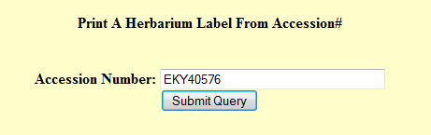

Simply enter the accession number with the prefix EKY into the text box and click “Submit Query” button.

A new screen should appear with the information necessary to print the herbarium label, simply print this screen and cut it to use for labeling of a specimen.

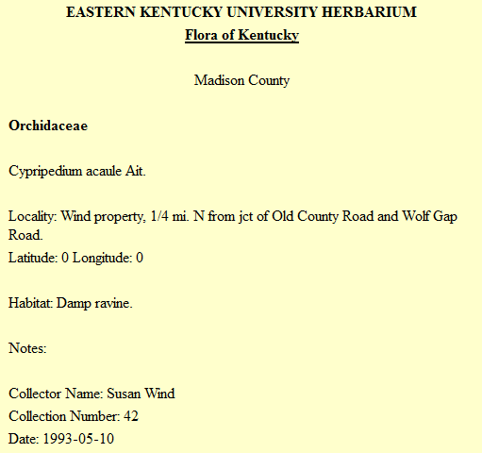

**Imaging Protocols**

On the desktop double-click the icon labelled Digital Photo Pro.

Turn on the Canon camera by rotating the switch to the ON position.

In Digital Photo Pro click Tools and then start EOS Utility.