
QuecPython Tracker Software Design Guide
LTE Standard/LPWA Module Series
Version: 1.0.0
Date: 2023-02-03

Status: Preliminary

At Quectel, our aim is to provide timely and comprehensive services to our customers. If you require any assistance, please contact our headquarters:

Quectel Wireless Solutions Co., Ltd.
Building 5, Shanghai Business Park Phase III (Area B), No.1016 Tianlin Road, Minhang District, Shanghai 200233, China
Tel: +86 21 5108 6236
Email: info@quectel.com

Or our local offices. For more information, please visit:
http://www.quectel.com/support/sales.htm.

For technical support, or to report documentation errors, please visit:
http://www.quectel.com/support/technical.htm.
Or email us at: support@quectel.com.

Legal Notices
We offer information as a service to you. The provided information is based on your requirements and we make every effort to ensure its quality. You agree that you are responsible for using independent analysis and evaluation in designing intended products, and we provide reference designs for illustrative purposes only. Before using any hardware, software or service guided by this document, please read this notice carefully. Even though we employ commercially reasonable efforts to provide the best possible experience, you hereby acknowledge and agree that this document and related services hereunder are provided to you on an “as available” basis. We may revise or restate this document from time to time at our sole discretion without any prior notice to you.

Use and Disclosure Restrictions
License Agreements
Documents and information provided by us shall be kept confidential, unless specific permission is granted. They shall not be accessed or used for any purpose except as expressly provided herein.

Copyright
Our and third-party products hereunder may contain copyrighted material. Such copyrighted material shall not be copied, reproduced, distributed, merged, published, translated, or modified without prior written consent. We and the third party have exclusive rights over copyrighted material. No license shall be granted or conveyed under any patents, copyrights, trademarks, or service mark rights. To avoid ambiguities, purchasing in any form cannot be deemed as granting a license other than the normal non-exclusive, royalty-free license to use the material. We reserve the right to take legal action for noncompliance with abovementioned requirements, unauthorized use, or other illegal or malicious use of the material.
Trademarks
Except as otherwise set forth herein, nothing in this document shall be construed as conferring any rights to use any trademark, trade name or name, abbreviation, or counterfeit product thereof owned by Quectel or any third party in advertising, publicity, or other aspects.

Third-Party Rights
This document may refer to hardware, software and/or documentation owned by one or more third parties (“third-party materials”). Use of such third-party materials shall be governed by all restrictions and obligations applicable thereto.

We make no warranty or representation, either express or implied, regarding the third-party materials, including but not limited to any implied or statutory, warranties of merchantability or fitness for a particular purpose, quiet enjoyment, system integration, information accuracy, and non-infringement of any third-party intellectual property rights with regard to the licensed technology or use thereof. Nothing herein constitutes a representation or warranty by us to either develop, enhance, modify, distribute, market, sell, offer for sale, or otherwise maintain production of any our products or any other hardware, software, device, tool, information, or product. We moreover disclaim any and all warranties arising from the course of dealing or usage of trade.

Privacy Policy
To implement module functionality, certain device data are uploaded to Quectel’s or third-party’s servers, including carriers, chipset suppliers or customer-designated servers. Quectel, strictly abiding by the relevant laws and regulations, shall retain, use, disclose or otherwise process relevant data for the purpose of performing the service only or as permitted by applicable laws. Before data interaction with third parties, please be informed of their privacy and data security policy.

Disclaimer
- We acknowledge no liability for any injury or damage arising from the reliance upon the information.
- We shall bear no liability resulting from any inaccuracies or omissions, or from the use of the information contained herein.
- While we have made every effort to ensure that the functions and features under development are free from errors, it is possible that they could contain errors, inaccuracies, and omissions. Unless otherwise provided by valid agreement, we make no warranties of any kind, either implied or express, and exclude all liability for any loss or damage suffered in connection with the use of features and functions under development, to the maximum extent permitted by law, regardless of whether such loss or damage may have been foreseeable.
- We are not responsible for the accessibility, safety, accuracy, availability, legality, or completeness of information, advertising, commercial offers, products, services, and materials on third-party websites and third-party resources.
Copyright © Quectel Wireless Solutions Co., Ltd. 2023. All rights reserved.

About the Document

Revision History
Version | Date | Author | Description
- | 2023-02-03 | Jack SUN | Creation of the document
1.0.0 | 2023-02-03 | Jack SUN | Preliminary

Contents
About the Document 3
Contents 4
Table Index 5
Figure Index 6
1 Introduction 7
1.1. Applicable Modules 7
2 System Framework 8
2.1. Hardware Framework 8
2.2. Software Framework 9
3 Key Components 10
3.1. Tracker 11
3.2. Location 12
3.3. Battery 15
3.4. History 17
3.5. PM/SPM 17
3.6. Sensor 18
3.7. aliyunIot 19
3.8. QuecThing 21
4 System Initialization Process 23
5 Business Process 25
6 Example 26
7 Appendix Terms and Abbreviations 28

Table Index
Table 1: Applicable Modules 7
Table 2: Terms and Abbreviations 28

Figure Index
Figure 1: Hardware Framework 8
Figure 2: Software Framework 9
Figure 3: Dependencies Among Various Function Components in Project (Take Tracker as Core) 10
Figure 4: System Initialization Flowchart 23
Figure 5: Business Process Flowchart 25

- Introduction

This document describes the design framework of QuecPython Tracker, including the software and hardware framework, function descriptions of key components, system initialization process, business process and function examples. It helps users quickly understand the overall architecture and functions of the Tracker.

  - Applicable Modules

Table 1: Applicable Modules
Module Series | Module
LTE Standard | EC21-AUX
 | EC200U Series
 | EG915U Series
 | EC200A Series
NB-IoT | BC65
LPWA | BG95 Series
 | BG77

- System Framework

- Hardware Framework

The hardware system framework is as follows:
- The module supports functions such as UART, GPIO and LTE.
- You can choose a module with built-in GNSS or a module with external GNSS.
- The module can be connected to different sensors.

Taking EC800G module as an example, the hardware framework is as follows:
Figure 1: Hardware Framework

- Software Framework

The software framework is as follows:
- Cloud is used to connect to cloud services for data interaction.
- Tracker implements core business, collects and manages module data, and parses uplink and downlink data.
- moduels contain different function components that can be added or subtracted as appropriate.
- Device is used to collect and control module information, such as firmware information, network status and power control.
Figure 2: Software Framework

- Key Components

The whole project takes Tracker as the core and integrates other function components to realize the core business logic. The dependencies among various function components in the project are shown in the figure below.
Figure 3: Dependencies Among Various Function Components in Project (Take Tracker as Core)

- Tracker

- Function description: Implement core business logic, interact with the cloud and parse uplink and downlink data, and control module.

- Principle:
- Obtain data of each function component (such as location information, battery information and sensor information) by registering the function components.
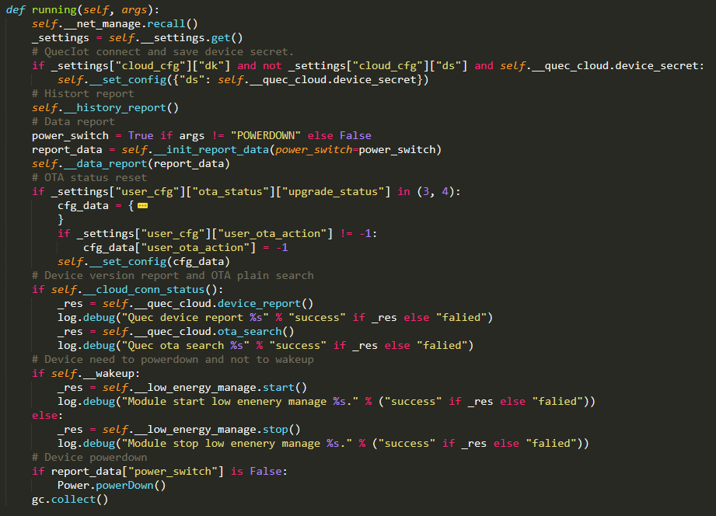

- Listen to the commands sent from the cloud through callback functions and process the relevant business.
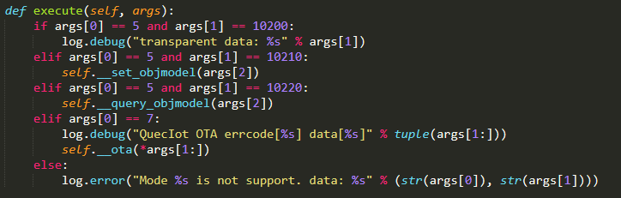

- Listen to the wake-up operation of the power management function component through callback functions and report business data.
- Register function components and configure callback functions.
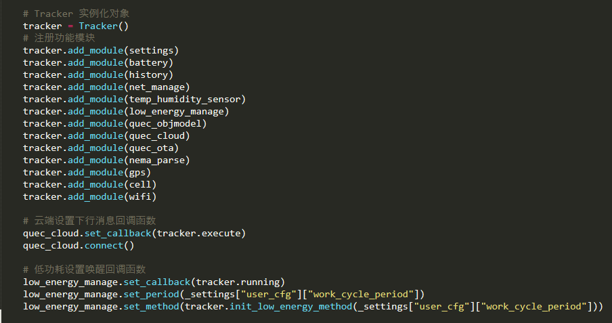
Set low power wake-up callback function
Set cloud downlink message callback function cloud
Register function components
Instantiate object

- Location

- Function description: Obtain the module location information through GNSS (built-in or external), base station and Wi-Fi.

- Principle:
- Built-in GNSS enables GNSS and reads GNSS data through quecgnss API.
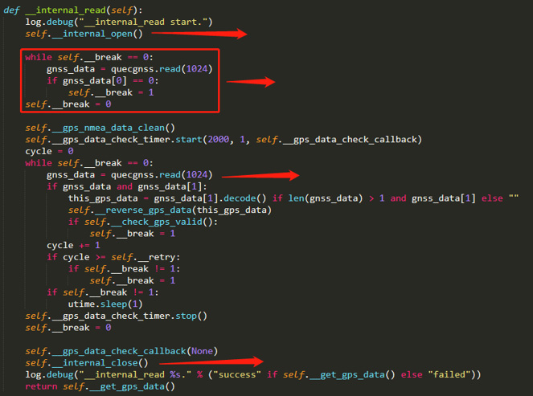
Read GNSS raw data
Clear the cached historical GNSS data
Enable GNSS
Disable GNSS

- External GNSS reads GNSS data through the UART serial port.
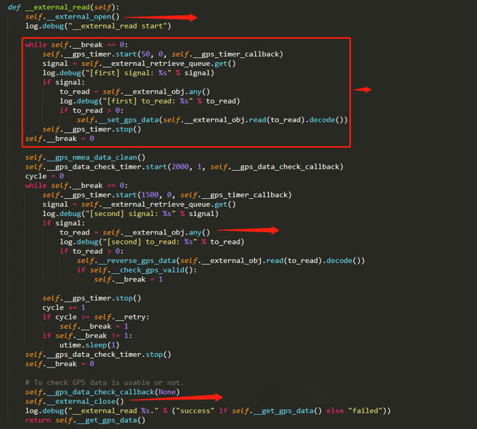
Close GNSS UART serial port
Read the GNSS raw data in the serial port
Clear the data cached in the serial port
Open GNSS UART serial port

- Base station positioning: obtain the base station positioning information such as latitude, latitude and accuracy through cellLocator base station positioning API.
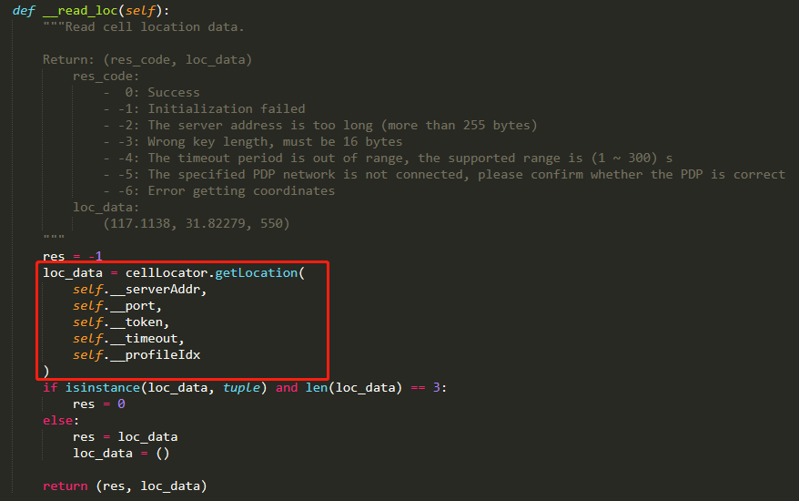

- Wi-Fi positioning: obtain positioning information such as latitude, longitude, accuracy and MAC address through wifilocator and wifiScan API.
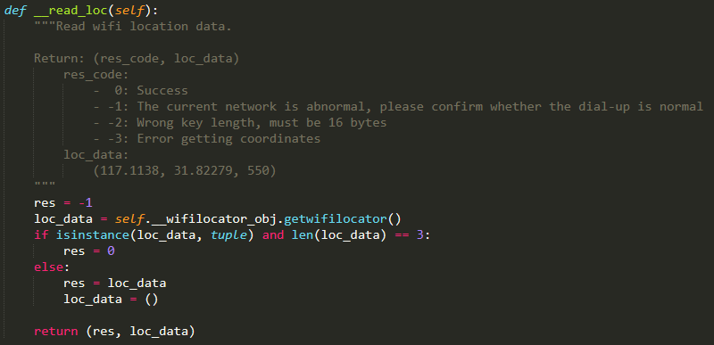
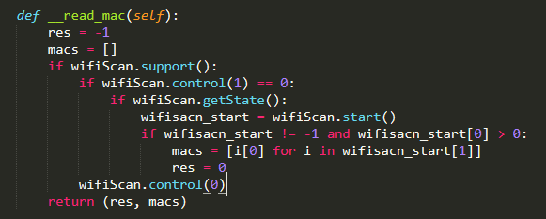
- Battery

- Function description: Read the battery power and voltage, obtain the charging state of the battery and notify the user of the battery charging state change through the callback functions.

- Principle:
- There are two ways to obtain the battery voltage: obtain the device power supply voltage through the power supply component and calculate the actual supply voltage based on the voltage obtained through ADC.
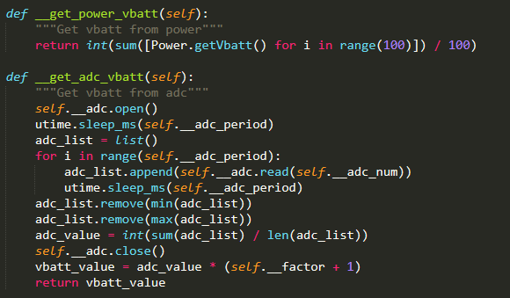

- Currently, only fuzzy calculation of battery power is supported, that is, a relationship table of battery power corresponding to voltage and temperature is entered for fuzzy calculation.
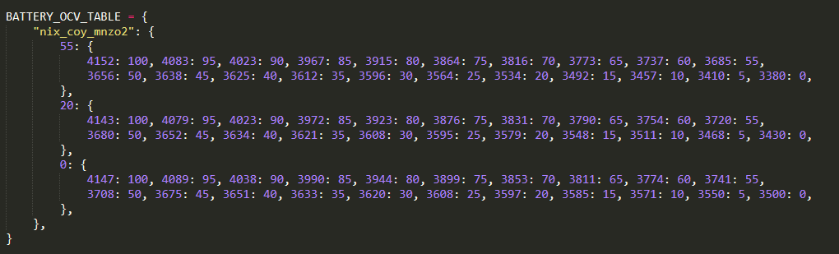

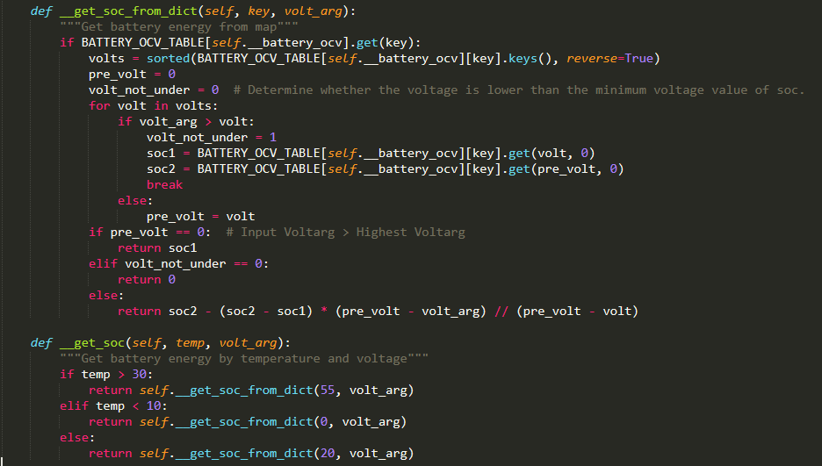

- The charging state of the battery is to determine the charging state of the module by obtaining the high and low level of the pin that triggers an interrupt.
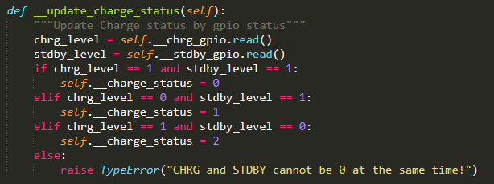
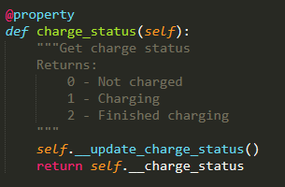

- History

- Function Description: Store and read the module data that fails to be reported to the server.

- Principle: If the business data of module fails to be reported to the server, the business data is stored in the module. When the module reports data to the server the next time, it reads the stored data and try to report it to the server again.

- PM/SPM

- Function description: Periodically wake up the module and process the business; After the business is processed, the module enters sleep mode.

The currently supported sleep modes are:
- PM
- PSM
- PowerDown (The module must support RTC wake-up)

- Principle: Use RTC or osTimer to wake up the module periodically and trigger the business processing logic.

- Start the RTC timer.
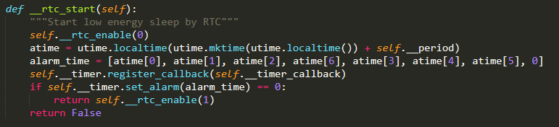

Start the osTimer timer.
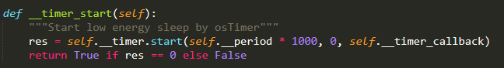

- The module is woken up by the timer to process business.
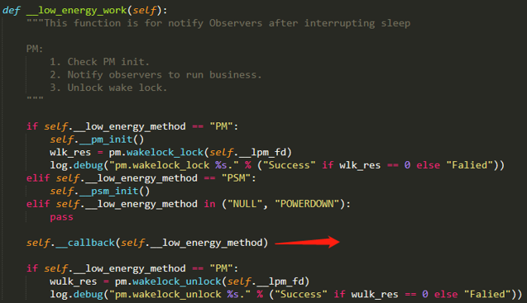
The task processed after the device is woken up

- Sensor

- Function description:
The current sensors are
- Humiture sensor (Obtain the temperature and humidity information of the module)
- Light sensor (Obtain the brightness change of the environment where the module is located through pin interrupt)
- G-sensor (Obtain module acceleration and acceleration direction)

- Principle: Control the switch of sensor and read the data of sensor through I2C.

The humiture sensor reads the temperature and humidity:
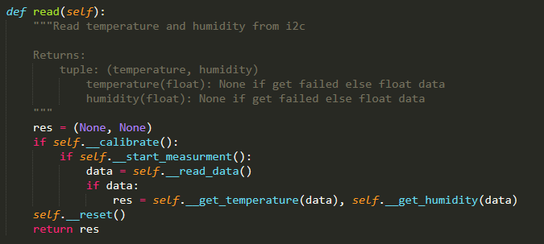

- aliyunIot

- Function description: The device interacts with Alibaba Cloud IoT platform through MQTT protocol.
- Registers on Alibaba Cloud IoT platform and log in to the platform.
- Module sends TSL data to Alibaba Cloud IoT platform.
- Module receives commands sent from Alibaba Cloud IoT platform.
- OTA upgrade is performed on the module.

- Principle: Log in to Alibaba Cloud IoT platform and the module interacts with the platform according to the communication rules of the platform through MQTT protocol.

- Register on Alibaba Cloud IoT platform and log in to the platform.
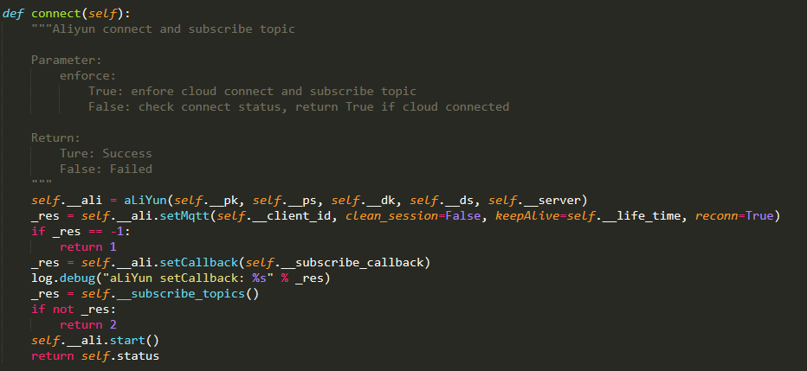

- Module sends data to Alibaba Cloud IoT platform.
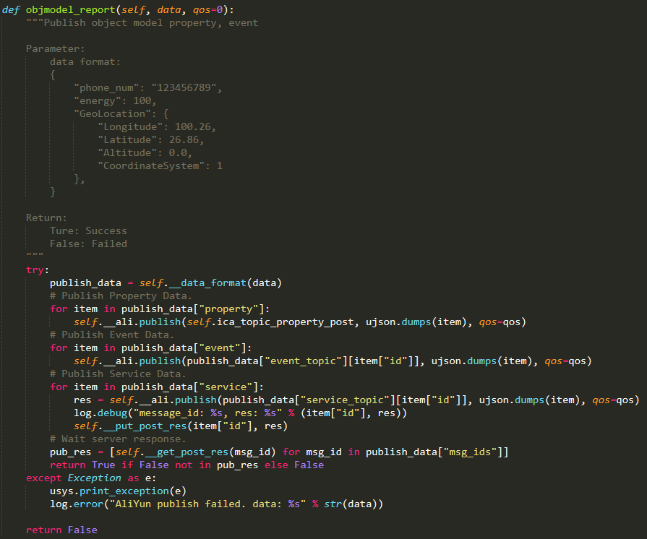

- Module receives command sent from Alibaba Cloud IoT platform and process the relevant business.
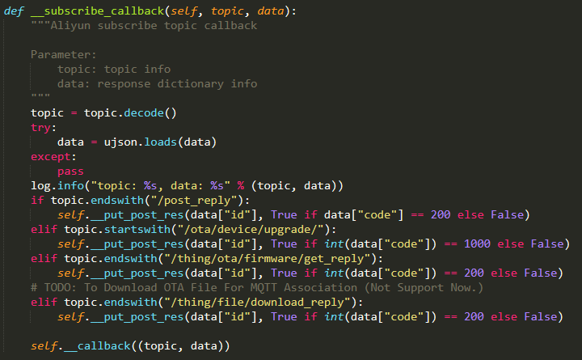
- QuecThing

- Function description: The module interacts with QuecCloud IoT platform through MQTT protocol.
- Register on QuecCloud IoT platform and log in to the platform.
- Module sends TSL data to QuecCloud IoT platform.
- Module receives commands sent from QuecCloud IoT platform.
- OTA upgrade is performed on the module.

- Principle: Encapsulate the QuecThing functions again to use the functions such as login, message sending and downlink command notification through callback functions.

- Register on QuecCloud IoT platform and log in to the platform.
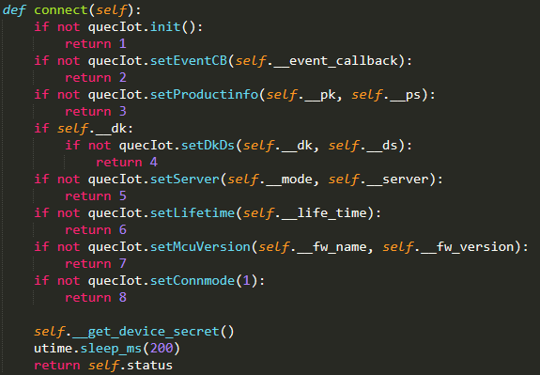

- Module sends TSL data and positioning information to QuecCloud IoT platform.
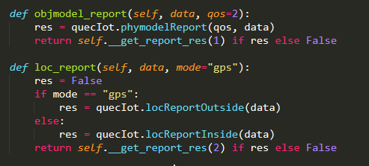

- Module receives command sent from QuecCloud IoT platform and process the relevant business.
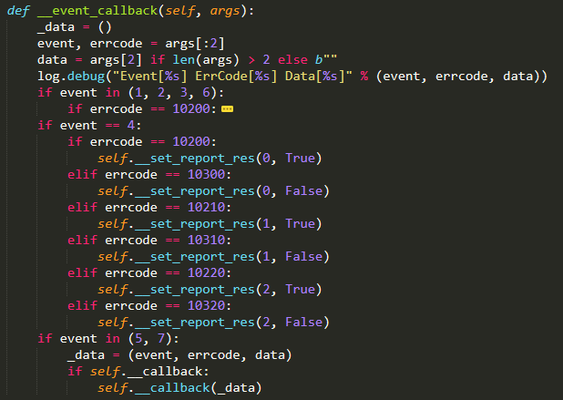

- System Initialization Process

Figure 4: System Initialization Flowchart

- Initialize basic function components, including PM/SPM, Settings, Battery, History, Location (GNSS, cellLocator and wifilocator) and Sensor.
- Initialize cloud service function components, such as aliyunIot, QuecThing or private cloud.
- Initialize the core service function component (Tracker) and add other function components to Tracker through add_module API, register trackers.execute to the Cloud object to receive commands from the cloud, and then register Trackers.running to the PM/PSM function component for the business logic that the module executes after it is woken up.

- Business Process

Figure 5: Business Process Flowchart

- Example

- Initialize basic function components.
def main():
log.info("PROJECT_NAME: %s, PROJECT_VERSION: %s" % (PROJECT_NAME, PROJECT_VERSION))
log.info("DEVICE_FIRMWARE_NAME: %s, DEVICE_FIRMWARE_VERSION: %s" % (DEVICE_FIRMWARE_NAME, DEVICE_FIRMWARE_VERSION))

# Initialize the Settings function component
settings = Settings()
_settings = settings.get()
# Initialize the Battery function component
battery = Battery()
#Initialize history
history = History()
# Initialize the NetManage function component
net_manage = NetManage(PROJECT_NAME, PROJECT_VERSION)
# Initialize the TempHumiditySensor function component
temp_humidity_sensor = TempHumiditySensor(I2C.I2C1, I2C.STANDARD_MODE)
# Initialize the LowEnergyManage function component
low_energy_manage = LowEnergyManage()
# Initializes the GPS raw data parsing function component
nema_parse = NMEAParse()
# Initializes the GPS function component
gps = GPS(**_settings["loc_cfg"]["gps_cfg"])
# Initializes the CellLocator function component
cell = CellLocator(**_settings["loc_cfg"]["cell_cfg"])
# Initializes the WiFiLocator function component
wifi = WiFiLocator(**_settings["loc_cfg"]["wifi_cfg"])

# Initializes the QuecOTA function component
quec_ota = QuecOTA()
# Initializes the QuecObjectModel function component to parse the uplink and downlink data
quec_objmodel = QuecObjectModel()
_cloud_cfg = dict(_settings["cloud_cfg"])
_cloud_cfg["fw_name"] = DEVICE_FIRMWARE_NAME
_cloud_cfg["fw_version"] = DEVICE_FIRMWARE_VERSION
quec_cloud = QuecThing(**_cloud_cfg)

- Initialize the core business function component and register the function components to start Tracker function.
# Tracker Instantiate object
tracker = Tracker()
# Register function components
tracker.add_module(settings)
tracker.add_module(battery)
tracker.add_module(history)
tracker.add_module(net_manage)
tracker.add_module(temp_humidity_sensor)
tracker.add_module(low_energy_manage)
tracker.add_module(quec_objmodel)
tracker.add_module(quec_cloud)
tracker.add_module(quec_ota)
tracker.add_module(nema_parse)
tracker.add_module(gps)
tracker.add_module(cell)
tracker.add_module(wifi)

# Set cloud downlink message callback functions
quec_cloud.set_callback(tracker.execute)
quec_cloud.connect()

# Set low power wake-up callback functions
low_energy_manage.set_callback(tracker.running)
low_energy_manage.set_period(_settings["user_cfg"]["work_cycle_period"])
low_energy_manage.set_method(tracker.init_low_energy_method(_settings["user_cfg"]["work_cycle_period"]))

# Start Tracker function (Periodically detect module status and report information, module enters low power mode )
tracker.running(None)

- Appendix Terms and Abbreviations

Table 2: Terms and Abbreviations
Abbreviation | Description
ADC | Analog-to-Digital Converter
API | Application Programming Interface
FS | File System
GC | Garbage Collector
GNSS | Global Navigation Satellite System
GPIO | General-Purpose Input/Output
GPS | Global Positioning System
IC | Integrated Circuit
IIC | Inter-Integrated Circuit
IoT | Internet of Things
LAN | Local Area Network
LTE | Long-Term Evolution
MAC | Medium Access Control
MQTT | Message Queuing Telemetry Transport
OTA | Over-the-air programming
PM | Power Manage
PSM | Power Saving Mode
RTC | Real-Time Clock
SIM | Subscriber Identity Module
UART | Universal Asynchronous Receiver/Transmitter
USB | Universal Serial Bus

