Tenant Policy Actual Screens Guide
Angular UI ke asli screenshots ke saath click → API → response → database table. 22 September 2026 code inspection. Angular project read-only raha; production API ya DB ko is document ke liye call nahi kiya.
Is guide ko kaise padhein: blue UI screenshot dekhein, uske neeche usi button ka route aur table dekhein. “Response” ka matlab API ka data; “table” ka matlab database mein saved row. Red font mein wahi gaps hain jo code/screenshot se verify hue.

Sabse chhota flow
Policy Type = Annual Leave ka reusable naam. Policy = India Permanent Annual Leave ka actual record. Policy Version = us record ka v1 Draft/Published. Rule = kya likha hai. Applicability = kin employees par lagegi. Assignment = kisi employee ko direct policy dena. Resolve = employee/date ke liye Published policy ka answer.
Policy Types → Policy Definitions Create → Submit → Approve → Publish → Resolve. Documents, Assignments, Exceptions, Acknowledgements, Approval progress, Audit = Policy Version ke andar tabs, alag main menu screens nahi.
GAP — UI Employee/get-all string employeeId (jaise 1OZ8MZRL) deta hai. Resolve/Assign/Exception UI Number(id) banata hai; backend long employeeId expect karta hai. Is identity mismatch ko fix/test kiye bina real employee flow ko working assume na karein.

Policy Types list
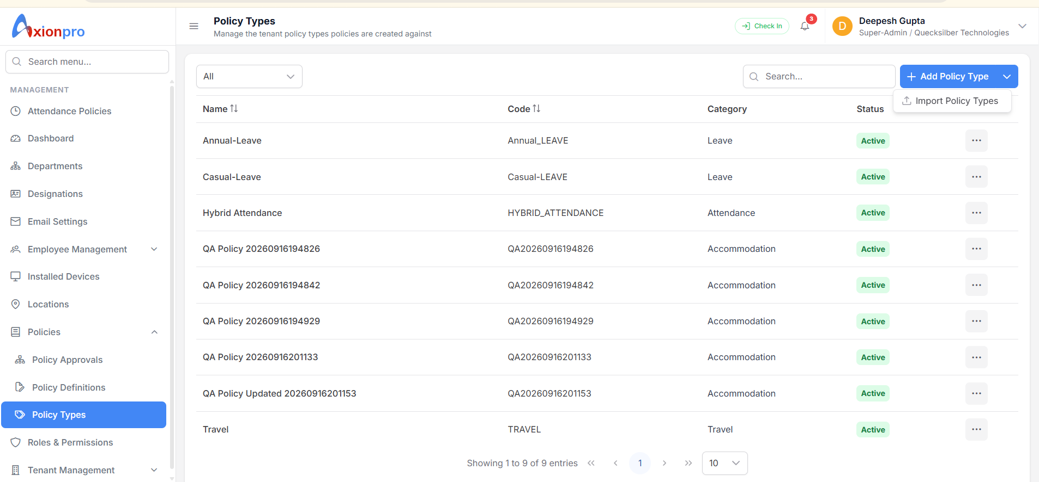
Yahan tenant reusable type banata hai. Screenshot mein Annual-Leave, Casual-Leave, Hybrid Attendance aur Travel dikhte hain. Category dropdown ka data PolicyCategory lookup se aata hai.

Is screen par click karne se kya hota hai
List load API: GET /api/TenantPolicy/types + GET /api/TenantPolicy/lookups | Result/table: data = type rows + categories; read PolicyType, PolicyCategory
Add Policy Type API: POST /api/TenantPolicy/types; body policyTypeCode, policyName, policyCategoryId, defaultCurrencyCode | Result/table: data = created {id,code,name,categoryId,...}; INSERT PolicyType
Edit / Deactivate API: PUT /types/{id} / PATCH /types/{id}/status | Result/table: updated type / boolean; UPDATE PolicyType
Import Policy Types API: /api/TenantPolicy/bulk/types/template, preview, confirm, jobs, report | Result/table: valid rows → PolicyType; failed rows report
GAP — Type create hone se Policy/PolicyVersion/employee leave balance create nahi hota. Screenshot ke QA types ko real business types na samjhein.

Policy Definitions list
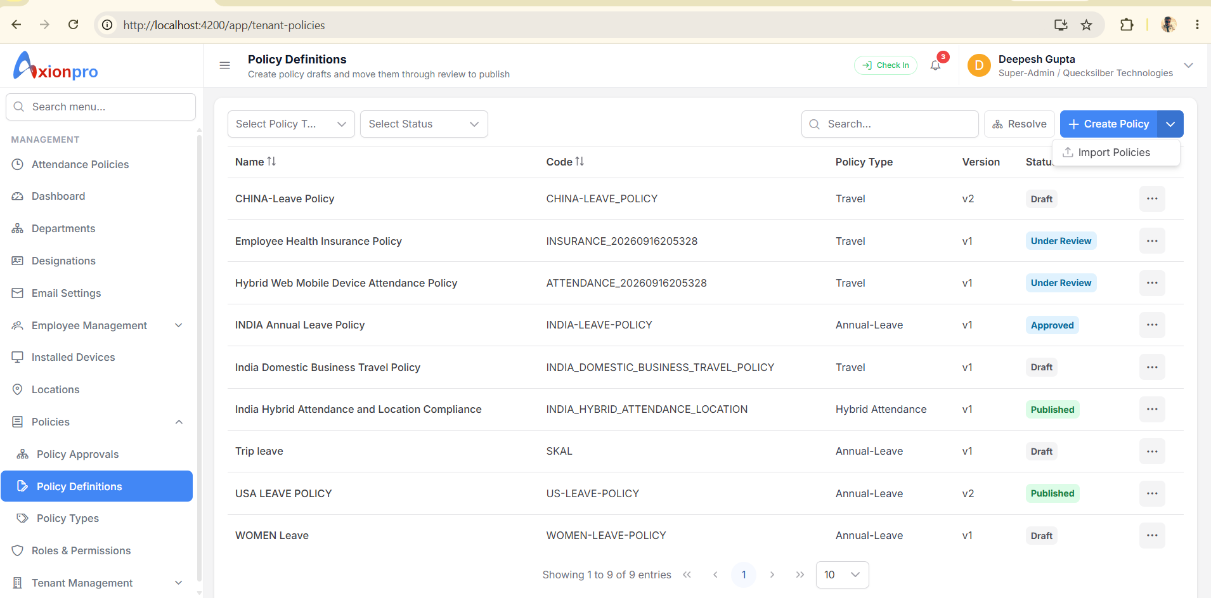
Yeh actual named policies ki list hai. Har row mein naam, code, policy type, latest version aur status. Filter Type/Status/Search se list API dobara chalti hai.

Is screen par click karne se kya hota hai
List load API: GET /api/TenantPolicy?pageNumber=1&pageSize=10&policyTypeId=...&statusId=...&search=... | Result/table: data = [{id,code,name,policyTypeId,currentVersionId,versionNumber,status}], totalRecords; READ Policy + PolicyVersion
Create Policy API: POST /api/TenantPolicy | Result/table: data = full policy detail with versionId/rules/applicability; INSERT Policy, PolicyVersion, PolicyRule, PolicyApplicability, PolicyChangeAudit
Edit draft API: PUT /api/TenantPolicy/{policyId}/versions/{versionId} | Result/table: full detail; UPDATE Policy/PolicyVersion, REPLACE child Rule/Applicability rows
Open workspace API: Angular navigation /app/tenant-policies/{policyId}/versions/{versionId} | Result/table: read detail; no insert
Import Policies API: /api/TenantPolicy/bulk/definitions/... | Result/table: confirmed valid rows create Policy + Version and children
GAP — Screenshot mein China Leave, Insurance aur Hybrid Attendance rows ka Policy Type “Travel” dikh raha hai. Type Policy.PolicyTypeId se aata hai; names dekhkar correct mapping assume na karein. Actual row IDs verify karke data correct karna hoga.

Create Policy form ke andar Rule aur Applicability
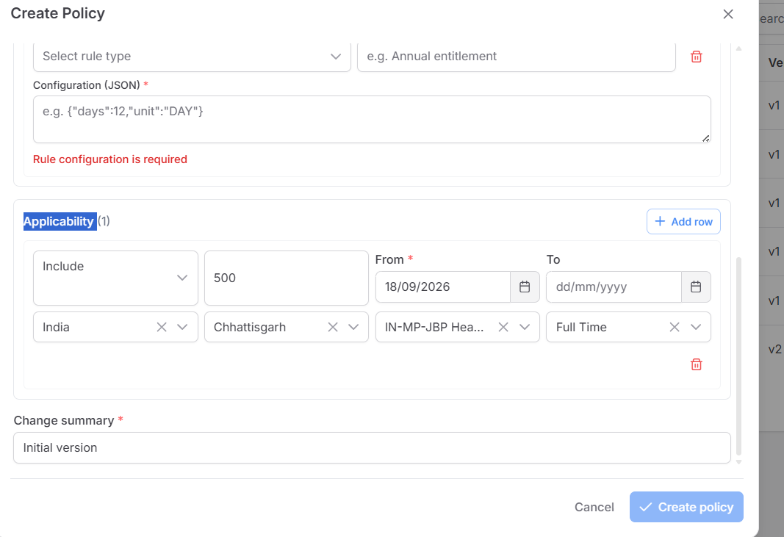
Create Policy popup ka neeche wala hissa. Rule ka matlab “kya terms hain”; Applicability ka matlab “kin employees par”. Owner Department top field policy ka owner hai; target Department applicability mein alag field hai.

Is screen par click karne se kya hota hai
Rule add API: POST /api/TenantPolicy body rules:[{policyRuleTypeId,ruleName,ruleOrder,ruleConfiguration}] | Result/table: PolicyRule rows; ruleConfiguration JSON object ka STRING, e.g. {"days":18}
Applicability add API: same POST body applicability:[{applicabilityMode,countryId,stateId,tenantLocationId,employeeTypeId,priority,effectiveFrom,...}] | Result/table: PolicyApplicability rows; 1 Include / 2 Exclude
Create Policy API: POST /api/TenantPolicy; top + rules + applicability ek body | Result/table: response data = policy detail; all 4 core tables in one creation
GAP — Raw JSON ka syntax valid hona business calculation ka proof nahi. Generic resolver ruleConfiguration se leave days, balance, attendance ya insurance payout calculate nahi karta. Work arrangement/employment-status selector UI mein nahi, although backend fields exist.

Create Policy mein Rule ka poora matlab
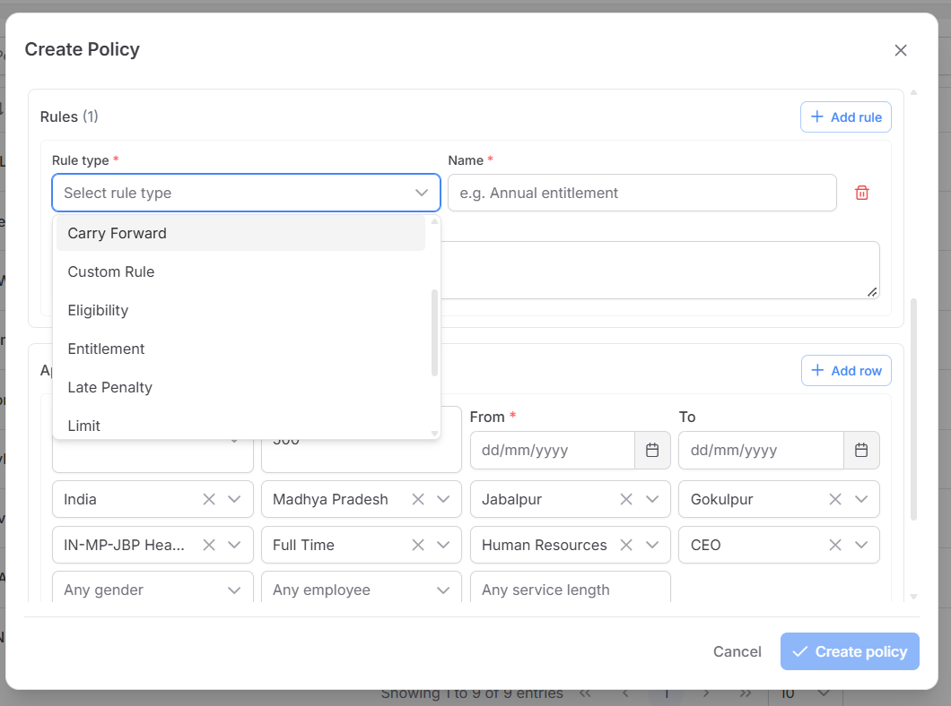
Rules (1) = ek PolicyRule row. Rule type dropdown PolicyRuleType seed/lookup se aata hai: Eligibility, Entitlement, Accrual, Carry Forward, Sandwich, Limit, Attendance Channel, Late Penalty, Overtime, Approval, Reimbursement, Calendar, Custom Rule. Ye names rule ki category batate hain; inke liye executable JSON schema ka evidence nahi mila.
Rule type: e.g. Entitlement choose karne par API ko us type ka actual policyRuleTypeId jaata hai. Name: e.g. Annual entitlement, HR ke liye readable label. Configuration (JSON): terms ka object. 2 Rules add karenge to 2 PolicyRule rows; UI array order se ruleOrder 1, 2 set karta hai. Same order duplicate backend reject karta hai.
Rule aur Applicability ka difference: Rule = “kya likha hai” (18 days); Applicability = “kis par aur kab” (India + Permanent + dates). Entitlement rule apne aap kisi employee ko 18 days credit nahi karta. Rules (0) allowed hain, isliye policy bina rules ke bhi create/publish ho sakti hai.
Rule Type Entitlement select karte hi days/unit ka form ya backend calculation activate hoti hai—aisa current code mein nahi hai. Dropdown ke labels ko calculator mat samjhein.

Configuration JSON ka exact format
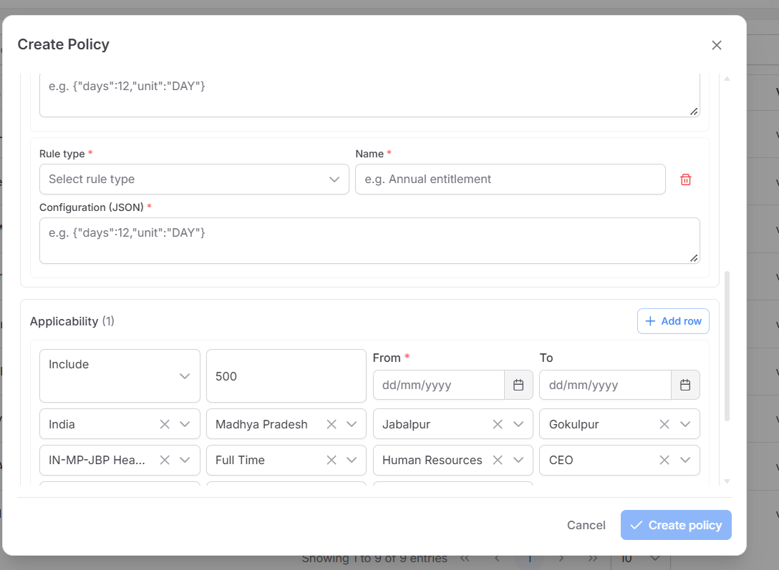
Textarea mein jo likhna hai (example declaration): {"days":18,"unit":"DAY"}. Curly braces { } required hain; key aur text value double quotes mein. Number 18 ko quotes ki zaroorat nahi. Comma entries ko separate karta hai. Example meaning HR intention hai: annual entitlement 18 days. Current backend is JSON se balance calculate nahi karta.
UI → API: textarea ki poori value string ban kar ruleConfiguration mein jaati hai. Copyable outer request ka relevant part: "rules":[{"policyRuleTypeId":<lookup ID>,"ruleName":"Annual entitlement","ruleOrder":1,"ruleConfiguration":"{\"days\":18,\"unit\":\"DAY\"}"}]. Backslashes sirf outer HTTP JSON string ke escaping ke liye hain; textarea mein backslashes nahi likhne.
DB: PolicyRule.RuleConfiguration PostgreSQL jsonb hai. GET policy detail mein rules:[{id,ruleTypeId,name,order,configuration}] milta hai; configuration UI/API type mein JSON string hai. RuleTypeId dropdown ke active PolicyRuleType row se hi aana chahiye.
Valid syntax: {"days":18,"unit":"DAY"} aur {}. Invalid: days:18 (quotes/braces missing), [1,2] (array), 18 (number), null (JSON null). Backend valid JSON object, active Rule Type ID aur unique ruleOrder check karta hai. UI non-empty textarea maangti hai; {} object backend syntax se valid hai.
Carry Forward example {"maxDays":5,"expiryMonths":3} aur Attendance Channel example {"allowedChannels":["WEB","MOBILE"]} sirf storage-format examples hain. Backend in keys ka meaning/range ya actual carry-forward/attendance action validate ya execute nahi karta. Production rule ke liye category-wise schema aur execution contract pehle define/test karna hoga.

Applicability fields ka seedha matlab
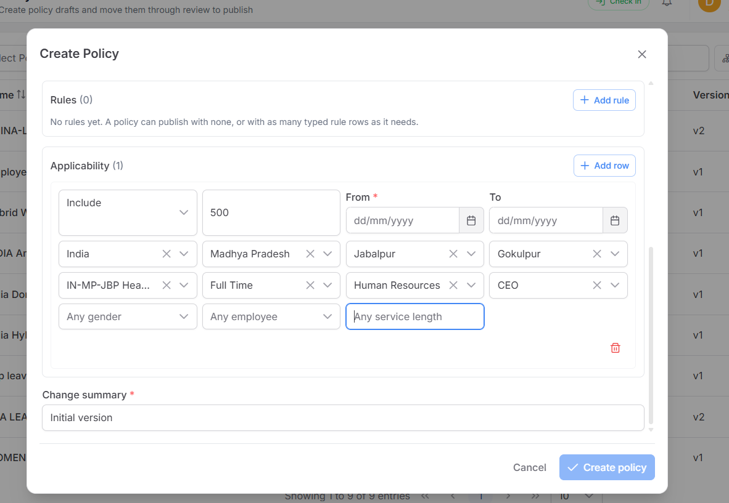
Yeh 1 Applicability row hai. Row ke andar selected fields AND hain: employee ko har bhari hui condition match karni hogi. Blank/Any/null field us property par filter nahi lagata. Date “From” required hai. Include = matching employee ko policy mile; Exclude = matching employee ko policy na mile.
GenderId: Female select karenge to sirf Employee.GenderId=Female; Male/Other bhi apni lookup ID se. “Any gender” (null) ka matlab Female, Male, Other sab allowed, agar baaki selected filters match karte hon.
DepartmentId: Human Resources select = sirf Employee.DepartmentId=Human Resources. “Any department”/null = kisi bhi department ka employee. Yeh Create Policy ke top wale Owner department se alag field hai.
DesignationId: CEO select = sirf Employee.DesignationId=CEO. “Any designation”/null = kisi bhi designation. Department + Designation dono select hon to employee ke dono values match hongi.
EmployeeTypeId: Full Time select = sirf matching employee type. TenantLocationId/geography: selected office aur country/state/district/locality match hone chahiye. EmployeeId select ho to sirf wahi person. MinimumServiceDays bharne par onboarding date se calculated service days kam nahi ho sakte.
“Any service length” = minimumServiceDays:null. Employee ne kal join kiya ho ya 5 saal pehle, tenure filter nahi lagega. 90 bharen to Resolve ki effective date par Employee.DateOfOnBoarding se kam se kam 90 calendar days poore hone chahiye. Backend serviceDays = max(0, effective date − onboarding date) calculate karta hai; onboarding date absent ho to 0 maana jaata hai. 0 bharne par practically sab pass; null ka matlab condition skip. Yeh years-of-experience ya designation nahi, isi company ki recorded onboarding se din hain.
Screenshot mein Human Resources aur CEO ek saath selected hain. Agar CEO designation HR department ki nahi hai, backend “DesignationId does not belong to DepartmentId” validation error dega. Actual designation-department mapping verify karein.

Null karne par exactly kya hota hai
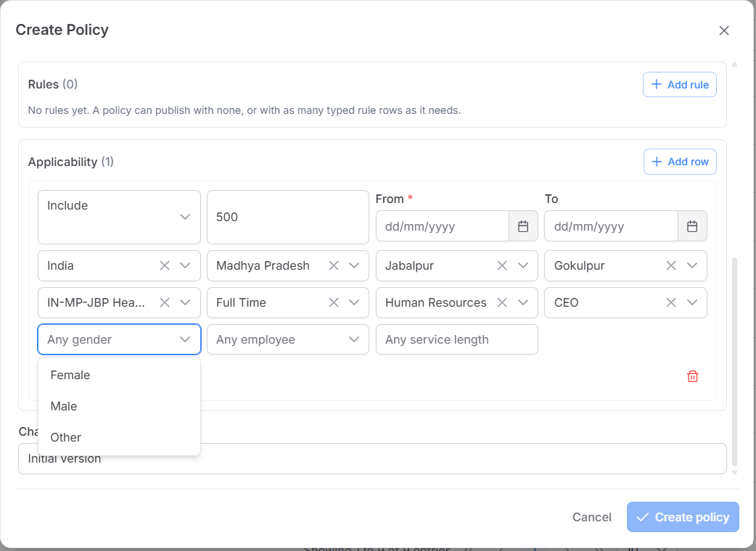

Chaar chhote examples
A. India + Permanent + Gender null + Department null + Designation null: India Permanent employee apply hoga, uska gender/department/designation jo bhi ho. Null sirf usi filter ko hatata hai.
B. Country null + Gender Female + baaki sab null: is tenant ki kisi bhi location ki Female employee match karegi, dates/status ke andar. Country null = sirf India nahi.
C. Country, State, District, Locality, TenantLocation, EmployeeType, Department, Designation, Employee, Gender, WorkArrangement, EmploymentStatus, MinimumServiceDays — sab null; Include row aur valid From date: tenant ke sab employees ko broadly match karegi. Yeh global eligibility hai, sirf ek “empty” row nahi.
D. Applicability rows hi zero: automatic Resolve ko scope match nahi milega. Published version bhi auto-eligible list mein nahi aayega; date-valid manual assignment ho to wo version aa sakta hai.
All-null EXCLUDE row sab employees ko broadly exclude karti hai, lekin resolver same version mein zyada specific Include row ko pehle choose kar sakta hai. Isliye Exclude ko bina soch-samajh global mat lagayein.
Row ke fields = AND. Alag Include rows = alternative matches (OR). Resolver matching rows mein pehle specificity, phir kam numeric priority dekhta hai; same specificity aur priority par Exclude jeetta hai. “500” priority hai, 500 employees ya 500 days nahi.

Database row aur API ka connection
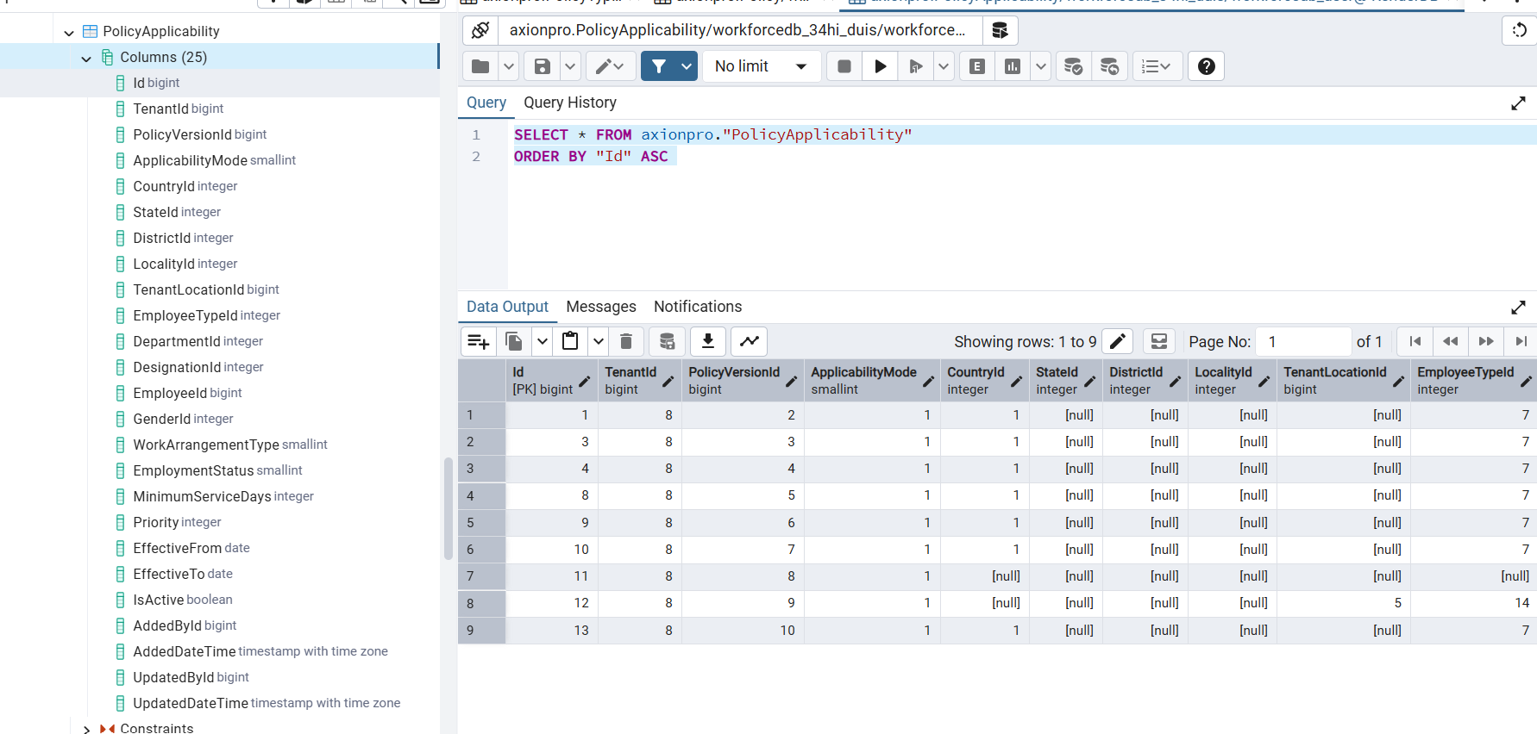
Is screenshot mein PolicyApplicability table ke 25 columns dikhte hain. Har row ek PolicyVersionId se linked hai. CountryId=1 aur EmployeeTypeId=7 wali row ka matlab sirf wahi country/type combination; baaki null columns us row mein filter nahi hain. Numeric IDs ka meaning master tables se join/lookup karke dekhein, screenshot se 1=India ya 7=Permanent assume na karein.

Save request mein kya bhejna hai
POST /api/TenantPolicy ya Draft PUT mein applicability:[{applicabilityMode:1,countryId:null,stateId:null,districtId:null,localityId:null,tenantLocationId:null,employeeTypeId:null,departmentId:null,designationId:null,employeeId:null,genderId:null,workArrangementType:null,employmentStatus:null,minimumServiceDays:null,priority:500,effectiveFrom:"2026-10-01",effectiveTo:null}]
Save ke baad PolicyApplicability row insert hoti hai. GET /api/TenantPolicy/{policyId} mein applicability array wapas aati hai; uska “mode” write wale “applicabilityMode” ka read name hai. GET /api/TenantPolicy/resolve?employeeId=<numeric>&effectiveDate=2026-10-01 Published/current version ki rows ko employee se compare karta hai. Draft ya Approved version resolve mein nahi aati.
Gender, Department, Designation null ko backend (!field.HasValue || field == Employee.field) se evaluate karta hai. Isliye null wildcard hai. Country/Location null bhi unki condition skip karta hai. Code source: GenericPolicyRepository.ScopeMatches, ScopeSpecificity, ResolveAsync; UI source: policy-definition-form.ts/html.
Production blocker: public EmployeeId 1OZ8MZRL jaisi string hai, lekin PolicyApplicability.EmployeeId aur Resolve request numeric long hain. “Any employee” null par yeh mismatch nahi aata; specific employee picker/Resolve par aata hai.

Effective Policies popup
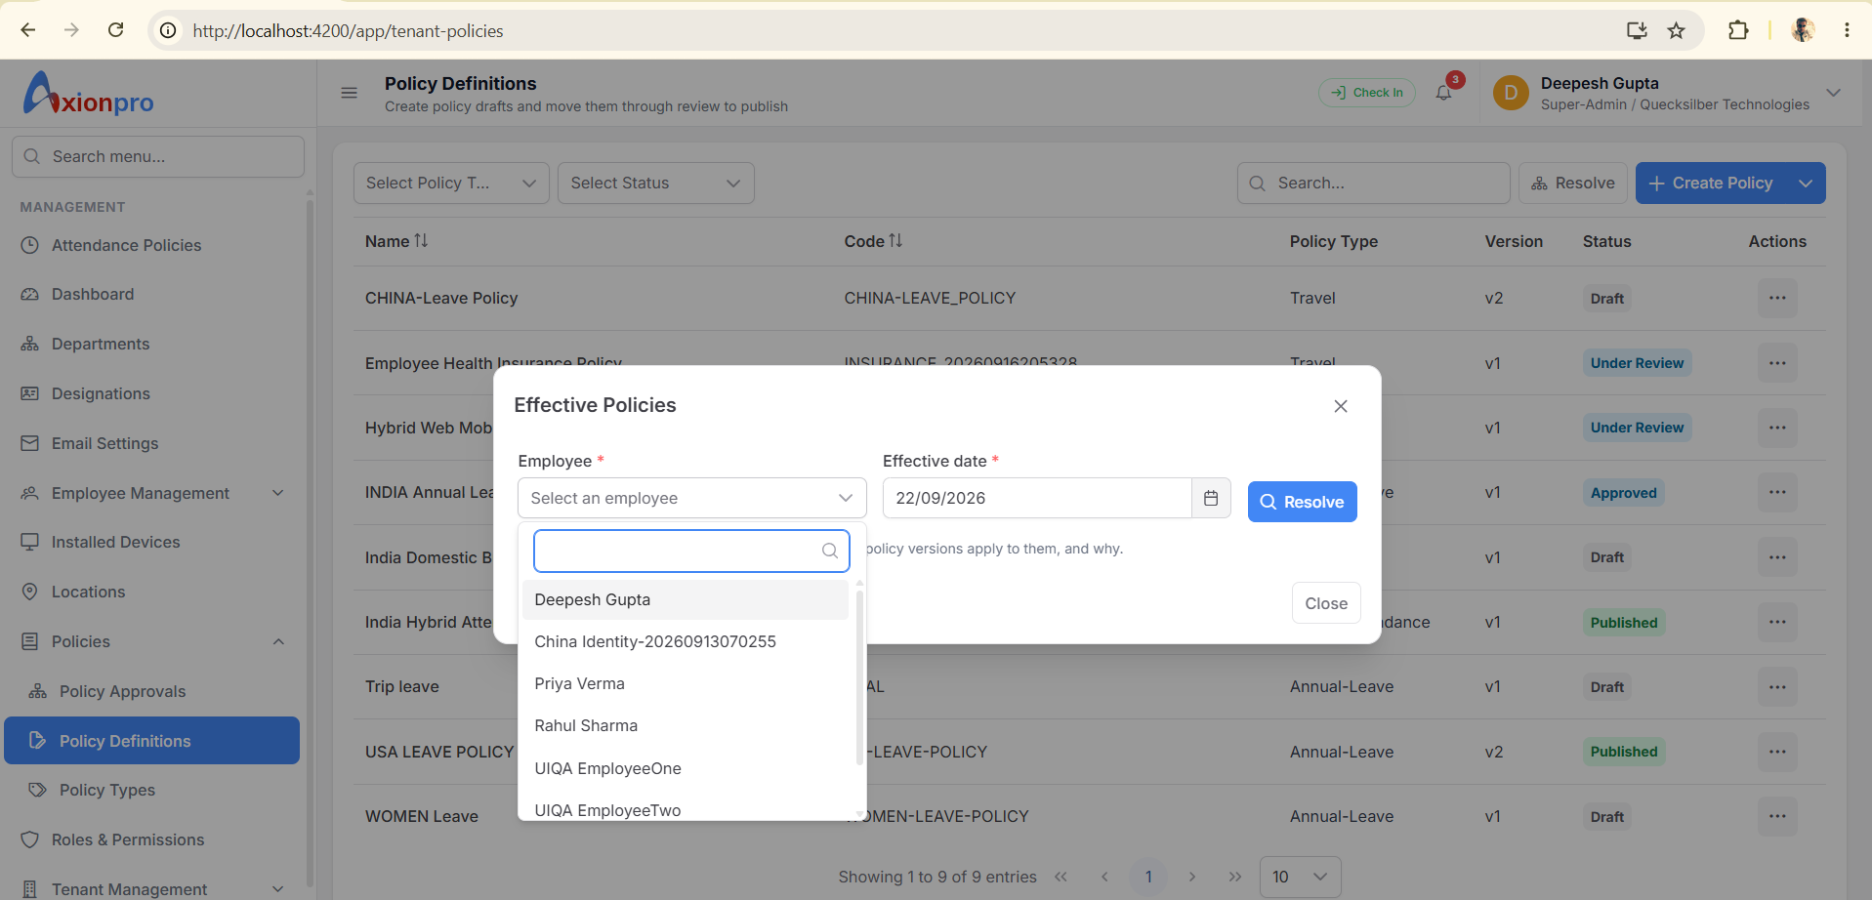
Definitions list ka Resolve button. Employee aur effective date chuniye. Ye preview hai: “is tareekh ko is employee par kaunsi Published policy lagti hai?”

Is screen par click karne se kya hota hai
Resolve API: GET /api/TenantPolicy/resolve?employeeId={numericId}&effectiveDate=YYYY-MM-DD | Result/table: data = [{policyId,policyVersionId,policyCode,policyName,priority,resolutionSource}]; READ Published PolicyVersion + Applicability + Assignment + employee location; WRITE kuch nahi
GAP — Employee dropdown public string employeeId deta hai; Number(id) non-numeric par fail hota hai. Resolve empty data ka matlab us date par matching Published policy nahi; automatic assignment row ka absence nahi.

Policy Approvals
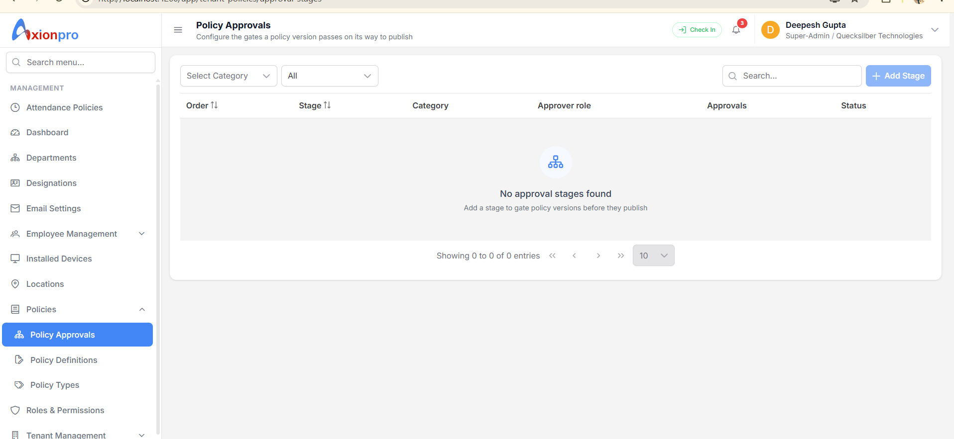
Yeh screen approval ka route/gate configure karti hai. Screenshot mein zero stage dikh raha hai. Stage banana aur policy approve karna do alag kaam hain.

Is screen par click karne se kya hota hai
List API: GET /api/TenantPolicy/approval-stages | Result/table: data = [{id,policyCategoryId,stageName,stageOrder,approverRoleId,minimumApprovals,isMandatory,isActive}]; READ PolicyApprovalStage
Add Stage API: POST /api/TenantPolicy/approval-stages | Result/table: INSERT PolicyApprovalStage; policyCategoryId null = all categories
Edit / Disable API: PUT /approval-stages/{id} / DELETE /approval-stages/{id} | Result/table: UPDATE/disable PolicyApprovalStage; prior history retained
Actual Approve API: Definitions row → POST /versions/{versionId}/transition action APPROVE | Result/table: PolicyApprovalHistory if mandatory stages; PolicyVersion may become Approved
GAP — Screenshot mein stage blank hai. Backend mandatory stage na hone par Under Review → Approve direct Approved kar sakta hai; multi-person gate chahiye to stages configure/test karna hoga.

Policy lifecycle buttons
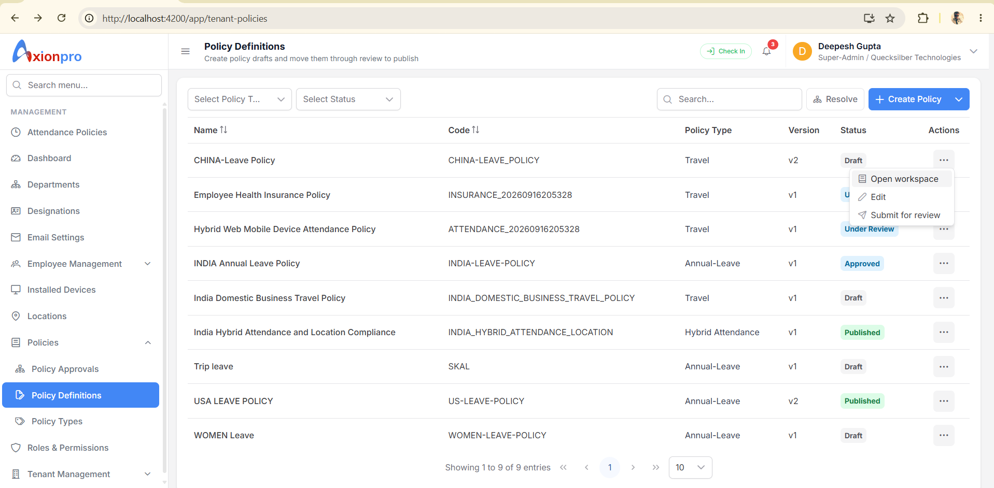
Definitions row ka menu status ke hisaab se badalta hai. Create ke baad Draft, fir Under Review, Approved, Published. Sirf Published/current/date-valid version Resolve mein milta hai.

Is screen par click karne se kya hota hai
Submit for review API: POST /api/TenantPolicy/versions/{versionId}/transition; action SUBMIT | Result/table: PolicyVersion status Under Review + PolicyChangeAudit
Approve / Reject API: same API; action APPROVE / REJECT | Result/table: PolicyApprovalHistory if stages configured; PolicyVersion status; audit
Publish API: same API; action PUBLISH | Result/table: PolicyVersion Published + IsCurrent=true; previous current unset; audit
Archive API: same API; action ARCHIVE | Result/table: PolicyVersion Archived + IsCurrent=false; audit
GAP — Approved status ko Published samajhkar employee ke liye active mat maanien. Publish alag click hai.

Policy Version Documents
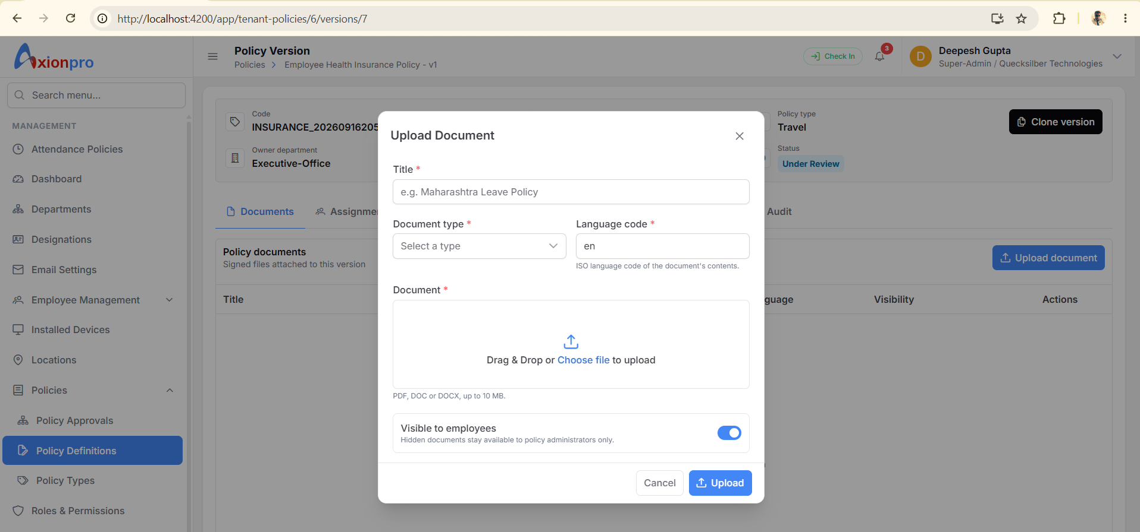
Workspace ka Documents tab. Document Type dropdown /lookups se. File binary object storage mein, uski metadata PolicyDocument row mein.

Is screen par click karne se kya hota hai
List API: GET /api/TenantPolicy/versions/{versionId}/documents | Result/table: data = [{id,title,originalFileName,languageCode,isEmployeeVisible,url}]; READ PolicyDocument
Upload API: POST /api/TenantPolicy/documents multipart file,policyVersionId,policyDocumentTypeId,documentTitle,languageCode,isEmployeeVisible | Result/table: data = document object; INSERT PolicyDocument + upload object
Open / Delete API: temporary url / DELETE /api/TenantPolicy/documents/{documentId} | Result/table: Open read only; Delete soft-delete PolicyDocument + stored file action
GAP — Published/Archived version par backend document mutation allow nahi karta. URL temporary hai; permanent link ke roop mein save na karein.

Policy Version Assignments
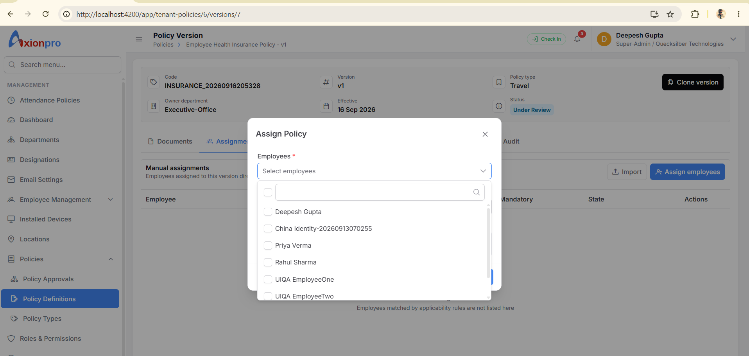
Assignments tab manual assignments dikhata hai. Applicability se automatically matched employees yahan list nahi hote. “No manual assignments” ka matlab policy kisi par nahi lagegi, aisa nahi.

Is screen par click karne se kya hota hai
List API: GET /api/TenantPolicy/versions/{versionId}/assignments | Result/table: data = manual assignment rows; READ PolicyAssignment
Assign employees API: POST /api/TenantPolicy/assignments; policyVersionId,employeeIds:[numeric],effectiveFrom,effectiveTo,isMandatory | Result/table: data = {inserted,existing}; INSERT/reactivate PolicyAssignment + missing PolicyAcknowledgement
Remove / Import API: DELETE /assignments/{id}; /bulk/assignments/... | Result/table: assignment inactive / bulk valid rows assigned
GAP — Only Published version assignable. UI selected string IDs ko Number(id) banata hai; real alphanumeric employee IDs drop ho sakte hain. Import address-bar version se restricted nahi: file mein policy/version per row aata hai.

Policy Version Exceptions
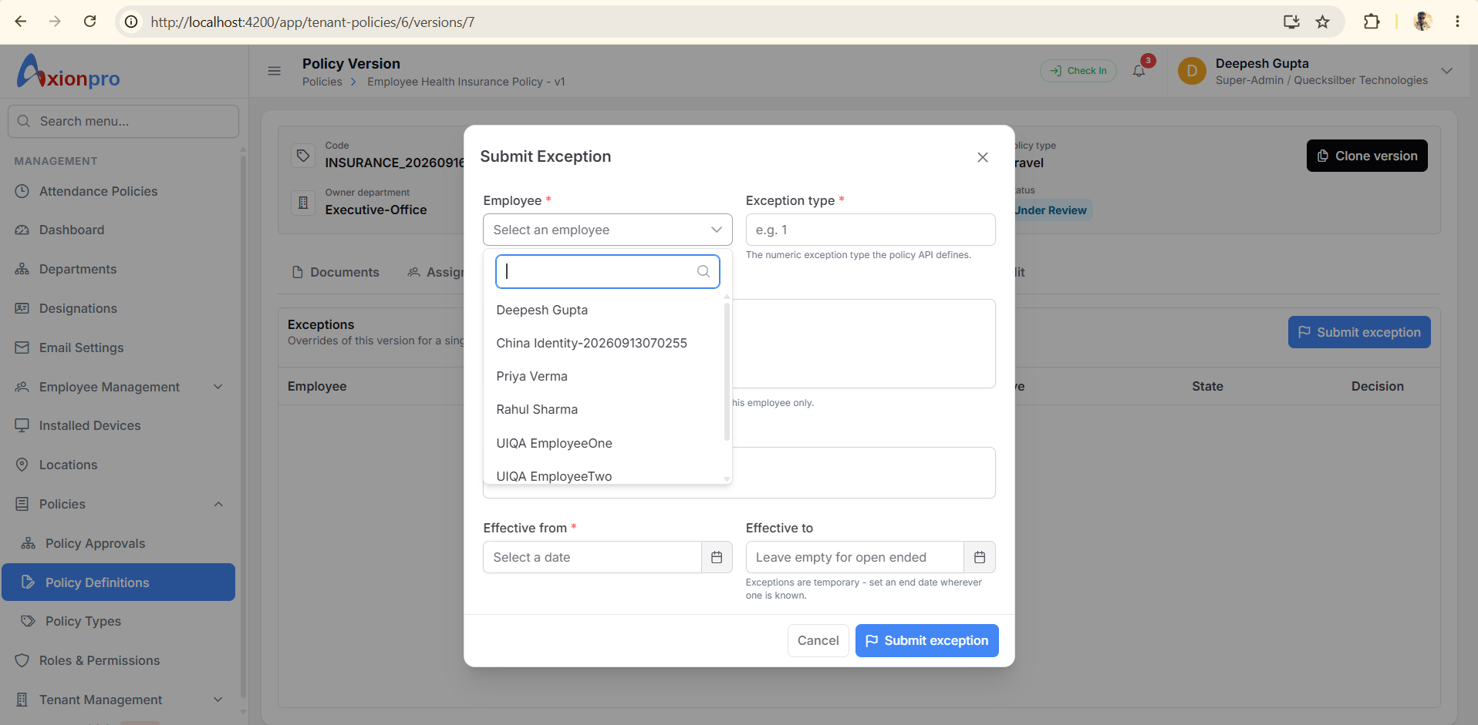
Exceptions tab ek employee ki temporary override request rakhta hai. Example: special period ke liye alag terms. Ye policy-wide Rule edit nahi hai.

Is screen par click karne se kya hota hai
Submit exception API: POST /api/TenantPolicy/exceptions; employeeId,policyVersionId,exceptionType,overrideConfiguration,reason,effectiveFrom,effectiveTo | Result/table: data = new exception ID; INSERT PolicyException
Approve / Reject exception API: POST /api/TenantPolicy/exceptions/{id}/decision; approve true/false | Result/table: data = boolean; UPDATE PolicyException approvalStatusId
List API: GET /api/TenantPolicy/versions/{versionId}/exceptions | Result/table: data = exception rows; READ PolicyException
GAP — Exception type UI numeric input hai, meaningful label/enum select nahi. Employee ID mismatch yahan bhi hai. Stored overrideConfiguration ko actual payroll/leave execution maan kar na chalayein.

Policy Version Clone and Audit
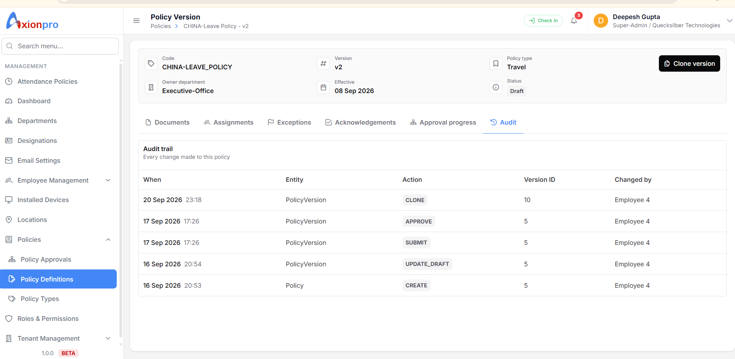
Workspace mein Clone se naya Draft version banta hai. Audit tab policy ke sab versions ki changes dikhata hai; sirf current version ki nahi.

Is screen par click karne se kya hota hai
Clone API: POST /api/TenantPolicy/{policyId}/versions/clone; sourceVersionId,effectiveFrom,changeSummary | Result/table: data = new versionId; INSERT PolicyVersion, copy PolicyRule + PolicyApplicability, audit
Audit API: GET /api/TenantPolicy/{policyId}/audit | Result/table: data = [{entityName,actionName,policyVersionId,changedById,changedDateTime,...}]; READ PolicyChangeAudit
Approval progress tab API: GET /api/TenantPolicy/versions/{versionId}/approval-progress | Result/table: data = stageId,minimumApprovals,approvalCount,isComplete; READ Stage + History
Acknowledgements tab API: GET /versions/{versionId}/acknowledgements; POST /acknowledgements for signed-in user | Result/table: READ/UPDATE PolicyAcknowledgement
GAP — Workspace URL versionId leta hai, par header GET /{policyId} se current/latest version fetch karta hai. Purana version URL kholne par header aur tabs alag versions ke ho sakte hain. Clone documents/assignments copy nahi karta.

Ek actual business example
HR ko 1 October se India ke Permanent employees ke liye 18 day annual leave terms record karne hain.
Policy Types → Leave category mein Annual Leave type existing hai to select karein; warna Add Type. PolicyType row banta hai. Abhi employee ko kuch assign nahi hua.
Policy Definitions → Create Policy: India Permanent Annual Leave; Rule “Annual entitlement”, JSON string {"days":18,"unit":"DAY"}; Applicability Include India + Permanent + 1 October. Policy + v1 Draft + Rule + Applicability rows bante hain.
Draft row → Submit; approver → Approve; Approved row → Publish. Tabhi current Published version Resolve mein aayega.
Effective Policies → ek valid employee + 1 October select. Response mein policy aaye to source APPLICABILITY. PolicyAssignment row automatically nahi banti.
Special employee ko direct dena ho to Assignments tab. Leave balance 18 credit karna generic Policy Rule save/Resolve API ka kaam nahi; uski separate business integration verify karni hogi.

Abhi kya missing ya broken hai
GAP — Employee identity mapping: string public employeeId vs numeric policy employeeId. Highest priority fix/test.
GAP — Screenshots mein Insurance/Attendance ka Policy Type Travel hai. DB PolicyTypeId mapping verify/correct.
GAP — Old version ke liye version-scoped detail/read screen missing; current header wrong version dikha sakta hai.
GAP — Automatic applicability se matched employees ka bulk coverage preview/list nahi; Resolve one employee/date hai.
GAP — Employee self-service “My Policies” dedicated route nahi mila; acknowledgement workspace mein signed-in employee ke liye hai.
GAP — Policy Rule ka raw JSON business schema/help aur exception type label missing. Valid JSON means calculated benefit nahi.
Source: Angular tenant-policies routes/components/service/interfaces; API TenantPolicyController; GenericPolicyDTOs; GenericPolicyRepository; GenericPolicyEntities. Request IDs actual menu/lookups se dynamically len. This was code inspection, not a deployed smoke test.

Policy module mein aur kya banana hai
Seedha jawab: nahi, screenshots wali screens poora product nahi hain. Abhi 3 policy menu pages aur 1 version workspace bana hai. 6 workspace tabs isi ek page ke hisse hain. Is waqt system policy records save aur resolve kar sakta hai; complete employee-facing policy journey aur actual benefit calculation ka evidence nahi mila.

Aaj jo UI sach mein hai
Screen | Current state | Kaam / database
Policy Types | Bana hai | Category ke andar reusable type; /types → PolicyType
Policy Definitions | Bana hai | Create/edit, rules, applicability, status, import, resolve; /TenantPolicy → Policy and version children
Policy Approvals | Bana hai | Approval stages; /approval-stages → PolicyApprovalStage
Policy Version workspace | Bana hai | Documents, Assignments, Exceptions, Acknowledgements, Approval progress, Audit tabs; version APIs
Employee Type and Tenant Location | Alag feature mein bana hai | Applicability ke input/master; generic policy menu ka part nahi
Employee location and work arrangement | Employee profile mein bana hai | Resolve ko date-effective location/work mode yahin se milte hain
Leave balance UI | Alag legacy leave feature | Generic PolicyRule JSON se automatic credited balance nahi

Complete practical journey ke liye missing UI aur API work
Employee My Policies page: Employee apni date-effective Published policies, document aur acknowledge action dekhe. Aaj dedicated route/list API nahi mila; existing Resolve one employee/date hai. Applicability-only employee ke liye acknowledgement backend active PolicyAssignment maangta hai, isliye end-to-end contract decide karna hoga.
Coverage and eligibility page: HR policy/version select karke “kaun eligible hai, kaun exclude hai, kyun” ki employee list dekhe. Aaj Resolve sirf one employee/date hai; existing Assignments tab keval manual assignments dikhata hai. Bulk coverage API/UI nahi mila.
Version history and version-specific detail: HR v1/v2 list khole, exact version ke rules/applicability/documents dekhe, compare kare. Aaj policy list ek version dikhati hai; workspace URL ka versionId header detail API ko nahi jaata. New version-list/detail API/UI contract needed.
Guided Rule editor within Create Policy: Raw JSON textarea ko rule-type-specific named fields, examples aur business validation deni hogi. Yeh same Create/Edit screen ka redesign ho sakta hai, alag page hona zaroori nahi. Backend se supported rule schemas/meaning decide karna hoga.
Policy benefit execution integration: Leave accrual/balance, attendance result, insurance eligibility/claim aur travel allowance actual calculate karne ka backend flow yahan proven nahi. Iske bina extra UI screen bhi business outcome nahi de sakti; category-wise API integration define/test karni hogi.

Ek employee ki poori journey ka checklist
1. Tenant setup
Screen/action: PolicyCategory/RuleType/DocumentType lookup seeded; TenantLocation aur EmployeeType available.
Table: Lookup/master tables
2. Employee setup
Screen/action: Employee profile mein type, date-effective location, work arrangement correct.
Table: Employee, EmployeeLocationAssignment, EmployeeWorkArrangement
3. HR type banaye
Screen/action: Policy Types par Annual Leave/Travel/Insurance reusable type.
Table: PolicyType
4. HR policy banaye
Screen/action: Definition mein actual name, Rule “kya”, Applicability “kis par”, dates.
Table: Policy + PolicyVersion Draft + PolicyRule + PolicyApplicability
5. Document lagaye
Screen/action: Version Documents tab mein signed document.
Table: PolicyDocument + object storage
6. Review aur publish
Screen/action: Submit → stages ke mutabik Approve → Publish.
Table: PolicyVersion, PolicyApprovalHistory, PolicyChangeAudit
7. HR eligibility dekhe
Screen/action: Resolve one employee/date possible; all-employee coverage missing.
Table: READ PolicyVersion, Applicability, location, Assignment
8. Employee apni policy dekhe
Screen/action: Dedicated My Policies absent; manual assign/acknowledge APIs available, automatic applicability-only acknowledgement contract gap.
Table: PolicyAssignment and PolicyAcknowledgement only where applicable
9. Actual business effect
Screen/action: Leave balance/attendance/insurance/travel engine separately integrate/test.
Table: Generic PolicyRule JSON save alone does not execute benefit
Production readiness ke teen immediate blockers: (1) public alphanumeric EmployeeId versus numeric policy EmployeeId mapping; (2) screenshot mein wrong Travel policy type on Insurance/Attendance/China Leave; (3) generic policy resolution ko benefit execution samajhne ki galti. Inko red gaps ki tarah treat karein, not “done”.
UI project read-only inspected. This document proposes missing screens/contracts; it does not claim those APIs or screens already exist.

