Skolenza Client Training Guide
  - Host setup se classroom delivery tak poora flow
Hinglish practical manual • 14 October 2026

Is guide se aap kya kar paayenge
Aap client ko samjha paayenge ki kis screen par kaunsa record banana hai, us record ka matlab kya hai, usse pehle kya taiyar hona chahiye aur save hone ke baad woh kahan use hoga. Training ko isi order mein karein; sirf tabs ke naam yaad karna zaroori nahi, unke beech ka relation samajhna zaroori hai.
Yeh guide Host Staff Category Catalogue, Professional Structure ke saare tabs, Staff Directory, Academic Structure ke saare tabs aur Curriculum ke saare tabs cover karti hai. Timetable approval, substitute coverage aur staff communication bhi isi flow se jode gaye hain.

Poore manual ka running example
Cheez | Training example
Institution | Red Rose St Marry School
Teacher | Ananya Sharma
Professional setup | Teaching → Academics → Mathematics Teacher
Academic setup | Academic Year 2026–27 → Grade 5 → Section C
Subject aur course | Mathematics → Grade 5 Mathematics
Curriculum | Fractions unit → Equivalent Fractions, Addition, Word Problems
Daily kaam | Lesson draft → Review → Class delivery → Approved coverage

Ananya, Section C aur lesson ke values training examples hain. Inhe pehle se saved records na samjhein. Existing record milne par use select karein; sirf demonstration ke liye duplicate record mat banayein.
18 screen reference pages mein aapke diye screenshots lage hain. Screenshot ki purani values aur is guide ke example values alag ho sakte hain. Screenshot number se relevant screen pehchanein; fill karte waqt example ki poori chain consistent rakhein.

Phase 1 se 5 ka training map
Phase | Is guide mein sambandhit kaam
1 | Professional categories, job families, positions, capabilities aur duties
2 | Staff ka professional profile, academic masters aur teaching assignments
3 | Curriculum, lesson planning, review, actual delivery aur progress
4 | Timetable, approval, publication, leave impacts aur substitute coverage
5 | Staff conversations, queries, broadcasts aur attachments

Guide ka navigation
Word ke Navigation Pane mein headings se seedha chapter khol sakte hain. Neeche diye chapter links clickable hain. Screen references document ke aakhri hisse mein hain; har screenshot apne poore resolution mein embedded hai, isliye Word mein zoom karke fields padhe ja sakte hain.
01 Basic terms aur dependency map
02 Screen navigation aur common buttons
03 Host Staff Category Catalogue
04 Institution Staff Categories aur Job Families
05 Capabilities aur Duties
06 Positions aur unki mappings
07 Staff Directory aur onboarding
08 Teaching aur Class Teacher Assignments
09 Session aur Programme
10 Academic Group aur Section
11 Subject aur Course Offering
12 Curriculum Frameworks
13 Units aur Topics
14 Lesson Plan banana
15 Lesson Plan review aur approval
16 Delivery Logs
17 Syllabus Progress
18 Timetable aur approval configuration
19 Leave aur Substitute Coverage
20 Staff Communication
21 Deactivate aur Reactivate
22 Poora practical classroom demonstration
23 Troubleshooting aur training completion
Screen references 01 se 18: Host Catalogue, Professional Structure, Staff Directory, Academic Structure aur Curriculum ki supplied screens.

1 Basic terms aur dependency map
Master ya catalogue ka matlab reusable list hai. Jaise Mathematics ek Subject master hai. Ananya ko Grade 5-C Mathematics padhane ki zimmedari dena Assignment hai. Monday ko uska period rakhna Timetable hai. Us period mein kya padhana hai woh Lesson Plan hai. Class mein asal mein kya padha woh Delivery Log hai.
Term | Bilkul simple matlab | Example
Host | Platform chalane wala administrator | Shared category types maintain karega
Institution | Ek school, college ya coaching ka apna workspace | Red Rose ka apna staff aur classes
Master | Baar baar select hone wali definition | Teacher position, Mathematics subject
Mapping | Do records ke beech allowed connection | Teaching category mein Academics family
Assignment | Kisi vyakti ko responsibility dena | Ananya ko Grade 5-C Mathematics
Workflow | Kaam ke states aur approvals ka order | Draft → Submitted → Approved
Active | Naye use ke liye available record | Section C current setup mein available

Do parallel foundations
Professional side: Host Category Type → Institution Category aur allowed Job Family → Position. Position ke saath required Capabilities aur default Duties jodte hain. Staff member ko us Position par assign karte hain.
Academic side: Session aur Programme alag master records hain. Group in dono ko jodta hai. Section us Group ke andar banta hai. Subject alag master hai. Course Offering Session + Group + Subject ko jodta hai.
Dono sides Teaching Assignment par milti hain: Staff Member + Course Offering + Section + effective dates. Curriculum mein Framework + Course Offering se Unit, aur Unit se Topics bante hain. Lesson Plan Teaching Assignment aur matching Topics ko use karta hai.

Setup ka sahi order
Pehle professional masters aur staff taiyar karein. Phir session, programme, group, section, subject aur offering. Uske baad teacher assignment, curriculum aur timetable. Roz ke kaam mein lesson draft, approval, delivery aur progress aate hain. Kisi list ko bhar dena uske agle transaction ko apne aap create nahi karta.
Client ko boliye: “Teacher ka pad, uski class ki responsibility, uska time aur us din ka lesson chaar alag cheezein hain. Inhe jodne se poora school operation banta hai.”

2 Screen navigation aur common buttons
Screen reference: 03 aur sambandhit tab ki screen
Sabse pehle upar right mein login ka role aur institution naam dekhein. Host-Super-Admin / Skolenza Host dikh raha ho to aap platform catalogue par hain. Institution Administrator / Red Rose St Marry School dikh raha ho to institution ke apne records par kaam kar rahe hain.
1. Host login mein Staff Category Catalogue menu kholein. Yeh shared category types ke liye hai.
2. Institution login mein Staff Management → Staff Directory kholein.
3. Professional Structure button se Staff Categories, Job Families, Positions, Capabilities aur Duties milte hain.
4. Academic Structure button se Session, Programme, Group, Section, Subject aur CourseOffering tabs milte hain.
5. Curriculum & Lessons button se Frameworks, Units & Topics, Lesson Plans, Delivery Logs aur Syllabus Progress milte hain.
Screen ka hissa | Kaise use karein
Left list | Saved records dekhein. Har row ka naam aur neeche relation/description padhein.
Right form | Naya record add karein; Edit dabane par isi form mein selected record ki values aati hain.
Code | Record ki stable pehchan; example MATH_TEACHER. Display Name se alag hai.
Name aur Description | Name user ko dikhta hai. Description mein purpose/scope samjhayen.
Active filter | Active, Inactive ya All available ho to zaroorat ke mutabiq list badlein.
Save aur Cancel | Save valid data persist karta hai. Cancel current unsaved editing chhodta hai.
Save draft | Draft persist karta hai; isse approval ya publication complete nahi hota.
Edit | Existing record kholta hai. Naya record banane ke liye purane record ko overwrite na karein.
Remove ya Deactivate | Action ka confirmation aur dependencies padhein. Lifecycle detail chapter 21 mein hai.

Required star wale fields bharna zaroori hai. Star na dikhne ka matlab har case mein optional nahi hota; selected record ke relation ke hisaab se validation bhi lag sakti hai. Save ke baad success message aur list mein saved value dono dekhein. Menu/action nahi dikh raha ho to pehle correct account aur permission check karein.

3 Host Staff Category Catalogue
Screen reference: 01
Category type staff ka sabse broad classification hai. Teaching, Administrative, Non-Teaching, Support aur Specialist jaise types Host catalogue mein aate hain. Host ko Grade 5, Mathematics ya kisi individual teacher ka naam yahan nahi banana hai.

Example aur ownership
School ko counsellors aur wellbeing staff ke liye ek type chahiye. Host “Student Services” type maintain karega. Institution is type ko select karke apni working category aur positions banayega. Screenshot mein Student Services pehle se hai; use dobara create karne ki zaroorat nahi.
Field | Kya bharna hai | Example
Code | Type ka stable identifier | STUDENT_SERVICES
Name | Catalogue mein dikhne wala naam | Student Services
Description | Kaunse staff is type mein aayenge | Counselling, wellbeing aur learner support
Display order | List mein relative ordering | 60
Active | Type ko available rakhna | On

Karne ka tareeqa
1. List mein existing type khojein. Wahi meaning ho to existing record reuse karein.
2. Naya meaning chahiye tab Add Staff Category form bharein. Code aur Name ko alag samjhein.
3. Save karein aur list mein correct name aur Active badge dekhein.
4. Institution login mein Staff Categories ke Category type dropdown mein us type ko dhoondhein.

Save hone ke baad kahan use hoga
Institution Staff Categories ke Category type dropdown mein. Host type se institution ko shared meaning milta hai; institution apna local name, code aur allowed families rakhta hai. Type banana kisi institution mein counsellor hire karna ya uski Position banana nahi hai.
System aur Custom badges record ke origin ko batate hain. Dono ko dekhkar ownership samjhein; badge ko permission ka substitute na samjhein. Host catalogue par change ka reach platform tak ho sakta hai. Institution category ka deactivate action sirf us institution ke record par hota hai.
Client ko boliye: “Host vocabulary deta hai. Aapka institute us vocabulary se apna staff structure banata hai.”

4 Institution Staff Categories aur Job Families
Screen reference: 02 aur 04
Staff Categories tab mein institute ki working category banti hai. Job Families tab mein related jobs ka functional group banta hai. Category aur family ke beech “Allowed job families” mapping decide karti hai ki kaunsi family is category mein valid hogi. Yeh sirf naam ki similarity se decide nahi hota.
Record aur field | Training value aur matlab
Category type | Teaching select karein. Yeh Host catalogue ka broad type hai.
Local Code aur Name | TEACHING_FACULTY / Teaching Faculty. Institute ka apna display name.
Category Description | Classroom teaching aur academic instruction ke liye staff.
Allowed job families | Academics choose karein. Is mapping ke baad hi is combination mein Position valid hogi.
Job Family Code aur Name | ACADEMICS / Academics. Teaching related posts ka functional group.
Family Description | Classroom, subject aur academic delivery positions.
Active | Category aur family dono active hon. Display order field ho to list order set karein.

Naya setup practical order
1. Job Families mein Academics existing hai to reuse karein; nahi hai to Code, Name, Description aur Active ke saath save karein.
2. Staff Categories mein Teaching type select karein, local Code/Name bharein aur Academics ko Allowed job families mein map karke save karein.
3. Category pehle se ho to Edit karke allowed family add karein. Mapping save hui hai, yeh edit/readback se dekhein.
4. Positions mein is active category aur mapped family ka valid combination use karein.
Ek family alag categories se map ho sakti hai jab institute ko waise positions chahiye. Isliye ise country-state ki bilkul rigid tree na samjhein. Position ko ek valid category-family combination chahiye; allowed mappings hi actual relation hain.

Doosra example
Student Services category → Student Wellbeing family → Student Counsellor position. Finance & Accounts family → Accountant position bhi ho sakti hai. Job Family “team of related work” hai; Department actual organisational department hai. Dono ka naam same hona compulsory nahi.
Category row par job families, positions aur staff counts use/dependencies samjhate hain. Sirf family bana dene se Staff onboarding mein woh option zaroor nahi aayega: selected category ke andar usable Position bhi honi chahiye. Isi wajah se pehle Position complete karein, phir staff onboard karein.

5 Capabilities aur Duties
Screen reference: 06 aur 07
Capability ka matlab staff ko kaam karne ke liye kya aana chahiye. Duty ka matlab staff se kya kaam expected hai. “Subject Teaching” capability hai; “Prepare lesson plans” duty hai. In dono ko software login permissions se alag rakhein.
Cheez | Capability example | Duty example
Teacher | Subject Teaching; Lesson Planning | Prepare lesson plans; Deliver assigned classes
Counsellor | Student Counselling | Deliver student wellbeing support
Accountant | Financial Accounting | Reconcile accounts
Electrician | Electrical Maintenance | Resolve electrical requests

Capabilities tab
Code SUBJECT_TEACHING, Name Subject Teaching, Description “Subject ko sahi concepts aur examples se padhana”, aur Active select karke save karein. Position mein is capability ko required map kiya ja sakta hai. Capability master banane se Ananya ko competent ya verified declare nahi kiya jata.
Staff ko Position assign hone par required capabilities ke assignments Pending Verification ho sakte hain. Authorised Institution Administrator staff ke evidence/qualification ko dekhkar verification karta hai. Required ka matlab position ki expectation hai; verified ka matlab us individual ke liye review ho chuka hai.
Certification, certification validity ya evidence requirements supported configuration mein hon to actual qualification policy ke mutabiq use karein. Supplied simple form mein yeh sab controls dikh nahi rahe; client ko aise controls ka demo na dein jo uski screen par available nahi hain.

Duties tab
Field | Kya bharna hai
Code | PREPARE_LESSON_PLANS
Name | Prepare lesson plans
Description | Assigned teaching work ke liye lesson plans taiyar karna
Default frequency | Weekly, agar institute weekly planning expect karta hai
Active | On, taaki duty Position mein map ki ja sake

Position ki default duties staff onboarding par individual duty assignments mein use hoti hain. Default frequency ka label apne aap calendar reminder, payroll rule ya scheduled task nahi banata. Har duty ko timetable period samajhna bhi galat hoga.
Client ko boliye: “Ananya ko padhana aana chahiye, yeh capability hai. Ananya ko har week lesson plan banana hai, yeh duty hai. App mein approve karne ka button milega ya nahi, yeh Access Role aur permissions decide karenge.”

6 Positions aur unki mappings
Screen reference: 05
Position ek concrete job post hai. Teaching Faculty category aur Academics family ke andar Mathematics Teacher position banegi. Isi Position par staff member assign hoga. Position ke saath capabilities aur duties map karne se har staff ke liye expectation alag se zero se likhne ki zaroorat kam hoti hai.
Field ya selection | Training example
Category | Teaching Faculty, jo Teaching type se bani hai
Job Family | Academics, jo selected category mein allowed hai
Code aur Name | MATH_TEACHER / Mathematics Teacher
Description | Primary school mathematics instruction
Required capabilities | Subject Teaching, Lesson Planning, Student Assessment
Default duties | Prepare lesson plans, Deliver assigned classes, Update syllabus progress
Active | On
Department ya Designation mapping | Agar form mein available ho to matching configured record select karein

1. Pehle category, allowed family, capabilities aur duties ready rakhein.
2. Positions mein Add position kholein. Category select karke corresponding family choose karein.
3. Code/Name aur relevant capabilities/duties select karein. Required aur optional ka option ho to actual expectation ke mutabiq set karein.
4. Save karke row aur Edit form mein mapping verify karein.
5. Staff create/edit screen mein same Category → Job Family → Position chain select karein.

Aage iska use
Staff onboarding mein effective primary Position assignment banta hai. Position ke mapped default duties aur required capabilities staff profile tak pahunchte hain. Baad mein position change karne par purane effective assignment ko close karke naya assignment maintain kiya jata hai; purane employment context ko silently overwrite karna sahi training nahi hai.
Position Teacher rakhne se Grade 5 Mathematics assign nahi hoti. Woh Teaching Assignment mein hoga. Position ke naam mein Teacher likhne se automatic app permissions bhi nahi milti; Access Role alag select hoga.
Screenshot 05 mein Category options “empty” dikh rahe hain. Yeh valid category names nahi hain. Aisi list mein andaze se option select karke Save na karein. Correct label milne tak selection ko unresolved samjhein; category ko duplicate bana kar presentation problem solve na karein.

7 Staff Directory aur onboarding
Screen reference: 03
Professional masters taiyar hone ke baad Staff Directory se actual person banate hain. “Mathematics Teacher” ek post hai; “Ananya Sharma” person hai. Ek Position par alag samay ya alag assignments mein staff ho sakte hain, isliye dono records alag hain.
Selection | Example | Kis sawal ka jawab
Staff Category | Teaching Faculty | Staff kis broad category mein hai
Job Family | Academics | Kis functional work group mein hai
Position | Mathematics Teacher | Kaunsi professional post par hai
Department | Mathematics Department | Organisation mein kis department ka hissa hai
Designation | Primary Mathematics Teacher | Official job title kya hai
Employment Type | Permanent | Employment arrangement kya hai
Access Role | Configured teacher role | Application mein kaunse actions kar sakta hai

1. Add StaffMember kholein aur real authorised staff ki identity/contact details bharein. Training mein Ananya example hai; real login/email bina owner ki details ke invent na karein.
2. Country aur other dependent fields mein correct corresponding options choose karein. Department choose karne ke baad matching Designation select karein.
3. Employment Type aur Category select karein. Category se relevant families, phir family se Position select karein.
4. Appropriate Access Role choose karein. Teacher ko timetable approval chahiye to sirf position rename karna kaafi nahi.
5. Form ke required dates aur official details complete karke Save karein. Profile/Overview mein professional selections aur verification state dekhein.

Directory screen padhna
Department, Designation, Type aur Search list ko filter karte hain. Row mein staff code, name, employment, department, designation, role aur completion indicator dikhte hain. Profile Completion employee information ki completeness batata hai; syllabus completion se iska koi sambandh nahi.
Total, Active, On Leave aur Inactive cards alag staff summaries hain. Supplied screenshot mein Total 1 aur On Leave 10 dikhte hain; in numbers ko matching live counts ka proof na batayein. Demo environment mein cards aur underlying staff/leave records reconcile karke hi client ko factual count batayein.
Staff save hone ke baad professional profile milti hai. Class/subject allotment, timetable aur lesson transactions abhi alag steps hain. Non-teaching staff ke liye academic setup mandatory business step nahi hai.

8 Teaching aur Class Teacher Assignments
Teaching Assignment teacher ko subject padhane ki responsibility deta hai. Class Teacher Assignment ek section ki pastoral/class coordination responsibility deta hai. Ananya Maths padhati ho sakti hain, jabki usi section ki Class Teacher Meera ho sakti hain. Dono ek vyakti bhi ho sakte hain, par separate assignments hain.
Is chapter se pehle academic records chapter 9 se 11 ke mutabiq ready hon. Staff profile ke academic/teaching assignment area mein selected staff ke assignments manage karein. Exact entry point aapke authorised menu/profile actions par depend karega; supplied screenshots mein assignment form nahi hai.
Teaching field | Example aur matlab
Staff member | Ananya Sharma, saved staff profile
Course offering | Grade 5 Mathematics, correct session ka offering
Class section | Grade 5 Section C, isi offering ke group ki section
Assignment type | Available configured teaching-role option select karein
Primary | Agar yeh Ananya ki primary teaching responsibility hai to select karein
Contribution percent | 100, agar poori teaching responsibility Ananya ki hai; shared teaching actual allocation ke mutabiq
Effective from aur to | 01 Apr 2026 se 31 Mar 2027, assignment ki valid period
Active | Current allocation ke liye On

1. Teacher profile mein Add Teaching Assignment kholein aur offering choose karein.
2. Usi academic group ki section choose karein; Grade 5 offering ke saath Grade 6 section match nahi karti.
3. Role/type, dates, primary flag aur contribution set karke save karein.
4. Staff overview aur lesson planning assignment list mein correct association verify karein.
5. Class Teacher responsibility chahiye to us section ke liye separate effective assignment banayein.
Ek teacher multiple subjects aur multiple sections padhata hai to har valid allocation ka separate assignment banega. Duplicate overlapping assignment banana additional responsibility define karne ka sahi tareeqa nahi hai. Dates aur existing assignments check karein.
Aage Teaching Assignment lesson plans aur timetable ko real teacher/course/section context deta hai. Staff ka Teacher position record alone is relation ko establish nahi karta. Assignment dropdown mein teacher name na dikhne se teacher absent hone ka conclusion na nikaalein; full staff assignment/profile dekhein.

9 Session aur Programme
Screen reference: 08 aur 09
Session batata hai academic activity kis time period ki hai. Programme batata hai education ka kaunsa course ya stage chal raha hai. Dono alag masters hain; Programme ko har baar Session ke child ke roop mein banana compulsory nahi. Academic Group selected Session aur Programme ko jodta hai.

Session tab
Field | Example | Matlab
Code | AY-2026-27 | Session ka identifier
Name | Academic Year 2026–27 | Visible session name
Description | Annual school academic session | Is session ka purpose
Start date | 01 Apr 2026 | Session ki shuruaat
End date | 31 Mar 2027 | Session ka end
Active | On | Current selection ke liye available

Academic Structure → Session mein form bharein, valid date range rakhein aur Save karein. Agla academic year aaye to naya Session banayein; purane session ka naam badal kar historical year ko naye year mein convert na karein. Session Groups, Course Offerings aur Curriculum Frameworks mein use hoga.

Programme tab
Field | Example aur matlab
Code aur Name | PRIMARY / Primary School
Description | Primary classes ki learning stage
Level | Primary, institution ke meaningful level descriptor ke roop mein
Active | On, taaki relevant groups ban sakein

Programme form mein details bhar kar Save karein. Primary School programme ko Grade 1, Grade 2 aur Grade 5 jaise Groups refer kar sakte hain. Programme Level mein value dene se classes automatically create nahi hoti.
Institution type | Session example | Programme example
School | Academic Year 2026–27 | Primary School
College | Academic Year 2026–27 | BSc Computer Science
Coaching | JEE 2027 preparation cycle | JEE Foundation

Client ko boliye: “Session WHEN batata hai; Programme WHAT course/stage batata hai. Grade ya semester in dono ke context mein Group hoga.”

10 Academic Group aur Section
Screen reference: 10 aur 11
Group school mein Grade/Class, college mein Year/Semester, aur coaching mein Batch ho sakta hai. Section us Group ka smaller division hai. Section A/B fixed rule nahi hai; institute sirf A, ya A/B/C, ya meaningful batch names configure kar sakta hai.
Group field | Example
Code aur Name | GRADE-05 / Grade 5
Description | Primary School Grade 5 for Academic Year 2026–27
Session | Academic Year 2026–27
Programme | Primary School
Active | On

Group save karne se pehle Session aur Programme save hone chahiye. Grade 5 existing ho to use reuse karein. Code aur Name se zyada important selected Session/Programme hain; same grade name alag sessions mein different academic context represent kar sakta hai.
Section field | Example
Code aur Name | GRADE-05-C / Grade 5 Section C
Description | Section C of Grade 5
Academic group | Grade 5, correct session/programme wala record
Capacity | 35, planned student capacity
Active | On

1. Group tab mein correct Grade 5 ki session/programme association verify karein.
2. Section tab mein Add form use karein; Grade 5 Section C ka code/name bharein.
3. Academic group Grade 5 select karein; Capacity 35 set karke Save karein.
4. List mein Section C aur Edit mein correct Group verify karein.
5. Teacher allocation/timetable mein nayi section select karein. Sirf section save hone se teacher ya students assign nahi hote.
Capacity planning value hai; is number ko bharne se 35 students auto-create ya auto-admit nahi hote. Kisi admission-capacity enforcement ko tabhi demonstrate karein jab woh admission flow mein verified ho.
College example: BSc Semester 1 group → Practical Batch B section. Coaching example: JEE Morning group → Weekday Batch A section. Programme, group aur section ke names institute apni terminology se rakh sakta hai; school ke Grade 1 se 10 ko universal limit na samjhein.

11 Subject aur Course Offering
Screen reference: 12 for Course Offering
Subject reusable subject name hai, jaise Mathematics. Course Offering batata hai ki us subject ko kaunse session aur group ke liye offer kiya ja raha hai. Sirf Mathematics Subject banane se Grade 5 ka Maths course ya teacher assignment nahi banta.

Subject tab
Academic Structure → Subject mein existing Mathematics khojein. Nahi ho to Code MATH, Name Mathematics, meaningful Description aur Active ke saath Save karein. Subject form mein jo additional metadata available ho use institution ke standard ke mutabiq bharein. Supplied set mein Subject tab ka separate screenshot nahi hai; Course Offering screenshot mein Subject dropdown dikhta hai.

CourseOffering tab
Field | Training value | Kyun chahiye
Code | GRADE-05-MATH | Offering ki stable pehchan
Name | Grade 5 Mathematics | User ko clear course context
Description | Maths course for Grade 5 in 2026–27 | Scope samjhane ke liye
Session | Academic Year 2026–27 | Offering ka academic period
Academic group | Grade 5 | Kis class/batch ko padhana hai
Subject | Mathematics | Kya subject padhana hai
Curriculum version | RRSMS-2026-27 | Applicable curriculum ka reference label
Active | On | New academic allocation ke liye available

1. Session, Group aur Subject pehle save karein.
2. Offering form mein matching Session aur Group select karein; group doosre session ka nahi hona chahiye.
3. Mathematics select karke code, name aur curriculum version bharein. Save karke relation dobara dekhein.
4. Isi offering ko Teaching Assignment aur Curriculum Unit mein use karein.
Offering Grade 5 Mathematics group-level course hai. Section A aur C ke teachers alag hon to same offering se separate section-specific assignments ban sakte hain. Har section ke naam se duplicate Subject banana zaroori nahi.
Curriculum version text reference hai. Is field ko bharne se Framework, Units aur Topics apne aap create ya approve nahi hote. Actual syllabus structure Curriculum & Lessons mein banega.
Client ko boliye: “Mathematics subject hai. 2026–27 mein Grade 5 ko padhayi jaane wali Mathematics course offering hai. Usko Section C mein Ananya padhayegi, yeh teaching assignment hai.”

12 Curriculum Frameworks
Screen reference: 13
Framework syllabus ka named/versioned container hai. Ismein session, board/university/authority, version aur effective period ka context hota hai. Framework ke andar Units bante hain; har Unit relevant Course Offering se linked hota hai.
Field | Example | Samjhein
Academic session | Academic Year 2026–27 | Syllabus kis academic session ka hai
Code | RRSMS-CURRICULUM-2026-27 | Framework identifier
Name | School Curriculum Framework 2026–27 | Visible framework title
Board or university or authority | School Academic Council | Syllabus ki defining authority
Version | 2026.1 | Version ka label
Effective from | 01 Apr 2026 | Applicable start date
Effective to | 31 Mar 2027 | Applicable end date
Active | On | Record ki availability

1. Curriculum & Lessons → Frameworks kholein aur existing framework check karein.
2. New framework chahiye to selected session aur details bharke Save framework karein.
3. Saved row par workflow status dekhein. Active aur Approved alag meanings rakhte hain.
4. Units & Topics tab mein isi framework ko select karke syllabus content add karein.
5. Approval required ho to authorised review actions se submit/review karein; sirf version/name type karne se approval nahi milta.
Screenshot mein existing framework Approved dikh raha hai. Usse yeh assume na karein ki har naya Framework automatically Approved hoga. Draft, Submitted aur Approved status ko actual row/action se verify karein.

Authority aur version ka practical use
School apne board/academic council ka syllabus reference rakhega; college university ya department curriculum rakh sakta hai; coaching apna course authority name rakh sakti hai. Ek relevant framework ke neeche multiple course offerings ki units ho sakti hain. Framework ko Subject ke barabar na samjhein.
Purane approved syllabus ko naya naam dekar change karna historical lesson context ko confuse kar sakta hai. Naye academic cycle/version ka setup institution ki approved process ke saath karein aur existing references/dependency messages respect karein.

13 Units aur Topics
Screen reference: 14
Unit syllabus ka chapter ya major block hai. Topic us Unit ka smaller learning item hai. Example Grade 5 Mathematics ke Fractions Unit mein Equivalent Fractions, Addition of Fractions aur Word Problems teen Topics hain.
Form aur field | Training example ya meaning
Top Framework selector | School Curriculum Framework 2026–27; pehle correct framework choose karein
Unit Course offering | Grade 5 Mathematics
Unit Code aur Name | G5-MATH-FRACTIONS / Fractions
Unit Sequence | 1; course ke andar teaching order
Unit Planned periods | 6; total planned class periods
Unit Learning outcome | Students fractions compare aur simple fraction problems solve karein
Topic Unit | Fractions; correct course/framework wala unit
Topic Code aur Name | G5-MATH-FRAC-EQ / Equivalent Fractions
Topic Sequence aur Planned periods | 1 aur 2; isi tarah Addition 2 periods, Word Problems 2 periods
Topic Learning outcome | Equivalent fractions ko models aur numbers se identify karna

1. Top framework choose karein. Add curriculum unit mein correct offering aur unit fields save karein.
2. Add curriculum topic mein just-saved Fractions unit choose karein. Pehla topic save karein.
3. Addition of Fractions aur Word Problems bhi corresponding sequence aur 2 periods ke saath save karein.
4. List mein course name, unit aur uske child topics ek saath padhein. Topic ko sirf naam se nahi, parent course se bhi verify karein.

Planned periods ka matlab
6 planned periods budget hain. Isse Monday Period 2 automatically timetable mein nahi banta. Timetable scheduling alag step hai. Is example mein 2 + 2 + 2 = 6 planned periods rakhe hain taaki unit aur topic planning meaningful ho; ise automatic validation rule ka claim na samjhein.
Sequence 1 har alag course ki first unit ho sakti hai; list mein multiple “1” dekhna hamesha duplicate error nahi. Parent offering dekhna zaroori hai. Same topic name alag classes/courses mein ho sakta hai, par unke saved topic records aur outcomes alag context ke hote hain.
Aage teacher Lesson Plan banate waqt apne teaching assignment ke course se matching Topics select karega. Delivery coverage aur progress bhi inhi topic records se link honge.

14 Lesson Plan banana
Screen reference: 15 aur 16
Lesson Plan batata hai ki teacher particular date/period mein kya aur kaise padhayega. Isse pehle teacher ka effective Teaching Assignment aur matching course ke curriculum topics hone chahiye. Lesson plan syllabus master bhi nahi hai aur timetable bhi nahi.
Field | Ananya ka filled example
Teaching assignment | Ananya ka Grade 5 Section C Mathematics assignment
Curriculum topics | Fractions unit ka Equivalent Fractions topic
Planned date | 19 Oct 2026, applicable assignment period ke andar
Period reference | P2, timetable ke matching period ka reference
Objectives | Students 1/2 aur 2/4 ki equivalence explain kar paayen
Teaching method | Paper folding aur guided examples
Resources | Fraction strips, board, worksheet
Activities | Pairs mein equal shaded parts compare karna
Assessment | 5 short questions; answers discuss karna
Homework | Equivalent fractions ke 5 examples banana

1. Lesson Plans tab mein correct Teaching Assignment choose karein.
2. Curriculum topics mein sirf us offering ke relevant topic(s) select karein.
3. Planned date aur period reference ke baad objectives, method, resources, activities, assessment aur homework bharein.
4. Save draft dabayein. List mein saved lesson aur Draft status verify karein.
5. Submit/review step chapter 15 ke mutabiq karein. Save draft ko Approved ya delivered na batayein.

Screenshot ki important correction
Screenshot 15 mein Grade 5 Mathematics select hai lekin Vocabulary in Context aur Grammar in Use topics dikh rahe hain. Maths training ke liye yeh selection sahi nahi. Matching Maths topic na mile to offering/topic association check karein. Irrelevant topic select karke aage badhna valid demo nahi hoga.
Resources field mein “worksheet” likhne se file upload nahi hoti. Period reference mein P2 likhne se reserved timetable slot automatically create nahi hota. Topic select karne se syllabus complete bhi nahi hota; yahan sirf planned learning save ho rahi hai.

15 Lesson Plan review aur approval
Lesson draft teacher ka proposal hai. Review mein authorised person check karta hai ki selected class, subject, topics, date aur teaching activity sahi hain. Current curriculum workflow ko timetable ke configurable multi-step approval se alag samjhein.
Status | Matlab | Agla valid business step
Draft | Teacher ne plan save kiya hai | Complete/edit karke Submit
Submitted | Plan review ke liye bheja gaya hai | Authorised reviewer Approve ya Reject kare
Rejected | Correction required hai | Remark padhein, correct karein aur resubmit
Approved | Plan approved hai | Is plan ke against actual delivery record karein

Practical review example
1. Ananya Equivalent Fractions plan Draft mein save karti hain.
2. Content ready hone par Submit karti hain; row Submitted honi chahiye.
3. Curriculum review permission wala authorised institution user plan kholta hai.
4. Reviewer class/course/topic match, achievable objectives aur assessment check karta hai. Sahi ho to Approve aur meaningful remark save karta hai.
5. Agar topic wrong ho, reviewer Reject remark “Grade 5 Maths ka Fractions topic choose karein” deta hai. Ananya correct karke dobara submit karti hain.

Kaun approve karega
Curriculum review ka access current institution permissions se control hota hai. Is flow mein named Grade Coordinator → Principal jaisi configurable multi-step lesson-plan chain ko confirmed feature ke roop mein train na karein. Timetable ke liye alag configurable approval chain hai, jiska detail chapter 18 mein hai.
Institution ko operationally decide karna hoga ki curriculum review ki permission kisko deni hai. “Manager” job title hone se har review ka permission automatic nahi milta. Actual reviewer login par visible action aur successful authorised transition verify karna training ka part hai.

Approved ke baad
Approved lesson actual delivery record ke dropdown mein eligible context deta hai. Approval ka matlab class ho chuki hai nahi. Published timetable mein period hona bhi lesson approval nahi hai. Lesson draft delete karne aur approved history delete karne ke rules alag hain; submitted/approved records ki history preserve ki jati hai.
Client ko boliye: “Planning approve ho gayi. Ab class padhane ke baad jo asal mein hua, woh Delivery Log mein aayega.”

16 Delivery Logs
Screen reference: 17
Delivery Log actual classroom work ka record hai. Approved Lesson Plan iska base hai. Agar class mein plan ka sirf aadha hissa hua, to actual coverage utni hi record karein. Planned periods ya lesson approval ko actual completion na banayein.
Field | Filled example aur meaning
Approved lesson plan | Approved Equivalent Fractions lesson choose karein
Delivered date | 19 Oct 2026, jis date class actually hui
Coverage notes | Students ne paper folding se equal fractions compare kiye
Homework | Worksheet questions 1 se 5 assigned
Evidence reference | School worksheet reference G5-FRAC-19OCT; yeh text reference hai
Exception or incomplete reason | Assembly ke kaaran practice time kam mila
Replan action | Next period mein remaining examples revise karenge
Topic coverage | Equivalent Fractions 50 percent, agar aadha learning scope cover hua; coverage control/approved flow mein actual value dein

1. Delivery Logs tab mein correct approved plan choose karein.
2. Actual date, coverage notes, homework aur relevant evidence reference bharein.
3. Incomplete ho to reason aur next action likhein; sirf numeric percent chhodna clear record nahi.
4. Save delivery draft karein; actual saved state verify karein.
5. Review ke liye submit karein. Authorised reviewer valid coverage approve/reject karega. Approved coverage progress mein count hoti hai.
Coverage percentages 0 se 100 ke beech aur approved plan ke selected topics ke liye honi chahiye. Screenshot mein coverage controls nazar nahi aa rahe; plan selection ke baad jo fields available hon unhe verify karein. Agar actual coverage capture ka option hi na mile to progress demonstration complete declare na karein.
Evidence reference field text hai. Yahan path/reference likhne ko S3 document upload ka proof na batayein. Staff Communication message attachment ka file upload flow alag hai.
Agar school band tha aur class nahi hui, to “100% delivered” record na karein. Incomplete reason aur replan actual situation batayen. Delivery draft save ya submit hone tak syllabus percent badhna zaroori nahi; approval complete hona relevant hai.

17 Syllabus Progress
Screen reference: 18
Syllabus Progress ek calculated view hai. Admin yahan manually syllabus percent type karke master save nahi karta. Approved delivery records mein approved topic coverage se Unit ki completion calculate hoti hai. Draft/rejected work ko completed syllabus na samjhein.

Fractions example se calculation samjhein
Topic | Highest approved coverage | Matlab
Equivalent Fractions | 100% | Is topic ka scope complete
Addition of Fractions | 50% | Half scope complete
Word Problems | 0% | Abhi approved coverage nahi
Fractions unit | 50% | (100 + 50 + 0) / 3

Current calculation har topic ki highest approved coverage leta hai, phir unit ke topics ka average karta hai. Isliye same topic ke do logs 50% aur 80% hon to topic ka counted coverage 80% hoga, 130% nahi. Repeat teaching ko total jodkar percent inflate nahi karna hai.
Is model mein unit percent topics ke average se nikalta hai; planned periods ke weight se nahi. Ek topic 2 periods ka aur doosra 6 periods ka ho to automatically period-weighted percentage assume na karein. Client ko actual calculation yahi samjhayen.

Progress screen kaise padhein
1. Relevant framework/course context dekhein. Same name wale unit ke neeche course offering padhein.
2. Unit ka topic count aur current percentage dekhein.
3. Expected percent alag ho to corresponding delivery ka status check karein.
4. Topic-course mapping aur approved coverage verify karein; screen refresh karke result dobara dekhein.
Screenshot 18 mein 0% rows dikh rahi hain. Yeh un screenshot records ki displayed state hai. Isse har environment ya har current record ka zero hona conclude nahi hota. Practical demo mein ek approved delivery ke before/after progress ko dekhna zyada useful hai.
Progress se coordinator samajh sakta hai kaunsi unit pending hai aur replan chahiye. Yeh student marks, learning achievement score, attendance percentage ya staff profile completion nahi hai. Student ne concept kitna samjha, woh assessment ka alag evidence hai.

18 Timetable aur approval configuration
Timetable WHEN aur WHERE batata hai: teacher kis din, kis time/period, kis section mein kaunsa course padhayega. Lesson Plan WHAT aur HOW batata hai. Ek period ka timetable hone ke baad bhi teacher ko lesson content plan karna hota hai.

Teacher khud banayega ya manager
Institution ki timetable workflow setting decide karti hai. Allow teacher draft proposal enabled ho aur user ke paas required permissions hon to teacher draft propose kar sakta hai. Setting disabled ho to authorised manager/coordinator draft banayega. Teacher proposal ka matlab direct Published timetable nahi.
Configuration | Example aur use
Periods | P2, 09:40 se 10:20. Institute ke active period options use karein.
Workflow name | Primary School Timetable Approval
Scope | Institution default; zaroorat par campus ya section-specific workflow
Teacher draft proposal | Enabled, agar teacher proposal allowed hai
Approval steps | 1 Grade Coordinator position; 2 Academic Head role
Auto publish | On ho to final approval par publish; Off ho to authorised manual Publish
Approver target | Reporting Manager, Access Role, Position ya named Staff Member

Multiple active scopes hon to most specific workflow apply hota hai: Section, phir Campus, phir Institution default. Role/Position/named staff targets institution ke actual configured records se select hone chahiye. Text mein “Principal” likhna complete approver mapping nahi hai.

Ananya ka period
Monday, P2, Grade 5-C Mathematics, Ananya Sharma, Room 105. Draft save → Submit → first configured reviewer → next reviewer → Approved → Published. Auto-publish enabled ho to final approval publication bhi karega. Rejected ho to reason ke mutabiq correction aur resubmission hogi.
Approve/Reject sirf current authorised approver ko available hona chahiye. Submitted status alone approval ka right nahi deta. Conflict aaye to teacher/section/room/time allocation check karke correct karein; clash ko bypass karke publish karna training step nahi hai.
Published entry ko directly overwrite nahi karte. Create revision se naya Draft banta hai, uska review hota hai aur publish hone par purana published revision archive hota hai. Isse history milti hai. Yeh timetable approval model curriculum lesson review ka automatic replacement nahi hai.

19 Leave aur Substitute Coverage
Teacher absent ho to approved leave ka impact published timetable se identify karke substitute arrange karte hain. Substitute assignment short-term period coverage hai; original teacher ki permanent Position ya saal bhar ki teaching assignment change karna zaroori nahi.

Example
Ananya ki Monday 19 Oct 2026 ki leave approved hai. Us din Grade 5-C Mathematics P2 unka scheduled period hai. Coordinator eligible available staff mein Rahul Verma ko substitute select karta hai. Yeh training scenario hai; leave, staff aur timetable actual saved records hone chahiye.
1. Approved leave list mein correct request choose karein. Pending/rejected leave ko approved leave ke roop mein use na karein.
2. Synchronize absence impacts action se affected periods identify karein. Date, teacher, section aur period verify karein.
3. Affected period par substitute staff aur applicable substitute workflow choose karein. Remark mein expected coverage likhein.
4. Workflow ke configured approver se Approve karayein; reject ho to reason ke mutabiq reassignment/correction karein.
5. Acceptance required ho to Rahul apne login se Accept karega. Decline ho to coordinator alternate coverage arrange karega.
6. Final coverage state verify karein; sirf assign button dabane ko covered class na batayein.
Action | Training mein matlab
Approve | Configured reviewer substitute proposal allow karta hai
Reject | Proposal approve nahi; reason/correction chahiye
Accept | Selected substitute responsibility accept karta hai, jab required ho
Decline | Selected substitute accept nahi karta
Cancel | Assignment ki coverage cancel hoti hai; current state rules apply

Substitute workflow ke approver targets bhi manager, access role, position ya named staff ho sakte hain. Institution apni requirement ke mutabiq configure karega. Timetable approval aur substitute approval separate workflows hain; ek ko configure karne se doosra automatic configured na samjhein.
Rahul ko instructions communication ke through bheje ja sakte hain. Message bhejne se substitute acceptance state automatic complete nahi hoti. Actual class delivery ke records authorised applicable teaching flow ke mutabiq maintain honge; substitute approval se syllabus auto-complete nahi hota.

20 Staff Communication
Communication staff coordination ka layer hai. Direct conversation ek discussion, Query classified formal request, aur Broadcast selected audience ko announcement hai. Message ke text mein approval likh dena actual lesson/timetable approval action ka replacement nahi hai.
Mode | Kab use karein | Example
Direct | Selected staff ke saath discussion | Ananya coordinator se worksheet discuss kare
Query | Category ke saath structured issue | Timetable Issue: P2 overlap
Broadcast | Configured audience ko notice | Primary teachers ke liye staff briefing

Direct aur Query ka practical flow
1. Communication settings aur user permissions ke mutabiq available mode kholein.
2. Direct mein recipients choose karein. Query mein active Query Category bhi choose karein.
3. Subject aur initial message clear likhein, jaise “Grade 5-C Maths P2 timing clarification”.
4. Conversation create karke response aur read state dekhein. Issue resolve ho to authorised Close action use karein.
Query categories institute-owned hain. Timetable Issue, Academic Support aur Leave Query examples hain; configured categories hi dropdown se select karein. New category ki zaroorat ho to authorised administrator catalogue mein create karega. Inactive category ko naye query ke liye choose na karein.

Broadcast audience
Audience Campus, Department, Staff Category, Access Role ya selected Staff Members ho sakti hai. Example Primary Campus ke Teaching staff. System selected targets se recipients resolve karke conversation participants save karta hai. Baad mein category membership badalne se purane broadcast ke participants automatically badal jayenge, yeh assume na karein.

Message attachment
Sender apne message par, open conversation mein, supported upload action se file attach karta hai. Current documented limit 10 MB hai. Upload ke baad message mein attachment link verify karein. Signed link time-limited ho sakta hai; permanent public URL samajhkar distribute na karein. Doosre sender ke message par attachment add karne ka right assume na karein.
Daily example: Coordinator Rahul ko fraction worksheet bhejta hai. Rahul message padhta hai, par required substitute Accept action apne coverage workflow mein karta hai. Conversation close karna lesson approval, attendance ya payroll process ko complete nahi karta.

21 Deactivate aur Reactivate
Deactivate record ko naye operational use se rokta hai aur history ko preserve karta hai. Hard delete aur deactivate same cheez nahi hain. Professional masters mein Deactivate use hota hai; academic/curriculum screens par Remove label ho sakta hai, lekin dependency aur workflow restrictions apply hoti hain.

Grade 5 Section C ko band aur wapas active karna
1. Pehle check karein Section C se kaunse active teaching/class-teacher assignments, timetable ya other records linked hain.
2. Dependency message aaye to actual linked use ko authorised process se end/reassign karein; record ko force-delete na karein.
3. Inactive/deactivate action available ho to use karke current availability band karein.
4. Wapas use karna ho to Inactive/All filter se same record kholein, valid parent Group/Session context verify karke Active karein.
5. Normal screen inactive record expose nahi karti ho to supported management flow/support use karein. Same code ka duplicate record bana kar history split na karein.
Parent ko band karna hai | Pehle kya resolve karein
Institution category | Active staff, positions aur allowed family mappings
Job Family | Linked positions aur category mappings
Position | Active staff assignments aur related generated assignments
Curriculum Framework | Dependent units
Curriculum Unit | Child units/topics
Curriculum Topic | Referenced lesson records
Lesson Plan | Draft/Rejected state aur no linked delivery required for removal
Delivery Log | Draft/Rejected state; submitted/approved history preserve karein

“Pehle child, phir parent” ka matlab har historical child ko delete karna nahi. Operational dependency ko close, reassign ya preserve karna situation par depend karta hai. Submitted/approved curriculum history ko freely remove karne ki training na dein.

Kis institution par asar hoga
Red Rose institution ka Section C deactivate karne se doosre institute ka Section C deactivate nahi hona chahiye. Institution-owned records institution context mein hain. Host Staff Category type platform catalogue hai; uska change broader availability par asar kar sakta hai, isliye use institute ki local category action ke barabar na samjhein.
Professional screen mein Active/Inactive filter supplied screenshot mein hai. Academic screenshot mein same filter nazar nahi aa raha. Reactivation ki UI availability ko client environment mein dekhkar demonstrate karein; screenshot se missing button invent na karein.

22 Poora practical classroom demonstration
Is exercise ko trainer ek connected story ki tarah chalaye. Existing records reuse karein. New person/account ya real employment data sirf authorised accurate details se banayein. Har Save ke baad record aur relation read back karein.
Step | Trainer kya karega | Trainee ko kya dikhna chahiye
1 | Teaching type ya Student Services existing record dekhein | Shared category type
2 | Academics family ko Teaching Faculty category se map karein | Allowed family relation
3 | Subject Teaching capability aur Prepare lesson plans duty map karein | Position ki expected skill/work
4 | Mathematics Teacher create ya existing use karein | Valid category-family-position
5 | Ananya ko matching Position aur role ke saath onboard karein | Individual professional profile
6 | 2026–27, Primary School, Grade 5 aur Section C configure karein | Group session/programme aur section parent
7 | Mathematics ko Grade 5 offering mein jodein | Session + Group + Subject
8 | Ananya ko Section C Maths allocate karein | Teacher ka effective teaching context
9 | Framework → Fractions → 3 Topics banayein | Matching course ka syllabus
10 | P2 proposal submit, review aur publish karein | Configured approvers aur published entry
11 | Equivalent Fractions plan draft aur submit karein | Correct topic aur date/period
12 | Authorised reviewer se approve karein | Approved lesson plan
13 | Actual topic coverage record aur approve karein | Approved actual teaching record
14 | 100/50/0 coverage example dekhein | Unit completion 50%
15 | Leave substitute aur communication demo karein | Assignment, approval, acceptance alag states

Trainee se samjhaane ko kahen
Step 14 ke 50% result ke liye Equivalent Fractions ki approved coverage 100% aur Addition ki 50% chahiye. Addition ko cover karne ke liye us topic ka matching lesson plan bhi approve karke actual delivery record karein. Sirf pehle Equivalent Fractions lesson se dono topics ka coverage nahi aayega.
“Agar main sirf Mathematics subject bana doon, kya Ananya Grade 5-C ki teacher ho jayegi?” Answer: nahi; offering aur teaching assignment chahiye. “Agar lesson approve ho gaya to syllabus complete?” Answer: nahi; approved actual coverage chahiye. “Agar teacher position de di to approve permission?” Answer: nahi; permissions/workflow alag hain.

23 Troubleshooting aur training completion
Dikkat | Pehle kya check karein
Category dropdown mein empty | Label rendering aur actual category data; random option select na karein
Job Family nahi dikh rahi | Category mapping active hai; onboarding ke liye matching active Position bhi hai
Position Save reject | Category-family relation, active state aur correct institution
Section nahi dikh rahi | Correct group/session aur active section
Teaching Assignment nahi milti | Correct staff context, effective dates, active assignment aur offering
Maths mein English topics | Course offering aur topic parent relation; wrong topic choose na karein
Approved plan dropdown empty | Lesson approval status aur current user/institution context
Progress unchanged | Delivery approved hai, correct topic coverage hai, current view refresh hua
Approve button absent | Current actor permission aur workflow step; sirf job title sufficient nahi
Remove blocked | Dependent records aur allowed state; history ko bypass na karein
Wrong dashboard counts | Cards ko actual records se reconcile karein; screenshot count ko fact na banayein

Client training complete kab maanein
- Trainee Host type, local category, family, position, capability aur duty ka farq apne example se samjha sake.
- Trainee correct Session/Programme/Group/Section aur Subject/Offering chain bana ya identify kar sake.
- Teacher ke staff profile se effective assignment aur correct lesson topic tak chain trace ho.
- Actual authorised users se Draft, Submit, Review aur delivery ka flow demonstrate ho; sirf screen khulna sufficient nahi.
- Progress ke expected calculation aur actual displayed result match hon.
- Timetable approval, lesson review aur substitute acceptance ko alag workflows ke roop mein samjha sake.
Screenshots ki specific cautions: Host name Administrative_ mein extra underscore hai; Position dropdown mein empty labels hain; Maths lesson example mein language topics dikhte hain; Directory cards ke counts inconsistent dikhte hain. Inhe normal expected output ke roop mein client ko na sikhayein.
Client environment mein configured controls/actions hi demonstrate karein. Is guide ka detailed flow documented product behaviour samjhata hai; har environment ka deployed acceptance certificate nahi hai. Timetable, substitute, communication, Subject aur individual assignment forms ke separate screenshots supplied set mein nahi the; unka flow text mein diya gaya hai.
Reference basis: Staff Professional Category Hierarchy, Staff Professional Structure, Academic Structure and Teaching Assignments, Curriculum and Lesson Delivery, Dynamic Timetable Approval, aur Staff Timetable Substitute Communication project handoffs. Yeh training manual technical endpoint/permission-ID handoff ka replacement nahi hai.

Screen 01 Host Staff Category Catalogue
Host shared category types maintain karta hai. Student Services existing custom category hai. Right side ke Code, Name, Description, Display order aur Active fields dekhein. Training chapter 3.
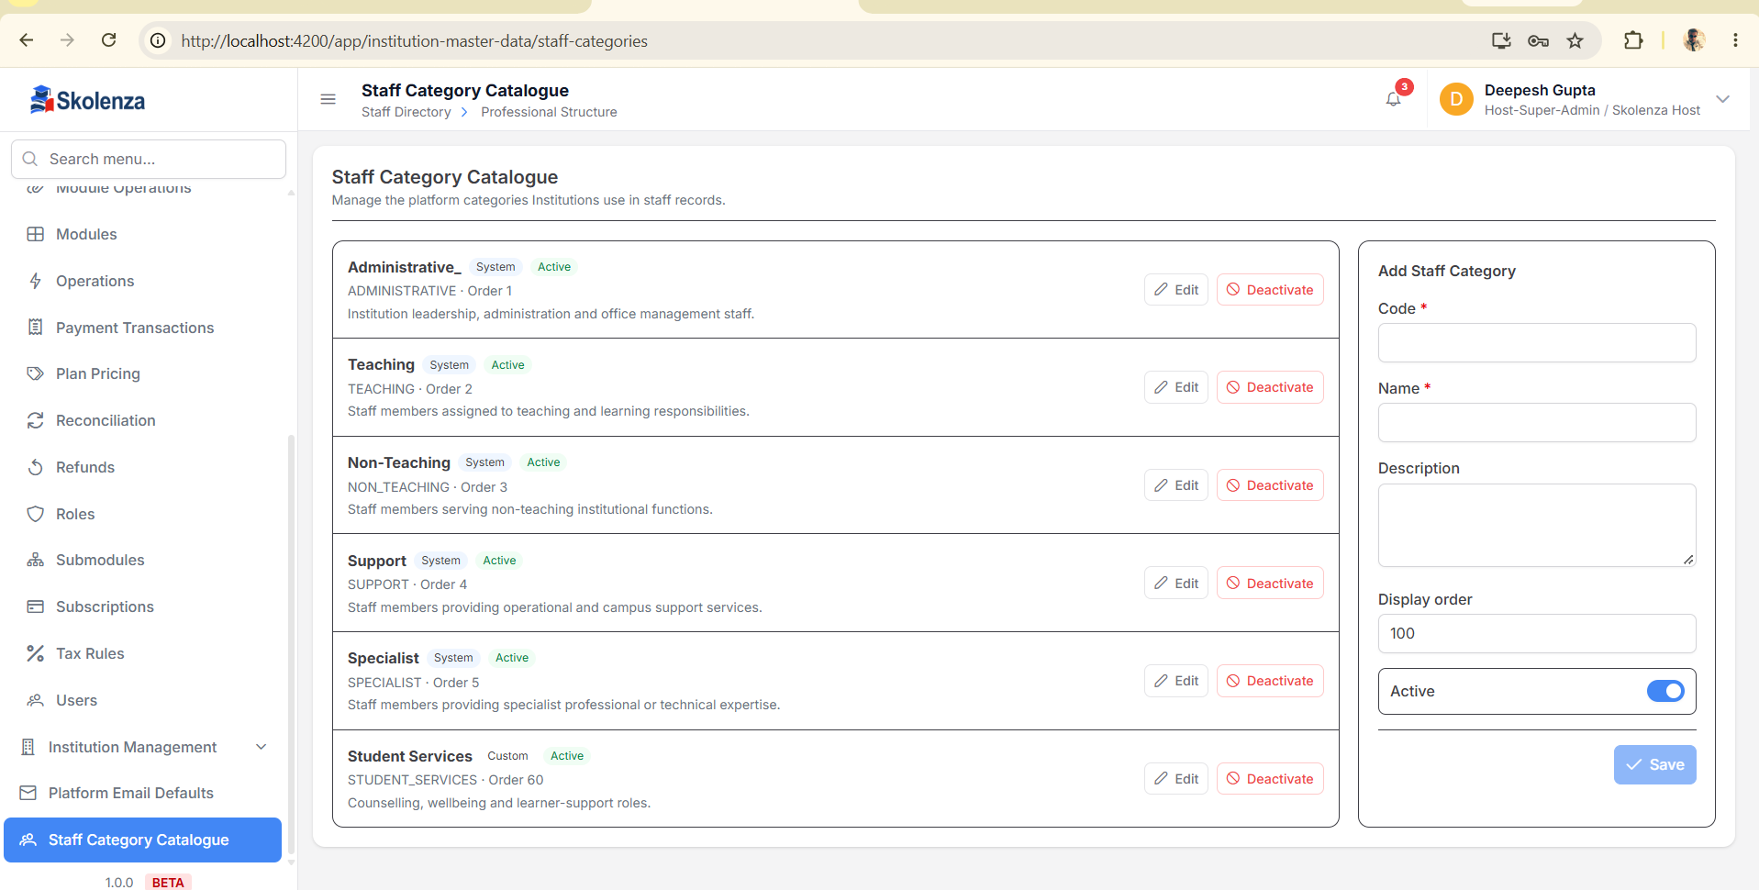
User supplied screen reference. Zoom in Word to inspect original field labels.

Screen 02 Institution Staff Categories
Category type Host catalogue se aata hai. Institution category ka apna Code/Name aur allowed Job Families hoti hain. Counts use/dependencies batate hain. Training chapter 4.
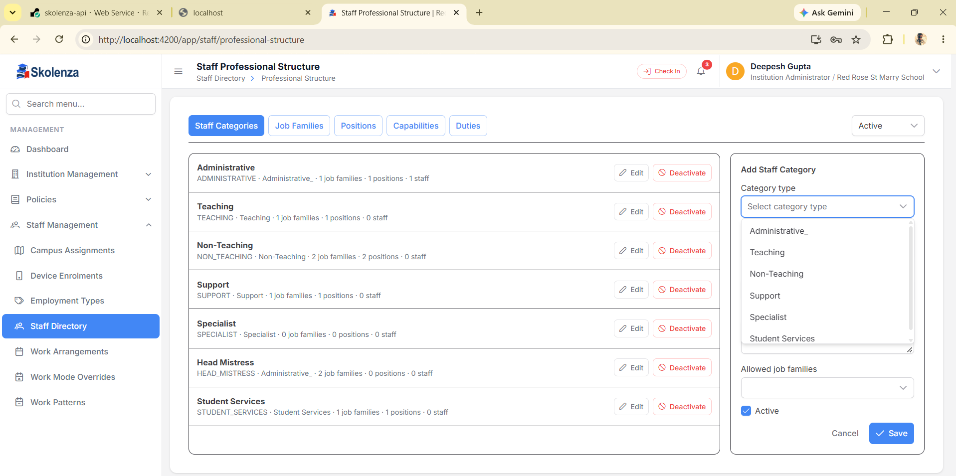
User supplied screen reference. Zoom in Word to inspect original field labels.

Screen 03 Staff Directory
Yahan actual staff members dikhte hain. Professional Structure, Academic Structure aur Curriculum & Lessons buttons next setup areas kholte hain. Profile completion syllabus completion nahi hai. Training chapter 7.
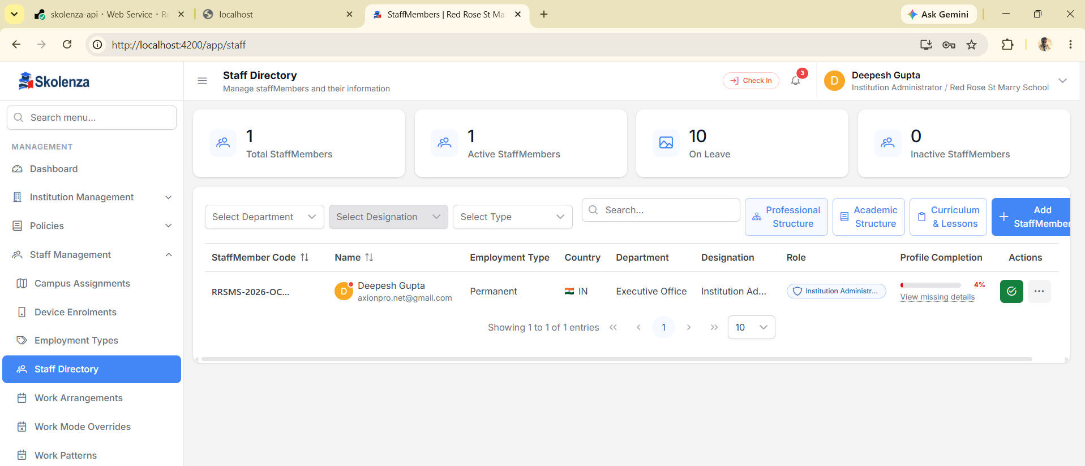
User supplied screen reference. Zoom in Word to inspect original field labels.

Screen 04 Job Families
Academics ek functional family hai. Right form se Code, Name, Description aur Active manage hote hain. Family ko category mein allow karke uske valid Positions banayein. Training chapter 4.
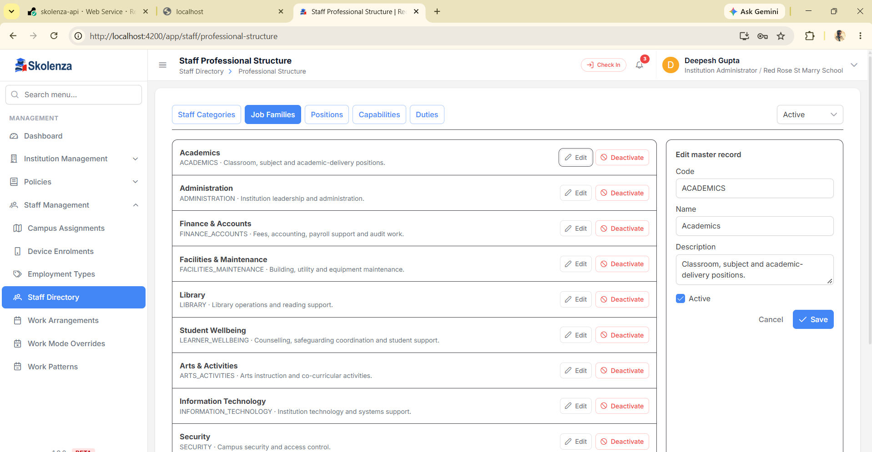
User supplied screen reference. Zoom in Word to inspect original field labels.

Screen 05 Positions
Position category aur family ko capabilities/duties se jodti hai. Screenshot ke empty category labels valid names nahi hain; random selection na karein. Training chapter 6.
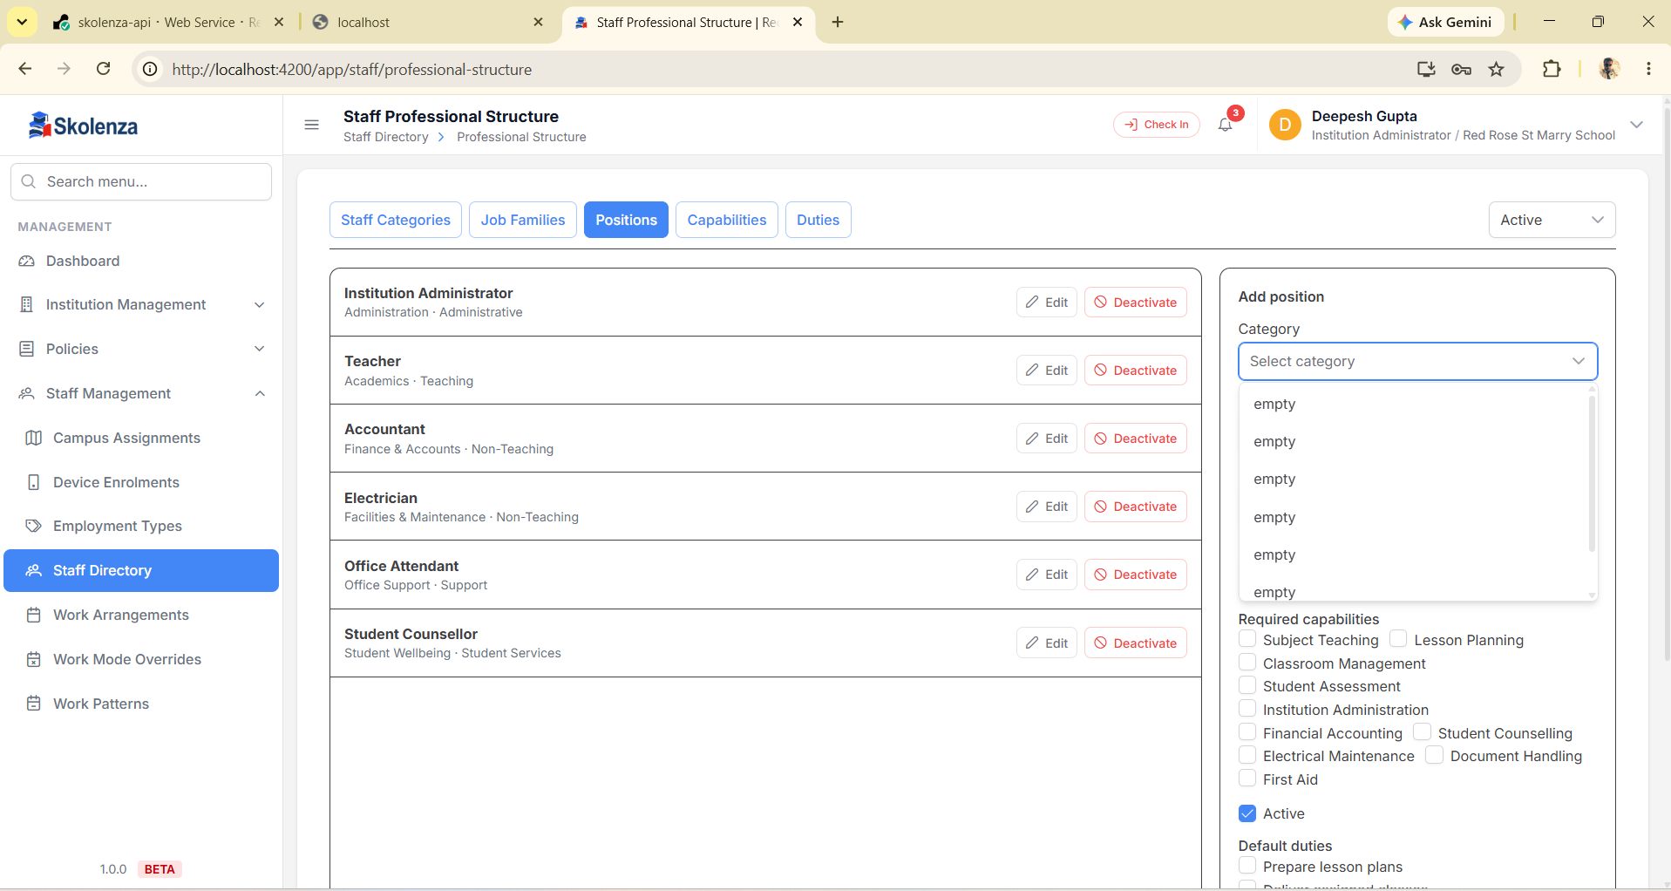
User supplied screen reference. Zoom in Word to inspect original field labels.

Screen 06 Capabilities
Subject Teaching ek skill expectation hai. Master define karna aur individual staff capability verify karna alag steps hain. Training chapter 5.
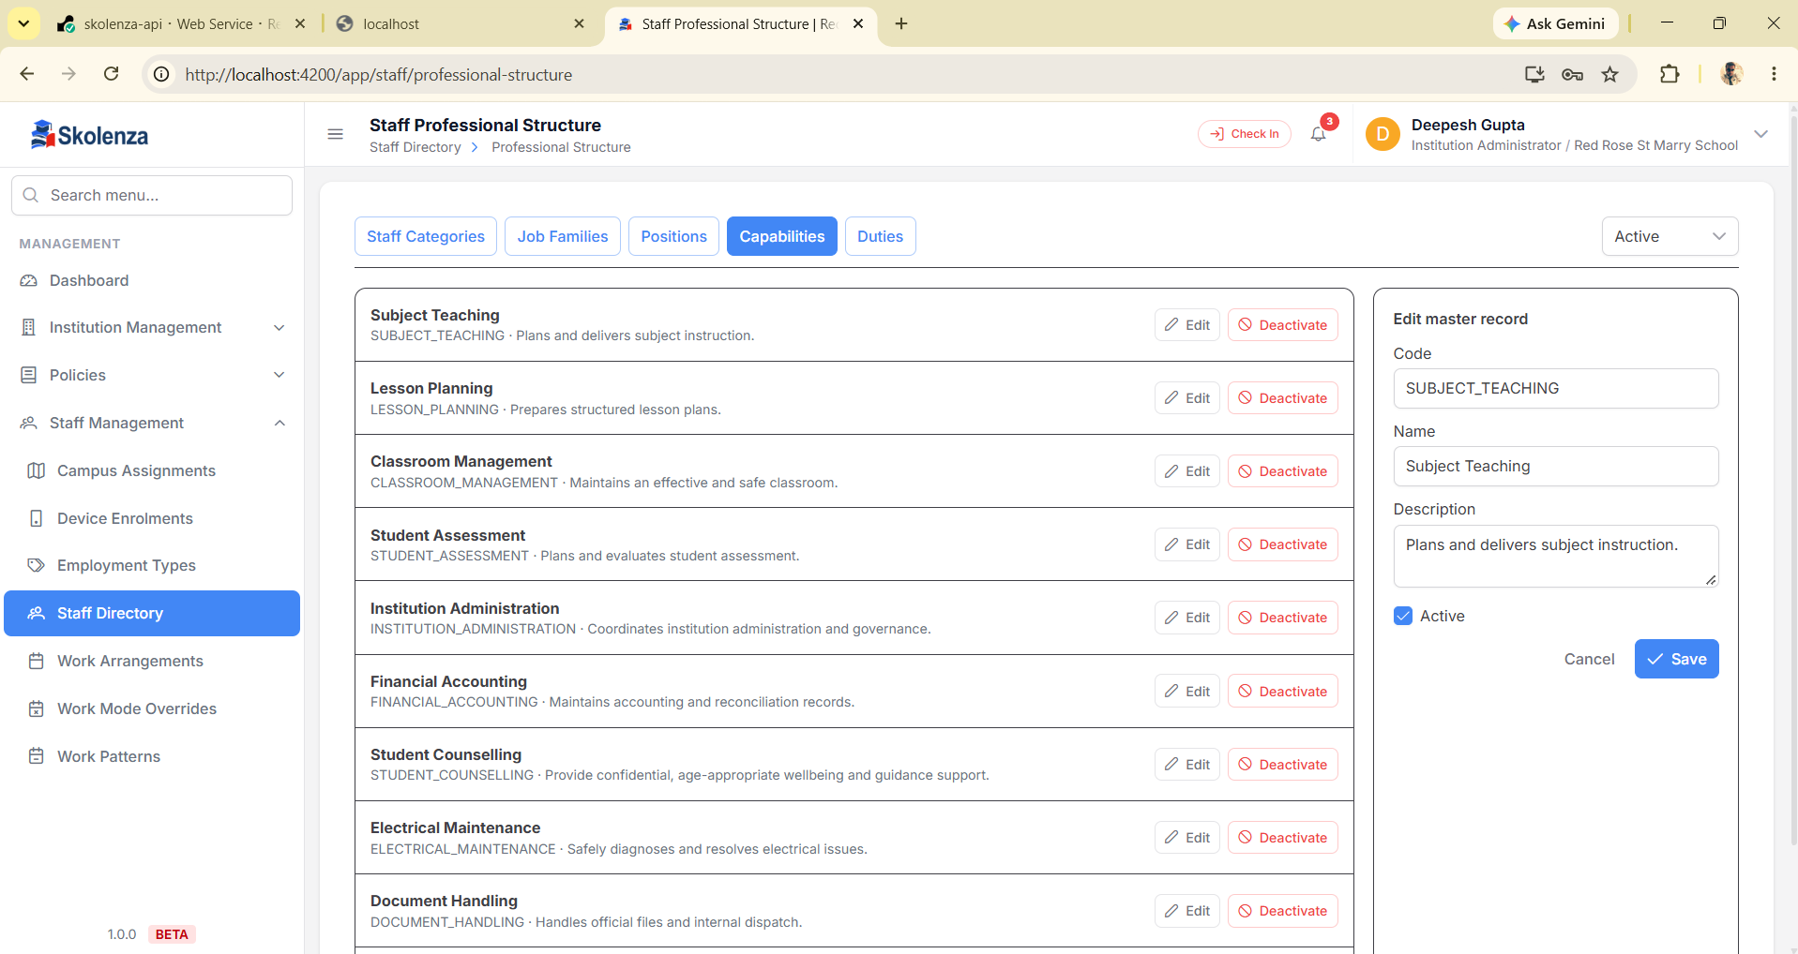
User supplied screen reference. Zoom in Word to inspect original field labels.

Screen 07 Duties
Prepare lesson plans expected work hai. Default frequency Weekly ka matlab planning expectation hai; automatic reminder ka claim nahi. Training chapter 5.
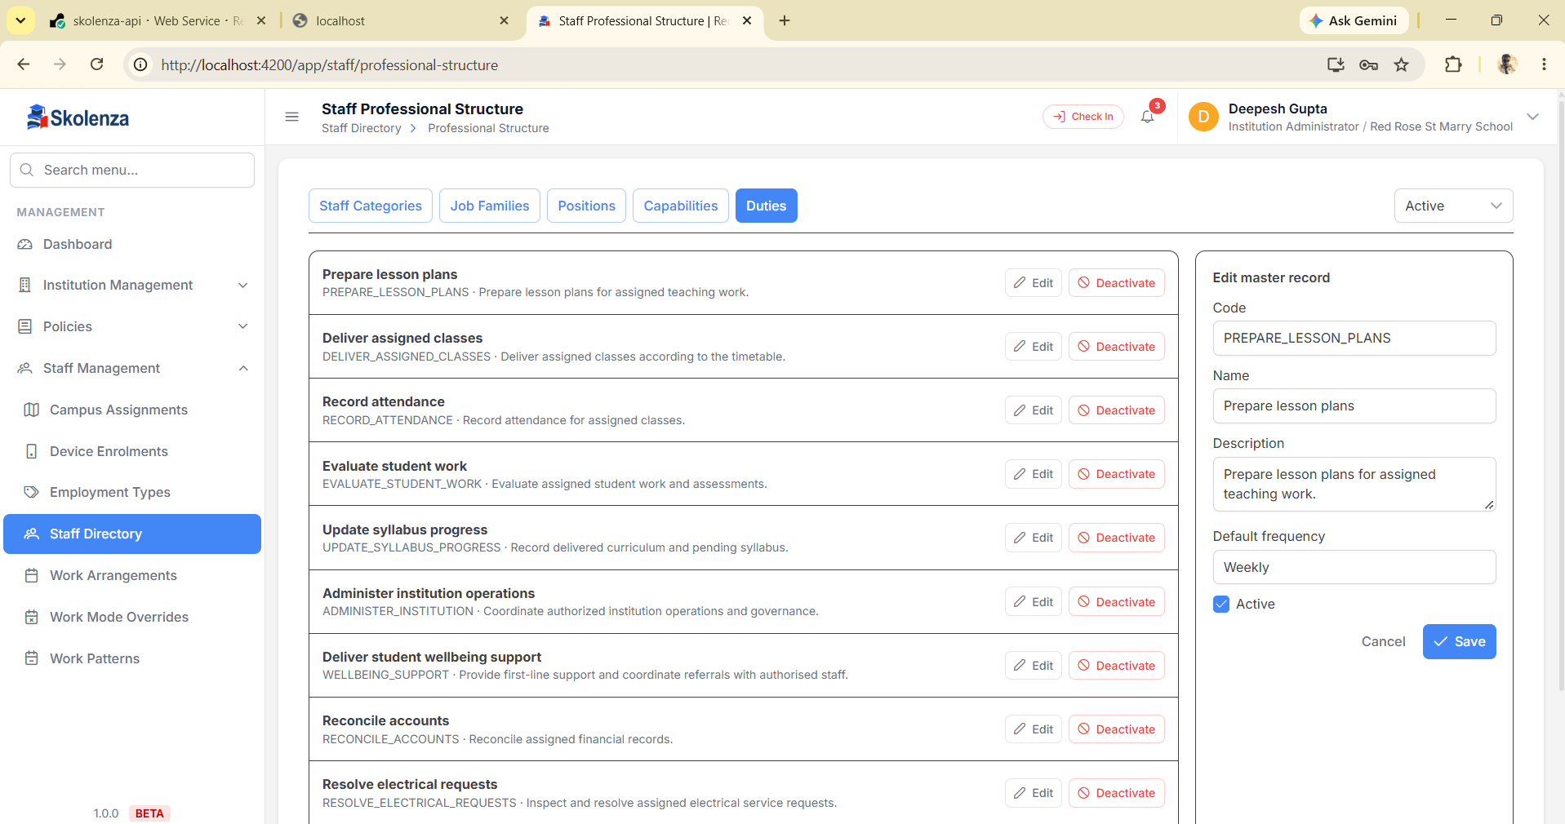
User supplied screen reference. Zoom in Word to inspect original field labels.

Screen 08 Academic Session
Academic year ka Code, Name aur Start/End dates define hote hain. Naya year aane par historical year ko rename karne ke bajay proper naya session use karein. Training chapter 9.
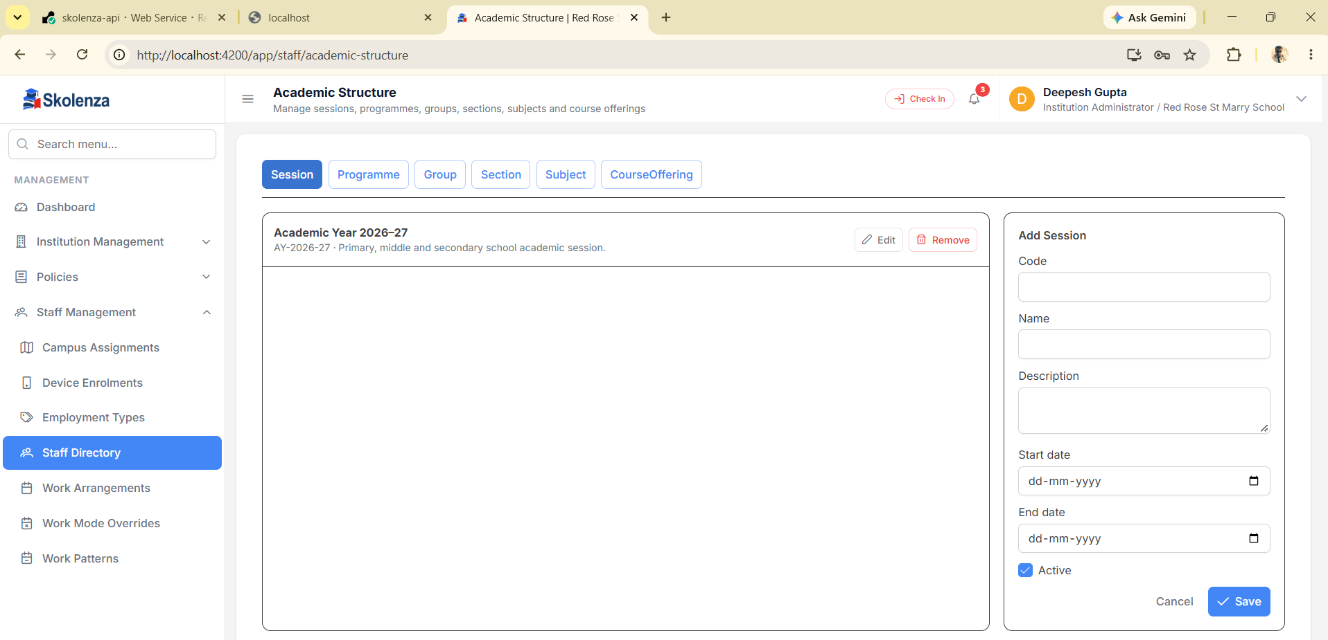
User supplied screen reference. Zoom in Word to inspect original field labels.

Screen 09 Programmes
Primary School programme/stage hai. Level uska descriptor hai. Programme aur Session ko Group jodta hai. Training chapter 9.
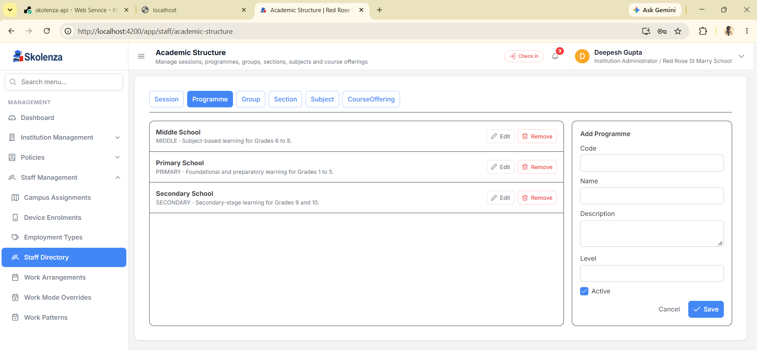
User supplied screen reference. Zoom in Word to inspect original field labels.

Screen 10 Academic Groups
Group school mein Grade, college mein semester/year, coaching mein batch ho sakta hai. Right form ke Session aur Programme relations important hain. Training chapter 10.
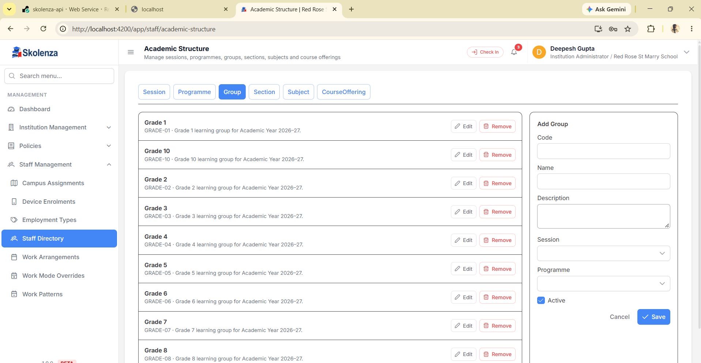
User supplied screen reference. Zoom in Word to inspect original field labels.

Screen 11 Sections
Section apne Academic Group ki subdivision hai. A/B/C ka fixed rule nahi. Capacity planning value hai, students auto-create nahi hote. Training chapter 10.
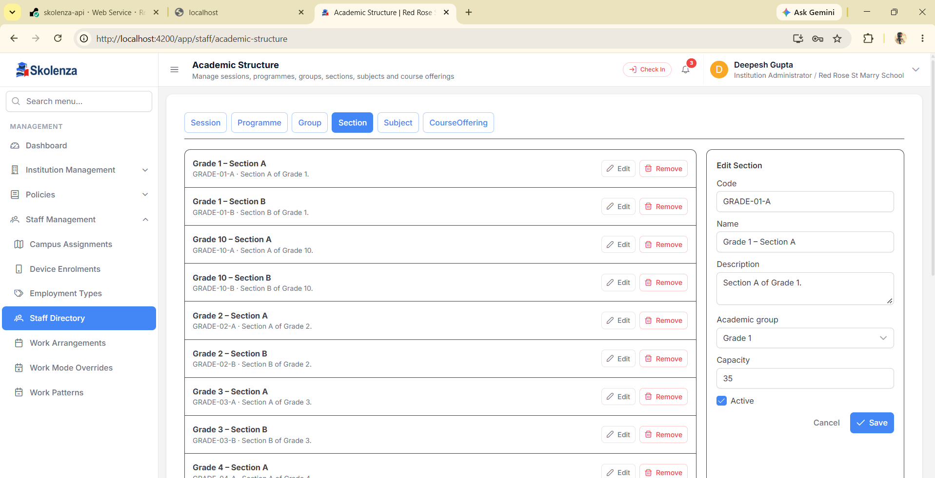
User supplied screen reference. Zoom in Word to inspect original field labels.

Screen 12 Course Offerings
Session + Academic group + Subject ka combination offering hai. Screenshot ka Grade 1 Art & Craft example relation samjhata hai; manual ka running example Grade 5 Mathematics hai. Training chapter 11.
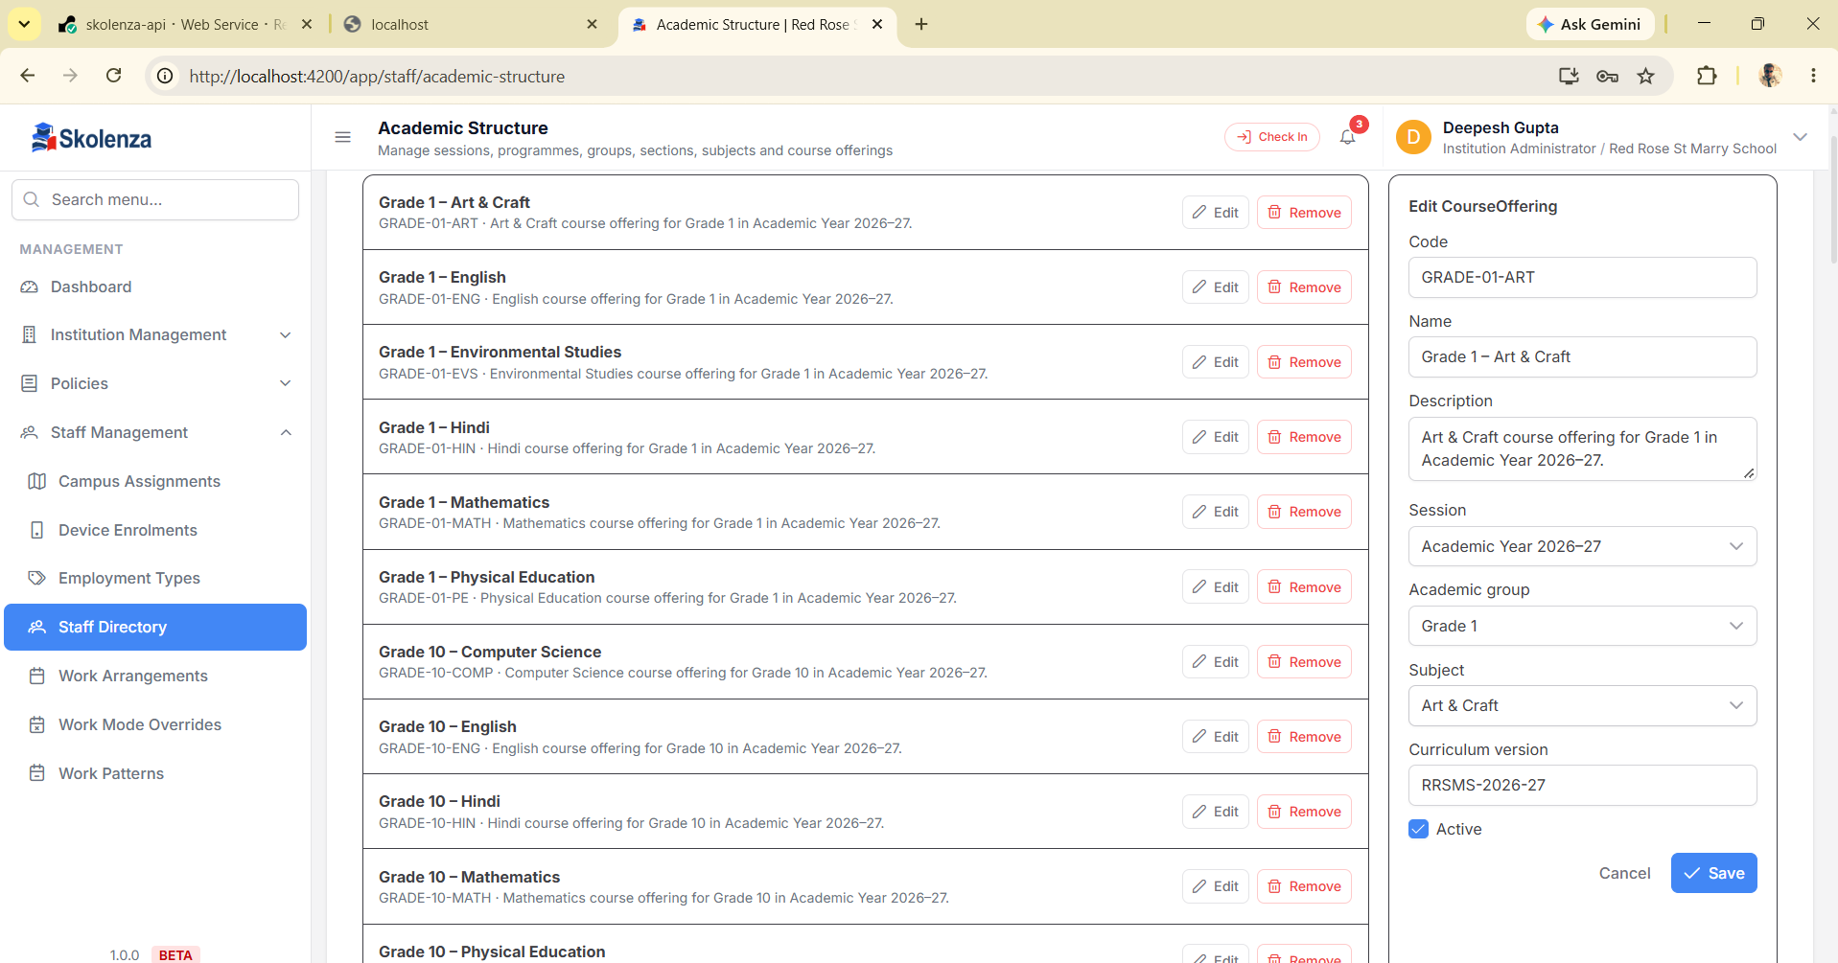
User supplied screen reference. Zoom in Word to inspect original field labels.

Screen 13 Curriculum Frameworks
Framework session, authority aur version ka syllabus context rakhta hai. Active aur Approved alag concepts hain. Training chapter 12.
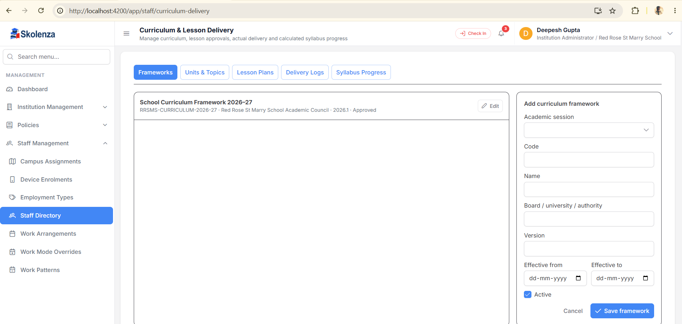
User supplied screen reference. Zoom in Word to inspect original field labels.

Screen 14 Curriculum Units aur Topics
Framework choose karein, Unit ko correct offering se link karein, phir child Topics banayein. Planned periods timetable automatically nahi banate. Training chapter 13.
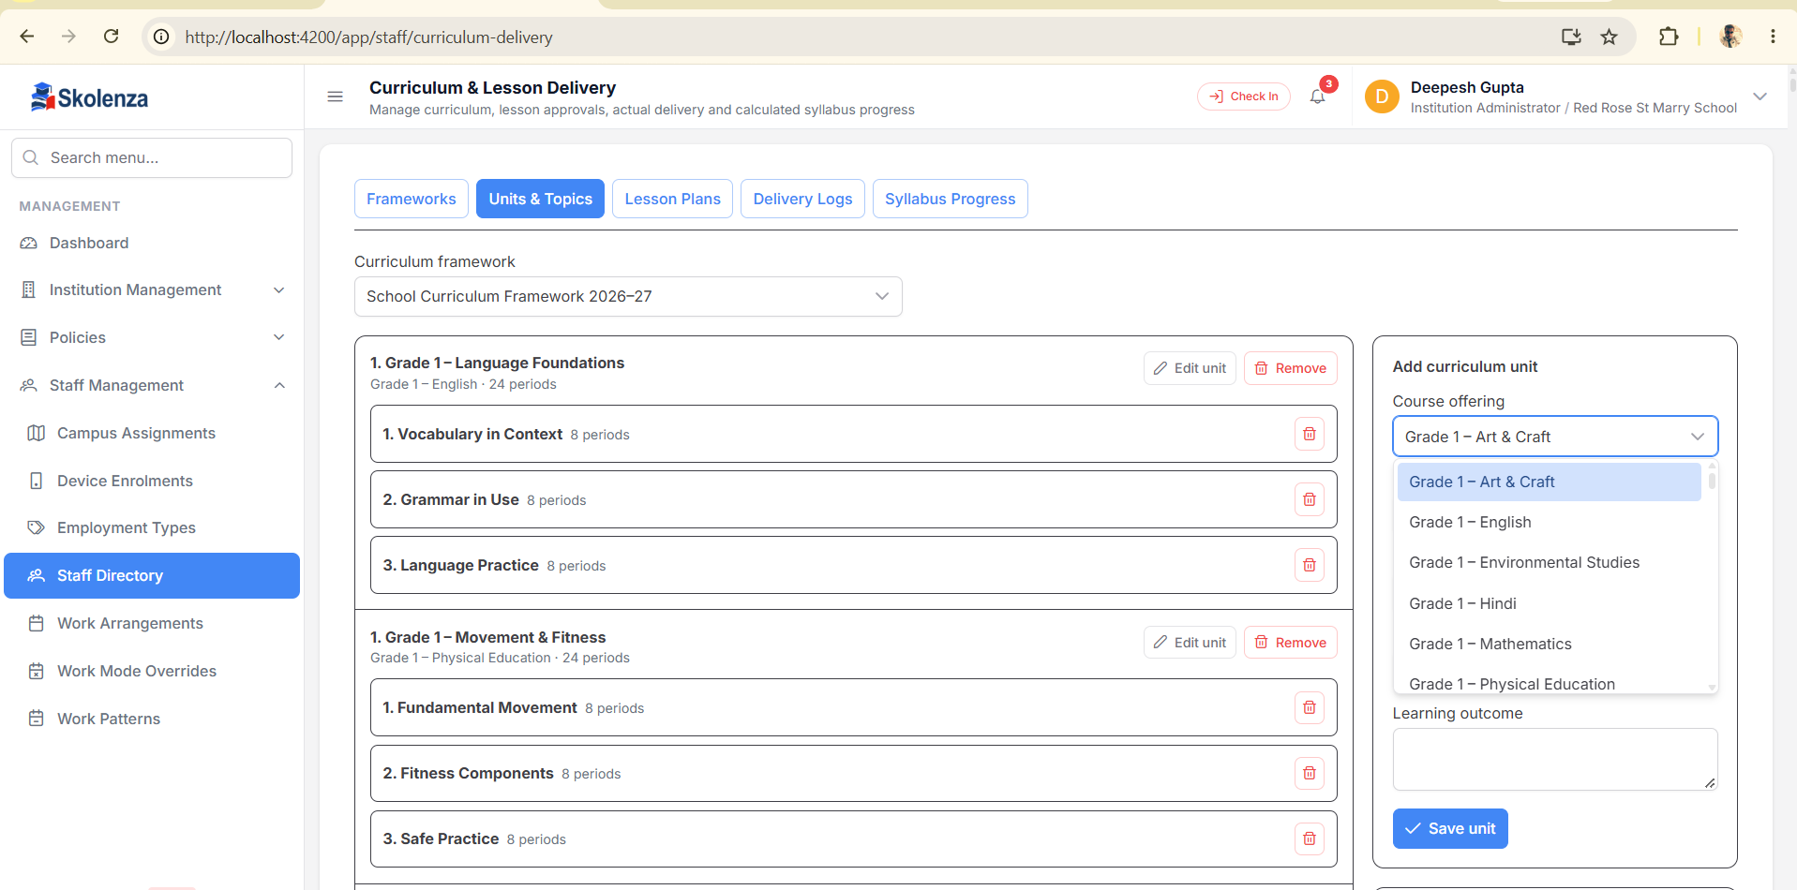
User supplied screen reference. Zoom in Word to inspect original field labels.

Screen 15 Lesson Plan topic selection
Is screenshot mein Maths assignment ke saath language topics dikhte hain. Yeh correct training selection nahi; relevant Maths topics select hone chahiye. Training chapter 14.
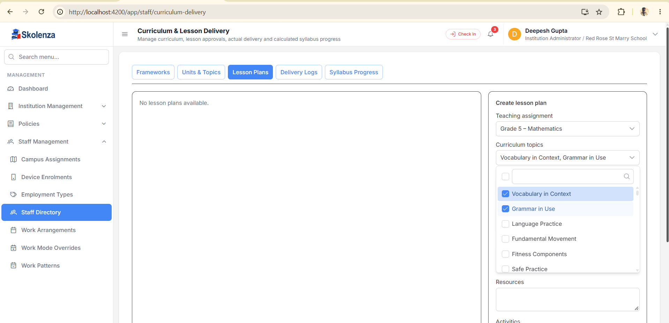
User supplied screen reference. Zoom in Word to inspect original field labels.

Screen 16 Lesson Plan content aur draft
Objectives, method, resources, activities, assessment aur homework se lesson ka plan complete hota hai. Save draft approval nahi hai. Training chapters 14 aur 15.
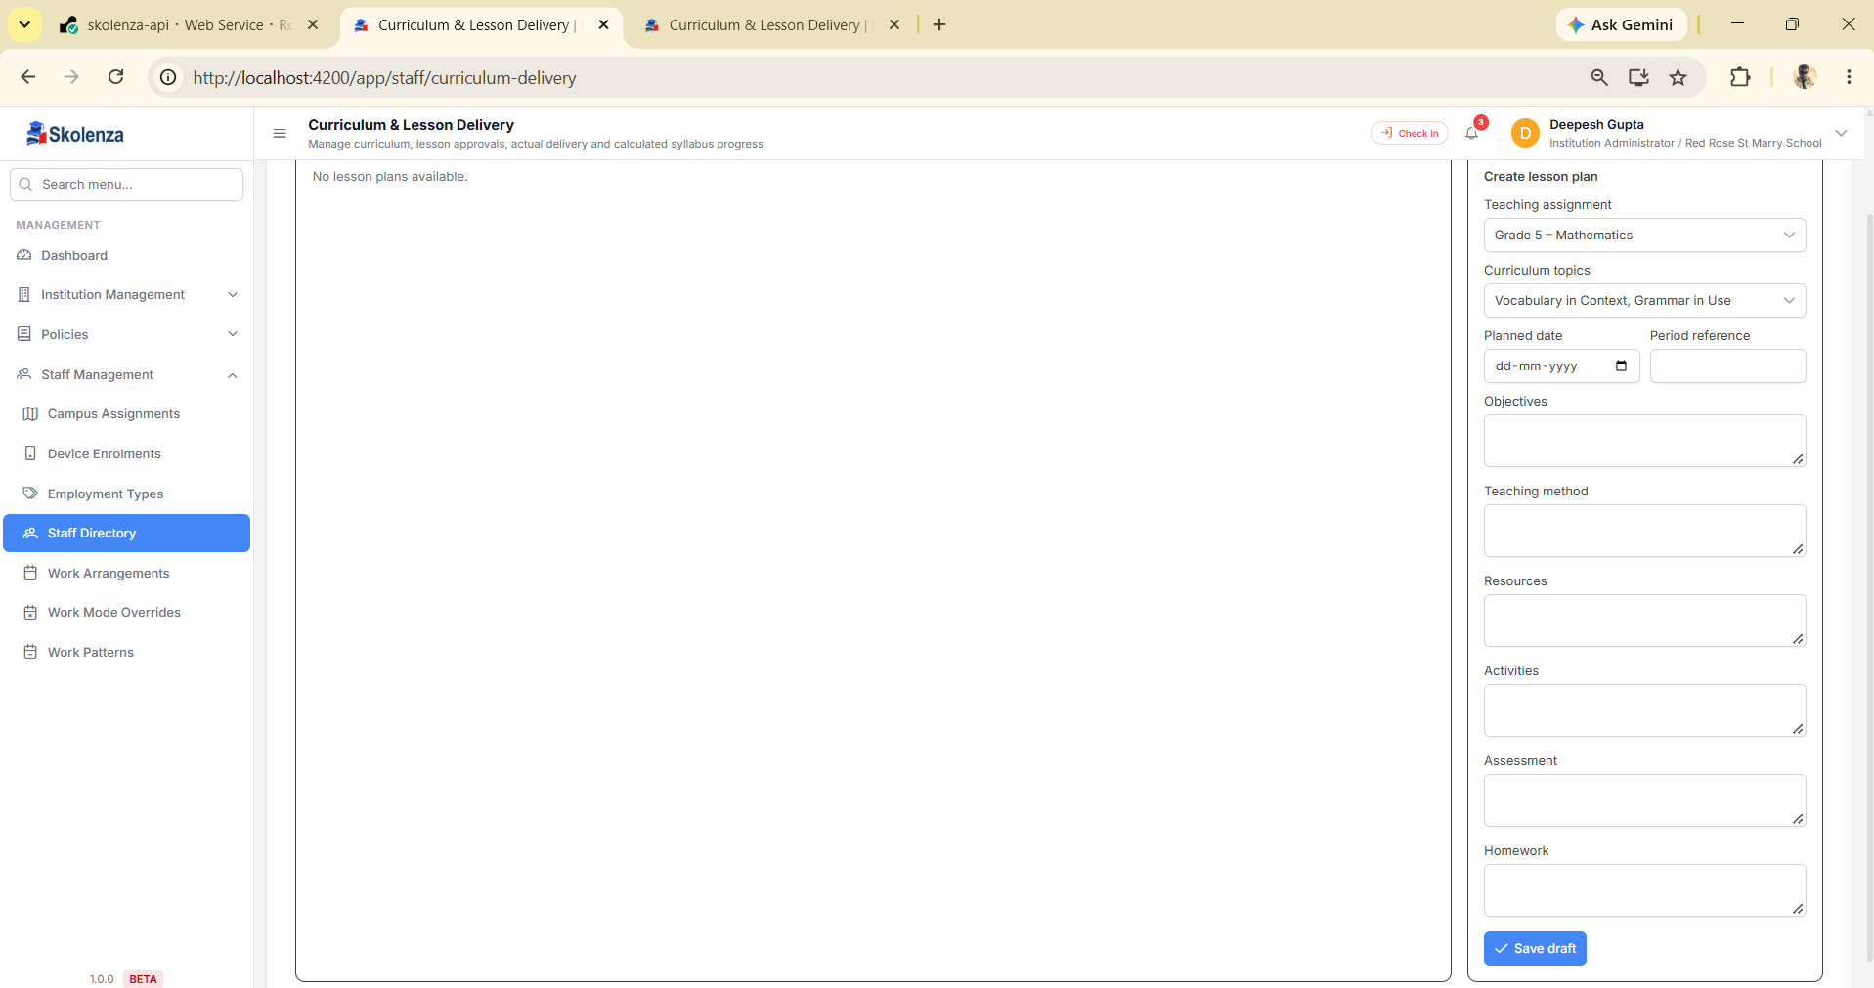
User supplied screen reference. Zoom in Word to inspect original field labels.

Screen 17 Actual Lesson Delivery
Approved plan se actual date, coverage notes, evidence reference, exception aur replan record karte hain. Evidence reference text ko file upload na samjhein. Training chapter 16.
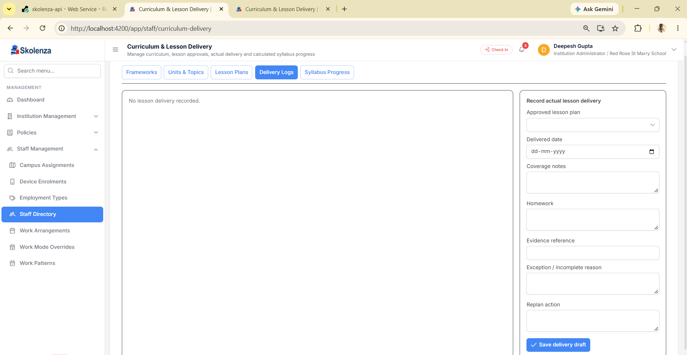
User supplied screen reference. Zoom in Word to inspect original field labels.

Screen 18 Syllabus Progress
Displayed completion approved topic coverage se calculated hai. Screenshot ke 0 percent ko lesson/content setup fail hone ka automatic proof na samjhein. Training chapter 17.
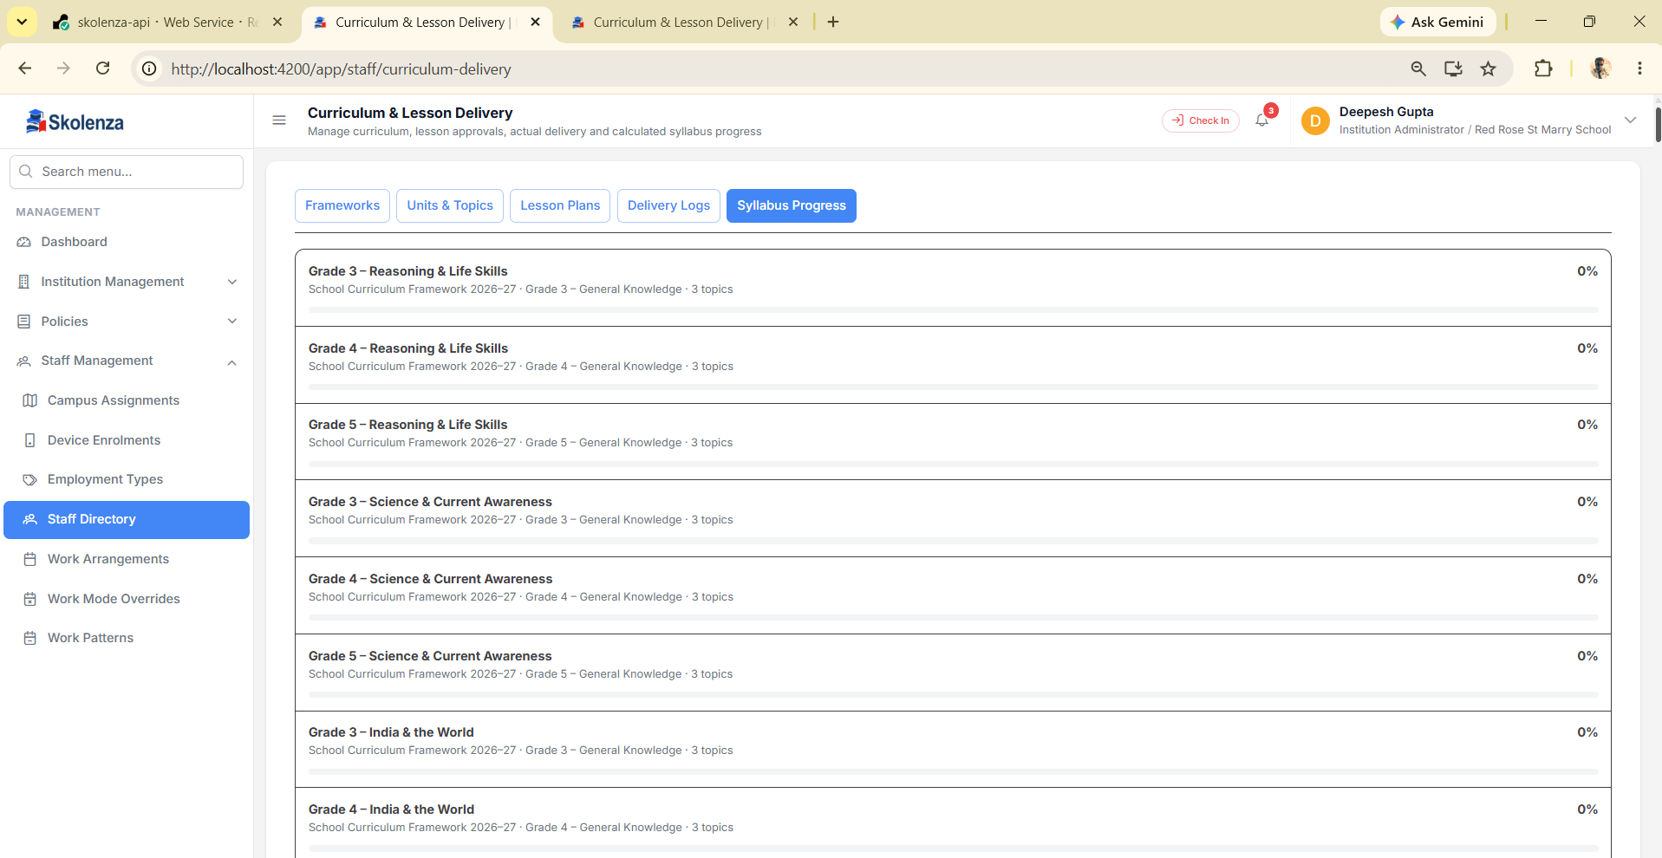
User supplied screen reference. Zoom in Word to inspect original field labels.

