Skolenza — Phase 0 se Phase 5
  - Client Training + Architecture Comparison + Local Verification Report
Prepared: 14 October 2026 (Asia/Calcutta)
Example institution: Red Rose St Marry School

Report mein kya milega | Seedha jawab
Zero-level training | Har tab kya hai, kis par depend karta hai, data baad mein kahan use hota hai.
Real example | Host catalogue se teacher lesson delivery aur timetable approval tak ek connected example.
Proposed vs implemented | Confirmed gaps, fixes, tests, aur jo deployed acceptance abhi pending hai.
Evidence | Current-day UI captures, authenticated API read-back, builds aur automated test counts.

Honest status
Local code, database read-back, authenticated API smoke aur builds PASS hain. Render deployment acceptance is run mein execute nahi hua; use PASS claim nahi kiya gaya. Do screenshots before-fix evidence ke roop mein clearly marked hain.

1. Sabse pehle: poora system ek line mein
Host platform categories define karta hai → institution apni professional hierarchy map karta hai → academic hierarchy banata hai → curriculum ko course offerings se jodta hai → teacher assignment aur lesson plan banata hai → approval ke baad delivery hoti hai → syllabus progress calculate hota hai → timetable, substitute aur communication institution ke dynamic rules se chalte hain.
Phase | Owner | Input | Output / next use
0 — Platform foundation | Host Admin | Module, operation, Staff Category Catalogue | Institution ko allowed central options
1 — Professional structure | Institution Admin | Category → Job Family → Position → Capability/Duty | Staff profile aur eligibility
2 — Academic structure | Institution Admin | Session → Programme → Group → Section → Subject → Course Offering | Teaching assignment ka base
3 — Curriculum delivery | Academic Admin / Teacher / Approver | Framework → Unit → Topic → Lesson plan → Delivery | Progress and audit evidence
4 — Timetable & substitute | Institution-configured actors | Periods, entries, approval chain, absence impact | Published timetable and class cover
5 — Communication | Institution Admin / Staff | Channels, categories, conversations | Traceable staff communication

Training order
- Host Staff Category Catalogue samjhao.
- Institution Professional Structure configure karao.
- Academic Structure banao.
- Curriculum & Lessons configure karo.
- Timetable approval aur substitute flow dikhao.
- Communication policy aur query flow dikhao.

2. Phase 0 — Host catalogue aur tenant boundary
Host Admin sirf platform-level semantic catalogue maintain karta hai. Institution us catalogue ko select karke apna record banata hai. Har institution-owned row InstitutionId se isolated hai. Red Rose Admin ka deactivate/update kisi doosre institution ke row ko affect nahi karta.
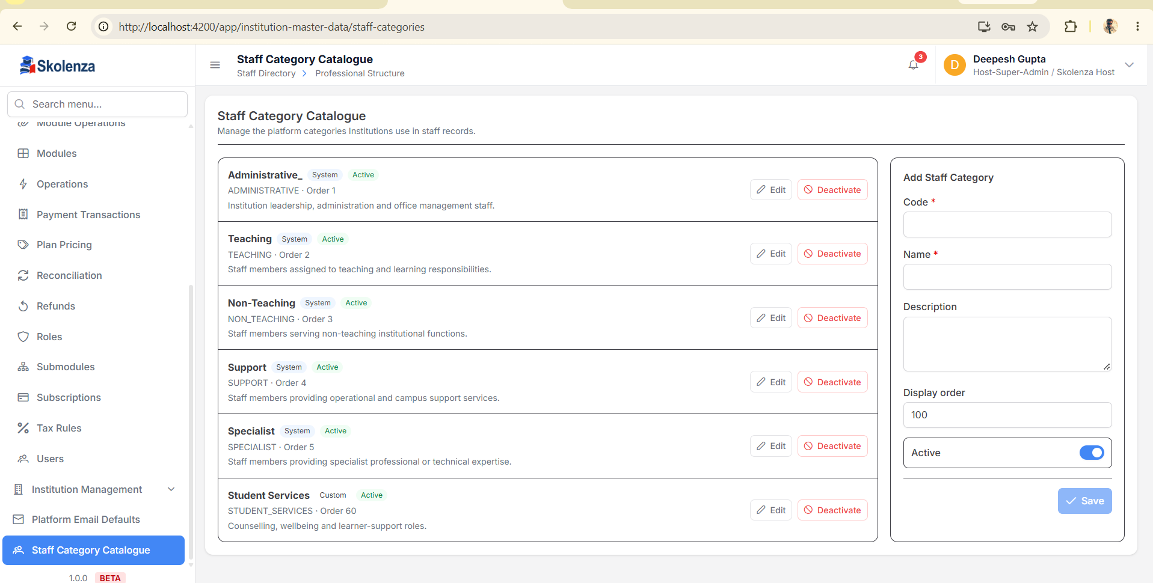
Host Staff Category Catalogue: system categories + custom category example.

Remove ka actual matlab
- Referenced master ko hard-delete karna unsafe hai; UI mein Deactivate use hota hai.
- Inactive record historical staff/assignment references ke liye database mein rehta hai.
- Admin inactive filter se record dekhkar Reactivate kar sakta hai.
- Parent ko deactivate karne se pehle dependent child relationships validate hote hain.

3. Phase 1 — Professional Structure: tab-by-tab
Dependency: Staff Category → allowed Job Families → Position. Capabilities batati hain ki position ke liye kaunsi ability chahiye. Duties batati hain ki assigned person ko kaunsa recurring/operational kaam karna hai.
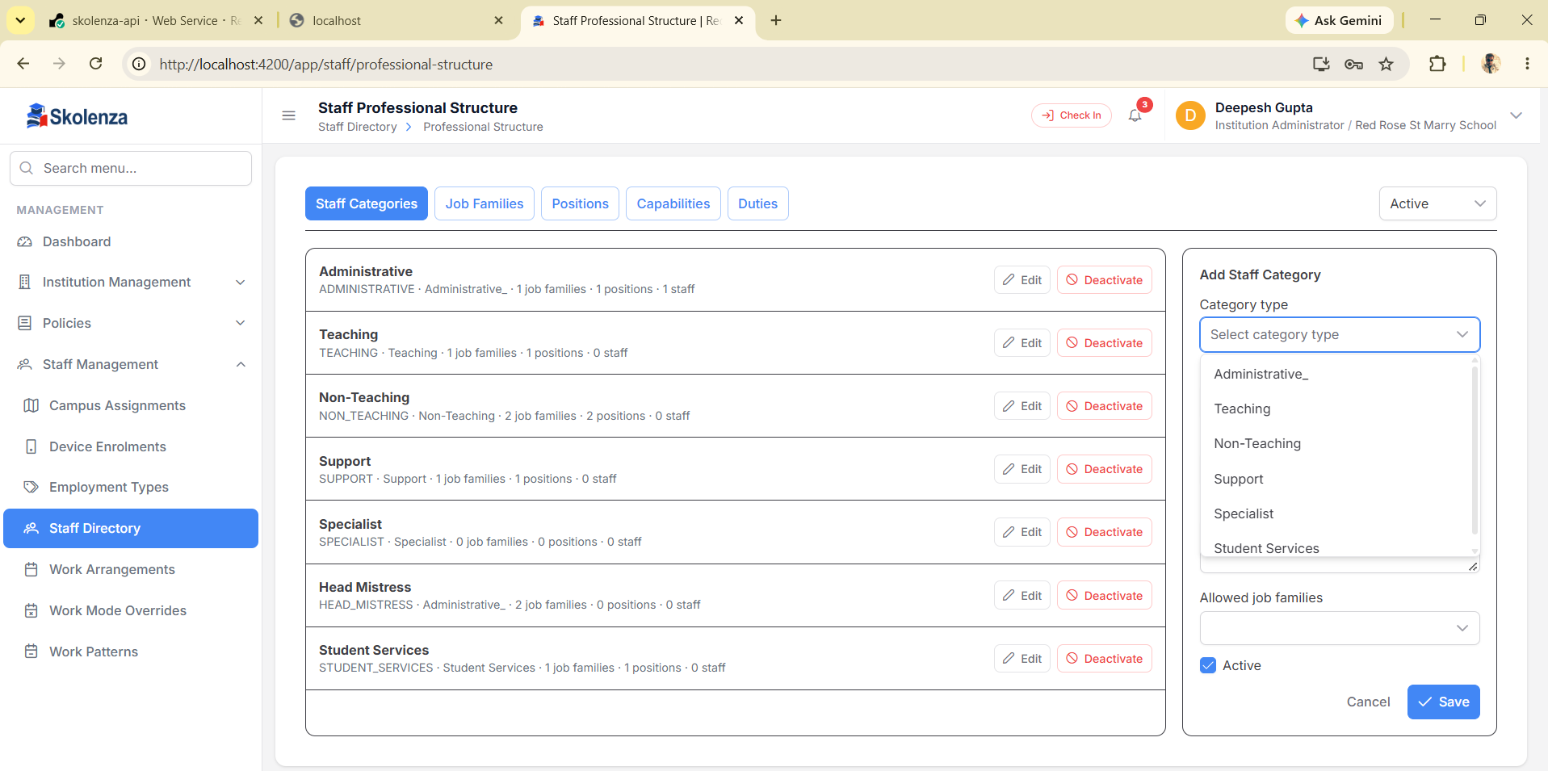
Institution Staff Categories: Host type select karke institution-owned category aur allowed job families map hote hain.
Tab | Kya store hota hai | Kahan use hota hai | Example
Staff Categories | Broad workforce type | Job Family/Position filtering, staff onboarding | Teaching
Job Families | Related role domain | Position grouping | Academics
Positions | Actual job title + required capabilities/default duties | Staff profile, eligibility, approvals | Teacher
Capabilities | Skill/authority | Position requirements and verification | Lesson Planning
Duties | Expected work + default frequency | Staff responsibilities | Prepare lesson plans — Weekly

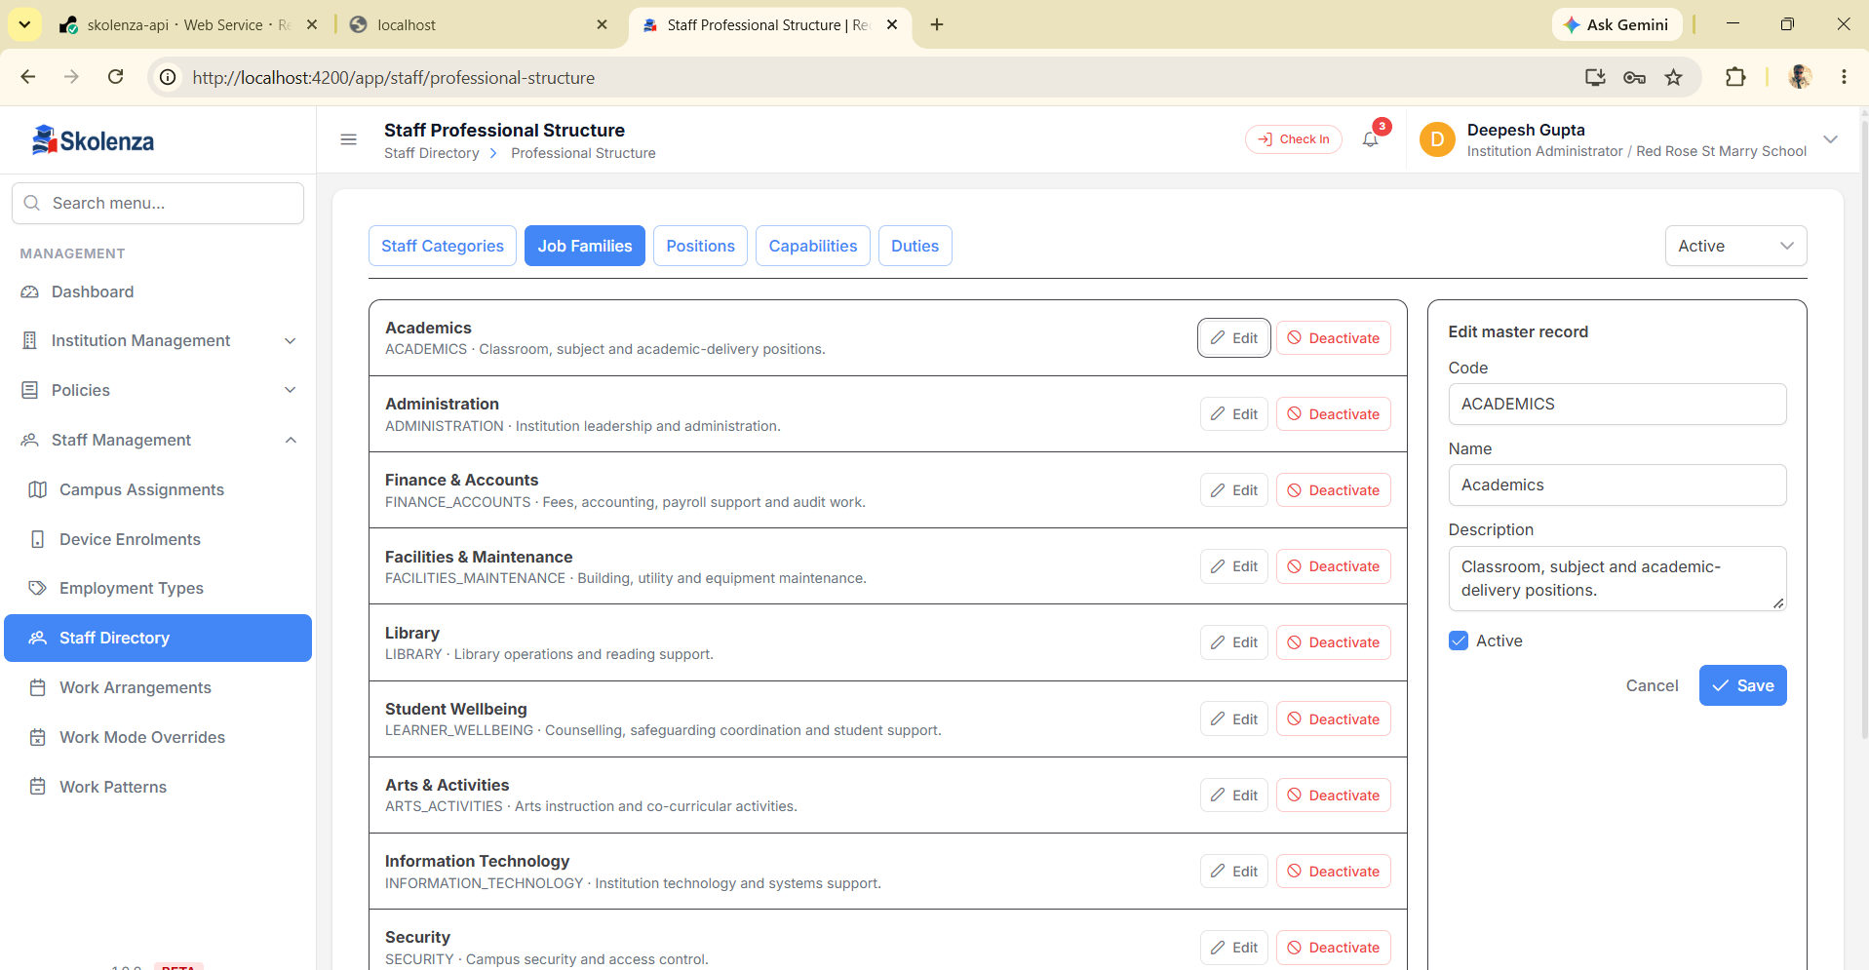
Job Families: Academics, Administration, Finance, Facilities, Wellbeing and other institution-defined domains.
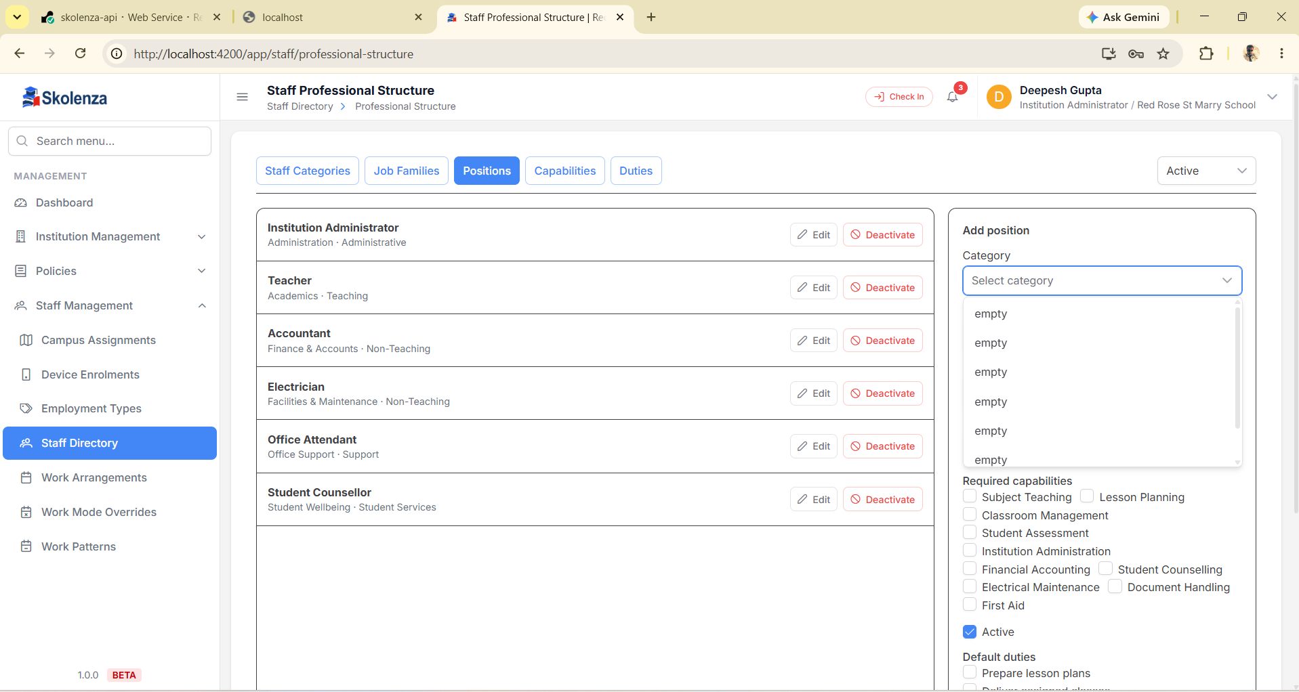
BEFORE-FIX EVIDENCE — Position form before UI binding fix: category options appeared as “empty”. Binding now uses the authoritative name field; automated test covers the contract.

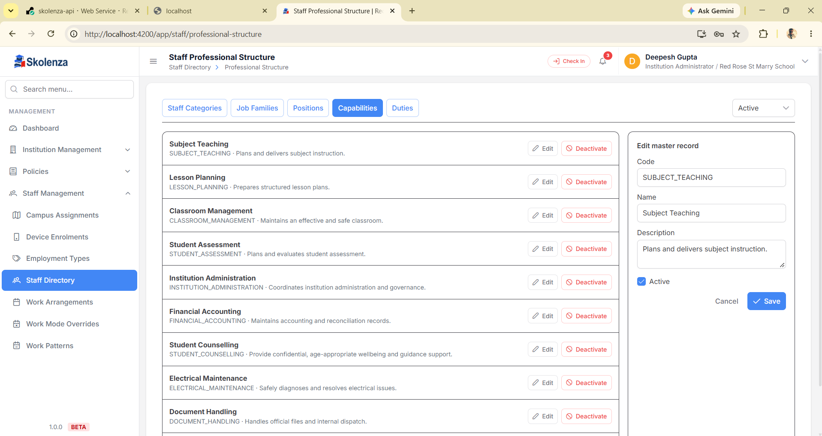
Capabilities: reusable requirements that positions select.
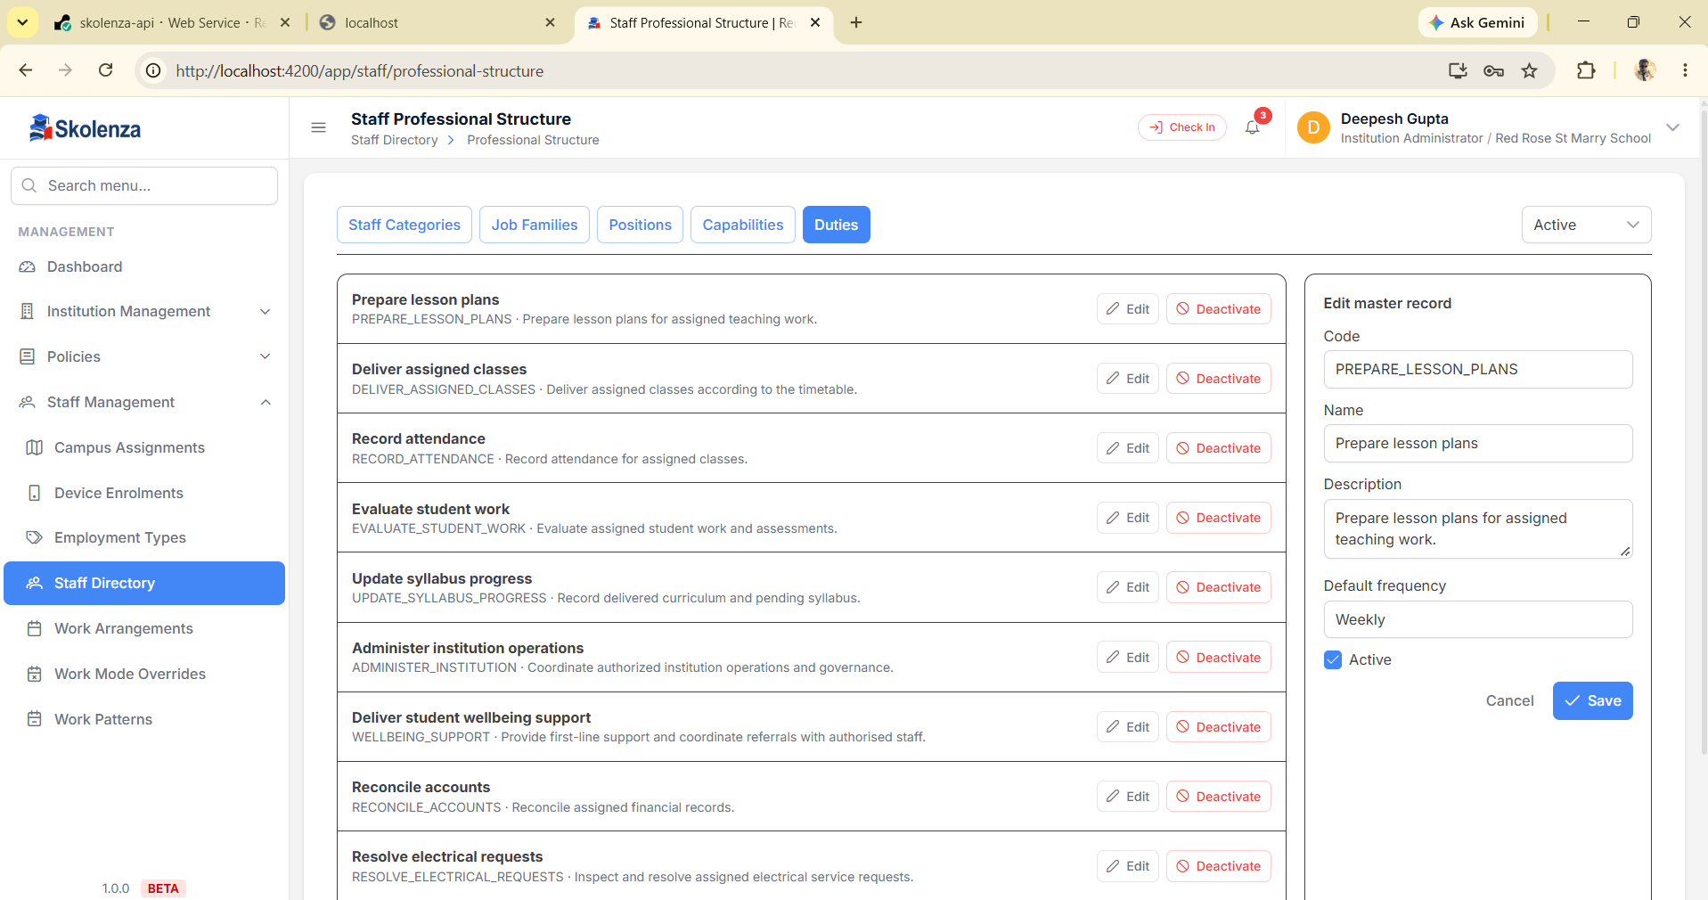
Duties: reusable work expectations with default frequency.

Real staff example
Teacher Anita Sharma ko Teaching category → Academics job family → Teacher position milega. Teacher position Subject Teaching, Lesson Planning aur Classroom Management capabilities maang sakta hai; default duties lesson plans banana, assigned classes deliver karna aur attendance record karna hain.

4. Phase 2 — Academic Structure: school, college, coaching sab dynamic
System Grade 1–10 hardcode nahi karta. Admin apne institute ke hisaab se names banata hai. School “Grade 5”, college “B.Tech CSE Semester 3”, coaching “JEE Advanced 2027 Batch” use kar sakta hai.
Level | Parent | Meaning | School example | College/coaching example
Session | — | Academic time window | AY 2026–27 | 2026–27 / JEE 2027
Programme | — | Programme/stage | Primary School | B.Tech CSE / JEE Advanced
Group | Session + Programme | Learning cohort | Grade 5 | Semester 3 / Target Batch
Section | Group | Physical/operational division | 5-A, 5-C, or only 5-A | CSE-A / Morning Batch
Subject | — | Teachable catalogue | Mathematics | Data Structures / Physics
Course Offering | Session + Group + Subject | This subject for this cohort/time | Grade 5 – Mathematics | Sem 3 – Data Structures
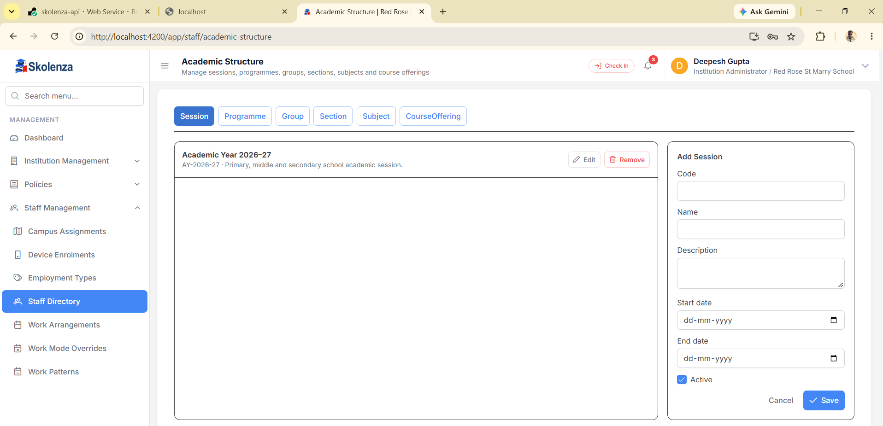
Session master: dates and active status institution-owned hain.

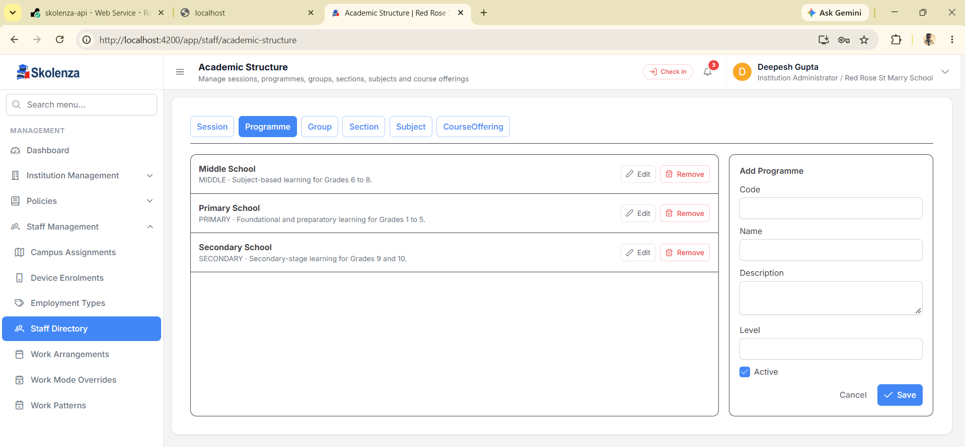
Programme: stages/programmes; school naming is only example, not a fixed rule.
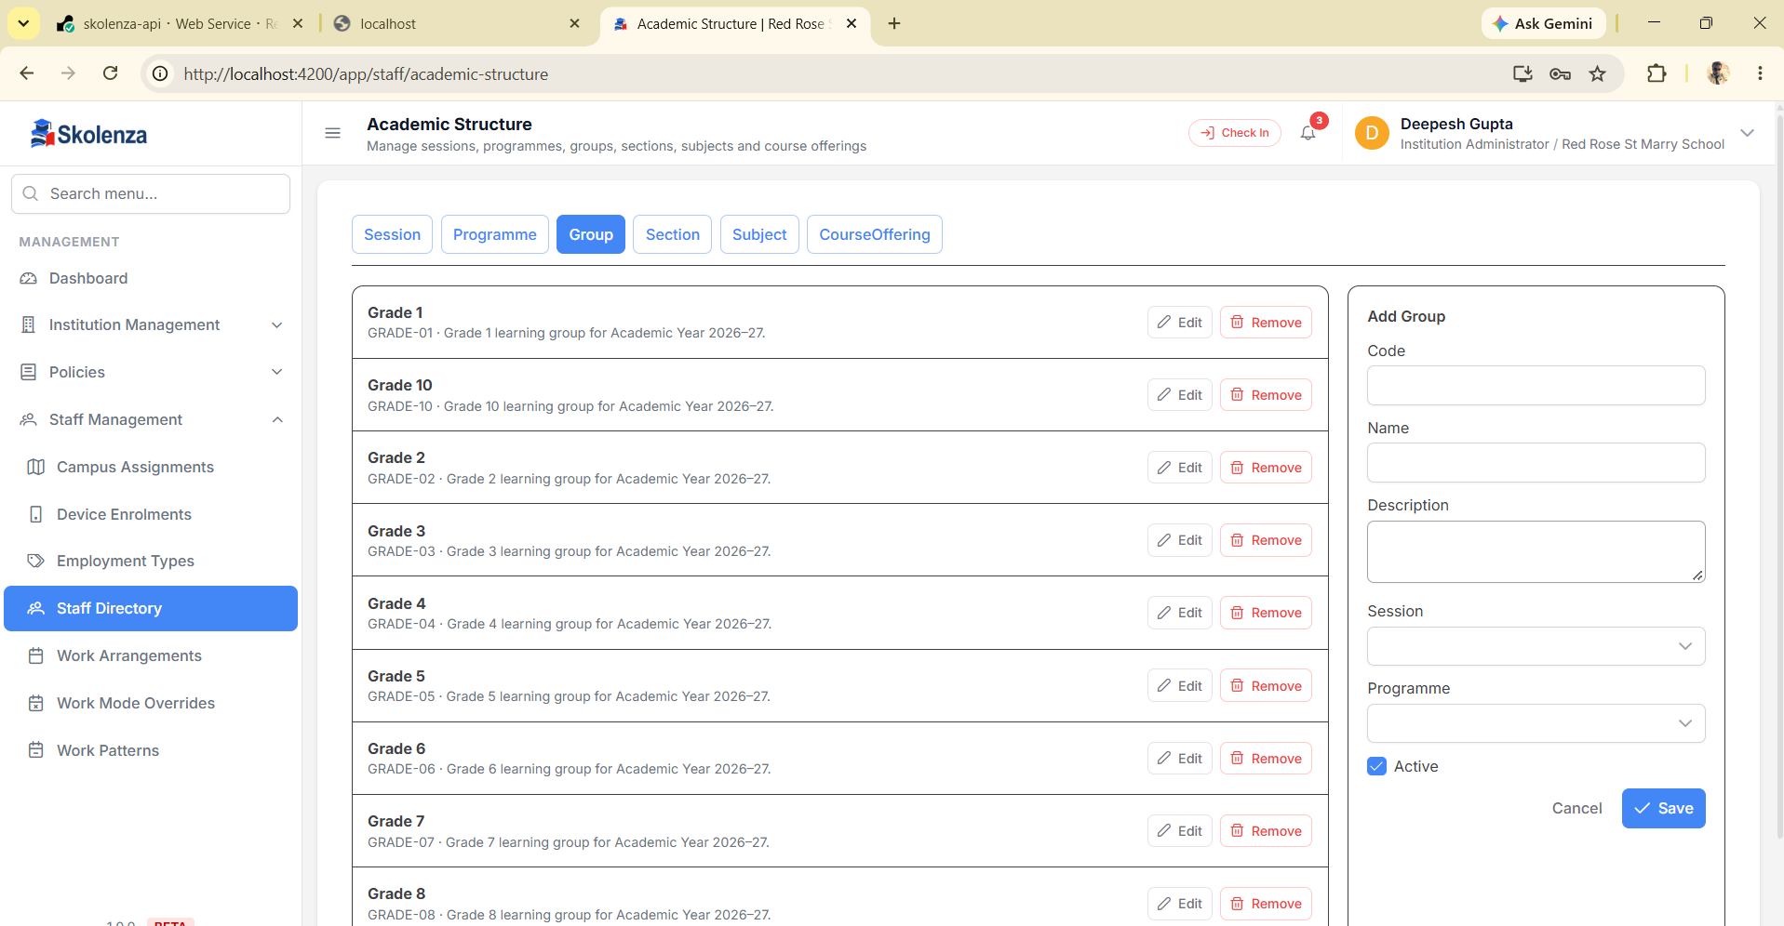
Group: Session + Programme ke andar institute-defined cohort.

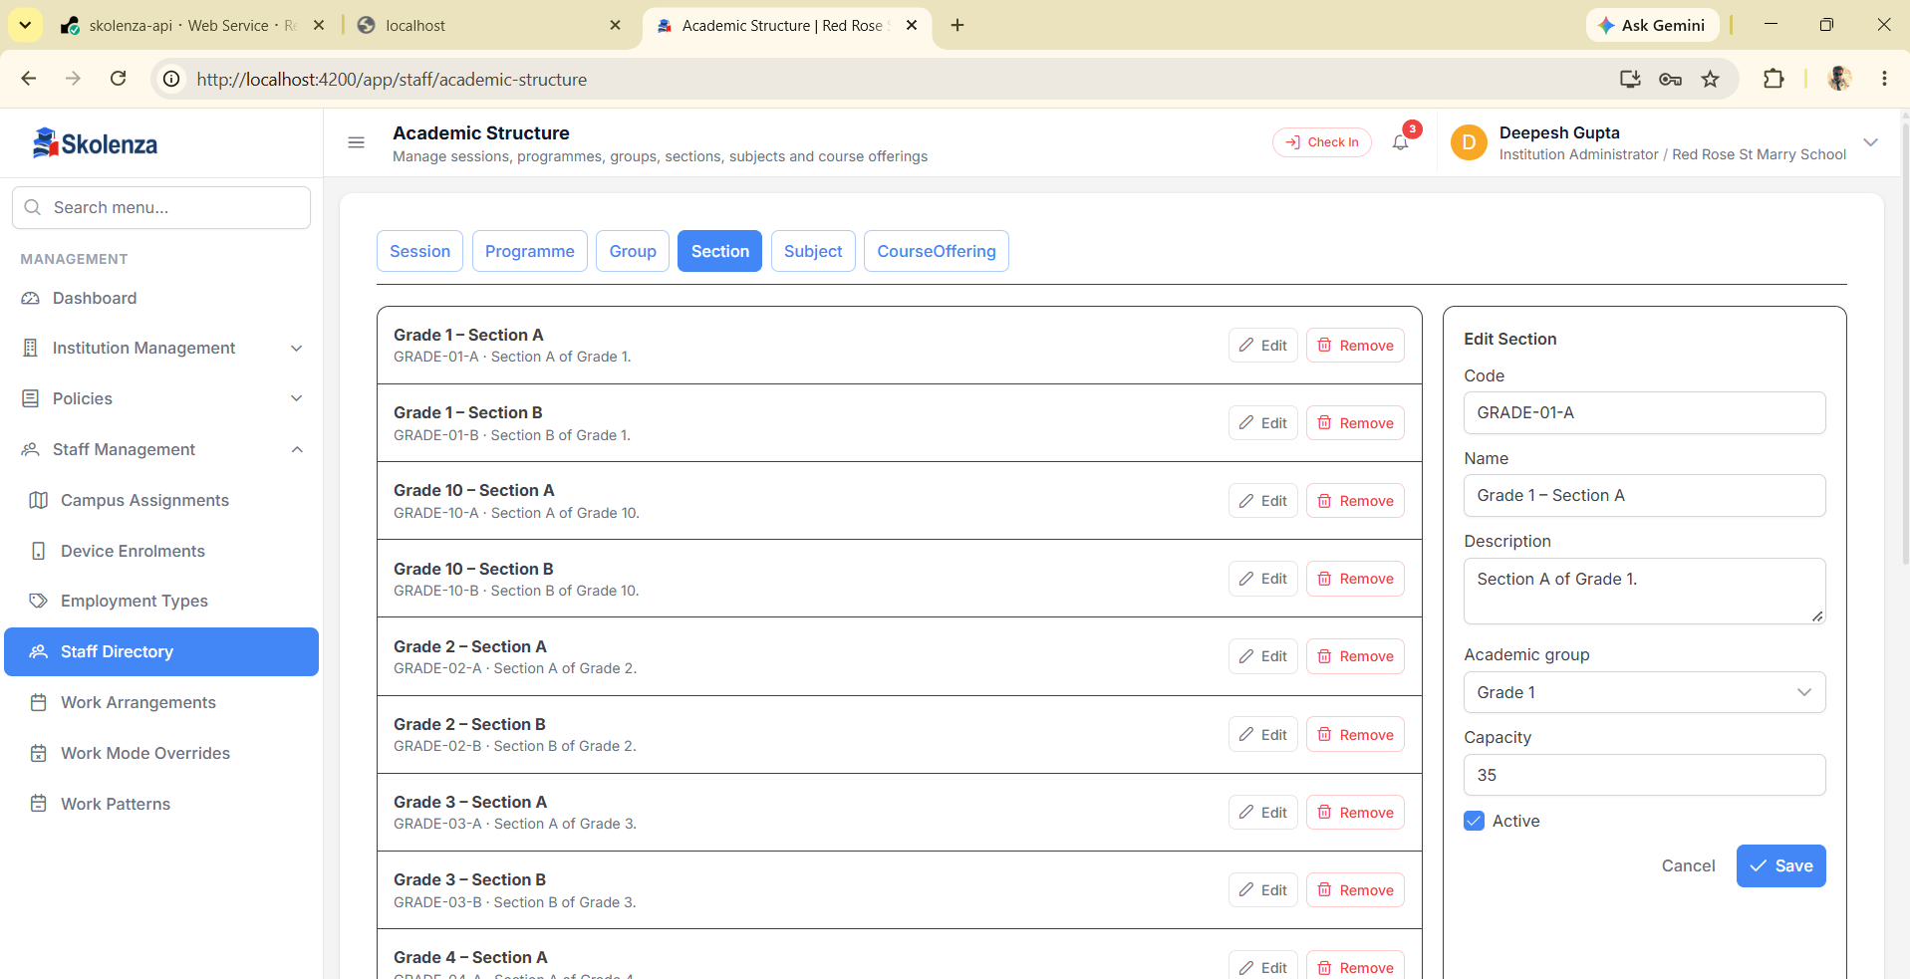
Section: Grade 5-A/5-B/5-C optional; institute jitni zarurat ho utni banata hai.
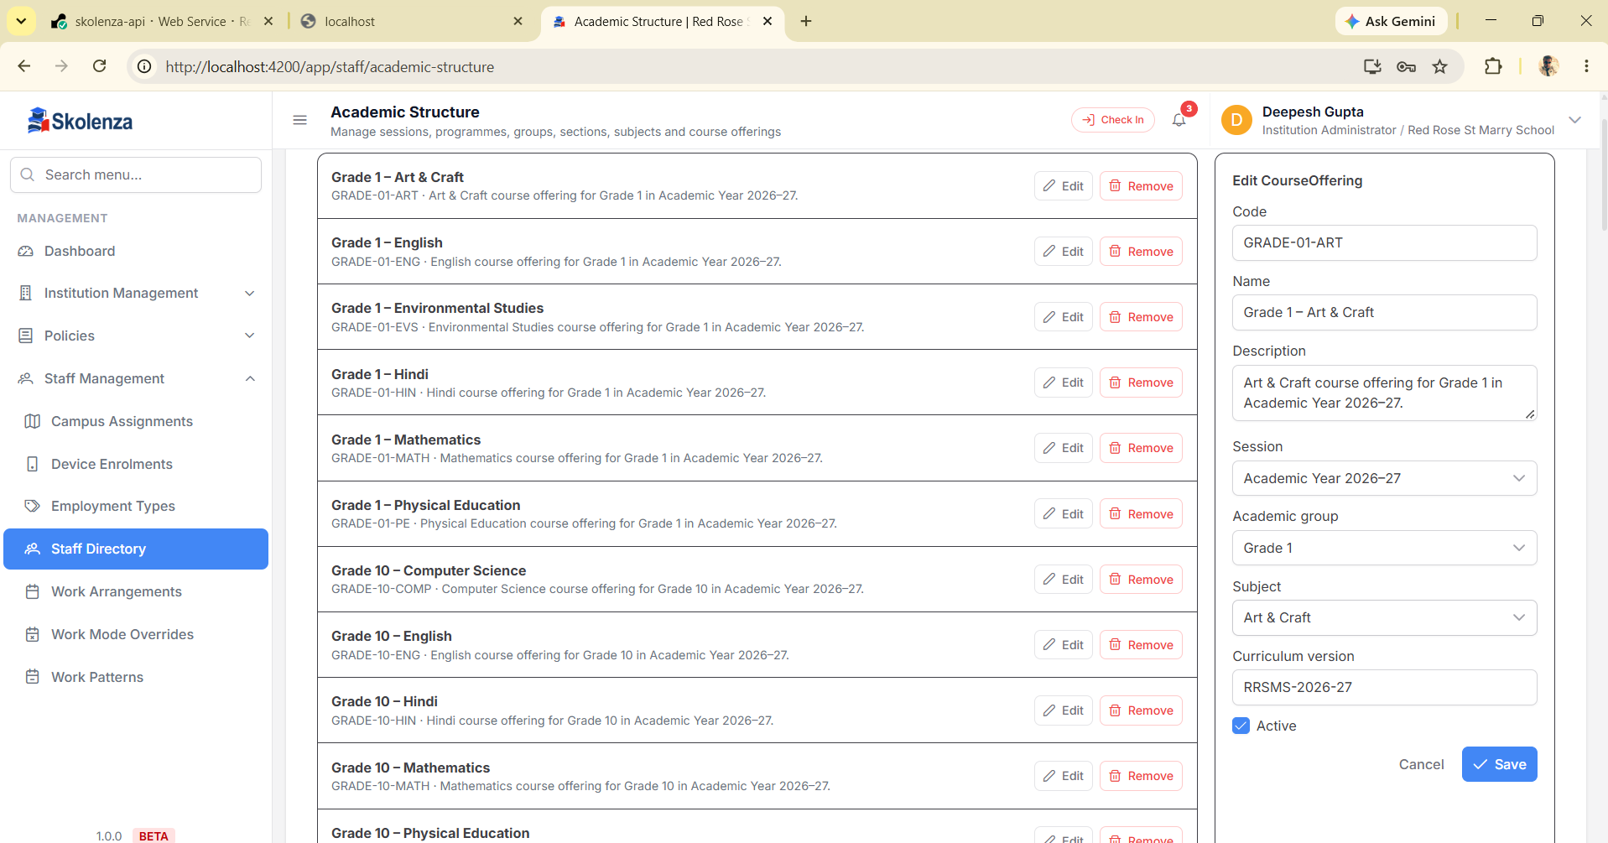
Course Offering: Session + Group + Subject ka teachable combination.

5. Phase 3 — Curriculum & Lesson Delivery
Dependency: approved Framework → Course Offering ke Unit → Unit ke Topics → Teaching Assignment ke Lesson Plan → approval → actual Delivery Log → calculated Syllabus Progress.
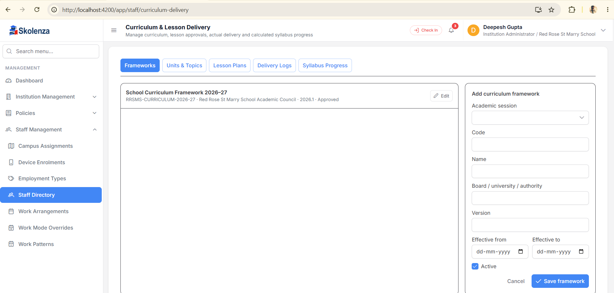
Framework: session, board/university/authority, version and effective dates.
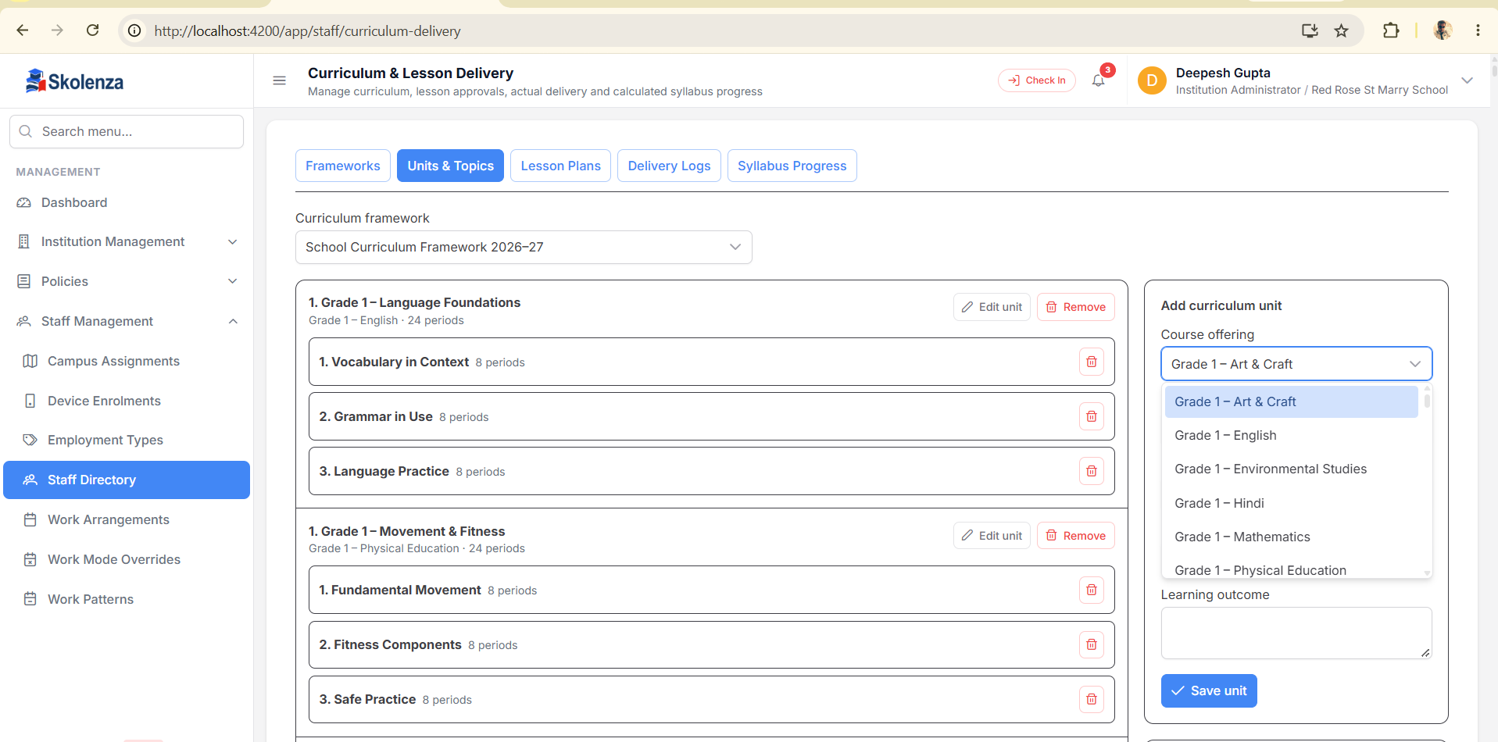
Units & Topics: course offering ke planned periods aur learning outcomes.

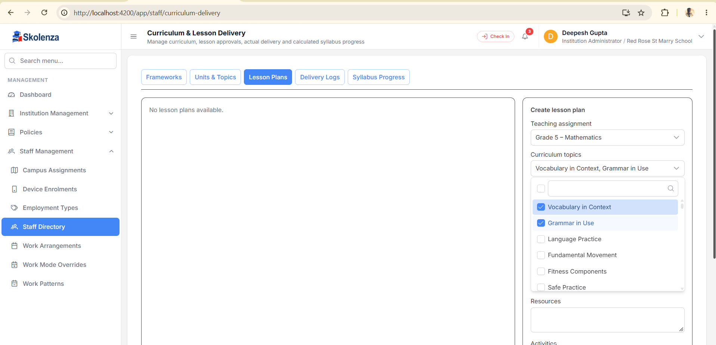
BEFORE-FIX EVIDENCE — Before-fix evidence: selected assignment ke saath unrelated topics visible ho sakte the. Ab options courseOfferingId se filter hote hain aur stale selections clear hote hain.
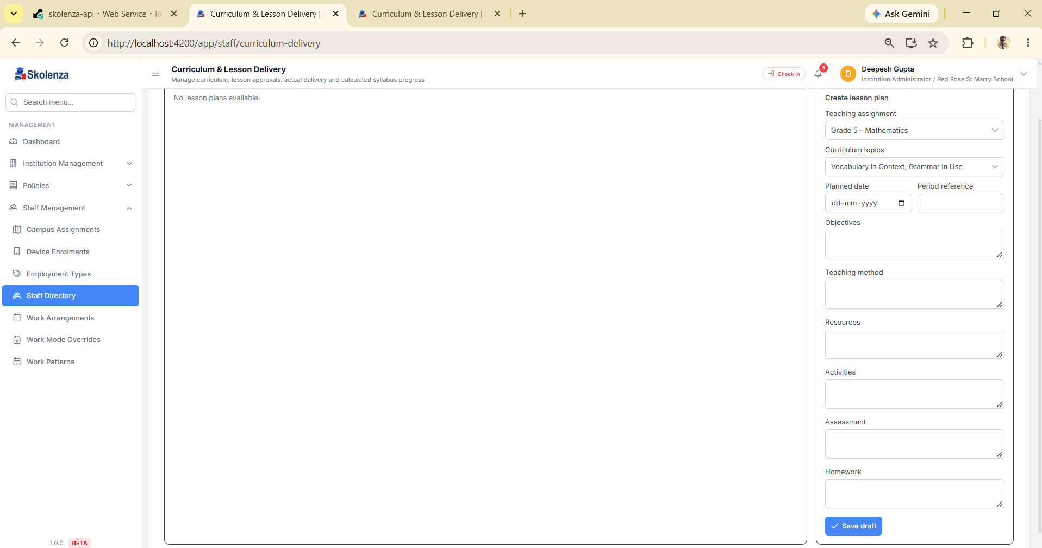
Lesson Plan draft: planned date, period, objectives, method, resources, activities, assessment and homework.

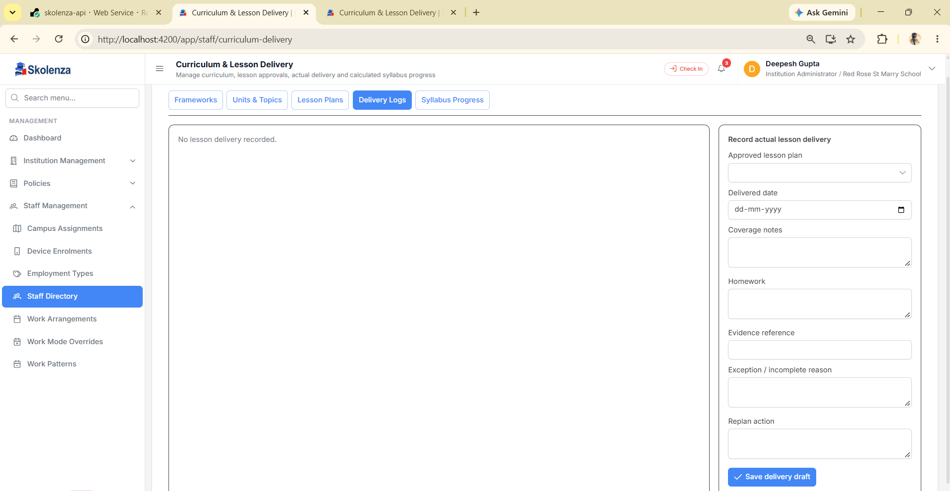
Delivery Log: approved lesson plan ke against actual date, coverage, homework, evidence and exceptions.
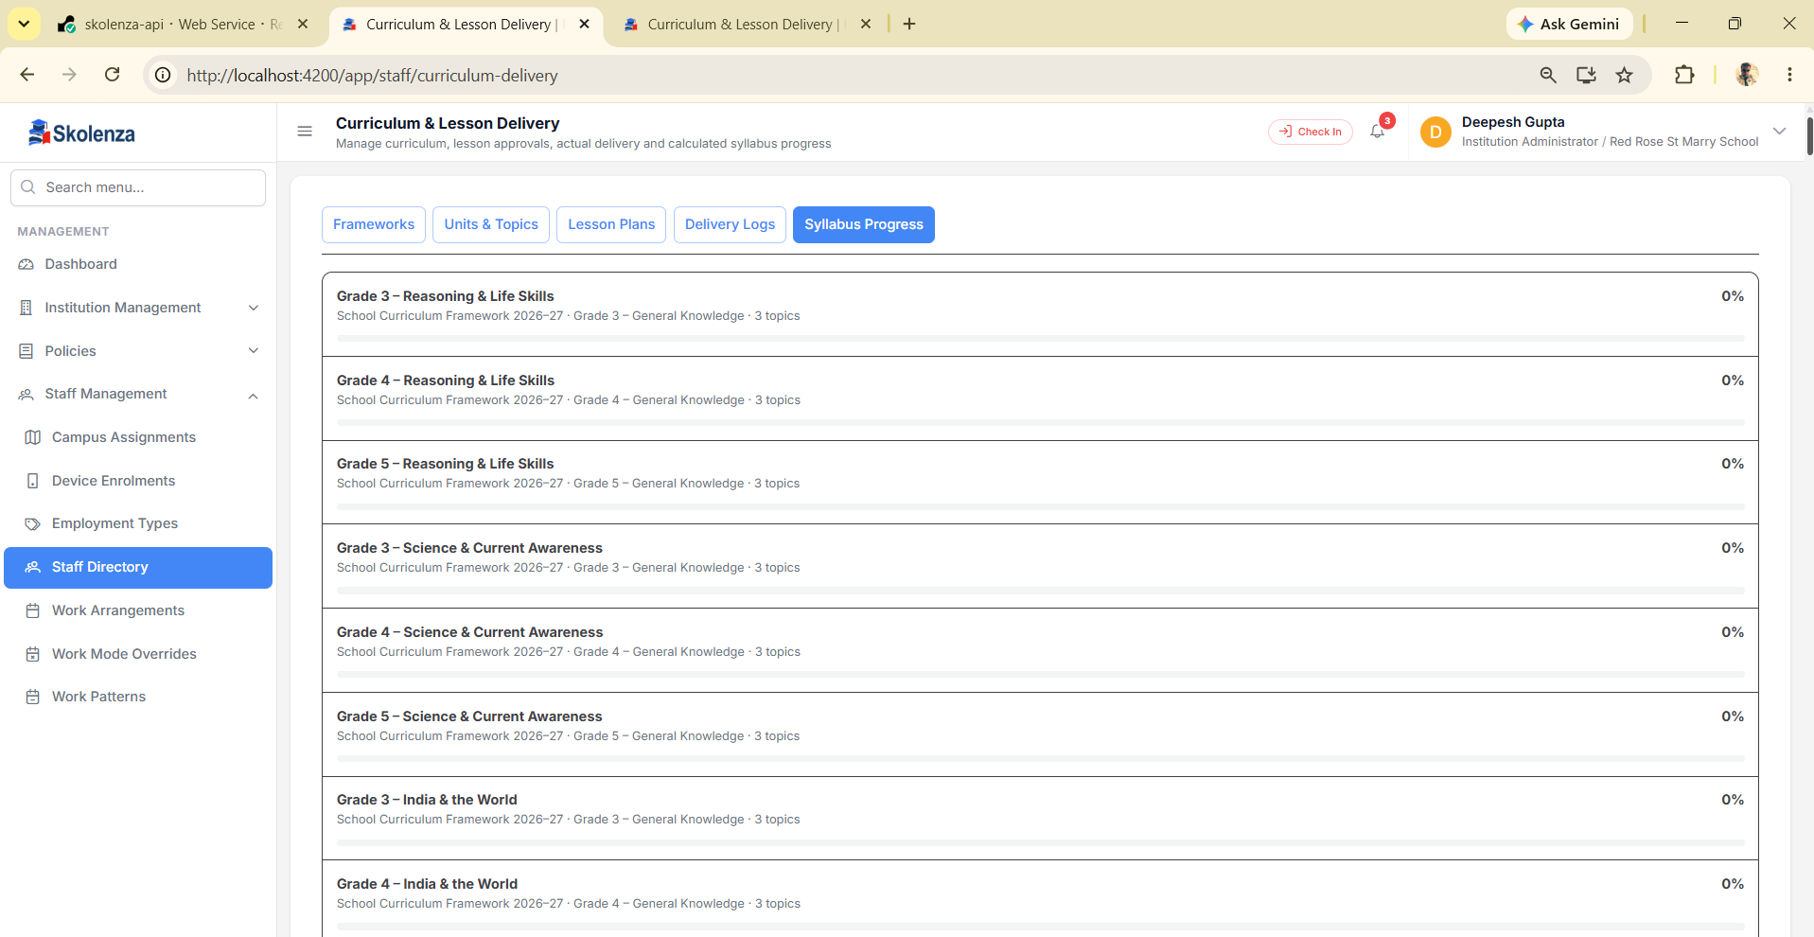
Syllabus Progress: delivered/approved coverage se calculated percentage; manual decoration nahi.

6. Teacher lesson-plan approval flow
Step | Actor | Action | Result
1 | Institution Admin / Academic Admin | Teacher ko Course Offering + Group/Section assign | Teaching Assignment
2 | Teacher or authorised planner | Lesson plan Save Draft | Editable Draft
3 | Teacher | Submit for review | Pending approval
4 | Configured approver | Approve, Reject, ya changes maange | Approved / Rejected / Revision
5 | Teacher | Approved plan deliver karke log save/submit | Actual delivery evidence
6 | System | Approved delivery/topics aggregate | Syllabus progress
Lesson-plan approval aur timetable approval alag workflows hain. Ek approved lesson plan timetable ko automatically approve nahi karta; dono ka apna audit status aur permission flow hai.

7. Phase 4 — Timetable: teacher khud banayega ya manager?
Dono possible hain. Institution workflow decide karta hai. Red Rose ke current local configuration mein allowTeacherDraftProposal = true hai: teacher draft bana sakta hai. Ek approval step configured hai; final approval ke baad autoPublishAfterFinalApproval = true hone se timetable publish ho jata hai.
Configuration | Meaning
allowTeacherDraftProposal | Teacher ko draft/proposal create karne ki permission
Approval steps | Sequence-wise Manager, Role, Position ya named Staff approver
autoPublishAfterFinalApproval | Final approval ke turant baad publish
Manual publish mode | False ho to authorised publisher separately publish karega
Revision/history | Change new revision aur audit history mein store hota hai

8. Substitute workflow
Approved leave/absence timetable entries ko absence-impact list mein laata hai. Authorised coordinator substitute nominate karta hai. Dynamic workflow approver chain chalti hai. Red Rose ke local rule mein manager approval ke baad substitute acceptance required hai.
State | Meaning
Open impact | Class/period cover chahiye
Proposed | Substitute nominate hua
Pending approval | Configured approver review
Pending acceptance | Chosen substitute accepts/declines
Confirmed | Class cover locked
Reassign | Decline/unavailable par next candidate
Self-nomination aur no-step auto-approval bhi institution settings hain; fixed business assumption nahi.

9. Phase 5 — Communication
Institution channels, retention aur query categories configure karta hai. Red Rose local setting: in-app + email enabled, SMS/push disabled, retention 730 days, six query categories.
Object | Purpose | Example
Setting | Allowed channels + retention | In-app and email
Query Category | Routing and reporting | Timetable Query
Conversation | One issue/thread | Grade 5 Maths room change
Message | Replies + read trail | Coordinator response
Attachment | Evidence | Revised timetable PDF

10. Proposed system vs implemented system
Area | Proposed expectation | Verified implementation | Status
Tenant isolation | InstitutionId-bound data | Authenticated Red Rose reads institution-owned rows | PASS local
Central catalogue | Host owns semantic categories | Host Catalogue + institution mapping | PASS local
Professional hierarchy | Category → family → position | With capabilities and duties | PASS local
Dynamic academics | School/college/coaching naming | No fixed grade/section requirement | PASS local
Curriculum | Offering → unit/topic → plan/delivery | Progress calculated from delivery | PASS local
Timetable | Configurable drafter/approvers/publish | Dynamic workflow and history | PASS local
Substitute | Absence impact + approval/acceptance | Dynamic workflow | PASS local
Communication | Institution channels/categories | Settings, categories, threads | PASS local
Deployment | Same build/data verified on Render | Not executed in this run | PENDING

Confirmed gaps fixed
- Teaching-assignment response now includes teacher name.
- Position category dropdown now reads the correct name property.
- Lesson-plan topic options now match the selected course offering.
- Stale duplicated test constants now consume the central source.
- Retired-entity audit now matches exact identifiers, avoiding false positives.

11. Verification report
Gate | Result
Backend full tests | 736 passed, 0 failed, 99 skipped, 835 total
Backend focused staff/catalogue | 25/25 passed
Backend cleanup + bulk permission | 84/84 passed
Angular full tests | 2474 passed; 1 suite-load timeout
Timed-out Angular file isolated | 26/26 passed
Angular focused curriculum/host/interceptor | 69/69 passed
API Release build | PASS, 0 errors
Angular production build | PASS
Authenticated API smoke | 10/10 protected read flows succeeded
Skipped tests ko pass nahi maana gaya. Full Angular result ko 2475/2475 nahi likha gaya: one timeout documented hai, aur same file isolated 26/26 pass hui. Render acceptance pending hai.

Authenticated local read-back
- 7 institution staff categories; 6 positions; 1 academic session.
- 1 teaching assignment with teacher name; 1 curriculum framework; 222 progress rows.
- 1 timetable workflow; 1 substitute workflow; communication settings + 6 query categories.

12. Client training checklist
- Host vs Institution ownership pehle explain karein.
- Parent-child order mein configuration karein; child dependency ke bina parent delete/deactivate na karein.
- One complete teacher example live create/read karein.
- Draft, Submit, Approve, Publish statuses separately dikhayein.
- Substitute decline/reassign scenario samjhayen.
- Communication query category aur retention policy samjhayen.
- Inactive filter se Reactivate demonstrate karein.
- Deployment training se pehle Render walkthrough repeat karein.

13. Quick FAQ
Question | Answer
Kya Grade 5-A aur 5-B mandatory hain? | Nahi. Sirf 5-A, 5-C, college semester ya coaching batch sab valid institute-defined names hain.
Remove se sab institutions ka data delete hoga? | Nahi. Institution-owned action sirf current InstitutionId par hota hai; dependency-safe deactivation preferred hai.
Deactivate ke baad wapas? | Inactive filter → Edit/Reactivate. Historical references safe rehte hain.
Teacher timetable khud banata hai? | Workflow setting allow kare to draft banata hai; otherwise authorised scheduler/manager banata hai.
Draft kab publish hota hai? | Configured approval chain ke final approval par auto-publish true ho to immediately; false ho to publisher action.
Capability aur Duty mein farq? | Capability = kaam karne ki ability/authority. Duty = assigned recurring/operational responsibility.
College/coaching kaise chalega? | Same generic hierarchy; institution apne Programme, Group, Section/Batch aur Subject names use karta hai.
Source evidence: current development working trees, local authenticated API/DB read-back, automated tests, production builds, and UI captures dated 14 October 2026.

