**Multi-tier Project**

**Name: Queen Sarah Anumu Bih**

**ID: 2311432**

**Date: 30/11/2023**

-Table Students

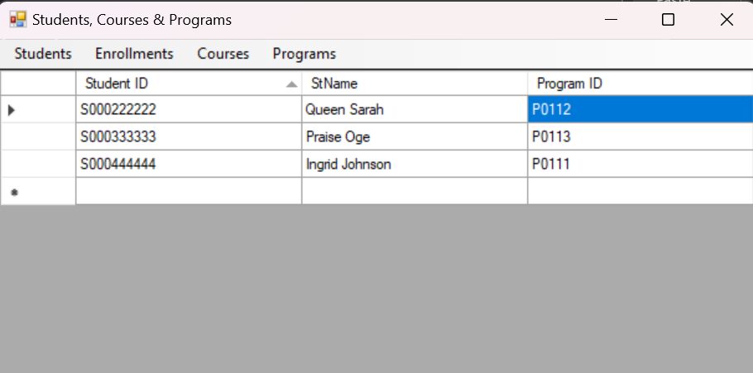

-Table Courses

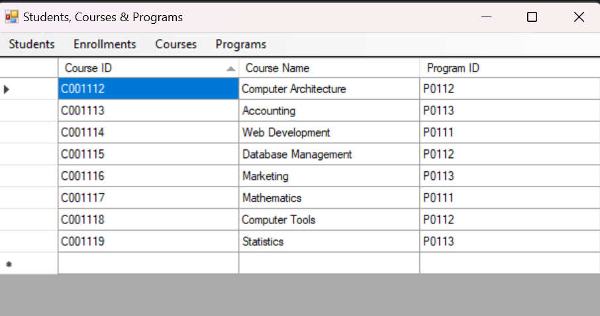

-Table Programs

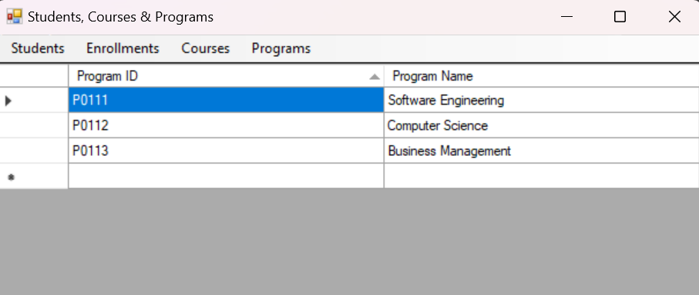

-Table Enrollments

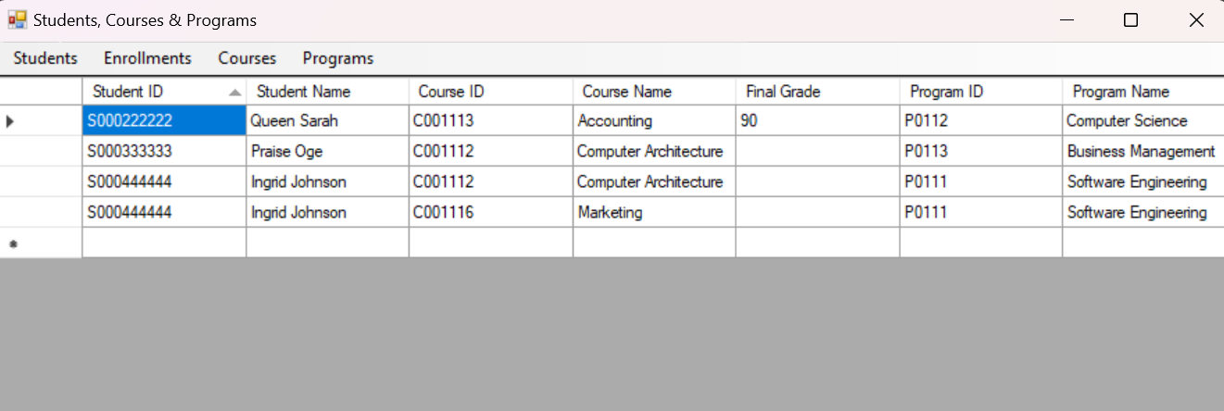

-Checking invalid id for the table Programs

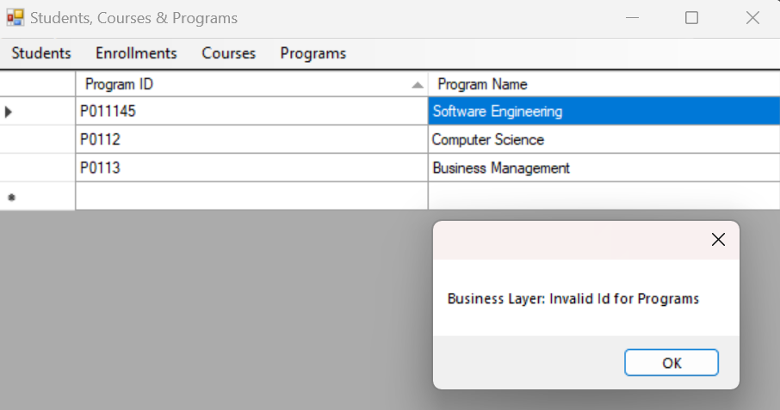

-Checking invalid id for the table Students

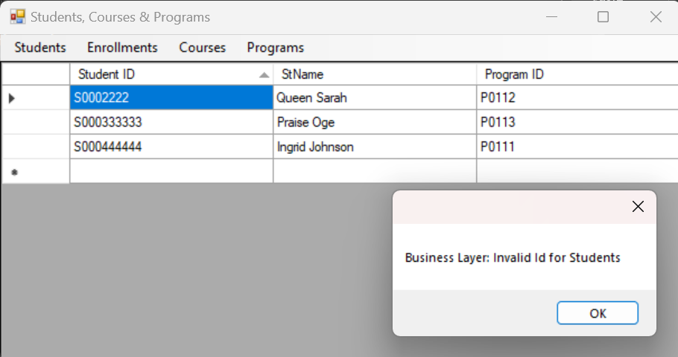

-Checking invalid id for the table Courses

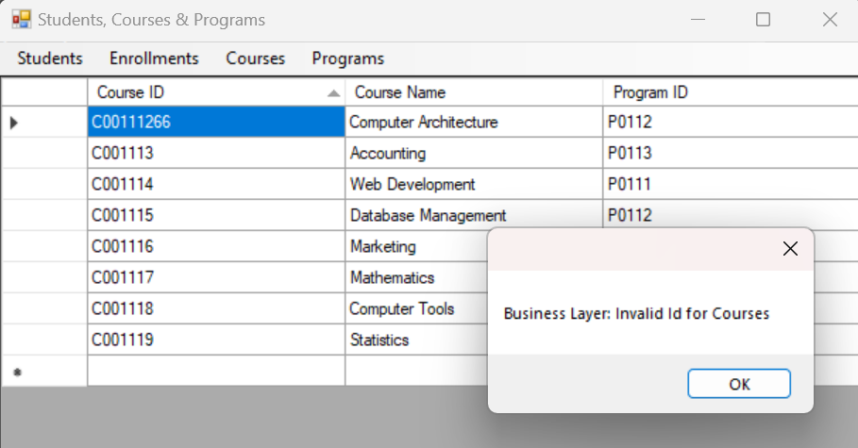

-A line must be selected before you can update

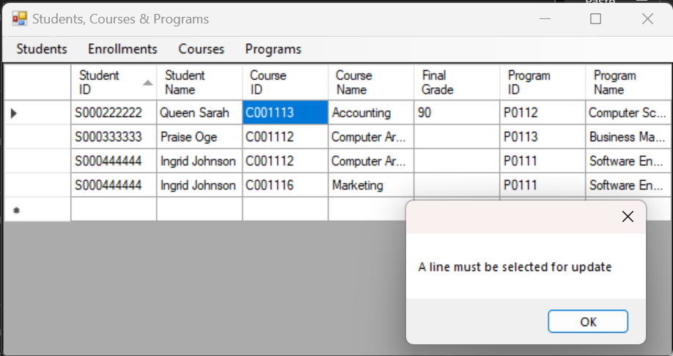

-Checking if an enrollment already exists

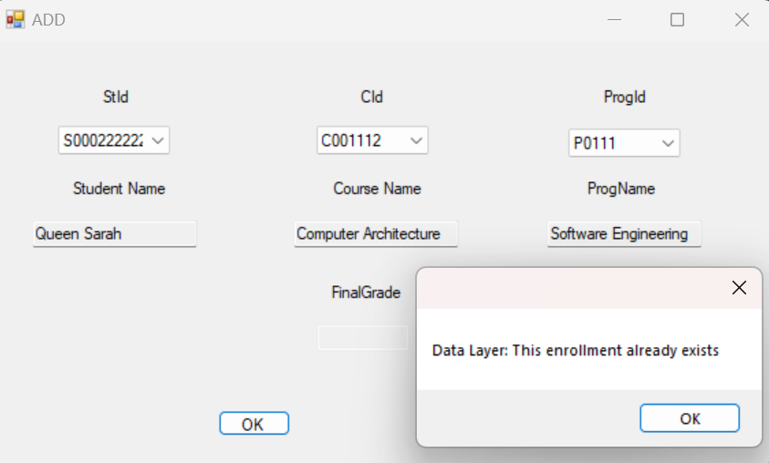

-Ensuring that the final grade is between 0 and 100 before it can be assigned

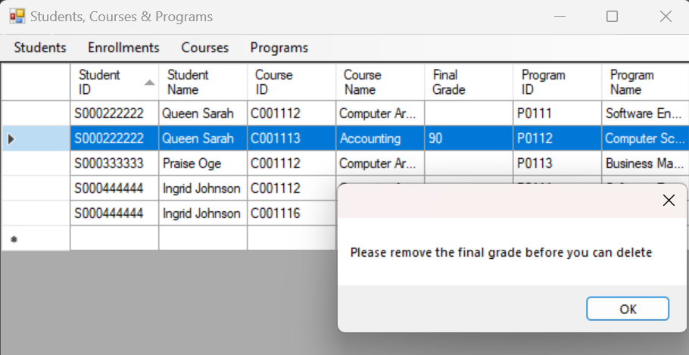

-Cannot delete a line if the final grade is already inserted

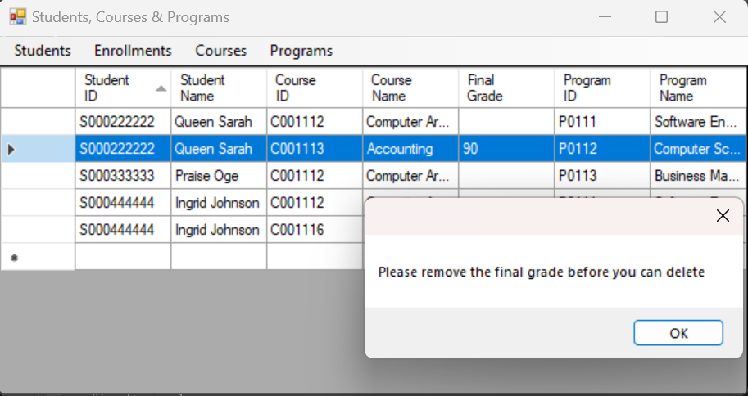

-Cannot add student to a course that is not in student’s program

