|  |
| --- |
| College LaSalle |
| Project - Internet Programming Technical Manual |
|  |
| Presented to: Mihai Maftei |

|  |
| --- |
| Author: Queen Sarah Anumu Bih  7/18/2023  Version: 1.0 |

**Start by adding a short description of your project, and the languages (technologies) used**

Languages:

1. Visual Studio Code
2. XHTML
3. HTML5
4. Css
5. Javascript

This project is made up of html5 and xhtml webpages styled with the help of css and has javascript functionalities. The main website is made of a frame having a top, a menu and content. The top webpage allows the user to login as well as logout. The menu contains all the available webpages created and the content is used to display these webpages.

**Presenting how the files/folders are organised.**

PROJECT_2023

1. vscode
2. content.html
3. En_tete.html
4. En_teteSignOut.html
5. En_teteSO.html
6. index.html
7. indexMenu.html
8. Login.html
9. login.js
10. menu.html
11. Menu0.html
12. TechnicalManual_V1.txt
13. UserIdentification.html
14. UserPage2.html
15. css
    1. cssForm.css
    2. style1.css
16. img
    1. 1$.jpg
    2. 2$.jpg
    3. 5$.jpg
    4. 5c.jpg
    5. 10$.jpg
    6. 10c.jpg
    7. 20$.jpg
    8. 25c.jpg
    9. 50$.jpg
    10. 50c.jpg
    11. 100$.jpg
    12. coffee.jpg
    13. coffee.png
    14. coffe2.jpg
    15. Logo.jpg
    16. none.jpg
    17. Prod1.jpg
    18. Prod2.jpg
    19. tea.jpg
    20. tea.png
    21. valid-css.png
    22. valid-xhtml10.png
    23. w3c validator links.txt
17. Pages

* .vscode

1. CoffeeAndTea.html
2. cookieFunctions.js
3. cookieShoe1.html
4. cookieShoe2.html
5. CssAndForms.html
6. FirstPage1Cookies.html
7. JavaScriptCal.html
8. Jquery-1.11.0.min.js
9. Jquery-3.6.1.min.js
10. Lab4.2_JS.html
11. none.jpg
12. SecondPage2Cookies.html
13. Planets
14. imgs
15. Earth.jpg
16. Jupiter.jpg
17. Mars.jpg
18. Mercury.jpg
19. Neptune.jpg
20. none.jpg
21. planets.jpg
22. Saturn.jpg
23. space.jpg
24. Sun.jpg
25. Uranus.jpg
26. Venus.jpg
27. p_css
28. Css_style.css
29. mystyle4.css
30. pages
31. Earth.html
32. Jupiter.html
33. Mars.html
34. Mercury.html
35. Neptune.html
36. Saturn.html
37. Space.html
38. Sun.html
39. Uranus.html
40. Venus.html

* Mapping-Solar System.html

**Present the screen shots of your web site, with a short description:**

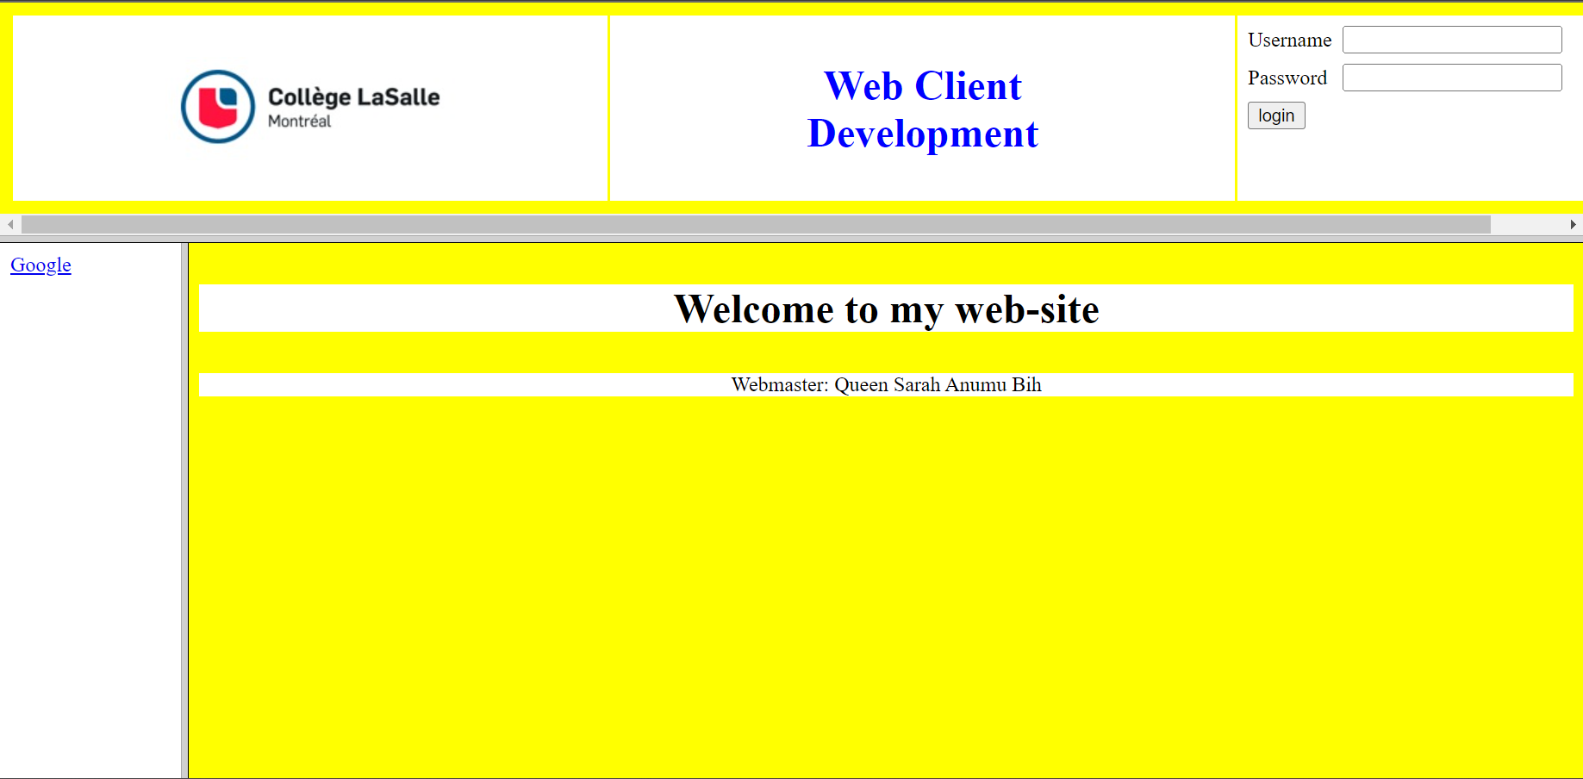

-This is the main website of this project. The user is to login to have access to the other webpages in the menu. Beneath the menu webpages, there are two available validator links; xhml and css which helps the user to see if the webpages are validated. The user can as well logout immediately after use.

Note: Username is admin and Password is 123.

-This is the Coffee and Tea Webpage. It consists of images, names, and descriptions of different types of coffee. It has all kinds of list and links in it. If the any of the images in the table are pressed, a new website is opened on another webpage which is the copyright of that image. In the list found in the first column of the table, when each name/link is clicked, it takes you down the page to where the user can get more information about the tea. In the paragraphs below, there are links that can take the user to the top of the page and there are links for the source website too.

-This is the CSS and Forms webpage that allows the user to input personal information, tells the user of a product available and allows the user to choose his/her preference. The webpage sends the user’s information to a server and also has a reset button used to clear all the inputted data.

Note: The user cannot enter a quantity above 100.

This is the CSS and Script webpage which is a display of Addition and Subtraction of variables using java script. The two first addition and subtraction buttons above opens a webpage over the current webpage when clicked to display information of how they function. The Addition and Subtraction buttons below now display the hidden variables and their various answers.

-This is the Planets and Mappings webpage; Solar system and its nine planets. It has image mapping with all types of links as well as a search button which searches all the planets and displays their images with detailed description.

Note: To search for a planet, it must be written in lowercase.

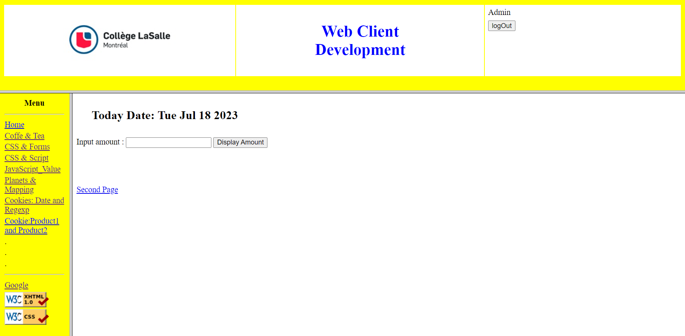

-This is the Cookies: Date and Regex webpage. The user is to enter an amount and the full amount is calculated with tax and displayed. The webpage also contains cookies; passing it to the second page. The second page receives the cookies and displays the images of the total amount after tax.

Note: The user must enter and amount before he/she can proceed to the second page.

-This is the Cookie: Product1 and Product2 webpage. The user is to basically enter the number of shoes to be bought and check out. When the user checks out, the total price of each of the items is displayed.

Also, the present date and time at which the user checks out is displayed at the top of the second page.

Note: The user must enter a number between 1-100.

-This the User Identification webpage which validates the user’s personal information using Regular Expression and passes a cookie to the second page which displays all the inputted information and tells the user how long he/she took to fill the form in seconds. If a wrong input is entered, a message is displayed in red indicating the right way for that field to be filled. This is done with the help of jQuery.

**Present the functions and/or methods that you create or you did use into the web project.**

|  |  |
| --- | --- |
| **Function/Method** | **Description** |
| 1. document.getElementById() | Used to return an element object representing the element whose id property matches the specified string. |
| 1. alert() | Used to display text in a dialog box that pops up on the screen. |
| 1. RegExp.test() | Used to test for match in s string. |
| 1. isNaN() | Used to check whether a given value is an illegal number or not |
| 1. Number() | Creates number objects |
| 1. .toFixed() | Used to format a number using fixed-point notation. |
| 1. checkCookie() | Checks whether the first name of a cookie is set or not |
| 1. setCookie() | Creates a cookie with an optional maximum attribute. |
| 1. getCookie() | Retrieves information about a single cookie, given its name and URL |
| 1. setTime() | Sets a date and time by adding or subtracting a specified number of milliseconds to/from midnight. |
| 1. getTime() | Returns the numeric value corresponding to the time for the specified date according to universal time. |
| 1. toUTCString() | Convert the given date object’s contents into a string according to the universal time zone UTC. |
| 1. decodeURIComponent() | Decodes a uniform resource identifier component previously created by encodeURIComponent() or by a similar routine. |
| 1. charAt() | Used to find the character at the specified index value of the string. |
| 1. substring() | Used to return the part of the given string from the start index to the end index. |
| 1. indexOf() | Returns the position of the first occurrence of a value in a string. |
| 1. display Amount() | Used to display the amount after tax. |
| 1. toDateString() | It interprets the date in the local timezone and formats the date part in English. |
| 1. parseInt() | Passes a string argument and returns an integer of the specified radix. |
| 1. open() | Contains the URL string of a webpage, which you wan to open. |
| 1. deleteCookie() | Removes a property from an object. |
| 1. login() | Used to login into the website. |
| 1. logOut() | Used to logout from the website. |
| 1. Date() | Returns a date object with the current date and time. |
| 1. validateInputs() | Validate all the input fields using Regular expression. |
| 1. JSON.stringify() | Converts a javascript value to a JSON string |
| 1. setTimeSpentCookie() | Gets the present time |
| 1. Date.now() | Gets the present time and date |
| 1. JSON.parse() | Parses a JSON string, constructing the JavaScript value or object described by the string |
| 1. .val() | Returns or select value attribute of the selected elements. |
| 1. .match() | Used to search if a string match against any regular expression. |
| 1. .addClass() | Adds one or more class names to the selected elements. |
| 1. .removeClass() | Removes one or more class names from an html element. |
| 1. .next() | It is used to return an object with two property values. |
| 1. .text() | Sets or returns the text content of the selected elements. |
| 1. .show() | Shows the hidden, selected elements. |
| 1. .setError() | Associates a message with one or several containers. |

**Present the difficulties that you have, what was the hardest and the easiest part of your project.**

… your presentation goes here …