NAME: ASHLEY JOYCE JARA

YR. & SEC: BSIT-2TAB

Introduction

The FacebookGraph app is a simple way to simulate a social network using a graph format. It represents users as points and friendships as lines connecting them. This program lets users set up their profiles, make connections with others, and recommend friends who might know each other based on current links.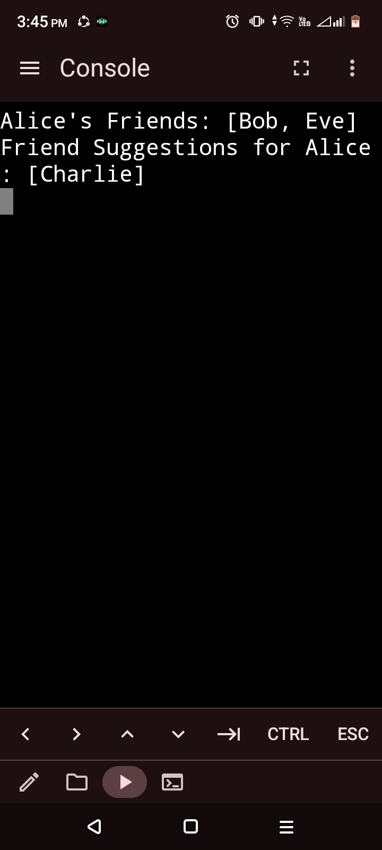

Features

1. Add Users: Create a profile for a user in the network.

2. Establish Friendships: Connect users to form friendships.

3. Retrieve Friends List: Display the direct friends of a user.

4. Friend Suggestions: Recommend mutual friends based on connections.

This application shows how graph data structures can help tackle everyday issues, like managing and representing social networks. It offers a practical look at graph theory in social networking, focusing on the idea of relationships and their importance in computer science. It also acts as a helpful base for grasping how platforms like Facebook

organize connections and interactions.

This application is a great resource for the community, acting as a helpful guide for students and developers to learn about graph theory and how it can be used in real life. It also provides a starting point for creating social networking solutions. It shows how technology can bring people together and improve connections. Personally, it deepens my grasp of graph theory, sharpens my problem-solving skills, and inspires creative thinking in building social networking platforms that can benefit everyone.