NAME: ASHLEY JOYCE JARA Username:QueenAshley-web

STUDENT GRADES MANAGER

Introduction

The Student Grades Management System is a simple Java application created to help store, find, and manage student grades easily with the help of a HashMap. By using hash-based data structures, the system allows for fast access to student records. It serves as a great resource for schools, teachers, and administrators who want to keep an eye on student performance.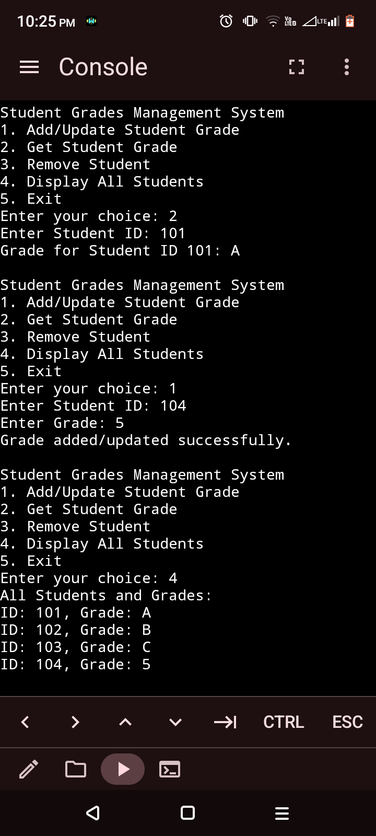

This application allows users to add, update, retrieve, delete, and view all student grades efficiently. Its simple console-based interface ensures easy and effective management of records.

1. For Developers: It serves as an excellent beginner-friendly project for those learning Java, HashMaps, and basic CRUD operations.

2. For Educators: Offers a simple and effective tool for managing grades without the need for expensive software.

3. For the Community: Provides a foundation for more advanced educational systems by showcasing the principles of data storage and retrieval.