





Use Calibri (Body) as the font.

12px as paragraph size.

# 20px as the Heading 1 size

## 16px as the Heading 2 Size

# Introduction

Company panel will be used by the company to broadcast their services. Companies overall settings will be done through this panel, managing their services and employees issues.

*Enter the name of the module here and over-all scenario for which the module will be used.*

The company module is designed for the companies who are hired by customers to perform a job. Modules interacting with Company: **Admin (Company)**

# Flow-Charts:

**Customer Dashboard:**

In this module user will enter its credentials and login into system. If credentials are wrong system will display the error. When user successfully enter into system the dashboard is display and in side navbar customer will see different module.



*Figure 1: Flow-Chart of the main Customer Component*

**Services:**

In this module customer will see the different service in grid/list view and map view of different company and the customer will book multiple services. The book services will open in right side nav in which customer check the terms and condition of company. After terms and condition customer select the payment method and also have option to add new payment card. After selecting click on submit the service will order successfully. Customer have option to filter the services by company name, categories, sub categories, service name and price.

**Changes 1/8/2018:**

1. In list and grid view the book button remove from all services and add only one button in bottom to checkout the book services in right sidebar popup.
2. The right sidebar open on book button remove the opening from checkbox.
3. Add information icon in front of services both list and grid view. In which customer can see the information of individual service
4. In right sidebar popup the item list change every services come under its company name as table.
5. Drop down payment button add in right side of every table end. In which different options are shown

**Changes 2/8/2018:**

1. In right sidebar popup make a separate card for every company in which selected service will shown with subtotal, total price and discount price. You can enter coupon for discount.
2. Add Proceed button.
3. At the of item list list the total is also added which contain the total price of all service.

**Changes 3/8/2018:**

1. Set the spacing in tables and remove discard heading in table..
2. Hide the payment and confirmation button which will show after accepting the terms and conditions.
3. Add Proceed button in the bottom of payment tab.
4. Add Content in confirmation tab in which two button are shown if you click on order now button customer order will placed successfully and Congratulations Message is shown with return button. click on ok button will close right sidebar. and if you click on cancel button the order will not placed.
5. Header-nav remove a button which is shown in mobile screen.
6. side-nav remove all comment code in this file.
7. Add Confetti picture in Congratulations tab
8. Add Card in confirmation tab which will show all the book services of company.

**Changes 6/8/2018:**

1. Add info modal on service.
2. Set the position of info icon in the middle.
3. Modal will not open on unchecked of the checkbox of terms and conditions.
4. Add more detail button in list view. Also set the layout.
5. Hide the book until customer select one service for book.

**Changes 7/8/2018:**

1. Add MapView button on top with gridView-listView.
2. On the click of mapview the new services is shown with there company detail in left sidebar and on right side the map shown in which marks of company will display.
3. In Services left sidebar also a search input.

**Changes 8/8/2018:**

1. Add three popup Menu on mapview button.
2. In Order Popup customer will its order history.
3. In Services popup customer will see all the services of company and customer can book these service from here.
4. In info popup the customer will see the complete information of company with reviews.

**Changes 9/8/2018:**

1. Remove Search Bar from above of map.
2. Add checkbox and book button in services. where user can easily book the services of company.
3. Add Search Box on the top of with two dropdown one for category and other for sub category.
4. Add order and service button in services section with icon

**Changes 10/8/2018:**

1. Remove search box on header and add on sub header of services.
2. Add time in mapview order popup.
3. Add individual services detail modal in services popup.
4. Update Flow Chart.

**Changes 11/8/2018:**

1. Initially open map view when customer will go to services page.
2. Add view information in breadcrumb.
3. Add test page in which category is shown in the form of cards.

**Changes 15/8/2018:**

1. Remove Test Page.
2. Add Schedule Tab in book right side popup with payment in which customer can schedule their book service and also select employee preference.
3. Remove date and time slot 1 & 2 and take date and time separately.

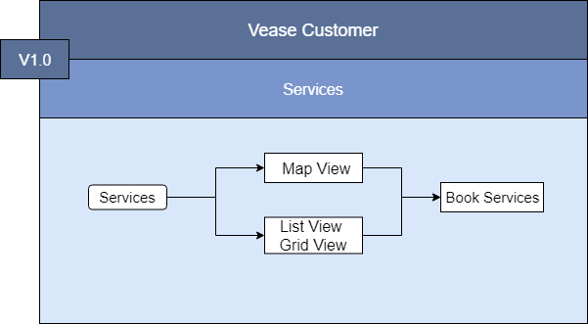

*Figure 2: Services Module flow chart.*

**Orders:**

In this module customer will see it pending, schedule/reschedule, started and completed orders. In pending orders company offer three date to customer to schedule the order and customer have also option to give its own two date. In schedule orders customer have option to reschedule it. To reschedule customer may pay the extra amount of money. The green line represent the company schedule/reschedule services and light purple line represent the customer reschedule services. In started order the schedule / reschedule services will show. In completed order customer will review the service and the reviewed service will show in that section. The customer have option to start dispute on complete services which will be handled in resolution center.



*Figure 3: Orders module flow chart*

**Estimated Response:**

In this module customer will see the response of companies on its requested service in list and grid view. Customer will also see the status on service which company accept, reject and give no response which is still pending. Customer have option to filter the services by company name, category, sub-category, status and service name. Customer will request a new service which is not offer by any company and the service which customer don’t like. This service will send to all company. The company will bid on that service.

C:\Users\Qaisar Ali\Downloads\Untitled Diagram (3).png

*Figure 4: Estimated Response Module Flow Chart*

**Resolution Centre:**

In this module customer will see its dispute services in table with its status completed and complaint. When customer click on any row of table the detail of that service is open in right side and in this section customer have option to submit a request of dispute.

C:\Users\Qaisar Ali\Downloads\Untitled Diagram (4).png

*Figure 5: Resolution Centre Module Flow Chart*

**Profile:**

In this module customer will update the profile like its personal detail, address detail and social links. In profile setting customer have option go to into security section in which customer change its password and add two factor authentication. In profile setting customer have payment section in which customer can add online payment, credit card and currency.

C:\Users\Qaisar Ali\Downloads\Untitled Diagram (6).png

*Figure 6: Profile Module Flow Chart*