

NerdPapers.com
On-Site SEO Analyze

Over-all Analyzing:

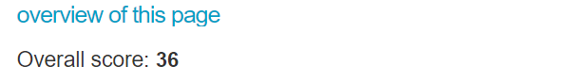
Over all score of the page according to different on-site SEO tools is only 36.
The score is dependent on the page size, keyword density, domain authority, page speed, and other content related algorithms.

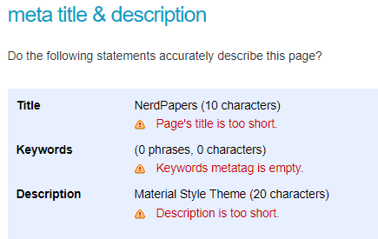
Title of the page should include any tagline/Keyword related to the content of the website
For example:
Nokia - Connecting People
NerdPapers - The Best Quality Essays

Description of the page also needs to be rendered correctly and be updated according to the keywords.

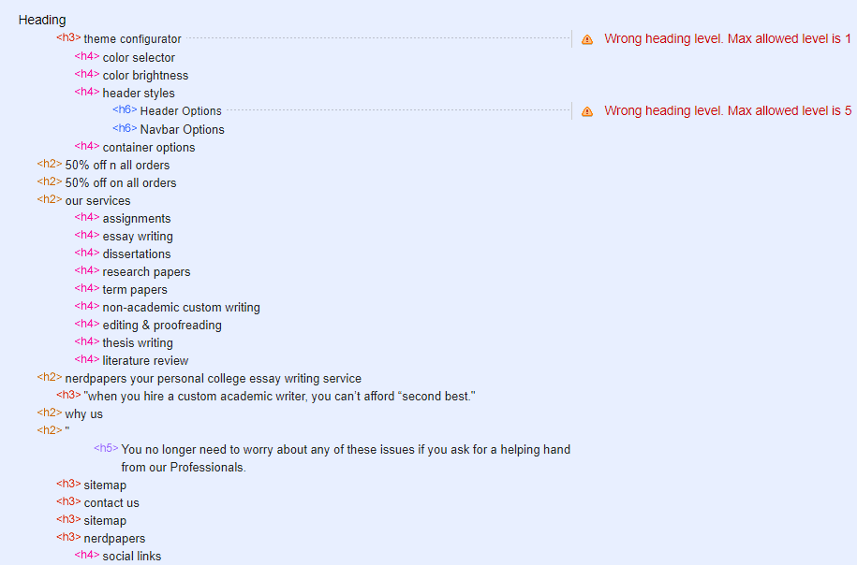

Heading structures and heading levels both need to be adjusted according to the content.
More keywords need to be added in a structured heading.

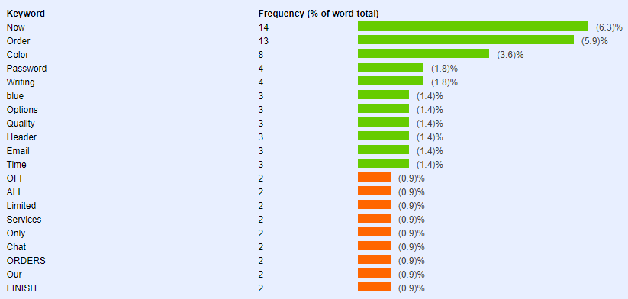

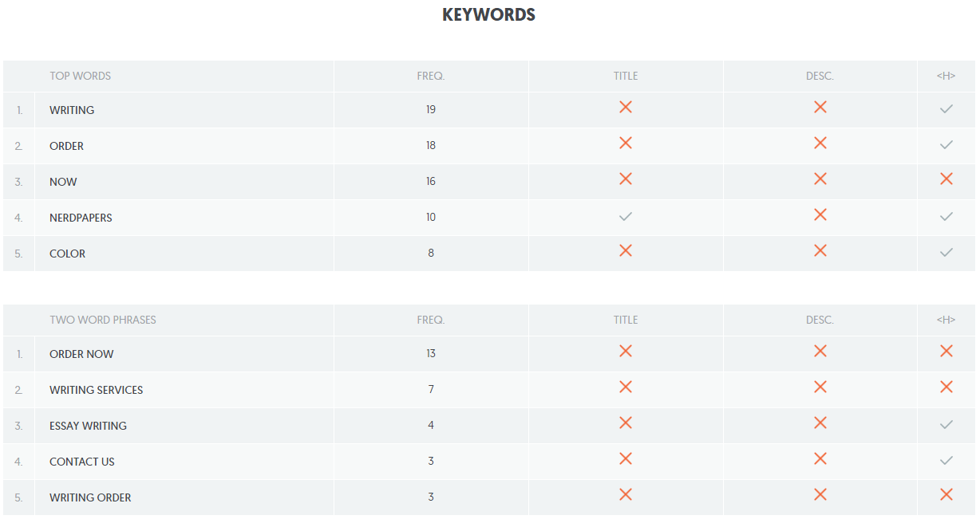

Over all keywords need to be re-aligned and placed accordingly on the website. Also the website lacks any markup for hiding of web page extensions which can be vulnerable for security of the page.

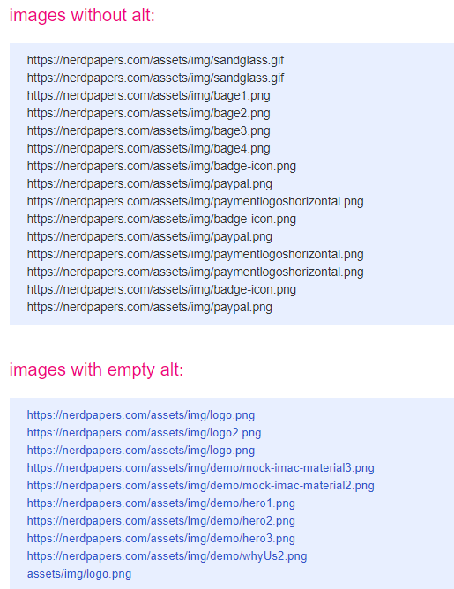

Alt of almost all the images on the website are missing. Alt images are a factor that search engine bots take to guide the system regarding the nature of the image.

Robots.txt and Site-map.xml are not found which are a primary requirement for the SEO crawlers to guide them regarding the crawling settings and the over all directory of the website.

Work-around regarding campaign:
Although google bans any selling of any intellectual related material (writing of thesis, essays etc) However the only work-around regarding this is to select the targeted countries and run the campaign. The only initial check that google does is checks the keywords eligibility.
Currently if I input essay related keywords the status for the keywords is eligible.

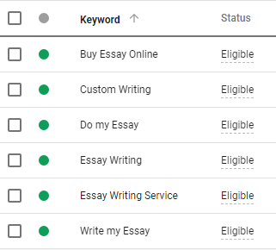

After this once the payment method is set up google will set up the ads and start displaying. Unless and until it is cancelled by google it will keep on being displayed and ofcourse will only utilize the money placed into the ads for which google has delivered results.
An example of under-review/rejected keywords/campaign is as follows:
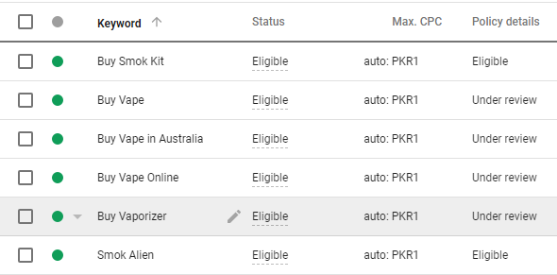

For vapes all the keywords regarding the selling of any product is not-eligible.
However the brand names are eligible. Where as our keywords for the campaign show APPROVED under policy details.

