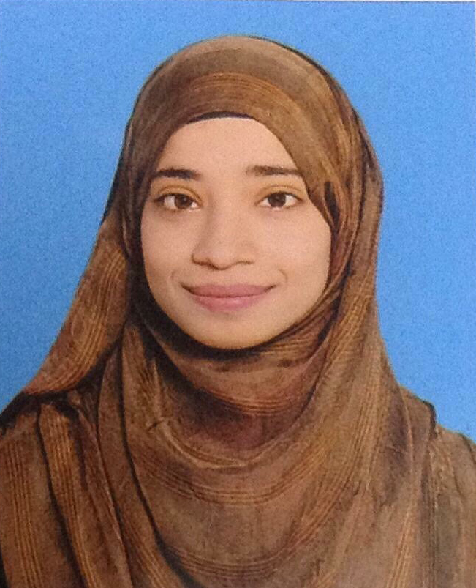
Syeda Farwa Qumber
H# 4-Civil-Line Colony, Civil Line , Jehlum | Cell. +92-331-5384345  E-mail: qumberfarwa@yahoo.com
Career Objective | Accept and enjoy the new situation, challenges and to attain a position in a dynamic organization to utilize my knowledge and skills in the most effective manner and achieve new heights in the field of media and communications.
Education  2011-2015  2010-2011  2008-2009  Work Experience  March 2015-May 2015 | BS Computer Science  COMSATS Institute of Information Technology, Islamabad  HSSC  Army Public School and College, Jehlum  SSC  Convent High School , Jehlum  Intern position at Grovlet in Development department | Extra-Curricular Activities  - Member of IDEA Society Girls Wing  - Played basketball for CS Department  - Head Girl at school  Community Involvement  - Organized many gatherings in the last semester.  - Head Girl at School (Also interacted with  a lot of people during this)  Honors and Achievements  • Member of CS basketball team(2011-2015)  •Member of Magazine named DEVMAG.
Development and Technical Skills | Tools: MS Office, Visual Studio, Adobe CS, Dreamviewer , Notepad ++  Languages: C++, HTML, Java Script, CSS, PHP.  DBMS: MySQL, SQL Server  Networking: Wire Shark  OS Platforms: Microsoft Windows
Academic Projects | - Pharmacy Management System  My final year project was titled “Pharmacy Management System” (Desktop + Web Application). The User of this App can be the owner of the pharmacy, this App is specifically for Ahsen pharmacy. From this App he can maintain his inventory of medicines and equipment. He can purchase order add/edit the suppliers and admins as well. He can generate daily invoices and can do daily weekly or monthly closings.

