QUENCH CHARGERS
180 kW ADLB DC Fast Charger
Commissioning & Test Guide
Physical Checks • Hardware Configuration • Software Configuration
Field | Reference
Source procedure | 72115-0000-13-60_PLTP
Build variant | Mahindra 180 kW ADLB1
Power stage | 6 × 30 kW modules → 180 kW, up to 1000 Vdc, dual CCS2
DLB mode | quintupleCombo
Companion file | ADLB_180kW_Test_Checklist.xlsx (machine-readable test set)

How to use this guide
This guide walks through commissioning and functional testing of the 180 kW ADLB charger in the order an engineer should follow on site: physical integrity first, then hardware device settings, then software configuration and functional/OCPP testing. Each step is a checkbox with its pass value stated inline, and the relevant on-screen view is shown beside it so the same value can be set or read back through the software tools.

Software interfaces used
Interface | Address / Access
LWI – SECC (Gun A) | http://10.20.27.100 (EcoG Local Web Interface)
LWI – SECC-LE (Gun B) | http://10.20.27.101
Application Board (AB) | http://10.20.27.50:3001/swagger
Router admin | http://10.20.27.1 (login admin / admin)
IO Mapper (readback) | SECC LWI → IO Mapper → data (live JSON key/value)
Safety first. All Section A electrical safety tests (insulation / HV) require the charger de-energised and the listed PE connections removed before applying test voltage. Do not energise the system until Section A is complete and passed.

A. Physical Checks
Performed with the charger de-energised. These are manual inspections and instrumented safety tests – not automatable – and gate everything that follows.

A.1 Mechanical assembly
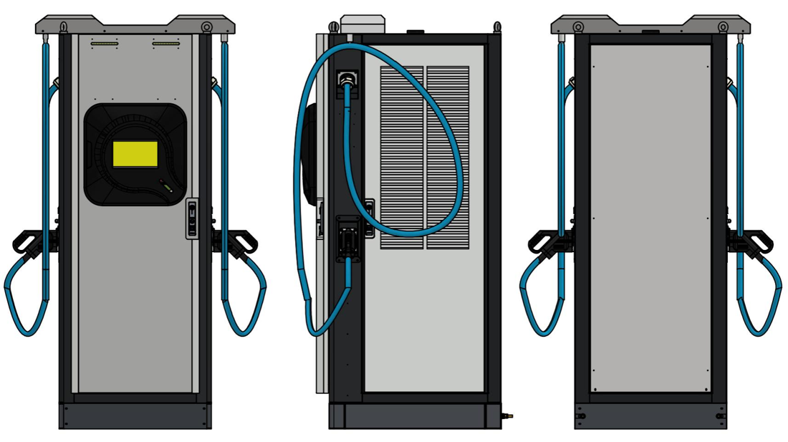
Reference build – front, side (with power module stack / cable management) and rear views.
❑ PHY-001 Fabrication free of dents; paint and finish correct per GA drawing.
❑ PHY-002 Standard and customer (Mahindra) stickers present per AWI.
❑ PHY-003 All internal components carry labelling stickers.
❑ PHY-004 Mechanical assembly complete per mechanical TC; all joints tightened.

A.2 Power wiring
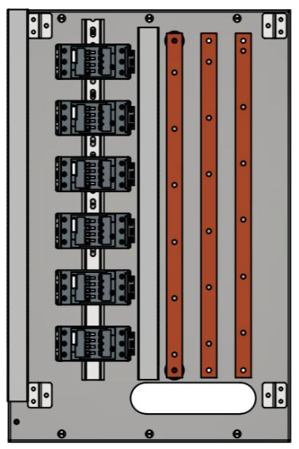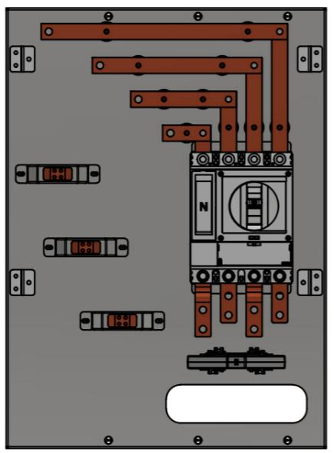
Power section – input busbar, MCCB, AC contactor and module feeds (PLTP Fig. 2).
❑ PHY-005 Input busbar, MCCB and AC contactor routed/connected per Fig. 2.
❑ PHY-006 Proper lugs and torque at SPD, ELR, MCB, AC & DC contactors, and module input/output.
❑ PHY-007 Each module output routed to its correct DC contactor and gun.
Expected: Module → contactor → gun mapping correct for all 6 modules.
❑ PHY-008 Earth distributed from busbar to all points; panel body bonded to earth busbar.
❑ PHY-009 Power hardware torqued with paint mark applied (AC and DC).
❑ PHY-010 All cables strain-relieved.

A.3 Control & communication wiring
❑ PHY-011 All control wiring per schematic (SMPS, relays, contactor coils, IMD, display, meters, TBs).
❑ PHY-012 Controller connectors fully seated – no loose connections.
❑ PHY-013 CAN bus shielded; 120 Ω termination at SECCLE (start) and PM2 (end).
❑ PHY-014 RS485 (IMD, AC/DC meters, Gun CP) shielded; 120 Ω termination at both ends.
❑ PHY-015 RJ45 sequence/tightness correct: Router → SECC, → SECC-LE, → AB.

A.4 Electrical safety tests
❑ PHY-016 Insulation (Megger) test at 500 V – AC input (R,Y,B,N) shorted, to earth.
Expected: Resistance ≥ 10 MΩ. Repeat for DC output (+,−) of both guns to earth.
❑ PHY-017 HV test at 1440 V (IS 17017) – AC input shorted, to earth.
Expected: Leakage current ≤ 5 mA.
Note: Disconnect PE from Controller, Router, SMPS, IMD, SPD, Power Modules, GNDF and main earthing before applying test voltage.

B. Hardware Configuration
Device-level settings made by hand (DIP switches, meter keypads, dial settings) and the power-up pre-checks. Meter settings can be confirmed afterwards through IO Mapper readback.

B.1 Pre-checks (continuity, earthing, power-up)
❑ HW-001 All fuse ratings correct; short links removed from 8-channel relay base.
❑ HW-002 Continuity on terminal-block links (XL, XN, 24V1, 0V1, 24V2, 0V2), earthing, SMPS1/2 outputs, AC-meter V↔MCCB.
❑ HW-003 No short circuit between 24V1 and 24V2.
Verify: Open circuit (must be isolated).
❑ HW-004 Power up via MCCB; confirm supply rail voltages.
Expected: AB jack = 5 V; HMI jack = 24 V; SECC_J1 = 24 V; CPPP_J8 = 24 V; SECC-LE_J1 = 24 V; DC meter = 24 V.
❑ HW-005 All boards/HMI power on; touch screen responsive.

B.2 Power module addressing
Set each module address via its DIP switch (binary).
Module | Address (binary)
Power Module 1 | 0 (default)
Power Module 2 | 1
Power Module 3 | 2
Power Module 4 | 3
Power Module 5 | 4
Power Module 6 | 5
❑ HW-006 Power module addresses set 0–5 across the six 30 kW modules.

B.3 ELR (earth-leakage relay)
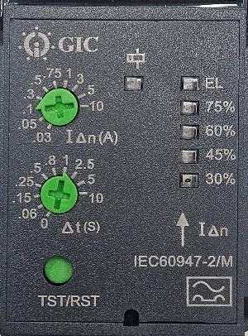
GIC ELR – leakage current (IΔn) and trip time (Δt) dials.
❑ HW-007 ELR leakage current and trip time set.
Expected: Leakage current = 0.1 In (A); trip time = 1 Δt (S).

B.4 IMD (insulation monitoring device)
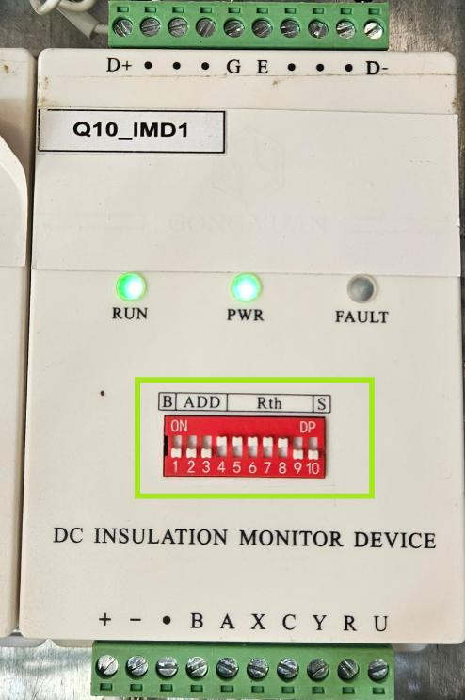
IMD address DIP block – enable switches 4 to 8 (10-switch block), same on both IMDs.
❑ HW-008 Both IMDs set to the same address – DIP 4 to 8 enabled.

B.5 AC energy meter (Selec)
❑ HW-009 Primary CT current rating set.
Expected: CT Primary = 200 A; Network = 3P4W.
Note: Confirm afterwards via IO Mapper: voltages/current/PF actual = display.
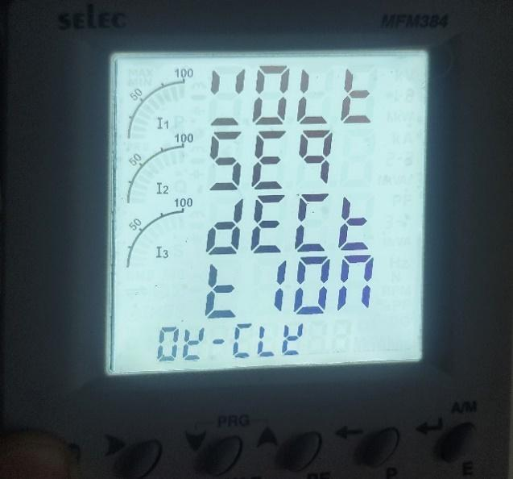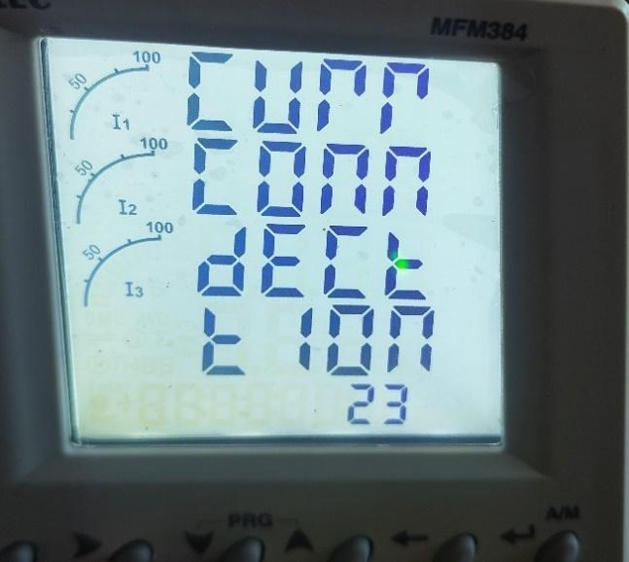
Left: phase-sequence check (hold V) → 'OK – CLK'. Right: current-connection check (hold I) → '23'.
❑ HW-010 Phase sequence check (hold 'V' 3 s).
Expected: Display reads 'OK – CLK'.
❑ HW-011 Current connection check (hold 'I' 3 s).
Expected: Display reads '23' (L2 & L3 reversed – required).
Note: If it reads '0', swap CT S1/S2 on L2 & L3, reboot the meter, re-check until it reads '23'.

B.6 DC energy meter (Dfun)
❑ HW-012 DC meter Modbus address, parity and shunt rating set (keypad password 1101).
Expected: Modbus address = Add-002; Parity = None; Shunt SH1 = 500 A, SH2 = 500 A.

C. Software Configuration & Testing
Network, firmware, controller/AB configuration, communication readback, charging and OCPP. Most of these steps are readable/assertable through the software interfaces, so they map directly to the automatable items in the companion checklist.

C.1 Router (network)
Model RB44 / Silbo. First-time setup over its own SSID (AP_…, password 12345678) at 192.168.1.1, then move it to the charger LAN.
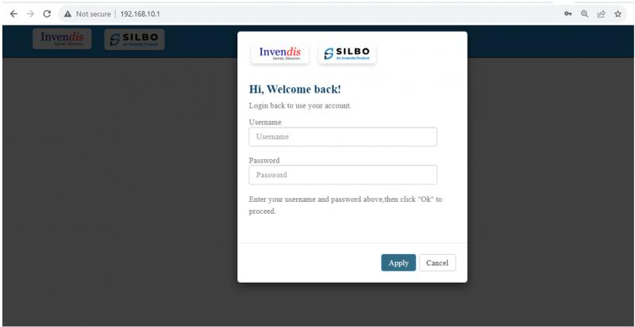
Router login – admin / admin.
❑ SW-001 Router Ethernet/LAN set to static IP and updated.
Expected: IP = 10.20.27.1; reachable on new address with admin / admin.
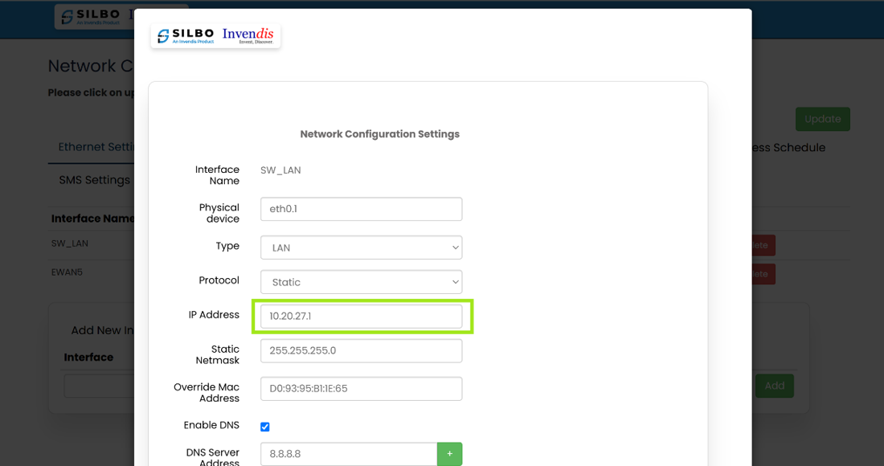
Network → Ethernet → set IP 10.20.27.1, then Save and Update.
❑ SW-002 WIFI client SSID & passphrase entered; router reaches internet (WAN up).
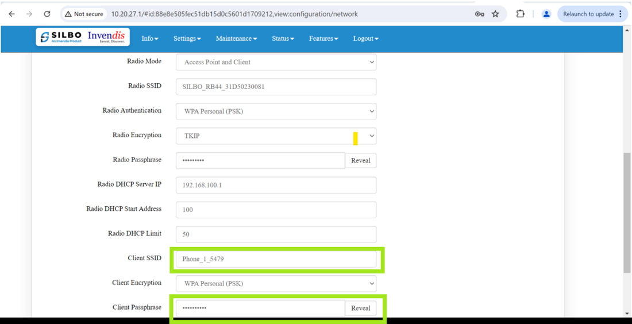
WIFI Settings – enter Client SSID and passphrase, then Save and Update.

C.2 Controller firmware & configuration (SECC / SECC-LE)
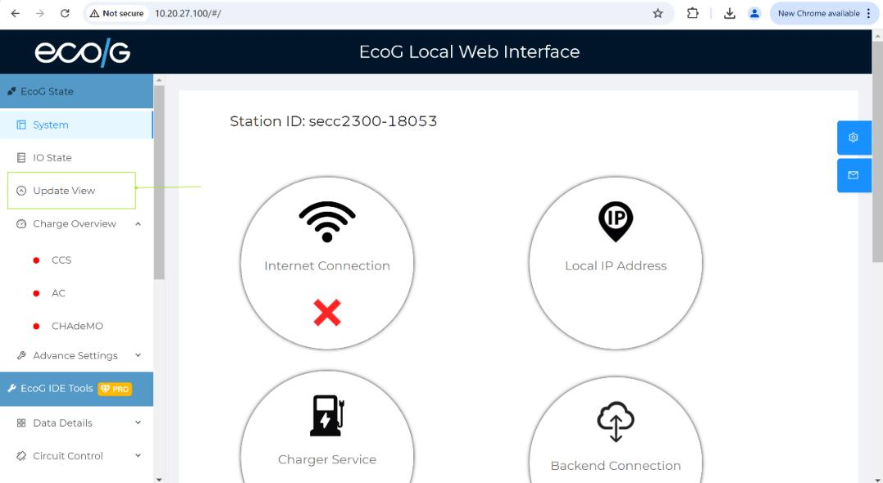
EcoG LWI → Update View – upload the .ecog-update file, run to 100 %, reboot, verify version.
❑ SW-003 SECC (10.20.27.100) and SECC-LE (10.20.27.101) updated to target release; firmware verified after reboot.
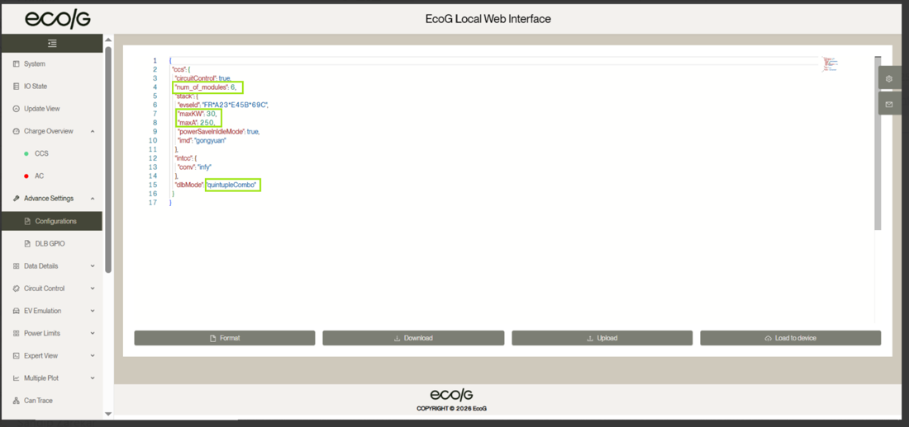
Advance → Configuration. Set the four values below on BOTH controllers, then 'Load to device'. (The screenshot shows the per-module defaults 30 / 250 – these must be changed for the 180 kW build.)
❑ SW-004 Controller configuration set on SECC and SECC-LE, then loaded to device.
Expected: num_of_modules = 6; maxKW = 180; maxA = 500; dlbMode = quintupleCombo.

C.3 Application Board (AB) firmware & OCPP config
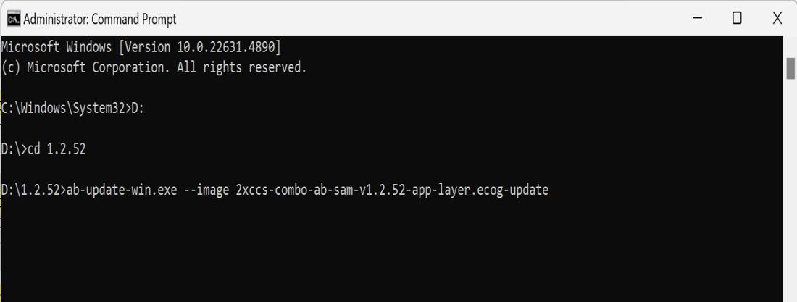
AB firmware update via command line: ab-update-win.exe --image <file>.ecog-update.
❑ SW-005 AB updated ('installation successful' + reboot); firmware verified via GET /release.
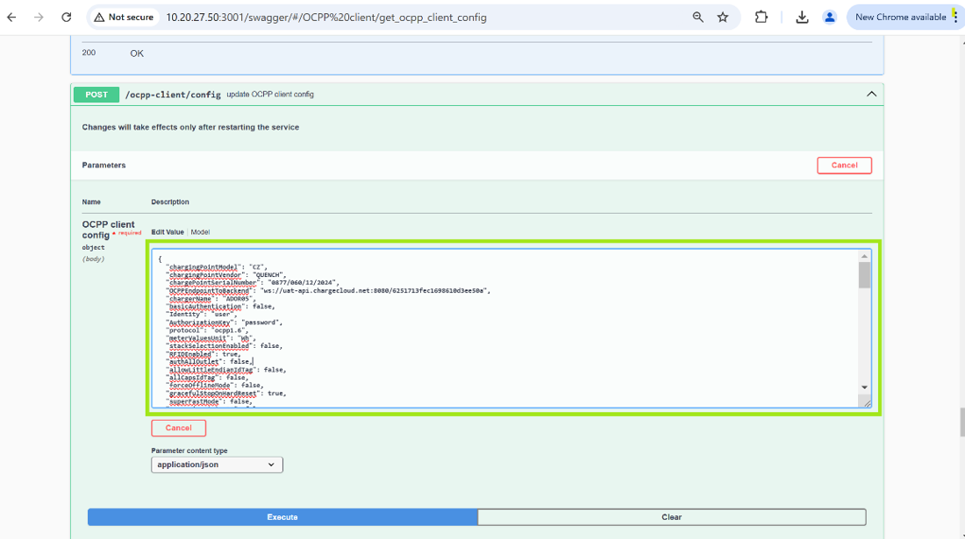
Swagger → POST /ocpp-client/config – edit and execute the OCPP config keys.
❑ SW-006 AB OCPP config set for this unit and verified via GET /ocpp-client/config.
Expected: chargingPointVendor = QUENCH; chargingPointModel = customer name; chargePointSerialNumber = unit serial; protocol = ocpp1.6; RFIDEnabled = true; OCPPEndpointToBackend = customer CMS URL; NumberOfConnectors = 2; powerSaveInIdleMode per requirement.
❑ SW-007 Confirm AB OCPP power/current limits intended for the 180 kW build.
Verify: PLTP example shows maxPowerLimitInkW = 80 and maxCurrentLimitInAmps = 200 (a 60 kW reference) while the controller is set to 180 kW / 500 A. Confirm the intended AB values – do not auto-correct if this is a deliberate CMS-side cap.
Note: Also confirm the two heartbeat keys (HeartbeatInterval = 300 vs HeartBeatInterval = 30) and dataTransfer VendorsId = [MSIL] against this build.

C.4 Communication readback (IO Mapper)
SECC LWI → IO Mapper → data. Confirm every device is online and live values are sane.
❑ SW-008 All 6 power modules communicating over CAN.
❑ SW-009 Meters & IMD online.
Expected: modbus.selec.online = true; modbus.dfun_dc.online = true; modbus.gongyuan_IMD.online = true.
❑ SW-010 IMD insulation resistance during cable check / charging.
Expected: 60000 (≥ 10 MΩ). 65535 indicates ≤ 10 MΩ (fault).
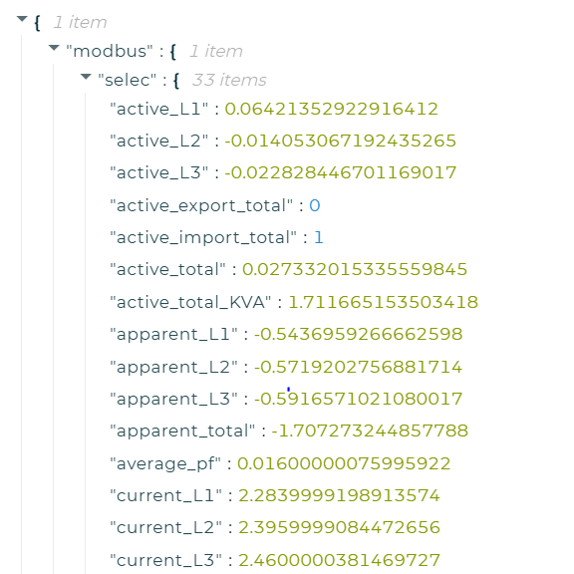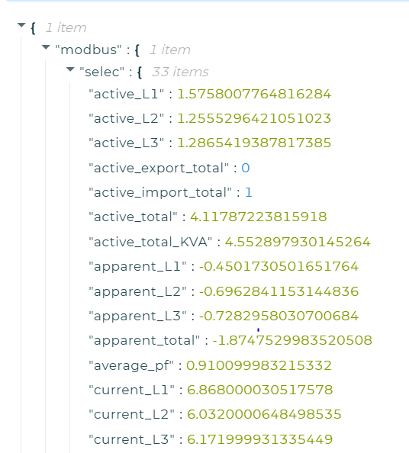
AC-meter values in IO Mapper. Left: idle (L1 +, L2/L3 −). Right: charging (all + , PF ≈ 0.9).
❑ SW-011 AC-meter sign convention correct (confirms CT direction).
Expected: Idle: avg PF +, Active L1 +, L2 −, L3 −. Charging: avg PF + (≈0.9), L1/L2/L3 all +, only active_import_total rising, export = 0.

C.5 Charging test (both guns)
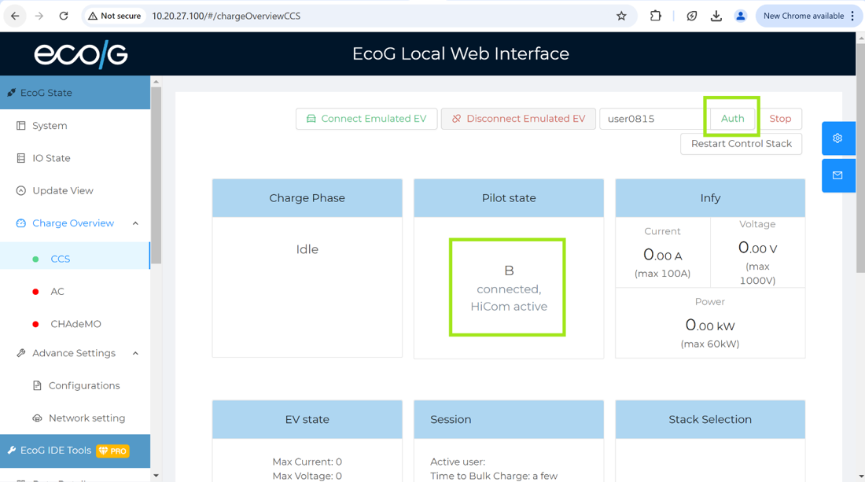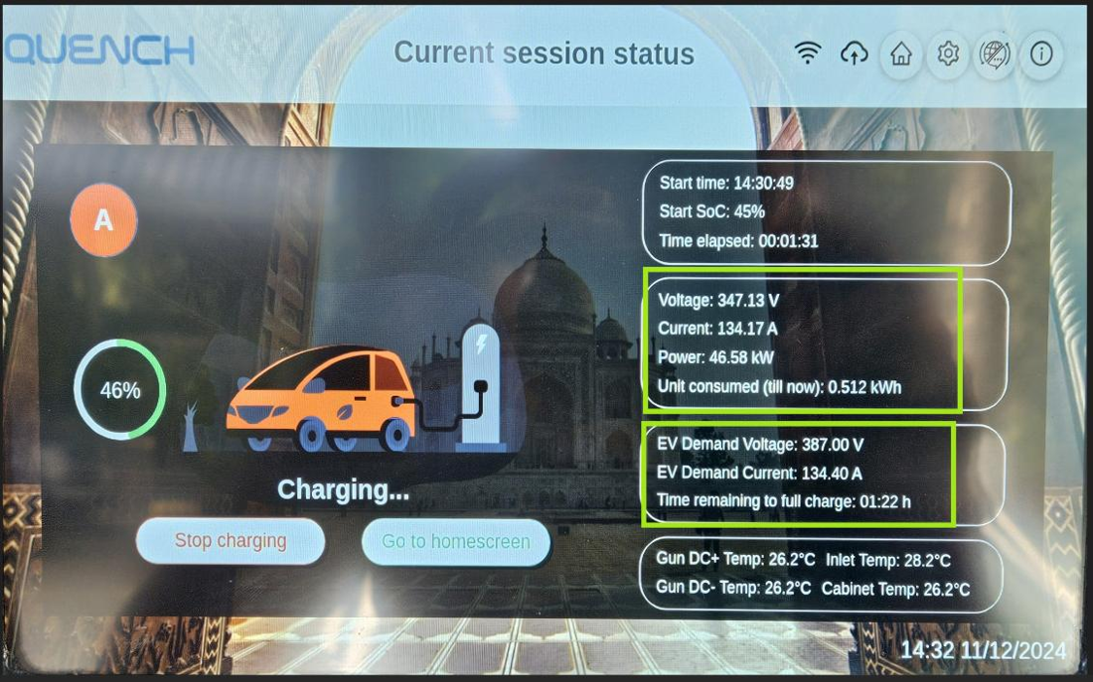
Left: LWI Charge Overview – pilot 'B connected, HiCom active'. Right: HMI live session screen.
❑ SW-012 Gun A pilot state on EV connect.
Expected: 'B connected, HiCom active'.
❑ SW-013 Authorize and run a session on Gun A; verify behaviour.
Expected: SOC matches vehicle; EV demand current = supply current; cable-check + pre-charge complete; clean stop/finishing.
❑ SW-014 Repeat the full session on Gun B (SECC-LE, 10.20.27.101).

C.6 OCPP & CMS
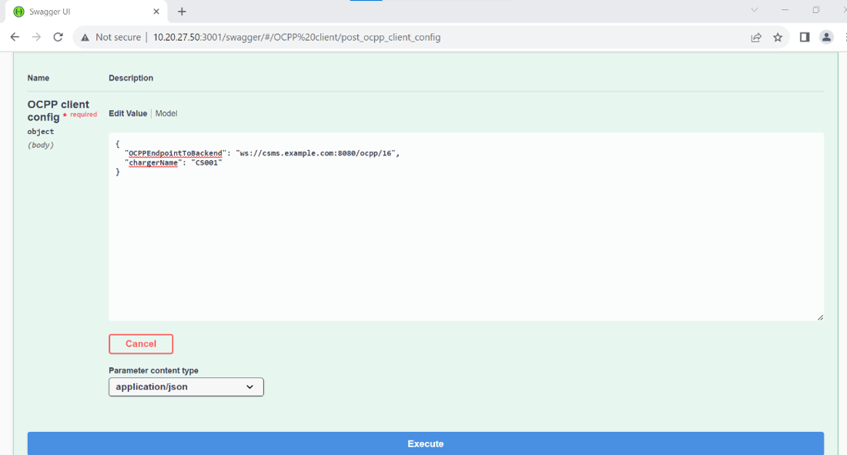
Swagger – POST /ocpp-client/config with CMS WebSocket URL + charger ID, then start and restart.
❑ SW-015 Connect to CMS (config → start → restart all return 200); cloud sign on HMI.
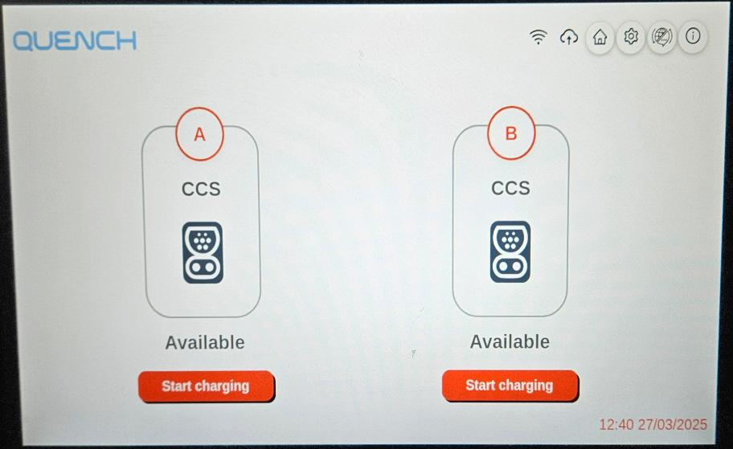
HMI – both guns 'Available' with CMS connected (cloud icon).
❑ SW-016 Authorization works by OTP, RFID and Remote; idle error codes verified across CMS log, screen and HMI alarm log.
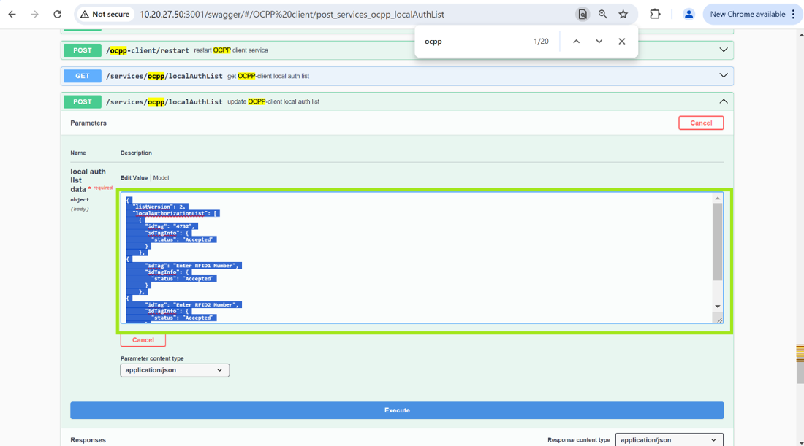
Swagger – offline local authorization list (OTP idTag + two RFID, status Accepted, updateType Full).
❑ SW-017 Offline OTP + 2 RFID loaded into local auth list; verified via GET.

Energy reset after OCPP test
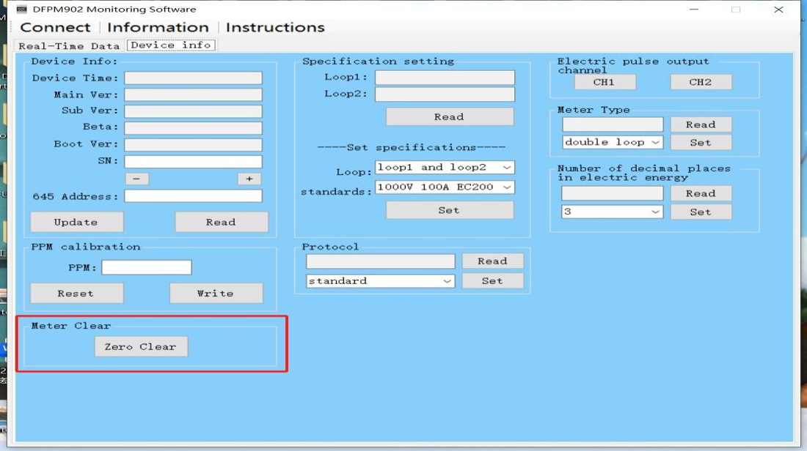
Dfun debug software – 'Meter Clear → Zero Clear' resets DC meter energy.
❑ SW-018 Reset AC meter energy (per AC-meter manual) and DC meter energy (Dfun 'Zero Clear').
End of guide. Record each item's result in the companion ADLB_180kW_Test_Checklist.xlsx (Actual / Result columns).

