**Report Work**

**Comparison Ephemeris, Prop0 fast, Prop0 all:**

**Chosen situation:**

LRO Spacecraft on 04/01/2021 for 1 hour (half a tour)

**Original position J2000:**

[ 3.81282724e+02, 1.02198780e+03, -1.42503932e+03, -1.31649576e+00, -6.17800830e-01, -8.18155142e-01]

**Final Position:**

**True:** [-3.48323382e+02, -1.03810994e+03, 1.50888855e+03, 1.28502153e+00,

6.44265532e-01, 7.16275917e-01]

**Fast:** [-3.48141393e+02, -1.03797117e+03, 1.50884682e+03, 1.28517466e+00,

6.44390569e-01, 7.16173062e-01]

**Prec**: [-3.48337832e+02, -1.03812600e+03, 1.50889371e+03, 1.28500874e+00,

6.44248647e-01, 7.16287541e-01]

**Absolut sum on Pos:**

True/Fast: 0.3624902547491047 km

True/Prec: 0.03567712986932747 km

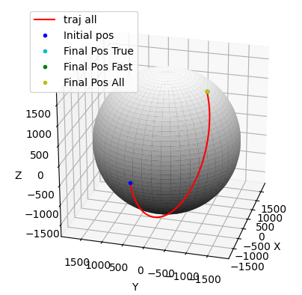

**Chosen situation:**

LRO Spacecraft on 04/01/2021 for 1 day (~12 lap)

**Original position J2000:**

[ 3.81282724e+02, 1.02198780e+03, -1.42503932e+03, -1.31649576e+00, -6.17800830e-01, -8.18155142e-01]

**Final Position:**

**Fast:** Comp Time = 1s

**Prec**: Comp Time = 2s

**Absolut sum on Pos:**

RMSF: 17.636638561800453 km

RMSP: 1.735950648400376 km

**Chosen situation:**

LRO Spacecraft on 04/01/2021 for 10 days

**Original position J2000:**

[ 3.81282724e+02, 1.02198780e+03, -1.42503932e+03, -1.31649576e+00, -6.17800830e-01, -8.18155142e-01]

**Final Position:**

**Fast:** Comp Time = 9s

**Prec**: Comp Time = 23s

**Absolut sum on Pos:**

RMSF: 551.8294220726702 km

RMSP: 530.4445375455846 km

**Chosen situation:**

LRO Spacecraft on 04/01/2021 for 1 month

**Same original position J2000**

**Fast:** Comp Time = 30s

**Prec**: Comp Time = 1min

**Absolut sum on Pos:**

RMSF: 3513.65653314265 km

RMSP: 3527.122912925529 km

Two propags are on the same spot. Pretty far from the true one

1 day, 60s: 3s

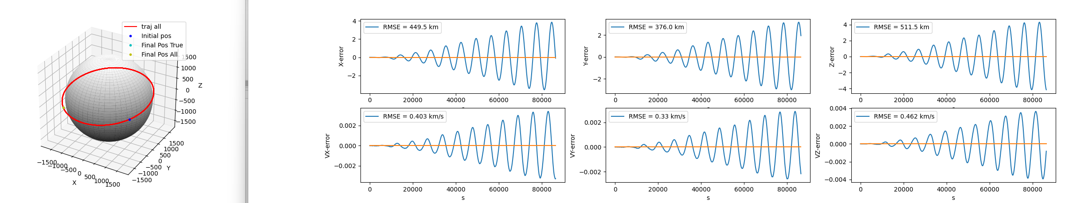1day, 1s: 4s

Ccl: 12 cycles: 2h = 1 lap 🡪 Bad geopotential. Maybe a clock error

Study on 1h = half lab: increasing potential

Exp 1) 1h, 0.01s, cputime=1.8s, n=3 :

Exp 2) 1h, 0.01s, cputime=1.8s, n=10 :

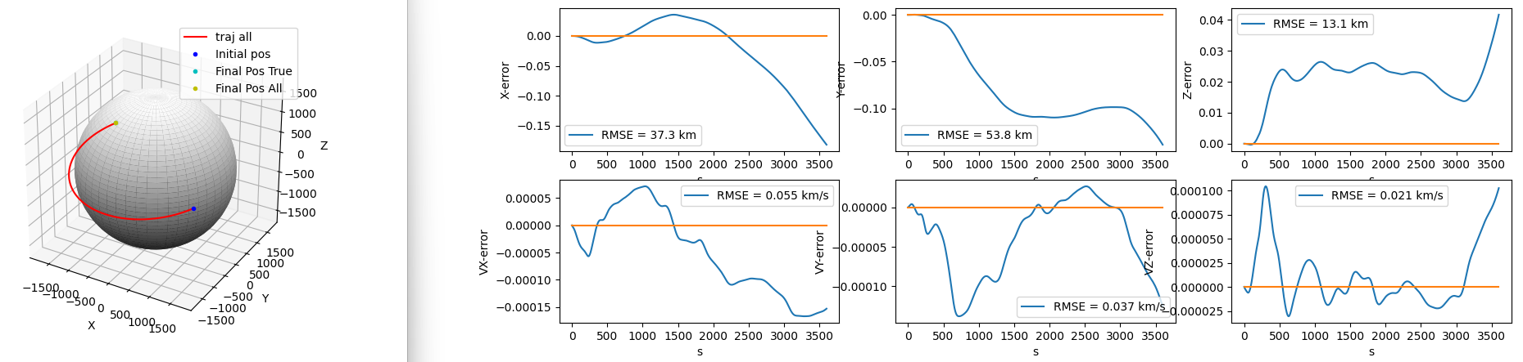

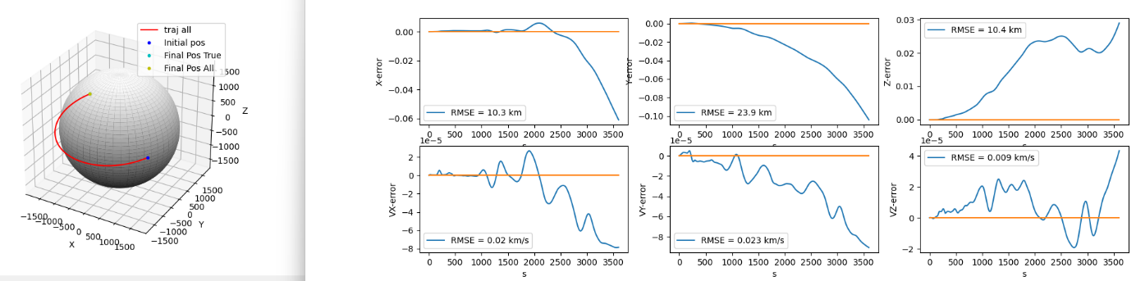Exp 3) 1h, 0.01s, cputime=2s, n=100 :

Exp 4) 1h, 0.01s, n=165 : cputime=1.95s

Exp 5) 1h, 0.01s, n=165, add all pert : cputime=1.98s

Exp 6) 1h, 0.001s, n=165, add all pert : cputime=16s (pytime 2min)

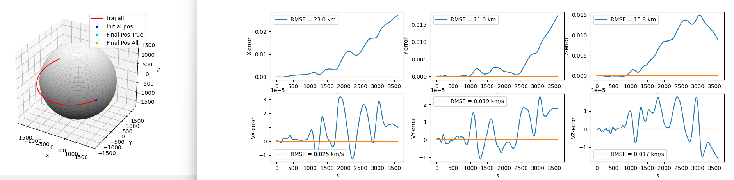

CCL:

* Improving the geop model helps a lot until a certain threshold n~70
* Adding all pert. helps also a lot and doesn’t add too much comp time.
* Reducing the timestep by 10 improve results by less than twice
* Increasing the timestep don’t reduce results
* CPU time very low

Exp 7) 1h, 0.1s, n=70, add all pert : cputime=0.3s 🡪 best choice

Disturbing CCl:

* Periodicity of error : because movement is periodic
* Reducing timestep doesn’t improve result

Hypothesis:

* Delay between true and sim, clock error
* Higher rank geop not well loaded

Study to try:

* Print true movement of satellite, 6 graphs 🡪 Sin curve
* Print last ranks

**Study 3: role of the timestep in the errors**

Exp6) 1day, 0.1s, precise: CT = 5.3s

Exp1) 1day, 1s, precise: CT = 2.4s

Exp2) 1day, 15s, precise: CT = 2.16s

Exp3) 1day, 30s, precise: CT = 2.17s

Exp4) 1day, 60s, precise: CT = 2.25s

Exp5) 1day, 300s, precise: CT = 2.37s

**Study 4: Improvement of the Lun Geop 🡪 1200 Nasa 2016**

Reference) 1day, 30s, Old (70*70): CT = 2.64s

Exp1) 1day, 30s, New (70*70): CT = 2.69s

Exp5) 1day, 30s, New (130*130): CT = 4.7s

Exp6) 1day, 30s, New (165*165): CT = 6.57s

Exp2) 1day, 30s, New (200*200): CT = 9.5s

Exp3) 1day, 30s, New (400*400): CT = 34s

Exp4) 1day, 30s, New (600*600): CT = 77s

Exp7) 1day, 30s, New (1200*1200): CT = 284s

CCl:

* Quadratic evolution of time (logic)
* Strange evolution of the RMSE
* Sort of shift to the left

**Studies Sum up:**

**Reference situation**: LRO Low lunar polar orbit, 1day, 60 sec, all pert, 70*70 geopotential

**Study of gravitational field:**

Try to change the Gravity field: 1200 Grail one

CT increase but performance doesn’t

**Study of Time step:**

Not what we could think: Reducing timestep don’t improve the accuracy

**Study of ode parameters:**

Decreasing RelTol improve results but threshold (at constant AbsTol) and time increases

Changing AbsTol don’t change anything

