**Report Work**

**Study 5: Improvement of the Lun Geop 🡪 GRAIL 2021**

Reference) 1day, 30s, Old (70*70): CT = 3.53s

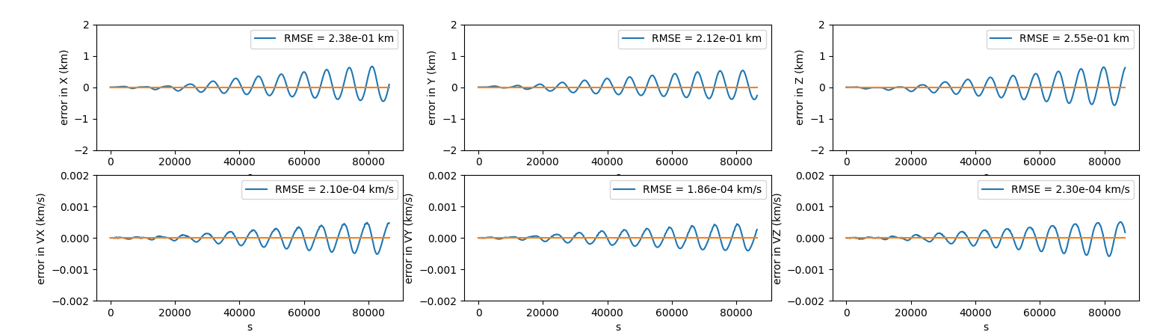

ReferenceMax) 1day, 30s, Old (165*165): CT = 11.67s

Exp1) 1day, 30s, New (70*70): CT = 4.19s

Exp2) 1day, 30s, New (350*350): CT = 37.6s

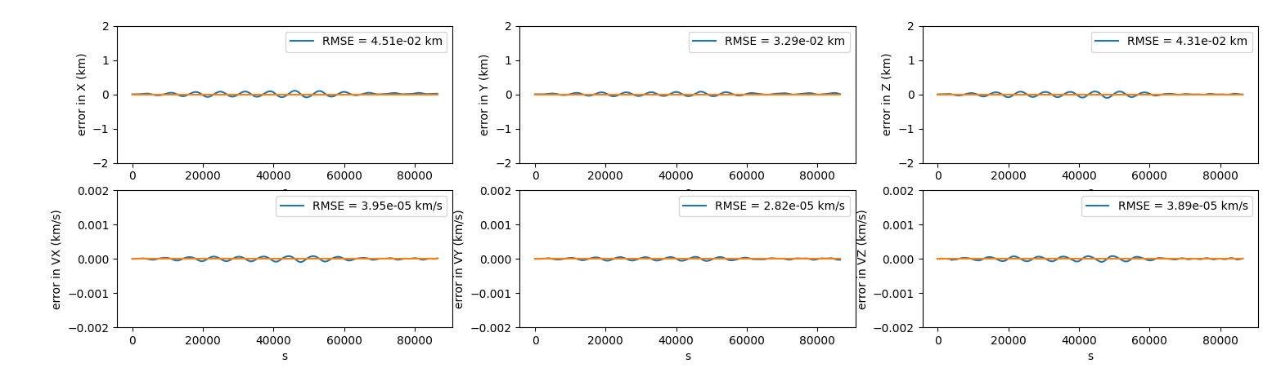

CCL There’s a real improvement of the GRAIL geopotential model 🡪 Keep

**Study 6: Implementation of Lunar Solid Tide**