Quentin Dye’s Portfolio

Central New Mexico Community College
Advisor—Robert Garner
Fall 2021

Table of Contents
Class Construction
Inheritance and Ploymorphism
GUI Construction
Database Manipulation
Web Research

1.0 Class Construction
1.1 Java:
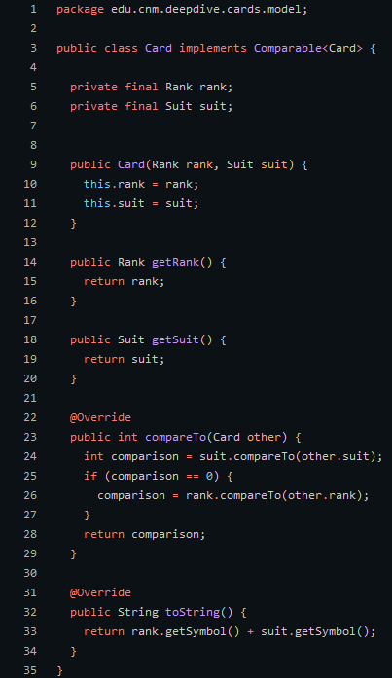
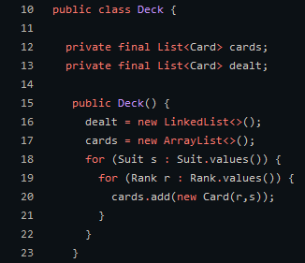
This example can be found on github. The class structure in java is fairly simple once you learn it. The only thing that is required is the class keyword and a valid class name. Almost anything you could imagine is a valid class name but you should stick to the uppercase noun convention. While those are the only things required in class declaration it has a lot more going on. First the implements keyword followed by an interface. This gives us the ability to override the compareTo() method. We also override the toString() method though that is not apart of the Comparable<T> interface. Finally we have a couple final variables called rank and suit which are set in our overloaded constructor. This example uses the card class to create a deck of cards. Each have a suit and rank, which is set automatically by the card constructor. Each unique card is added to the cards Array-List.

1.2 C++:
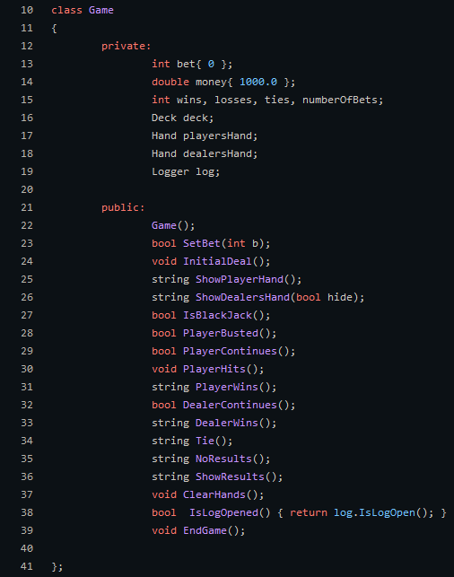
In C++ the way classes are created are actually done in the header files. This is a game class for a card game called craps. As you can see this class structure here in c++ is far different than that of java. For example in java you need to set each member variable as public or private but it c++ you simply have a block of private variables/methods and a block of public variables/methods. In the actual c++ files Game.cpp we find that there is no class, but methods that define they are apart of the game class as shown below.
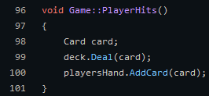
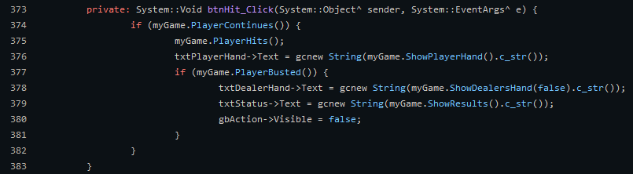
In the code above we actually see our game class in action as we have a button click event the triggers some methods like ‘PlayerContinues()’ and ‘PlayerHits()’ which continues the game, and alters the state of the actual game object.
1.2 C#:
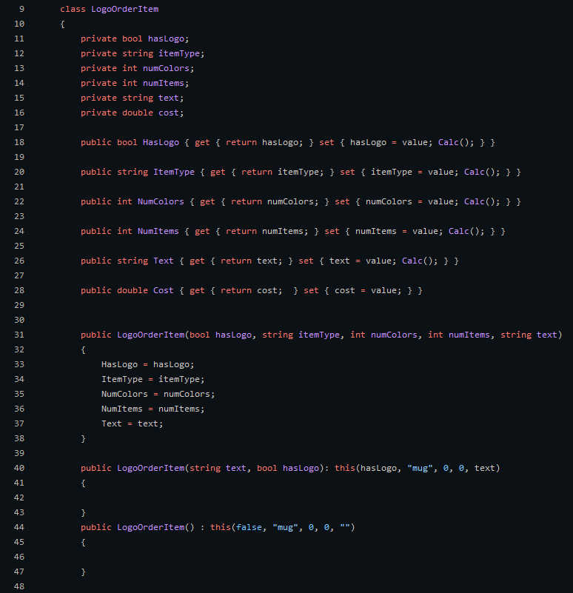
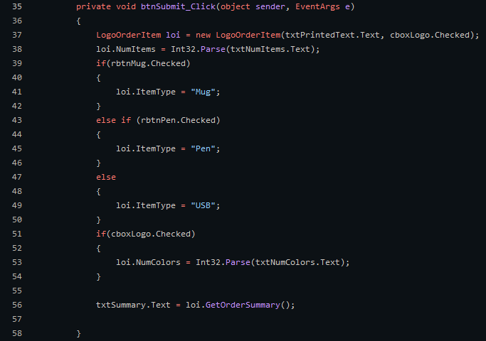
In C# the actual class declaration is similar to java in that the only thing required is the class keyword and the valid Class name. The big difference in C# is that you can have these things called properties that eliminate the need to create setter and getter methods for each private variable for proper encapsulation. C# also gives us the ability to do what is called constructor chaining. While you can do this in java I did not have a good example. Constructor chaining gives us the ability to reduce code redundancy and set default values fairly easily.
In the code we have a button click event that creates a LogoOrderItem grabs all of the relevant data and calculates the final price. It then calls its GetOrderSummary method to display the relevant info to the user.

2.0 Inheritance and Polymorphism
In programming inheritance is the idea that a base class can pass on properties and behaviors to another derived class. In this example I have programmed Conway's game of life. LifeCell is the base cell type for all other cell types.
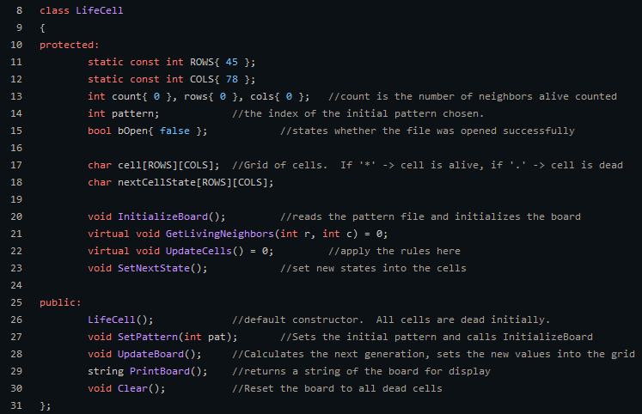
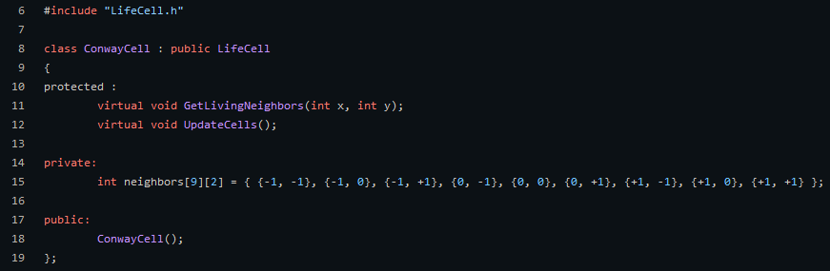
The ConwayCell class, as seen below, inherits from the LifeCell class. As you can see this only implements the virtual classes from LifeCell, all other methods are already done by using LifeCells methods.

In the code below we see the creation of an array of LifeCell pointers. We then add 5 unique Cell Type objects to the array. This works because all of the Cell types seen below are children of the base class LifeCell.
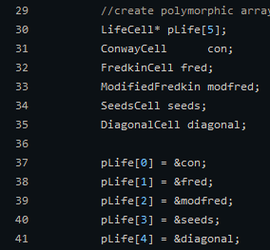
In the code below we see that our array of LifeCell pointers is being used to update our UI which we refer to as UpdateBoard(). How does this happen if each pointer is a unique type?
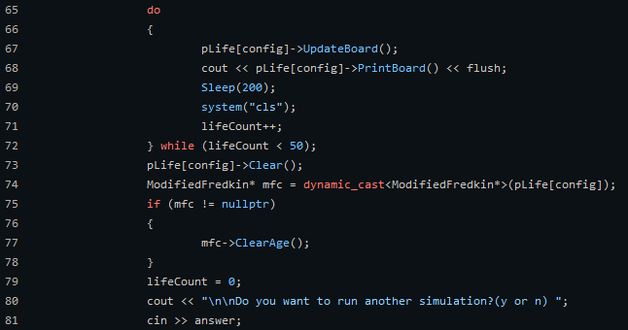
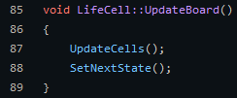
While UpdateBoard is a base class method only it calls UpdateCells() which is unique to each type. This gives us the ability to quickly switch between types and utilize unique behavior in each.

3.0 Graphical User Interface Construction
While at CNM I created both windows form apps in both C# and C++. I also created some java GUI Applications using JavaFx. Although I believe in general C# and C++ are better when developing Desktop applications. The only down side is neither are very easy to port over to Mac or Linux. Below you see a group project I worked on in my first year that lets you play Blackjack.
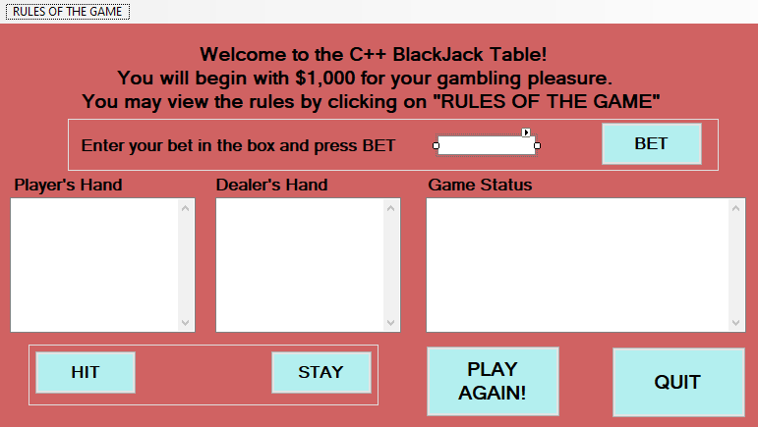
Creating these forms is fairly simple with Visual Studios design mode, though there is also the option to write these forms using code. Although this difficult to visualize without actually looking at the form, so the designer mode is easiest. If you name all of you elements appropriately writing code to utilizing this GUI is fairly simple. The only difficult part is converting the type returned by the element to a useful type like Integer or String.
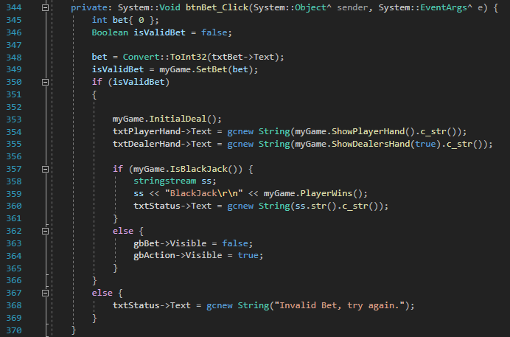
As you can see below this is the on click method written for the ‘bet button’ name ‘btnBet.’ To write code to use this UI we use the elements name and the element propertie we want. For example ‘txtBet→Text’ will return the text property associated with the txtBet element.

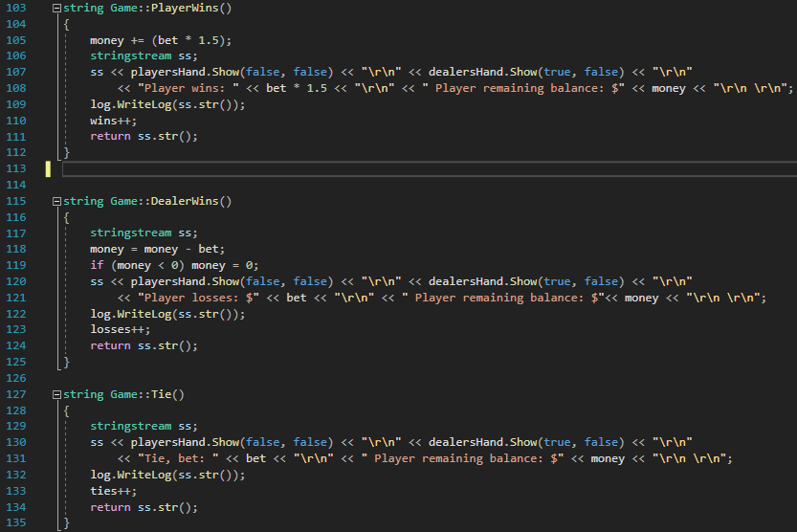
This program also keeps track of all of the wins and losses via a file it writes to every time the player wins, losses or ties with the dealer. It also performs a close action to summarize the games played while the logger was open.
This GUI Application gives the user the ability to play black jack and

4.0 Database Manipulation:
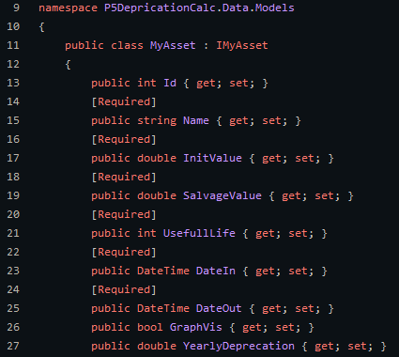
Connecting to a database was one of the more challenging things but I was able to accomplish this with both java spring and c#. This example uses C# with Linq.

