Research Methods E. Meunier

Densely Connected

Convolutional Networks

[Gao Huang](https://arxiv.org/search/cs?searchtype=author&query=Huang%2C+G), [Zhuang Liu](https://arxiv.org/search/cs?searchtype=author&query=Liu%2C+Z), [Laurens van der Maaten](https://arxiv.org/search/cs?searchtype=author&query=van+der+Maaten%2C+L), [Kilian Q. Weinberger](https://arxiv.org/search/cs?searchtype=author&query=Weinberger%2C+K+Q)

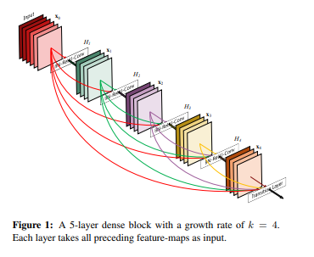

BOERSMA Hélène

JAOUEN Guillaume

COURTOIS Quentin

Introduction

DenseNet is a paper release on January 28th 2018, its acronym stands for Densely Connected Convolutional Networks. A classical convolutional networks usually has the same number of connections and layers with a linear scheme where as in DenseNet, we find convolutional networks that connect each layers to each other in cascade, therefore the number of connections is L(L+1)/2 connections. Each previous layers output are used as connections for the next one.

Conv networks that connect each layers to each other

classicial conv nets : L layers have L connections

Here : L(L+1)/2 connections

Each previous layers output are using as connection for the next

Advantages :

- Vanishing gradient solving ( weights receives update

proportionally to the partial derivative of the error function with respect to the current weight.

Problem : gradient will be vanishingly small effectively preventing the weight from changing its value )

- Strenghten feature propagation

- Reduce number of parameters

Benchmark on multiple DataSet widely used for competition & testing (cifar,imagenet)

Significant improvement on the state-of-the-art conv nets

Clean available implementation

No hyperparameter tuning except LR that is modified during training

Dropout layers

Less overfitting than other models

Can be scaled to hundreds of layers easily

Achieve state-of-the-art with less parameters & computational power

- I - partie avec introduction du papier

- Contexte, présentation, comparaison

- Description du DenseNet

- Résultats & Expériences

- II - Implémentation permettant de donner une idée de comment ça fonctionne

-

Usning this implementation of pytorch :

https://github.com/bamos/densenet.pytorch

Changing some structure of the code to make it work with pytorch current version

https://github.com/NVIDIA/flownet2-pytorch/issues/113