Levi Amen

Quentin Covert

Mark Hernandez

Cameron Johnson

Collin Victor



CSCE 361

Dr. Cohen

**Phase II Report**

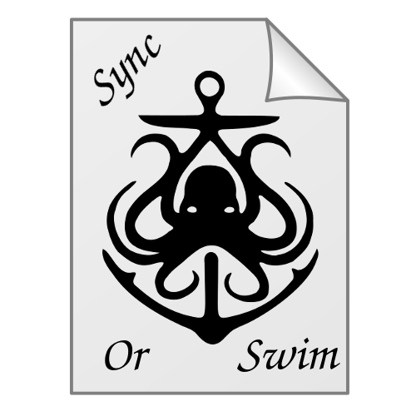

1. Communication Mechanisms:
   1. Our primary form of communication is through a designated Slack channel set for use by all Sync or Swim team members. We also use Google Hangouts for remote meetings, should in-person meetings prove infeasible. The majority of our work is done remotely through Google Drive, where we also communicate as we work.
2. Team Members, Structure and Roles:
   1. Members:
      1. Levi Amen
      2. Quentin Covert
      3. Mark Hernandez
      4. Cameron Johnson
      5. Collin Victor
   2. Structure:
      1. We subscribe to the Valve Corporation style of management: pure horizontal positions. No one is anyone’s actual manager during development. While it is true that Cameron has emerged as our de facto leader, no one on the team technically holds predefined authority over development.
   3. Roles:
      1. Team Lead: Cameron
      2. Developers: Levi, Quentin, Mark, Cameron and Collin
      3. Repo Owner and Slack Manager: Quentin
      4. UI Design and Management: Levi
3. Progress:
   1. As of the time of writing for this report, the final touches are being placed on the Written Specifications for the deliverable. All other diagrams have already been created.
4. GIT Policies
   1. All major design work will be done on separate branches. Smaller changes (like adding files) will be done via direct commits to master. Before merging, all code is reviewed by any relevant team members, changes will be discussed and made if needed, and then the branch will be merged into master. Creation of new branches will be done ad hoc.
5. Brainstorming Techniques:
   1. The general idea for the project was pitched to us by Team Lead Cameron and was further refined through discussion amongst the team and with Doctor Cohen
   2. The use cases were brainstormed by acting out and discussing how a user could use the system based on the discussions that had already been made about it.