Levi Amen

Quentin Covert

Mark Hernandez

Cameron Johnson

Collin Victor



CSCE 361

Dr. Cohen

**User Manual**

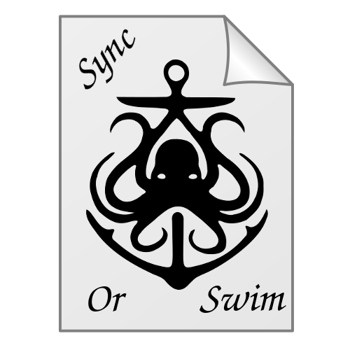

# Index:

## Installation and Initial Setup

## Proper Usage and Procedures

## Database Integrity

## Installation and Initial Setup

### Dependencies

* + 1. A Linux distribution based system.
    2. SQLAlchemy v1.1.4
    3. Python v3.4.1
    4. PyQt4 v4.11.4 (Qt version 4.8.7)
    5. Watchman v4.7.0

### Installation

* + 1. For SQLAlchemy, Python 3.4 and PyQt4 follow the linked installation guides to install these softwares on your system:
       1. <http://docs.sqlalchemy.org/en/latest/intro.html#installation>
       2. <https://www.ics.uci.edu/~pattis/common/handouts/pythoneclipsejava/python.html>
       3. <http://pyqt.sourceforge.net/Docs/PyQt4/installation.html>
    2. For Watchman, we suggest using our following guide on getting it installed on your system:
       1. <https://github.com/QuentinCovert/SyncOrSwim/blob/master/additional-info-watchman-installation.md>
    3. Once all the proceeding programs have been properly installed on your system, follow theses instructions to setup SyncOrSwim:
       1. Download the SyncOrSwim.zip file available on the GitHub releases page.
       2. Unzip the file into your Programs directory.
       3. (Optional) Create a Sync link to the Main.py script on your desktop.

### Initial Setup of SyncOrSwim

* + 1. When you first start up SyncOrSwim on a computer you’ll see the follow window. The Sync directory will be the directory you’ll store files you wish for SyncOrSwim to encrypt and sync to the remote directory, which you’ll specify in the next line. The remote will have to be a located in the local filesystem, but it can be, and is encouraged to be, a flash drive or external hard disk drive.

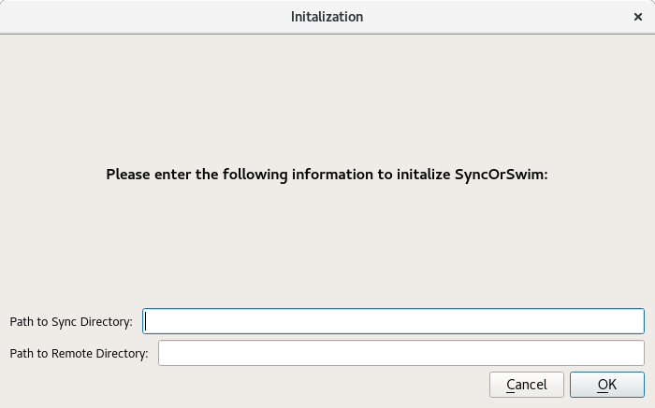

* + 1. Next you’ll be prompted about an Access Key. Currently none will be present on your system, so press No to continue.

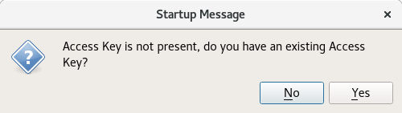

* + 1. Now you’ll be prompted with the following window. Be sure to read the warning carefully. A good setting to be safe is 100 MB as indicated below.

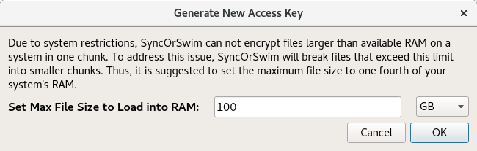

* + 1. Now you’ll be greeted with the SyncOrSwim GUI and you’re ready to go!

## Proper usage procedure

### Normal Operation

Our product is aimed at allowing you to transport and backup your files with peace of mind. This means no busywork is needed to have your files backed up or encrypted! Simply create, or copy and paste, files and directories into SyncOrSwim’s Sync directory and it will handle the rest.

Upon startup of the SyncOrSwim program, it’ll download and decrypt the Remote directory into the Sync directory. This will make the Sync directory appear as it did when SyncOrSwim was last watching it. The application will then begin to watch the Sync directory to look for any changes or additions to the directory. Any changes made while SyncOrSwim is open will be reflected onto the remote in the form of encrypted files.

**Note:** the remote directory will not have the same file structure the Sync directory will, this is done intentionally. By not mirroring the file structure and instead having a flat directory with files having randomly generated names, SyncOrSwim guarantees greater protection if the remote were to be accessed by another party.

### Using Remote Between Computers

SyncOrSwim has been designed to allow you to access and work with the same files located on the remote between two different computers. To do this, you’ll follow similar instructions found in Installation and Initial Setup section, but with these key differences in the SyncOrSwim Setup:

* When selecting the remote directory, enter the path to the same remote directory used by the first computer. Note that if you’re using a flash drive to store the remote, the actual path may vary slightly.
* When prompted about an Access Key not existing, indicate that you do have an existing Access Key, then give the path to the same Access Key used by the first system. This Key can be found in the SyncOrSwim’s install directory under the resources folder as: *global_settings.p*. It is suggested you provide this key via moving it to the second computer using a flash drive, then deleting it off the flash drive once finished.

Once this all has been successfully done, SyncOrSwim will follow the same process found under part a. An indication of success will be if the Sync directory on the second computer contains the same files and directories as found in the Sync directory on the first computer.

### Warnings and Pitfalls

Unfortunately, SyncOrSwim is not without it’s issues, and these are some you should be mindful of when using SyncOrSwim:

1. Currently the Item Ignored and Auto-Encrypt Enable drop down menus do not have any functional code tied to them. These GUI elements will begin to be operational with later releases of SyncOrSwim. They will have no effect on the program's performance.
2. SyncOrSwim cannot track changes to files in the Sync directory unless it’s open. **Any changes to files already watched by SyncOrSwim made while the application is not open will be overridden once it is opened.** This is due to the application replacing them with the versions found on the remote. This issue does not extend to new files created in the Sync directory while SyncOrSwim is not open.
3. Losing the Access Key, i.e. the *global_settings.p* file, will mean the remote can no longer be accessed.
4. Files or directories deleted in the Sync directory of one computer will not be deleted on any other computer that uses the same remote. They will have to be deleted locally on each individual computer. If they are not deleted on other computers accessing the same remote, it is possible for the deleted file to later show up on the system where it was originally deleted.
5. SyncOrSwim will not function correctly if the remote is not present in the local filesystem.
6. See below for concerns regarding the database used by SyncOrSwim.

## Database Integrity

## SyncOrSwim requires the use of an sqlite database to manage the file system structure, securing the database integrity is an important part of maintaining a project. In case of catastrophic database failure, a sql script has been provided to create a new empty database. A sqlite database file titled SyncOrSwimDB.db must always be present in the resources folder of the project. If this file is missing, create a new file with this same name, and paste the text from resources/database_builder.sql into the editor to create the database.

## Alternatively, if you have sqlite3 on linux, run “sqlite3 SyncOrSwimDB.db < database_builder.sql” from the command line while inside the resources folder. This should rebuild a blank database and allow the program to proceed.