# How to use

Disclaimer

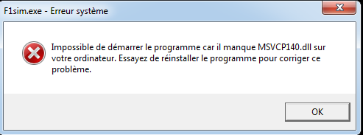

If you have this error it means you missed some redist package.

Please install VC_redist.x64.exe which is packaged with the executable.

At the beggining of the simulation

The program asks you if you want to manually choose which adjustments to do every lap or to let the program handle that.

During the race simulation

Every lap you can choose to make a pit stop and make an adjustment by pressing the corresponding number.

0 = Nothing

1 = Tyre pressure

2 = Tyre wear

3 = Fuel tank

4 = Motor's oil wear

5 = DRS wear

6 = Anti-lock braking system wear

7 = brake system wear

666 = ?