Introduction

This website is to make losing someone at least a little easier. Its purpose to allow families to easily plan a burial. The intended audience is a family who has lost a loved one, or someone who is planning a burial for when they pass away.

Github

Github URL to open the website on a browser

<https://quentinquaile.github.io/WebDesign/>

URL of Github Repository

<https://github.com/QuentinQuaile/WebDesign>

Original Mockup sketch of Website home page

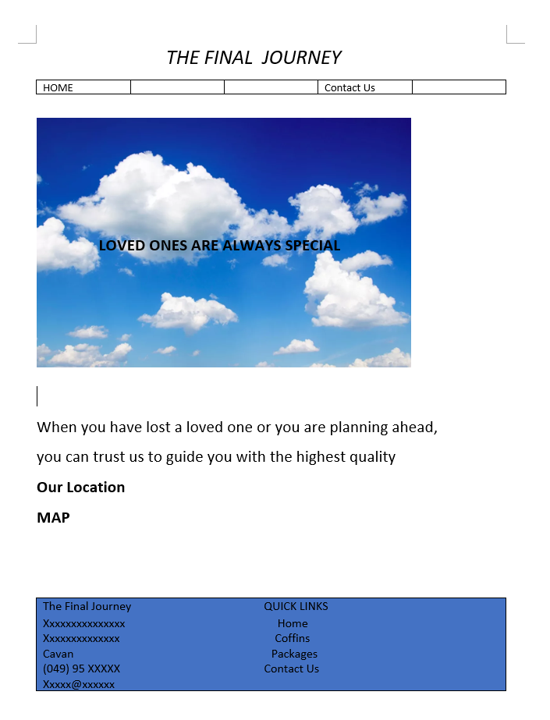

Website Described

Page 1 – This page is used to introduce you to the website and allow you to see where the organisation is located. The sky picture and favicon was found on google images that was free to be reused. The home icon was drawn by me.

Page 2 – This page is used to show examples of bundles that could be purchased on the website. The page uses a slide show. This was done by using a script so when you click the arrow it goes forward one, and when it goes above the max number of pictures it loops. The pictures in slide show were found on google images free to be reused. The picture depicting a headstone and coffin in top left was drawn by me.

Page 3 – This page is specifically for headstones. I used to give examples of symbols that can be put on a headstone and what they represent. I then also had a youtube video to show Irish headstones. The picture of a coffin in top left was drawn by me.

Page 4 – The survey was made to be linked after the headstone page so that the person filling out he survey will have some idea of what they may want to order.

Page 5 – This page was made so that the person on the website could contact the owner given the following details and what time they are open. The picture in the center of page and phone icon in top left were both drawn by me.