Project Requirements for Together

Vision
Creating a generic gaming software/platform/library which will use a computer/tv screen as the view and smartphone as a controller to allow people to play together at video games without having to carry, or buy, a heavy controller. Most of the people have a smartphone which can be used as a substitute and can even be made “smart”. This library will allow games to be easily built with its component (network, controller, …).

Goals

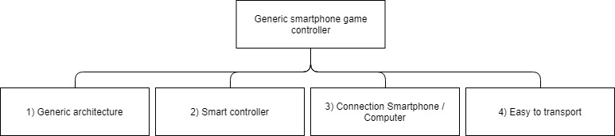

System context

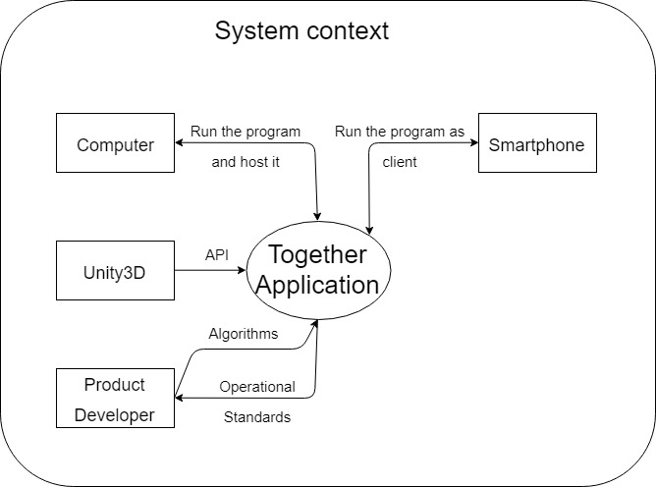

Legend and additional information:
Table columns definition
• Nr := identification number
• P := Priority (3 levels expressed in with numbers: 1;2;3)
• V := Variability (3 levels expressed in with numbers: 1;2;3)
• C := Complexity (3 levels expressed in with numbers: 1;2;3)
• R := Risk calculated from {P;V;C} (numerical value)
• Status := planned (will be done) / stand by (nice to have) / done
• Goals := goals reference(s)

Functional Requirements
Number |  | Description | Status | P | V | C | R | Goals
1 |  | Connection
 | 1.1 | Connection from smartphone to computer. | Approved | 3 | 1 | 2 | 1.83 | 3
2 |  | Build generic
 | 2.1 | The system must be designed to allow for optimal extensibility and reusability. | Approved | 3 | 3 | 3 | 3 | 1
3 |  | Extendable
 | 3.1 | Dynamic HUB which accept new games | Approved | 2 | 1 | 3 | 2.17 | 1
4 |  | Smartphone possibility
 | 4.1 | Exploit the components of the smartphone to deepen the singularity of the concept. | Approved | 3 | 1 | 1 | 1.33 | 2
5 |  | User Interface (UI)
 | 5.1 | Design and implement a UI that allows the user to interact with the system on smartphone using touch technology. | Approved | 3 | 1 | 1 | 1.33 | 2
 | 5.2 | Design and implement a UI that allows the user to interact with the system on computer. | Approved | 3 | 1 | 1 | 1.33 | -

Technical Requirements
Number |  | Description | Status | P | V | C | R | Goals
1 |  | Software
 | 1.1 | C# | Approved | 3 | - | - | - | -
 | 1.2 | Unity3D 2018.3.7f1 or lower 2018 version. | Approved | 3 | - | - | - | -

5.3 Quality Requirements
Number |  | Description | Status | P | V | C | R | Goals
1 |  | Platform compatibility
 | 1.1 | Compatibility with Android / Apple phones | Approved | 2 | 1 | 2 | 1.83 | -

Stakeholder Descriptions

Thesis advisor
Prof. Dr. Hudritsch Marcus

Interests:
- The project owner wants to satisfy the users
- The game should be windows runnable

Product owner / Development team
Flückiger Quentin

Interests:
- The development team wants to develop a way to link people through their hobby of playing on their smartphone

User
Everyone who wants to experience multiplayer cross-platform mobile game.

Interests:
- Spending an enjoyable time playing the games.

