ORGANIZATIONAL STRUCTURE
& ORGANIZATION CHART

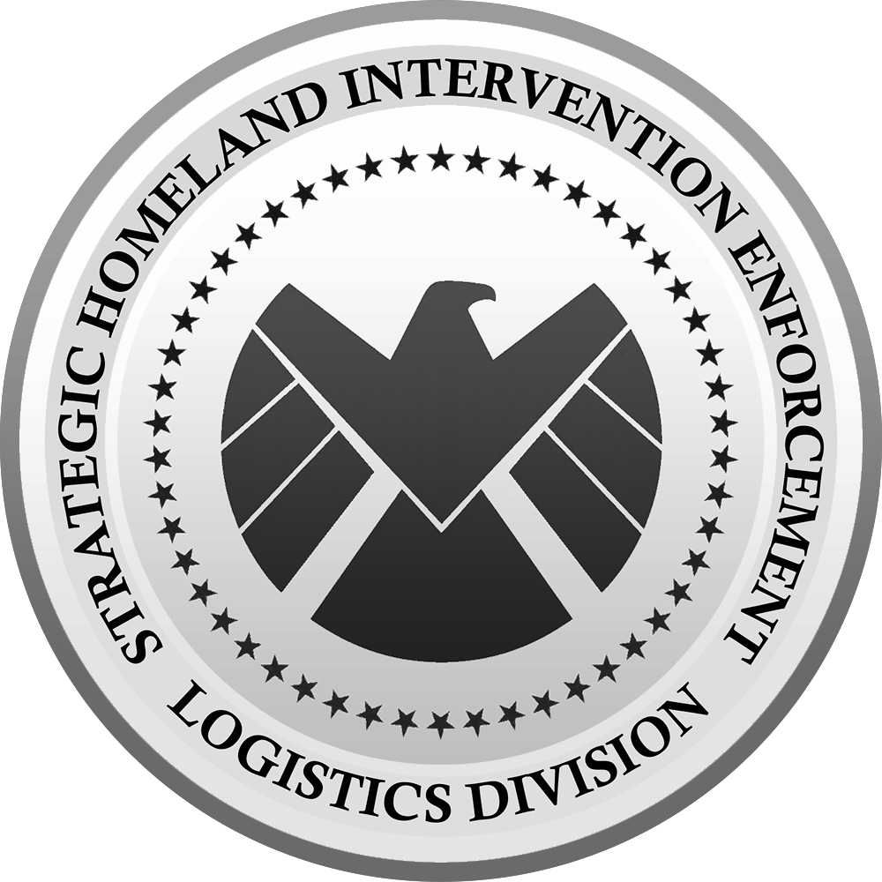

S.H.I.E.L.D.
13 JULY 2026

TITLE 1

The World Security Council was established just after the transition of the Strategic Scientific Reserve (S.S.R.) into the Strategic Homeland Intervention, Enforcement, and Logistics Division (S.H.I.E.L.D.) to address a fundamental problem: no single nation could be trusted with the monopoly on advanced global defense and special threat response. Recognizing that emerging threats–whether enhanced individuals, rogue advanced technology, or otherworldly forces–transcended traditional borders, leading global powers such as the United States, United Kingdom, Republic of India, Republic of China (Taiwan) now People’s Republic of China formed a coalition council to oversee S.H.I.E.L.D. and its global operations. The World Security Council was born out of necessity to act as the check and balance of S.H.I.E.L.D.

TITLE 2

