A Recipe Website

This website is designed to store a database of recipes and enable the user to view recipe details in a neat, aesthetic manner. It allows the user to search for recipes and ingredients.

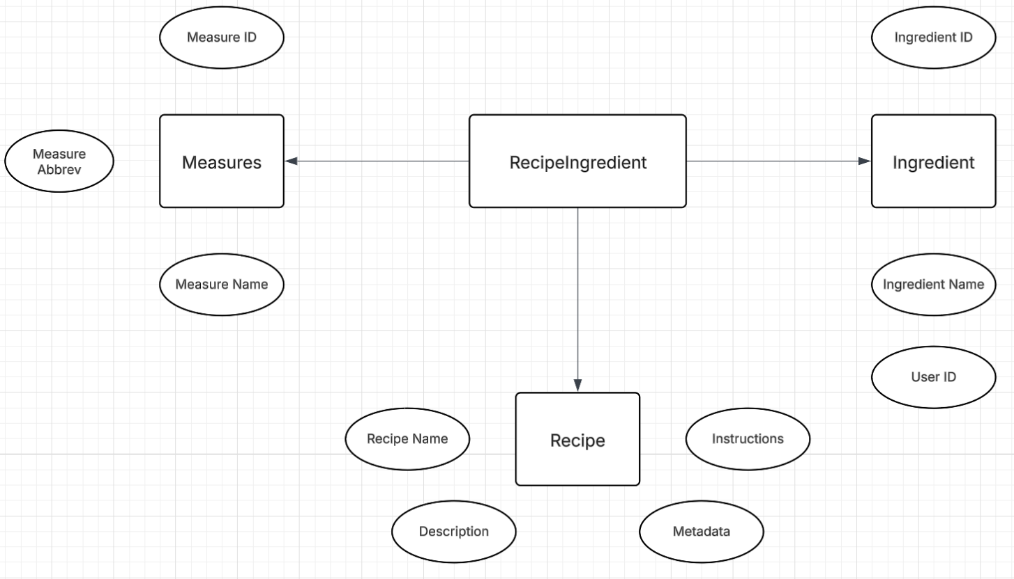

DDL Commands:

DROP DATABASE IF EXISTS recipeDB;

CREATE DATABASE recipeDB;

USE recipeDB;

DROP TABLE IF EXISTS recipeingredient;

DROP TABLE IF EXISTS recipe;

DROP TABLE IF EXISTS ingredient;

DROP TABLE IF EXISTS measure;

CREATE TABLE recipe (

id INT AUTO_INCREMENT PRIMARY KEY,

name VARCHAR(20),

meta VARCHAR(100),

description VARCHAR(50),

instructions VARCHAR(2000)

) ENGINE=InnoDB;

CREATE TABLE ingredient (

id INT AUTO_INCREMENT PRIMARY KEY,

name VARCHAR(20)

) ENGINE=InnoDB;

CREATE TABLE measure (

id INT AUTO_INCREMENT PRIMARY KEY,

name VARCHAR(15),

abbrev VARCHAR(5)

) ENGINE=InnoDB;

CREATE TABLE recipeingredient (

recipe_id INT NOT NULL,

ingredient_id INT NOT NULL,

measure_id INT,

amount DECIMAL(5,2),

FOREIGN KEY (recipe_id) REFERENCES recipe(id),

FOREIGN KEY (ingredient_id) REFERENCES ingredient(id),

FOREIGN KEY (measure_id) REFERENCES measure(id)

) ENGINE=InnoDB;

DELIMITER //

Example of insert into recipe command:

insert into recipe (name, description, meta, instructions) values('muffin', 'a dozen muffins', 'Serves: 12, Takes: 20 mins, Calories: 246 calories / serving, Dietary: Vegetarian', 'Gather all ingredients. Preheat the oven to 400 degrees F (200 degrees C). Grease a 12-cup muffin tin or line cups with paper liners. Stir flour, baking powder, salt, and sugar together in a large bowl; make a well in the center. Beat egg with a fork in a small bowl or 2-cup measuring cup; whisk in milk and oil. Pour egg mixture all at once into flour mixture; mix quickly and lightly with a fork until just moistened. The batter will be lumpy. Spoon batter into the prepared muffin cups, filling each 3/4 full. Bake in the preheated oven until tops spring back when lightly pressed, about 25 minutes.');

Example of insert into measure command:

insert into measure (name, abbrev) values('cup','cup');

insert into measure (name, abbrev) values('fluid ounce','fl oz');

insert into measure (name, abbrev) values('gallon','gal');

Example of insert into ingredient command:

insert into ingredient (name) values ('Butter');

insert into ingredient (name) values ('Cauliflower');

insert into ingredient (name) values ('Pomegranate');

Example of insert into recipeingredient command:

INSERT INTO recipeingredient (recipe_id, ingredient_id, measure_id, amount) VALUES (1, 212, 1, 2.0);

INSERT INTO recipeingredient (recipe_id, ingredient_id, measure_id, amount) VALUES (1, 48, 15, 3.0);

INSERT INTO recipeingredient (recipe_id, ingredient_id, measure_id, amount) VALUES (1, 480, 15, 0.5);

Triggers:

CREATE TRIGGER before_recipe_insert

BEFORE INSERT ON recipe

FOR EACH ROW

BEGIN

SET NEW.id = COALESCE((SELECT MAX(id) FROM recipe), 0) + 1;

END//

CREATE TRIGGER before_ingredient_insert

BEFORE INSERT ON ingredient

FOR EACH ROW

BEGIN

SET NEW.id = COALESCE((SELECT MAX(id) FROM ingredient), 0) + 1;

END//

CREATE TRIGGER before_measure_insert

BEFORE INSERT ON measure

FOR EACH ROW

BEGIN

SET NEW.id = COALESCE((SELECT MAX(id) FROM measure), 0) + 1;

END//

DELIMITER ;