توثيق مشروع تحليل بيانات عملاء الاتصالات المصرية
Egypt Telecom Customer Analytics & Churn Analysis
Data Analysis Track — مبادرة رواد مصر الرقمية، الدفعة الرابعة
Final Project Documentation

1. Project Overview & Objectives
Customer churn — subscribers leaving for a competitor — is one of the most costly problems telecom operators face. This project builds a complete analytics pipeline on Egyptian telecom customer and network-performance data to understand who churns, why, and what drives revenue and satisfaction.

Objectives
- Identify the customer segments, operators, and governorates most affected by churn.
- Analyze revenue drivers across operators, plan types, and device tiers.
- Study the relationship between network quality (speed, latency), satisfaction, and churn.
- Deliver the analysis through five complementary tools: Excel, SQL, Python (Streamlit), Power BI, and Tableau.

Scope
- 5,500 customer records (raw) + 5,000-record calibrated churn dataset.
- 965 network performance measurement points (Ookla-format, Q4 2024) across 27 governorates.
- Four operators covered: Orange, Vodafone, e&, and WE.

2. Data Description & Sources
Dataset | Description | Size
egypt_telecom_dataset-1 | Raw customer-level data: demographics, plan, usage, revenue, churn | 5,500 rows
egypt_telecom_calibrated_5000 | Calibrated customer dataset used specifically for churn analysis | 5,000 rows
tiles_raw | Ookla-format synthetic network performance dataset (Q4 2024) | 965 tiles
gov_summary | Aggregated network performance metrics per governorate | 27 governorates

Key Fields
customer_id, operator, phone_prefix, governorate, region, age, age_group, gender, plan_type, customer_segment, tenure_months, network_type, data_bundle, data_used_GB, voice_minutes, sms_count, monthly_revenue_EGP, recharge_frequency, device_tier, complaints_count, satisfaction_score, churn, registration_date.

3. Data Cleaning & Preparation (Excel)
The raw dataset was cleaned and prepared in Excel before being used across the other tools. The workbook contains the cleaned customer table alongside several pivot-table summary sheets used to power the Power BI/Tableau visuals and sanity-check the data:
- egypt_telecom_dataset-1 / egypt_telecom_calibrated_5000 — cleaned customer-level tables.
- gov_summary — pivoted network performance metrics per governorate.
- Additional pivot sheets summarizing revenue by governorate, operator, device tier, and customer segment.

Data Quality Checks Performed
Based on the final cleaned workbook, the following checks and standardizations are reflected in the data:
- No missing values in any of the 23 columns across the full 5,500-row dataset.
- No duplicate customer_id values and no fully duplicated rows.
- Categorical fields standardized to a fixed, consistent set of values — e.g. operator (Orange, Vodafone, WE, e&), region (Urban/Rural), gender (Male/Female), plan_type (Prepaid/Postpaid), customer_segment (Low, Regular, Business, VIP), network_type (2G–5G), and device_tier (6 tiers from Feature Phone to Tablet).
- All 27 Egyptian governorate names standardized and spelled consistently in Arabic.
- age_group correctly derived from age for every row (18-25, 26-35, 36-45, 46-55, 55+), with age itself bounded to a realistic 18-69 range.
- phone_prefix consistently mapped one-to-one with operator (e.g. Vodafone → 10, e& → 11, Orange → 12, WE → 15).
- Numeric fields fall within realistic bounds after cleaning: satisfaction_score (1-5), churn (binary 0/1), complaints_count (0-5), monthly_revenue_EGP (≈8-2,354 EGP), and registration_date (valid dates between 2022-01-01 and 2024-11-16).
- data_bundle standardized to 9 consistent plan names (e.g. Mini 1GB, Smart 5GB, Super 10GB, Mega 20GB, Unlimited+, Business 10/25/40/Max).
These checks indicate the raw export was de-duplicated, had its categorical labels normalized, and had derived fields (like age_group and phone_prefix) validated for consistency before being used across SQL, Python, Power BI, and Tableau.

4. Database Design & Analytical Queries (SQL)
A relational database (EgyptTelecomAnalysis) was created in SQL Server (T-SQL) with three tables:
Table | Key Columns | Relationship
Customers | customer_id (PK), operator, governorate, plan_type, monthly_revenue_EGP, churn, ... | Linked to GovernorateSummary via governorate name
NetworkTiles | tile_id (PK), governorate_en (FK), avg_d_kbps, avg_u_kbps, avg_lat_ms | FK → GovernorateSummary(governorate_en)
GovernorateSummary | governorate_en (PK), governorate_ar, avg_d_mbps, avg_u_mbps, total_tests | Referenced by NetworkTiles

Entity-Relationship Diagram (ERD)
GovernorateSummary is the parent table: NetworkTiles has a formal foreign key to it (governorate_en), so GovernorateSummary must be seeded before NetworkTiles. Customers links to GovernorateSummary informally, by matching governorate names (governorate_ar = governorate) — this relationship exists in the data but is not enforced by a foreign key constraint.
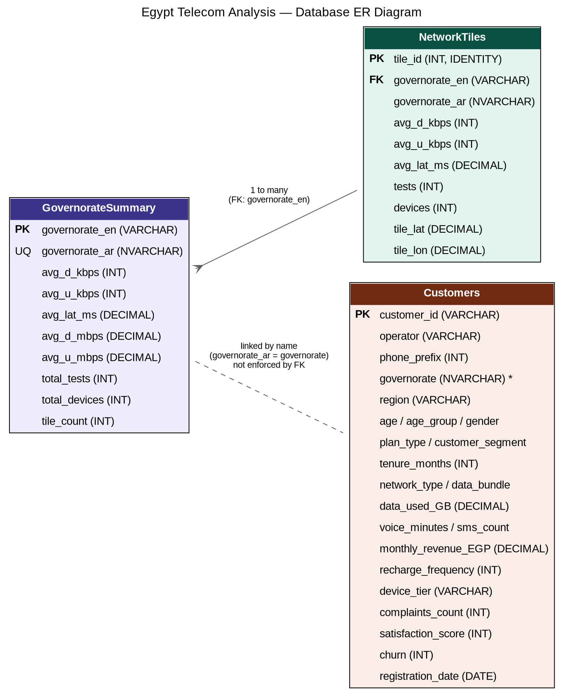

Organizing the SQL File for the Repository
The original script combines schema, ~5,500 rows of seed data, and analytical queries in a single 7,000-line file. For the repository, it was split into ordered files so each part is easy to review and run independently:
File | Contents
00_run_all.sql | Instructions describing the required run order
01_schema.sql | CREATE DATABASE + 3 CREATE TABLE statements
02_seed_customers.sql | 5,500 Customers rows (no FK dependency)
03_seed_governorate_summary.sql | 27 GovernorateSummary rows — must run before step 4 (FK dependency)
04_seed_network_tiles.sql | 965 NetworkTiles rows (FK to GovernorateSummary)
05_analytical_queries.sql | Row-count checks + all churn / revenue / usage / geographic / time / advanced-join queries

Note: the original file inserted NetworkTiles before GovernorateSummary, which would fail under the declared foreign key. The split above corrects the run order — seed GovernorateSummary first.

Analytical Query Categories
- Churn analysis — churn rate by operator, age group, network type, and tenure bucket.
- Revenue analysis — top customers, revenue by device tier, total revenue per operator.
- Usage analysis — data/voice/SMS usage by age group, high-usage customers, bundle efficiency.
- Geographic analysis — churn and satisfaction by governorate, urban vs. rural comparison.
- Time analysis — new customers and churn trend by registration month, tenure by operator.
- Advanced joins — network quality combined with satisfaction and churn per governorate.
- Customer segmentation — high-value customers, at-risk customers (high complaints + low satisfaction), operator ranking per governorate.

5. Interactive Dashboard (Python + Streamlit)
An interactive Streamlit application (Project_Final_Telecom.py) was built using Pandas and Plotly Express, with three linked dashboards and sidebar filters (operator, governorate, plan type, customer segment):

📊 Dashboard 1 — Customer & Revenue Overview
- KPIs: customer count, average monthly revenue, churn rate, average satisfaction, average tenure.
- Charts: revenue by operator, top 10 governorates by customer count, age distribution by gender, churn rate by customer segment, data usage by bundle, plan-type split.

📶 Dashboard 2 — Network Performance by Governorate
- KPIs: average download/upload speed, average latency, total tests.
- Charts: download speed by governorate, speed-vs-latency scatter, geographic map of measurement tiles.

⚠️ Dashboard 3 — Churn Analysis
- KPIs: overall churn rate, churned customer count, average complaints and satisfaction (churned vs. retained).
- Charts: churn by segment, churn vs. complaint count, satisfaction distribution by churn status, churn by device tier, tenure distribution by churn, churn by e-wallet usage.

6. Power BI Dashboard
The Power BI report (Power_BI_Final_Project.pbix) presents three report pages:

Page 1 — Customers & Revenue Overview
- KPI cards: 5.5K customers, 794.67K EGP total monthly revenue, 40.78 months average tenure.
- Revenue by governorate (bar chart), tenure distribution by age group (pie), plan type by customer segment, revenue share by operator (donut — Vodafone leads with ~46.7%).
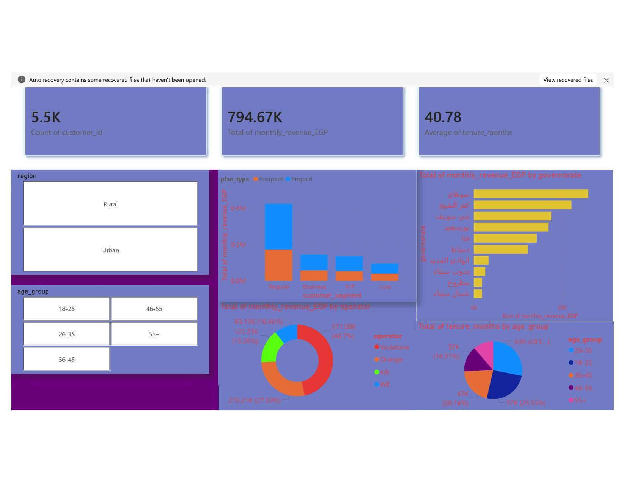

Page 2 — Churn Analysis
- KPI cards: total churn 162 customers (~3% average churn rate).
- Churn by operator (pie — Vodafone ~38.9%, Orange ~27.2%, WE ~20.9%, e& ~13.0%), average churn by tenure (line), customer count by satisfaction score and churn (bar), churn by plan type.
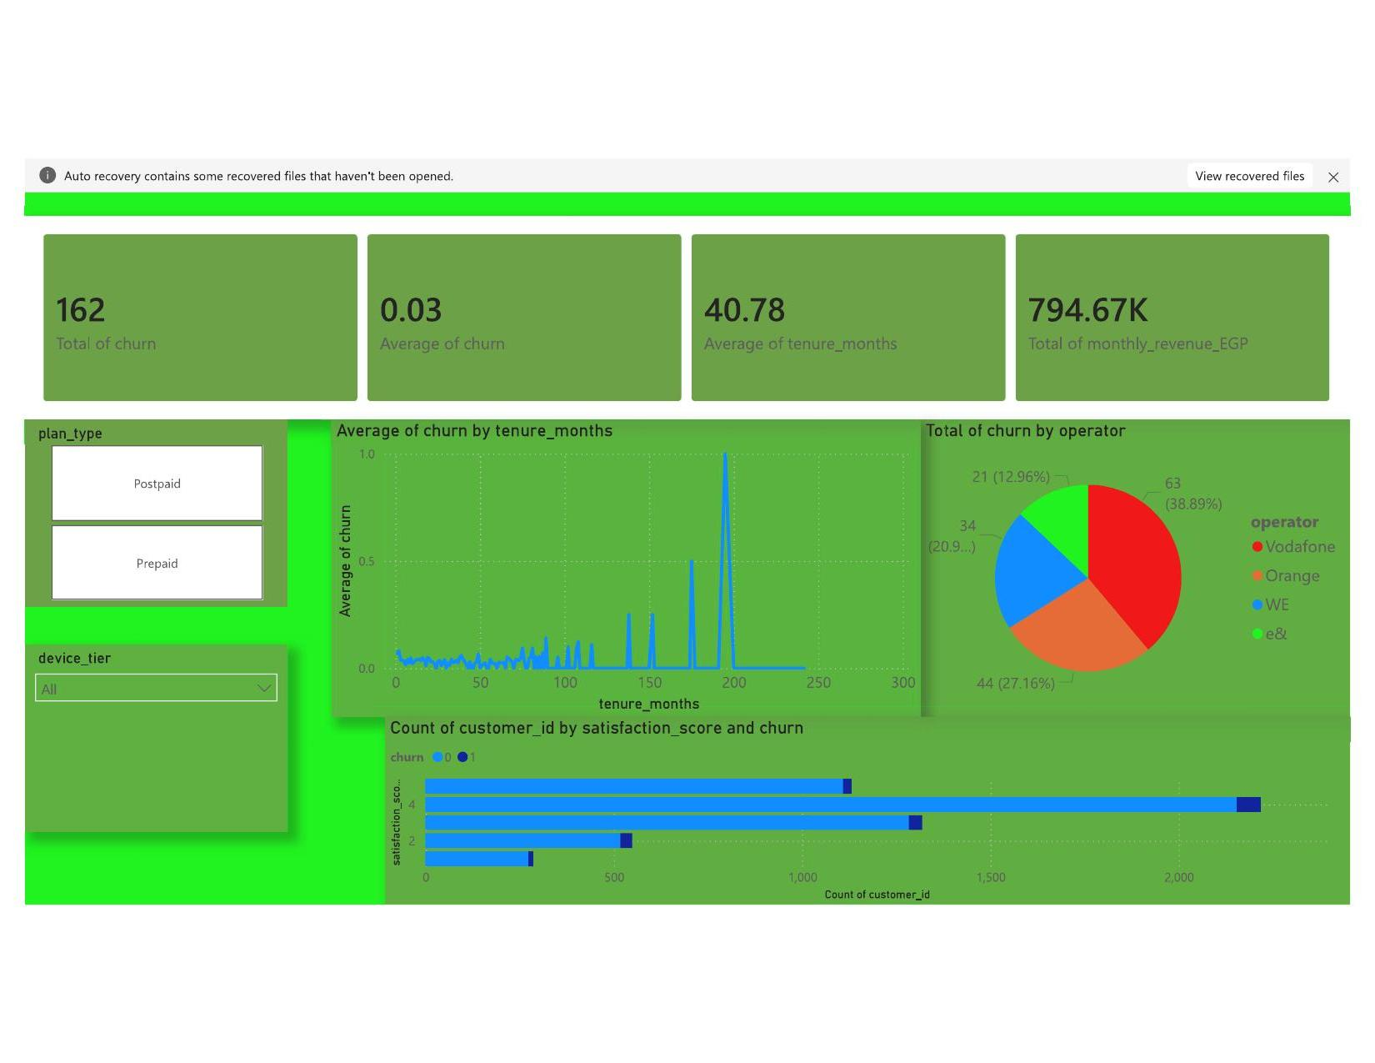

Page 3 — Usage, Complaints & Network
- KPI cards: 5K total complaints, 3.61 average satisfaction score, 2M total voice minutes, 54.45K GB total data used.
- Complaints by governorate, satisfaction by operator, customer count by data bundle, customer count by device tier and network type.
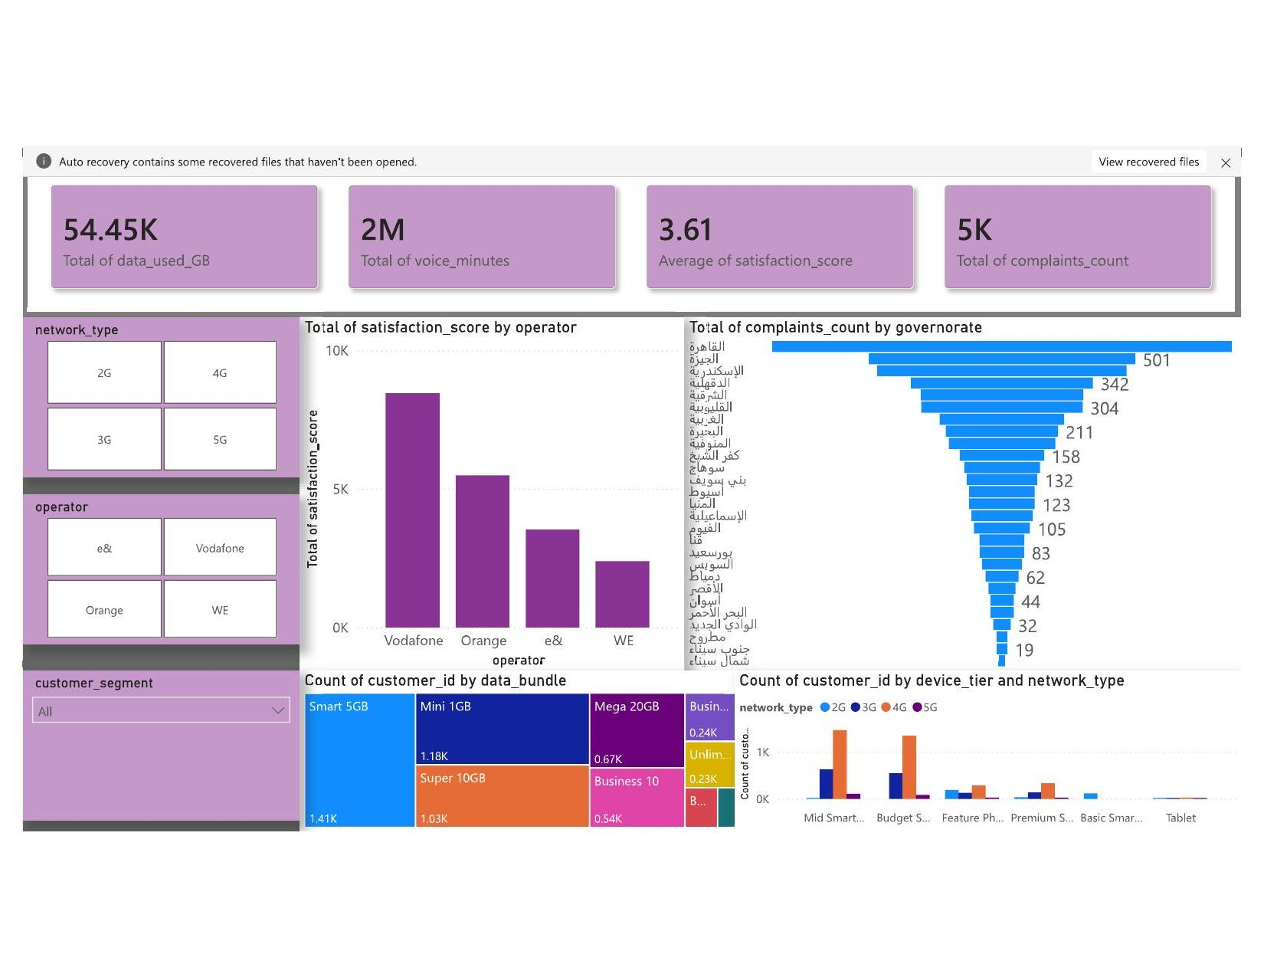

7. Tableau Dashboards
The Tableau analysis below (Network Performance and Customer & Revenue Performance dashboards, including key observations and interpretive notes) was prepared by Marina and is included here in full.
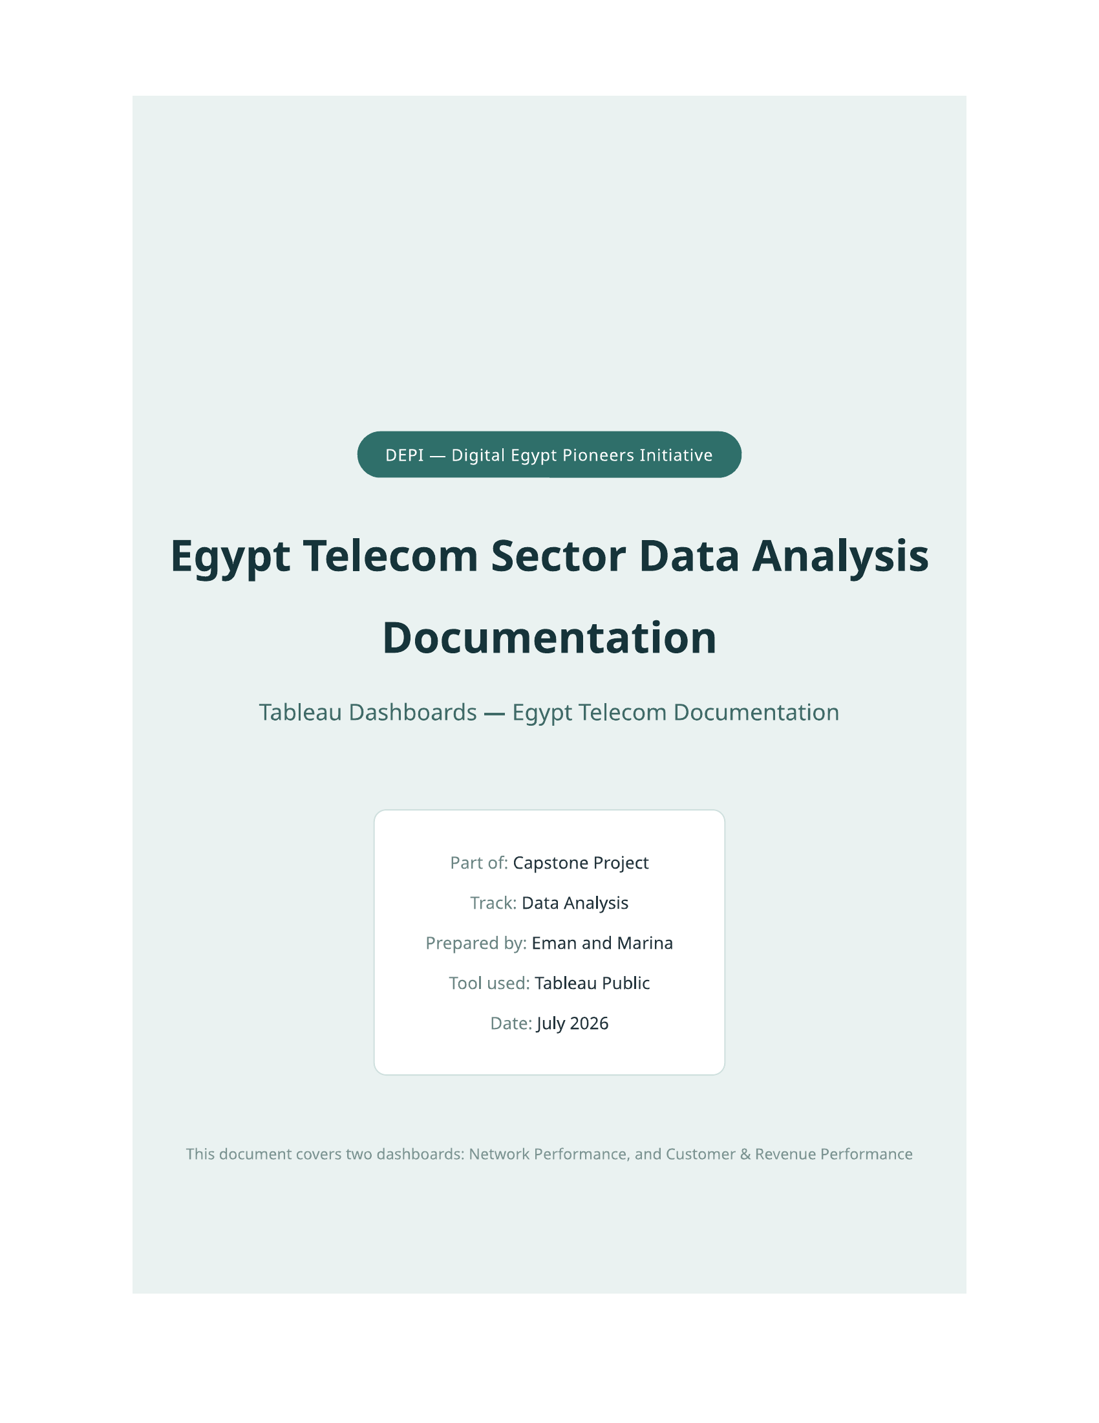
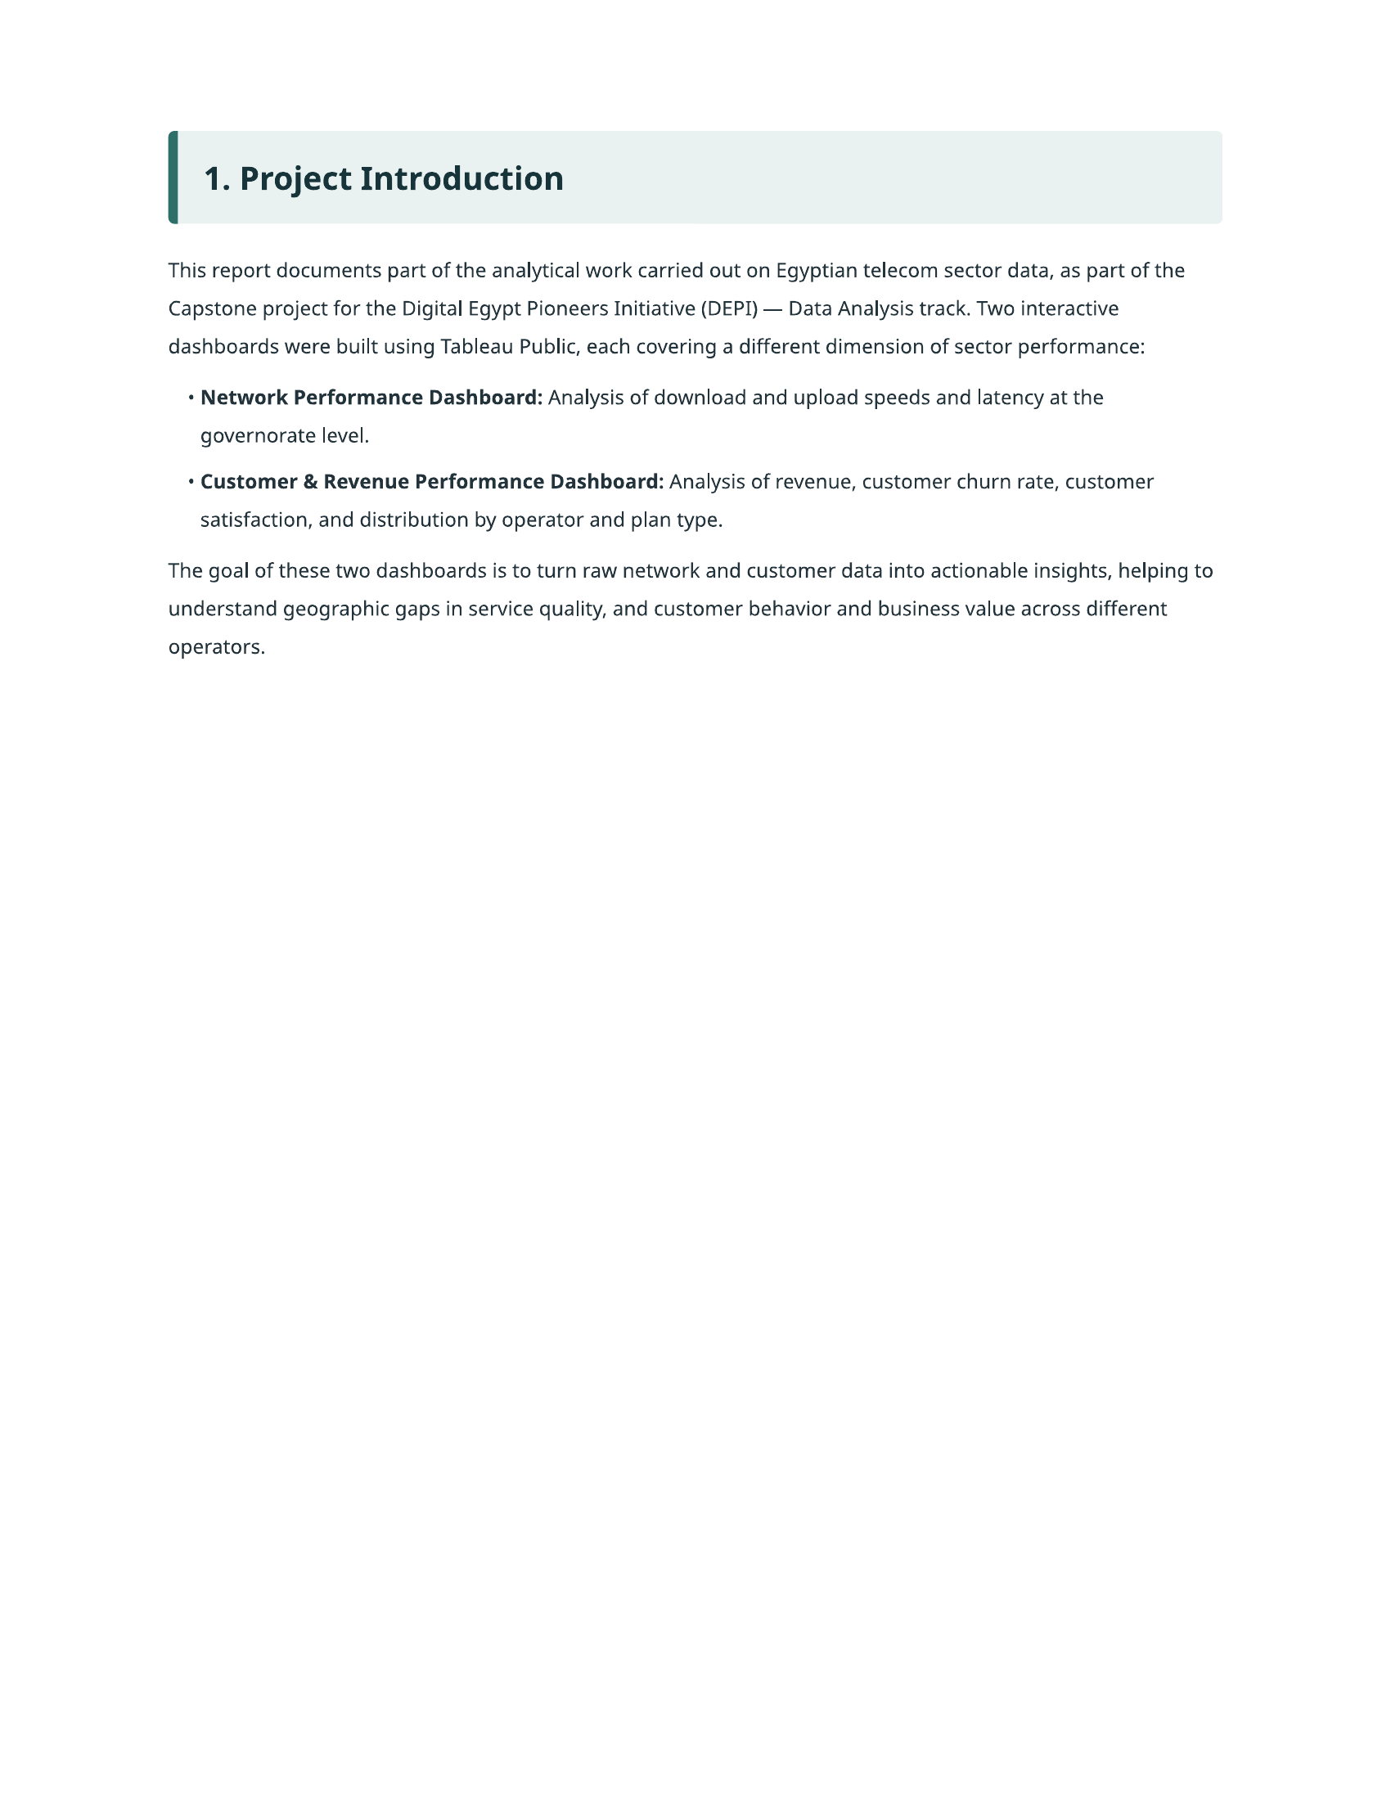
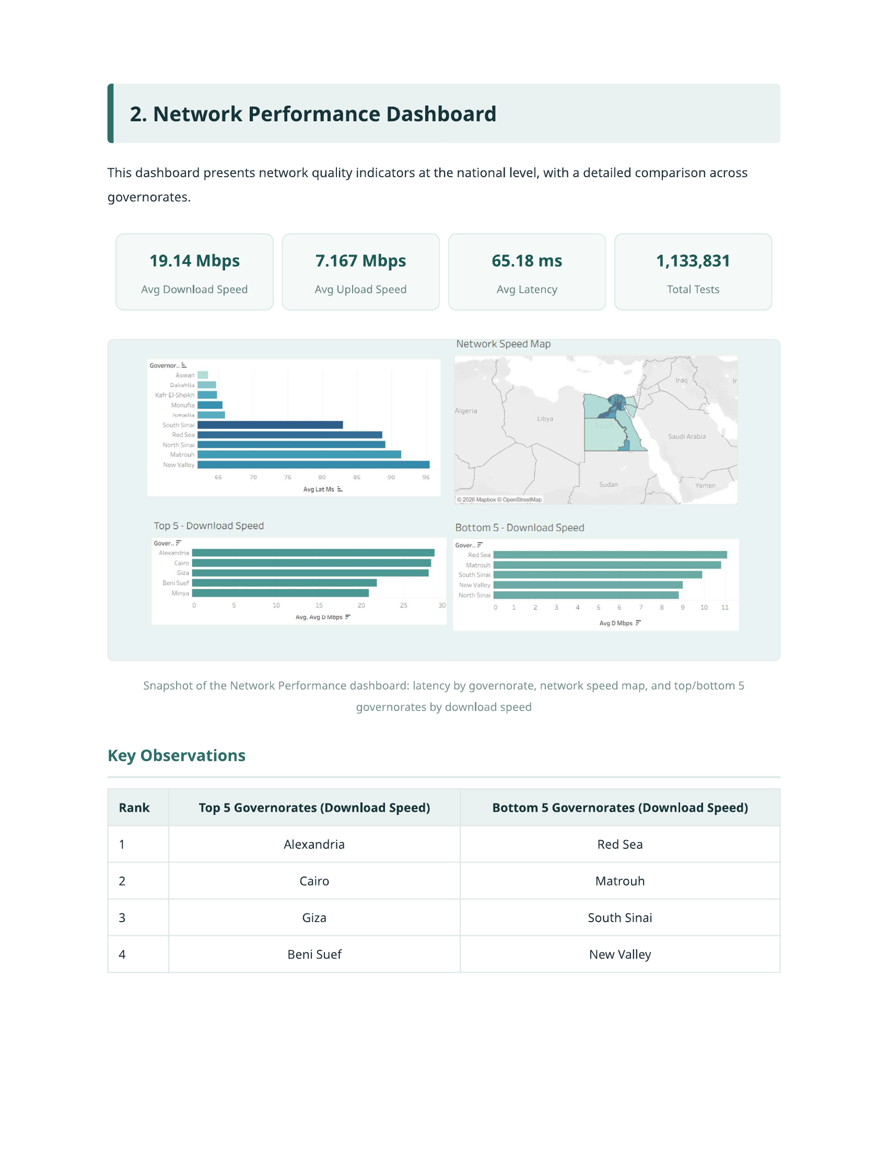
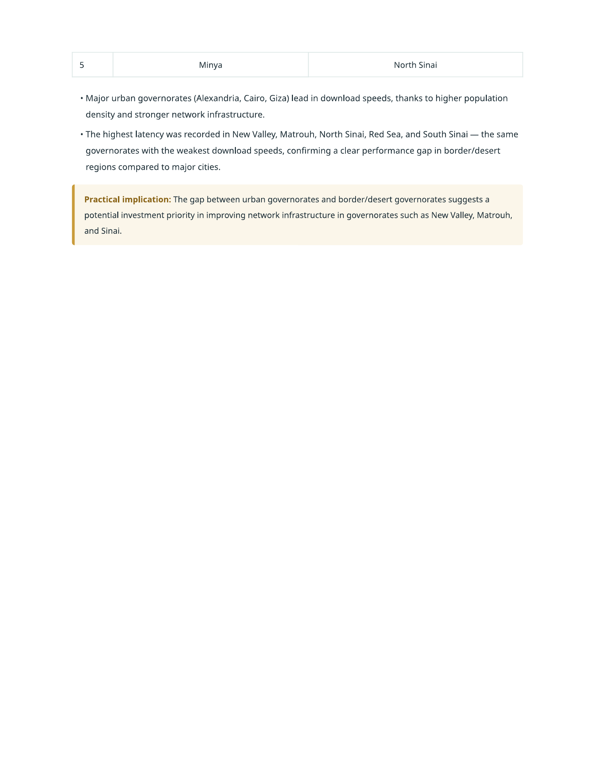
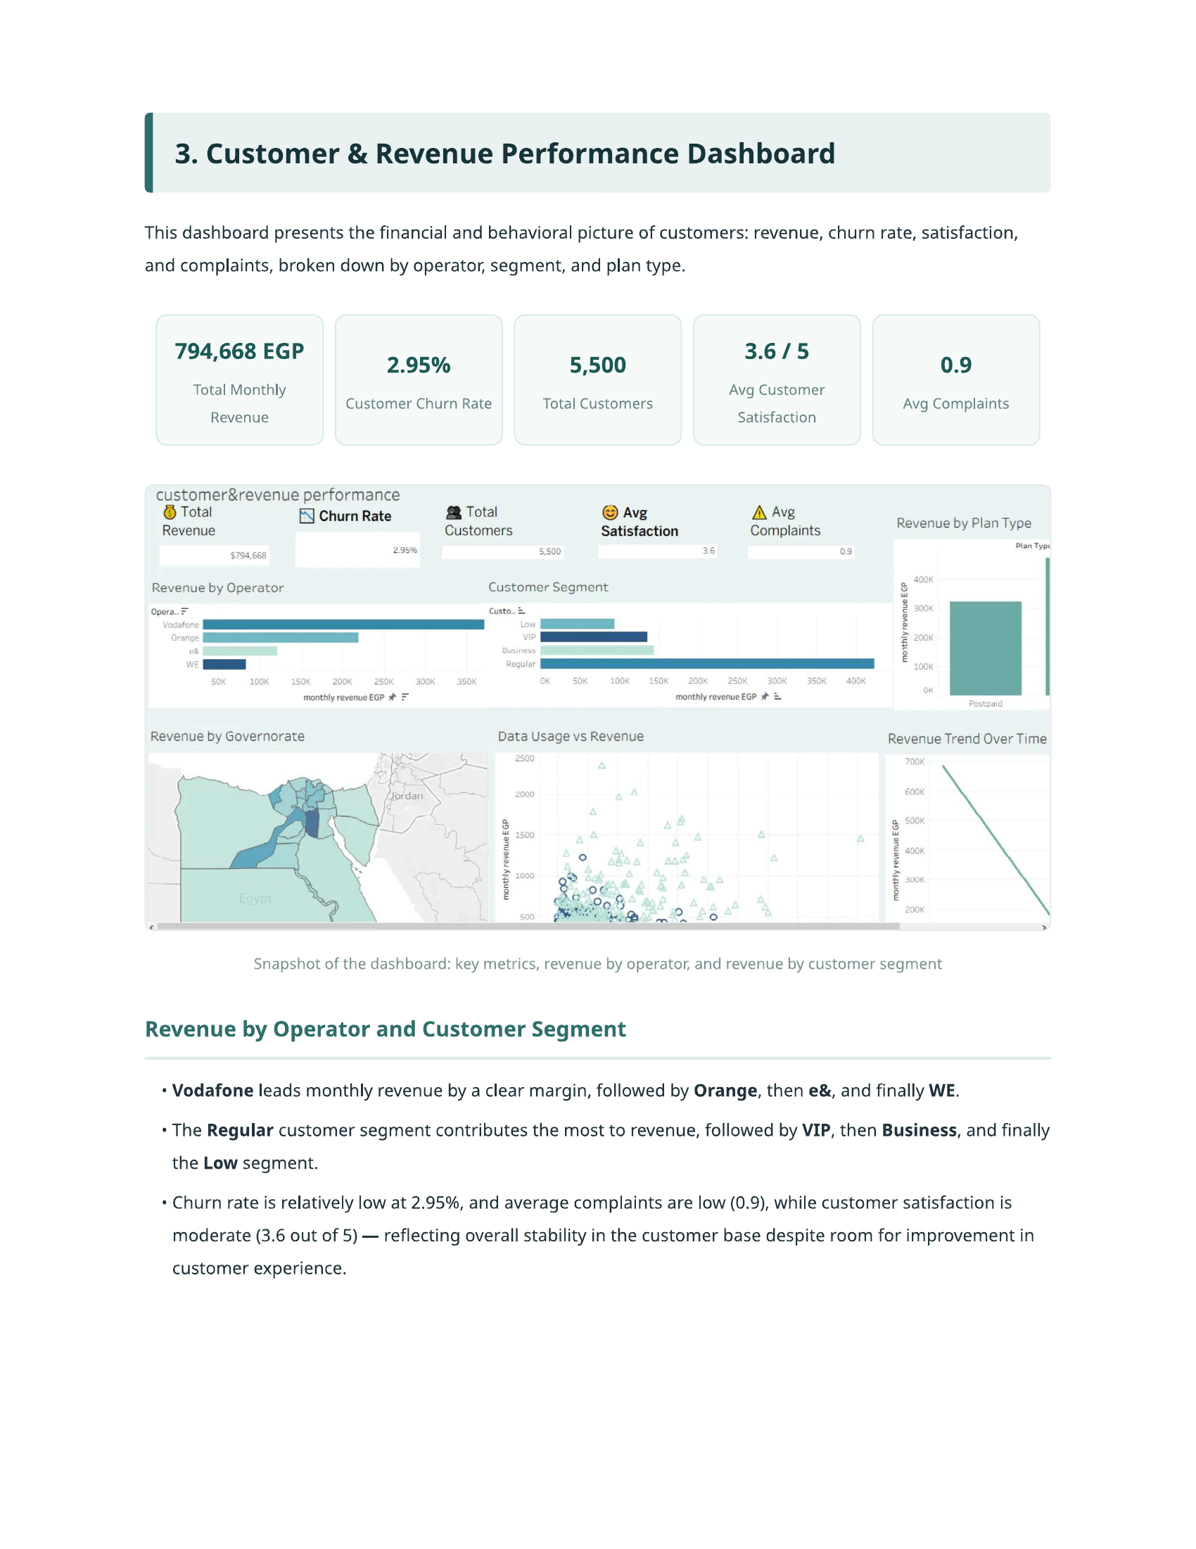
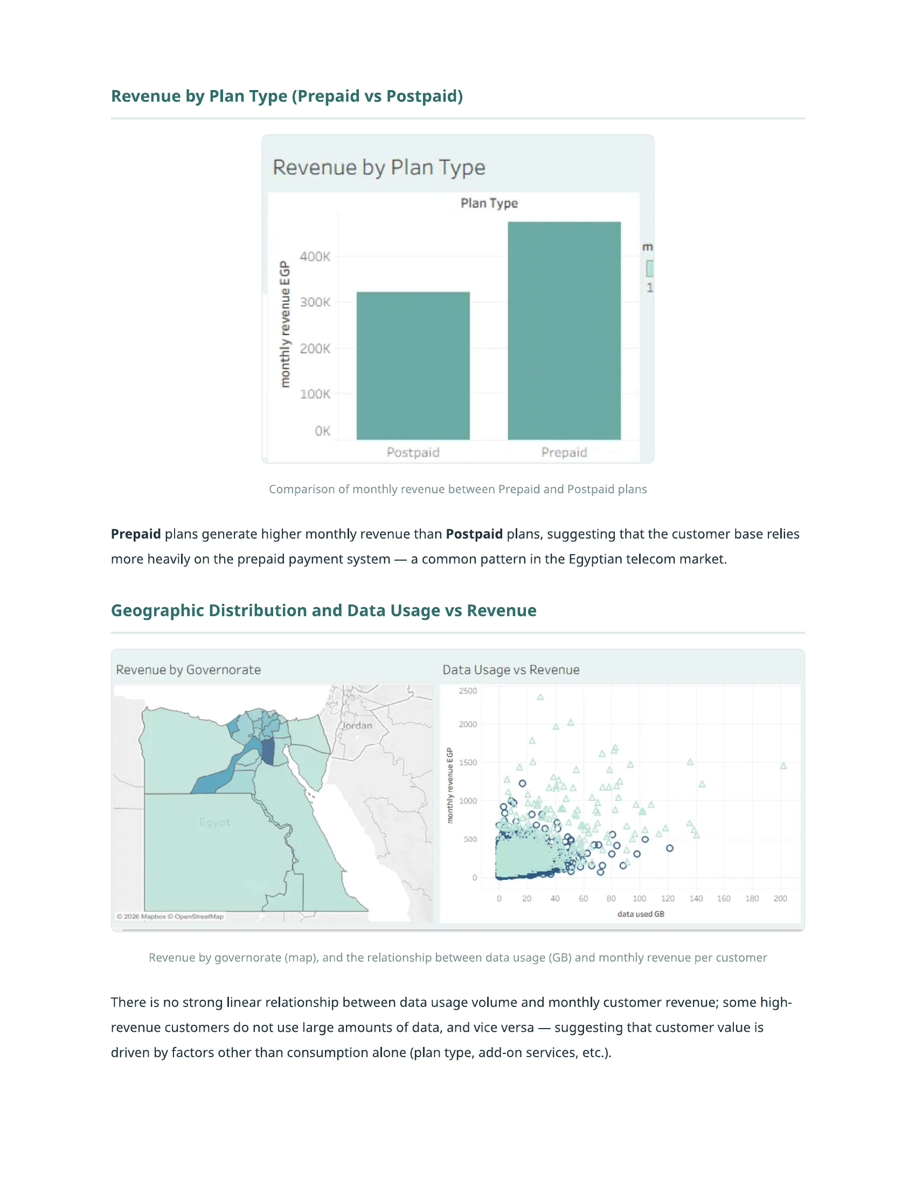
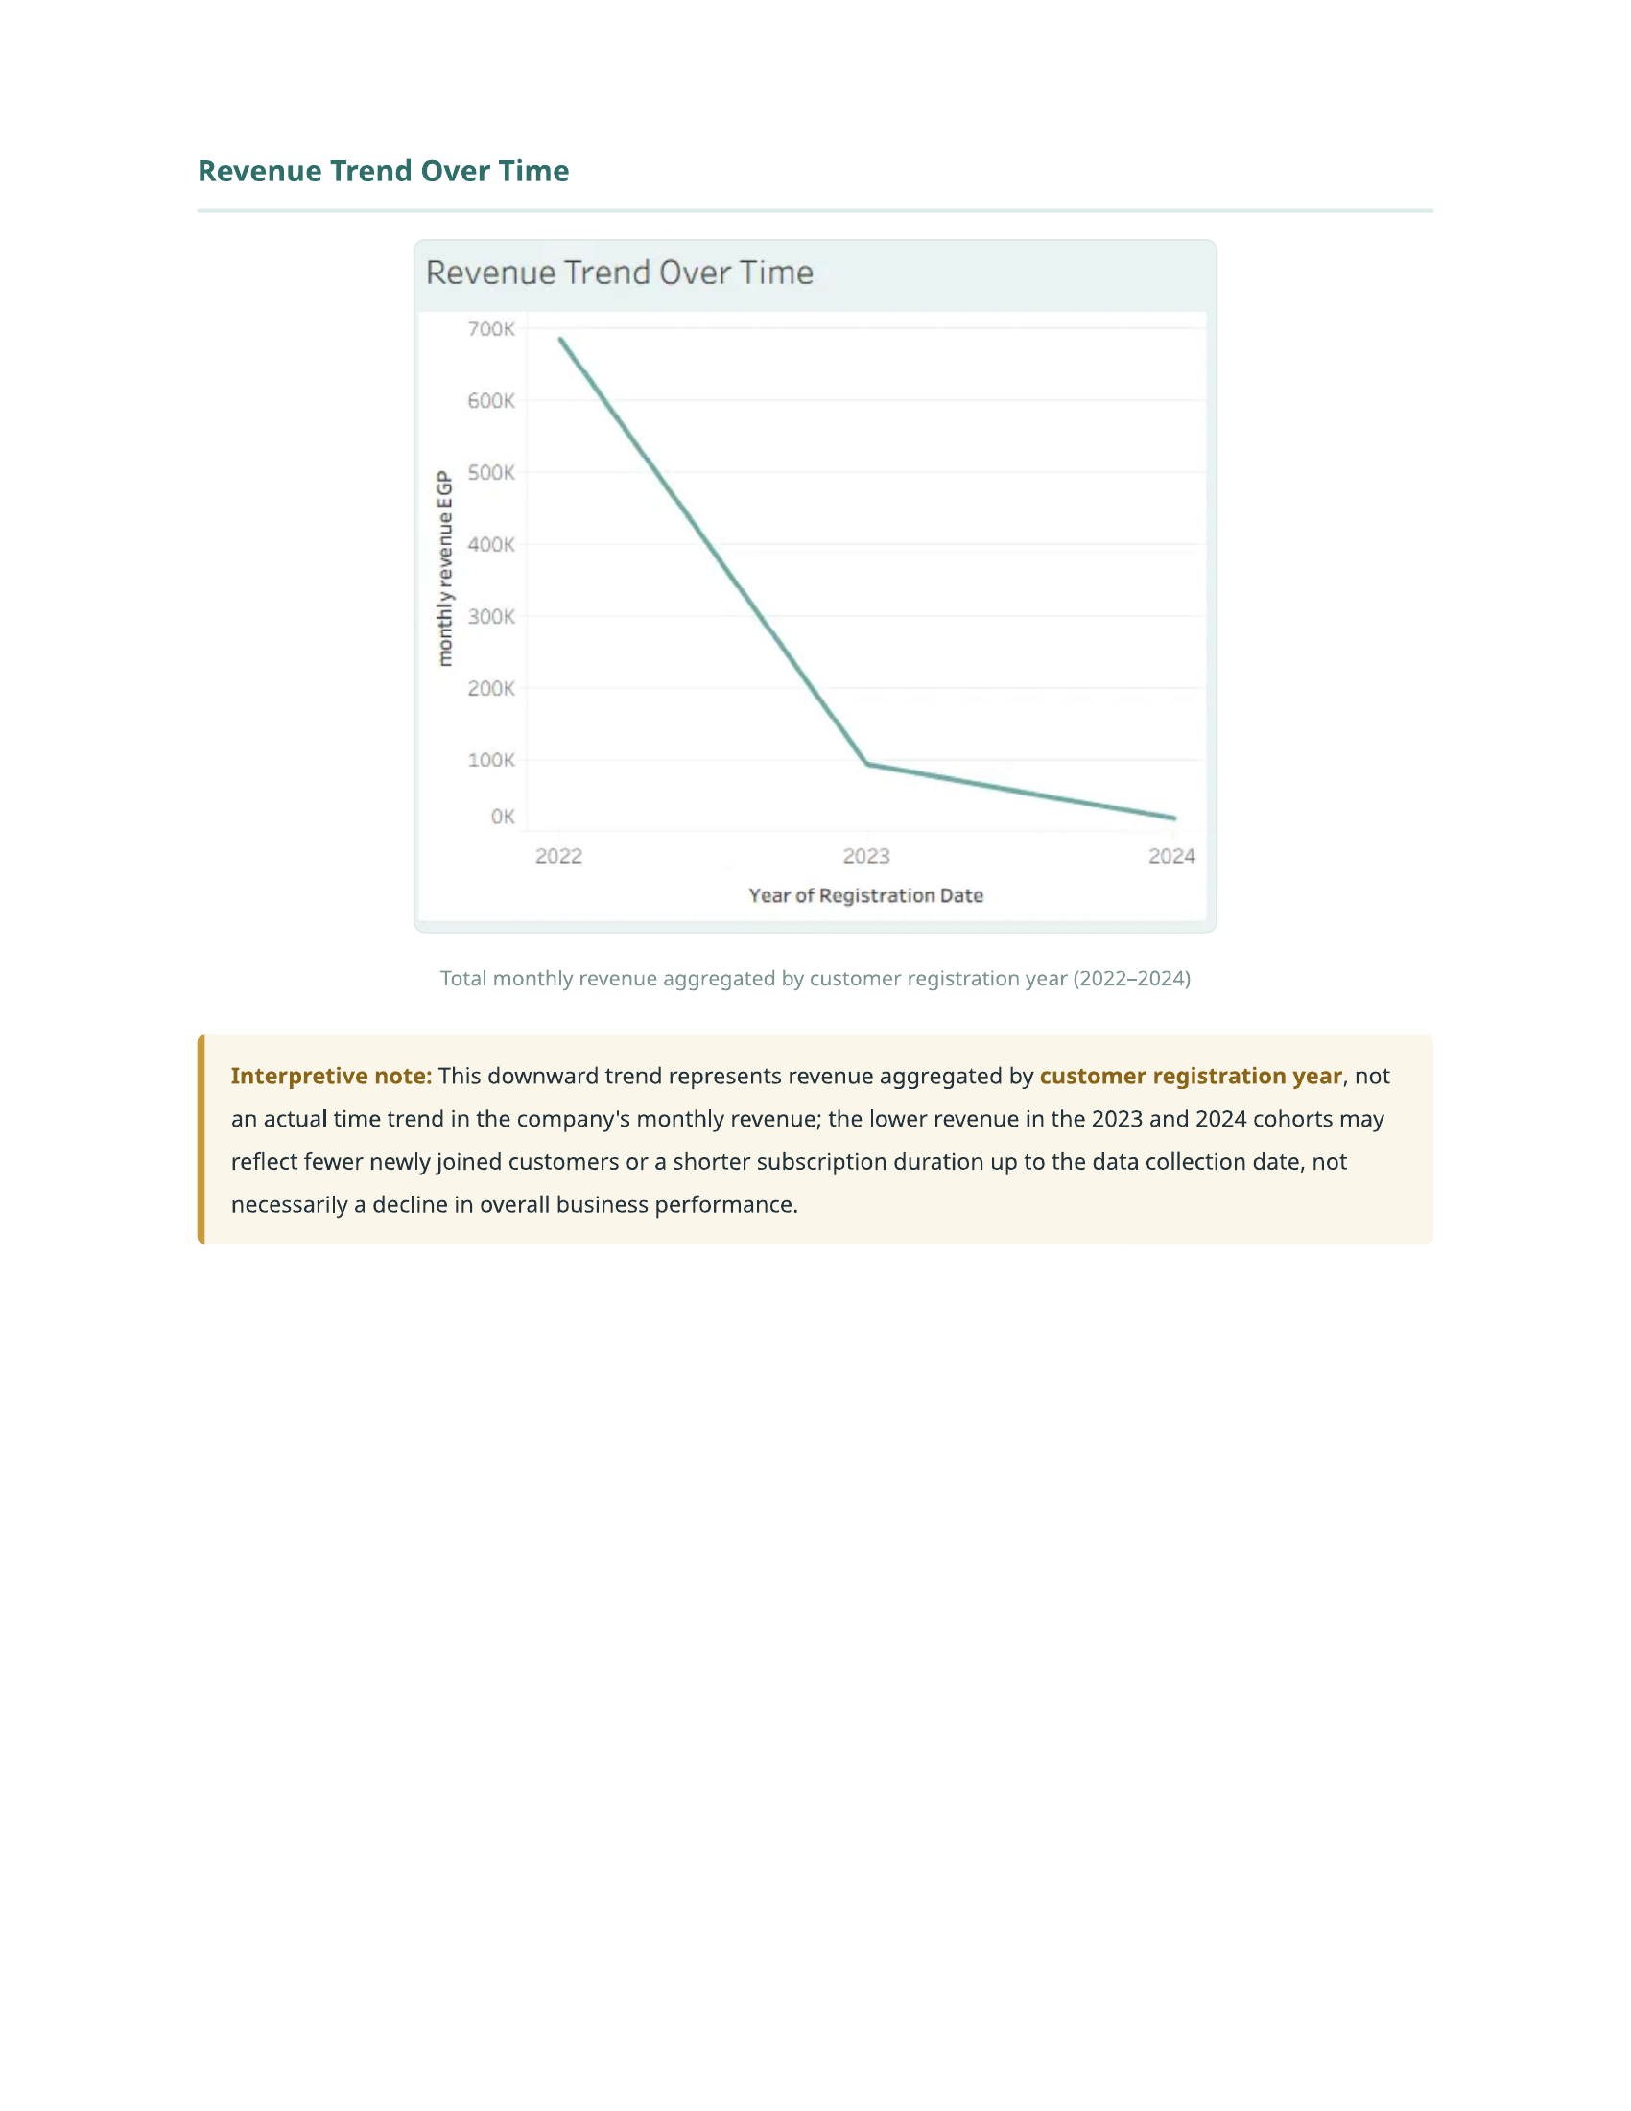
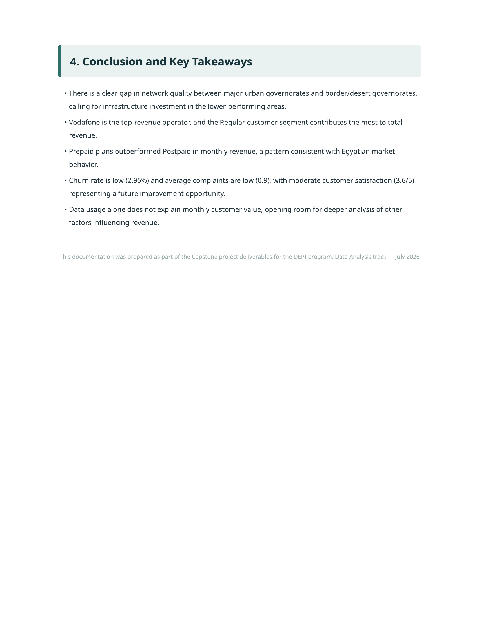

8. Data Validation & Testing
- Row counts verified after SQL import (Customers, NetworkTiles, GovernorateSummary) via COUNT(*) checks.
- Referential integrity checked between NetworkTiles and GovernorateSummary (orphan-governorate query).
- Cross-tool consistency checked: KPI totals (customer count, revenue, churn) match across Excel pivots, SQL aggregates, the Streamlit app, and Power BI.

9. Key Insights
- Overall churn rate is low (~3%), but is concentrated among specific operators, high-complaint customers, and low-satisfaction segments.
- Vodafone holds both the largest revenue share (~46.7%) and the largest share of churned customers (~38.9%) — consistent with it having the largest customer base.
- Customers with more complaints and lower satisfaction scores churn at a visibly higher rate — complaint volume is a strong early-warning signal.
- Network performance (download speed, latency) varies notably by governorate, which correlates with regional differences in satisfaction.
- Postpaid and high-value/high-usage customers tend to generate disproportionately higher revenue relative to their numbers.

10. Conclusion & Recommendations
- Prioritize retention efforts on customers with 3+ complaints and satisfaction scores ≤ 2 — the clearest at-risk group in the data.
- Investigate network quality in low-performing governorates, since it appears linked to lower satisfaction and higher churn risk.
- Consider operator-specific retention campaigns, given the concentration of churn and revenue within Vodafone's customer base.
- Extend this analysis with a predictive churn model (e.g., logistic regression / gradient boosting) using the calibrated 5,000-record dataset as a next step.

