Course Four

Regression Analysis: Simplifying Complex Data Relationships
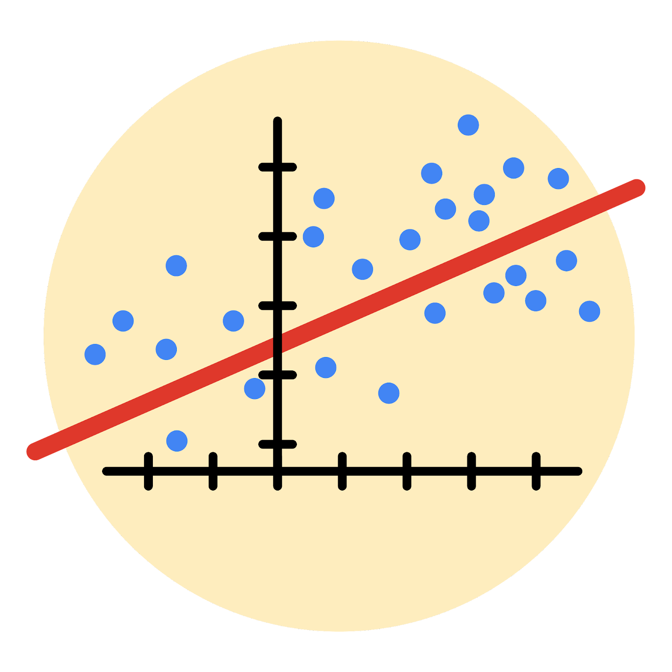

Instructions
Use this PACE strategy document to record decisions and reflections as you work through this end-of-course project. As a reminder, this document is a resource that you can reference in the future, and a guide to help you consider responses and reflections posed at various points throughout projects.

Course Project Recap
Regardless of which track you have chosen to complete, your goals for this project are:
- Complete the questions in the Course 4 PACE strategy document
- Answer the questions in the Jupyter notebook project file
- Build a multiple linear regression model
- Evaluate the model
- Create an executive summary for team members

Relevant Interview Questions
Completing the end-of-course project will empower you to respond to the following interview topics:
- Describe the steps you would take to run a regression-based analysis
- List and describe the critical assumptions of linear regression
- What is the primary difference between R² and adjusted R²?
- How do you interpret a Q-Q plot in a linear regression model?
- What is the bias-variance tradeoff? How does it relate to building a multiple linear regression model? Consider variable selection and adjusted R².
Reference Guide
This project has seven tasks; the visual below identifies how the stages of PACE are incorporated across those tasks.
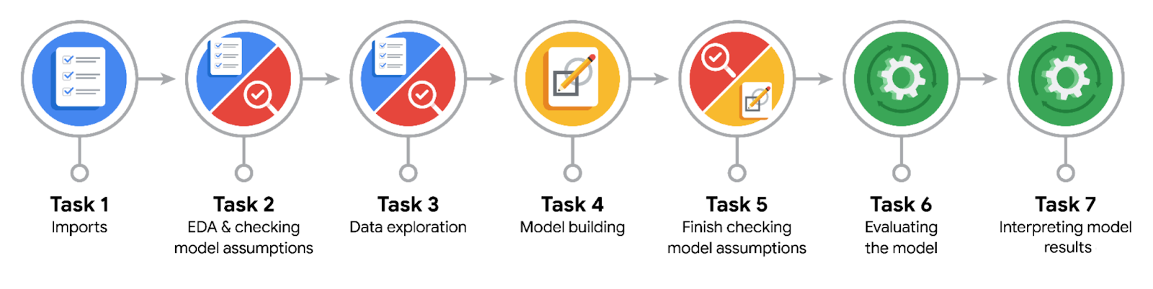

Data Project Questions & Considerations
PACE: Plan Stage
- Who are your external stakeholders for this project?

- What are you trying to solve or accomplish?

- What are your initial observations when you explore the data?

- What resources do you find yourself using as you complete this stage?

PACE: Analyze Stage
- What are some purposes of EDA before constructing a multiple linear regression model?

- Do you have any ethical considerations at this stage?

PACE: Construct Stage
- Do you notice anything odd?

- Can you improve it? Is there anything you would change about the model?

- What resources do you find yourself using as you complete this stage?

PACE: Execute Stage
- What key insights emerged from your model(s)?

- What business recommendations do you propose based on the models built?

- To interpret model results, why is it important to interpret the beta coefficients?

- What potential recommendations would you make?

- Do you think your model could be improved? Why or why not? How?

- What business/organizational recommendations would you propose based on the models built?

- Given what you know about the data and the models you were using, what other questions could you address for the team?

- Do you have any ethical considerations at this stage?

